# Project Assessment – Online sports shop

# Deliverable C – Customer browsing

## Criteria

### Unit code, name and release number

• ICTDBS507 - Integrate databases with websites (1)

• ICTWEB513 - Build dynamic websites (1)

• ICTWEB514 - Create dynamic web pages (1)

• ICTWEB517 - Create web-based programs (1)

### Qualification/Course code, name and release number

ICT50220 - Diploma of Website Development

## Assessment Declaration

When you submit this assessment online you are agreeing to the following assessment declaration:

* This assessment is my original work and no part of it has been copied from any other source except where due acknowledgement is made.
* No part of this assessment has been written for me by any other person except where such collaboration has been authorised by the assessor concerned.
* I understand that plagiarism is the presentation of the work, idea or creation of another person as though it is your own. Plagiarism occurs when the origin of the material used is not appropriately cited. No part of this assessment is plagiarised.

Version: *1.0*

Date created: *2 March 2019*

Date modified: *26/10/2022*

For queries, please contact:

*Hornsby Campus Information Technology.*

© 2019 TAFE NSW, Sydney  
RTO Provider Number 90003 | CRICOS Provider Code: 00591E

The contents in this document is copyright © TAFE NSW 2019, and should not be reproduced without the permission of the TAFE NSW. Information contained in this document is correct at time of printing: 26 October 2022. For current information please refer to our website or your teacher as appropriate.

## Assessment instructions

Table 1 Assessment instructions

|  |  |
| --- | --- |
| Assessment details | Instructions |
| **Assessment overview** | The objective of this assessment is to assess your knowledge and performance as would be required to plan, design, create, document and test a website used to sell sports equipment. |
| **Assessment Event number** | 2 of 3 for the web build stream |
| **Instructions for this assessment** | This is a project-based assessment and will be assessing you on your knowledge and performance of the units.  This assessment is in 3 parts and includes an assessment checklist:   1. Website 2. Documentation 3. Assessment Checklist |
| **Submission instructions** | On completion of this assessment, you are required to **upload** it to your assessor for marking and **publish the website on the supplied webserver**.  It is important that you keep a copy of all electronic assessments submitted to TAFE. When submitting your assessment, you agree to the assessment declaration. |
| **What do I need to do to achieve a satisfactory result?** | To achieve a satisfactory result for this assessment all sections must be implemented correctly. |
| **What do I need to provide?** | XAMPP |
| **What the assessor will provide?** | Project brief  Documentation template |
| **Due date and time allowed** | Week 12 |
| **Assessment feedback, review or appeals** | Appeals are addressed in accordance with Every Students Guide to Assessment. |

## Specific task instructions

The instructions and the criteria in the tasks and activities below will be used by the assessor to determine if you have satisfactorily completed this assessment event. Use these instructions as a guide to ensure you demonstrate the required knowledge.

## Part 1 Website customer browsing

For this deliverable the application enables customers to view featured items on the home page, browse, search for items and contact sports warehouse using the contact page.

A database needs to be created with the correct tables, columns and relationships. The products and categories are stored in the database.

### Section A - Home page requirements

The home page for the website displays the store’s featured items. These are items that have been marked as featured in the database. Use SQL to retrieve the data. For each item display the item photo, price, sale price (if applicable) and product name.

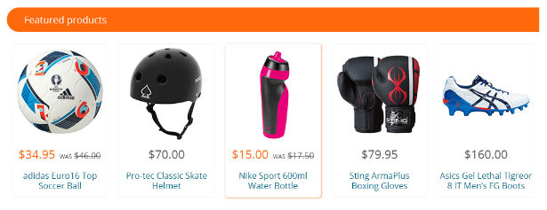

Figure 1. Featured items in desktop view

#### Categories

The items for sale are organised into categories. An item belongs to just one category and categories can have many items. The categories displayed in the website are stored in the database. Use SQL to retrieve the data.

These categories are displayed towards the top of the page:



Figure 2. Categories in desktop view

And in the footer:

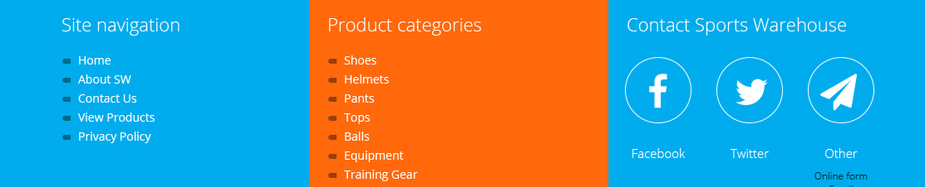

Figure 3. Categories in the footer in desktop view

### Section B - Contact us page

The contact page was created in deliverable A – pre-launch. For this deliverable you will need to edit the layout of the page so that it fits in with the rest of the website design. The contact page can be accessed by clicking on the “Contact Us” link in the top navigation, and at the bottom of the page.

### Section C - Browsing by category

The user can browse the site to view the items for sale. The items can be browsed by selecting the category. When a category is selected all the items that belong to the category are displayed.

For each item, display:

* Item name
* Price and sale price if applicable
* Photo of item

Items are grouped into categories. An item belongs to one category only and categories may contain more than one item. Use SQL to retrieve the data.

### Section D - Searching for an item

The user can search for an item by providing the item name or part of the name. Use SQL to retrieve the data.



Figure 4. Product search

For each item, display:

* Item name
* Price and sale price if applicable
* Photo of item

### Section E - Viewing an item

When an item is displayed the user can click on the item to view the items:

* Item name
* Price and sale price if applicable
* Photo of item – you may choose to display a larger photo for the item (optional)
* Description of the item

Use SQL to retrieve the data.

### Section F - Coding and database requirements for deliverable C

* A MySQL database is setup, and the PHP code connects to it with the correct credentials.
* Data for the database is imported into the tables
* Test the database connection works on both the local web server (XAMPP) and the remote web server (Web host)
* Create a class which will handle the database connection and retrieval of data.
* Create a layout template which contains the common elements of the web pages.
* Identify and create templates to separate the user interface from the programming logic.

### Section G - Testing requirements for deliverable C

* Create a checklist for each of the requirements and check the website against these requirements and debug/amend accordingly (include checklist with the documentation)
* Give an example of a bug you found and the process you took to debug the code.
* The website functions well in edge and Chrome
* The website validates against W3C HTML 5 and CSS
* The website is uploaded to the allocated web server and tested

## Part 2 Documentation and planning

### Section H - Documentation:

Using the supplied template address the following items:

* What are the benefits of using object-oriented programming when developing an application?
* Why is it important to do some analysis and design before starting to code?
* How can wireframes, storyboards and prototypes assist when planning, designing and building the website?
* Describe why a MySQL database has been utilised in this project, what other alternatives are there?
* Create a checklist for each of the requirements to be used for testing

### Section I - Wireframes

Create a wireframe/storyboard to demonstrate the customer purchasing functionality.

Physical evidence required:

You will need to submit to your teacher:

* Your documentation file
* Wireframes
* Your website files

On the webserver

* Your website files
* Your database
* Make sure you test the website works on the server

## Part 3: Assessment Checklist

The following checklist will be used by your assessor to mark your performance against the assessment criteria of your submitted project. Use this checklist to understand what skills and knowledge you need to demonstrate in your submission. All the criteria described in the Assessment Checklist must be met. The assessor may ask questions after the task has been submitted.

Your assessor will complete the following table and provide you with the feedback. Note S means satisfactory and US means unsatisfactory.

|  |  |  |  |  |
| --- | --- | --- | --- | --- |
| TASK | Instructions | S | US | Assessor Comments |
|  | **Implementation** |  |  |  |
| 1 | Database created with correct tables |  |  |  |
| 2 | Items marked as featured in the database are displayed on the home page |  |  |  |
| 3 | Categories stored in the database are displayed in the top menu and footer |  |  |  |
| 4 | The contact us page is integrated into the website |  |  |  |
| 5 | When a category is selected all items that belong to that category are displayed |  |  |  |
| 6 | Users can search for an item by supplying the item name or part of the name |  |  |  |
| 7 | The correct data is displayed for each item |  |  |  |
| 8 | An item can be selected to view the item’s name, photo, price and sale price and description |  |  |  |
| 9 | The website is uploaded and tested on the web server |  |  |  |
| 10 | Class is created to access the database |  |  |  |
| 11 | Data is imported into the database tables |  |  |  |
| 12 | database connection works on both the local web server (XAMPP) and the remote web server (Web host) |  |  |  |
| 13 | Layout template created containing common elements of the web pages |  |  |  |
| 14 | Templates are used to separate the user interface from the programming logic |  |  |  |
|  | Testing requirements |  |  |  |
| 15 | Checklist created for each requirement |  |  |  |
| 16 | Bugs identified, debugged and corrected |  |  |  |
| 17 | Website functions well in 2 browsers |  |  |  |
| 18 | Website validates against the W3C HTML 5 and CSS |  |  |  |
| 19 | Website is uploaded to the allocated web server and tested |  |  |  |
|  | **Documentation** |  |  |  |
| 20 | What are the benefits of using object-oriented programming when developing an application |  |  |  |
| 21 | Description of the benefits of analysis and design |  |  |  |
| 22 | Description of the purpose of wireframes/storyboards/prototyping |  |  |  |
| 23 | Describe why a MySQL database has been utilised and other alternatives |  |  |  |
| 24 | Wireframes demonstrate the customer purchase functionality |  |  |  |

## Assessment Feedback

### Assessment outcome

Satisfactory

Unsatisfactory

### Assessor Feedback

Was the assessment event successfully completed?

If no, was the resubmission/re-assessment successfully completed?

Was reasonable adjustment in place for this assessment event?  
*If yes, ensure it is detailed on the assessment document.*

Comments:

### Assessor name, signature and date:

***Feedback provided electronically***