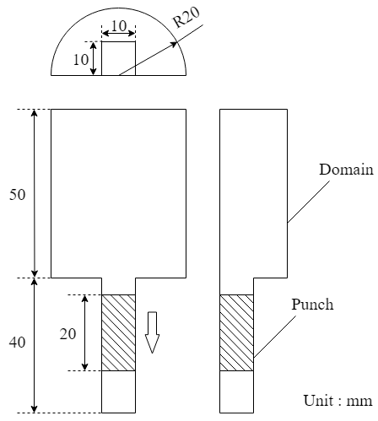

Figure 1. Schematic Geometry

Table 1. Physical Properties

|  |  |
| --- | --- |
| Gas phase |  |
| Viscosity | 1.8×10-5 Pa・s |
| Density | 1 kg/m3 |
| Solid phase |  |
| Density | 1500 kg/m3 |
| Spring constant | 50 N/m |
| Coefficient of restitution | 0.9 |
| Coefficient of friction | 0.3 |

Table 2. Calculation conditions

|  |  |
| --- | --- |
| Particle diameter | 250 μm |
| Number of particles | 500,000 |
| Grid size | 0.5 mm |
| Calculation time | 0.24 s |

自然落下

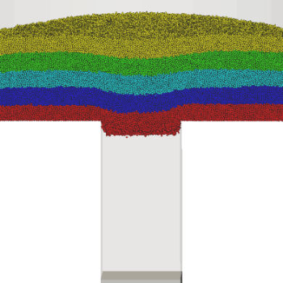 0.02 s

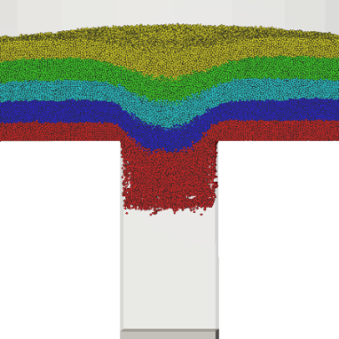 0.04 s

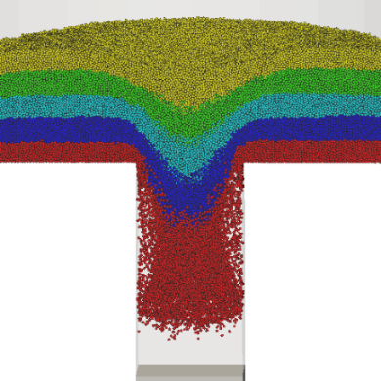 0.06 s

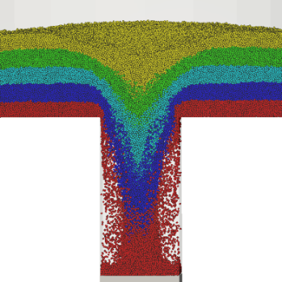 0.08 s

Figure 2. Particle distribution

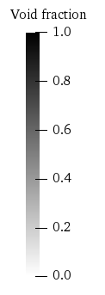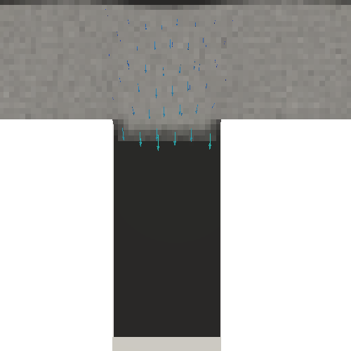 0.02s

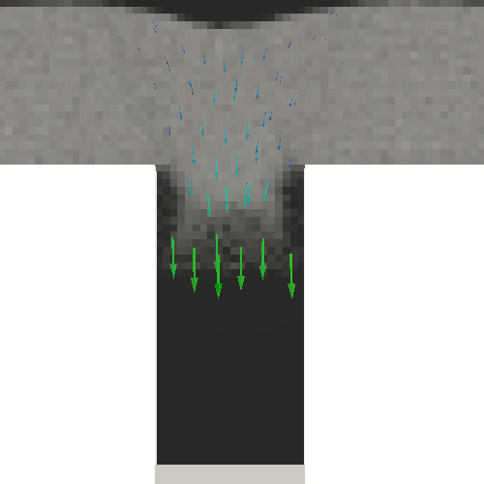 0.04s

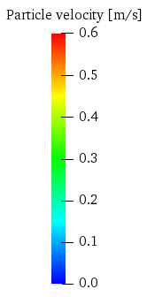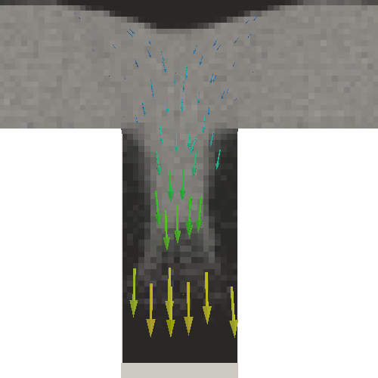 0.06s

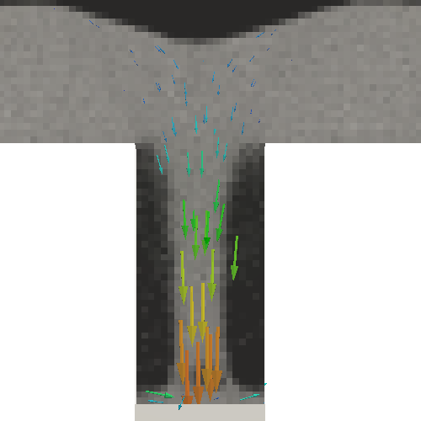 0.08s

Figure 3. Particle velocity and void fraction rate

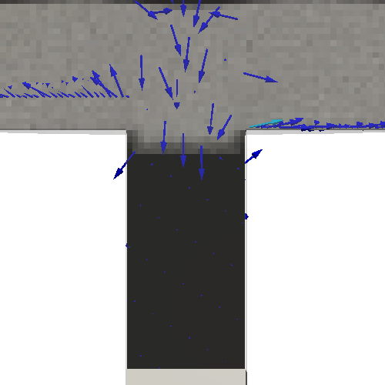 0.02s

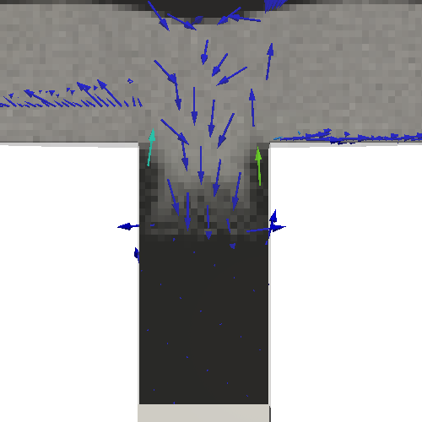 0.04s

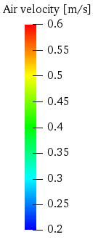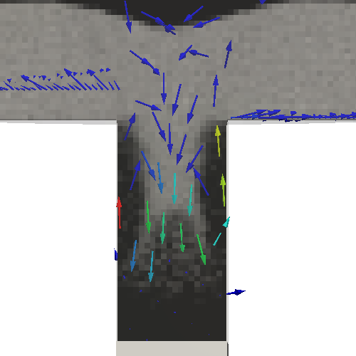 0.06s

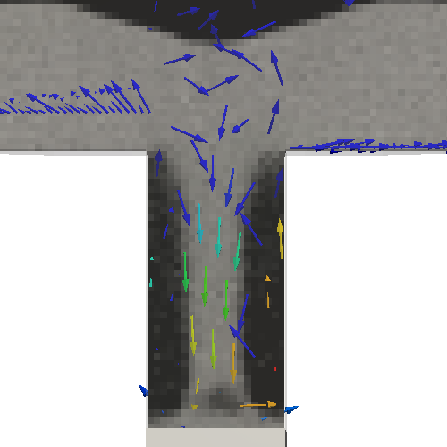 0.08s

Figure 4. Air velocity and void fraction rate

吸引効果有り

下杵降下速度100, 300, 500, 700 [mm/s]

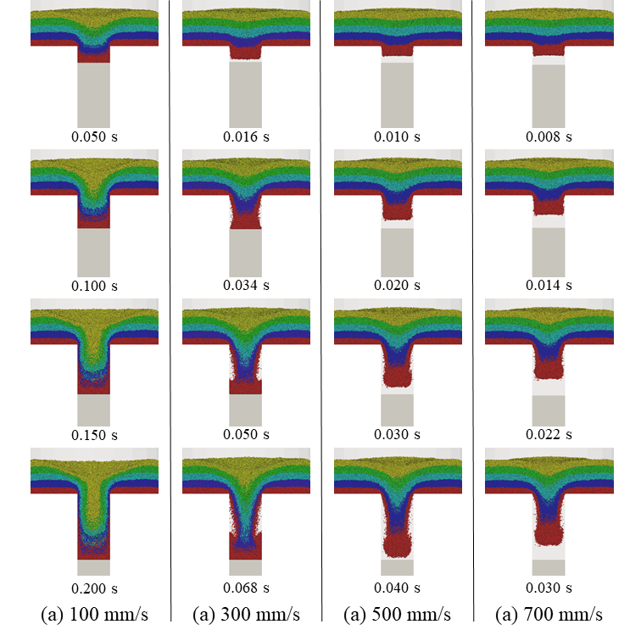

Figure 5. Particle distribution

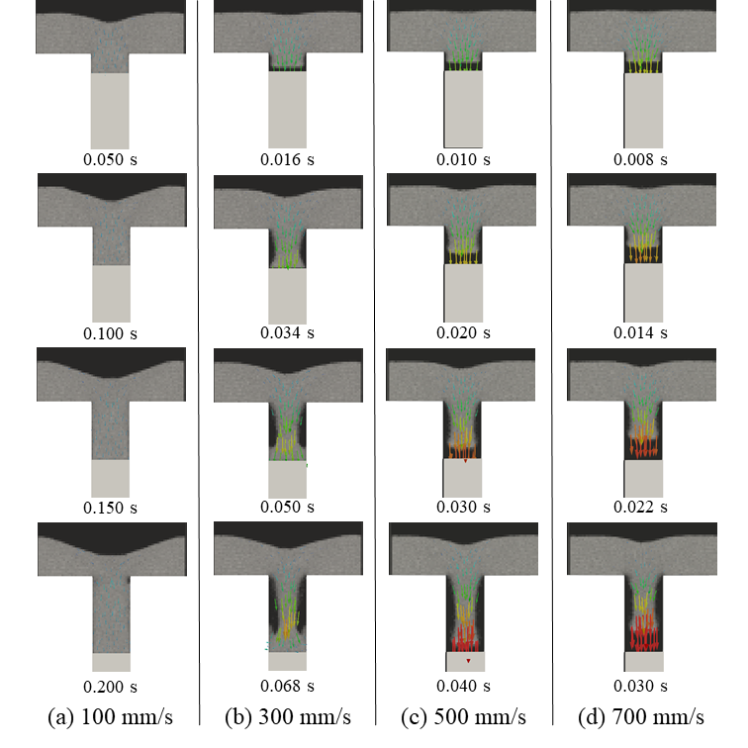

Figure 6. Particle velocity and void fraction rate

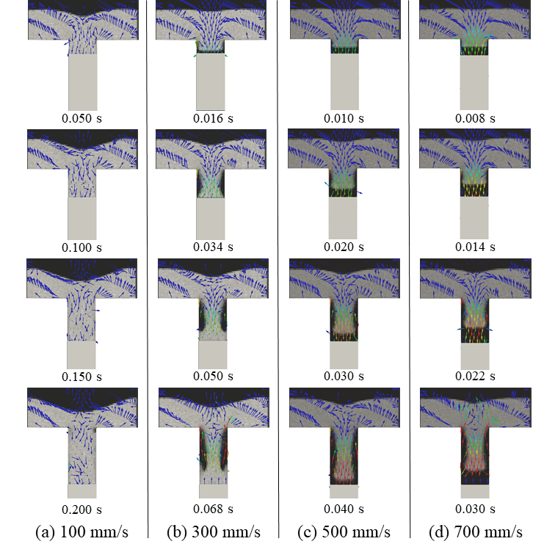

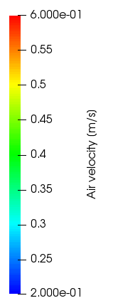

Figure 7. Air velocity and void fraction rate



Figure 8. Number of particles in die region



Figure 9. Flux of powder flow

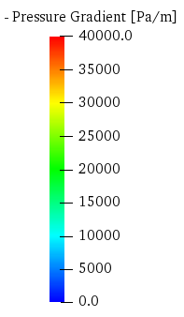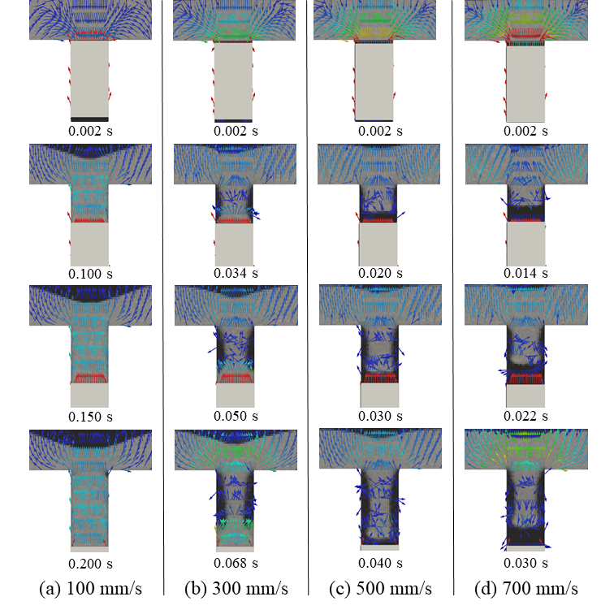

Figure 10. Pressure gradient

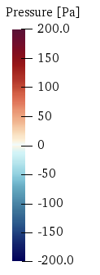

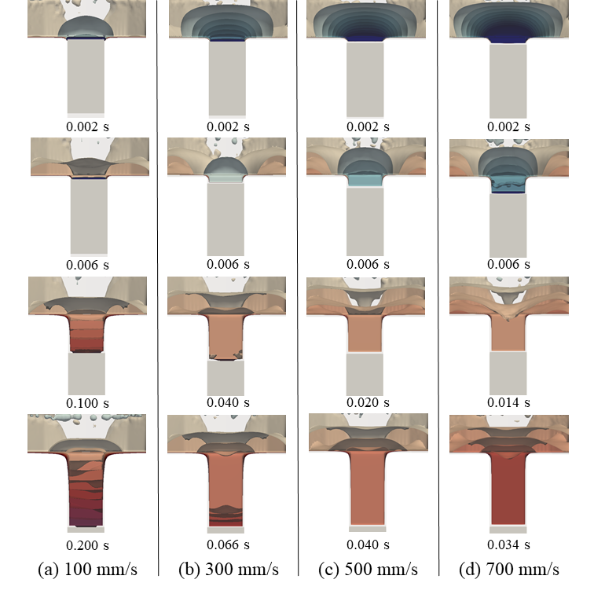

Figure 10*. Pressure contour



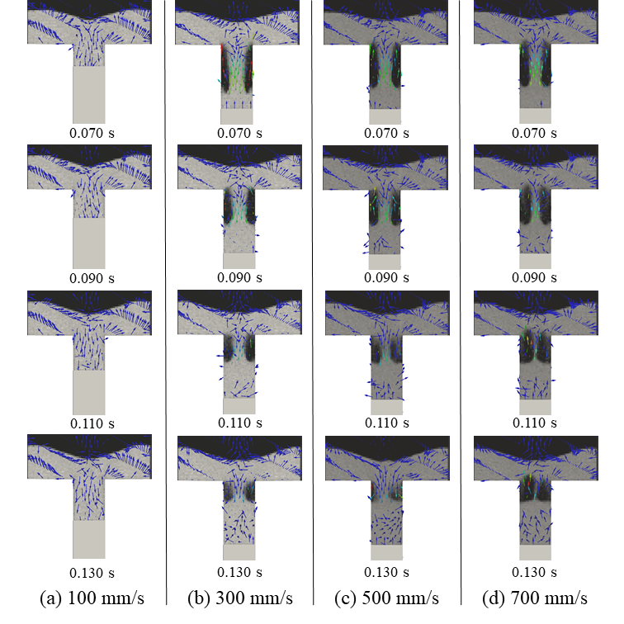

Figure 11. Bubble velocity



Figure 12. Filling time