真空

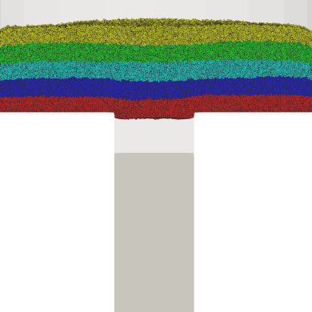0.010 s

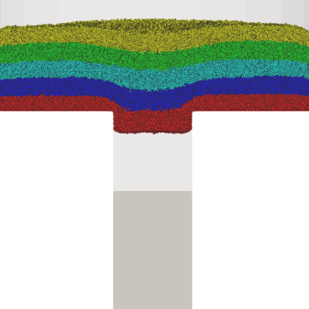0.020 s

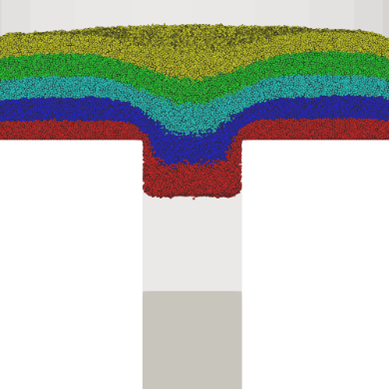0.030 s

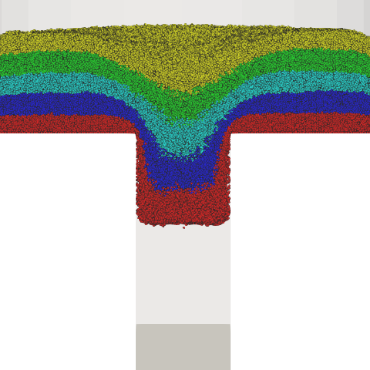0.040 s

Figure 11. Particle distribution

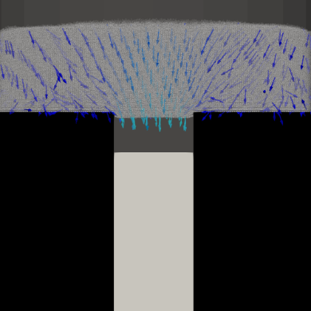 0.010 s

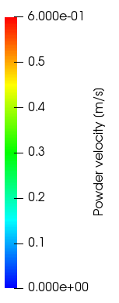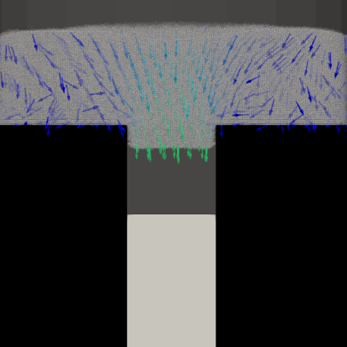 0.020 s

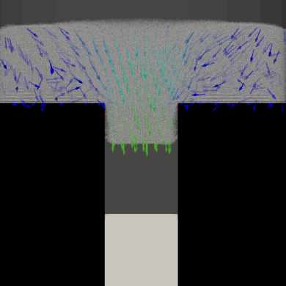 0.030 s

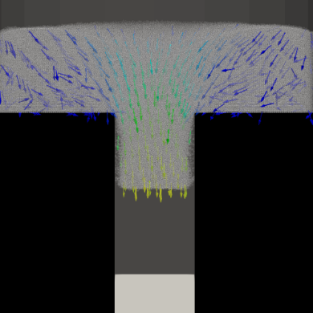 0.040 s

Figure 12. Powder velocity

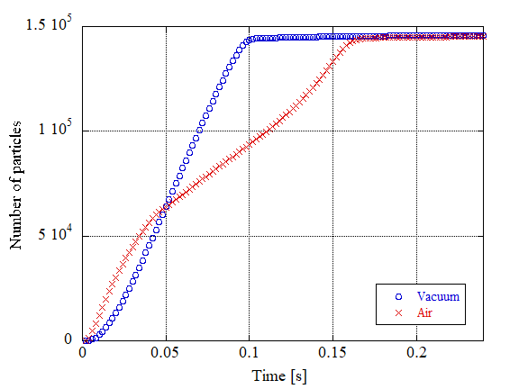

Figure 13. Number of powder particles in die region

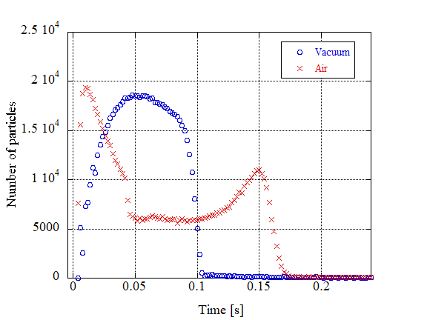

Figure 13. Flux of powder flow

|  |  |  |
| --- | --- | --- |
|  | Vacuum | Air |
|  | 31655 | 30792 |
|  | 31062 | 31521 |
|  | 31812 | 30974 |
|  | 27332 | 27153 |
|  | 24051 | 24797 |

Table 3. Number of particle in each layer