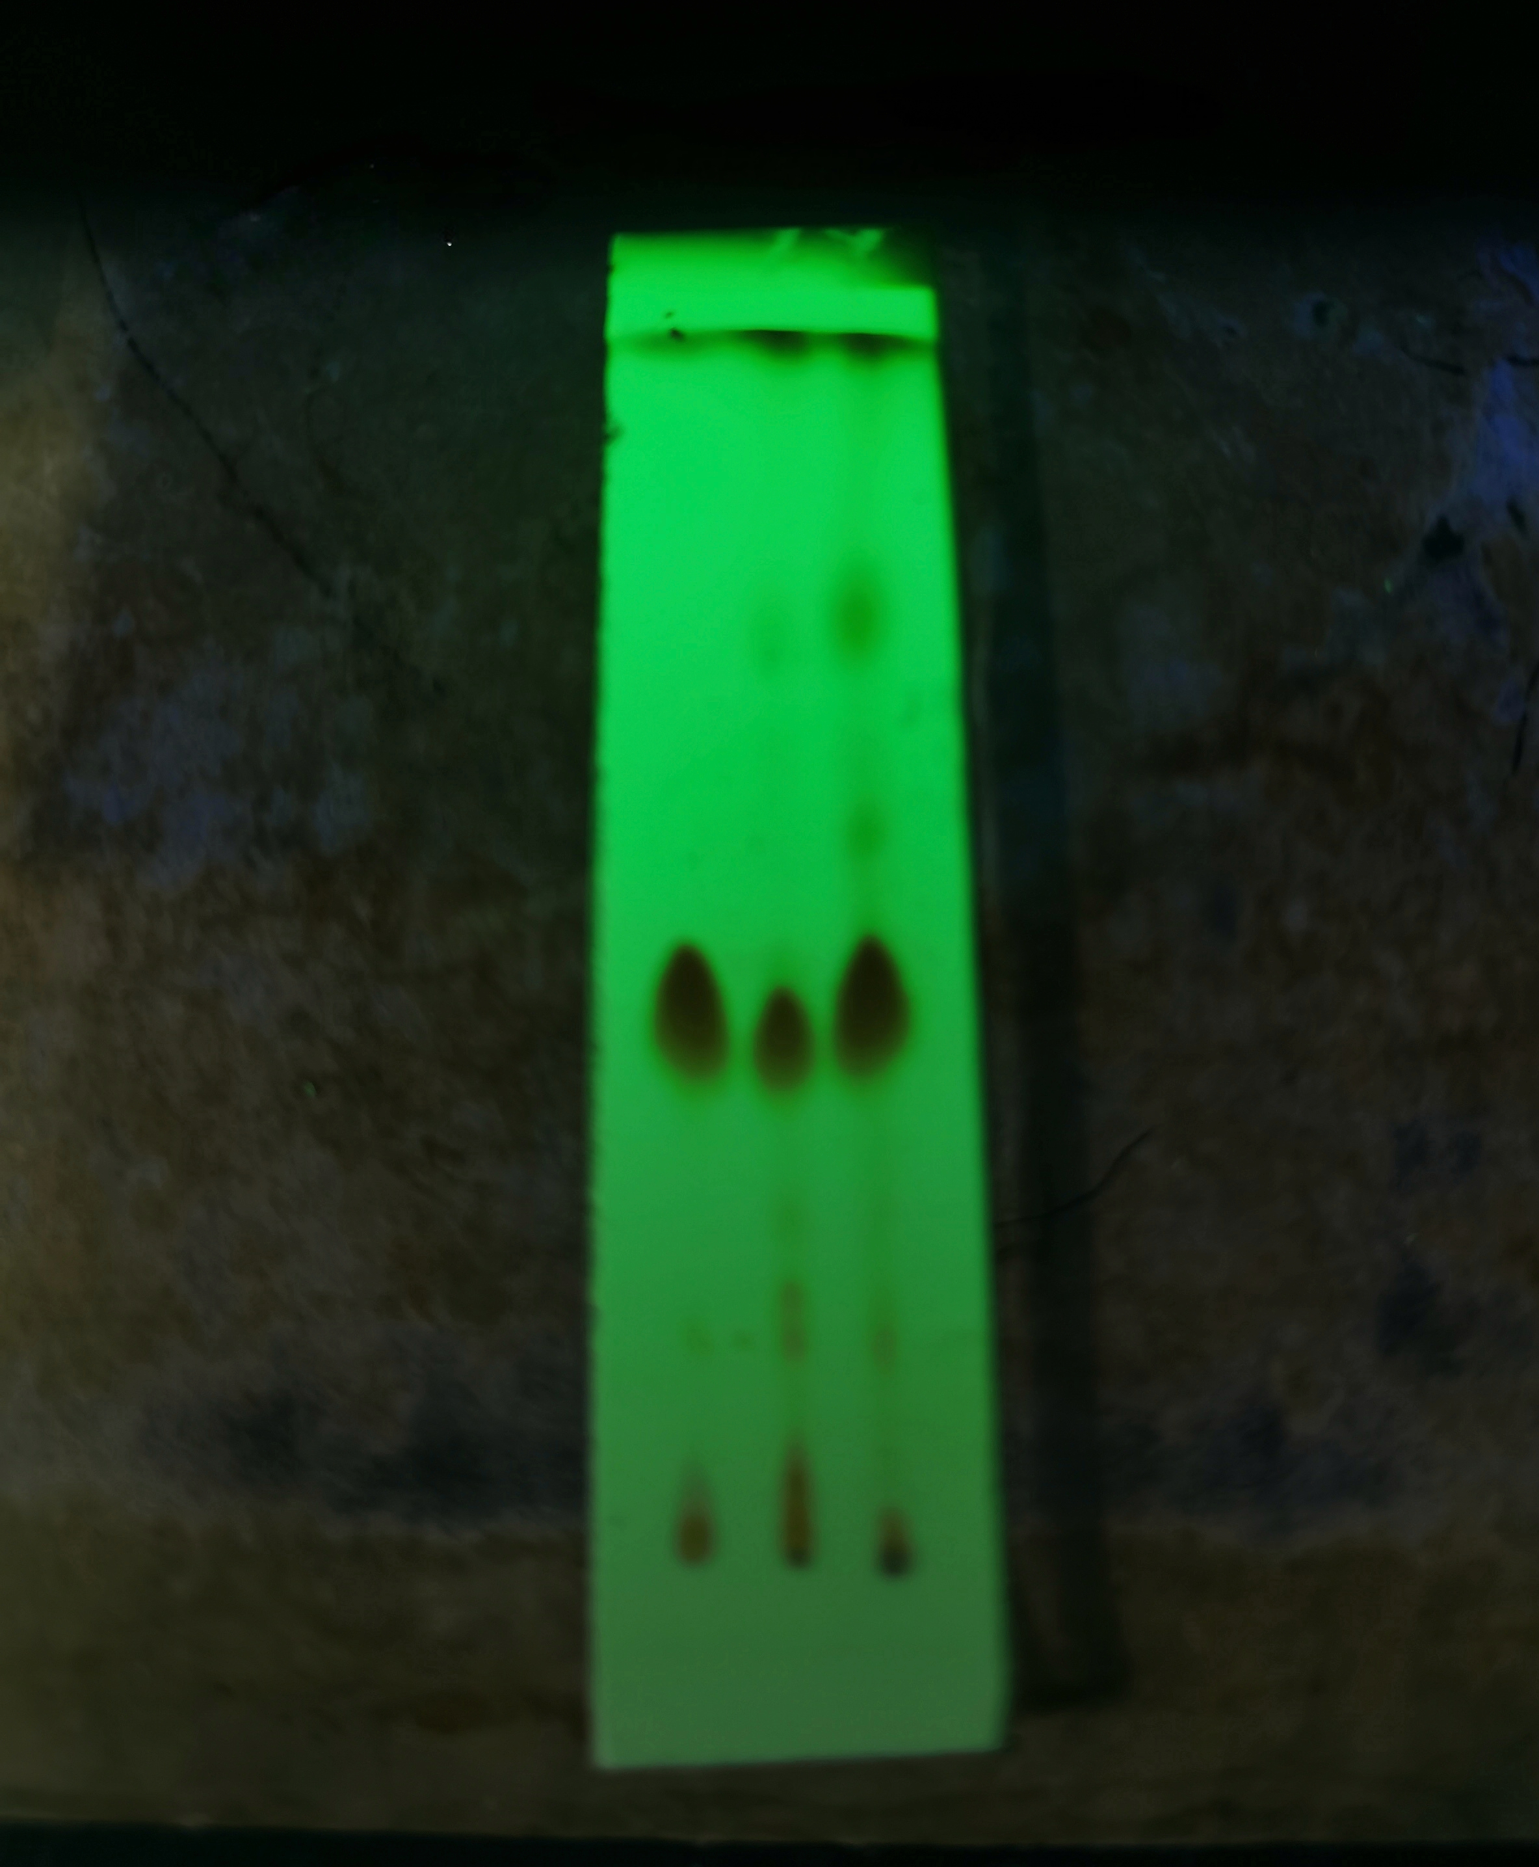
Uncropped image of Figure S1

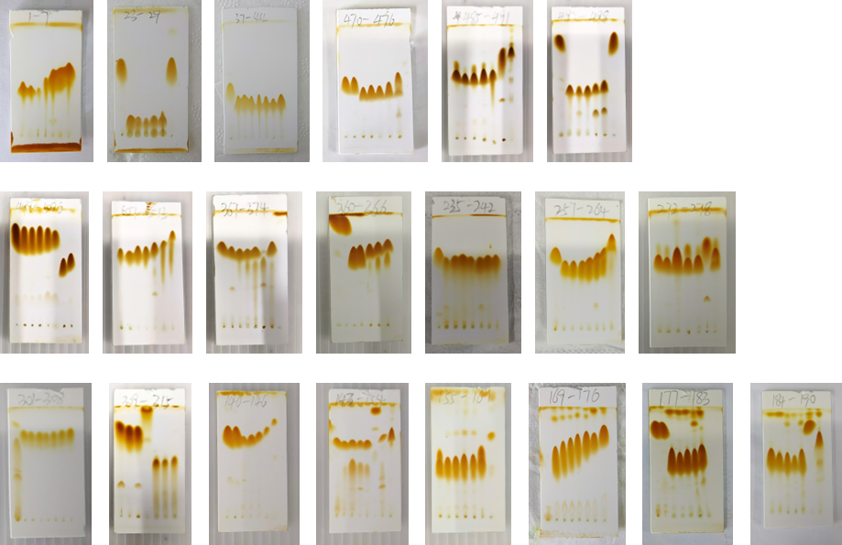
Uncropped images of Figure S45. The rows and columns of this figure each correspond to the rows and columns of Figure S45.

