Experiment Code |  | RM-006 (Synthesis of Tail 1a.) | Date: | 12.3.2024
Reference

Reaction scheme:

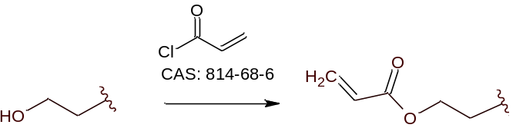

Order of addition | Reagents | MW (g/mol) | Density  (g/mL at 25°C) | Mass/Volume | mMols | Equiv.
1 | Acryloyl chloride  CAS: 814-68-6 | 90.51 | 1.114 | 201 uL | 2.475 | 1.2
2 | 2-Hexyl-1-decanol  CAS: 2425-77-6 | 242.44 | 0.836 | 598 uL | 2.062 | 1
3 | Triethylamine  CAS: TX1202 | 101.19 | 0.72 | 434 uL | 3.0935 | 1.5
Order of addition | Solvent/s |  | Volume (mL) |  | mM
 | DCM |  | 8 mL (4mL/mmol of 2)

Procedure:
A solution of 2-Hexyl-1-decanol (500 mg, 1 equiv.) and triethylamine (434 uL, 1.5 equiv.) in dichloromethane (8 mL) was cooled to 0°C using an ice-water bath. Then, acryloyl chloride (201 uL, 1.2 equiv.) was added dropwise to the medium. The mixture was allowed to warm to room temperature and stirred overnight. Upon completion (as monitored by TLC), the solvent was removed under vacuum and the crude product was purified via silica gel column chromatography (hexane/ethyl acetate).

Analysis of LC-MS Data:

Purification:

TLCs:

Appearance:
Yield:

Notes:
The reaction medium rapidly turned pale yellow after addition of the acryloyl chloride.

