Experiment Code |  | RM-008 (Synthesis of Tail 1c.) | Date: | 12.10.2024
Reference

Reaction scheme:
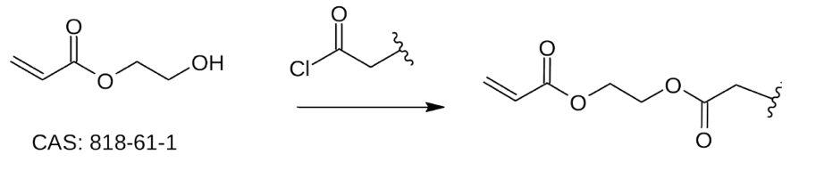

Order of addition | Reagents | MW (g/mol) | Density  (g/mL at 25°C) | Mass/Volume | mMols | Equiv.
1 | 2-hydroxyethyl acrylate  CAS: 818-61-1 | 116.12 | 1.098 | 176 uL | 1.6616 | 1
2 | Oleoyl chloride  CAS: 112-77-6 | 300.91 | 0.91 | 549 uL | 1.6616 | 1
3 | Triethylamine  CAS: TX1202 | 101.19 | 0.72 | 467 uL | 3.2325 | 2
Order of addition | Solvent/s |  | Volume (mL) |  | mM
 | DCM |  | 5 mL (3mL/mmol of 1.66)

Procedure:
Et3N (2 eq) is slowly added to a stirred solution of 2-hydroxyethyl acrylate (1 equiv) in DCM (3 mL/mmol) at 0°C. The acyl chloride (1 equiv, diluted in 1 mL of DCM) was added dropwise to the medium and the reaction was stirred at 0°C for 30 minutes and then warmed at RT overnight (the reaction is monitored by TLC until consumption of the acyl chloride). After completion, the medium is concentrated and the crude is purified by flash chromatography
(hexane/EtOAc).

Analysis of LC-MS Data:

Purification:

TLCs:

Appearance:
Yield:

Notes:

