Experiment Code |  | RM-016 (Synthesis of Tail 2b.) | Date: | 02.18.2024
Reference

Reaction scheme:
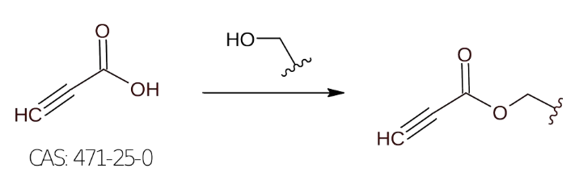

Order of addition | Reagents | MW (g/mol) | Density  (g/mL at 25°C) | Mass/Volume | mMols | Equiv.
1 | Propiolic acid  CAS: 471-25-0 | 70.05 | 1.138 | 439 uL | 7.13 | 1.1
2 | Linoleyl alcohol  CAS: 506-43-4 | 266.46 | 0.83 | 2.08 mL | 6.48 | 1
3 | DCC  CAS: 538-75-0 | 206.33 | 1.01 | 1.471 g | 7.13 | 1.1
4 | DMAP  CAS: 1122-58-3 | 122.17 | N/A | 79.2 mg | 0.648 | 0.1
Order of addition | Solvent/s |  | Volume (mL) |  | mM
 | DCM |  | ~25 mL (4 mL/mmol of 2)

Procedure:
General procedure: Alcohol (6.48 mmol, 1 equiv) and propiolic acid (500 mg, 7.13 mmol, 1.1 equiv) were dissolved in dichloromethane (4 mL/mmol of alcohol -> ~ 25 ml) and the mixture was cooled to 0°C using an ice bath. A solution of DDC (7.13 mmol, 1.1 equiv) and DMAP (catalytic amount ~ 0.1 equiv) in dichloromethane (2mL) was slowly dropped to the medium at 0°C. The reaction mixture was stirred overnight at room temperature. The reaction is monitored by TLC. The precipitate was filtered off, and the solvent was removed under reduced pressure. The crude was purified by silica gel chromatography (hexane/EtOAc).

Analysis of LC-MS Data:

Purification:

TLCs:

Appearance:
Yield:

Notes:

