Experiment Code |  | RM-066 (Synthesis of Tail 2a via BF₃OEt₂) | Date: | 08.25.2025
Reference

Reaction scheme:
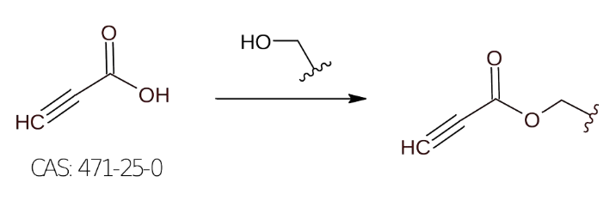

Order of addition | Reagents | MW (g/mol) | Density  (g/mL at 25°C) | Mass/Volume | mMols | Equiv.
1 | Propiolic acid  CAS: 471-25-0 | 70.05 | 1.138 | 184.7 uL | 3.0 | 1.0
2 | 2-hexyl-1-decanol  CAS: 2425-77-6 | 242.44 | 0.836 | 957 uL | 3.3 | 1.1
3 | BF₃·Et₂O  CAS: 109-63-7 | 141.93 | 1.154 | 1106.9 uL | 9.0 | 3.0
Order of addition | Solvent/s |  | Volume (mL) |  | mM
 | (N/A)

Procedure:
To a solution of propiolic acid (210.15 mg) in 2-hexyl-1-decanol was added via syringe freshly distilled boron trifluoride etherate. The solution was refluxed for 3h at 60C and further stirred at room temperature overnight. Water (200 mL) was added, and the mixture was extracted with dichloromethane (100 mL). The organic layer was removed, and the aqueous portion was further extracted with 3 X 100 mL of dichloromethane. The combined organic layers were washed sequentially with 200 mL of water and 100 mL of brine. The organic solution was dried over magnesium sulfate, the solvent was removed, and the crude residue was directly loaded on a silica gel column and purified by column chromatography.

Analysis of LC-MS Data:

Purification:

TLCs:

Appearance:
Yield:

Notes:

