Lucy Report
My code was performed on ‘water-quality-cleaned’ dataset; this dataset is a cleaner version of the original dataset - Kosi has performed pre-processing to remove missing data and has carried out imputation. I have carried out my code of outlier removal and generated a new, cleaned dataset called ‘water-quality-FINAL-cleaned.csv’. After conducting feature engineering using PCA, I generated a new dataset called ‘PCA_transformed_dataset.csv’.

Outlier Removal
Mahalanobis Distance is a depth-based method for removing outliers. It works by measuring how many standard deviations away a data point is from the mean taking into account the covariance of the data [1]. It is coupled with Hotelling’s T² to determine a cutoff threshold to effectively remove outliers in a dataset. As values in our dataset are highly correlated, this method of outlier removal was chosen as this method accounts for highly correlated features within a dataset and standardises the data.
Critical values were obtained by calculating the Hotelling’s T² from n rows with k columns. The Mahalanobis distance for each row was calculated from the overall multivariate mean. If a data point has a high Mahalanobis distance, this indicates that the data point is far away from the bulk of the data and is likely an outlier [1]. The covariance matrix standardises the data, ensuring that highly correlated values do not bias the outcome.
Only numeric columns can be selected for covariance calculation. Therefore, only columns containing numeric values have their outliers removed. This should not impact our results, as the only categorical data in our dataset is the ‘Season’ column which was generated from the raw dataset’s ‘Collect DateTime’ column in previous pre-processing work. The dataset spans from 1970 to 2011 and does not contain data records outside this range, therefore we do not need to consider outlier removal for the categorial data.

Box plots of all numerical features were generated before and after applying outlier removal code, confirming that outliers had been successfully removed. Outliers detected are shown in the graph below. This graph displays the Mahalanobis distances for each data point, with the red line indicating the Hotellings T² threshold. There are a few extreme outliers, which were expected based off the boxplots generated. 5,075 rows were removed from the dataset after removing outliers. The dataset now has 138,981 rows remaining – still plenty of data to work with.
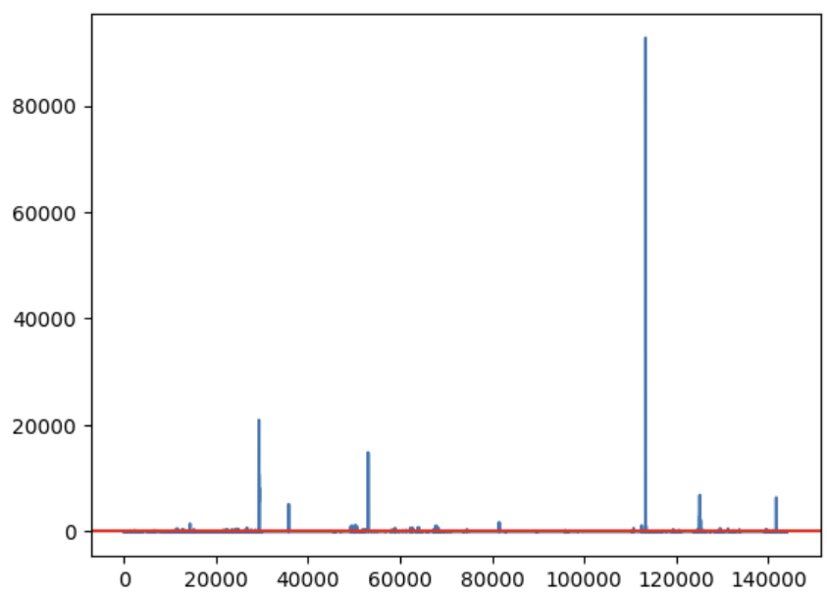

Multiple Linear Regression (MLR)
Ordinary Least Squares (OLS) Regression technique was carried out to identify correlation between variables. We can explore if multiple variables (the independent variables) can predict, or explain the variation, in another variable (the dependent variable) [2]. In our case, the dependent variable will be temperature.
It is important to identify if multicollinearity exists within our model as this can cause unstable coefficients and inflate standard errors, leading to wrong conclusions being made. Strong correlation between variables in our dataset will mean that our model will be very sensitive to any minor changes in the data, meaning that when it comes time to make predictions with our data, some parameters will have volatile weights which could bias the results.

Temperature clearly correlates with a lot of other parameters, as noted in the heatmap generated. Therefore, temperature will be the target of the MLR analysis (OLS Regression). The predictors are ‘pH', 'DO', 'Conductivity', ‘Total_N', 'Total_P', ‘Nitrate’ and ‘Orthophosphate. Year, Month and Season parameters are not included in this initial MLR model as we wish to see if the chemical indicators alone can explain trends in temperature.
Visualisation charts were generated as exploratory analysis of the data (found in code)
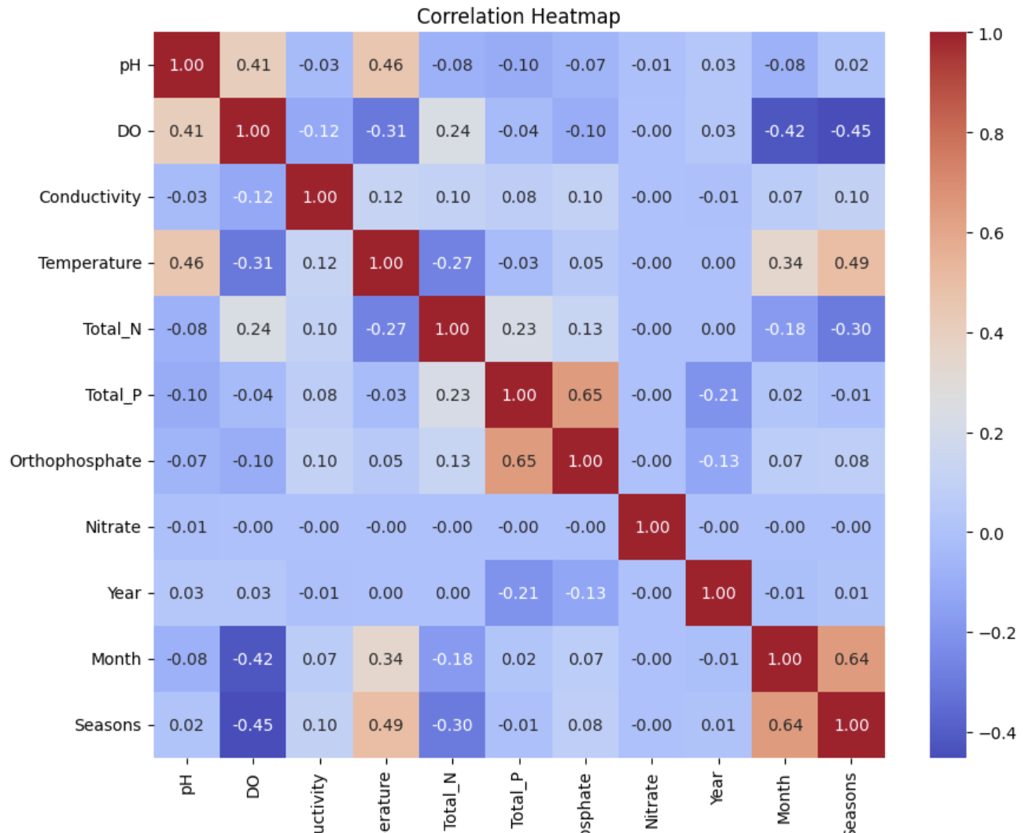

Analysing the OLS Regression Results (using just chemical indicators)
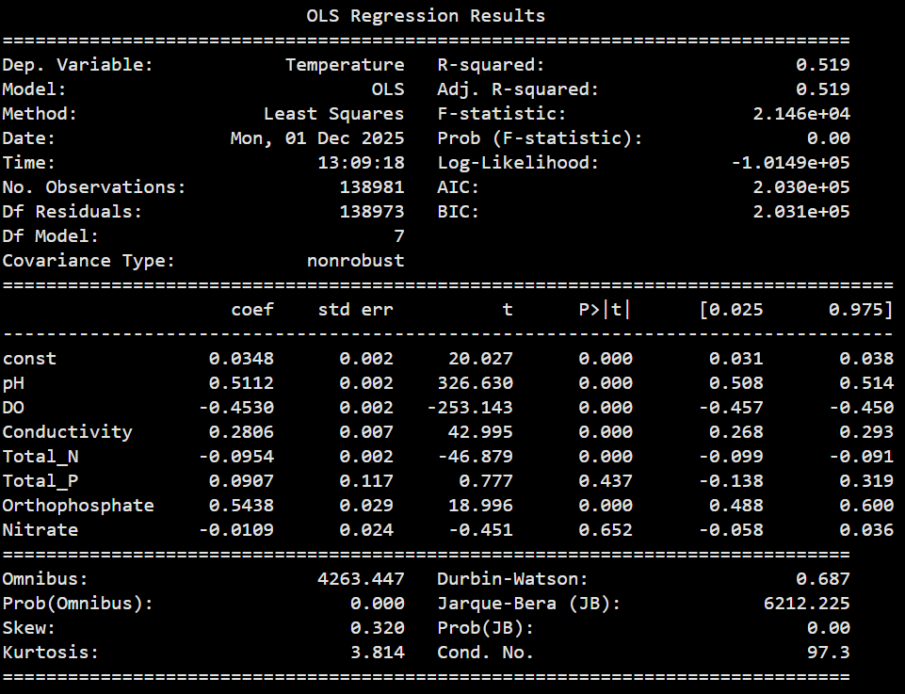

- An R-squared value of 0.519, and an adjusted R-squared value of 0.519, tells us that 51.9% of the variance in temperature is explained by the model. The model moderately accounts for trends in temperature, but not for all of it. This may suggest that long term climate trends, which are not accounted for in this OLS Regression model, may also be able to account for the trends in temperature.
- The F-statistic score is 21,460. This high score means the model as a whole is statistically significant, with all the predictors grouped together being able to predict the target variable (temperature).
- The model suggests low multicollinearity with a condition number of 97.3.
- pH and Orthophosphate are highly positively correlated with temperature and DO is highly negatively correlated with temperature. This tracks with what we would expect to find.

There are problems with the model:
- The AIC and BIC scores are 203,000 and 203,100 respectively – very high numbers.
- The Durbin-Watson score is 0.687, which is quite low. The ideal score is around 2. This indicates positive autocorrelation of residuals.
- The columns ‘Total_P’ (p = 0.437 > 0.05) and ‘Nitrate’ (p = 0.652 > 0.05) should be removed as they are not statistically significant and do not have a reliable relationship to temperature, the target variable.

Analysing the OLS Regression Results (using all predictors, including year, month and season)
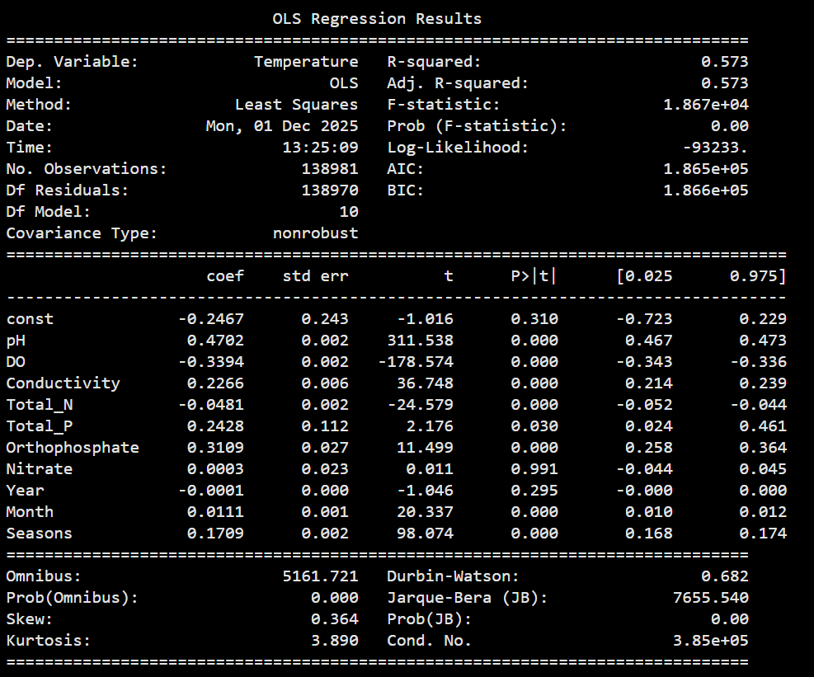
- The inclusion of year, month and seasons columns increase the r-squared values to 0.573, meaning that 57.3% of the variance in temperature is explained by the model. This is an increase from 51.9% explained by just chemical indicators.
- The F-statistic score is now 18,670, a decrease from 21,460.
- The model suggests high multicollinearity with a condition number of 385,000, much higher than 97.3 previously when just using chemical indicators. This is expected, however, as temperature obviously will correlate with year, months and seasons.

Therefore, we know that our model is statistically significant, and that multicollinearity issues only arise when year, month and seasons columns are used. The chemical indicators alone explain the variance in temperature by 51.9% and indicate no multicollinearity.

Residual Analysis
As indicated by the OLS Regression showing a Durbin-Watson score of 0.687, there are problems with the residuals.
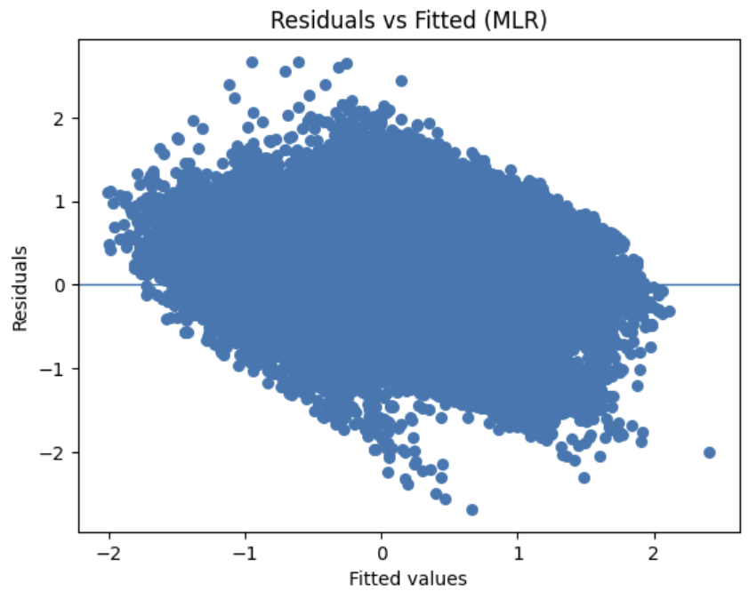
This residuals plot is problematic as it is not a random cloud of data points. This plot indicates heteroscedasticity, meaning the variance of residuals is not constant.
The plot shows some data points straying from the main cluster, however, as outliers were already removed, we can assume that these are natural extreme variations within the environmental dataset.

Variance Inflation Factor (VIF) Analysis
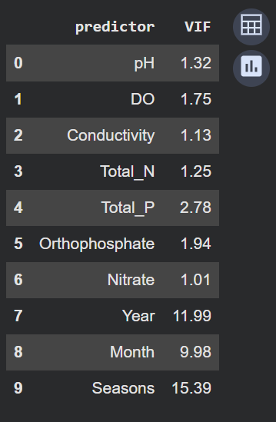
Ignoring Year, Month and Seasons (which we know to be highly correlated with temperature), all chemical predictors have a VIF score below 2 except ‘Total_P’. This is a column that should be removed anyways, as indicated by our OLS Regression analysis. These results mean little multicollinearity is present between the predictors in the model. A VIF score below 5 indicates that multicollinearity is not a problem, therefore, with scores below 2, we can conclude that our model does not have a multicollinearity problem.

Principal Component Analysis (PCA)
Skikit learn code was utilized [3], YouTube videos helped.
Principal Component Analysis (PCA) will be carried out to transform the data to try to improve the model.
To make a ML model that can accurately predict WQI scores, which is the end goal of this project, feature reduction must be carried out on the data. Feature reduction techniques must be conducted before training the ML model to prevent problems of overfitting and to improve prediction accuracy and generalisation ability. In order to calculate accurate WQI scores, all of our features chosen are important and we cannot afford to drop any particular feature. Therefore, transforming the data will be done instead.
Principal component analysis (PCA) is an unsupervised feature reduction technique that constructs principal components from the relevant features in a dataset. It does so by linearly transforming correlated variables into a smaller number of uncorrelated variables which capture the majority of the variance. [4] A new set of variables are created from the original variables that explain the variation in the dataset. The two sets of variables (original and transformed) are orthogonal to each other, meaning they are uncorrelated.

A correlation matrix was coded and shows the data is mildly correlated with ρ=0.41.
PCA was carried out, the transformed data has been uploaded to github.

Scree Plot to Visualise
Scree plots are a good way to visualize the variation % explained by each principal component (PC) [5].
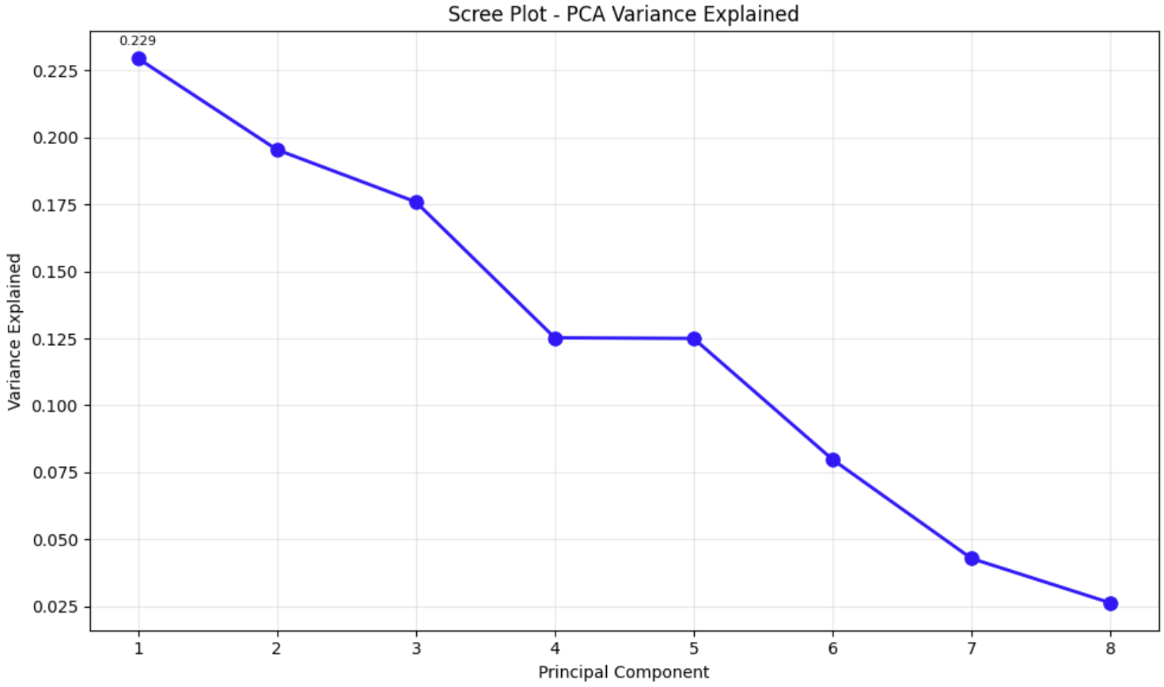
On X-axis shows the PCs and the Y-axis shows the percentage of total variance that is explained by each individual PC. In our data, the first PC explains 22.9% of the variance, the second PC explains 19.5% of the variance and the third PC explains 17.6% of the variance.

References
[1] D. Kumar, ‘Mahalanobis Distance usage in Machine learning’, Medium. Accessed: Nov. 10, 2025. [Online]. Available: https://dilipkumar.medium.com/mahalanobis-distance-usage-in-machine-learning-2bd4bcacbcd2
[2] A. Wooditch, N. J. Johnson, R. Solymosi, J. Medina Ariza, and S. Langton, ‘Ordinary Least Squares Regression’, in A Beginner’s Guide to Statistics for Criminology and Criminal Justice Using R, A. Wooditch, N. J. Johnson, R. Solymosi, J. Medina Ariza, and S. Langton, Eds, Cham: Springer International Publishing, 2021, pp. 245–268. doi: 10.1007/978-3-030-50625-4_15.
[3] ‘PCA’, scikit-learn. Accessed: Nov. 24, 2025. [Online]. Available: https://scikit-learn/stable/modules/generated/sklearn.decomposition.PCA.html
[4] B. Mwangi, T. S. Tian, and J. C. Soares, ‘A review of feature reduction techniques in neuroimaging’, Neuroinformatics, vol. 12, no. 2, pp. 229–244, Apr. 2014, doi: 10.1007/s12021-013-9204-3.
[5] Z. Bobbitt, ‘How to Create a Scree Plot in Python (Step-by-Step)’, Statology. Accessed: Nov. 24, 2025. [Online]. Available: https://www.statology.org/scree-plot-python/

