The main purpose of this report is to provide additional information about code structure and the design of a website, using only Hypertext Markup Language (HTML5 in this case) and Cascading Style Sheets (CSS). Furthermore a discussion about encountered problems will be apposed below, among with an analysis about code implementation and functionality.

The basic idea of this assignment is to develop a ‘starter’ personal portfolio which provides information about ourselves (real or fictional). The design and the style of this web page are quite minimalistic. 4 (four) personal webpages created: curriculum vitae.html, bio.html, contact.html and index.html. All of the four html pages have to be modified with CSS only, in a different stylesheet, so a style.css file created to modify these pages. For writing the code I used Atom text editor instead of notepad. Meanwhile more than 15 meaningful commits pushed to GitHub in order to explain the structure of the code step by step.

Initially the first page I created is the Home page (index.html). Below is a wireframe which shows the design of the page.

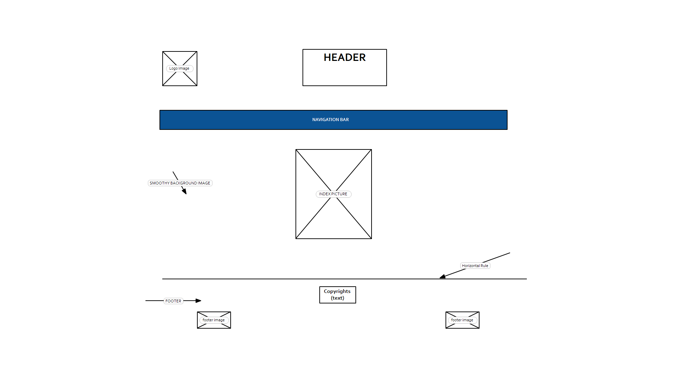The index contains a header with (my name and surname).The header has been modified with class.*name***.** Text in my header is aligned in the center for all of my webpages. **Google Webfonts API** used to modify header. In this case I used *Lobster* font-family and a font size of 3.25 **em.** Header is static for all pages. Moreover an optimized copyright free logo image placed in upper left corner and links back to the landing page (index) with an alternative name *DogPawLogo*. Navigation bar is the first element which created in my project. First of all, I created an unordered list in HTML and later modified with CSS. The final form of my unordered list is my navigation bar. The navigation’s bar design is based on **Material Design UI Style guide.** Navbar’s color is navy blue. Based on Material Design guide, hover effect should be slightly darker (Navigation bar is static for all of my webpages). Moreover a “smooth “background image added in CSS in order to make my website more attractive and elegant. Furthermore in html an image added with an alternative name *Photo of Me.* Image has been optimized as expected and later modified with CSS id *#myDog.*

Subsequently, a horizontal rule added in order to create a footer below. Footer contains a text about copyrights among with two images. Text is aligned in the center for all of my webpages. **Google Webfonts API** used to modify footer text. In this case *Pacifico* font-family used, with font size of 1.25 **em.** One of my two images is aligned on bottom left and the other one on bottom right.

The second developed page is Curriculum vitae (CV.html). The CV page contains all of the static parts of my homepage. More specifically contains a header, a footer, the logo image, the navigation bar, the horizontal rule and the background. Below is a wireframe which shows the design of CV’s page.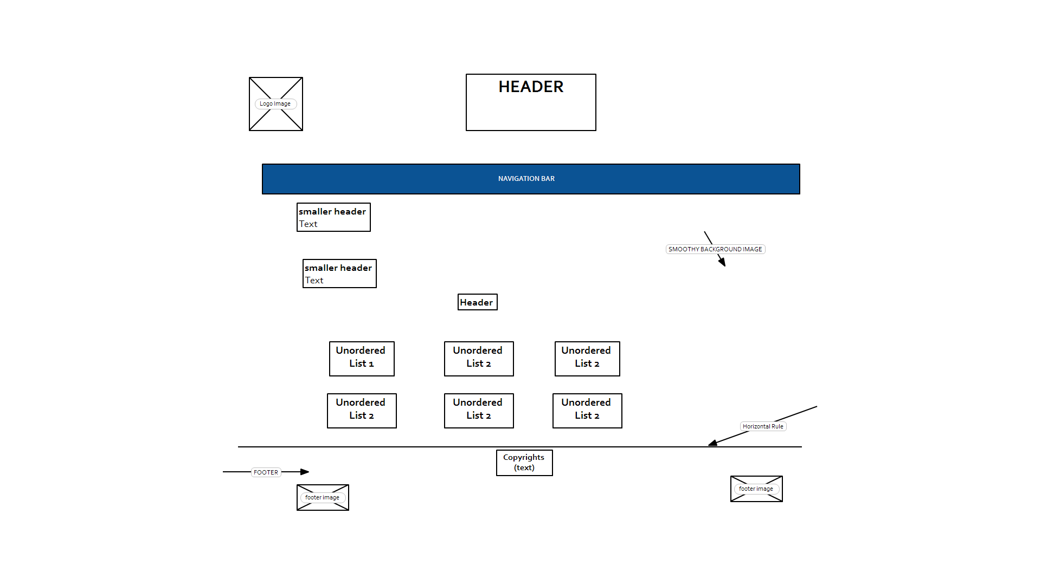

Moreover the CV contains two headers, each one has a paragraph. Six unordered lists have been made and modified with CSS. The first three are in the same row and the other three are listed with the same way below. The unordered lists contains information about my first year modules.

The page which created third is the Biography homepage (Bio.html).Biography page contains the same static parts of my homepage (header, a footer, the logo image, the navigation bar, the horizontal rule and the background). It is also includes 2 headers among with 2 paragraphs. Each paragraph contains one or two working links which provides information about me and my hobbies. Below is a wireframe of my Biography page.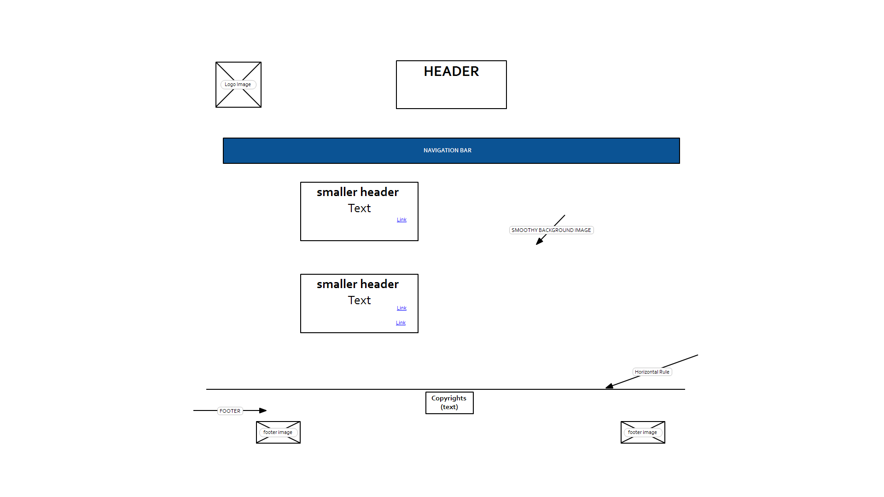

Finally the last developed page is my contact page (contact.html). The contact page contains a contact form where someone can contact with me(the contact form doesn’t actually work). Moreover contains the same static parts of my homepage (header, a footer, the logo image, the navigation bar, the horizontal rule and the background). Below is a wireframe of my contact page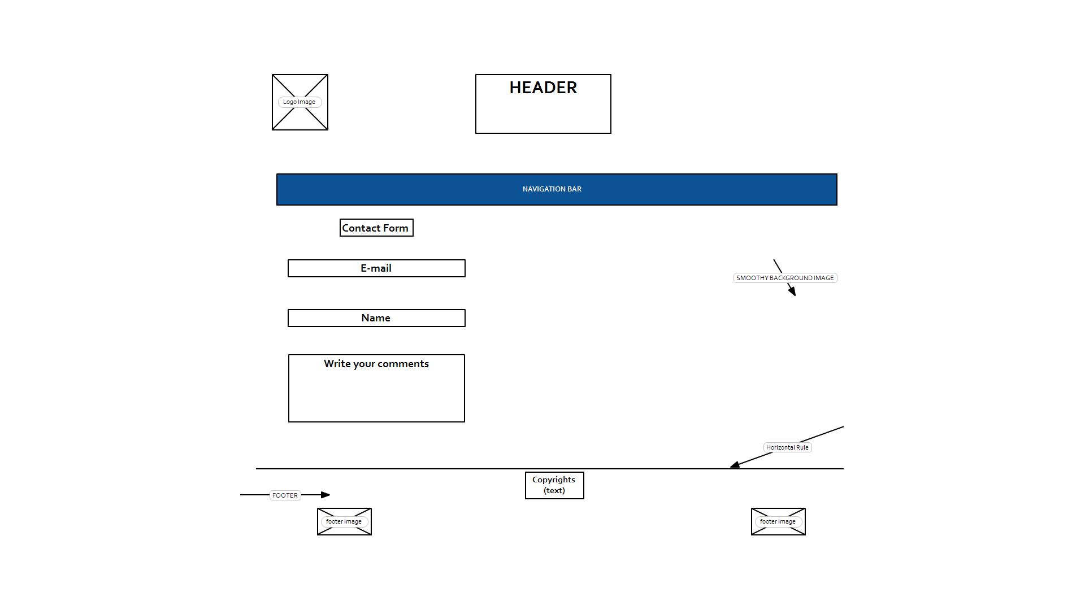

This assignment approximately took me 110 hours. Emmanouil Rigas provided assistance in order to complete this project. .All of my HTML and CSS pages passes the official HTML5 and CSS specifications via <https://validator.w3.org/> and  <https://jigsaw.w3.org/css-validator/>.

***INDEX.HTML VALIDATION PROOF***

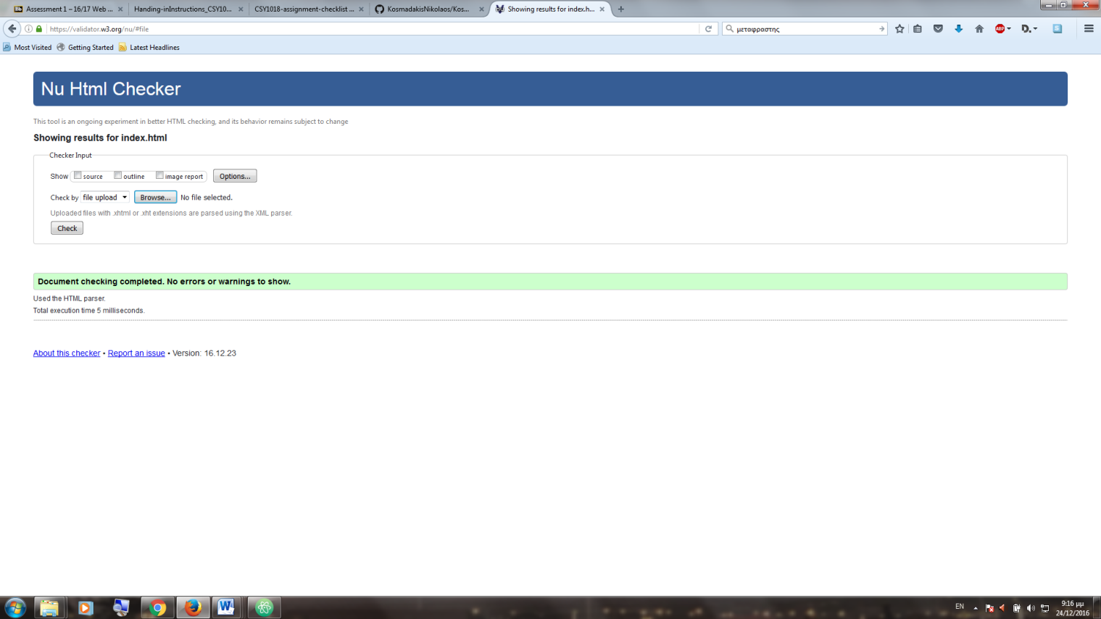

***CONTACT .HTML VALIDATION PROOF***

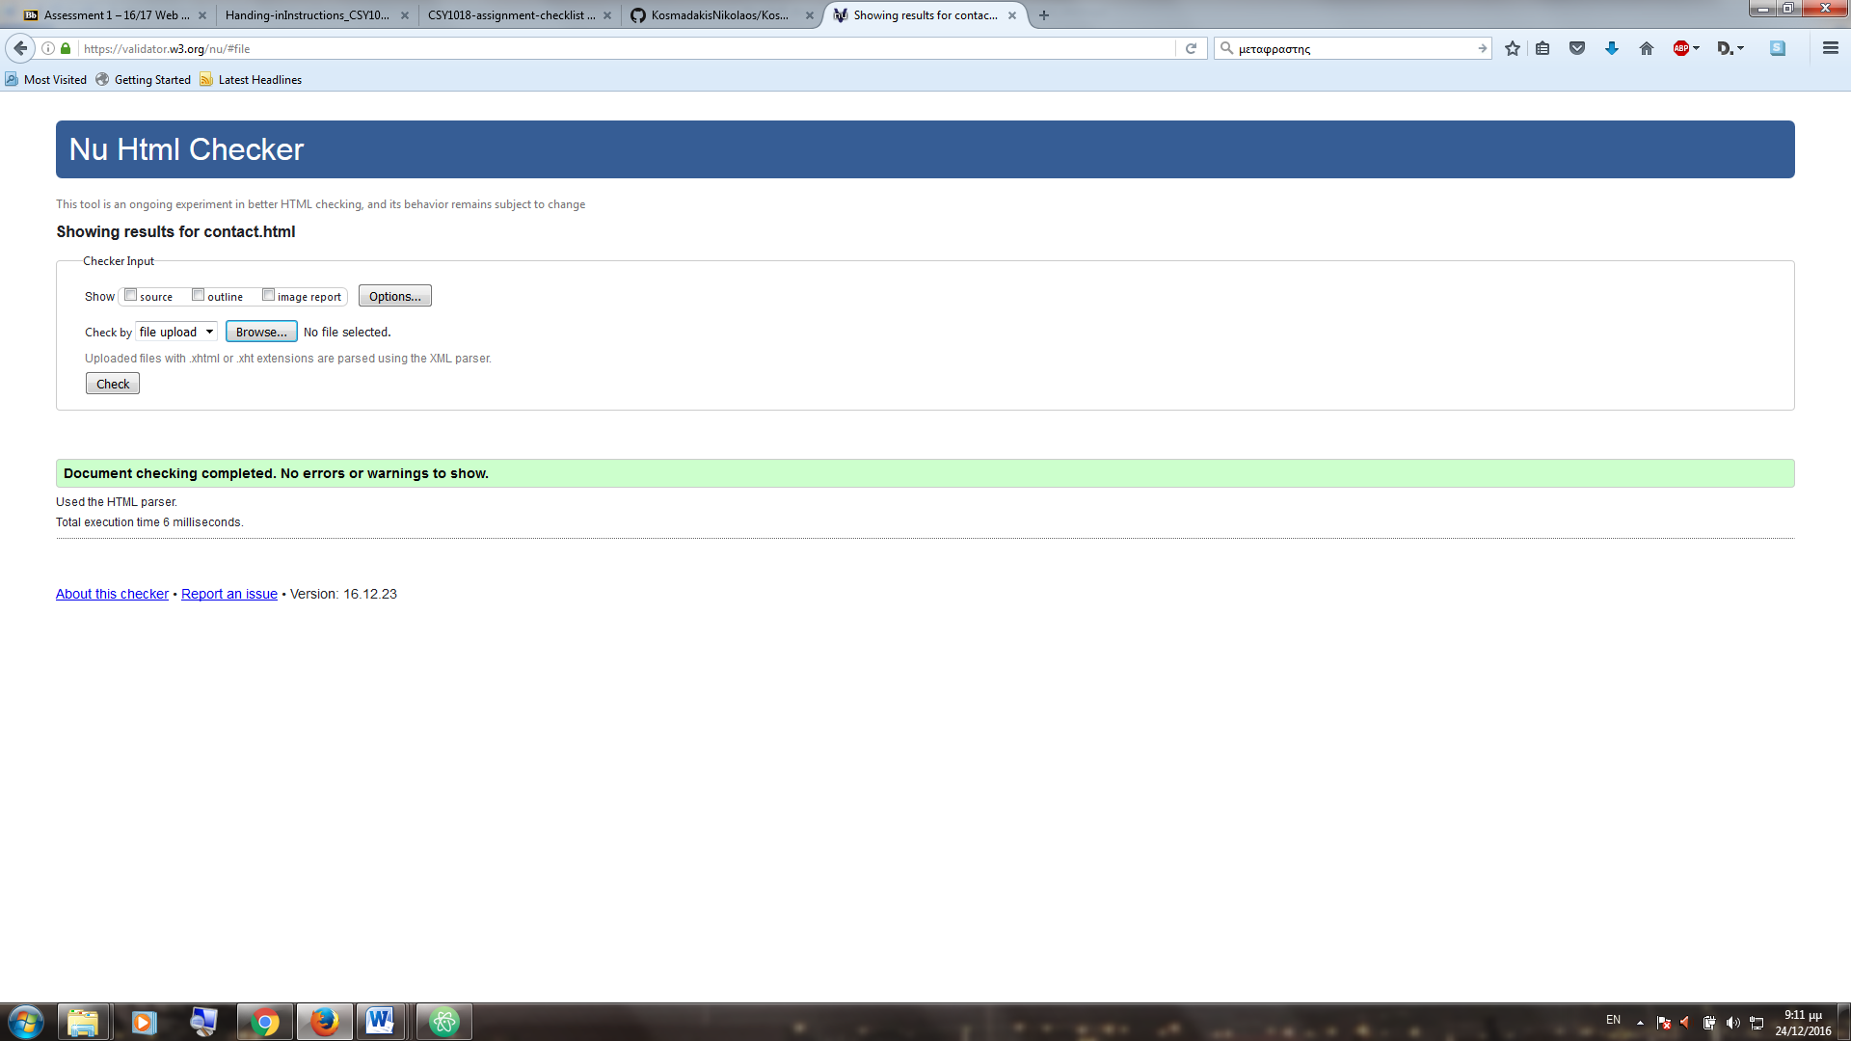

***CV.HTML VALIDATION PROOF***

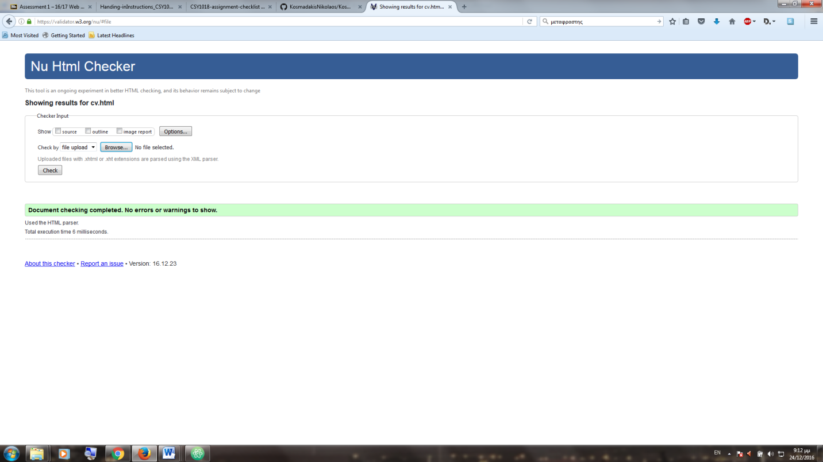

***BIO .HTML VALIDATION PROOF***

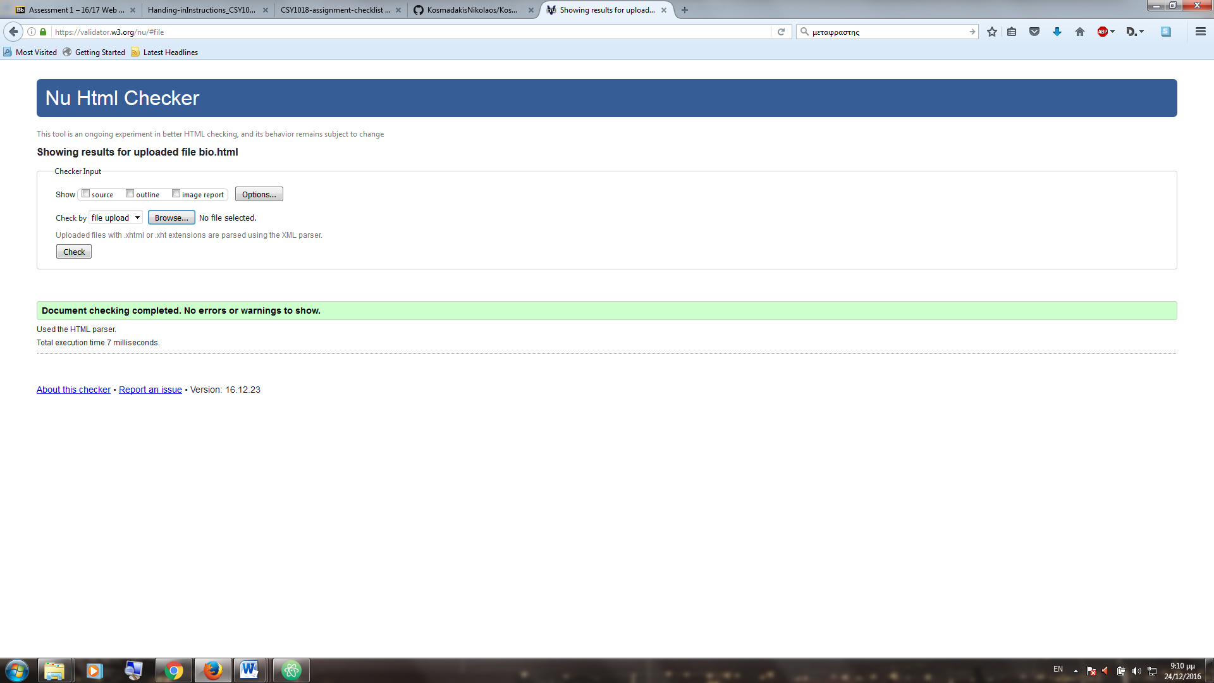

***CSS VALIDATION PROOF***

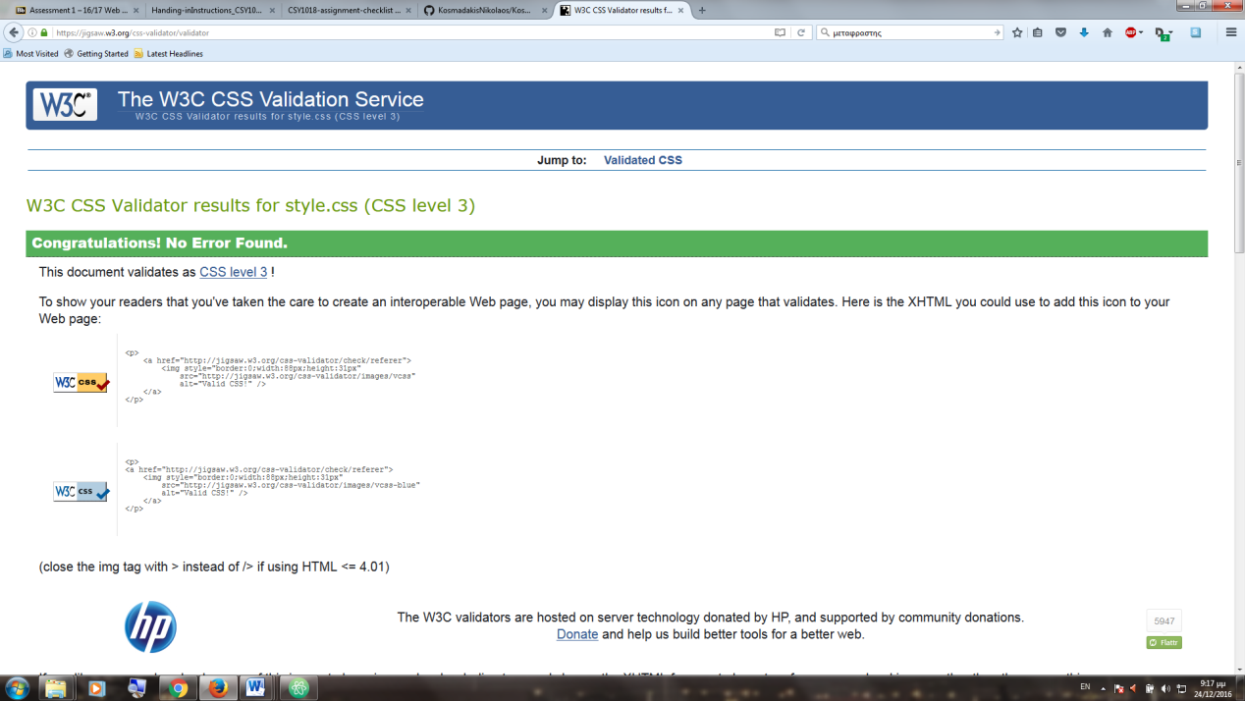

References

"W3schools Online Web Tutorials". W3schools.com. N.p., 2016. Web. 17 Dec. 2016.

Stanford, Joel. "Joel.Sh - Home Of Joel Stanford". joel.sh. N.p., 2016. Web. 22 Nov. 2016.

"Simple HTML Contact Form Code For Your Website & Blog". 123contactform.com. N.p., 2016. Web. 29 Nov. 2016.

Rigas, Emmanouil. "Emmanouil Rigas". Emmanouil Rigas. N.p., 2016. Web. 26 Nov. 2016.