What are your goals for this course?

I was looking to get hands-on experience on using wsl for astrophysics and this course is excellent place for me to not only do so but i expect to become pretty familiar with it by the end of the course. Additionally i want to understand and do a hands-on astrophysical data fetching and processing, for research purposes. Understanding building a CV & analysing research papers. Finally the topic exoplanets is something im interested in, hence looking forward to getting a better understanding of the subject at the end of workshop.

What topics in astronomy interest you?

To begin with, Supernovae, to be more specific Type Ia Supernovae. I have had some theoretical and competitional experience in the subject, having written a technical report, a talk and winning a national level research competition. I am currently interested in understanding exoplanets. Other topics that i find intriguing are the observational astronomy techniques, cosmic rays, stellar & galaxy evolution.

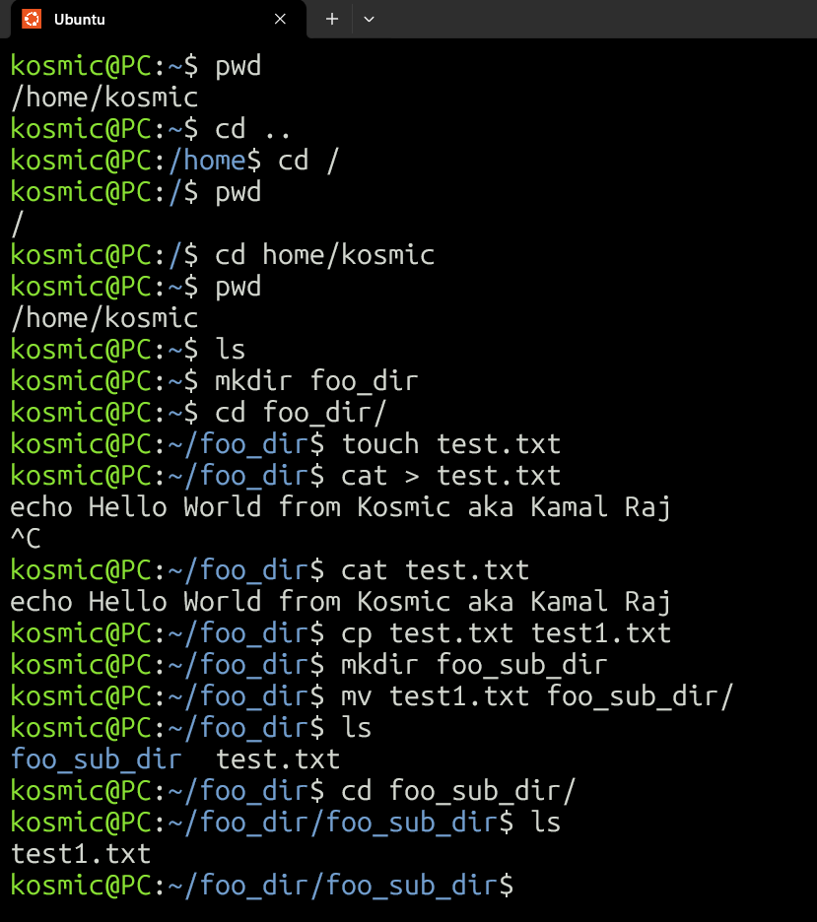

Commands learnt:

1.) ls - Lists contents of the directory.

2.) cd- to change directory.

3.) pwd- shows the current working directory.

4.) mkdir- creates new directory at present location.

5.) touch- to create/modify a file.

6.) cat >- to edit content within the file.

7.) cp- to create a copy of a file.

8.) mv- to move a file to a location.

9.) clear- to clear content displayed in the terminal window.

10.) rm- remove file.

11.) echo- works similar to print command

“Which paper proposes a novel method that could be utilized to attract the attention of, and ultimately communicate with, extraterrestrial intelligence?”

TRANSIT LIGHT-CURVE SIGNATURES OF ARTIFICIAL OBJECTS attached paper.