GEWINN

Old School Renaissance Fantasy
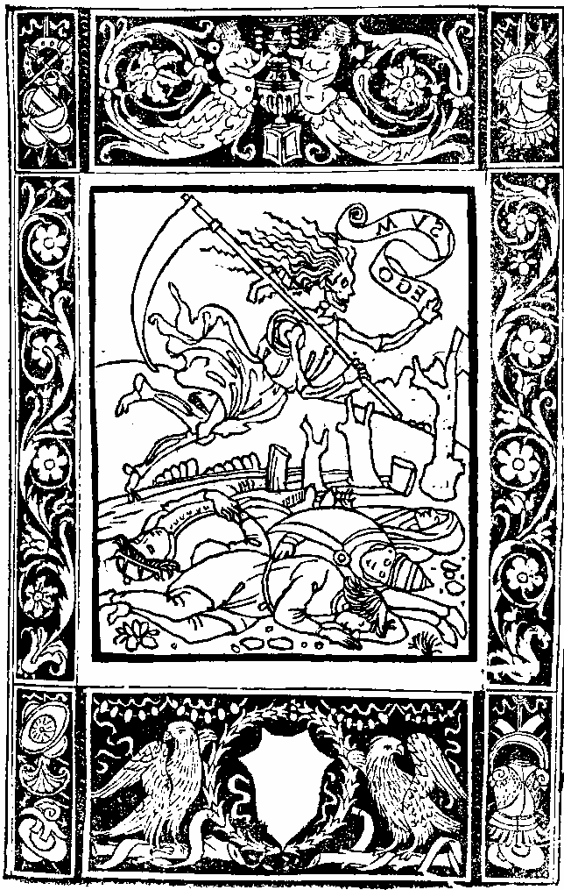

Copyright and Attribution
Gewinn: Old School Renaissance Fantasy - Tabletop RPG
This work is licensed under the Creative Commons Attribution-ShareAlike 4.0 International License. You are free to share, copy, distribute, and transmit the work, as well as to remix and adapt it, provided that you attribute the work in the manner specified and share alike.
Art and Illustrations
- Predica del arte del bene morire (Sermon on the Art of Dying Well) by Girolamo Savonarola, 1502.
- Der Weisskunig 109 Landsknecht Battle by Hans Burgkmair, 1516.
- Danse Macabre (16, 19, 27, 31, 42) by Hans Holbein, 1493.
- Wound Man from Hans von Gersdorff's Feldtbuch der Wundartzney, 1519.
- Arkebusier, Nbg.1 kl

Acknowledgments
Gewinn is a fork of Old School Essentials (OSE) and uses its rules unless otherwise stated. OSE is based on the classic 1980s Basic/Expert (B/X) Dungeons & Dragons ruleset, and this work is compatible with decades of material written for those rules. The original rules and inspiration come from the rich tradition of Old School Renaissance (OSR) gaming.
This project has been made possible thanks to the contributions of many creators and the open-source gaming community. All rules, tables, and artwork are inspired by or derived from the classic traditions of tabletop role-playing games and medieval art.
Credit to cavegirlgames for the “Horrible Wounds” system and Mothership for the “Stress” system.
Published by: Marshall Alexander, 2024 — Updated August 24th, 2025
Disclaimer: This work is provided "as is" without warranty of any kind. The publisher shall not be held liable for any damages resulting from the use of this material.
Contact: Kosmosius@protonmail.com
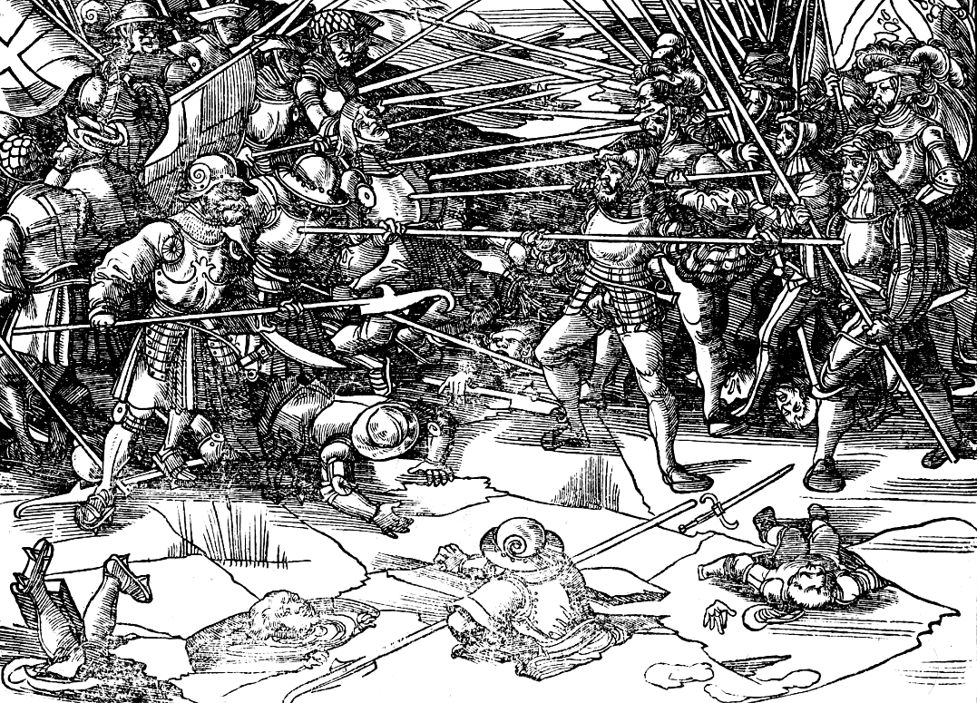

Gewinn
Gewinn is Hael, and Hael ne æfre ceorfað hwæt ælc man mid eagan on his hēafde wiste, þæt Gewinn toweard wæs; Winnan, Giefu, and Gewinn.
War is Hell, and Hell never changed what any man with eyes in his head knew when war was at hand; Conflict, Gain, and Profit.

CORE RULES

Dice Mechanics
OSR D&D: attacker rolls to-hit vs AC (ascending/descending); many rules expect roll-over target numbers and DC-style modifiers.
Gewinn: default player-facing rolls: attackers roll damage as initiative and keep the value on a hit; player defenders rolls AC Save (roll-under AC) to negate. Almost everything else is roll-under Ability; only a few checks are roll-over (Stress / Disease). Advantage [+] / Disadvantage [-] (roll twice and take the most/least favorable result) and the Inversion rule replace scattered ± modifiers.
- Convert all attack bonuses/penalties to the defender’s AC Save using Inversion: attacker +X → defender at [–]; attacker –X → defender at [+] (cancel one-for-one).
- Replace DCs and flat modifiers with [+] / [–] on a roll-under Ability test.

Initiative & Action Economy
OSR D&D: B/X: side or individual d6; AD&D: segments, casting times, weapon speed.
Gewinn: Initiative = Damage (roll full weapon damage dice; sum is your initiative and, on a hit, your damage). Spells roll 1d8/level for initiative. Non-combat actions roll 1d4.

Armour & HP vs. AC+DR & Wounds
OSR D&D: HP buffer, increased on level up; AC reduces hit chance only.
Gewinn: No health and no levels. AC Save avoids or deflects attack; DR absorbs; damage that clears DR becomes typed Wounds with persistent effects; if one physical blow > total DR, highest-DR piece breaks and the target goes Prone; shields can be shattered to halve one physical hit.
- Rebuild humanoid NPC Armour using precalculated values from Armour section to get AC & DR or use legacy AC.
- For monsters without gear, keep AC and convert HD to DR.

Saves, Effects, & Special Attacks
OSR D&D: Death/Poison, Wands, Paralysis/Petrify, Breath, Spells with roll-over targets.
Gewinn: roll-under Ability saves with a specified mapping. Ability checks can be made for any type of action that involves risk and uncertainty, rather than rolling against a set DC.
- Paralysis, Poison, or Death: Will
- Petrify or Polymorph: Strength
- Rod, Staff, or Wand: Intelligence
- Breath Weapon: Faith or Will
- Spells: Intelligence or Faith

Magic & Caster Level
OSR D&D: Vancian casting, many effects scale by caster level, and turning undead uses a table.
Gewinn: casting is roll-under Intelligence (spells) or Faith (prayers) with critical/memory outcomes; for effects that scale by caster level, rules replace CL with 3× relevant Ability modifier; turning and miracles key off Faith mechanics.
- Keep lists and spell texts, but when a numeric scale calls for caster level, substitute 3× INT/FAITH modifier (round normally).
- If that under/overshoots your table’s tone, nudge via [+] / [–] or tweak the constant (e.g., ×2 or ×4) consistently across the campaign.

Monsters: THAC0, Morale, & Reactions
OSR D&D: THAC0/attack matrices, explicit attack bonuses, sometimes weapon speed; morale/reaction tables in 2d6.
Gewinn: monsters don’t roll to hit by default; their advantages become the players’ AC Save [–] via Inversion. Morale/reaction still OSR-friendly, but you may express situational edges as [+] / [–] instead of ±1s.
- Throw away monster THAC0 or attack bonus; instead, write why they’re dangerous (reach, size, venom, swarm, numbers) and convert that to [+] / [–] on the AC Save.
- Keep HD, movement, damage dice, special abilities. If a monster relied on many low dice, consolidate into fewer, bigger dice or add a wound-type that pressures PCs despite DR (e.g., toxic).

Ranged Combat, Reloads, & Gear
OSR D&D: B/X bows & crossbows have simple rates; AD&D adds speed & segments; firearms are rare.
Gewinn: explicit range bands, [–] outside ideal; reload (↺) equals number of damage dice; equipment assumes early-modern kit (arquebus, pavise).

Economy, Encumbrance, & Time
OSR D&D: gp economy, coin-weight encumbrance, movement 120/90/60; 10-minute Turns / 1-minute Rounds (varies by edition).
Gewinn: British £ s d currency, slot-based encumbrance (~3 lb/slot), base movement 40′ modified by STR/slots; round/turn handling is compatible in spirit but numbers differ.

Classes & Levels
OSR D&D: Classes carry attack/save progressions, Hit Dice/HP by level, spell slots & caster level scaling, thief percentiles, turning tables, and attack matrices/THAC0;
Gewinn: Classless, raceless, level-less—no XP tables, no attack/save progressions, no HP. Progression comes from raising Ability scores (via spending Stress and coin) and improving gear (limited Encumbrance).

Philosophy
- Fiction First, Fast Rulings: State intent → method → risk. If the fiction makes it certain, it happens. If it’s uncertain or dangerous, the DM rules and you roll.
- Avoid Fair Fights: Scout, bribe, bait, parley, trap, misdirect, or flee. Use reaction rolls and morale. Every fight won before dice are rolled is a fight survived.
- Know the Core Loop: Attackers roll damage; defenders roll 1d20 < AC to avoid it. Initiative = your weapon’s damage die (lowest acts first); keep that die for damage on a hit.
- Manage Time, Light, & Load: Torches, noise, watches, and encumbrance kill as surely as blades. Count every slot, every minute, every sound. Exhaust the site, not yourselves.
- Armour Buys Time, Not Immortality: AC avoids harm; DR absorbs it. If a single hit beats total DR, your highest-DR piece breaks and you go Prone. Sacrifice a shield to halve one physical hit.
- Wounds Stack and They’re Specific: Damage becomes typed Wounds with lasting effects. Bleed out after 1+Will rounds unless aided. First Aid buys time; Treatment stops it; magic removes Wounds directly. Dead Man Walking means you’ll act—and then die—unless healed.
- Stress Is the second Health Bar: Failures and horrors add Stress. Panic when Stress exceeds nerve. Rest and Revelry reduce it; at 20+, overflow destroys your stats. Guard your mind as you guard your flesh.
- Spend Resources to Live: Eureka, Divine Favour, Transcendent Exertion, stance swaps, grapples, reach, cover—use them all. Dying rich is still dead.
- Magic Always Has a Hook in You: Cast with INT or FAITH saves. 1: cast, remember, effects at [+]. Success: cast, remember. Fail: cast, forget. 20: backfire, forget. Power answers—but collects. Burn stress to make a fail a success, incur wounds to push for a crit.
- Play the World, Not the Sheet: It’s Seventeenth-century brutalism—tools, terrain, people, price. Track coin and consequence. Share spotlight, keep notes, and cleave to the tone: War is Hell; Conflict, Gain, & Profit.

ABILITIES
Generate scores. Roll 3d6 per Ability (default: in order). If your table prefers a different tone: classic (3d6, arrange to taste) or heroic (4d6 drop lowest, arrange). Record values for Strength, Intelligence, Faith, & Will.
How rolls work. You resolve Saves and Checks by rolling 1d20 < Ability score (roll-under). When two sides directly contest, each rolls 1d20 + relevant Ability modifier; higher total prevails. Apply [+] / [–] to the entire test; multiple edges cancel one-for-one.
Ability modifiers. Use these for Attacks, damage, casting, languages, Eureka, Divine Favour, movement, and opposed checks.
Ability Score | Modifier
3-11 | +0
12-13 | +1
14-15 | +2
16-17 | +3
18-19 | +4
20 | +5
Scores above 20 (rare magic) follow the same pattern at the table’s discretion.

Ability Setup Checklist
- Roll 3d6 for STR, INT, FAITH, WILL (choose order method per your table’s tone).
- Assign modifiers from the table and record:
  - Attack = Will-mod
  - Move = 40′ +5′/STR-mod –5′ per 5 slots
  - Languages = INT-mod
  - Eureka = INT-mod Actions/day
  - Divine Favour = Faith-mod rerolls/day
  - Bleed-out = 1 + Will-mod rounds
- Note Saving Throw mappings.
- Mark memorization caps: Spells known = 2×INT-mod; Prayers known = 2×Faith-mod.

Strength
Bodily power, athletic training, and the extent to which you can exert raw physical force.
- Weapon scale. Your maximum effective damage dice equals your STR modifier (e.g., +3 STR → up to 3dX). Wielding beyond this cap imposes [–] on your attack method and on your damage total.
- Movement & load. Base 40′, then +5′ per STR mod and –5′ per 5 filled slots.
- Checks. Force doors, bend bars, break bindings, swim against current, climb rough stone, shove/grapple (used in Opposed checks).
- Saves. Petrify/Polymorph.

Intelligence
Mental acuity, accuracy of recall, ability to reason, learning, and magic.
- Languages. Know INT-mod additional tongues (minimum 0). Literacy is assumed for civilized backgrounds; otherwise test INT once to gain it.
- Eureka. Gain extra Actions equal to INT-mod, usable any time (even outside the normal turn order). Regain via study and reflection during Revelry.
- Magic (spells). Casting tests are roll-under INT (effects and memory live in Magic). For spells that scale by “caster level,” use 3× INT-mod instead.
- Spells known. May memorize 2 × INT-mod spells per day from available sources.
- Checks: Recall lore, identify creatures/items, decipher scripts, disarm devices, solve riddles, map accurately.
- Saves. Rod/Staff/Wand, Spells.

Faith
Conviction, grace, perception beyond the veil, Spiritual and supernatural fortitude.
- Divine Favour. You have Faith-mod rerolls to spend on any die you witness. Regain through prayer/atonement during Revelry. You must accept the second result.
- Turning Undead. Ability bonus determines maximum HD of undead that can be turned; resolved with a Faith check.
- Prayers (cleric magic). Casting tests are roll-under Faith; for level-scaled effects, use 3× Faith-mod instead of caster level.
- Prayers known. May memorize 2 × Faith-mod prayers per day from available rites.
- Checks: Spot hidden doors; hear faint noises; track creatures; turn undead.
- Saves. Breath, Spells, certain curses and fear.

Will
Nerve, health, resistance to disease and poison, hardiness, reaction, endurance.
- Attack. Your Attack bonus equals your Will modifier (used if your table employs a to-hit roll; in the default loop it colours opposed/grapple and tie-breaks for split-second actions).
- Grit & recovery. Add Will-mod to natural recovery during safe rest (details under Wounds). Bleed-out buffer: you survive 1 + Will-mod rounds while mortally bleeding before death (unless aided).
- Checks: Balance, dodge, tumble, stealth, breath-hold, endure exposure.
- Saves. Paralysis/Poison/Death, Breath, fear, sudden shocks.

MAGIC
Some characters have the ability to memorize and cast magical spells or prayers. A spell or prayer consists of a pattern of energy memorized in a character’s mind.

Casting Spells & Prayers
To cast a spell or prayer make an Intelligence or Faith save, respectively. For spells that are altered by Caster Level, multiply your relevant Ability Modifier by three. Forgotten spells must be re-memorized from their source.
- Critical Success (Natural 1): The spell is cast successfully, remains memorized, and all effects are rolled at Advantage.
- Success: The spell is cast successfully and is remembered.
- Failure: The spell is cast, but is forgotten.
- Critical Failure (Natural 20): The spell backfires and is forgotten.
Transcendent Exertion: You may spend Stress equal to your margin of failure to turn a failed roll into a success, and incur Wound damage to upgrade a success into a critical to the margin.
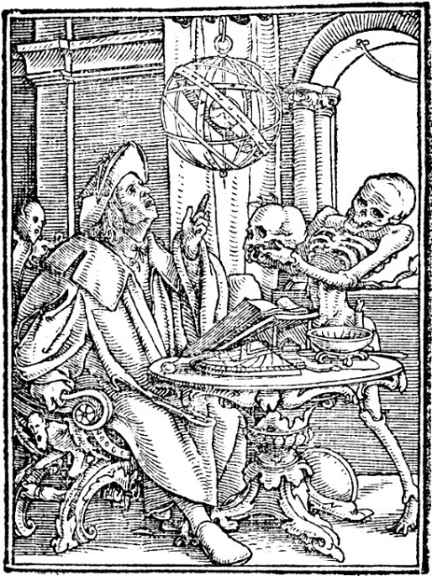

ITEMS
1 pound (£) = 20 shillings (s) = 240 pence (d)
1 shilling (s) = 12 pence (d)
1 pence (d) = 1 D&D “gold piece” (gp)

Encumbrance
Each inventory weight slot is roughly equivalent to 3 lbs. Items with an inventory slot of “0” can be bundled into a single inventory slot.

Tools
Item | Slots | Price
Mason's tools | 2 | 3d
Spade & shovel | 2 | 3d
Augur | 1 | 3d
Flint & steel | 0 | 3d
Chisel | 0 | 4d
Pickaxe | 2 | 5d
Axe | 1 | 5d
Metal file | 0 | 5d
Crowbar | 1 | 6d
Hammer | 1 | 8d
Rope, 50' | 3 | 10d
Grappling hook | 2 | 1s
Bear trap | 5 | 2s 6d
Anvil | 17 | £1
Vise | 6 | 13s 4d
Block & tackle | 5 | £1 10s
Bellows | 10 | £1 10s
Set of Armourer's tools | 17 | £3 6s

Food
Item | Slots | Price
2 Dozen Eggs | 0 | 1d
Oats, 3lb | 1 | 1d
3 lb cheese | 1 | 3d
Ale (Poor) | 3 | 0.5d/gal
Beer (Good) | 3 | 2d/gal
Ale (Good) | 3 | 1.5d/gal
Wine (Cheapest) | 3 | 3d/gal
Wine (Best) | 3 | 8d/gal
Dried Fruit | 0 | 2.5d/lb
Chicken, Whole | 1 | 3d/lb
Bacon, salted | 2 | 4d/lb
Beef steak | 2 | 5d/lb
Lamb leg | 2 | 6d/lb
Salted herring | 1 | 8d each
Spices (various) | 0 | 2s/lb
Pepper | 0 | 4s/lb
Saffron | 0 | 14s/lb

Miscellaneous
Item | Slots | Price
Ceramic cooking pot | 1 | 0.5d
1 mattress | 3 | 2d
3 Candle (tallow) | 1 | 3d
Barrel | 3 | 3d
Bottle | 0 | 4d
1 sheet | 1 | 4d
4 pillows | 1 | 4d
Towel | 0 | 6d
2 stools | 3 | 8d
Perfume | 0 | 10d
3 Candles (wax) | 1 | 1s
2 buckets | 2 | 1s
Coffer | 3 | 1s
Oil lantern | 1 | 1s 5d
Oil | 1 | 1s
Metal chain (10’) | 2 | 1s 10d
Brass pot | 2 | 2s
Chest with necessaries | 5 | 2s 2d
Basin and ewer | 1 | 2s 8d
Silver spoon | 0 | 2s 4d
Cart (one-horse) | [500] | 3s
Compass | 0 | 10s
Silver mirror | 0 | 12s
Wagon (four-horse) | [1,500] | 15s
Gold necklace | 0 | £1 3s
Bagpipes | 2 | £1 5s
Gold ruby ring | 0 | £1 6s 8d
Strings of pearls | 0 | £1 10s
Gold diamond ring | 0 | £7 10s

Cloth & Clothing
Item | Price
Fashionable gown | £10
Gentry
Shoes | 4s
Boots | 6s
Purse | 2s
Hat | 1s
Craftsman's tunic | 3s
Reeve's red robe | 5s 3d
Peasant (wealthy)
Linen Chemise | 8d
Shoes | 6d
Woolen garment | 3s
Fur-lined garments | 6s 8d
Tunic | 3s
Linen | 1s
Landless serfs' tunics | 1d
Cloth for peasant tunics | 1s/ yard
Best Wool | 5s/yard
Silk | 12s per yard
Furs added to garment | +£2

Livestock
Item | Price
Fowl | 1d
Sheep | 1s 5d
Ram | 1s 5d
Pig | 3s
Cow | 6s
Cow (good) | 10s
Ass | 10s 6d
Ox | 13s 2d
Draught horse | 15s
Mule | 18s
High-grade riding horse | £7
War horse | £10

Buildings
Item | Price
Rent
Cottage | 5s/year
Craftsman's house | 20s/year
Merchant's house | £2-£3/year
Cottage | £2
Row house (well built) | Up to £5
Wooden gatehouse and drawbridge | £5 6s 8d
Craftsman's house | £10-£15
Modest hall and chamber | £15
Stone Gatehouse | £30
Merchant's house | £45
Large tiled barn | £83
House with courtyard | £90+
Stonework of church | £113
Goldsmiths' Hall | £136
Tavern with the exclusive right to sell sweet wines | £120
Castle tower | £333
Abbey | £781

Books & Education
Item | Price
Book rental | 2s/day
Books (1 slot each)
Mundane | 15s
Holy | £1/level
Arcane | £1/level
Monastery School | £2
School
Board | 2s/week
Instruction | 13s 4d/year
Fencing Instruction | 10s/month
University | £6/year
Board | 104s/year
Clothing | 40s/year
Instruction | 26s 8d/year

Wages
Profession | Wage
Gentry
Squire | 1s/day
Knight | 2s/day
Regular Army
Archers | 3d/day
Veterans | 6d/day
Infantry | 8d/day
Musketeer | 12d/day
Cavalryman | 1s 6d/day
Esquires | 1s/day
Drummer or trumpeter | 1s 8d/day
Ensign | 2s/day
Lieutenant | 4s/day
Captain | 8s/day
Laborer | 2d/day
Top lawyer | £1/day
Clerk | 10d/day
Barber-Surgeon | 12d/day
Apothecary | 8d/day
Armourer
Chief | 26s 8d/month
Journeyman | 24s/month
Apprentice | 6d/day
Farrier | 5d/day
Master mason | 4d/day
Master carpenter | 3d/day
Priest | £4 13s/year
Carters, porters, falconers, grooms, messengers | 8s 8d/year
Boys and pages | 4s/year
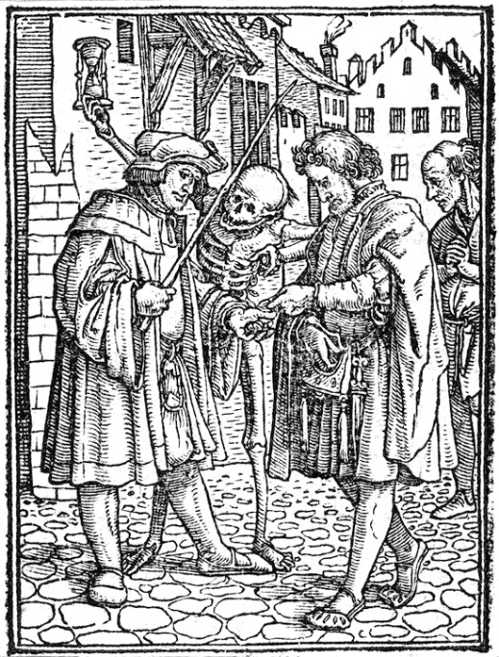

Weapons
Crits ignore DR or disarm the opponent; fumbles result in your weapon either being lost or broken.

Initiative
Initiative in combat is determined by rolling the damage dice for the weapon being used. Non attacks roll 1d4 for initiative, spells and prayers both roll 1d8 for each spell level. Lower rolls act first. Keep the initiative roll to use for damage rolls.

Melee
Versatile (†): Wield with both hands to increase the damage die by one rank, i.e., 1d8 → 1d10.
Two-handed (‡): Requires both hands; the character cannot use a shield.
Reach (❧): This weapon can attack from the second rank of a formation.
Type |  | Slots |  | Cost
Improvised | 1 | 0 | -
Dagger | 1d4 | 0 | 6d
Axe | 1d4 | 1 | 1s
Club | 1d4 | 2 | 4d
Short sword | 1d6 | 1 | 1s
Mace | 1d6 | 1 | 2s
Estoc | 1d8 | 1 | 15s
Longsword† | 1d8 | 1 | 18s
Warhammer† | 2d4 | 2 | 9s
Spear† | 1d8 | 1 | 10d
Halberd‡❧ | 1d10 | 3 | 8s
Pike‡❧❧ | 1d12 | 3 | 1s 6d
Great Sword‡ | 2d6 | 3 | £1 5s
Great Axe‡ | 3d4 | 2 | 4s
Claymòre‡❧ | 2d8 | 2 | £1 10s
Flail‡ | 4d4 | 2 | 10s
Zweihänder‡❧ | 3d6 | 5 | £2 6s
Flamberge‡❧ | 2d10 | 4 | £3 10s
Maul‡ | 5d4 | 3 | £1 4s
Lance❧  (mounted charge) | 4d6 | 7 | £2
Ceremonial Sword‡❧ | 6d6 | 6 | £6
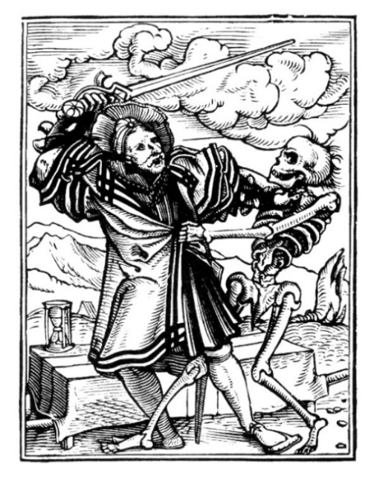

Ranged
Range: Attacks made outside of the ideal Range are made at disadvantage [-]. Long range hits roll damage at [-].
Self-propelled (✠): These weapons don't require or receive Strength bonuses.
Reload (↺): Requires a number of rounds to reload between shots equal to the number of damage die.
Type |  | Slots |  |  | Range | Cost
Sling | 1d4 |  | 0 | 10’-600’ |  |  | 2d
Crossbow✠↺ | 1d6 |  | 1 | 20’-300’ |  |  | 15s
Javelin | 1d6 |  | 1 | 10’-50’ |  |  | 6d
Short Bow | 2d4 |  | 1 | 20’-300’ |  |  | 6s
Arbalest✠↺ | 1d10 |  | 6 | 30’-800’ |  |  | £1
Composite Bow | 3d4 |  | 1 | 30’-900’ |  |  | 10s
Pistol✠↺ | 1d12 |  | 2 | 5’-150’ |  |  | £3
Long Bow | 4d4 |  | 1 | 30’-700’ |  |  | £1 6s
Arquebus✠↺ | 2d8 |  | 3 | 30’-300’ |  |  | £2 10s
Musket✠↺ | 2d12 |  | 4 | 30’-400’ |  |  | £4 6s
Rifle✠↺ | 3d12 |  | 4 | 30’-800’ |  |  | £7

Ammunition
Type | Slots | Cost
Arrows (30) | 1 | 1s
Bolts (30) | 1 | 3s
Black powder ) | 1 | 8s
Bullets (40) | 1 | 1s

Armour
Armour provides both an Armour Class (AC) bonus (base value of 0), representing blow reflection, and a Damage Reduction (DR), representing blow absorption, values. To avoid being wounded, roll 1d20 under your AC. A roll of 1 is a critical parry, granting a free action; a roll of 20 is a fumble, resulting in DR being ignored. When incoming damage exceeds total Armour DR, the lowest DR piece of Armour is destroyed. Armour does not reduce Shocking, Burning, or Toxic damage. Only one piece of armour from each section can be equipped at a time.
examples | AC | DR | Slots | Cost
Yeoman | 1 | 2 | 2 | 14 s
Soldier | 2 | 2 | 4 | £1 4 s
Veteran | 3 | 4 | 5 | £2 0 s
Squire | 6 | 4 | 8 | £3 11 s
Knight | 7 | 10 | 11 | £5 2 s
Lord | 11 | 13 | 15 | £7 12 s
Baron | 13 | 14 | 15 | £10 0 s
Duke | 15 | 17 | 17 | £11 14 s
Prince | 20 | 20 | 27 | £20 18 s

Helmets
Type | AC | DR | Slots | Cost
Spangenhelm | 1 | 1 | 1 | 10s
Mail Coif | 1 | 2 | 2 | 14s
Morión | 2 | 1 | 2 | 16s
Barbute | 2 | 2 | 2 | £1 2s
Burgonet | 3 | 1 | 2 | £1 4s
Sallet | 1 | 3 | 3 | £1 5s
Great Helm | 2 | 4 | 4 | £1 15s
Great Bascinet | 4 | 2 | 3 | £2 2s
Armet | 3 | 3 | 3 | £2 10s
Frog-mouth Helm | 4 | 3 | 4 | £2 18s

Body Armour
Type | AC | DR | Slots | Cost
Buff Coat | 0 | 1 | 2 | 8s
Gambeson | 1 | 2 | 3 | 18s
Scale Armour | 3 | 2 | 5 | £2 3s
Brigandine | 4 | 4 | 6 | £3
Cuirass | 4 | 5 | 4 | £4
Mail Hauberk | 2 | 5 | 5 | £4 5s
Half-Plate Armour | 4 | 6 | 8 | £5
Jousting Plate Armour | 5 | 8 | 10 | £11

Shields
Shields can be shattered to reduce all damage from a single physical attack by half.
Type | AC | DR | Slots | Cost
Buckler | 2 | 0 | 1 | 6s
Kite Shield | 2 | 1 | 3 | 12s
Heater Shield | 2 | 2 | 2 | £1
Tower Shield | 3 | 2 | 3 | £1 9s
Pavise Shield | 4 | 2 | 7 | £2

Arms
Type | AC | DR | Slots | Cost
Leather Gloves | 0 | 1 | 0 | 3s
Chainmail Sleeves | 1 | 2 | 3 | 10s
Chainmail Mittens | 2 | 2 | 1 | 12s
Plate Gauntlets | 2 | 3 | 1 | £1
Plate Mittens | 3 | 3 | 2 | £2

Legs
Type | AC | DR | Slots | Cost
Leather Boots | 0 | 1 | 1 | 4s
Padded Legs | 1 | 2 | 1 | 10s
Sabatons | 2 | 1 | 1 | 15s
Mail Legs | 2 | 4 | 4 | £1 13s
Plate Greaves | 3 | 3 | 2 | £1 15s
Full-Plate | 4 | 4 | 4 | £3
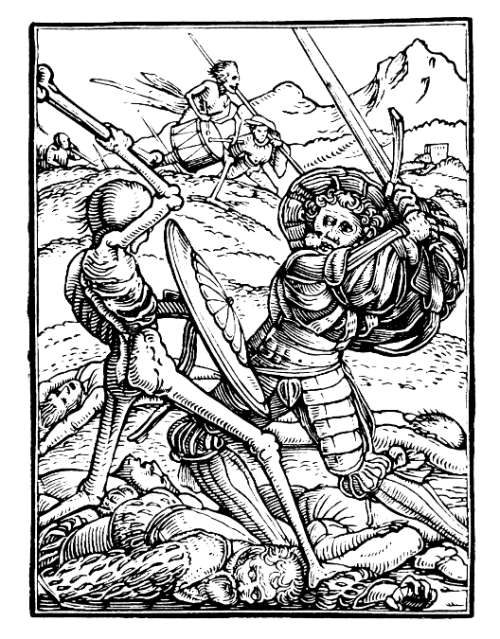
Note: Legacy dungeons and monsters may require additional damage die to challenge heavily Armoured characters.

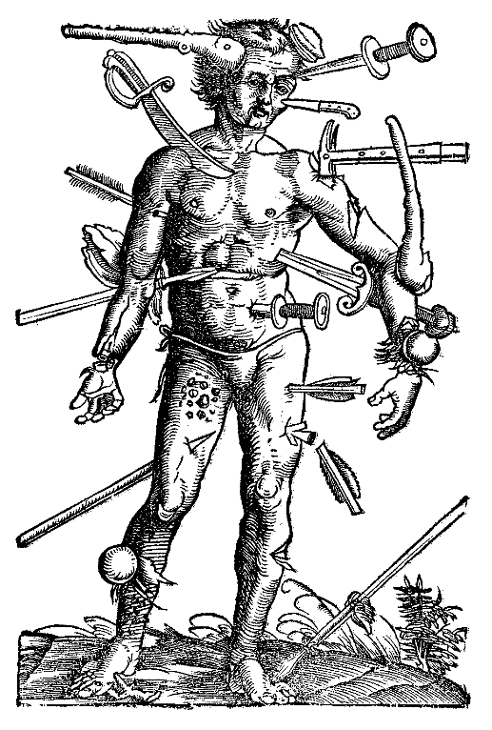
9. Sling
16. Estoc
17. Short Bow
11. Dagger
10. Longsword
4. Improvised
14. Great Sword
15. Pistol
20. Claymòre
7. Short Sword
18. Composite Bow
12. Warhammer
1. Zweihänder
5. Halberd
2. Arquebus
6. Long Bow
3. Arbalest
19. Spear
13. Mace
8. Club

0.
If you want to forgo a starting Loadout and buy gear piecemeal, roll and spend 2d4£, 1d20s, & 1d12d. If you select a loadout roll for shillings and pence only.
1. Landsknecht
AC 5 | DR 8 | Slots 20 | 3d6
Zweihänder, Brigandine, Sallet, Leather Boots, Dagger, Flint & Steel, Oil Lantern, Oil, Cheese (3 lb), Bottle, Rope (50′)
2. Musketeer
AC 3 | DR 4 | Slots 11 | 2d8
Arquebus, Morión, Buff Coat, Chainmail Sleeves, Bullets (40), Black Powder, Flint & Steel, Candle, Bottle
3. Crossbowman
AC 6 | DR 5 | Slots 20 | 1d10
Arbalest, Bolts (30), Pavise Shield, Buff Coat, Morión, Leather Gloves, Flint & Steel, Hammer, Oil Lantern, Oil, Waterskin
4. Scholar
AC 0 | DR 1 | Slots 10 | —
Linen Chemise, Leather Boots, Arcane Book (Level 1), Arcane Book (Level 2), Ink & Quill, Flint & Steel, Candle, Mattress, Ceramic Pot, 2 Dozen Eggs, Oats (3 lb), Oil Lantern, Oil
5. Halberdier
AC 3 | DR 4 | Slots 16 | 1d10
Halberd, Gambeson, Morión, Leather Gloves, Wine, Waterskin, Chisel, Spade & Shovel, Rope (50′)
6. Longbowman
AC 4 | DR 5 | Slots 10 | 4d4
Long Bow, Arrows (30), Brigandine, Leather Gloves, Salted Herring, Waterskin, Axe, Flint & Steel
7. Mercenary
AC 5 | DR 6 | Slots 13 | 1d6
Short Sword, Heater Shield, Gambeson, Leather Boots, Morión, Rope (50′), Flint & Steel, Waterskin, Chicken
8. Monk
AC 0 | DR 2 | Slots 9 | 1d4
Club, Linen Chemise, Leather Gloves, Leather Boots, Ale (Good), Holy Book (Level 1), Holy Book (Level 2), Ceramic Pot, Ink & Quill set, Parchment
9. Shepherd
AC 0 | DR 3 | Slots 7 | 1d4 Sling, Buff Coat, Leather Boots, Leather Gloves, Flint & Steel, Holy Book (level 1), Candle, Lamb Leg, Waterskin
10. Squire
AC 6 | DR 7 | Slots 13 | 1d8
Longsword, Kite Shield, Brigandine, Leather Boots, Leather Gloves, Whetstone, Brass Pot, Flint & Steel
11. Thief
AC 0 | DR 2 | Slots 9 | 1d4
Dagger, Leather Boots, Leather Gloves, Ale (Good), Flint & Steel, Crowbar, Rope (50′), Jewels, Strings of pearls, Lockpick set
12. Foot Soldier
AC 4 | DR 4 | Slots 15 | 2d4
Warhammer, Gambeson, Burgonet, Leather Boots, Flint & Steel, Spade & Shovel, Pickaxe, Rope (50′), Waterskin
13. City Guard
AC 3 | DR 6 | Slots 14 | 1d6
Mace, Buff Coat, Chainmail Sleeves, Heater Shield, Leather Boots, Wine (Cheapest), Whistle, Oil Lantern, Oil, Manacles
14. Swordsman
AC 4 | DR 8 | Slots 12 | 2d6
Great Sword, Gambeson, Leather Boots, Leather Gloves, Great Bascinet, Whetstone, Waterskin, Fur Cloak, Brass Pot
15. Privateer
AC 0 | DR 2 | Slots 10 | 1d12
Pistol, Bullets (40), Black Powder, Buff Coat, Leather Gloves, Flint & Steel, Bottle, Compass, Rope (50′), Grappling Hook
16. Noble Scion
AC 3 | DR 6 | Slots 10 | 1d8
Estoc, Gambeson, Plate Gauntlets, Leather Boots, Wine (Best), Flint & Steel, Signet Ring, Arcane Book (Level 1), Perfume
17. Ranger
AC 2 | DR 3 | Slots 16 | 2d4
Short Bow, Arrows (30), Buff Coat, Leather Gloves, Morión, Flint & Steel, Waterskin, Candle, Bear Trap, Rope (50′), Axe, Hunting Knife
18. Horse Archer
AC 3 | DR 4 | Slots 11 | 3d4
Composite Bow, Arrows (30), Scale Armour, Leather Gloves, Leather Boots, Flint & Steel, Waterskin, Rope (50′), Dried Fruit
19. Village Militia
AC 2 | DR 4 | Slots 13 | 1d8
Spear, Buff Coat, Heater Shield, Leather Gloves, Flint & Steel, Bottle, Rope (50′), Spade & Shovel, Ale (poor)
20.Gallowglass
AC 4 | DR 7 | Slots 15 | 2d8
Claymòre, Mail Hauberk, Morión, Leather Boots, Flint & Steel, Barrel, Tartan Cloak, Bagpipes, Horn

COMBAT
In Gewinn you role-play freely until the fiction presents immediate physical jeopardy: blades are drawn, spell patterns glow, or any single action could maim or kill. At that moment the table shifts from loose narration to Combat Rounds so that every player has the same granularity of risk and opportunity. When the danger passes play returns to narrative time.

Round Sequence
Frame & Surprise
The DM sets distances and footing, then (optionally) rolls 1d6 per side. On 1–2 a side is surprised: it takes no actions in the first round and rolls its opening AC save at [-].

Initiative
Each creature rolls the damage die of the weapon it will use (non-attacks = 1; spells/prayers roll 1d8 per spell level, summed). Lowest acts first; ties are simultaneous. Keep that die: if you land a hit, it becomes your damage roll.

Turn
On your initiative you may:
- Move up to 40′ + 5′ per STR bonus minus 5′ per five carried slots.
- Take one Action: attack, cast/pray, reload (↺ rounds = damage dice), change Stance, grapple, aid, flee, etc.

End of Round
Decrease Bleeding counters and reload ticks, check morale, trigger Panic, advance torches, and so on.
Attacks are player-facing: the attacker rolls damage only; the defender rolls 1d20 < AC to parry or dodge. A 1 is a critical parry (no damage, gain a free action). A 20 is a fumble—incoming damage ignores DR.

Damage & Protection
If the AC save fails, subtract Damage Reduction (DR) from the rolled damage; any remainder converts to Wound points of the chosen type. A shield may be sacrificed to halve one physical hit. When a single physical blow exceeds your total DR, the highest-DR item is destroyed and you fall Prone (Speed 0; attacks against you [+]; no shield or ‡ weapon; standing costs your Action unless you first win an opposed STR/Will check).

Stances
At the start of your turn you may adopt, change, or drop one Stance without cost; only one may be active.
- Vom Tag “From the Roof” High guard ready to deliver crushing overhead blows; Damage [+], Attack [-].
- Ochs “Ox” Point held at head or ear for powerful thrusts and strong parries; AC [+], Damage [-].
- Pflug “Plow” Blade pointed low and forward to control distance and set up bindings or ripostes; AC [+], Attack [-].
- Alber “Fool” Sword held low and open to bait your opponent into committing, opening them to counter-strikes; Attack [+], Damage [-].
- Halbschwert “Half-Sword" Grip the blade with your off-hand for precise thrusts into Armour gaps; Attack [+], AC [-].
- Mordhau “Murder-blow" Reverse your blade and strike with pommel or cross-guard like a warhammer; Damage [+], AC [-].
A brief narrative description and a flip of Advantage/Disadvantage communicates the whole stance, no further math necessary.

Grappling

Opposed Checks
When grappling, each combatant rolls 1d20 + STR or WILL (or 2×HD for monsters). Apply situational [+]/[–]; highest result wins.

Standing
Feet shifting, eyes locked, poised to strike.
- Standard Actions: Attack, cast/pray, move freely, etc.
- Takedown: Opposed check at [–]; on success, deal 1d4 bludgeoning and move to Top position.
- Clinch: Opposed check; move to Clinched position.
- Trip: Opposed check; knock opponent Prone.

Clinched
Locked close, bone-rattling struggle. Shields and two-handed weapons ineffective.
- Strike: Two handed weapons roll at [–].
- Takedown: Opposed check; success moves you to Top.
- Throw: Opposed check; opponent thrown Prone, taking 1d4 bludgeoning.
- Break: Opposed check; return to Standing.

Top
You bear down on your adversary like an anvil.
- Strike: Attack and damage rolls at [+].
- Submission: Opposed check at [+]; deal 1d6 bludgeoning (ignores DR).
- Escape: Return freely to Standing.

Bottom
Pinned and gasping, you hunt for leverage.
- Sweep: Opposed check; success reverses positions, moving you to Top.
- Submission: Opposed check at [–]; deal 1d6 bludgeoning (ignores DR).
- Escape: Opposed check; return to Standing.

Additional Rules
- Prone: Movement = 0; standing costs half of full movement; melee attacks against you gain [+]; your attacks are made at [-].
- Attacking Into Grapple: A hit strikes your chosen foe; on a miss, the blow instead falls on the other combatant.
- Spellcasting in Grapple: Spellcasting rolls are made at [-] while in Clinched and Bottom positions.
- Called Shots: declare intent; roll attack at [-]; on a hit inflict a location-specific effect.
- Cover & Concealment: A creature behind light cover (waist-high wall, trees) or concealment (fog, darkness) gains [+] on its AC save; heavy cover (thick walls, stone pillars) grants [++].

Leaving the Fight
You can safely leave melee by using your Action to Disengage; otherwise, each adjacent foe may oppose with STR/Will to halt, trip, or grapple you. Weapons with Reach (❧) threaten from an extra 5′ away.
If you attempt to Flee, move up your maximum movement. If you end this move beyond all foes' reach, you escape. Otherwise, enemies with enough remaining movement can pursue to make an attack or force an opposed STR check—failure leaves you Prone. While fleeing, you may spend your Action to drop any number of inventory slots immediately.

When Combat Ends
Combat ends when no creature keeps time in rounds—foes flee, negotiate, lie dead, or the party withdraws beyond pursuit speed. The DM returns to broad narration: torches burn in minutes, kit is rearranged, wounds are bound, pockets are picked, and the cost of war—coin, courage, comrades—can be counted.

MORTAL WOUNDS

Applying Mortal Wounds

Taking Damage
When a character takes damage, refer to the appropriate Wound Table based on the type and amount of damage received (e.g., Piercing, Slashing, etc.). The result determines the severity and specific effects of the wound.

Stacking Wounds
Wounds of the same type accumulate. When new damage of the same type is taken, add all existing wounds to the total to determine the new wound (e.g., if a character with a piercing wound of 4 damage receives an additional piercing wound of 3 damage, they would receive a new wound of 7).

Bleeding to Death
Mortally wounded characters can survive a number of rounds equal to their Will modifier plus one, before bleeding out.

Staunching Bleeding:
Aid can be applied by rolling over the wound value.
First Aid: Takes 1 round. Success slows bleeding to turns instead of rounds.
Treating Bleeding: Requires a full turn. Success stops bleeding entirely.
Magical Healing: Magic reduces wound damage by the amount healed, altering the affects accordingly.

Dead Man Walking
Definition: Death is imminent, but there is a brief window to act before the inevitable occurs.
Duration: A doomed character may act for one additional round plus a number of rounds equal to Will bonus, then dies. Death is inevitable unless magical healing is used.

Healing Wounds
Immediate Effects: Non-Mortal Wounds, such as those causing unconsciousness or ongoing bleeding, can be stabilized immediately with a successful treatment roll. A character experiencing Dead Man Walking can only avoid death if magical healing is administered before their final round ends.
Recovery: When resting safely with proper medical care, characters naturally recover a number of Wound points in each damage category equal to 1 plus their Will Modifier per rest period. Magical healing (e.g., Cure Serious Wounds) directly reduces wound damage by the amount healed. All wound-related effects persist until fully healed; some severe effects may be permanent.
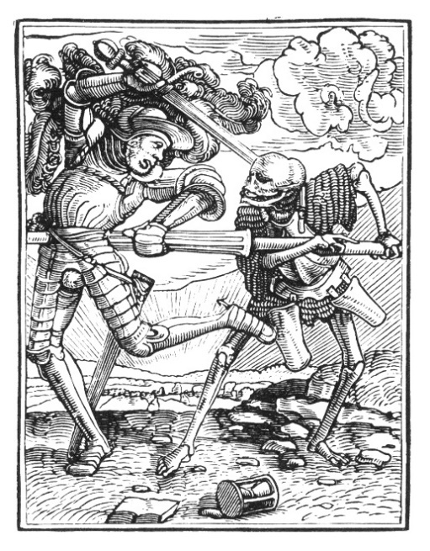

Wound Tables

Piercing Wounds
Damage | Effect
1 | Flesh Wound: Superficial puncture, little bleeding. [-] on fine motor skill rolls for 1d6 rounds due to pain.
2 | Muscle Nick: Deeper puncture affecting muscle tissue; –5′ movement speed.
3 | Tendon Graze: Fatigue from blood loss; -1 Strength.
4 | Nerve Strike: Affected limb is partially paralyzed for 1d4 hours; fine control is impossible, -1 Intelligence.
5 | Bleeding Puncture: Deep wound. Bleeding Out at turn intervals.  –1d2 Will
6 | Deep Organ Threat: Puncture near vital organs. Bleeding Out. –1d2 Will
7 | Gut Wound: Severe abdominal trauma; [-] on all actions, –1d4 Faith. Bleeding Out.
8 | Eye destroyed: Vision goes dark; [-] on ranged attacks, -1d4 Will, -1d4 Intelligence. Bleeding Out.
9 | Punctured Lung: Breathing severely impaired; Reduce movement by half,  –1d4 Strength, -1d4 Faith. Bleeding Out.
10–15 | Spinal Graze: Partial paralysis or nerve damage; –1d6 Intelligence, –1d6 Will. Dead Man Walking
16+ | Heart Pierced: The body succumbs entirely. Instant Death.

Slashing Wounds
Damage | Effect
1 | Minor Laceration: Light bleeding; –5′ movement speed.
2 | Superficial Cut: A slice that requires stitches. [-] on fine motor tasks for 1d6 rounds.
3 | Shallow Gash: A moderately cut with noticeable bleeding. Reduce movement by 5′ until rested.  –1 Strength
4 | Deep Laceration: A severe cut that damages muscle tissue. Bleeding Out at turn intervals. –1 Strength
5 | Tearing Wound: A cut that severs superficial tendons, –1d2 Strength & [-] when using limb until healed. Bleeding Out at turn intervals.
6 | Severed Tendon: A deep slash that severs major tendons; –1d2 Will &  [-] when using limb until healed. Bleeding Out at turn intervals.
7 | Heavy Bleeding: A deep, gaping wound causing rapid blood loss;  –1d4 Will. Bleeding Out.
8 | Arterial Laceration: A deep, disfiguring cut that damages muscle and nerve tissue; [-] when using limb, –1d6 Strength. Bleeding Out.
9 | Amputation: A wound that severs a limb entirely; –1d8 Strength. Bleeding Out.
10–15 | Severe Disembowelment: A slash that ruptures the abdomen, causing massive internal bleeding, despair sets in; –1d6 Faith, –1d6 Will. Dead Man Walking.
16+ | Instant Decapitation: A violent slash separating the skull from the body. Instant Death.

Bludgeoning Wounds
Damage | Effect
1 | Bone Rattle: A strong jolt causing lingering pain. Must succeed on a Will save or drop any held items.
2 | Swelling: The injured area throbs with pain. [-] on fine motor tasks for 1d6 rounds.
3 | Fracture: limb use impaired without proper immobilization; [-] on Strength rolls, –1 Strength.
4 | Cracked Ribs: Breathing difficulties and risk of internal injury; –1 Will. Bleeding Out at turn intervals.
5 | Joint Dislocated: Limb effectively unusable for 1d4 hours; –1d2 Strength, excruciating pain until reset, [-] on Strength saves.
6 | Concussion: High risk of confusion, agitation, or passing out; [-] on all mental rolls, lose consciousness for 1d6 rounds, –1d4 Intelligence.
7 | Ruptured Organ: Major internal damage to liver, kidney, or spleen;  –1d4 Will. Bleeding Out.
8 | Spinal Impact: Partial numbness or temporary paralysis. Movement reduced to 5′, –1d6 Strength, –1d6 Will. Bleeding Out
9 | Major Crushing: Severe tissue and bone damage. [-] on all physical rolls; –1d8 Strength. Dead Man Walking.
10–15 | Bones Shattered: Fragments threaten surrounding organs; –1d8 Strength,  –1d6 Will. Dead Man Walking
16+ | Skull Crushed: Brains ooze and the body crumples. Instant Death.

Shocking Wounds
Damage | Effect
1 | Nerve Flicker: A sharp jolt passes through the body; [-] on fine motor tasks for 1d6 rounds.
2 | Stinging Arc: Flash causes skin burns and nerve agitation; –5′ movement speed.
3 | Flashover Burn: Skin arcs with lightning patterns; skin scorched. [-] on weapon attack rolls, –1 Will.
4 | Keraunoparalysis: Affected limb turns cold, numb, and limp for 1d4 hours. Cannot wield weapons or tools with that limb, –1 Strength.
5 | Tympanic Rupture: Deafened by blast wave; lose hearing for 1d4 hours, disoriented. [-] on all initiative and surprise checks, –1d2 Intelligence.
6 | Internal Arc: Current courses through flesh; –1d2 Strength. Bleeding Out at turn intervals.
7 | Cardiac Flutter: Heart skips and stutters; Will save or fall unconscious for 1d4 rounds, –1d4 Will. Bleeding Out.
8 | Rhabdomyolysis: Flesh boils from within. Kidney strain, searing pain;  –1d6 Strength. Bleeding Out.
9 | Nervous Collapse: Seizures, memory loss, loss of control. [-] on all actions,  –1d6 Intelligence. Bleeding Out.
10–15 | Lightning Trauma: Bones crack, organs rupture, and vision fades; reduced movement to 5′, –1d8 Will  –1d6 Strength. Dead Man Walking
16+ | Thunderbolt: Your body is the path to ground; heart stops, breath fails. Instant Death.

Burning Wounds
Damage | Effect
1 | Smoke Inhalation: Coughing fits and stinging lungs; [-] on all vocal or stealth tasks for 1d6 turns.
2 | Scorched Airways: Raspy, painful breathing; [-] on communication and spellcasting for 1d4 hours.
3 | First‑Degree Burn: Blistering pain. Will save or drop held items, -1 Will.
4 | Second‑Degree Burn: Skin bubbles and peels; [-] on any action using the area for 1d6 turns, -1 Strength.
5 | Third‑Degree Burn: Waxy, blackened skin. No surface pain, but deep inflammation, –1d2 Strength. Bleeding Out at turn intervals.
6 | Fourth‑Degree Burn: Skin and subdermal tissue destroyed; severe fluid loss, –1d4 Will. Bleeding Out.
7 | Nerve Destruction: Limb function lost; must be amputated;  -1d6 Strength. Bleeding Out.
8 | Charred to the Bone: Complete destruction of flesh, limb lost; –1d4 Faith, -1d4 Strength. Bleeding Out.
9 | Organ Failure: Lungs, heart, or kidneys begin to shut down. Collapse imminent; –1d6 Faith & Will. Dead Man Walking.
10–15 | Full‑Body Burned: Skin sloughs off; immune system, organs, and willpower break down; –1d6 Faith -1d6 Will. Dead Man Walking.
16+ | Complete Immolation: Body consumed in flame; nothing remains but ash. Instant Death.

Toxic Wounds
Damage | Effect
1 | Mild Nausea: Upset stomach, dizziness, [-] on rolls requiring focus for 1d6 turns.
2 | Skin Irritation: Redness, swelling, and itching; [-] on fine tasks.
3 | Feverish Weakness: Fatigue sets in, reduce movement by half; [-] on Strength-based checks, –1 Strength.
4 | Persistent Vomiting: Unable to eat or drink; heal half, rounded down, of normal Wound damage from rest,  –1 Will.
5 | Internal Bleeding: Blood seeps from mouth, nose, and eyes; –1d6 Will. Bleeding Out at turn intervals.
6 | Paralysis: Progressive loss of movement and sensation in affected areas; reduce movement to 5′, -1d4 Intelligence -1d4 Strength. Bleeding Out at turn intervals.
7 | Sepsis: Vital organs threatened; [-] on Saves vs. Poison; -1d4 Intelligence  –1d4 Will. Bleeding Out.
8 | Organ Failure: Liver or kidneys cease functioning; –1d6 Will, –1d4 Faith. Bleeding Out.
9 | Toxic Shock Syndrome: Body shuts down in violent convulsions, foaming at the mouth; –1d8 Intelligence. Dead Man Walking.
10–15 | Nervous System Collapse: Full paralysis, loss of sensation, unable to move or speak; –1d8 Intelligence,  –1d6 Will. Dead Man Walking.
16+ | Cellular Disintegration: The toxin has ravaged the entire body; no chance of survival. Instant Death.

STRESS

Mental, Physical, Emotional
You gain 1 Stress every time you fail a roll. Occasionally, certain locations or events can automatically give you Stress from interacting with or witnessing them. Your Minimum Stress starts at 2, and based on events that happen in game it can be increased or decreased. The maximum Stress you can have is 20. Any Stress you take over 20 instead reduces the most relevant Attribute by that amount.

Relief
You can relieve Stress by resting in a relatively safe place. To do this, make a Save against your current Stress. If you succeed, reduce your Stress by the difference between your roll and the check (e.g., if you rolled 5 under your Stress of 8, reduce your Stress by 3). If you fail, you gain 1 Stress instead.
Players can gain Advantage on their Rest Save by participating in sex, drug use, a night of heavy drinking, prayer, or any other relieving activity. Unsafe locations may incur Disadvantage on Rest Saves at the DM’s discretion. Finally, if you have more time, and coin, you can take Revelry and convert your Stress into improved Stats.

Panic
Stress, Damage, and emotional wear and tear eventually bring characters to their breaking point. When that happens, there’s a chance they Panic. You determine this by making a Panic Check.
A Panic Check determines whether the character can keep maintain their composure and even their sanity under extreme pressure. To make a Panic Check, roll 1d20 and attempt to roll greater than your current Stress. If you roll less than or equal to your current Stress you fail, and you look up your result on the Panic Table.

WHEN TO MAKE PANIC CHECKS
You must make a Panic Check anytime you roll a Critical Failure on a Ability Check or Save. Additionally, the Dungeon Master may call for a Panic Check at any other appropriate time, including, but not limited to:
- Watching another companion die.
- Witnessing a companion Panic.
- Gaining a mortal Wound.
- Encountering forces beyond the ken of Man.
- Whenever you, the player, want.

Revelry
To improve from this stress, characters can participate in a Revelry during their downtime. Revelry involves spending their hard-earned money on feasts, celebrations, religious devotion, and other forms of leisure. By doing so, they can convert some of their Stress Points into improved Abilities up to a maximum of 20.
- Cottager (2 s) – 1 stress: 6 share barley-and-vegetable pottage, coarse bread, and ale in earthenware.
- Tradesman (7 s) – 1d4 stress: 12 guild members eat roast pork, bread, cheese, and ale on pewter plates.
- Yeoman (18 s) – 2d4 stress: 24 neighbours enjoy capon or chicken, meat pies, bread, cheese, and cider.
- Professional & Clergy (£2) – 3d4 stress: 30–50 guests receive two courses—roasted fowl or peacock pie with imported cheeses, bread, and wine.
- Gentry & Knight (£6) – 4d4 stress: 80–100 guests enjoy three to four courses—venison or swan, suckling pig, sweetmeats, fruit, and rare wines—on silver platters.
- Noble (£12) – 5d4 stress: 150 attend a three- to five-course banquet—boar’s head, sturgeon, sugar sculptures, and spiced pies—on fine glass and porcelain.
- Royal (£24) – all stress: 200+ guests enjoy lavish courses of exotic spices, sugar sculptures, game, at long tables set with porcelain and crystal.

Panic Table
D20 Roll | Panic Effect
01 | Euphoria: Gain [+] on all rolls for the next 2d4 hours. Reduce Stress by 1d5.
02 | Jitters: Hands shake slightly, [-] to delicate tasks (lockpicking, writing, etc.).
03 | Irritability: Allies gain stress when you gain stress.
04 | Restless Sleep: Heal half, rounded down, of normal Wound damage from rest.
05 | Coward: You must make a Will Save to engage in combat, otherwise you flee.
06 | Shaky Hands: [-] to attack rolls with ranged weapons and delicate tasks.
07 | Hypervigilance: Constant alertness; gain [-] to initiative (roll twice take the lowest) & [-] on Stress Relief rolls.
08 | Self-Doubt: [-] on all rolls until rolling a natural 20.
09 | Fatigue: Movement halved; [-] on all Strength saves.
10 | Panic Attack: Must pass a Will save to take decisive actions under pressure or be stunned for a turn.
11 | Paranoia: Whenever someone new joins your group (even if they only left briefly), make a Will Save or gain 1 Stress.
12 | Obsessive Compulsions: Must perform repeated rituals to feel safe or suffer [-] to all rolls.
13 | Tremors: [-] on all attack rolls with weapons and delicate tasks.
14 | Flashbacks: At moments of high stress (like Panic Checks) roll a Will save or lose a turn reliving past trauma.
15 | Hopelessness: Roll a Will save each morning or be unable to take action for 2d4 hours.
16 | Emotional Numbness: Immune to fear but unable to feel joy; [+] on Panic rolls, resting no longer relieves Stress.
17 | Hysterical Fits: On a failed roll, make a Will save or experience uncontrollable sobbing or laughter for 1d6 minutes.
18 | Fugue State: Lose track of time and reality for 1d4 days with no memory of events afterwards.
19 | Catatonia: Collapse into an unresponsive state for 1d6 hours.
20 | Mental Break: Cardiovascular Collapse, Stroke, Autonomic Overload; roll 2d6 on the Toxic Wounds table.

DISEASE

Pestilence, Plague, & Disease

INFECTIONS
Make a Disease Check while resting after the following occurs:
- A character with untreated Wounds spends more than a turn in unhygienic or unsafe conditions (sewers, siege camps, rotting crypts, etc.).
- A character is exposed to infected corpses, animals, or contaminated food/water.
- At the DM’s discretion for exposure to filth, famine, or disease.

Disease Vulnerability
Add the character’s current Stress and total Wound Points from all active Wounds to determine disease Vulnerability.

Disease Check
Roll the 1d20 and attempt to roll greater than your current Vulnerability. If you roll less than or equal to your current Vulnerability you fail, and you look up your result on the following tables where the margin between Vulnerability and the roll determines the severity of the infection and the number of days required for a natural recovery.
- Margin 1–5 → Moderate Infection
- Margin 6–9 → Severe Infection
- Margin 10+ → Critical Infection
Then roll 1d6 on the appropriate chart to determine the specific disease and its effects. If there is a more

Recovery
Disease heals at a rate of one point per day. A treatment roll can be made once per day to remove an additional point by attempting to roll over the disease total. Magical healing can reduce these disease points as Hit Points.

Moderate Infection
1d6 | Effect
1 | Wound Infection: [-] on weapon attacks.
2 | Dysentery: Unable to eat or drink; heal half during rest
3 | Fever: [-] to all saves.
4 | Chest Cold: Movement halved; [-] to initiative.
5 | Skin Infection: [-] on Strength rolls.
6 | Strep Throat: [-] on spellcasting rolls.

Severe Infection
1d6 | Effect
1 | Sepsis: [-] on all rolls.
2 | Gangrene: A limb becomes necrotic. Amputation may be required.
3 | Severe Fever: [-] to saves. Make save vs. Poison or collapse for 1d4 days.
4 | Pneumonia: Halved movement, [-] on Strength and Initiative rolls.
5 | Peritonitis: Unable to eat or heal naturally.
6 | Systemic Infection: [-] to Saves. Wounds won’t heal until cured.

Critical Infection
1d6 | Effect
1 | Bubonic Plague: -1 Will/day.
2 | Septic Shock: All checks at [-]. Make a Death save every day.
3 | Necrotizing Fasciitis: Flesh devours itself. 50% chance lost limb each day.
4 | Toxic Collapse: Make all saves at [-]. -1d4 STR/day.
5 | Meningitis: -1 Intelligence and Will per day.
6 | Pneumonic Plague: Half movement speed. Make a Death save every day.
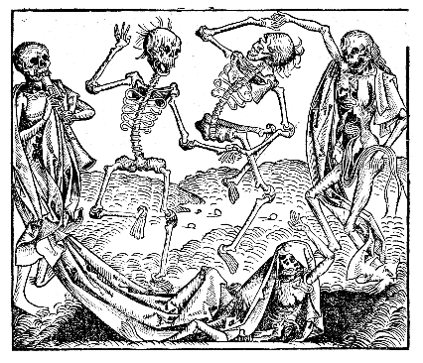

REFERENCE

Combat Essentials

Combat Round
Combat begins when danger looms. Roll Initiative by rolling your weapon’s damage die (lower acts first). On your turn, move up to 40' (+5' per STR bonus, -5' per 5 carried slots) and take one Action (attack, cast spell/prayer, grapple, reload, or change stance). Keep your initiative die—it becomes your damage roll if you hit. Attackers roll damage; defenders roll 1d20 < AC to negate hits. A natural 1 is a critical parry (gain free action), natural 20 a fumble (damage ignores DR).

AC, DR, Armour & Damage
Armour Class (AC) represents evasion/parry (base 0). To negate damage, roll 1d20 < AC. Damage Reduction (DR) subtracts directly from incoming damage. If damage exceeds total DR, your highest-DR armour breaks and you fall Prone (movement 0, attacks against you [+], standing uses your Action or an opposed STR/Will check). Shields can be sacrificed to halve a single hit's damage.

Advanced Fighting

Stances
One stance per turn; adopt/change freely at turn start:
- Vom Tag (From the Roof): Overhead strikes. Damage [+], Attack [–].
- Ochs (Ox): High guard, strong thrusts/parries. AC [+], Damage [–].
- Pflug (Plow): Low forward guard, control & riposte. AC [+], Attack [–].
- Alber (Fool): Low open guard to bait foes. Attack [+], Damage [–].
- Halbschwert (Half-Sword): Precise thrusts. Attack [+], AC [–].
- Mordhau (Murder-blow): Pommel-strike crushing blow. Damage [+], AC [–].

Grappling
Roll opposed 1d20 + STR/WILL (or 2×HD monsters), highest wins:
- Standing: Attack/spell freely. Actions: Takedown ([–], 1d4 dmg, move to Top), Clinch (to Clinched), Trip (foe prone).
- Clinched: Bone-close fighting; two-handed weapons at [–]. Actions: Takedown (to Top), Throw (foe prone, 1d4 dmg), Break (return to Standing).
- Top: Dominate foe. Actions: Strike [+], Submission ([+], 1d6 dmg ignores DR), Escape (return to Standing).
- Bottom: Vulnerable. Actions: Sweep (to Top), Submission ([–], 1d4 dmg ignores DR), Escape (return Standing).
Attacks into a grapple hit your target on success, ally on miss. Spellcasting in grapples at [–].

Special Combat Rules
- Called Shots: Attack at [–] for special effects.
- Cover: Light cover/concealment AC [+], heavy cover AC [++].
- Disengaging: Safely leave melee by using your Action, else foes may contest with STR/WILL check. Reach weapons threaten extra 5'.

Initiative & Ranges
Weapon initiative equals damage die size. Spells/prayers roll 1d8 per spell level. Lower rolls act first. Attacks outside ideal range have disadvantage [–]; hits at extreme range also damage at [–].

Armour Durability
Each armour type has AC/DR. Helmets and shields have separate ratings and may break individually. When damage > total DR, highest DR piece breaks. DR ineffective vs. non-physical damage.

Injury & Survival

Mortal Wounds
Exceeding DR converts damage to Mortal Wounds; effects stack and persist until healed. Characters bleed out after Will rounds unless stabilized:
- First Aid (1 round): slows bleeding to turns.
- Treatment (1 turn): stops bleeding.
- Magical Healing reduces wounds directly.
A mortally wounded character acts (Dead Man Walking) for 1 + Will bonus rounds before death unless magically healed.

Stress & Panic
Stress accumulates with failures, witnessing horror, or harsh environments (max 20; excess reduces Stats). Relieve Stress by resting: succeed on Stress Save (1d20 < Stress) to reduce by margin of success; fail adds +1 Stress. Advantage gained through revelry, sex, prayer, intoxication, etc.

Roll Panic Check (1d20) when failing critical rolls or experiencing trauma. Rolling ≤ Stress triggers a Panic effect—ranging from mild jitters and compulsions to full mental collapse.

Disease & Infection
After exposure to filth, corpses, contaminated water/food, or untreated wounds, roll Disease Check (1d20) vs. Vulnerability (Stress + total Wound points). Failure indicates infection:
- Margin 1–5: Moderate Infection (minor penalties, reduced recovery).
- Margin 6–9: Severe Infection (disabling symptoms, delayed healing).
- Margin 10+: Critical Infection (life-threatening symptoms, rapid deterioration).
Heal naturally at 1 point/day; successful daily treatment rolls and magical healing accelerate recovery.

Equipment & Currency
Currency: £1 = 20s (shillings) = 240d (pence).
Inventory: Each slot ~3 lbs. Encumbrance reduces movement by 5' per 5 filled slots. Base movement 40' (+5' per STR bonus).

Spellcasting & Magic
Spells/prayers cast by rolling 1d20 < Intelligence or Faith.
- Critical Success (20): Cast, remembered, effects [+].
- Success: Cast & remembered.
- Failure: Cast & forgotten.
- Critical Failure (1): Spell backfires & forgotten.
Use Transcendent Exertion to turn failures into successes (spend Stress) or successes into criticals (spend Wounds).

Bleeding Out & Death
Bleeding characters have rounds equal to 1 + Will before death without aid. Magical healing immediately reduces wound severity and can prevent death during Dead Man Walking.

Ending Combat
Combat ends when enemies flee, surrender, or no longer threaten. Return to narrative time: bind wounds, track torches, count lost gear, and tally the grim cost of battle.

War is Hell, and Hell never changed what any man with eyes in his head knew when war was at hand: Conflict, Gain, and Profit.

