**CURRICULUM VITAE**

🙞🟋🙜

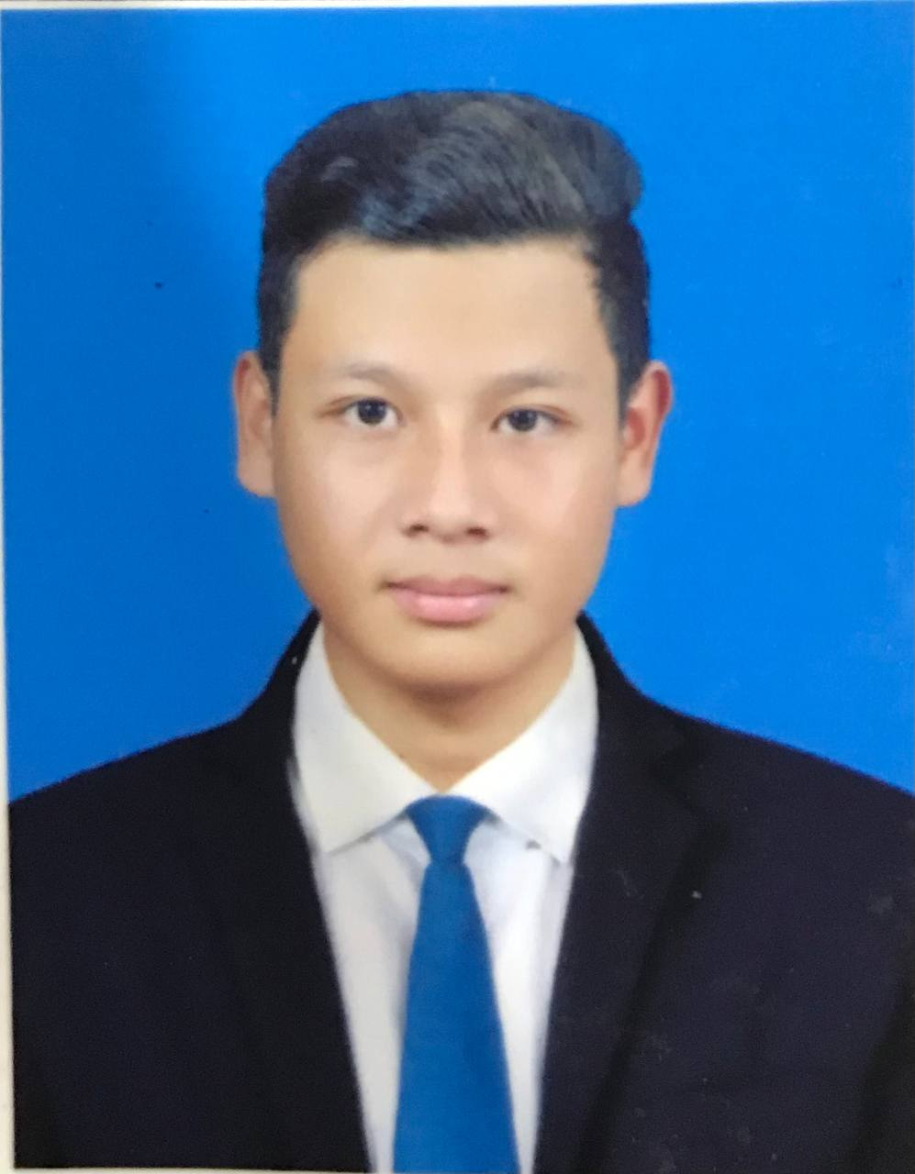

**Name**   **:** Mr. Yoeng Kosorl

**Address**  **:** Sangkat Stueng Mean Chey, Khan Mean Chey, Phnom Penh

**Tel :** 097 93 11 581/ 096 30 63 580

**Applying for : Developer & Support Internship**

______________________________________________________________________________________________________________

**PERSONAL DATA**

Name : Yoeng Kosorl

Sex : Male

Nationality : Cambodian

Religion : Buddhism

Marital Status : Single

Date of Birth : 02. February. 2001

Place of Birth : Prek Ptoul Village, Angkor Borey Commune, Angkor Borey District,

Takeo Province.

Health : Good

**EDUCATION BACKGROUND**

2020- Present : 3rd year student, at The National University of Management.

2017- 2020 : Graduated 12th grade at the Hun Sen Angkor Borey High School

2014- 2017 : Hun Sen Angkor Borey Secondary School

2008- 2014 : AngKor borey Primary School

**OTHER SKILLS**

English : Beginner, Headway, Elementary

Computer Literature : Microsoft word, Excel, PowerPoint

Information Technology : HTML, CSS, PHP, Bootstrap, JQuery

**LANGUAGE**

Khmer : Native Language

English : Reading , Writing , Speaking and Listening (Medium)

**HOBBIES**

* Listen to music , social media, watch TV
* Search the internet for knowledge more that relate in my specialization skill
* Like communication with other people