**Побудовані таблиці**

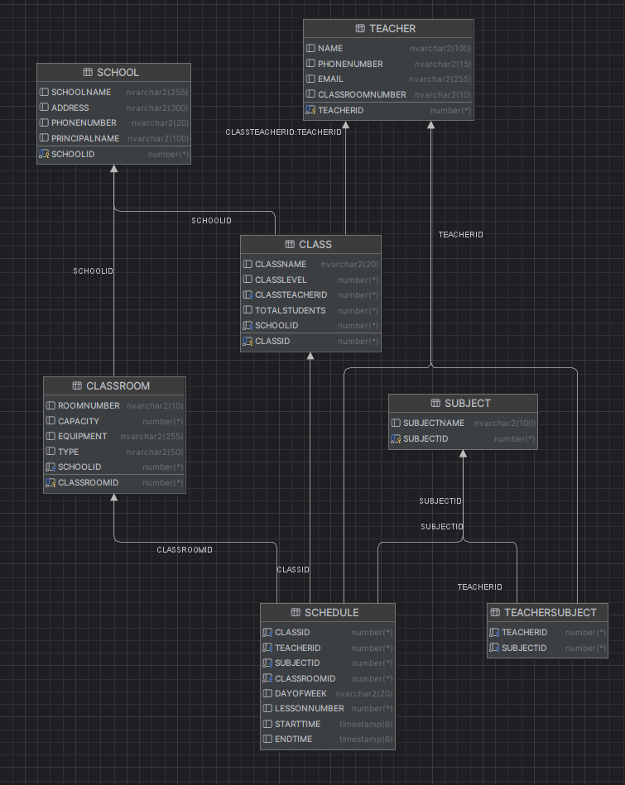

Побудувати зв’язки між таблицями. Зверніть увагу – половину конструкцій зробити з описом клічів при створенні таблиць (CREATE TABLE), другу половину прописуємо ключі через ALTER TABLE.

**Створення за допомогою CREATE TABLE**

CREATE TABLE SCHOOL (

SCHOOLID NUMBER PRIMARY KEY,

NAME NVARCHAR2(255),

ADDRESS NVARCHAR2(300),

PHONENUMBER NVARCHAR2(20),

PRINCIPALNAME NVARCHAR2(100)

);

CREATE TABLE TEACHER (

TEACHERID NUMBER PRIMARY KEY,

NAME NVARCHAR2(100),

PHONENUMBER NVARCHAR2(15),

EMAIL NVARCHAR2(255),

CLASSROOMNUMBER NVARCHAR2(10)

);

CREATE TABLE CLASS (

CLASSID NUMBER PRIMARY KEY,

CLASSNAME NVARCHAR2(20),

CLASSLEVEL NUMBER,

CLASSTEACHERID NUMBER,

TOTALSTUDENTS NUMBER,

SCHOOLID NUMBER,

FOREIGN KEY (SCHOOLID) REFERENCES SCHOOL(SCHOOLID),

FOREIGN KEY (CLASSTEACHERID) REFERENCES TEACHER(TEACHERID)

);

CREATE TABLE CLASSROOM (

CLASSROOMID NUMBER PRIMARY KEY,

ROOMNUMBER NVARCHAR2(10),

CAPACITY NUMBER,

EQUIPMENT NVARCHAR2(255),

TYPE NVARCHAR2(50),

SCHOOLID NUMBER,

FOREIGN KEY (SCHOOLID) REFERENCES SCHOOL(SCHOOLID)

);

CREATE TABLE SUBJECT (

SUBJECTID NUMBER PRIMARY KEY,

SUBJECTNAME NVARCHAR2(100)

);

**Створення за допомогою ALTER TABLE**

CREATE TABLE SCHEDULE (

CLASSID NUMBER,

TEACHERID NUMBER,

SUBJECTID NUMBER,

CLASSROOMID NUMBER,

DAYOFWEEK NVARCHAR2(20),

LESSONNUMBER NUMBER,

STARTTIME TIMESTAMP,

ENDTIME TIMESTAMP

);

ALTER TABLE SCHEDULE

ADD CONSTRAINT fk_schedule_class FOREIGN KEY (CLASSID) REFERENCES CLASS(CLASSID);

ALTER TABLE SCHEDULE

ADD CONSTRAINT fk_schedule_teacher FOREIGN KEY (TEACHERID) REFERENCES TEACHER(TEACHERID);

ALTER TABLE SCHEDULE

ADD CONSTRAINT fk_schedule_subject FOREIGN KEY (SUBJECTID) REFERENCES SUBJECT(SUBJECTID);

ALTER TABLE SCHEDULE

ADD CONSTRAINT fk_schedule_classroom FOREIGN KEY (CLASSROOMID) REFERENCES CLASSROOM(CLASSROOMID);

CREATE TABLE TEACHERSUBJECT (

TEACHERID NUMBER,

SUBJECTID NUMBER

);

ALTER TABLE TEACHERSUBJECT

ADD CONSTRAINT fk_teachersubject_teacher FOREIGN KEY (TEACHERID) REFERENCES TEACHER(TEACHERID);

ALTER TABLE TEACHERSUBJECT

ADD CONSTRAINT fk_teachersubject_subject FOREIGN KEY (SUBJECTID) REFERENCES SUBJECT(SUBJECTID);

**5 Прикладів ADD:**

ALTER TABLE TEACHER

ADD HIRE_DATE DATE;

ALTER TABLE SCHOOL

ADD EMERGENCY_CONTACT nvarchar2(20);

ALTER TABLE CLASSROOM

ADD HAS_INTERNET NUMBER(1);

ALTER TABLE SUBJECT

ADD CREDIT_HOURS number(2);

ALTER TABLE CLASS

ADD IS_ACTIVE NUMBER(1) DEFAULT 1;

**5 Прикладів MODIFY:**

ALTER TABLE TEACHER

MODIFY PHONENUMBER nvarchar2(20);

ALTER TABLE CLASSROOM

MODIFY CAPACITY number(4);

ALTER TABLE SCHOOL

MODIFY PRINCIPALNAME nvarchar2(150);

ALTER TABLE CLASS

MODIFY CLASSNAME nvarchar2(50);

ALTER TABLE CLASSROOM

MODIFY EQUIPMENT nvarchar2(500);