Homework 3

Problem 1: Convolutional networks

Following the instructions given we construct two networks and use data from the MNIST database to train them. The training progress for both networks is show in the following figure:

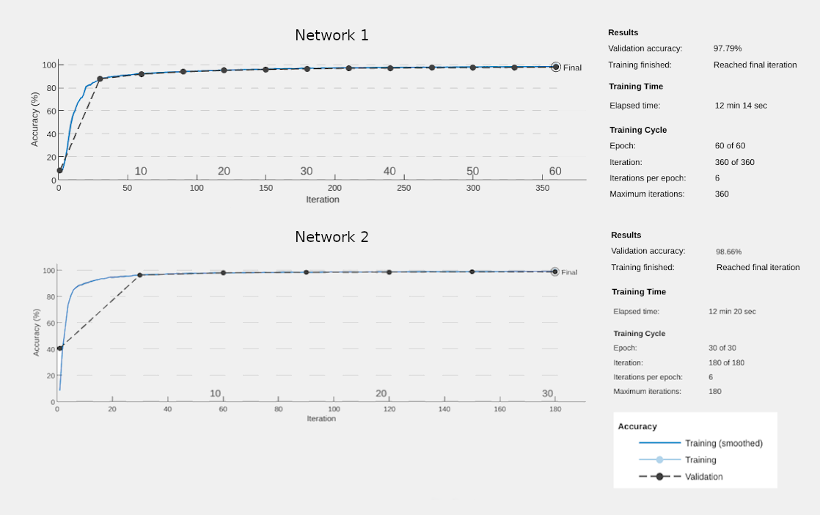

We can see that the second network reaches higher validation accuracy faster than the first network and the overall validation accuracy of the second network is better. We notice the same when we calculate the errors obtained on the training, validation and test sets:

 | Network 1 | Network 2
Training Set Error | 0.0162 | 0.0094
Validation Set Error | 0.0221 | 0.0134
Test Set Error | 0.0192 | 0.0120

The second network performs better than the first because it is deeper and this way the multiple layers can learn more intermediate features between the raw data and the high-level classification. For example the first layer will train itself to recognize very basic things like edges while the next layer will recognise collection of edges such as shapes. Thus deeper layers will learn more complicated and higher-order features.

Problem 2: Fully connected Autoencoder
Appendix A

For the first problem I wrote the following programm in MATLAB:

clear all;

exerciseNumber = 4;
[xTrain, tTrain, xValid, tValid, xTest, tTest] = LoadMNIST(exerciseNumber);

options = trainingOptions('sgdm', ...
'Momentum',0.9, ...
'InitialLearnRate',0.001, ...
'MaxEpochs',60, ...
'MiniBatchSize',8192, ...
'Shuffle', 'every-epoch', ...
'ValidationData',{xValid, tValid}, ...
'ValidationFrequency',30, ...
'ValidationPatience',5, ...
'Plots','training-progress');

layers = [
imageInputLayer([28 28 1]);
convolution2dLayer(5, 20, 'Padding', 1, 'WeightsInitializer', 'narrow-normal');
reluLayer
maxPooling2dLayer(2, 'Stride', 2);
fullyConnectedLayer(100, 'WeightsInitializer', 'narrow-normal');
reluLayer
fullyConnectedLayer(10, 'WeightsInitializer', 'narrow-normal');
softmaxLayer
classificationLayer
];

network1 = trainNetwork(xTrain, tTrain, layers, options);

trainPred1 = classify(network1, xTrain);
validPred1 = classify(network1, xValid);
testPred1 = classify(network1, xTest);

trainError1 = sum(trainPred1 ~= tTrain)./numel(tTrain);
validError1 = sum(validPred1 ~= tValid)./numel(tValid);
testError1 = sum(testPred1 ~= tTest)./numel(tTest);

fprintf('The training set error is: %.4f\n.', trainError1);
fprintf('The validation set error is: %.4f\n.', validError1);
fprintf('The test set error is: %.4f\n.', testError1);

clear all;

exerciseNumber = 4;
[xTrain, tTrain, xValid, tValid, xTest, tTest] = LoadMNIST(exerciseNumber);

options = trainingOptions('sgdm', ...
'Momentum',0.9, ...
'InitialLearnRate',0.01, ...
'MaxEpochs',30, ...
'MiniBatchSize',8192, ...
'Shuffle', 'every-epoch', ...
'ValidationData',{xValid, tValid}, ...
'ValidationFrequency',30, ...
'ValidationPatience',5, ...
'Plots','training-progress');

layers = [
imageInputLayer([28 28 1]);
convolution2dLayer(3, 20, 'Padding', 1, 'WeightsInitializer', 'narrow-normal');
batchNormalizationLayer
reluLayer
maxPooling2dLayer(2, 'Stride', 2);
convolution2dLayer(3, 30, 'Padding', 1, 'WeightsInitializer', 'narrow-normal');
batchNormalizationLayer
reluLayer
maxPooling2dLayer(2, 'Stride', 2);
convolution2dLayer(3, 50, 'Padding', 1, 'WeightsInitializer', 'narrow-normal');
batchNormalizationLayer
reluLayer
fullyConnectedLayer(10, 'WeightsInitializer', 'narrow-normal');
softmaxLayer
classificationLayer
];

network2 = trainNetwork(xTrain, tTrain, layers, options);

trainPred2 = classify(network2, xTrain);
validPred2 = classify(network2, xValid);
testPred2 = classify(network2, xTest);

trainError2 = sum(trainPred2 ~= tTrain)./numel(tTrain);
validError2 = sum(validPred2 ~= tValid)./numel(tValid);
testError2 = sum(testPred2 ~= tTest)./numel(tTest);

fprintf('The training set error is: %.4f\n.', trainError1);
fprintf('The validation set error is: %.4f\n.', validError1);
fprintf('The test set error is: %.4f\n.', testError1);
Appendix B
For the second problem I wrote the following programm in MATLAB:
% Network 1

clear all;

exerciseNumber = 4;
[xTrain, tTrain, xValid, tValid, xTest, tTest] = LoadMNIST(exerciseNumber);
numOfImages = size(xTrain, 4);
xTrain = reshape(xTrain, 784, numOfImages)./255;
xValid = reshape(xValid, 784, size(xValid,4))./255;

options = trainingOptions('adam', ...
'InitialLearnRate',0.001, ...
'MaxEpochs',800, ...
'MiniBatchSize',8192, ...
'Shuffle', 'every-epoch', ...
'ValidationData',{xValid, xValid}, ...
'ValidationFrequency',30, ...
'ValidationPatience',5, ...
'Plots','training-progress', ...
'ExecutionEnvironment', 'gpu');

layers = [
sequenceInputLayer(784);
fullyConnectedLayer(50, 'WeightsInitializer', 'glorot');
reluLayer
fullyConnectedLayer(2, 'WeightsInitializer', 'glorot');
reluLayer
fullyConnectedLayer(784, 'WeightsInitializer', 'glorot');
reluLayer
regressionLayer
];

network1 = trainNetwork(xTrain, xTrain, network1.Layers, options);
trainPred1 = predict(network1, xTrain);

layers_encode1 = network1.Layers(1:5);
layers_encode1(6) = regressionLayer;
encoder1 = assembleNetwork(layers_encode1);

layers_decode1 = sequenceInputLayer(2);
layers_decode1(2:4) = network1.Layers(6:8);
decoder1 = assembleNetwork(layers_decode1);

testDataSize = size(xTest, 4);
xTest1 = reshape(xTest, 784, testDataSize)./255;
testEnc1 = predict(encoder1, xTest1);
testDec1 = predict(decoder1, testEnc1);

save('Net1', 'network1'); % save network to resume training later

clear all;

% Network 2

exerciseNumber = 4;
[xTrain, tTrain, xValid, tValid, xTest, tTest] = LoadMNIST(exerciseNumber);
numOfImages = size(xTrain, 4);
xTrain = reshape(xTrain, 784, numOfImages)./255;
xValid = reshape(xValid, 784, size(xValid,4))./255;

options = trainingOptions('adam', ...
'InitialLearnRate',0.001, ...
'MaxEpochs',800, ...
'MiniBatchSize',8192, ...
'Shuffle', 'every-epoch', ...
'ValidationData',{xValid, xValid}, ...
'ValidationFrequency',30, ...
'ValidationPatience',5, ...
'Plots','training-progress', ...
'ExecutionEnvironment', 'gpu');

layers = [
sequenceInputLayer(784);
fullyConnectedLayer(50, 'WeightsInitializer', 'glorot');
reluLayer
fullyConnectedLayer(4, 'WeightsInitializer', 'glorot');
reluLayer
fullyConnectedLayer(784, 'WeightsInitializer', 'glorot');
reluLayer
regressionLayer
];

network2 = trainNetwork(xTrain, xTrain, network2.Layers, options);
trainPred2 = predict(network2, xTrain);

layers_encode2 = network2.Layers(1:5);
layers_encode2(6) = network2.Layers(8);
encoder2 = assembleNetwork(layers_encode2);

layers_decode2 = sequenceInputLayer(4);
layers_decode2(2:4) = network2.Layers(6:8);
decoder2 = assembleNetwork(layers_decode2);

testDataSize = size(xTest, 4);
xTest2 = reshape(xTest, 784, testDataSize)./255;
testEnc2 = predict(encoder2, xTest2);
testDec2 = predict(decoder2, testEnc2);

save('Net2', 'network2'); % save network to resume training later

