|  |  |
| --- | --- |
|  | Coursework 3 |
|  | Group 43: Mujin Li [sc20ml2], Hon lo [el19htl], Marius-Catalin Popa [sc19mcp], Konstantinos Biris [sc19kb], Sina Ghanbari Saheli [sc19sgs] . |
|  | Course Title: User Interfaces |

Course Coordinator: Tom Kelly

Table of Contents

PACT Analysis 2

Person Analysis 2

Activities Analysis 2

Contexts Analysis 2

Technology Analysis 3

Personas 3

Jason 3

Sarah 3

Scenarios 4

1st Scenario 4

2nd Scenario 4

Target Platform 4

1st Cycle 5

Prototype 5

Goal 5

Prototyping Technique and Software Used. 5

Design Motivation 5

Evidence of the Design 6

Evaluation 6

Evaluation Technique Used 6

Outcomes of the Evaluation 7

# PACT Analysis

## Person Analysis

* **Primary users:** outdoor enthusiasts, adventurers, people who love nature.

**Secondary users:** people who want to watch their personal recordings, content creators, most of them would have action cameras (e.g. GoPro), video drones (e.g. DJI Mavic).

* **Physical differences:** young people of similar age, physically athletic, majority of the user would neither have physical disabilities nor eyesight problems.
* **Psychological differences:** short attention span, fast paced lifestyles, quick learners.
* **Mental models:** familiar with technology but not technical about it, having basic or limited video editing skills, content creators might have mature editing skills.
* **Social Differences:** different languages, cultural differences.

## Activities Analysis

* **Temporal Aspects:** frequent use, used throughout the whole day, continuous use if used by serious video editors, interrupted use (dragging videos from different timelines), fast response time (app already downloaded on the user’s computer, hence no network latency, unless the user tries to upload videos on the internet).
* **Cooperation:** users work individually, little to no cooperation.

* **Complexity:** simple task (click and watch videos), well-defined (step-by-step), drag and drop videos in an order.

* **Safety critical:** misuse will not cause injury, safe to use.
* **Nature of content:** multimedia, does not require much user input, raw data from/to equipment or sensor: GoPro/DJI Mavic.

## Contexts Analysis

* **Physical Environment:** the user’s computer room, edit video during a trip: using laptop on the train or hotel/airbnb with limited internet speed/access.

* **Social and Legal Contexts:** support communities on Reddit, Twitter, Facebook may arise. If the user decided to upload a video on a platform like YouTube, then a license for the music or other contents which are not of their intellectual property, will be required to avoid having videos demonetized.

## Technology Analysis

* **Input:** mouse and keyboard.
* **Output:** physical display, audio
* **Platform:** Windows 10, Linux, Mac OS computers.

# Personas

**Background:**

20, Male

University Student, Biology

Outdoor Enthusiast

**Motivations:**

Wants to record his expeditions and show them to his friends

**Frustrations:**

Does not have much knowledge about technology.

## Jason

Jason studies at the University of Leeds and is his 2nd year of studies. He is and overachiever and highly passionate about what he is doing. He likes to spend time with his wide group of friends, who enjoy doing outdoor activities like trekking and rock-climbing but are not very much into playing videogames or reading Tech news.

Jason is also very athletic and likes watching sports on TV as well as animal documentaries. His favorite show is “Into the Wild” with Bear Grylls.

Nevertheless, he enjoys travelling and while he is not focusing on his studies, he tries to always be on the move, visiting new and exciting places in the United Kingdom and other countries.

**Background:**

26, Female

Prof. Video Editor

**Motivations:**

Make her job easier and more productive

**Frustrations:**

She is not an outdoor enthusiast herself and prefers life in the big city.

## Sarah

Sarah lives in her apartment in London with her fiancé Michael and their cat Snowball. She works in a small studio room inside her house. Hard working personality, aiming for the perfect result to please her clients and always up to date with the latest video editing trends and technologies.

When she is not working, she likes going out shopping with her friends or having a romantic dinner with Michael, but also finds pleasure in cuddling with Snowball on the sofa while watching a movie late at night.

Finally, she likes travelling to hot spot tourist destinations during the holidays, with her favorite one being Barcelona, Spain.

# Scenarios

## 1st Scenario

Michelle has just returned home from her vacation. This time last week she was to be found in the Scottish Highlands, spending some fun time trekking with her friends and her husband Josh. During their stay, she took group pictures and recorded the untamed scenery with her mobile camera. Josh also got some the aerial footage with his drone. Tomorrow, they have arranged to meet at Michelle’s house and taking this into account, Michelle will open up the “Tomeo” video player/editor on her computer. This way, she will be able to organize her video archive, combine it with Josh’ drone’s footage and make sure that no memories are lost. Unfortunately, some recordings appear to be dark or the wind is messing with the camera’s microphone, making the audio terrible. But, thanks to “Tomeo”, with just a few clicks she can fix these issues or decide to delete certain problematic videos. Finally, tomorrow night has come and the whole group gets together. After having their dinner, they all get seated in the living room with a glass of wine while Michelle connects her computer to the television. Unable to take their eyes from the screen, they start laughing, making jokes and recalling what a great they had in Scotland.

## 2nd Scenario

Jonathan works as a video editor, collaborating with a big number of professional YouTubers. One of his clients runs a channel with content around Travelling. He has asked Jonathan to edit his new video “Roaming Africa”. Jonathan knows that it will contain a great deal of outdoor footage, fast paced GoPro recording and aerial material from drones. Because he needs an application that is good at organizing vast amounts of video files and one that offers editing tools specialized for the needs of such content, he chooses “Tomeo”. Now he can be sure that with Tomeo’s capabilities and user-friendly, straightforward user interface, he will be able to complete his task quickly and leave his client satisfied.

# Target Platform

Our target platforms are Windows 10, Linux and Mac OS computers. This choice has been made by taking into account the many capabilities unlocked by the use of a mouse and keyboard as well as the fact that most people are familiar with using a computer. Also, using the above platforms enable users to spend more time using Tomeo than they would if they used their tablets or mobile phones.

# 1st Cycle

## Prototype

### Goal

The goal of this cycle is to add new features to the application’s user interface, along with the existing ones. The new features include one (1) horizontal scroller, and the following buttons:

1. Play
2. Pause
3. Video Library
4. Add Videos
5. Edit
6. Settings
7. Stream

### Prototyping Technique and Software Used.

For this Cycle, we used the “Native Protype” technique. For this purpose, we used Adobe XD and QtCreator to design and implement our prototype. This Prototyping technique was chosen taking into consideration that we possess knowledge on programming. That said, it would be faster for us to build our Prototype using this technique compared to the other ones. It would also give us hands on experience with our production tools, thus making the creation of the application later on much easier.

### Design Motivation

This design compared to the first version of Tomeo contains a lot of changes both visually and functionally. Dark colours tend to be less tiring to the eyes as well as help the user concentrate on the playing video. Also, the being able to pause/play videos is vital for any video player application. Finally, extra features like “edit”, “add video” and “stream” will make it easier to manipulate videos and also prove useful to professional video editors using “Tomeo”.

### Evidence of the Design

## Evaluation

### Evaluation Technique Used

We decided to conduct our research into how well the first prototype was received in the form of a questionnaire. It would not have been wise for us to expect the average person to be able to set up and run the Tomeo prototype from their own end and due to the restrictions caused by COVID-19, we were not able to invite a test group of people, for them to use the software. To bypass this, we utilised “Teamviewer” in order for them to remotely use the software. Immediately following their use, a questionnaire form was sent to them to be filled out, containing a range of questions. We conducted this process on a sample size of 30+ people, with ranging abilities in regards to using computers, in order to get a more realistic and accurate set of results.

The reason behind using a questionnaire approach was to cement the teams confidence behind implementing certain aspects of the prototype, such as, whether or not the coding team should go through the effort of adding a “Time Bar”, as there would be no point in going to such lengths, only to realise that it wouldn’t be a desired feature. Furthermore, it also helped to make sure our prototype had the right foundations in place, for example, in terms of colour schemes, or just plain first impressions, as these seemingly simple things can impact a user’s experience surprisingly heavily.

### Outcomes of the Evaluation

The following results firstly let us know that our foundations are received well by the test group. This can be seen due to the overwhelmingly positive reaction (86.7%) to our primary colour, which is already black. Moreover, the colour of our video controls also seem to be accepted. We went in with the video control colour design wanting a colour that pops out to the user, whilst also not looking out of place, and the colour we went with, purple, was seen as the best option by 86.2% of the users.

Our most contested result was whether the play/pause video control buttons should be merged or not. This was not seen as a priority at the beginning, but due to how close the results are, it may be something we look to adjusting in the final stages.

Three questions that we believed were significant to the structure of the prototype were whether the prototype looks visually adequate at all window sizes, if it was easy to navigate and if it represents its intended purpose at a glance. Although all three had positive results, they weren’t overwhelming majorities, so that shows there is still doubt. We aim to improve these 3 results in particular for prototype at the end of the second cycle.

Finally, the target audience in our eyes, despite being varied, is primarily people who are casual video enthusiasts, such as adventure seekers and nature lovers, who would like to see and alter their own personal recordings. This seems to be represented by the feedback we have received, but it is also a positive to have people believe that the application could be used by more advanced audiences, as it gives our prototype more versatility and a bigger reach.

### Evidence of the Evaluation

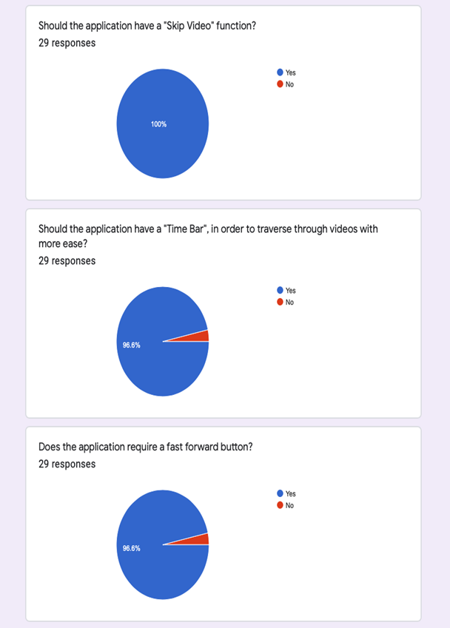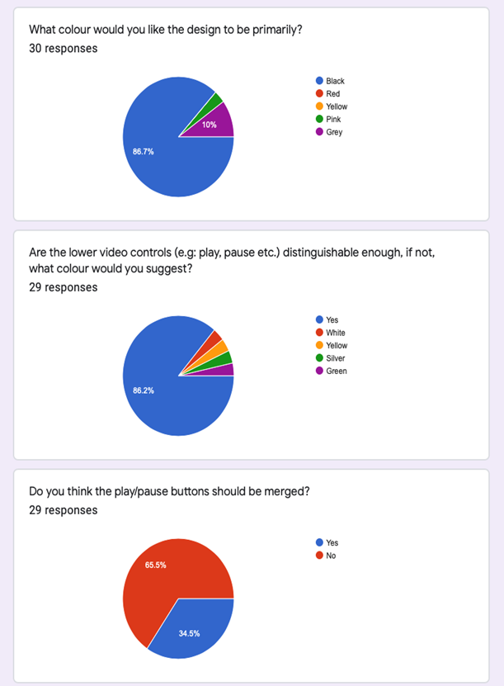

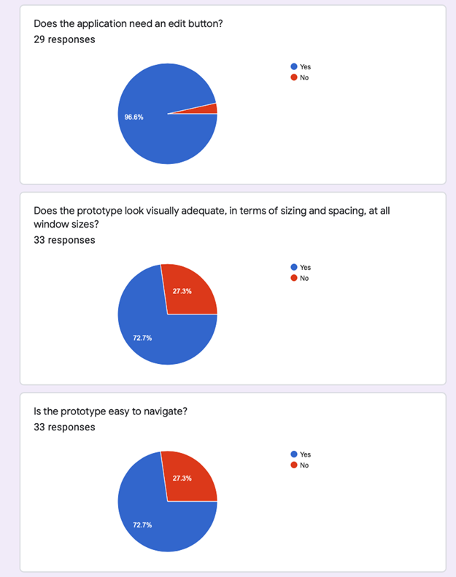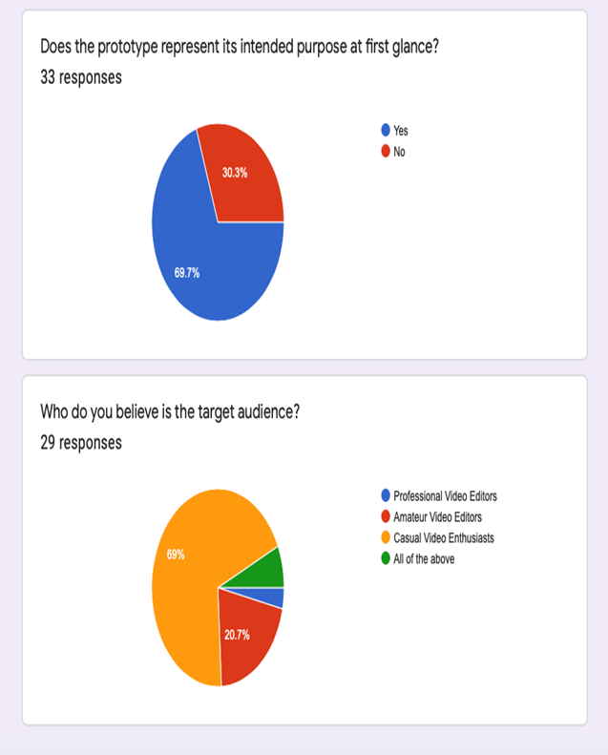

## Code

### Video

(To be added)

### GitLab Repository Link

<https://gitlab.com/mintman/UI-Coursework-3/-/tree/master/Prototype_2_with_Tomeo>

# 2nd Cycle

## Prototype

### Goal

The goal of this cycle is to implement some of the features so that they can function properly. Also, it is within our plan to add two horizontal scrollbars from where the user can adjust the volume of the video and also its timeline.

### Prototyping Technique and Software Used.

For this Cycle, we used the “Native Protype” technique. For this purpose, we used QtCreator to design and implement our prototype based on the one produced during the 1st Cycle. Again, this Prototyping technique was chosen because it is faster for us to build our Prototype using “Native Prototyping” and also gives us hands on experience with our production tools, hence making the creation of the final product much easier and well organized.

### Design Motivation

This design compared to the 1st Cycle does not contain many changes in terms of visual appearance. It has proven that our design pattern appears to be satisfactory among our users so instead we only wished to focus on the more technical and functional aspects of “Tomeo”.