|  |
| --- |
| [Web Development Resit] |

[Kostandin Toci] | [CSY1018] | [30/4/2017]

We had to do an essay that include 4 pages index.html, bio.html, collection.html and contact.html

and to upload them to Github(KostasLeon/KostasLeon.github.io).

In the creation of the website I had many difficulties but my hardest think to do was the contact page.I couldn't do the label but after an hour

I went to W3school because I couldn't do alone.After was the position

of the photographies in the collection page, that 2 was my worst difficulties.

After I make the website we should pass our pages from the validator (<https://validator.w3.org/>) for the html5 pages and the css file (<https://jigsaw.w3.org/css-validator/>) and to show some screenshot.

The first screenshot is from Home index.html page:

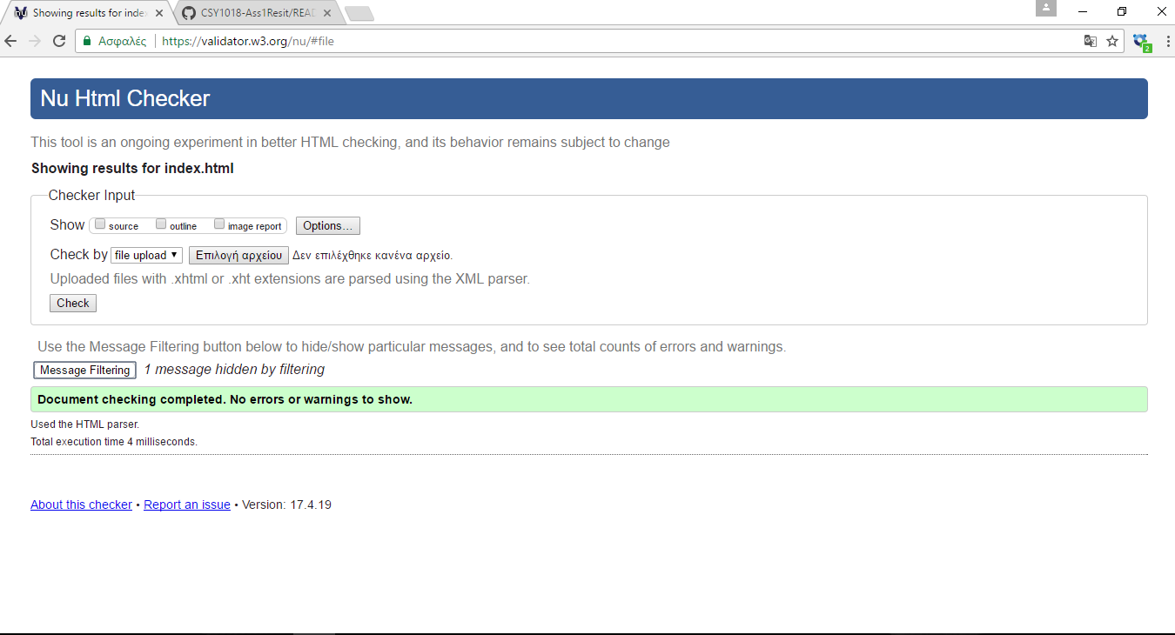

The screenshot is from Biography bio.html:

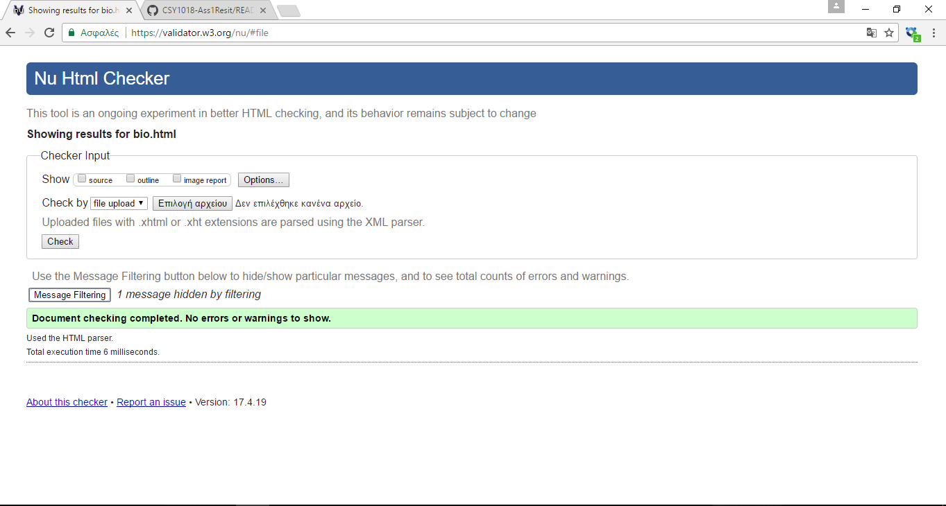

The screenshot is from Contact contac.html,i had some errors here but in the in end

I done it.

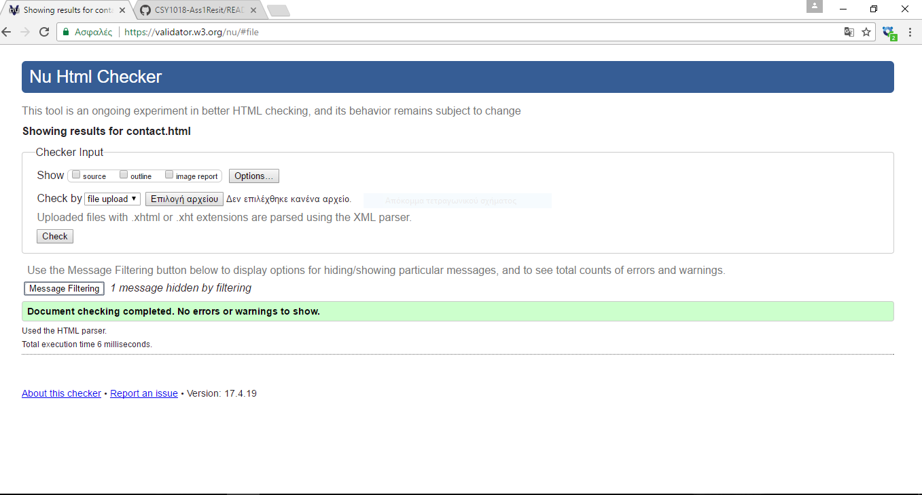

And the last is Collection collection.html page:

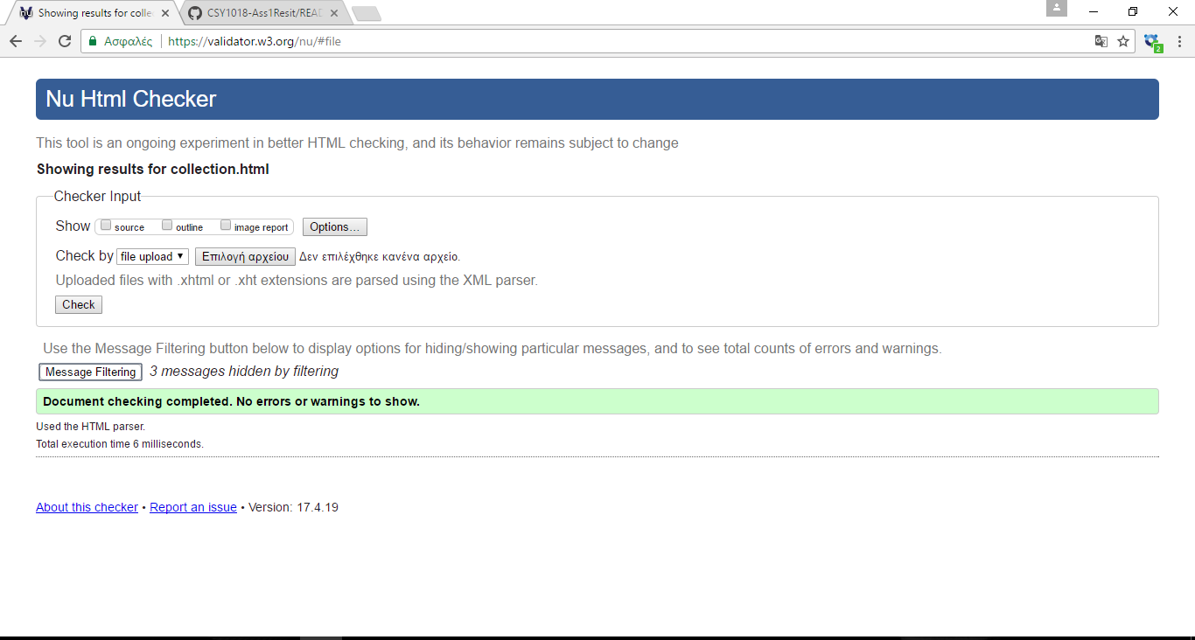

Now is CSS turn style.css

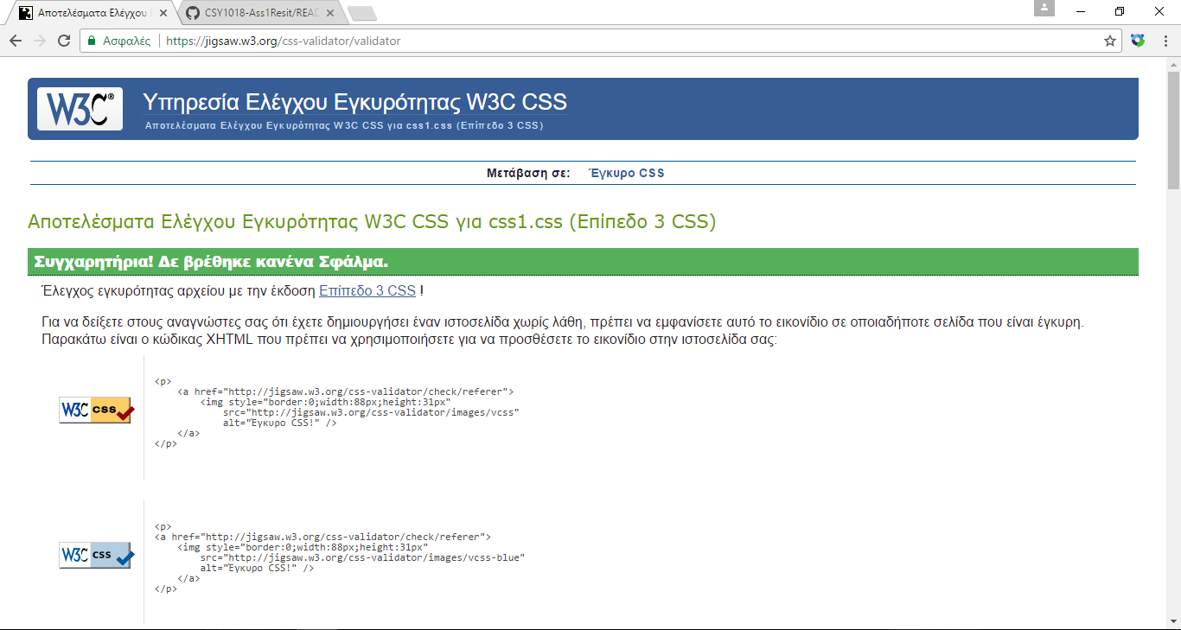

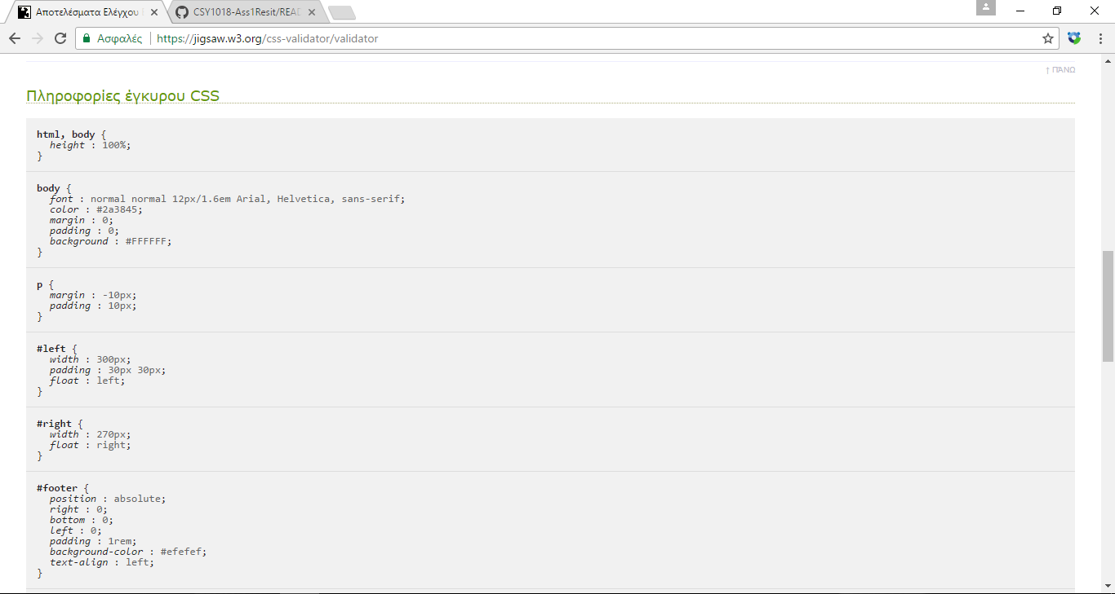

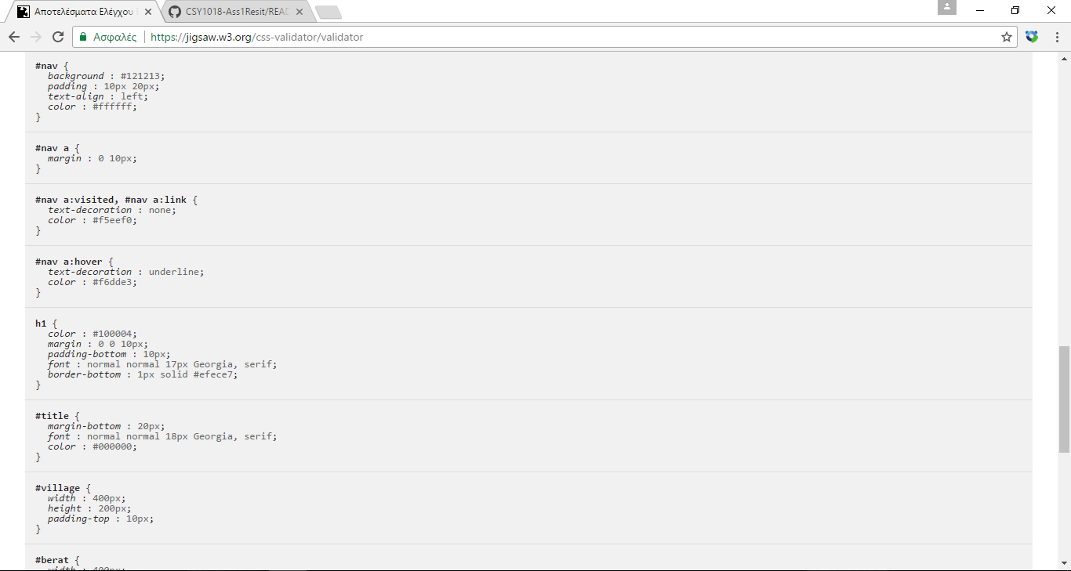

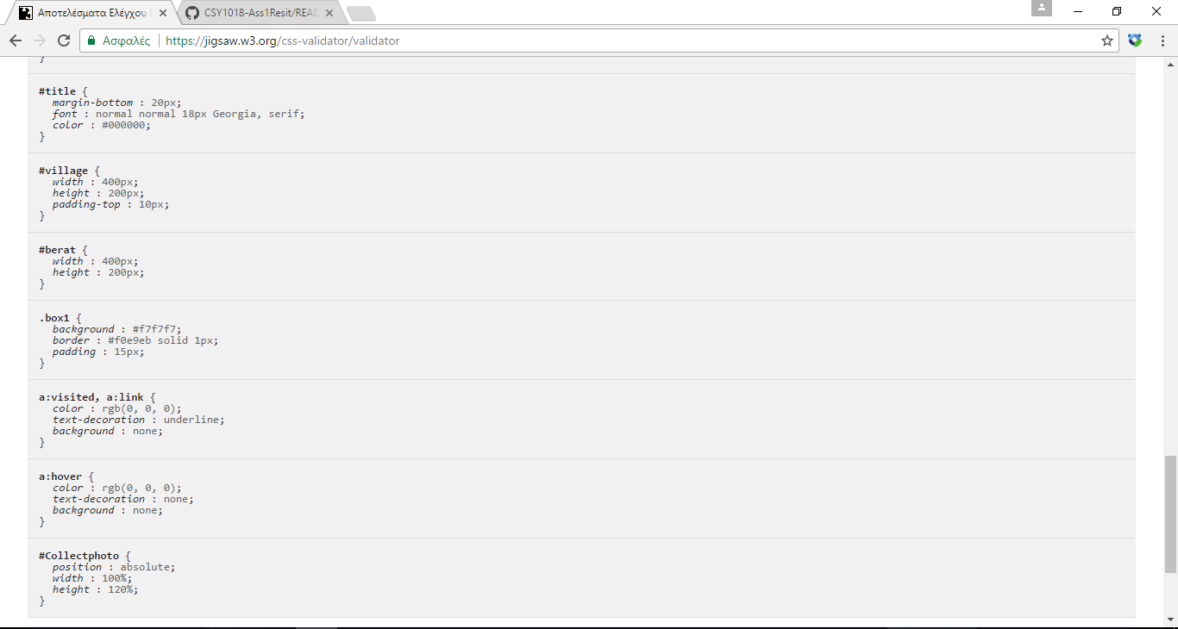

I spend a week of work to achieve the website it was an good essay because i learn

Some new thinks about web development.

References:

I take help only from W3schools.

https://www.w3schools.com/