**Table of Contents**

Introduction

Hardware Setup

Installing MicroPython Firmware

Running the MicroPython Script

Retrieving Logged Readings

Conclusion

**1. Introduction**

This guide provides detailed instructions for prototyping an IoT rig using a Huzzah32 Feather microcontroller and an OLED Featherwing display. The IoT rig will be capable of logging sensor data and displaying it on the OLED screen. The guide covers hardware setup, installation of MicroPython firmware, running a MicroPython script for data logging, and retrieving the logged readings.

[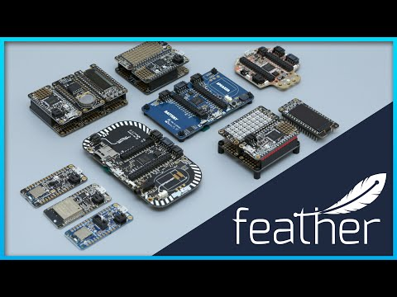](https://www.youtube.com/embed/W9jjgKaE1_k?feature=oembed)

**2. Hardware Setup**

Components Required:

*Huzzah32 Feather microcontroller*

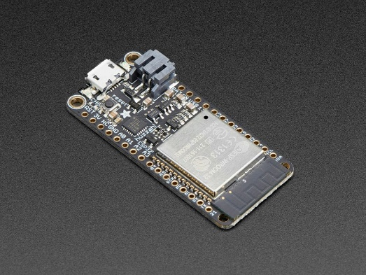

*OLED Featherwing display*

Jumper wires

**Steps:**

Connect the Huzzah32 Feather to the OLED Featherwing using jumper wires. Refer to the pinout diagram for correct connections.

Ensure that the connections are secure and there are no loose wires.

Power on the Huzzah32 Feather using a suitable power source.

**[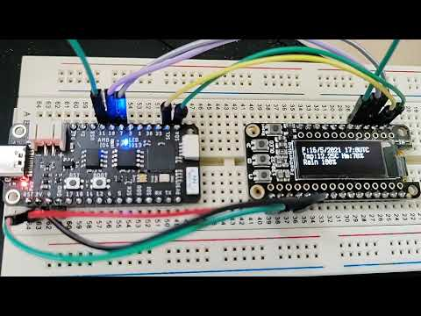](https://www.youtube.com/embed/N26DCrZLNB0?feature=oembed)**

**3. Installing MicroPython Firmware**

**Steps:**

Download the latest MicroPython firmware for the Huzzah32 Feather from the official MicroPython website.

Connect the Huzzah32 Feather to your computer using a USB cable.

Put the Huzzah32 Feather into bootloader mode by pressing the "BOOT" button.

Flash the MicroPython firmware onto the Huzzah32 Feather using a tool like esptool.py.

Once the firmware is flashed successfully, the Huzzah32 Feather will restart automatically.

**Tutorial:**

https://docs.micropython.org/en/v1.11/esp32/tutorial/intro.html

**4. Running the MicroPython Script**

**Steps:**

Write or download the MicroPython script for data logging onto the Huzzah32 Feather.

Connect to the Huzzah32 Feather using a serial terminal emulator like PuTTY or minicom.

Upload the MicroPython script to the Huzzah32 Feather using the serial terminal.

Run the MicroPython script on the Huzzah32 Feather to start logging data from sensors.

Monitor the OLED Featherwing display for real-time data visualization.

**5. Retrieving Logged Readings**

**Steps:**

Connect the Huzzah32 Feather to your computer using a USB cable.

Access the filesystem of the Huzzah32 Feather from your computer.

Locate the log file containing the logged sensor readings.

Copy the log file to your computer for further analysis or processing.

**6. Conclusion**

Congratulations! You have successfully prototyped an IoT rig using a Huzzah32 Feather microcontroller and an OLED Featherwing display. You can now explore various applications of IoT and sensor data logging using this setup. For further experimentation, consider adding more sensors or integrating with cloud platforms for data analytics.