**Guide to Running the Desktop Application for IoT System**

**Purpose:**

This guide provides step-by-step instructions for running the desktop application for your IoT system. It also explains how to retrieve the logged readings from the IoT system into the desktop application for visualization and analysis.

**Step 1: Download and Install the Desktop Application**

Navigate to the download link provided for the desktop application.

Download the application installer compatible with your operating system (Windows, macOS, or Linux).

Run the installer and follow the on-screen instructions to complete the installation process.

**Step 2: Launching the Desktop Application**

Locate the installed desktop application icon on your computer.

Double-click the icon to launch the application.

**Step 3: Connecting to the IoT System**

Ensure that your IoT system is powered on and connected to the same network as your computer.

In the desktop application, navigate to the "Connection" or "Settings" menu.

Select the option to connect to the IoT system.

Enter the required connection details such as IP address, port number, or device ID, as applicable.

Click the "Connect" button to establish a connection to the IoT system.

**Step 4: Retrieving Logged Readings**

Once connected, navigate to the "Data Retrieval" or "Logs" section of the desktop application.

Choose the time period or specific data logs you wish to retrieve from the IoT system.

Click the "Retrieve" or "Sync" button to initiate the data retrieval process.

Wait for the application to fetch the logged readings from the IoT system.

**Step 5: Visualizing and Analyzing Data**

After the data retrieval process is complete, navigate to the "Visualization" or "Analysis" section of the desktop application.

You will see a graphical representation of the retrieved data, such as charts, graphs, or tables.

Use the interactive features of the application to analyze the data further, such as zooming, filtering, or exporting.

**Step 6: Understanding Application Outputs**

Take screenshots of the various screens and visualizations within the desktop application.

Include annotations or descriptions explaining what each screenshot depicts, such as the type of data displayed, time range, and any notable trends or patterns observed.

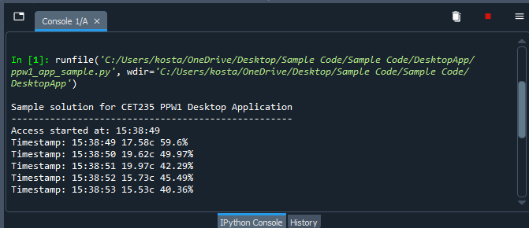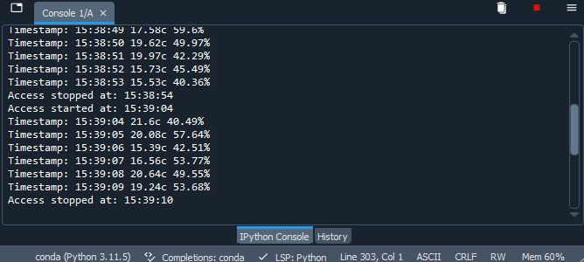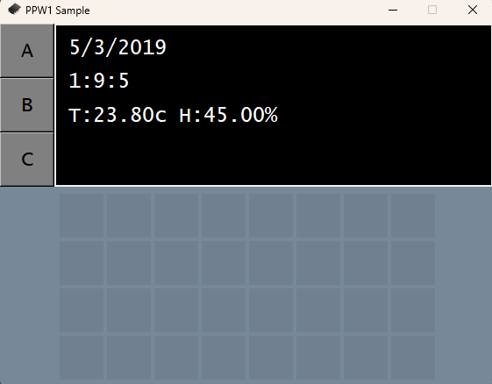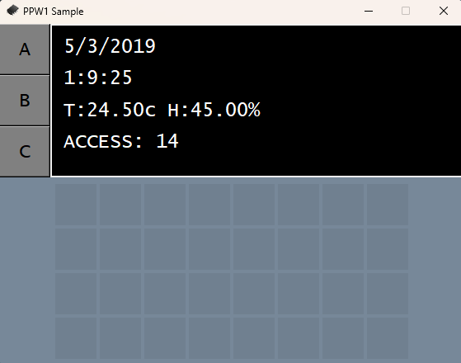

**Step 7: Saving and Exporting Data**

If desired, save the retrieved data or analysis results within the desktop application.

Use the application's export feature to save data in a format compatible with other tools or software, such as CSV, Excel, or PDF.

**Conclusion:**

By following this guide, you will be able to effectively run the desktop application for your IoT system, retrieve logged readings, visualize and analyse data, and understand the outputs generated by the application.