Problem Chosen  F | 2023  MCM/ICM  Summary Sheet | Team Control Number  2308685

G + GDP Problem
Summary
GDP is an essential indicator to measure the economic health of a country. However, it does not consider the impact of economic development on environmental hazards and resource consumption. GGDP is proposed as a new indicator to stimulate governments to adopt specific environmental protection measures.
Our team analyzed several primary accounting methods for GGDP and decided to synthesize them to build our model.
A country's economic health should reflect its financial strength and the extent to which it uses and protects its natural resources. Therefore, our team developed a reliable model and utilized the GGDP to assess the fiscal health of countries with the hope that governments will adopt policies to mitigate the impact of economic development on the global climate. To measure the financial health of each country's system, we selected raw data on five critical factors for 50 countries from 2010 to 2020. We then validated the data distribution patterns and selected the 80% quartile as the healthy range for each indicator. We used analytic hierarchical process (AHP) to determine the weights of each hand. Finally, we introduced the concept of the Economic Health Index (EHI) concept, which represents an economy's actual health. We also use Markov chains to predict the future global climate impact of flexible government policy measures to promote GGDP growth after GGDP replaces GDP. To measure the effect on global climate, we use the achievement of the GHG emissions and energy consumption targets agreed upon by countries in the Paris Agreement.
We proposed and tested four hypotheses for GGDP to replace GDP based on the principle that something new must replace something old, and all of them passed. This proves that it is inevitable that GGDP will replace GDP as the new standard and that the relative valuation of GGDP is higher. In addition, our model has three new features: stability, rewarding and penalizing. For large economies, the ranking trend becomes more moderate; for small economies with a relative advantage in natural resources, the ranking increases in a rewarding manner; and for economies whose pursuit of economic growth leads to natural resource misuse, the size decreases in a punitive way. The model is then evaluated for its strengths and weaknesses in climate mitigation based on our analysis of global climate impacts. Our main advantage is that climate mitigation is no longer the sole responsibility of developed or developing countries, promoting cooperation among countries worldwide and accelerating the pace of climate mitigation. Our main disadvantage is that we need a buffer time to achieve the GGDP standard, we cannot assume immediate global adoption of the GGDP standard based on reality, and we need a long-term joint effort to achieve climate mitigation.
We conducted an in-depth analysis of India, based on our model, to measure the country's current economic health. We find a problem of natural resource misuse behind India's high-growth economy, for which we propose a vision for future development and examine the sustainability of economic health by building a DEA-Malmquist model. Finally, we wrote a non-technical report to recommend that the leaders of India take GGDP as a new standard to measure economic health.

Key words: GGDP, AHP, the Paris Agreement, Markov chain, K-S test, DEA-Malmquist
Contents
I. Introduction 3
1.1 Background 3
1.2 Our works 3
II. Basic assumption 4
III. Symbol 4
IV. Models 5
4.1 Analysis and Solving of Question One 5
4.1.1 Concept of GGDP 5
4.1.2 Accounting Method Filtering 5
4.1.3 Confirm our method 6
4.2 Analysis and Solving of Question Two 6
4.2.1 Main Factors 6
4.2.2 Data Selection 7
4.3 Models for GGDP and Climate 8
4.3.1GGDP Health Model 9
4.3.2 Determine the Weight of Indicators 9
4.3.3 Select Health Range 11
4.3.4 Diagnosis of Health Conditions 13
4.3.5 Climate Model Realized by Using Markov Chain 14
4.3.6 The Paris Agreement 15
4.3.7 Climate Impact Timeline 15
4.4 Models Influence Analysis 16
4.4.1 Development Direction Analysis 16
4.4.2 Relevance Analysis 17
4.4.3 Superiority Analysis 17
4.4.4 Adaptability Analysis 18
4.5 Impact on Climate Analysis 18
4.5.1 Advantages 18
4.5.2 Disadvantages 19
4.6 The Impact of the Transition on India 19
4.6.1 Economic Health Diagnostic 19
4.6.2 Our Vision 19
4.6.3 Our Sustainability Analysis with DEA-Malmquist Model 20
V. Evaluation and Promotion of Model 22
5.1 Strengths 22
5.2 Weaknesses 22
VI. Policy Recommendations 23
VII. References 24

I. Introduction

1.1 Background
Environment and ecology are part of a country's comprehensive economy. The current national economic accounting system needs to reflect its financial situation entirely, but it does not include environmental and ecological factors. A series of apparent flaws in GDP statistics have not been corrected for a long time. GGDP is an adjustment to the GDP index, which is the gross domestic product after deducting the cost of resources and environment invested in economic activities.

Under the new situation, each Country should accelerate the research and application of GGDP to provide necessary data support for the implementation of the scientific concept of development. To seize the high ground of future global economic development, governments of various countries have sought the path of green development. The green economy will lead to a new international economic pattern in the foreseeable future.

1.2 Our works

In order to deal with the situation, we have completed the following tasks.

• Our team analyzed several major accounting methods for GGDP and decided to synthesize them to build our model.

• We developed an economic health model and selected raw data on five key factors for 50 countries from 2010 to 2020. By validating the distribution pattern of the data and selecting the 80% quartile as the health range for each indicator, an analytic hierarchical process (AHP) was used to determine the weights of each indicator. Finally, we introduced the concept of Economic Health Index (EHI) and use Markov Chains to predict the future climate impact of flexible government policy measures based on the Paris agreement.

• According to the principle that "new things must replace old things," we put forward and tested the four assumptions that GDP should replace GDP, and all passed. In addition, we found that our model has three new characteristics: stability, rewarding, and penalizing. It has different impacts on different types of economies. Then, based on our analysis of the global climate impact, the advantages and disadvantages of the model in climate mitigation are comprehensively evaluated.
• We have conducted an in-depth analysis of India. By measuring the country's current economic health, we have found the problem of natural resource abuse behind India's high-growth economy. For this reason, we have put forward a vision for future development and studied the sustainability of economic health by establishing the DEA-Malmquist model. Finally, we wrote a non-technical report to recommend that the leaders of India take GGDP as a new standard to measure economic health.

II. Basic assumption

To enable the model to reflect a country's economic health through GGDP accurately, we draw inspiration from the health assessment method of the medical system and make the following assumptions.
- The statistics we collect from our website are accurate and reliable.

- The general health of the economy is related only to our assessment indicators.

- The indicators we chose have the same distribution pattern as the economy's population, so we can estimate the overall situation from our sample.

- Similar to the medical examination indicators, there is a specific interval to determine whether the indicator values are healthy or not.

5. Some indicators will not be affected by the implementation of GGDP in a certain period of time and can be considered as invariant.

III. Symbols
Symbols | Definition
Iij | Input metrics for continuity analysis
Oij | Ouput metrics for continuity analysis
EHI | Economic health index
{pi} | 0-1 cohort of performance health status
PIE | Policy implementation effect
BU | Buffer for modeling parameters
DCH | Difference between current value and healthy value

IV. Models

4.1 Analysis and Solving of Question One
4.1.1 Concept of GGDP

The green gross domestic product (green GDP or GGDP) is an index of economic growth with the environmental consequences of that growth factored into a country's conventional GDP. Green GDP monetizes the loss of biodiversity and accounts for costs caused by climate change.

4.1.2 Accounting Method Filtering

• GGDP
GGDP accounting consists of three components: gross domestic product, environmental degradation cost, and ecological damage.
(1) Environmental degradation cost: air pollution, water pollution, and soil pollution can lead to environmental degradation. The price of environmental degradation caused by air pollution mainly includes the cost of air pollution treatment and the increase in living and cleaning costs.
(2) Cost of ecological damage. The cost accounting of environmental damage in the basin mainly focuses on the loss of ecological regulation services caused by humans' unreasonable use of forests, grasslands, wetlands, farmlands, and other ecosystems.
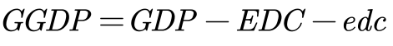
EnDC is the environmental degradation cost, EnDCa is the environmental degradation cost of air pollution. EcDCw is the environmental degradation cost of water pollution, EnDCs is the cost of soil pollution and environmental degradation, EcDCf is the damage loss of forest ecosystem, EcDCg is the damage loss of grassland ecosystem, EnDCw is the damage loss of wetland ecosystem, and EcDCa is the damage loss of farmland ecosystem.
• GeGDP
The value of GGDP is smaller than that of GDP, that is, the value of GeGDP^{[1]} is equal to subtracting the following two values on the basis of the current GDP accounting value: one is called "resource depletion cost", the other is called "environmental degradation cost".
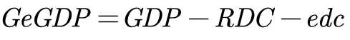
• MEWGDP
MEWGDP is a model that measures annual real household consumption, called the Measure of Economic well-being. MEW adjusts GDP to include the value of leisure time, unpaid work and environmental damage. The values of the Ministry of Sustainable Water and Power (MEW-S)^{[2]}, whose work is a precursor to more complex sustainable development measures, are also defined.
4.1.3 Confirm our method
In summary, our team analyzed several major accounting methods for GGDP and decided to combine them to build our model.
4.2 Analysis and Solving of Question Two
4.2.1 Main Factors

To achieve the replacement of GDP with GGDP as the primary measure of the country's economic health, we need to make a new and reasonable assessment of the actual state of the country's economy, and we need to consider not only GDP as the primary indicator, but also to judge its impact on natural resources and climate. Similar to the definition of physical health, the health of a system refers to its ability to function correctly and to respond to external changes. A healthy national economic system not only has the function to indicate its financial strength but also to repair and renew itself according to the changes in natural resources and climate and to act back on them to achieve sustainable development of resources.
Based on the above definition, we have developed five factors to measure the economy's health after considering the use of natural resources, which are described below.

• Heart
Gross Domestic Product (GDP) is the final result of the production activities of all resident units in a country (or region) over a certain period. It has long been recognized as the core indicator of national economic accounting and an essential indicator of a country's or region's financial status and development. In our new economic system, it deserves to occupy the heart position.

• Resource
Resource is an evaluation of the level of natural resource holdings in different countries. Its content is vibrant, and we have chosen four indicators to describe it: total freshwater, agricultural land, forest coverage, and land and sea area. The development of society and the progress of science and technology require the development and use of more and more natural resources. This indicator allows for determining the maximum total amount of natural resources available to the country.

• Expense
Expense is a comprehensive assessment of national resource consumption in each country, which is described as seven indicators: loss of fixed capital, agricultural value-added, use of renewable energy, energy depletion, mineral depletion, forest depletion and population density. Fixed capital is the loss in use value and value caused by the use of resources in production and processing and the impact of natural forces. Agricultural value-added is the value added by agricultural, forestry, and fishery production. The use of renewable energy is the value added by the use of renewable energy. The use of renewable energy reflects the development of renewable energy sources and the efforts made by the country in the sustainability of resources; energy depletion, mineral depletion, and forest depletion are the three significant resource losses in the country's economic development. Population density is a reflection of the use of land resources.
• Emission
Emissions are a count of national contributions to global climate change in each country. According to the Kyoto Protocol, greenhouse gas emissions profoundly impact global climate change, and we have selected the emissions of six gases (CO2, CH4, N2O, HFCs, PFCs, SF6), which are subject to emission limits, as the total greenhouse gas emissions. In addition, with the increase in air pollution, PM2.5 not only becomes a significant factor affecting global climate but also endangers human life and health.

• Diversity
Diversity is a measure of the national biological resources of each country. Biological resources are a valuable asset given by nature to each country. Following the UN Millennium Development Goals, we have selected the area of the reserve and the red list index^{[3]} indicators to assess biodiversity.

4.2.2 Data Selection

We used the same dataset but different evaluation methods to evaluate health status and climate impacts. To assess health status, we will calculate the data weights and list the leading indicators, thus constructing a confidence interval similar to the pathology test.
The approach to assessing climate impacts is slightly different. We use the carbon reduction target agreed upon in the Paris agreement^{[4]} as a measure of global climate change, divided explicitly into global greenhouse gas emissions and global energy consumption over the next 50 years after adopting the GGDP standard.
Below is a table of selected indicators. The letter 'P' in the Impact column indicates that the indicator positively impacts GGDP. ' N' refers to the opposite. Specific indicators can have a negative effect on the results when they are too high or too low.
When they are too high or too low, they can negatively affect the results, so we assign them the letter 'M'.
Table 1: Economic health indicators
Factor | Indicator | Symbol | Unit | Impact | D.S
Heart | GDP | 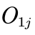 | $ | M | a
Resource | Total fresh water | 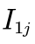 | Kg | P | a
Resource | Agricultural land | 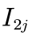 | % | P | b
Resource | Forest coverage | 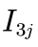 | % | P | a
Resource | Land and sea area | 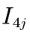 | % | P | c
Resource | Loss of fixed capital | 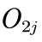 | $ | N | a
Expense | Agricultural value-added | 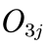 | $ | P | c
Expense | Use of renewable energy | 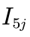 | Kt | P | b
Expense | Energy depletion | 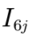 | Kt | N | a
Expense | Mineral depletion | 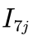 | Kt | N | a
Expense | Forest depletion | 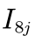 | Kt | N | a
Expense | Population density | 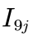 | % | M | b
Emission | Greenhouse gases | 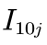 | Kt | N | a
Emission | PM2.5 in air | 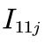 | % | N | a
Diversity | Area of the Reserve | 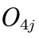 | % | P | b
Diversity | Red list index | 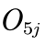 | - | P | d
Note: D.S. is the abstract of data source. D.S. a is collected from World Bank World Development Indicators [4]. D.S. b is collected from the OECD. D.S. c is collect from ourdatainworld.org [6]. D.S. d is collect from IUCN.

Considering hypotheses 3 and 4 and that the main contributors to climate impacts tend to be countries that are more developed in the economy or natural resources, we surveyed a random sample of these countries for their indicators from 2010 to 2020. The selected example of 50 is shown below.
Table 2: Countries we selected
Countries | 1 | 2 | 3 | 4 | 5
1 | Argentina | Czech Republic | Ireland | New Zealand | South Korea
2 | Australia | Denmark | Israel | Norway | Spain
3 | Austria | Egypt | Italy | Pakistan | Sweden
4 | Belarus | Estonia | Japan | Philippines | Switzerland
5 | Belgium | Finland | Kazakhstan | Poland | Thailand
6 | Brazil | France | Lebanon | Portugal | Turkey
7 | Canada | Germany | Malaysia | Russia | Ukraine
8 | Chile | Greece | Mexico | Saudi Arabia | United Arab Emirates
9 | China | India | Mongolia | Singapore | United Kingdom
10 | Colombia | Indonesia | Netherlands | South Africa | United States

Here is a map showing the countries we have chosen.

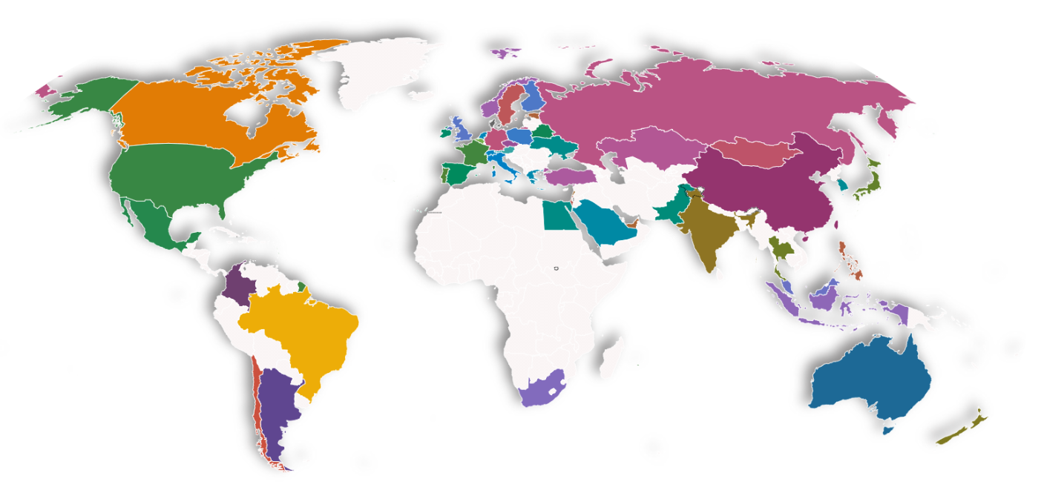
Figure 1: Map for countries we selected

4.3 Models for GGDP and climate

In this section, we build a GGDP health model and a climate impact model^{[5]} of a country's economy. Using these two models, we can perform a medical examination and diagnosis of each country's health and climate impacts. We can describe this process in the following diagram.
4.3.1 GGDP Health Model

During a physical examination, the doctor usually checks the patient's various indicators and determines whether they are within the normal range. Determine whether they are within the normal range or not. These indicators have different weights, and those with larger weights have a greater impact on health status, while those with smaller weights have a relatively smaller impact, and we use a similar approach to measure the health status of the economy. Based on the previous assumptions, we determine the corresponding health range^{[6]} of each indicator and use the Analytic Hierarchy Process to determine the weight of each indicator. Through these analyses, we will give the overall health and the health of each factor.

4.3.2 Determine the Weight of Indicators

The primary method we used to determine the weights was the analytical hierarchy process.
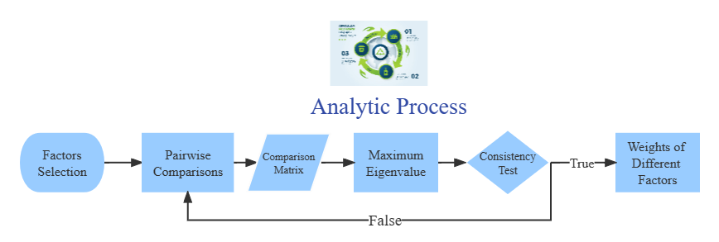
Figure 2: Our analytic process

Analytic Hierarchy Process (AHP) is an accurate approach for quantifying the weights of decision criteria, widely used in different decision situations, in fields like government, business, healthcare, shipbuilding, industry and education [8]. In our analysis, we use this method to determine weights of different main factors. Similarly, we determine the weights of different indicators in each factor. The following are the steps.

• Factors selection

We have selected several main factors previously. For each main factor, we have chosen some indicators as well.

• Pairwise comparisons between different factor

According to pairwise comparisons, we establish priorities among the factors. We think that the importance of main factors satisfies the following relationship:

• Calculation of comparison matrix

With the relationship discussed before, we get our comparison matrix 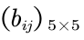
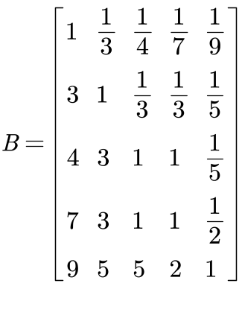
Where Fi for i = 1, 2, · · · , 5 represent heart, resource, expense, emission, diversity respectively.

• Consistency Test

We can calculate the eigenvalues and eigenvectors of the matrix before. Next we need to perform consistency test with the maximum eigenvalue 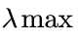.
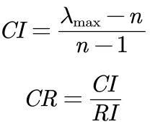

According to the calculation above, CR of the judgment matrix is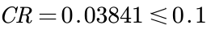, thus the comparison matrix is acceptable.

• Calculation of weights Passing the consistency test

we can get the weights of main factors by the eigenvector corresponding to the maximum eigenvalue, they are as follow: heart(0.4892), resource(0.2209), expense(0.1709), emission(0.0816), diversity(0.0374).

Using the same method, we obtain the weights of the different indicators for each factor, as shown in the figure below.
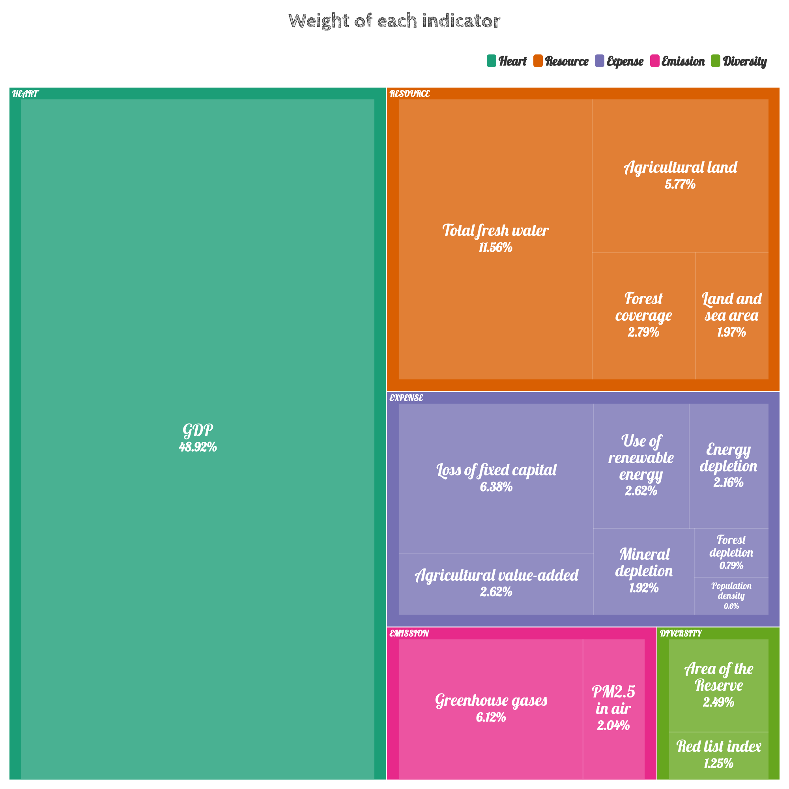
Figure 3: Weight of indicators

The weighted analysis allows us to obtain the ranking of each indicator by weight. The top-ranked indicators are called primary indicators, which considerably impact overall health. The more down-rated indicators are called secondary indicators, which have little impact on overall health, but we cannot ignore their cumulative effect.

4.3.3 Select Health Range

We fixed the economic health ratio by analyzing the GDP rankings overtime at 0.8. This suggests that 80% of the economic population is healthy. Based on these assumptions, We developed the following principles for selecting health ranges.

• Positive indicators
The sample data from the highest to the lowest 80% quartile were selected as the estimators of the overall lower limit.

• Negative indicators
The sample data from the low to the high 80% quartile was selected as the estimator of the overall upper bound.

• Interval Indicators
Estimate the distribution pattern of the population through the sample and determine the
intervals.

We found the range of health corresponding to the easy positive and negative indicators. Hence, the distribution pattern of the interval indicators needs to be considered: GDP and population density. By plotting the frequency histograms of these two indicators, we found that they have a pattern similar to the normal distribution. To test this conjecture, we tested these two indicators with SPSS using the Kolmogorov - Smirnov (K-S) test^{[7]}. Due to space limitations, we will not discuss the detailed principles of the K-S test here. Instead of discussing it here, only the results are shown.

At the significance level α = 0.05, we obtained the following results of the K-S test for both indicators. Since the significance levels of both hands are higher than α, we can conclude that they both pass the K-S test.

Table 3: Single sample Kolmogorovs-Minov test
 |  | Population density |  | GDP
abs |  | 50 |  | 245
Normal parameter | Average value |  | 4.3942 |  | 25.2529
Normal parameter | SD |  | 1.53211 |  | 2.99909
Extreme difference | Absolute value |  | 0.1 |  | 0.06
Extreme difference | Positive value |  | 0.084 |  | 0.06
Extreme difference | Negative value |  | -0.1 |  | -0.033
Inspection statistic |  | 0.1 |  | 0.06
Progressive significance(bilateral) |  | .200 |  | 0.031

Below is the Q-Q plot of the two data to verify the correctness of the results. We can see that the data points of both data are distributed near a straight line, and the results of the K-S test are acceptable.
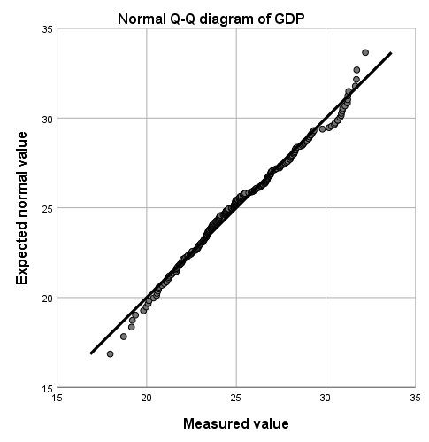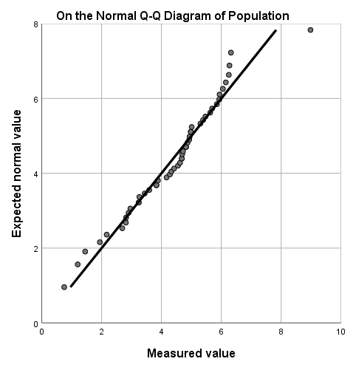
Figure 4: Q-Q diagram of GDP Figure 5: Q-Q diagram of Population density

Therefore, we can give the acceptable health range for both in terms of normal distribution.

Table 4: Weights of Indicators
Indicator | Upper Bound | Lower Bound
GDP | 1.67E26 | 2.38
Total fresh water | - | 11.34
Agricultural land | - | 20.46
Forest coverage | - | 12.59
Land and sea area | - | 5.06
Loss of fixed capital | 2.4E11 | -
Agricultural value added | - | 4.61E9
Use of renewable energy | - | 1.22
Energy depletion | 1.6E10 | -
Mineral depletion | 3.06E9 | -
Forest depletion | 9259307 | -
Population density | 84.55 | 62.91
Greenhouse gases | 644558 | -
PM2.5 in air | 27.96 | -
Area of the reserve | - | 16.96
Red list index | 1 | 0.78

4.3.4 Diagnosis of Health Conditions

We use a simple acceptance/rejection model (0-1 model) to determine the health conditions. The overall health condition can be measured with point gain and the occurring problem can be located. For each indicator i, if the value falls in the range of GGDP, the point = 1, otherwise = 0. is the weight of indicator i. We calculated the point gain with the equation below:
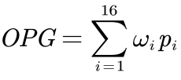
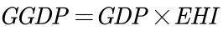
Economic health index (EHI) ^{[8]} describes the GGDP condition of a system, but only when its value is 1 can it proves that the system is completely proper. If the EHI value is too low, it means that the GGDP of the country has at least one main indicator or a large number of secondary indicators that are wrong.
We have classified the health status as follows:
• Good: EHI = 1, showing that all indicators are normal.
• Sub-good: EHI ⩾ 0.9, showing that the system has small problems.
• Not good: 0.6 ⩽ EHI < 0.9, showing that one or more main indicators are wrong, which can be improved.
• Extremely not good: 0.4 ⩽ EHI < 0.6, showing that the overall problem of the system is serious, and more reasonable construction of higher education is needed.
• Serious: 0.2 ⩽ EHI < 0.4, showing that the higher education system is seriously out of balance and cannot perform its normal functions.
• Bad: EHI ⩽ 0.2, showing that the country has no higher education system.

4.3.5 Climate Model Realized by Using Markov Chain

After each country uses GGDP instead of GDP as a measure of economic health, as we choose the indicator's health range for each indicator, governments will introduce relevant policies to take corresponding measures to promote the growth of GGDP, which is like GDP, except that the aspects that are focused on are much changed and increased. In the future, the "unhealthy" indicators will move closer to the "healthy" ones. However, our hands can only provide the direction of change; efficiency cannot be specified. In this case, we consider the implementation effect of policies later changed by the GGDP influence as a stochastic process^{[9]}. To facilitate subsequent modeling, we make the following assumptions based on general assumptions.

• One of the three states of the implementation model per year: good, poor, or counterproductive. If the politics are effectively implemented, the indicator will change rapidly and approach its expected value. Still, if the policy is not effectively implemented, the indicator state will remain the same or even worse.

• The state that occurs in the following year depends on the current state and the value of the current indicator. If the policy worked well in the previous year, it would be easier to implement in the following year. In addition, the closer the current indicator is to its normal value, the weaker the effect of the policy will be. This assumption considers the degree of unhealthy indicators versus the degree of unhealthy indicators and the role of the policy. The less healthy the indicator is, the stronger the willingness to implement the corresponding policy and the greater the acceptability of countries. On the contrary, if the indicator reaches the health limit, the effect of politics will be less noticeable.

• Under the control of the policies, unhealthy calculated metrics will eventually reach normal values. These policies are flexible. As the effect decreases due to its proximity to normal values, the policies are appropriately adjusted, and finally, the indicators will converge to normal values. We use the above assumptions to build the model and determine the Markov chain^{[10]} to predict the indicator's trend under the policy's influence. We consider the policy implementation effect (PIE) and buffer (BU) as the factors determining the current state, which are random variables with the following distribution. Since the difference between the present value and the health value of the indicator (DCH) affects the policy intensity, we add it to the distribution function of PIE to represent its effect. The distribution laws of PIE and BU are shown in the table below.

Table 4: Distribution law for modeling parameters
Last state | PIE | BU | Distribution law
Good | 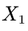 | 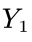
Poor | 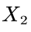 | 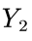 | 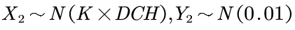
Counterproductive | 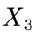 | 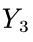
The variable k is used to control the severity of the value change. It varies from indicator to indicator. As for modeling, if 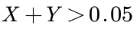, it indicates that the policy is in good state. If 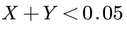, it indicates that policy has counterproductive effect. With the discussion above, we can use the indicator value of the i-th year to determine the value of the (i + 1)-th year, and the transfer equation can be given in the following form:
4.3.6 The Paris Agreement

The Paris Agreement, a climate change agreement signed by 178 parties worldwide, is suitable for global action to address climate change after 2020. The long-term goal of the Paris Agreement is to limit the global average temperature to less than 2 degrees Celsius compared to the pre-industrial period and to work towards limiting the temperature increase to less than 1.5 degrees Celsius.

A more specific timeline is shown below.

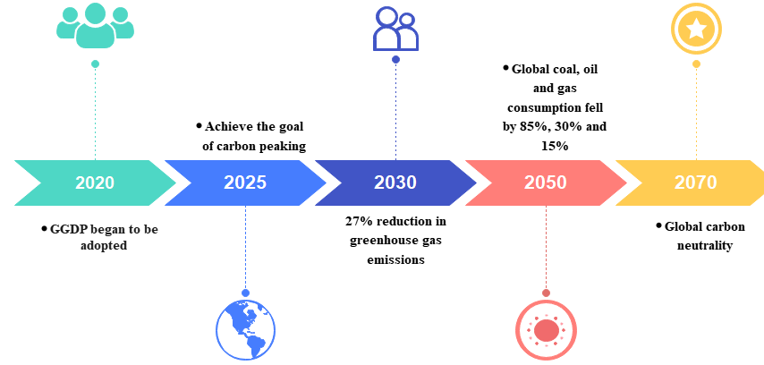
Figure 6: Timeline for the Paris Agreement

4.3.7 Climate Impact Timeline

Based on the above model, we forecast the achievement of the targets agreed upon in the Paris Agreement. We selected the changes of two indicators, greenhouse gas emissions, and energy depletion, for all countries separately to reflect global climate change^{[11]}.

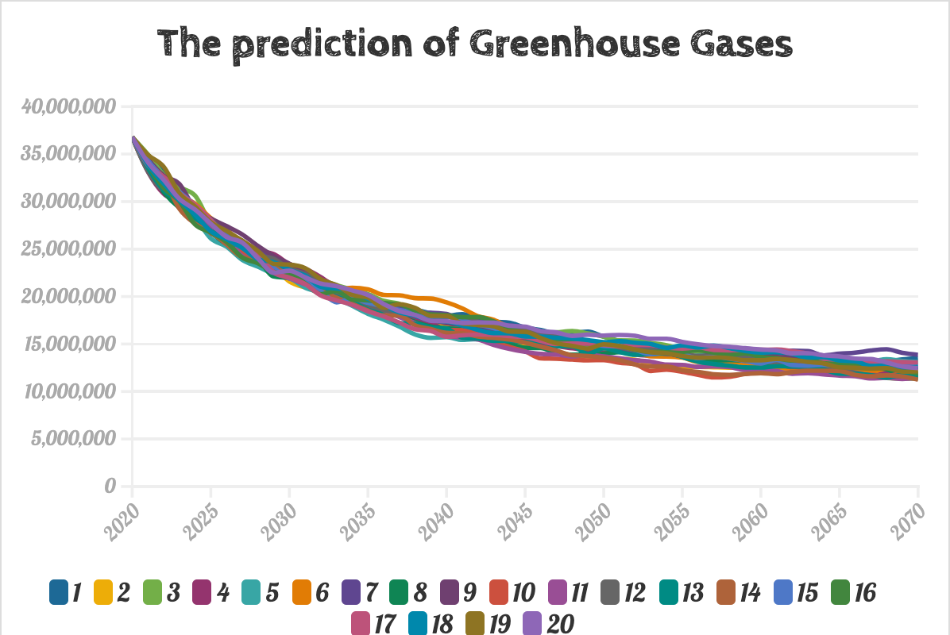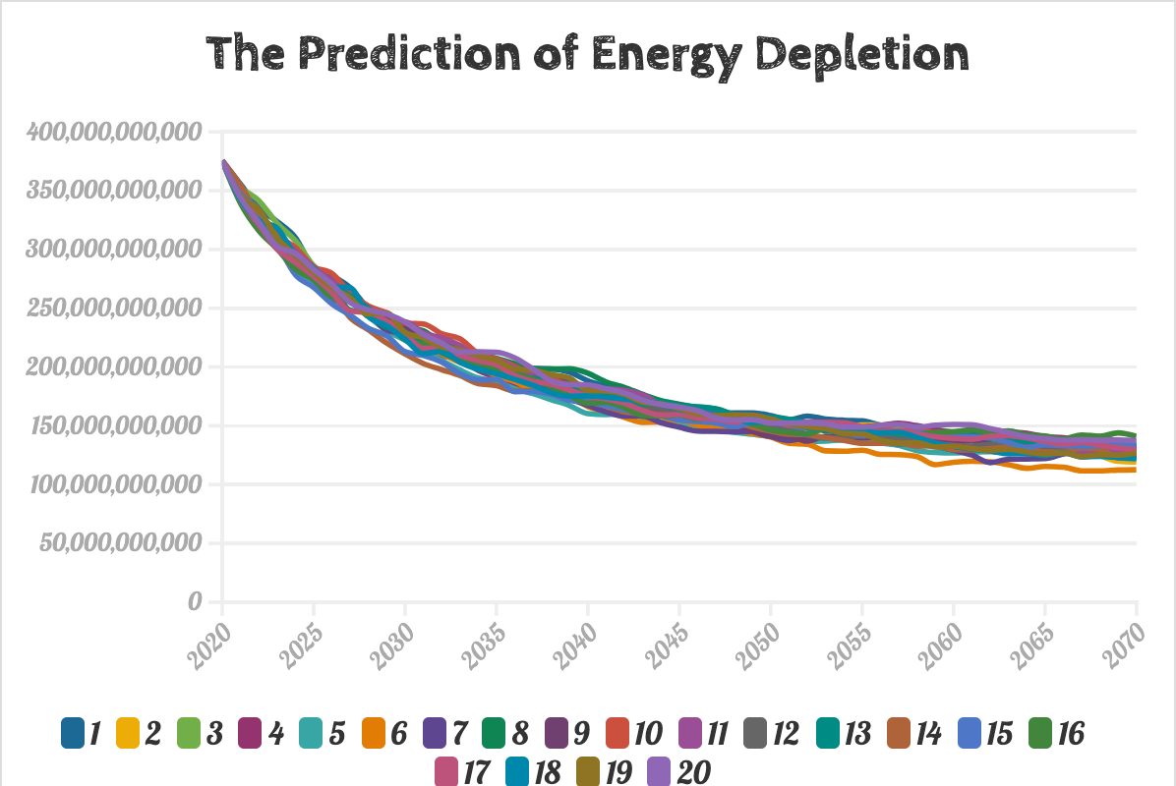
Figure 7: The prediction of GHS Figure 8: The prediction of Energy depletion

After 20 independent iterations of the experiment (different curves in the graph), we find that GHG emissions have reached an average reduction of about 40% by 2030, exceeding the target and reaching a healthy level by 2070. And energy depletion lives up to expectations, with an average reduction of 60% in 2050, well in line with the target. With the GGDP criteria, the vision of the Paris Agreement seems more achievable and has been realized.

4.4 Model influence analysis

Historical experience shows that the new will replace the old even though there will be a lot of resistance in the process, the general trend is unchanged.

In this regard, we propose the following three hypotheses for the process of GGDP replacing GDP and test each to show that the conversion of the model to a global scale is worthwhile.

• GGDP represents the direction of GDP development and is in line with the law of GDP development.

• GGDP is derived from within GDP, and GDP cannot overcome or eliminate GGDP.

• GGDP, created based on GDP, discarded the negative, obsolete, and corrupt elements of GDP by "abandoning" them and evolves.

• GGDP has a new structure and function that adapts to an already changed environment and conditions.

4.4.1 Development direction analysis

We present the global GDP and GGDP trends from 2010 to 2020, respectively. It shows that the development dynamics of GDP and GGDP are the same, so our hypothesis 1 passes the test.

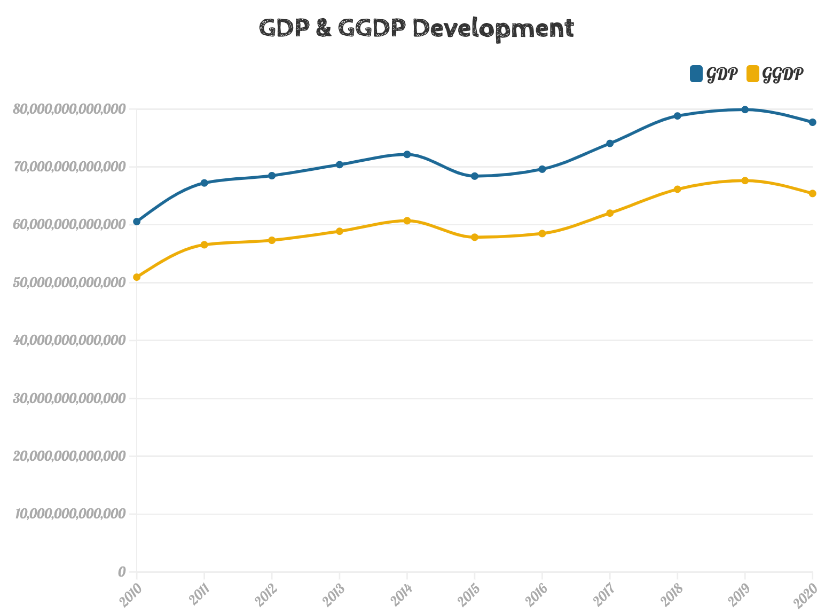
Figure 9: GDP & GGDP development
4.4.2 Relevance analysis

We found that there should be a strong positive correlation between GDP and GGDP since the share of GDP indicator in our economic health index is 48.92%. In this regard, we analyzed the correlation between GDP and GGDP. We obtained a Spearman correlation coefficient of 0.9909 with a p-value = 3.76E-09 < 0.05, accepting the hypothesis that GDP is strongly positively correlated with GGDP. Therefore, hypothesis 2 passed the test.

4.4.3 Superiority Analysis

Our GGDP not only reflects the economic strength of countries but also compensates for the fact that natural resource depletion is not considered in GDP growth. Some countries that seek high economic growth at the expense of depleting natural resources have relatively unhealthy economies, and we penalize them with appropriate rankings. Next, we give the changes in the ranking of the main countries from 2010 to 2020.
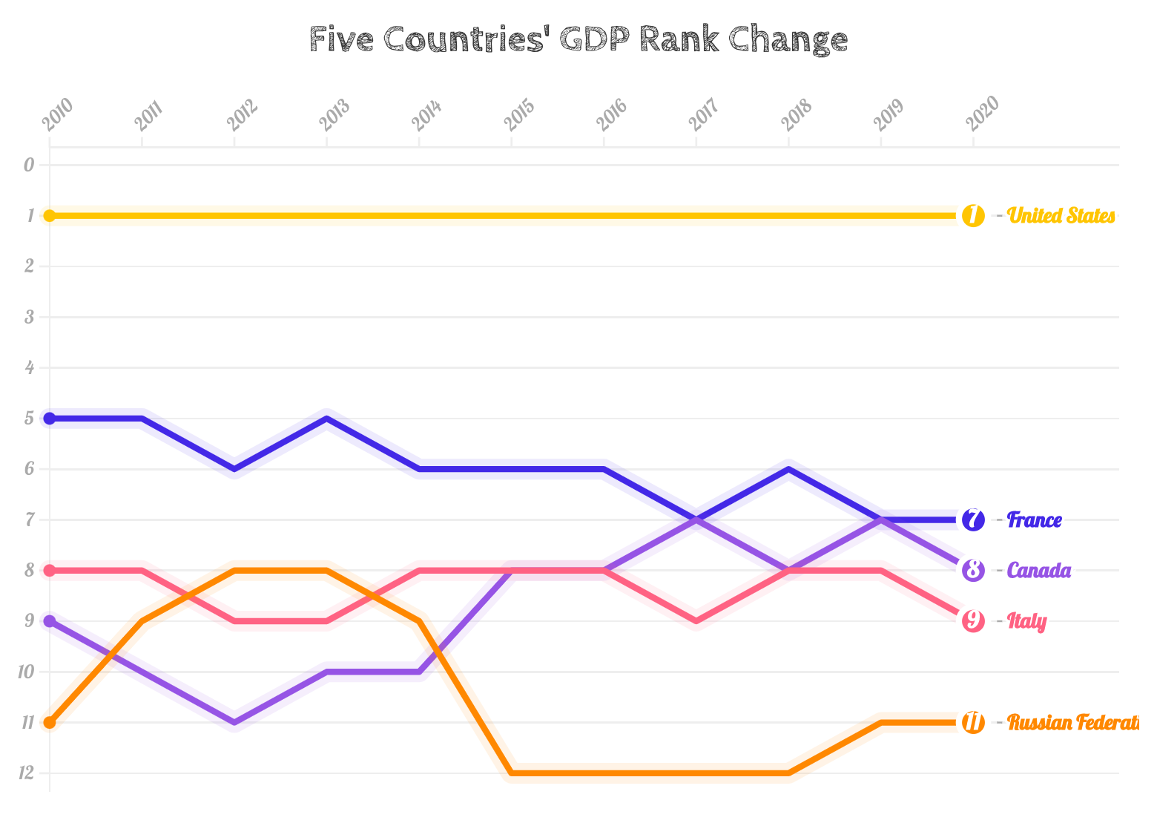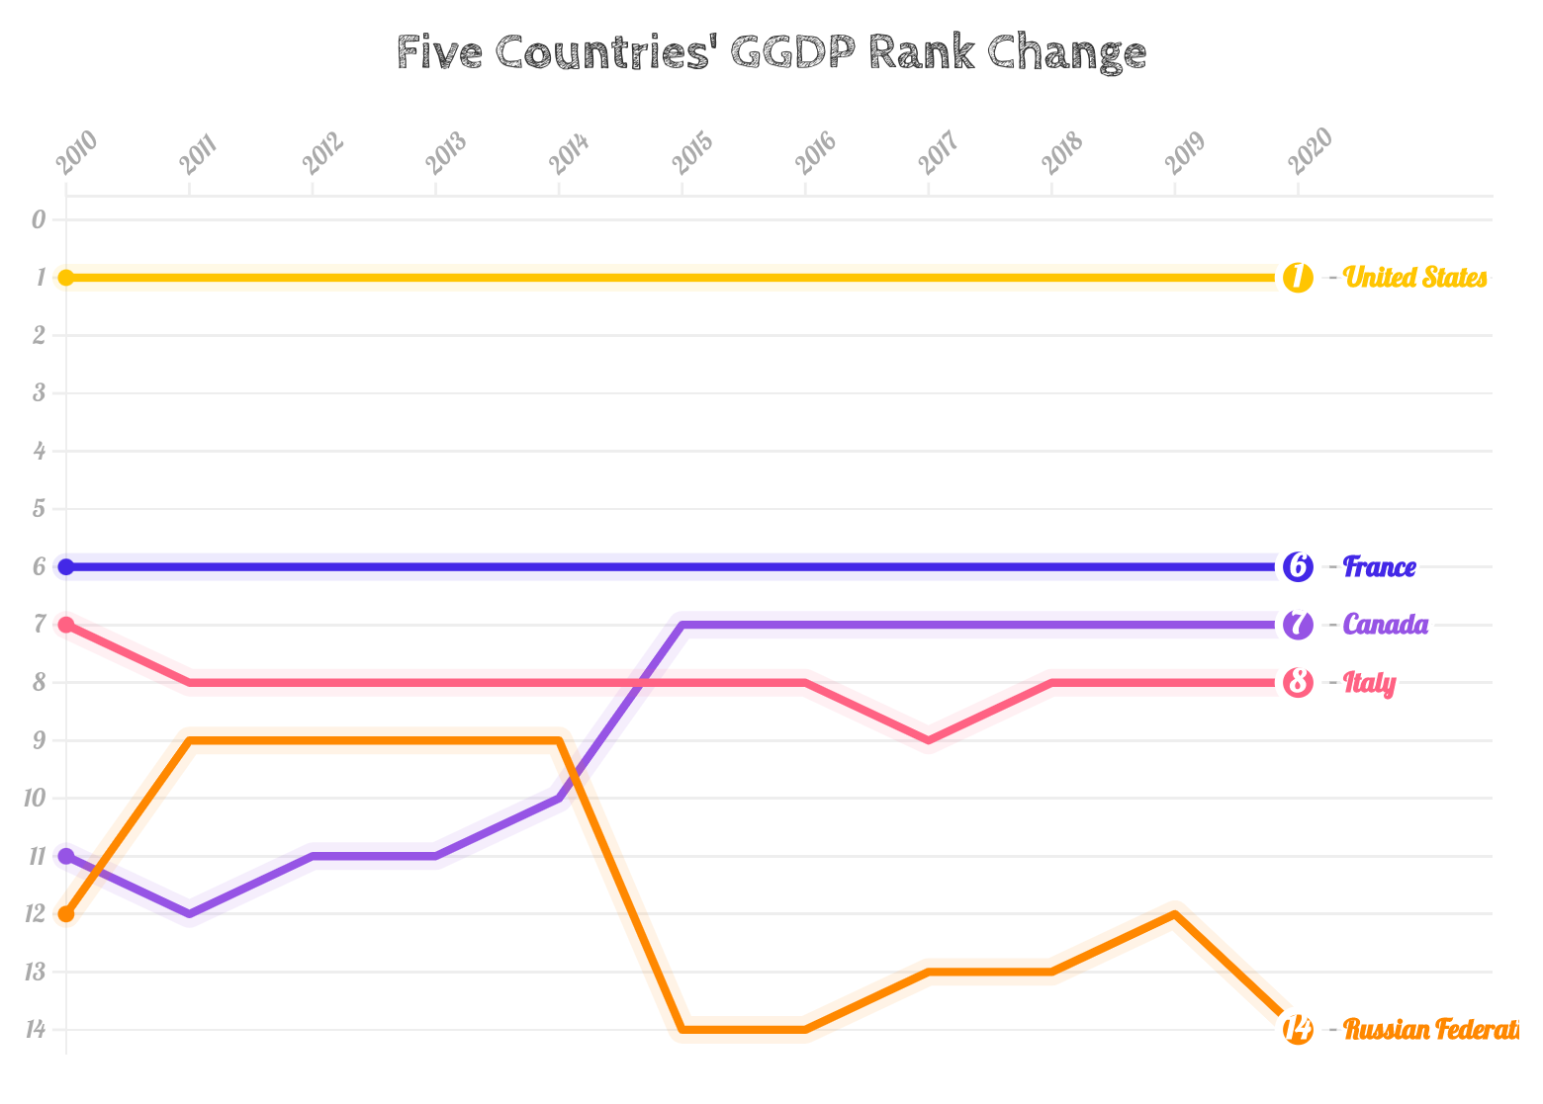
Figure 10: GDP rank change Figure 11: GGDP rank change
We found that GGDP has the following characteristics.

• Stability
For countries such as the U.S. and France, the ranking trend based on GGDP shows a more moderate performance than that based on GDP. It does not suffer from small economic fluctuations due to random events that cause changes in the rankings.

• Rewarding
Countries such as Italy and Canada, which are lagging in GDP due to their economic underdevelopment and industrial backwardness, can have more room to rise in the GGDP ranking by virtue of their environmental protection and natural resource advantages.
• Punitive
For country Russian, its economy is unhealthy due to the abuse and destruction of natural resources caused by the obsessive pursuit of economic growth. Our model will penalize it to some extent. Under the GGDP criterion, the ranking will be reduced due to insufficient natural advantage, even if the GDP is at a relative advantage.

Therefore, hypothesis 3 passes the test.

4.4.4 Adaptability analysis

We perform a sensitivity analysis on us, and sensitivity reflects the degree of adaptation of our GGDP to the already changing environment and conditions.

We increased or decreased the value of each indicator by 5% and observed the change in each country's ranking. We found an average ranking change of 1.37, which indicates that the GGDP has good adaptability.

Finally, all hypotheses passed the test, which proves that our GGDP will become a global trend and will eventually replace GDP.

4.5 Impact on climate analysis

4.5.1 Advantages

• Catalysts
Through our vision of carbon emissions in the Paris Agreement, we have selected two metrics to measure global climate impact: greenhouse gas emissions and energy depletion. This metric is reliable and accurate. In addition, the conversion from GDP to GGDP helps inspire countries to accelerate the achievement of carbon emission targets and develop renewable energy sources to mitigate the impact on the global environment.

• Robust
We regard the policy implementation effect changed by the influence of GGDP as a random process. If the politics is effectively implemented, the indicator will change rapidly and approach its expected value; otherwise, the indicator state will remain unchanged or worse.We put forward three hypotheses for the trend and characteristics of the process of GGDP replacing GDP, and tested each hypothesis. The solution results of the model all show that the trend of GGDP replacing GDP is a sign of historical progress and the development of human civilization.

• High sensitivity of Markov models
We sensitize this model: We increase or decrease the value of each index by 5%, the result reflects that our GGDP has a high degree of adaptation to the changed environment and conditions. In the context of global warming, only by paying attention to the measurement standard of GGDP can we transform and upgrade the industrial results of various countries, so as to step into the right track of sustainable development. So that the GGDP evaluation system will become a global trend and eventually replace GDP.

4.5.2 Disadvantages

• There are not enough countries
When determining the health range, we assumed and verified that certain indicators obey a normal distribution, thereby determining the reasonable range of the indicators. However, due to the small total number of countries in the world, our calculated range may deviate from the range of true normal distribution.

• We did not consider the changes in standards over time
When analyzing the GGDP system, we followed the standards in 2018. However, the various indicators of different countries may change in the future. In our model, we have not considered changes in standard.

4.6 The Impact of the transition on India

We looked at the change in the ranking of each country under GDP and GGDP criteria separately over the period 2010 to 2020 and found a case study worth exploring in depth. India's rapid economic development in the last decade is evident to all. Still, its rankings under the GDP and GGDP criteria are 6 and 7, respectively, and India has instead regressed by 1 place. So we calculated the health of the Indian economy in our model for each indicator and found it to be very unhealthy. Even a drop of 1 unit is a quantity that should not be underestimated, so we chose India to analyze the reasons in depth.

4.6.1 Economic Health Diagnostic

We obtain the current economic health of India by comparing it with the range of economic health in Table 3, with the following series of indicators {pi} and EHI.

{pi} = {1, 1, 1, 1, 0, 0, 1, 1, 1, 0, 0, 0, 0, 0, 0, 0}, EHI = 0.7644

We found many indicators that contribute to the unhealthy Indian economy: land and sea area, loss of fixed capital, mineral depletion, forest depletion. population density, greenhouse gases, PM2.5 in air, area of the reserve, and red list index. There are many hidden problems behind the appearance of India's high economic growth. Despite India's current financial strength, its ability to support future generations and achieve sustainability may be lacking due to the depletion of natural resources.

4.6.2 Our Vision

Putting the above analysis together, we make the following recommendations for unhealthy indicators to help India's economy overgrow even after achieving the shift from GDP to GGDP standards.

• Implementation of budget, welfare policies and infrastructure development.
Due to the economic downturn brought by the epidemic, India's inflation rate and fiscal deficit remain high. The plan of "using fiscal force to maintain growth" is no longer suitable for the current benign development vision of India. In order to achieve "sustainable recovery", the Indian government needs to solve the problem of high inflation and maintain India's internal demand.
• Implement forest protection policies and standardize agricultural infrastructure construction. More than 70 percent of the country's surface water is polluted, and 80 percent of residents lack access to clean drinking water, according to official surveys. The phenomenon is the result of excessive logging over a long period of time, so the Indian government has to implement policies to regulate water use and mitigate environmental degradation.
• Further study of India's carbon emissions and regulate carbon emissions.
After analyzing the impact of GGDP in northern and southern India, we find that the change trend of the index of new greenhouse gas emissions is inversely correlated with the predicted trend of GGDP. Therefore, in order to achieve the balance of green GDP development between regions, it is necessary to start from low-carbon policies.
• Energy transition, promoting investments in clean energy.
Our team predicted the impact of GGDP on India's oil consumption and pollution level of power generation industry through the Markov chain model, and finally concluded that with the implementation of GGDP, India's clean energy action will be positively affected. Therefore, developing circular economy is an important part of India's development of green economy. Through the formation of shared resources and interaction between different enterprises, the waste generated in the upstream production process becomes the raw material for the downstream production, so as to achieve a closed ecological industrial network. In today's population explosion in India, the Indian government can realize the efficient recycling and utilization of resources.
• Develop relevant environmental regulations and a sound regulatory system.
India is short of research into carbon trading systems has limited enforcement of environmental regulations. Local governments should vigorously implement environmental policies to reduce the intensity of greenhouse gas emissions and increase the share of non-fossil fuels in the national energy mix.
• Formulate a long-term international trade development strategy.
The Indian government needs to take advantage of the natural advantages of the country, raise financing at a reasonable scale, engage with developed countries and neighboring countries, expand trade, and improve the balance of manufacturing and green development to boost domestic demand, thus activating "economies of scale" and ensuring India's international competitiveness.

4.6.3 Sustainability Analysis with DEA-Malmquist Model
Data Envelopment Analysis (DEA) is one of the most common methods for analyzing sustainability. The CCR model developed by Charnes, Cooper, and Rhodes has a simple form and a complete theory. Without a priori weights for inputs and outputs, DEA can be used to assess the relative efficiency between different decision-making units (DMUs) with multiple inputs and outputs. In the single-input, single-output case, efficiency is usually defined as the ratio of results to inputs. Similarly, efficiency is defined as follows.
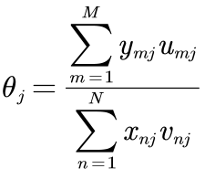
Where 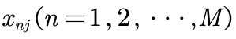,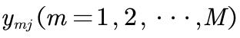 represent N inputs and M outputs of the 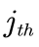 DMU respectively, with the corresponding input weights and output weights 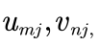with all inputs, outputs and weights non-negative. Thus the analysis to the performance of the system is transformed to the following linear programing problem:
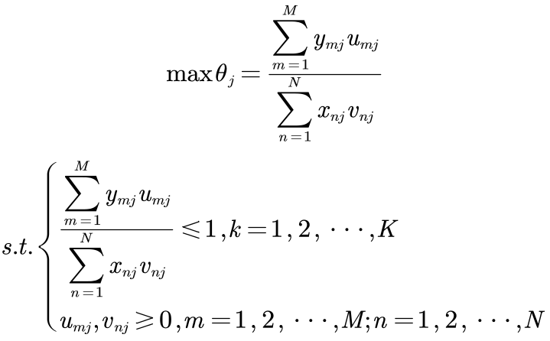

where K is the total of DMUs. If the optimal solution of the above problem exists and 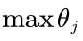 is 1, then we can judge this DMU is effective, meaning the corresponding ratio of outputs to inputs can be maximized.

DEA is a reliable tool for measuring relative efficiency among DMUs. However, the basic CCR model only calculates and compares efficiency values across time in time series analysis. It ignores the changes in productivity over time factors. Therefore, we use the DEA^{[12]}. Malmquist model to perform time series analysis. This approach introduces the Malmquist distance, which considers the time variation of productivity. We can perform dynamic analysis of efficiency in several ways.
• If a country's efficiency has declined for three consecutive years in the last five years, country's GGDP is considered unsustainable.
• If a country's efficiency has declined for only two consecutive years in the last five years, then the country's GGDP sustainability could be better.
• If a country's efficiency has declined over a year in the last five years, then the country's GGDP is healthy and sustainable.
• In the first scenario, we consider the system unable to maintain its effectiveness. In the second scenario, the system can sometimes retain its current state. Finally, volatility exists, but a highly sustainable economic system can recover quickly from a recession.
Based on the above model, we analyze the impact on the country's economic health and sustainability before and after the changes we expect.
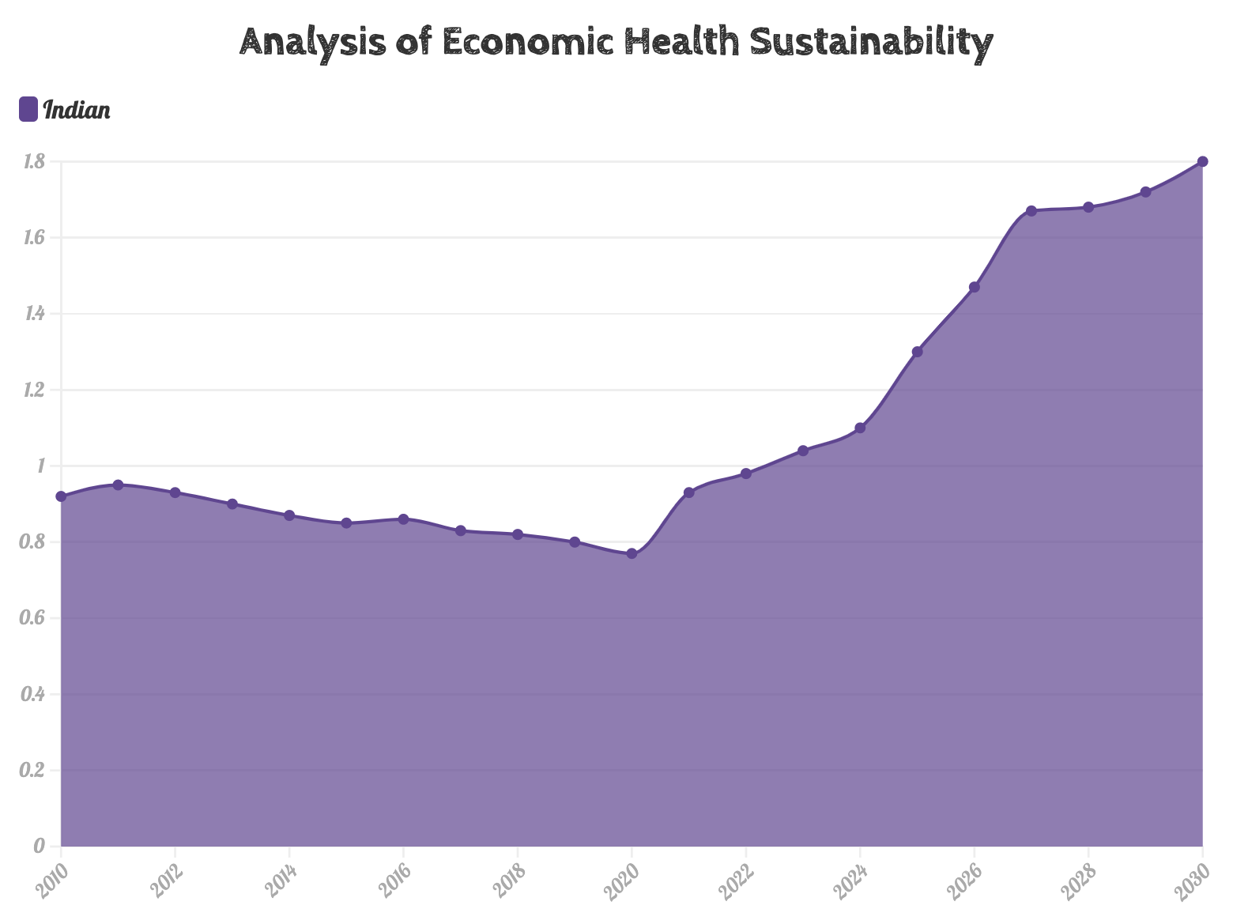
Figure 12: Sustainability analysis

Before 2020, India's economic health and sustainability are not optimistic, but after 2020, due to the adoption of the new standard of GDP, the sustainability of its financial health has improved.

V. Evaluation and Promotion of Model
5.1 Strengths
Using DEA to analyze efficiency does not need to specify the weights of various indicators in advance. Each weight is completely determined by the data. Moreover, the basic DEA model is not suitable for analyzing time series. Markov chain can predict the impact of policy well. The premise of Markov chain is that the next state of the system is only related to the current state. In the process of policy implementation, the government will adjust the policy direction of the next year according to the implementation in that year. Therefore, the Markov chain is very suitable for analyzing the impact of policies and GGDP.
5.2 Weaknesses
When analyzing the GGDP system, we followed the standards in 2018. However, the various indicators of different countries may change in the future. In our model, we have not considered changes in standard.
VI. Policy Recommendations
Policy Advice for National Leaders
To: National Leaders
Date: 21 January 2023
Subject: Proposed adoption of Global GGDP Evaluation System
Dear Prime Minister Modi:
We thank MCM-ICM for giving our team this opportunity to study GGDP. We have developed a model to address your concerns about the existing problems with India's economic development. We aim to replace the flawed GDP national accounting system with a more comprehensive GGDP system.
Considering that the model was designed from the global GGDP evaluation system, we built a complex, agent-based model based on commonalities and differences among countries worldwide. After making a comprehensive indicator system and a series of evaluations, we found that some third-world countries should slightly improve their ranking in GGDP compared to GDP, considering that they are economically underdeveloped but have abundant natural resources. At the same time, backward industries have a reduced environmental impact.
The policies we advise are as follows:
• Transformation of non-renewable energy
our team predicted the impact of GGDP on the pollution level of India's oil consumption and power generation industry through the Markov chain model. Finally, it concluded that implementing GGDP would positively affect India's clean energy action. Therefore, the development of the circular economy is an integral part of India's development of green economy. In today's population explosion in India, the Indian government can realize the efficient recycling and utilization of resources.
• Develop reasonable environmental regulations
India's lack of research into carbon trading systems has limited enforcement of environmental regulations. Enterprises need to reduce the intensity of greenhouse gas emissions and increase the proportion of non-fossil fuels in the national energy structure. In addition, the Indian government needs to provide green subsidies for businesses and citizens.
• Reasonable allocation of land and sea resources
At present, the Indian government must pay attention to the allocation of land and sea resources, take advantage of India's unique geographical environment, address the root causes of the limited distribution of land and sea resources, promote the transformation of the Marine economy to a quality and efficiency model, and promote the coordinated development of population, economy, resources and environment between the sea and land.
With these policies, the government must consider the interaction between people, the economy, and the environment to form a balanced green development system as the population grows.
We thank you for your cooperation and cooperation in this great cause and wish India better and better!

Best wishes
Team 2308685

I X. References
[1] Gao Minxue. Sustainable development and "green GDP" accounting[J]. China Development, 2002(1):5.
DU Tao, RAN Lun, LI Jinlin, et al. Efficiency-based organizational multi-attribute decision-making and empirical research: DEA-TOPSIS combination method[J]. CMS, 2017(7):10.
[3] CHEN Junfei, WANG Huimin. Sustainable Development Evaluation of Urban Ecosystem Based on TOPSIS Model[J]. Ecological Economy, 2005(9):3.
[4] YANG Hongqiang, ZHANG Xiaoxin. Coordination of carbon trading and environmental protection constraints under the Kyoto Protocol mechanism[J]. Journal of International Trade, 2005(10):5.
CUI Peng, XU Haigen, WU Jun, et al. Evaluation of Red List Index of Vertebrates in China[J]. Biodiv Sci, 2014, 22(5):7.
Chao Qingchen, Zhang Yongxiang, Gao Xiang, et al. Paris Agreement: A New Starting Point for Global Climate Governance[J]. Climate Change Research, 2016, 12(1):7.
[7] HUANG Yajiang, LI Shuquan, XIANG Sisi. Evaluation of metro fire safety resilience based on AHP-PSO fuzzy combination weighting method[J]. Journal of Catastrophology, 2021, 36(3):7.
[8] Zhu Jiayu, Ye Haiyan, Gao Ying.Portfolio model of Stock price Prediction based on Hidden Markov Model [J]. Computer Engineering and Design, 2009(21):4.
[9] LIU Jun, HUANG Chongshan. Policy Implementation Effect and Bureaucratic Discretion: A Study on the Minimum Subsistence Guarantee System for Urban Residents in Guangzhou[J]. Sun Yat-sen University Graduate Journal:Social Science Edition, 2011, 32(3):13.
[10] DING Yihui, REN Guoyu, SHI Guangyu. National Assessment Report on Climate Change (I.): History and Future Trends of Climate Change in China[J]. Climate Change Research, 2006, 3(z1):1-5.]
[11] JIANG Qi,WANG Yue. Government Quality, Science and Technology Innovation and Green GDP: Comparison of Interprovincial Spatial Spillover Effect and Regional Differences in China[J]. Journal of Guizhou University of Finance and Economics, 2020(6):13.
[12] Lei Ming. Sustainable Development Evaluation——Green Gross Domestic Product (GGDP) Accounting[J]. Economic Research Reference, 2001, 000(029):14-24

