Problem Chosen  F | 2023  MCM/ICM  Summary Sheet | Team Control Number  2308685

2023 Mathematical Contest in Modeling (MCM) Summary Sheet
Title（此处应写论文标题）
Summary
美赛论文的摘要的英文一般用Summary，摘要最好在本页完成。
标题为16号Times New Roman字体加粗并居中
摘要为14号Times New Roman字体加粗并居中
关键词为12号Times New Roman字体加粗并居左
行间距一般为1倍行距，为控制在一页可适当调整。
首页不需要页眉和页码。
“00000”修改为自己的控制编号（Team Control Number），“A”改为自己的选题题号（A/B/C/D/E/F）

使用此模板可以开始输入电子报告的第一页（摘要页）。这个模板使用了一个12点倍的新罗马字体。将您的论文以Adobe PDF电子文件（例如1111111.pdf）的形式提交，以英文输入，可读字体至少为12点类型。 不要在本页或任何页面上包括您的学校、顾问或团队成员的姓名。 论文必须在25页的限制范围内。 请务必更改上面的控制编号和问题选择。

Key words: 三到五个关键词

注：红色字为解释说明部分，使用时应全部删除或换成黑色字。

Contents
I. Introduction 4
1.1 Background 4
1.2 Our works 4
II. The Description of the Problem 5
2.1 Problem statement 5
2.2 Analysis of Specific Issues 5
2.2.1 Analysis of Problem 1 5
2.2.2 Analysis of Problem 2 5
2.2.3 Analysis of Problem 3 5
2.2.4 Analysis of Problem 4 2
III. Basic assumption 2
IV. Glossary & Symbols 3
4.1 Glossary 错误！未定义书签。
4.2 Symbols 错误！未定义书签。
V. Models 3
5.1 Analysis and Solving of Question One 3
5.1.1 Model Preparation 4
5.1.2 Model Establishment 18
5.1.3 Results 19
5.1.4 Analysis of the Result 错误！未定义书签。
5.2 Analysis and Solving of Question Two 4
5.2.1 Model Preparation 错误！未定义书签。
5.2.2 Model Establishment 错误！未定义书签。
5.2.3 Results 错误！未定义书签。
5.2.4 Analysis of the Result 错误！未定义书签。
5.3 Analysis and Solving of Question Three 错误！未定义书签。
5.3.1 Model Preparation 错误！未定义书签。
5.3.2 Model Establishment 错误！未定义书签。
5.3.3 Results 错误！未定义书签。
5.3.4 Analysis of the Result 错误！未定义书签。
5.4 Analysis and Solving of Question Four 错误！未定义书签。
5.4.1 Model Preparation 错误！未定义书签。
5.4.2 Model Establishment 错误！未定义书签。
5.4.3 Results 错误！未定义书签。
5.4.4 Analysis of the Result 错误！未定义书签。
VI. Error Analysis and Sensitivity Analysis 19
6.1 Error Analysis 19
6.1.1 Error Analysis of Model One 19
6.1.2 Error Analysis of Model Two 20
6.1.3 Error Analysis of Model Three 20
6.2 Sensitivity Analysis 20
6.2.1 Sensitivity Analysis of Model One 20
6.2.2 Sensitivity Analysis of Model Two 20
6.2.2 Sensitivity Analysis of Model Three 20
VII. Evaluation and Promotion of Model 21
7.1 Strength and Weakness 21
7.1.1 Strength 21
7.1.2 Weakness: 21
7.2 Promotion 21
Ⅷ. Conclusions 22
8.1 Conclusions of the problem 22
8.2 Methods used in our models 22
I X. References 22
X. Appendix 23
10.1 Appendix One 23
10.2 Appendix Two 24

从目录开始有页眉和页码，把“00000”改为自己的控制编号，页码会自动调整可以不用编辑。

I. Introduction

Background
Environment and ecology are part of a country's comprehensive economy. The current national economic accounting system needs to reflect its financial situation entirely, but it does not include environmental and ecological factors. A series of apparent flaws in GDP statistics have not been corrected for a long time. GGDP is an adjustment to the GDP index, which is the gross domestic product after deducting the cost of resources and environment invested in economic activities.

Under the new situation, each Country should accelerate the research and application of GGDP to provide necessary data support for the implementation of the scientific concept of development. To seize the high ground of future global economic development, governments of various countries have sought the path of green development. The green economy will lead to a new international economic pattern in the foreseeable future.

Our works

- Task 1

- Task 2

- Task 3

- Task 4

II. The Description of the Problem

Problem statement

Analysis of Specific Issues

Analysis of Problem 1
针对问题一，我们需要利用文献法，搜集相关已有的GGDP核算方法，目前已有的相关计算方法有：GGDP核算方法包含GDP、环境退化成本和生态破坏成本三大部分；GeGDP核算方法包含资源耗减成本和环境降级成本；GrDP核算方法；MEWGDP核算方法，我们团队在搜集完方法之后，统一都列出了每种方法的计算公式并分析模型的优劣。

Analysis of Problem 2

针对问题二，我们需要在问题一所给出的模型的基础上，建立基于DEA-TOPSIS的组合评价模型，我们考虑到每个国家的环境资源的实际情况、气候变化的具体情况和人口数量等其它因素的差异，所以我们需要在评估模型中衡量不同指标的权重，用来区分出不同国家的不同指标，最终得出每个国家的GGDP得分，通过K-means聚类划分出以GGDP为依据的发达国家和发展中国家，对每类国家的实际情况通过马尔科夫链条模型进行预测。

Analysis of Problem 3
针对问题三，我们主要任务就是具体分析出用GGDP替代GDP后对气候造成的积极影响和消极影响从而证明GGDP构建的合理性，因此我们需要对气候变化数据和GDP进行预测，我们将预测分为短期、中期、长期，直到收敛为止，然后，我们通过相关性检验比较出预测前的GGDP与气候变化的趋势和预测后GGDP的变化与气候变化之间的关联性，观察灰色关联系数的变化趋势从而得出对气候减缓的关联性。此外还需要对模型的精度进行检验，通过精度的不同也可以反映出优势与劣势。

Analysis of Problem 4

III. Basic assumption
To enable the model to reflect a country's economic health through GGDP accurately, we draw inspiration from the health assessment method of the medical system and make the following assumptions.

- The statistical data we collected from the website is accurate and reliable.

- The economy's overall health is only related to our assessment indicators.

- The indicators we choose have the same distribution law as economic population so that we can estimate the overall situation through samples.

- The population of the higher education system conforms to the hypothetical distribution law and can be used to measure health status. The population does not exist, which is inconsistent with the overall situation of all countries.

- Similar to the physical examination index, there is a specific interval to determine whether the index value is healthy.

- In a certain period, some indicators will not be affected by the implementation of GGDP and can be regarded as constants.

- Based on the above assumptions, we selected a good data set and used the processing method of the national economic health comprehensive evaluation standard under the corresponding GGDP standard.

IV. Symbols
Symbols | Definition | Units
Z | The index of development | J
CI | Coordinated index of development | J
DI | Sustainability index of development | J
A | Economic index of development | J
B | Social index of development | K
C | Environment index of development | K
F | Impact index value | km³
S | Reality index value | m
 | Influence coefficient | m²

V. Models

5.1Analysis and Solving of Question One
5.1.1 Concept of GGDP

The green gross domestic product (green GDP or GGDP) is an index of economic growth with the environmental consequences of that growth factored into a country's conventional GDP. Green GDP monetizes the loss of biodiversity and accounts for costs caused by climate change.

5.1.2 Accounting Method Filtering

- GGDP
GGDP核算由国内生产总值、环境退化成本和生态破坏成本三部分组成。
(1)环境退化成本：大气污染、水污染和土壤污染会导致环境退化。大气污染导致的环境退化成本主要包括大气污染治理成本和生活清洁费用增加成。
(2)生态破坏成本：流域内生态破坏成本核算主要是针对因人类不合理利用森林、草地、湿地和农田生态系统，从而导致的生态调节服务损失。
GGDP=国内生产总值-环境退化成本-生态破坏成本
环境退化成本=EnDCa+EnDCw+EnDCs
生态破坏成本=EcDCf+EcDCg+EcDCw+EcDCa
其中：EnDC为环境退化成本，EnDCa为大气污染环境退化成本，EcDCw为水污染环境退化成本，EnDCs为土壤污染环境退化成本，EcDCf是森林生态系统破坏损失，EcDCg是草地生态系统破坏损失，EnDCw是湿地生态系统破坏损失，EcDCa是农田生态系统破坏损失。
- GeGDP
GGDP的值小于GDP的值，即GeGDP的值等于在现行GDP核算值的基础上，再减去以下两项数值：一项称"资源耗减成本"，另一项称"环境降级成本"。
GeGDP = GDP -资源耗减成本-环境降级成本。
- MEWGDP
MEWGDP是衡量家庭年度实际消费的模型，称为经济福利衡量标准，MEW调整了GDP，它另外了包括闲暇时间、无偿工作和环境破坏的价值。还定义了可持续的水电部（MEW-S）的值，其工作是更复杂的可持续发展措施的先驱。

- DEA的组合模型
将DEA方法与其它模型结合使用，比如，DEA与Malmquist结合，从不同的角度对DMU的效率进行测算或基于效率展开进一步的分析与研究，达到了跨越不同时期分析的效果。
有一些学者将DEA方法与Tobit回归方法相结合，该方法首先用DEA方法对DMUs的相对效率进行测算，再运用Tobit回归模型对影响DEA效率值的影响因素进行分分析。
另外有学者将DEA方法与TOPSIS评价模型相结合，针对传统DEA模型无法对有效地对DMUs进行排序的问题，建立了基于DEA的组织多属性决策的DEA－TOPSIS组合方法，它可以测算具有多种投入多种产出指标的组织的效率以及各投入产出指标的松弛改进量。运用TOPSIS方法的可以实现有效DMUs的排序问题。它首先运用DEA模型测算DMUs的相对效率，并基于效率确定决策目标和备选方案。然后，根据DEA方法中各指标的松弛改进量构造各方案的决策矩阵，并运用TOPSIS方法对备选方案进行排序。DEA－TOPSIS组合方法不仅可以有效地对基于效率的决策备选方案进行排序，还可以通过选择不同的模型和指标处理方法来尽可能地反映实际情况，具有很强的实践性。
综上所述，我们团队选择了基于DEA和TOPSIS的组合评价模型。

5.2 Analysis and Solving of Question Two
5.2.1 Main Factors

To achieve the replacement of GDP with GGDP as the primary measure of the country's economic health, we need to make a new and reasonable assessment of the actual state of the country's economy, and we need to consider not only GDP as the primary indicator, but also to judge its impact on natural resources and climate. Similar to the definition of physical health, the health of a system refers to its ability to function correctly and to respond to external changes. A healthy national economic system not only has the function to indicate its financial strength but also to repair and renew itself according to the changes in natural resources and climate and to act back on them to achieve sustainable development of resources.

Based on the above definition, we have developed five factors to measure the economy's health after considering the use of natural resources, which are described below.

- Heart

Gross Domestic Product (GDP) is the final result of the production activities of all resident units in a country (or region) over a certain period. It has long been recognized as the core indicator of national economic accounting and an essential indicator of a country's or region's financial status and development. In our new economic system, it deserves to occupy the heart position.

- Resource

Resource is an evaluation of the level of natural resource holdings in different countries. Its content is vibrant, and we have chosen four indicators to describe it: total freshwater, agricultural land, forest coverage, and land and sea area. The development of society and the progress of science and technology require the development and use of more and more natural resources. This indicator allows for determining the maximum total amount of natural resources available to the country.

- Expense

Expense is a comprehensive assessment of national resource consumption in each country, which is described as seven indicators: loss of fixed capital, agricultural value-added, use of renewable energy, energy depletion, mineral depletion, forest depletion and population density. Fixed capital is the loss in use value and value caused by the use of resources in production and processing and the impact of natural forces. Agricultural value-added is the value added by agricultural, forestry, and fishery production. The use of renewable energy is the value added by the use of renewable energy. The use of renewable energy reflects the development of renewable energy sources and the efforts made by the country in the sustainability of resources; energy depletion, mineral depletion, and forest depletion are the three significant resource losses in the country's economic development. Population density is a reflection of the use of land resources.

- Emission

Emissions are a count of national contributions to global climate change in each country. According to the Kyoto Protocol, greenhouse gas emissions profoundly impact global climate change, and we have selected the emissions of six gases (CO2, CH4, N2O, HFCs, PFCs, SF6), which are subject to emission limits, as the total greenhouse gas emissions. In addition, with the increase in air pollution, PM2.5 not only becomes a significant factor affecting global climate but also endangers human life and health.

- Diversity

Diversity is a measure of the national biological resources of each country. Biological resources are a valuable asset given by nature to each country. Following the UN Millennium Development Goals, we have selected the area of the reserve and the red list index indicators to assess biodiversity.

5.2.2 Data Selection

We used the same dataset but different evaluation methods to evaluate health status and climate impacts. To assess health status, we will calculate the data weights and list the leading indicators, thus constructing a confidence interval similar to the pathology test.

The approach to assessing climate impacts is slightly different. We use the carbon reduction target agreed upon in the Paris agreement as a measure of global climate change, divided explicitly into global greenhouse gas emissions and global energy consumption over the next 50 years after adopting the GGDP standard.

Below is a table of selected indicators. The letter 'P' in the Impact column indicates that the indicator positively impacts GGDP. ' N' refers to the opposite. Specific indicators can have a negative effect on the results when they are too high or too low.

When they are too high or too low, they can negatively affect the results, so we assign them the letter 'M'.

Considering hypotheses 3 and 4 and that the main contributors to climate impacts tend to be countries that are more developed in the economy or natural resources, we surveyed a random sample of these countries for their indicators from 2010 to 2020. The selected example of 50 is shown below.

Countries | 1 | 2 | 3 | 4 | 5
1 | Argentina | Czech Republic | Ireland | New Zealand | South Korea
2 | Australia | Denmark | Israel | Norway | Spain
3 | Austria | Egypt | Italy | Pakistan | Sweden
4 | Belarus | Estonia | Japan | Philippines | Switzerland
5 | Belgium | Finland | Kazakhstan | Poland | Thailand
6 | Brazil | France | Lebanon | Portugal | Turkey
7 | Canada | Germany | Malaysia | Russia | Ukraine
8 | Chile | Greece | Mexico | Saudi Arabia | United Arab Emirates
9 | China | India | Mongolia | Singapore | United Kindom
10 | Colombia | Iodonesia | Netherlands | South Africa | United States

Here is a map showing the countries we have chosen.

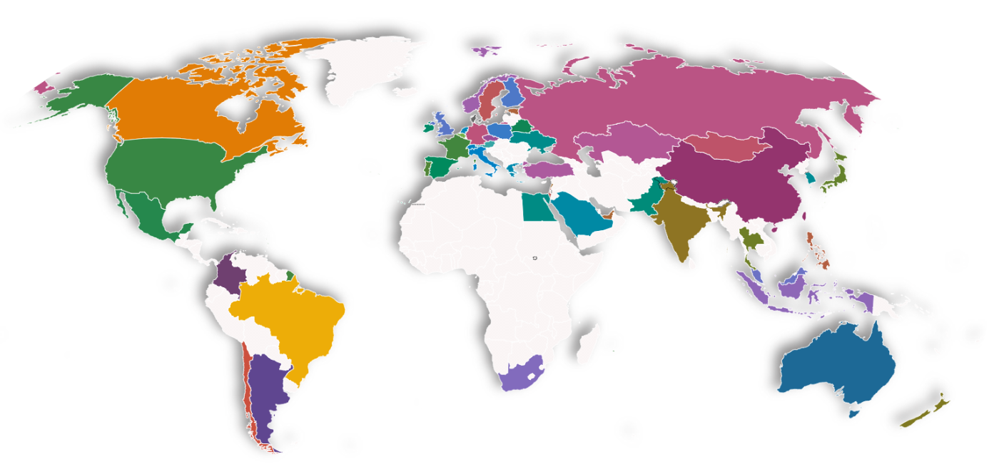
5.3 Models for GGDP and climte

In this section, we build a GGDP health model and a climate impact model of a country's economy. Using these two models, we can perform a medical examination and diagnosis of each country's health and climate impacts. We can describe this process in the following diagram.

5.3.1 GGDP Health Model

During a physical examination, the doctor usually checks the patient's various indicators and determines whether they are within the normal range. Determine whether they are within the normal range or not. These indicators have different weights, and those with larger weights have a greater impact on health status, while those with smaller weights have a relatively smaller impact, and we use a similar approach to measure the health status of the economy. Based on the previous assumptions, we determine the corresponding health range of each indicator and use the Analytic Hierarchy Process to determine the weight of each indicator. Through these analyses, we will give the overall health and the health of each factor.

5.3.2 Determine the Weight of Indicators

The primary method we used to determine the weights was the analytical hierarchy process.
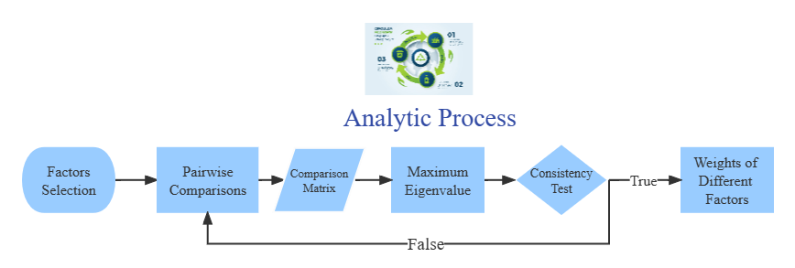
Analytic Hierarchy Process (AHP) is an accurate approach for quantifying the weights of decision criteria, widely used in different decision situations, in fields like government, business, healthcare, shipbuilding, industry and education [8]. In our analysis, we use this method to determine weights of different main factors. Similarly, we determine the weights of different indicators in each factor. The following are the steps.

• Factors selection

We have selected several main factors previously. For each main factor, we have chosen some indicators as well.

• Pairwise comparisons between different factor

According to pairwise comparisons, we establish priorities among the factors. We think that the importance of main factors satisfies the following relationship:

• Calculation of comparison matrix

With the relationship discussed before, we get our comparison matrix 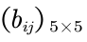
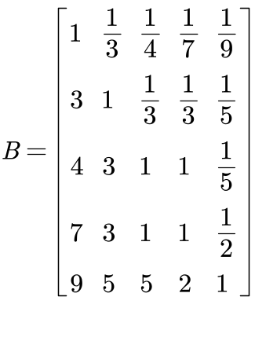
Where Fi for i = 1, 2, · · · , 5 represent heart, resource, expense, emission, diversity respectively.

• Consistency Test

We can calculate the eigenvalues and eigenvectors of the matrix before. Next we need to perform consistency test with the maximum eigenvalue 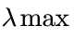.
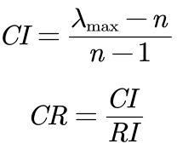
According to the calculation above, CR of the judgment matrix is 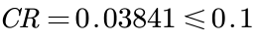, thus the comparison matrix is acceptable.

• Calculation of weights Passing the consistency test

we can get the weights of main factors by the eigenvector corresponding to the maximum eigenvalue, they are as follow: heart(0.4892), resource(0.2209), expense(0.1709), emission(0.0816), diversity(0.0374).

Using the same method, we obtain the weights of the different indicators for each factor, as shown in the figure below.

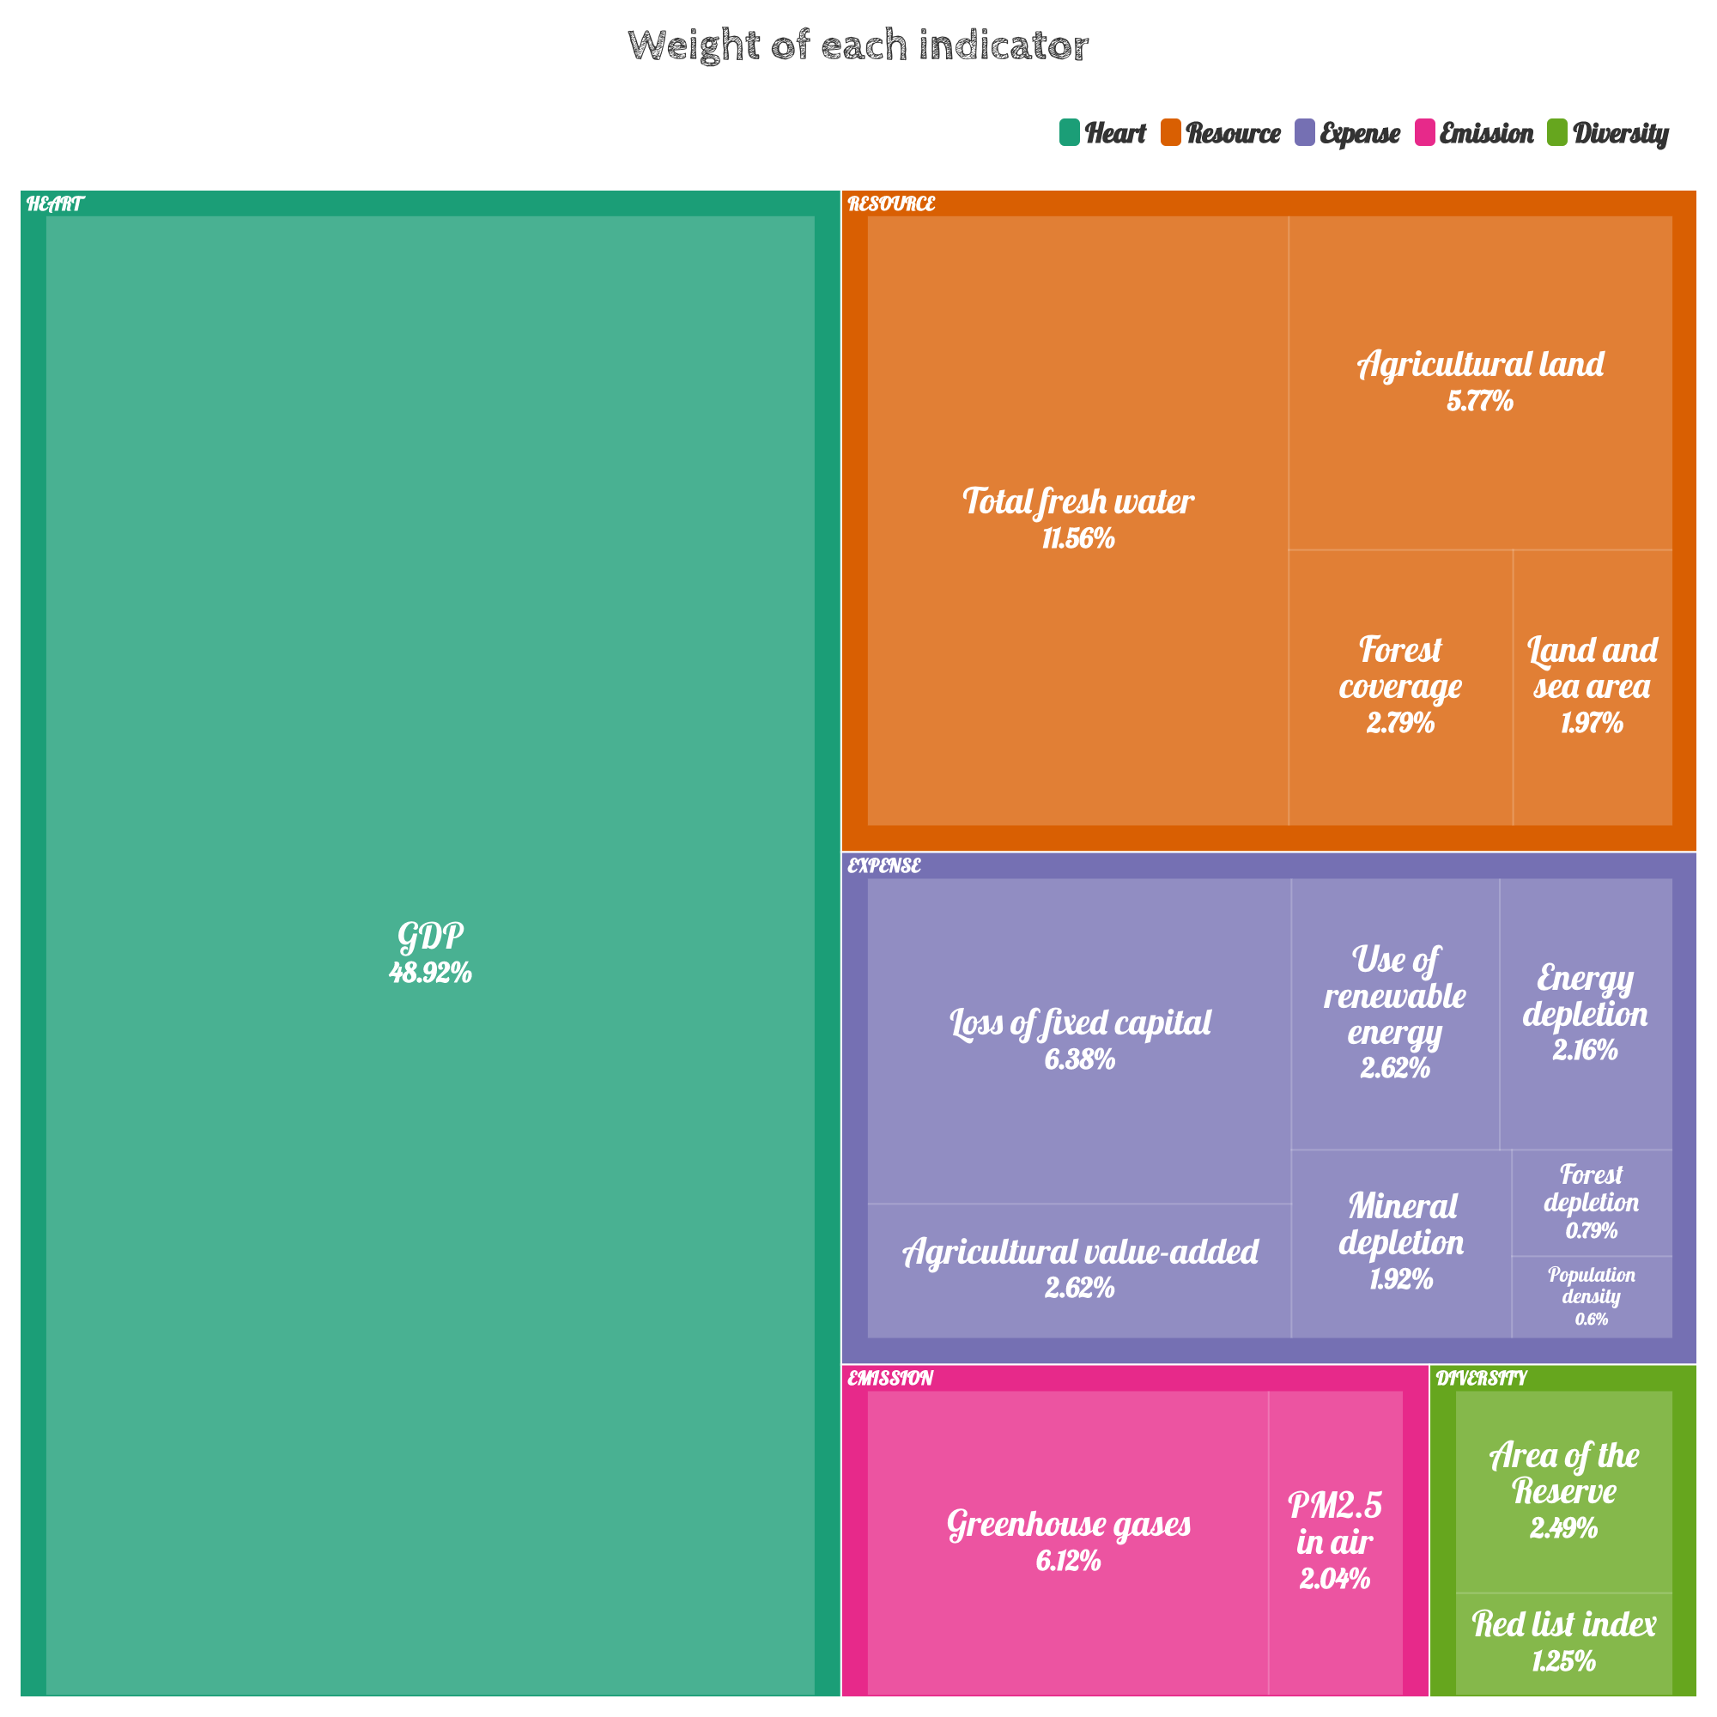

The weighted analysis allows us to obtain the ranking of each indicator by weight. The top-ranked indicators are called primary indicators, which considerably impact overall health. The more down-rated indicators are called secondary indicators, which have little impact on overall health, but we cannot ignore their cumulative effect.

5.3.3 Select Health Range

We fixed the economic health ratio by analyzing the GDP rankings overtime at 0.8. This suggests that 80% of the economic population is healthy. Based on these assumptions, We developed the following principles for selecting health ranges.

- Positive indicators
The sample data from the highest to the lowest 80% quartile were selected as the estimators of the overall lower limit.

- Negative indicators
The sample data from the low to the high 80% quartile was selected as the estimator of the overall upper bound.

- Interval Indicators
Estimate the distribution pattern of the population through the sample and determine the
intervals.

We found the range of health corresponding to the easy positive and negative indicators. Hence, the distribution pattern of the interval indicators needs to be considered: GDP and population density. By plotting the frequency histograms of these two indicators, we found that they have a pattern similar to the normal distribution. To test this conjecture, we tested these two indicators with SPSS using the Kolmogorov - Smirnov (K-S) test. Due to space limitations, we will not discuss the detailed principles of the K-S test here. Instead of discussing it here, only the results are shown.

At the significance level α = 0.05, we obtained the following results of the K-S test for both indicators. Since the significance levels of both hands are higher than α, we can conclude that they both pass the K-S test.

表 1: Single sample Kolmogorovs-Minov test
 |  | Population density |  | GDP
abs |  | 50 |  | 245
Normal parameter | Average value |  | 4.3942 |  | 25.2529
Normal parameter | SD |  | 1.53211 |  | 2.99909
Extreme difference | Absolute value |  | 0.1 |  | 0.06
Extreme difference | Positive value |  | 0.084 |  | 0.06
Extreme difference | Negative value |  | -0.1 |  | -0.033
Inspection statistic |  | 0.1 |  | 0.06
Progressive significance(bilateral) |  | .200 |  | 0.031

Below is the Q-Q plot of the two data to verify the correctness of the results. We can see that the data points of both data are distributed near a straight line, and the results of the K-S test are acceptable.
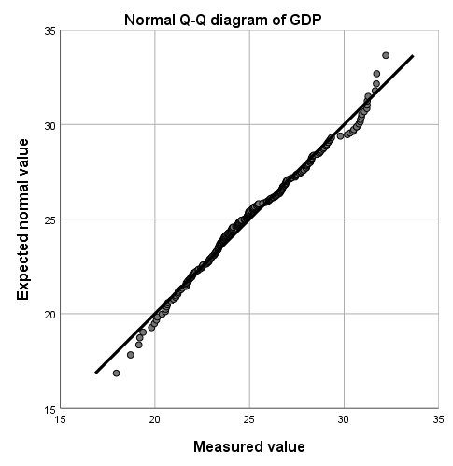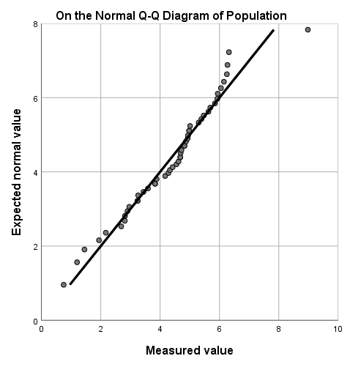
Therefore, we can give the acceptable health range for both in terms of normal distribution.

表 2
Indicator | Upper Bound | Lower Bound
GDP | 1.67E26 | 2.38
Total fresh water | - | 11.34
Agricultural land | - | 20.46
Forest coverage | - | 12.59
Land and sea area | - | 5.06
Loss of fixed capital | 2.4E11 | -
Agricultural value added | - | 4.61E9
Use of renewable energy | - | 1.22
Energy depletion | 1.6E10 | -
Mineral depletion | 3.06E9 | -
Forest depletion | 9259307 | -
Population density | 84.55 | 62.91
Greenhouse gases | 644558 | -
PM2.5 in air | 27.96 | -
Area of the reserve | - | 16.96
Red list index | 1 | 0.78

5.3.3 Diagnosis of Health Conditions

We use a simple acceptance/rejection model (0-1 model) to determine the health conditions. The overall health condition can be measured with point gain and the occurring problem can be located. For each indicator i, if the value falls in the range of GGDP, the point = 1, otherwise = 0. is the weight of indicator i. We calculated the point gain with the equation below:
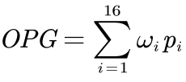
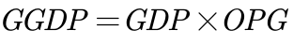
Overall point gain (OPG) describes the GGDP condition of a system, but only when its value is 1 can it proves that the system is completely proper. If the OPG value is too low, it means that the GGDP of the country has at least one main indicator or a large number of secondary indicators that are wrong.

We have classified the health status as follows:

• Good: OPG = 1, showing that all indicators are normal.

• Sub-good: OPG ⩾ 0.9, showing that the system has small problems.

• Not good: 0.6 ⩽ GGDP < 0.9, showing that one or more main indicators are wrong, which can be improved.

• Extremely not good: 0.4 ⩽ GGDP < 0.6, showing that the overall problem of the system is serious, and more reasonable construction of higher education is needed.

• Serious: 0.2 ⩽ GGDP < 0.4, showing that the higher education system is seriously out of balance and cannot perform its normal functions.

• Bad: GGDP ⩽ 0.2, showing that the country has no higher education system.

The following figure shows the lower bound for each status more intuitively.
【画图GGDP】

5.3.4 Climate Model Realized by Using Markov Chain

After each country uses GGDP instead of GDP as a measure of economic health, as we choose the indicator's health range for each indicator, governments will introduce relevant policies to take corresponding measures to promote the growth of GGDP, which is like GDP, except that the aspects that are focused on are much changed and increased. In the future, the "unhealthy" indicators will move closer to the "healthy" ones. However, our hands can only provide the direction of change; efficiency cannot be specified. In this case, we consider the implementation effect of policies later changed by the GGDP influence as a stochastic process. To facilitate subsequent modeling, we make the following assumptions based on general assumptions.

• One of the three states of the implementation model per year: good, poor, or counterproductive. If the politics are effectively implemented, the indicator will change rapidly and approach its expected value. Still, if the policy is not effectively implemented, the indicator state will remain the same or even worse.

• The state that occurs in the following year depends on the current state and the value of the current indicator. If the policy worked well in the previous year, it would be easier to implement in the following year. In addition, the closer the current indicator is to its normal value, the weaker the effect of the policy will be. This assumption considers the degree of unhealthy indicators versus the degree of unhealthy indicators and the role of the policy. The less healthy the indicator is, the stronger the willingness to implement the corresponding policy and the greater the acceptability of countries. On the contrary, if the indicator reaches the health limit, the effect of politics will be less noticeable.

• Under the control of the policies, unhealthy calculated metrics will eventually reach normal values. These policies are flexible. As the effect decreases due to its proximity to normal values, the policies are appropriately adjusted, and finally, the indicators will converge to normal values. We use the above assumptions to build the model and determine the Markov chain to predict the indicator's trend under the policy's influence. We consider the policy implementation effect (PIE) and buffer (BU) as the factors determining the current state, which are random variables with the following distribution. Since the difference between the present value and the health value of the indicator (DCH) affects the policy intensity, we add it to the distribution function of PIE to represent its effect. The distribution laws of PIE and BU are shown in the table below.

表 3
Last state | PIE | BU | Distribution law
Good | 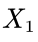 | 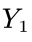 | 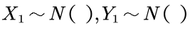
Poor | 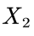 | 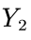 | 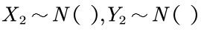
Counterproductive | 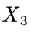 | 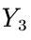 | 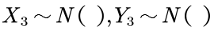

The variable k is used to control the severity of the value change. It varies from indicator to indicator. As for modeling, if 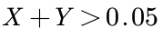, it indicates that the policy is in good state. If 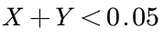, it indicates that policy has counterproductive effect. With the discussion above, we can use the indicator value of the i-th year to determine the value of the (i + 1)-th year, and the transfer equation can be given in the following form:
5.3.5 The Paris Agreement

The Paris Agreement, a climate change agreement signed by 178 parties worldwide, is suitable for global action to address climate change after 2020. The long-term goal of the Paris Agreement is to limit the global average temperature to less than 2 degrees Celsius compared to the pre-industrial period and to work towards limiting the temperature increase to less than 1.5 degrees Celsius.

A more specific timeline is shown below.

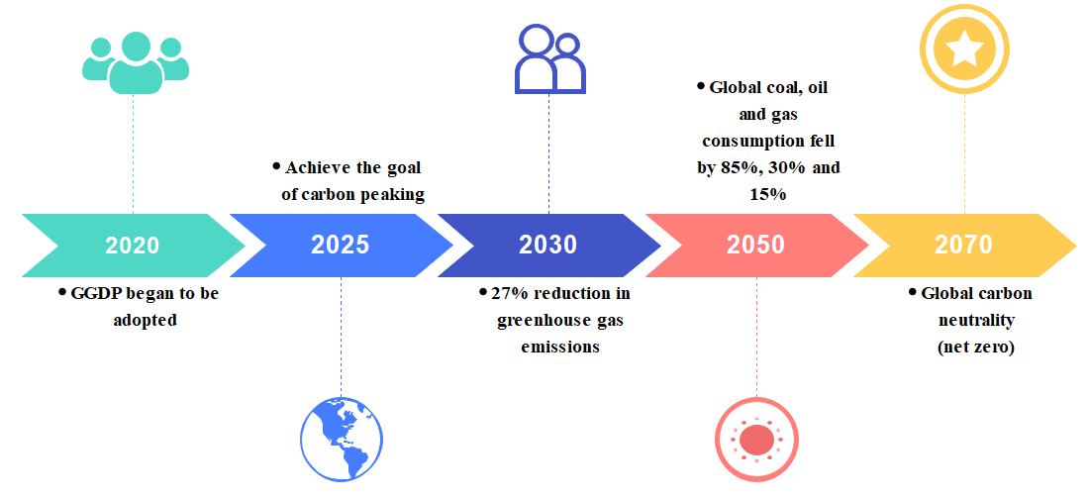

5.3.6 Climate Impact Timeline
Based on the above model, we forecast the achievement of the targets agreed upon in the Paris Agreement. We selected the changes of two indicators, greenhouse gas emissions, and energy depletion, for all countries separately to reflect global climate change.
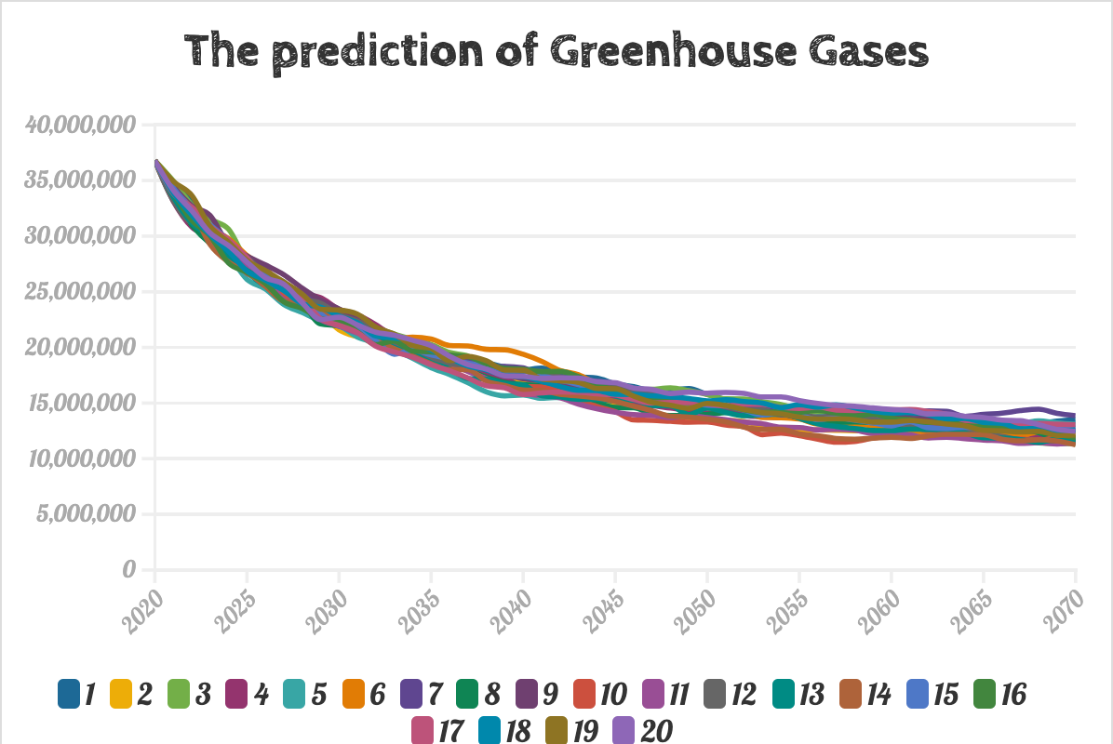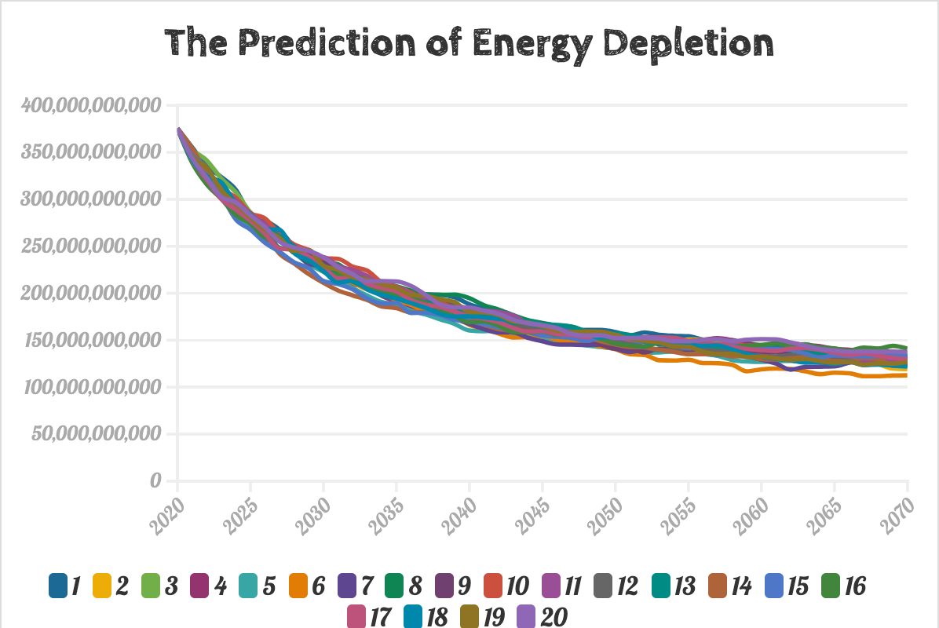

After 20 independent iterations of the experiment (different curves in the graph), we find that GHG emissions have reached an average reduction of about 40% by 2030, exceeding the target and reaching a healthy level by 2070. And energy depletion lives up to expectations, with an average reduction of 60% in 2050, well in line with the target. With the GGDP criteria, the vision of the Paris Agreement seems more achievable and has been realized.

5.4 有效性模型
5.4.1 Health Model 灵敏度分析
5.4.2 潜在优势和劣势 挑具体几个国家分析 语文

5.5 为某个国家手术
5.5.1 经济状况 GDP/GGDP 支持后代的能力 可持续性分析 DEA

- 技术性报告
- 睡觉
-------

Step1：综合绿色GDP指标体系构建理论基础
- 投入产出分析的基本概念
投入产出分析是在一定经济理论指导下通过编制投入产出表构建相应的投入产出模型，全面地、系统地分析国民经济各部门、社会再生产各环节之间的数量依存关系的一种数量分析方法。它是经济学、统计学和数学相结合的产物是对具有复杂联系现象进行经济数量分析的一种方法。
所谓投入是指从事一项经济活动消耗或占用。主要是指生产活动中对原材料、辅助材料、燃料、办公用品、服务、劳动力、机器设备等资源或要素的消费或占用，它是人类生产生活的条件。所谓产出，是指生产活动的成果，即从事经济活动而得到的货物和服务的总量以及它们的分配使用去向，其中既包括了中间使用又包括最终使用。
国民经济在实现实物运动和价值运动过程中各个部门 、社会再生产各环节之间存在着极其复杂的生产技术联系和经济联系。生产部门的生产成果即为另外一些部门的生产投入一种产品的产出会影响其他产品的产出一种产品的价格也会影响其他产品或服务的价格。同时随着生产的发国民经济内在的联系会更趋复杂。尽管如此但它们之间的内在联系可概括为消耗和被消耗即投入和产出之间数量依存的关系。因此可以从投入与产出的角度来研究国民经济的复杂联系。
Step2:综合绿色GDP指标选取原则
- 科学性原则
假设、界定合理，体结构清晰、分类正确。统计方法要求规范，测算方法合理，确保测算结果不仅反映社会经济活动对环境与资源的利用动态，而且也能反映自然生态系统对人类提供的福祉。
- 与现有国民经济核算相衔接原则
综合绿色GDP核算体系属于国民经济核算体系的附属账户，因此，综合绿色GDP核算体系应尽可能与现有的国民经济核算的基本原则、规范及其重要核算指标相互衔接。
- 与国际接轨原则
SEEA-2012为国民经济核算提供了国际统一的统计标准，要尽可能地参照SEEA-2012的国际统计标准,并将自己国家的GGDP与其他国家或地区进行横向比较。
- 资源、环境和生态服务核算并重原则
综合绿色GDP核算体系涵盖了三个主要领域的统计：（１）经济生产过程中的资源量的变化量；（２）与经济活动有关的环境质量变化量；（３）生态系统服务价值。因此，综合绿色GDP核算体系应遵守资源、环境和生态服务核算并重原则。
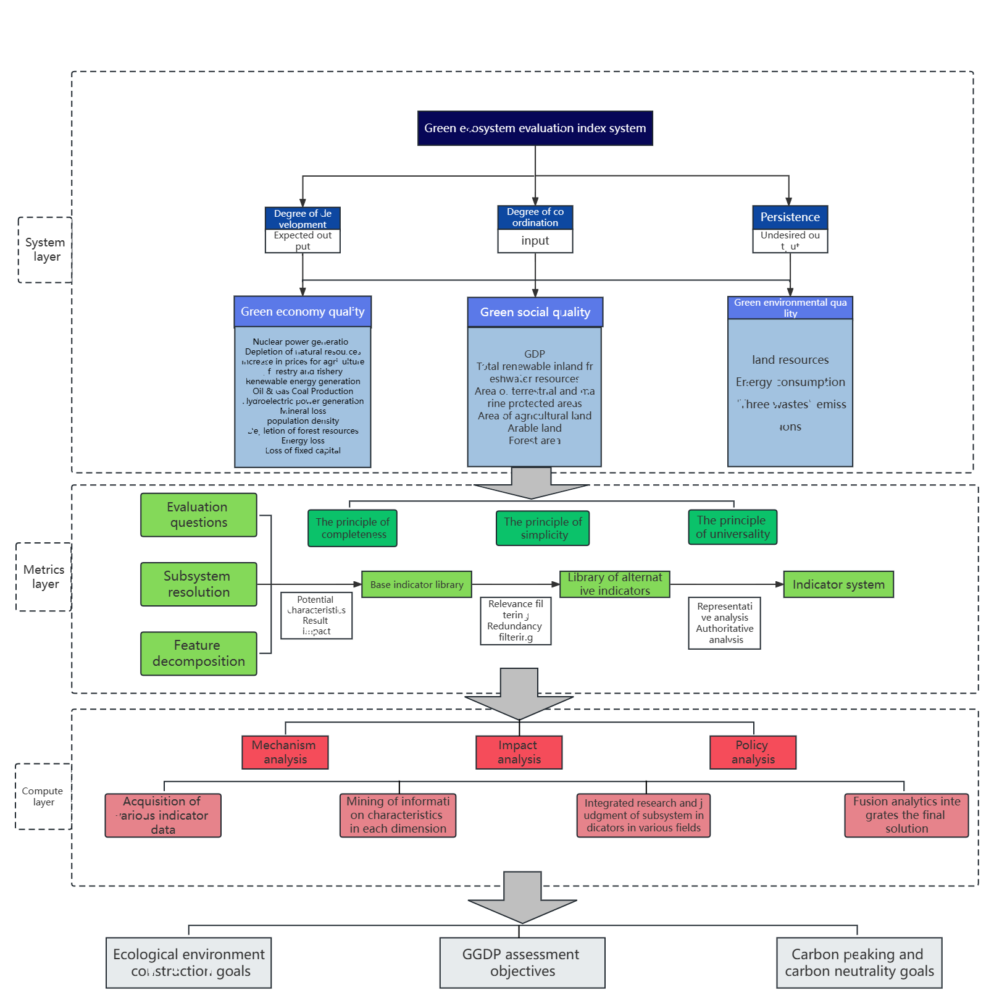

Step6: GGDP核算并分类

Step7:基于DEA的GGDP评价模型
Data envelopment analysis (DEA) is one of the most common methods in the analysis of the performance of universities. There are several models of DEA. Among them, the CCR model by Charnes, Cooper and Rhodes, has a simple form and a complete theory .The model is easy to understand and perform.
Without prior weights on the inputs and outputs, DEA can be used to evaluate the relative efficiency among multiple-input and multiple-output different decision making units (DMUs) . In a one-input, one-output situation, efficiency is usually defined as the ratio of output over input. Similarly, the efficiency is defined as follow:
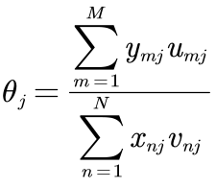
Where 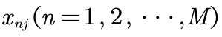,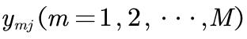 represent N inputs and M outputs of the 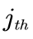 DMU respectively, with the corresponding input weights and output weights 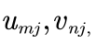with all inputs, outputs and weights non-negative. Thus the analysis to the performance of the system is transformed to the following linear programing problem:
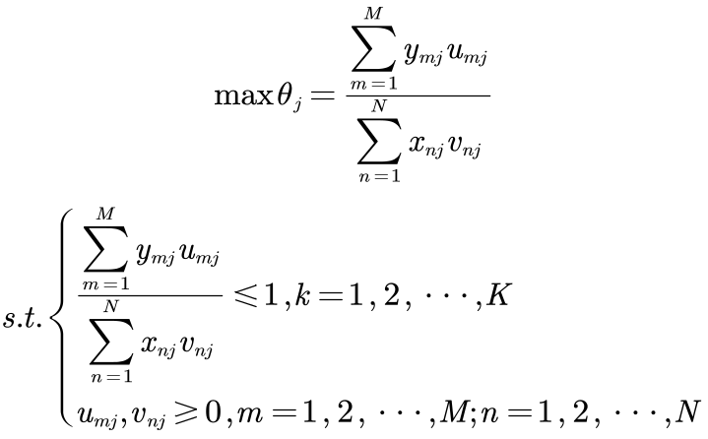
where K is the total of DMUs. If the optimal solution of the above problem exists and 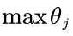is 1,
then we can judge this DMU is effective, meaning the corresponding ratio of outputs to inputs can be
maximized.
Step8:基于 Super-SBM 模型的生态效率测算法 （基于评价指标体系）
因为我们团队研究侧重绿色GDP的可持续发展，绿色GDP高水平意味着全球能用较少的资源消耗和环境代价取得社会经济的较大发展，因此选择采优于传统 CCR/ BCC 模型的非期望产出的 Super-SBM 模型，该模型考虑了要素的“松弛”影响，能够有效解决忽略非期望产出而导致效率评价结果偏差的问题，能弥补传统 DEA 模型无法对有效决策单元进行排序和区分的缺陷，对各个国家能够更好地进行GGDP测度。
假定存在n个样本国家，将每个国家作为一个决策单元构造生产前沿，每个决策单元使用m种投入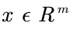，得到种期望产出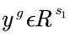和种非期望产出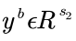。定义矩阵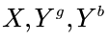分别为：
假设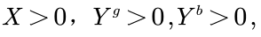可以将生产可能性集合定义为：
生产可能性函数种的三个不等式分别表示实际投入水平不低于前沿投入水平，实际期望产出水平不超过前沿期望水平，实际非期望产出不低于前沿非期望产出水平，其数学规划式如下：
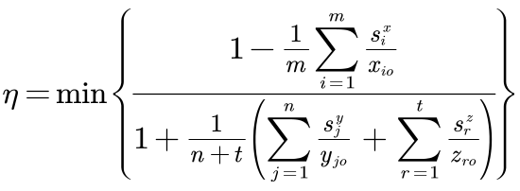

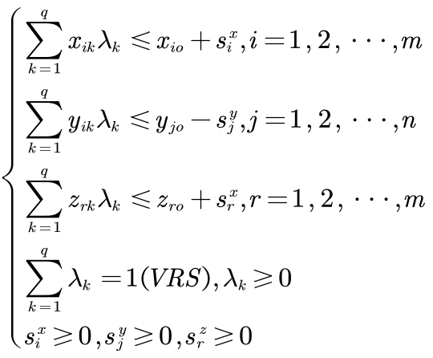
其中，为规模报酬可变（VRS）的决策单元q的超效率值，即第q个沿线国家的可持续发展效率值，当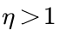时，DMU为DEA无效，即改DMU的投入或产出需要做出相应调整，当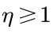时，DMU为DEA有效；min为最小函数；假设社会系统有q个同质DMU，单个DMU都有m种投入，n种期望产出以及t种非期望产出；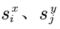和分别为投入、期望产出和非期望产出的松弛变量，即投入、期望产出和非期望产出能够优化的量；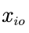为第o个决策单元对第i类输入的投入量，期望产出量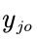和非期望产出量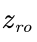可以以此类推；为第k个DMU线性规划的权重系数；VRS表示规模报酬可变。

Step9:评价部分结果分析：
通过Super-SBM模型，我们得到了相邻两年的效率比。基于可持续性和GGDP趋势的四个方面，我们提出了以下标准：
如果在过去【】年里，一个国家的效率连续3年下降，那么这个国家的制度被认为是不可持续的。
如果在过去五年中，一个国家的效率只有连续两年下降，那么该体系的可持续性就被认为很差。
如果在过去五年中，一个国家的效率下降不超过一年，那么这个国家的体系就被认为是高度可持续的。
在第一种情况下，我们认为该系统无法保持其有效性。在第二种场景中，系统有时可以保持当前的状态。最后，我们相信波动是存在的，但一个高度可持续的系统可以迅速从衰退中恢复过来。

Step10:基于马尔科夫链的GGDP预测模型建立
In the 21st century, with the signing of the Kyoto Protocol and the Paris Agreement, climate change has attracted more and more attention from the United Nations and heads of state, we take the carbon reduction targets agreed in the Paris Agreement as the standard for measuring global climate change, specifically divided into global greenhouse gas emissions and global coal, oil and gas consumption, in the output of forecasts, mainly observe the impact of these three indicators on the country.
·Our Vision and Comparison
The problems in global GGDP are complex and serious, and it is difficult to make changes simply. In order to analyze the positive impact and the negative impact on the global GGDP, we have to build our vision for different period of time. With the goal of achieving a comprehensive GGDP establishment (OPG = 1), we have formulated the following three-phase vision for short-term, medium-term and long-term.
·Short-term vision:
Normalize the main indicators (including school enrollment, employment rate, and related indicators) in 10 - 15 years. The first requirement for disease treatment is to prevent the deterioration of GDP. Similarly, for the higher GGDP over the world, our vision is to prevent the deterioration of the higher GGDP and make it develop sustainably. Compared with the current situation, the OPG value in every country, which has realized its short-term vision, will be greater than 0.7324. At the same time, the stability of the system will be greatly improved, from a downward trend to an upward trend.
• Mid-term vision:
Adjust the remaining indicators except the number of countries to make the system close to the sub-health state in 50 years. Through economic development, We gradually improve 自然资源损耗国际标准， According to the best estimate, in about 50 years, global GGDP will break through zero, while other indicators
will basically normalize. The value of OPG will be close to 0.8799, reaching the lower bound of sub-good. Compared with the previous sustainable growth rate, it will gradually slow down and approach a steady state.
• Long-term (final) vision
build a healthy GGDP assessment system in a hundred years. Through centuries of continuous efforts, gradually increase the number of countries using the system. Our vision is to make the value of OPG equal to 1, while maintaining sustainability without decline. This is the final destination for our policies.

For the long-time vision, the main factor, through Markov chain, we can set specified goals for the
government to achieve. Here is the implementation timeline for health status:
【长期预测】

For the sustainability part, our policies begin with curing and maintaining a sustainable system, so【初期预测结论】With short-term and mid-term visions achieved, the【中长期预测结论】，growth of sustainability slows down and shows a stable trend. Using DEA-Malmquist model, we can plot the timeline for sustainability. Through our observation, we can conclude that all our visions are achieved properly.
【DEA结果图】

5.2.3第二问模型结果分析

5.2.4 Model 稳健性（或灵敏性）检验

  - Step1:
  - Step2:
  - Step3:

  - Step4:
  - Step5:
  - Step6:
  - Step7:
  - Step8:
  - Step9:

（1）
公示居中，后面要标序号
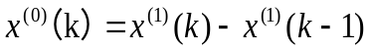 （2）

5.2.5 Results

表格要有标头，居中，在表格上方。

VI. Error Analysis and Sensitivity Analysis

Error Analysis

Error Analysis of Model One

Error Analysis of Model Two

Error Analysis of Model Three

Sensitivity Analysis

Sensitivity Analysis of Model One

Sensitivity Analysis of Model Two

Sensitivity Analysis of Model Three

VII. Evaluation and Promotion of Model

Strength and Weakness

7.1.1 Strength

Weakness:

Promotion

Ⅷ. Conclusions

Conclusions of the problem

Methods used in our models

给国家领导人的政策建议
致：国家领导人
日期：2023年1月21日
主题：建议采纳全球GGDP评估体系
落实调整环境问题严重地区的碳排放量，减少东西部地区绿色GDP差距和绿色发展效率差距。经过对中国东西部GGDP的实证分析，我们发现不同地区的GGDP排名与GDP排名呈反相关关系，因此要实现地区之间绿色GDP发展平衡，需要从缩小地区之间绿色经济增长质量开始。
开展绿色GDP试点取得经验，建立我国绿色GDP核算体系。在我们团队选取的样本国家中，中国在GGDP评价体系中的排名相比较于GDP排名有所下降，目前由于资源环境与市场化的进程密不可分的，因此，随着我国市场经济的不断完善，资源、环境市场的逐渐形成，实行绿色GDP的可能性会越来越大。
加大绿色科技创新力度。在我们团队对发达国家和发展中国家的GGDP预测研究中，我们发现引进绿色GDP会给现有的经济带来一定的负面影响，我们需要保持经济和绿色生态的动态平衡，国家及地方政府应当鼓励企业积极的引入绿色生产技术，通过技术升级来减少能源的消耗。
建立“回收-再利用-设计-生产”的循环经济模式生态业园区。我们团队通过【】模型进行人口预测，得出【】，因此，发展循环经济是绿色经济的重要一环。通过不同企业之间形成共享资源，交互衔接，上游生产过程中产生的废物成为下游生产的原料,达到闭合的生态工业网络，在人口爆炸的今天，我们可以实现资源高效回收利用。
Best wishes
2308685团队

I X. References
[1] Xu Lun Hui,Luo Qiang,Fu Hui.Car following safe distance model based on braking process of leading vehicle f [J].Journal of Guangxi Normal University(Natural Science Edition),2010,28(1):1-5.
[2]

[3]

[4]

X. Appendix

Appendix One
美赛中可以有附录也可以没有附录，即此部分可以省略

Appendix Two

