Problem Chosen  F | 2023  MCM/ICM  Summary Sheet | Team Control Number  2308685

2023 Mathematical Contest in Modeling (MCM) Summary Sheet
Title（此处应写论文标题）
Summary
美赛论文的摘要的英文一般用Summary，摘要最好在本页完成。
标题为16号Times New Roman字体加粗并居中
摘要为14号Times New Roman字体加粗并居中
关键词为12号Times New Roman字体加粗并居左
行间距一般为1倍行距，为控制在一页可适当调整。
首页不需要页眉和页码。
“00000”修改为自己的控制编号（Team Control Number），“A”改为自己的选题题号（A/B/C/D/E/F）

使用此模板可以开始输入电子报告的第一页（摘要页）。这个模板使用了一个12点倍的新罗马字体。将您的论文以Adobe PDF电子文件（例如1111111.pdf）的形式提交，以英文输入，可读字体至少为12点类型。 不要在本页或任何页面上包括您的学校、顾问或团队成员的姓名。 论文必须在25页的限制范围内。 请务必更改上面的控制编号和问题选择。

Key words: 三到五个关键词

注：红色字为解释说明部分，使用时应全部删除或换成黑色字。

Contents
I. Introduction 3
1.1 Background 3
1.2 Our works 3
II. The Description of the Problem 4
2.1 Problem statement 4
2.2 Analysis of Specific Issues 4
2.2.1 Analysis of Problem 1 4
2.2.2 Analysis of Problem 2 4
2.2.3 Analysis of Problem 3 4
2.2.4 Analysis of Problem 4 5
III. Basic assumption 5
IV. Glossary & Symbols 5
4.1 Glossary 5
4.2 Symbols 6
V. Models 6
5.1 Analysis and Solving of Question One 6
5.1.1 Model Preparation 6
5.1.2 Model Establishment 7
5.1.3 Results 8
5.1.4 Analysis of the Result 8
5.2 Analysis and Solving of Question Two 8
5.2.1 Model Preparation 8
5.2.2 Model Establishment 9
5.2.3 Results 10
5.2.4 Analysis of the Result 10
5.3 Analysis and Solving of Question Three 10
5.3.1 Model Preparation 10
5.3.2 Model Establishment 12
5.3.3 Results 12
5.3.4 Analysis of the Result 13
5.4 Analysis and Solving of Question Four 13
5.4.1 Model Preparation 13
5.4.2 Model Establishment 14
5.4.3 Results 14
5.4.4 Analysis of the Result 15
VI. Error Analysis and Sensitivity Analysis 15
6.1 Error Analysis 15
6.1.1 Error Analysis of Model One 15
6.1.2 Error Analysis of Model Two 15
6.1.3 Error Analysis of Model Three 16
6.2 Sensitivity Analysis 16
6.2.1 Sensitivity Analysis of Model One 16
6.2.2 Sensitivity Analysis of Model Two 16
6.2.2 Sensitivity Analysis of Model Three 16
VII. Evaluation and Promotion of Model 17
7.1 Strength and Weakness 17
7.1.1 Strength 17
7.1.2 Weakness: 17
7.2 Promotion 17
Ⅷ. Conclusions 17
8.1 Conclusions of the problem 17
8.2 Methods used in our models 18
I X. References 18
X. Appendix 18
10.1 Appendix One 18
10.2 Appendix Two 19

从目录开始有页眉和页码，把“00000”改为自己的控制编号，页码会自动调整可以不用编辑。

I. Introduction

Background
工业革命以来，人类社会生产高速发展，人们的物质生活得到了极大提高，但同时自然资源的加速耗竭和生态环境的极大破坏将人类自身置于 “资源－环境”双重压迫的窘境。这也使得当前以应对气候变化为主要内涵的国际环境谈判不再只是单纯的环境事务， 而是涉及到未来各国争取发展空间和选择发展道路的问题，关乎各国重大的政治和经济利益。环境和生态是一个国家综合经济的一部分，现行国民经济核算体系由于没有将环境和生态因素纳入其中，因而不能全面反映国家的真实经济情况。GDP统计中存在着一系列明显缺陷，但长期以来没有得到修正。绿色GDP是对GDP指标的一种调整，是扣除了经济活动中投入的资源和环境成本后的国内生产总值。在新形势下，必须加快绿色GDP的研究与运用，使其为落实科学发展观提供重要的数据支持。为抢占未来全球经济发展的制高点，各国政府纷纷寻求绿色发展之路。如美国提出绿色新政， 出台了《美国清洁能源和安全法案》; 日本已制定 “绿色发展战略” 总体规划，在可预见的未来，绿色经济将引导出一个全球的经济新格局。
GDP 的核算中是以牺牲自然资源和生态环境为代价，只计算了人类所创造的这部分财富的价值。因此， GDP 只反映一个国家(地区)经济增长的数量，并不能真实反映其增长的质量。寻求一种考虑自然资源和环 境资源的损耗成本因素来衡量一个国家(地区)真实状况的核算方。随着国家生态文明建设的深入推进，重启地区绿色GDP研究的呼声日益高涨。据《中国青年报》调查，有 96. 4% 的公众认为我国有必要进行绿色 GDP 核算工作，“十三五”规划也强调资源和环境是未来生态文明建设的重点领域，应将其纳入经济社会发展体系中。绿色 GDP可以兼顾发展和可持续两项原则，弥补传统 GDP 未能衡量自然资源 消耗和生态环境破坏的缺陷。因此，研究绿色 GDP 及其评价方法对地区社会经济可持续发展具有重要理论和现实意义

Our works

- Task 1

- Task 2

- Task 3

- Task 4

II. The Description of the Problem

Problem statement

Analysis of Specific Issues

Analysis of Problem 1
针对问题一，我们需要利用文献法，搜集相关已有的GGDP核算体系，目前已有的相关计算方法有：GGDP核算方法包含GDP、环境退化成本和生态破坏成本三大部分；GeGDP核算方法包含资源耗减成本和环境降级成本；GrDP核算方法；MEWGDP核算方法，我们团队在搜集完方法之后，统一都列出了每种方法的计算公式。

Analysis of Problem 2

针对问题二，我们需要在问题一所给出的模型的基础上，建立基于DEA-TOPSIS的组合评价模型，我们考虑到每个国家的环境资源的实际情况、气候变化的具体情况和人口数量等其它因素的差异，所以我们需要在评估模型中衡量不同指标的权重，用来区分出不同国家的不同指标，最终得出每个国家的GGDP得分，通过K-means聚类划分出以GGDP为依据的发达国家和发展中国家，对每类国家的实际情况通过马尔科夫链条模型进行预测。

Analysis of Problem 3
针对问题三，我们主要任务就是具体分析出用GGDP替代GDP后对气候造成的积极影响和消极影响从而证明GGDP构建的合理性，因此我们需要对气候变化数据和GDP进行预测，我们将预测分为短期、中期、长期，直到收敛为止，然后，我们通过相关性检验比较出预测前的GGDP与气候变化的趋势和预测后GGDP的变化与气候变化之间的关联性，观察灰色关联系数的变化趋势从而得出对气候减缓的关联性。此外还需要对模型的精度进行检验，通过精度的不同也可以反映出优势与劣势。使用传统预测模型的话（灰色预测），就需要进行精度检验，使用机器学习模型的话就需要对R²、MSE、RMSE等评价指标进行比较。

Analysis of Problem 4

III. Basic assumption
- The convection of water inside the bath tub does not affect the current water temperature. The reason is that heat exchange caused by convective occurs only between the parts of the water in the bathtub, this process does not get heat exchange from the outside of the system, in other words, only water temperature distribution changed.

IV. Glossary & Symbols

Glossary
- Load degree: V / C is maximum traffic service divided by basic capacity under ideal conditions,. The basic capacity is the maximum amount of traffic on the four-hour service level half.

Symbols
Symbols | Definition | Units
Z | The index of development | J
CI | Coordinated index of development | J
DI | Sustainability index of development | J
A | Economic index of development | J
B | Social index of development | K
C | Environment index of development | K
F | Impact index value | km³
S | Reality index value | m
 | Influence coefficient | m²

V. Models

5.1Analysis and Solving of Question One
5.1.1绿色GDP概念
绿色GDP "的概念是指大量调整后的GDP指标，其中包括环境污染和开发的成本以及社会成本，这就是为什么绿色GDP是衡量一个 国家的经济增长由于社会和环境破坏而产生的货币效应的另一种方式。特别是，绿色GDP作为增长经济学中的一种先进的测量方法，可以提供关键的数据，用来检验古典经济学中关于GDP和增长源之间的联系的传统假设。
5.1.2项目筛选
投入产出分析技术在绿色 GDP 核算中得到了充分应用，但是一方面，SEEA 理论不便于分析绿色 GDP 总量的结构，仅能提供总量指标；另一方面，尽管绿色投入产出理论能分析其结构，但是它为了研究资源和环境，增加了资源恢复部门和环境治理部门。表格中只是列出了实物资产与环境资产，以便反映各部门对实物资产与环境资产的占用，但指标体系中控制数还是总产出和增加值，它仅仅是把资源、环境因素都放入投入产出表中而构成经济、资源、环境投入产出表而已。因此，此时的投入产出矩阵只是原投入产出矩阵的加边矩阵，不便于分行业核算资源耗减和环境降级。
基于DPSIR的TOPSIS绿色GDP评价模型核算准确率有所提升，它遵循了 GGDP 核算和评价的基本原理，同时它可以根据实情做了部分调整，从各子系统绩效来看，各子系统的贴近度都有所提升，且与真实值的变化趋势相比较，它的贴近度变化趋势差异逐渐减小。驱动力子系统、状态子系统、响应子系统贴近度上升速度最快，压力子系统和影响子系统贴近度提升幅度较小，且比较影响子系统贴近度的波动。综合来看基于DPSIR的TOPSIS绿色GDP评价模型有很广阔的提升空间。
目前可搜集到的有关计算方法有：
·GGDP
GGDP核算由国内生产总值、环境退化成本和生态破坏成本三部分组成。
(1)环境退化成本：大气污染、水污染和土壤污染会导致环境退化。大气污染导致的环境退化成本主要包括大气污染治理成本和生活清洁费用增加成。
(2)生态破坏成本：流域内生态破坏成本核算主要是针对因人类不合理利用森林、草地、湿地和农田生态系统，从而导致的生态调节服务损失。
GGDP=国内生产总值-环境退化成本-生态破坏成本
环境退化成本=EnDCa+EnDCw+EnDCs
生态破坏成本=EcDCf+EcDCg+EcDCw+EcDCa
其中：EnDC为环境退化成本，EnDCa为大气污染环境退化成本，EcDCw为水污染环境退化成本，EnDCs为土壤污染环境退化成本，EcDCf是森林生态系统破坏损失，EcDCg是草地生态系统破坏损失，EnDCw是湿地生态系统破坏损失，EcDCa是农田生态系统破坏损失。
·GeGDP
GGDP的值小于GDP的值，即GeGDP的值等于在现行GDP核算值的基础上，再减去以下两项数值：一项称"资源耗减成本"，另一项称"环境降级成本"。
GeGDP = GDP -资源耗减成本-环境降级成本。
·GrDP
它扩展了国内生产总值的范围，将自然、社会和自然资源的消耗纳入考虑范围。这一新衡量标准是通过从标准国内生产总值衡量标准中减去与生产商品和服务相关的外部成本计算得出的。
·MEWGDP
MEWGDP是衡量家庭年度实际消费的模型，称为经济福利衡量标准，MEW调整了GDP，它另外了包括闲暇时间、无偿工作和环境破坏的价值。还定义了可持续的水电部（MEW-S）的值，其工作是更复杂的可持续发展措施的先驱。

将DEA方法与其它模型结合使用，比如，DEA与Malmquist结合，从不同的角度对DMU的效率进行测算或基于效率展开进一步的分析与研究，达到了跨越不同时期分析的效果。有一些学者将DEA方法与Tobit回归方法相结合，该方法首先用DEA方法对DMUs的相对效率进行测算，再运用Tobit回归模型对影响DEA效率值的影响因素进行分分析，还有学者将DEA方法与TOPSIS评价模型相结合，针对传统DEA模型无法对有效地对DMUs进行排序的问题，建立了基于DEA的组织多属性决策的DEA－TOPSIS组合方法，它可以测算具有多种投入多种产出指标的组织的效率以及各投入产出指标的松弛改进量。运用TOPSIS方法的可以实现有效DMUs的排序问题。它首先运用DEA模型测算DMUs的相对效率，并基于效率确定决策目标和备选方案。然后，根据DEA方法中各指标的松弛改进量构造各方案的决策矩阵，并运用TOPSIS方法对备选方案进行排序。DEA－TOPSIS组合方法不仅可以有效地对基于效率的决策备选方案进行排序，还可以通过选择不同的模型和指标处理方法来尽可能地反映实际情况，具有很强的实践性。
所以我们团队选择了基于DEA的TOPSIS模型。

5.2 Analysis and Solving of Question Two
5.2.1Data Processing
5.2.2 Model Establishment
Step1：综合绿色GDP指标体系构建理论基础
投入产出分析的基本概念
投入产出分析是在一定经济理论指导下通过编制投入产出表构建相应的投入产出模型，全面地、系统地分析国民经济各部门、社会再生产各环节之间的数量依存关系的一种数量分析方法。它是经济学、统计学和数学相结合的产物是对具有复杂联系现象进行经济数量分析的一种方法。
所谓投入是指从事一项经济活动消耗或占用。主要是指生产活动中对原材料、辅助材料、燃料、办公用品、服务、劳动力、机器设备等资源或要素的消费或占用，它是人类生产生活的条件。所谓产出，是指生产活动的成果，即从事经济活动而得到的货物和服务的总量以及它们的分配使用去向，其中既包括了中间使用又包括最终使用。
国民经济在实现实物运动和价值运动过程中各个部门 、社会再生产各环节之间存在着极其复杂的生产技术联系和经济联系。生产部门的生产成果即为另外一些部门的生产投入一种产品的产出会影响其他产品的产出一种产品的价格也会影响其他产品或服务的价格。同时随着生产的发国民经济内在的联系会更趋复杂。尽管如此但它们之间的内在联系可概括为消耗和被消耗即投入和产出之间数量依存的关系。因此可以从投入与产出的角度来研究国民经济的复杂联系。
Step2:综合绿色GDP指标选取原则
经济发展过程中必然消耗资源，产生经济价值和带来环境负效益，也即投入大量资源，经过社会生产活动后获得一定的经济增长（期望产出），同时产生废弃物（非期望产出）影响环境。依据新经济增长理论及数据可得性，确定生态效率测算的投入和产出指。由于工农业生产生活中需要消耗大量能源、水资源、土地资源、人力资源和物质资本等，投入指标从这五要素选取有代表性的代理变量。产出指标分为有期望产出和非期望产出，期望产出通常选择代表经济发展总量的 GDP 作为指标，非期望产出则选择代表污染物排放量的“三废”等其它作为指标。
Step3：综合绿色GDP指标体系构建
表 1
countries | 1 | 2 | 3 | 4 | 5
1 | Argentina | Czech Republic | Ireland | New Zealand | South Korea
2 | Australia | Denmark | Israel | Norway | Spain
3 | Austria | Egypt | Italy | Pakistan | Sweden
4 | Belarus | Estonia | Japan | Philippines | Switzerland
5 | Belgium | Finland | Kazakhstan | Poland | Thailand
6 | Brazil | France | Lebanon | Portugal | Turkey
7 | Canada | Germany | Malaysia | Russia | Ukraine
8 | Chile | Greece | Mexico | Saudi Arabia | United Arab Emirates
9 | China | India | Mongolia | Singapore | United Kindom
10 | Colombia | Iodonesia | Netherlands | South Africa | United States

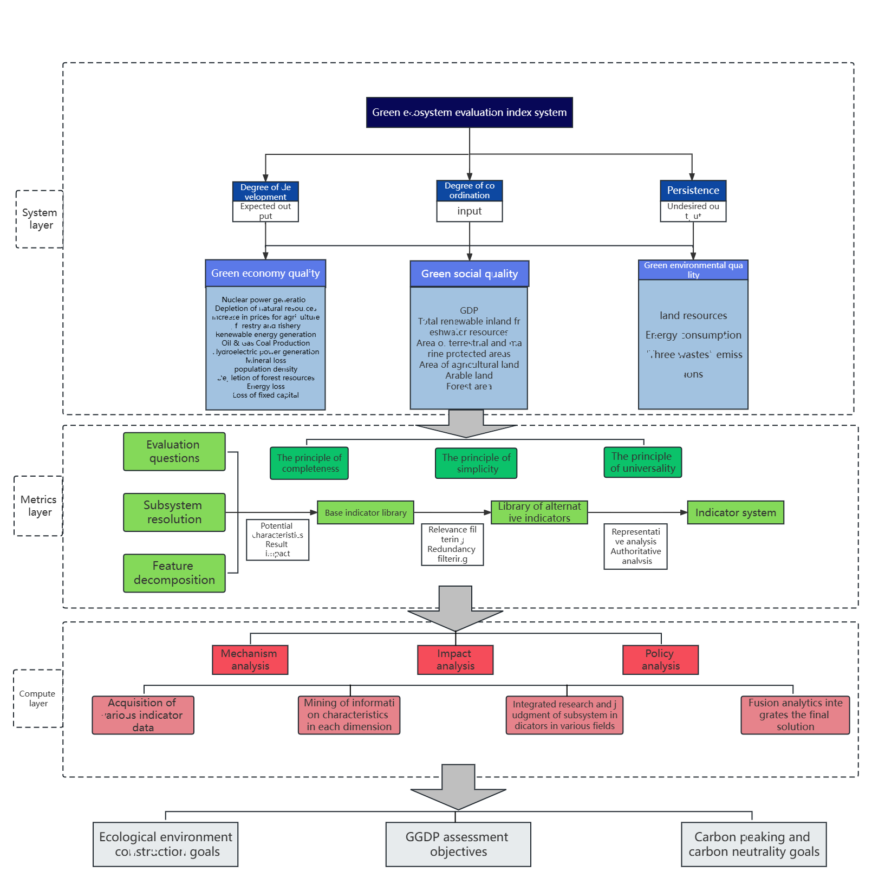

Step4：AHP确定指标权重
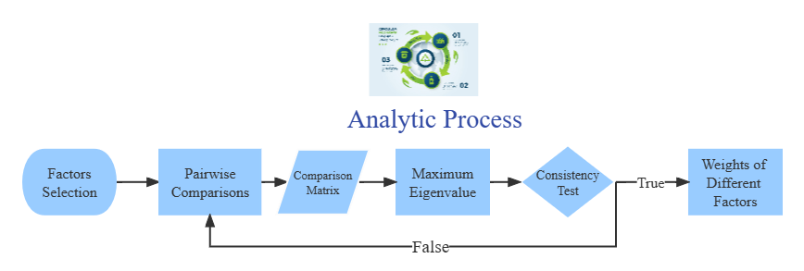
Analytic Hierarchy Process (AHP) is an accurate approach for quantifying the weights of decision criteria, widely used in different decision situations, in fields like government, business, healthcare, shipbuilding, industry and education [8]. In our analysis, we use this method to determine weights of different main factors. Similarly, we determine the weights of different indicators in each factor. The following are the steps.
• Factors selection: We have selected several main factors previously. For each main factor, we have chosen some indicators as well.
• Pairwise comparisons between different factors
According to pairwise comparisons, we establish priorities among the factors. We think that the importance of main factors satisfies the following relationship:
• Calculation of comparison matrix: With the relationship discussed before, we get our comparison matrix 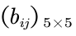
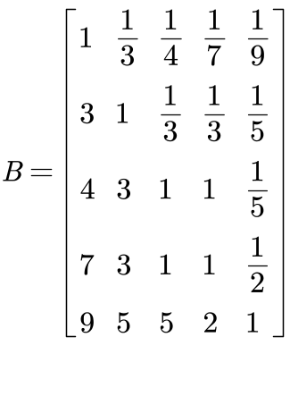
Where Fi for i = 1, 2, · · · , 6 represent investment, access, education, research, equity, attraction respectively.
• Consistency Test：We can calculate the eigenvalues and eigenvectors of the matrix before. Next we need to perform consistency test with the maximum eigenvalue 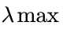.
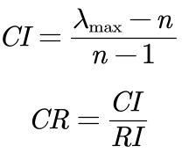
判断矩阵的CR值为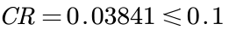,thus the comparison matrix is acceptable.
• Calculation of weights Passing the consistency test, we can get the weights of main factors by the eigenvector corresponding to the maximum eigenvalue, they are as follow:

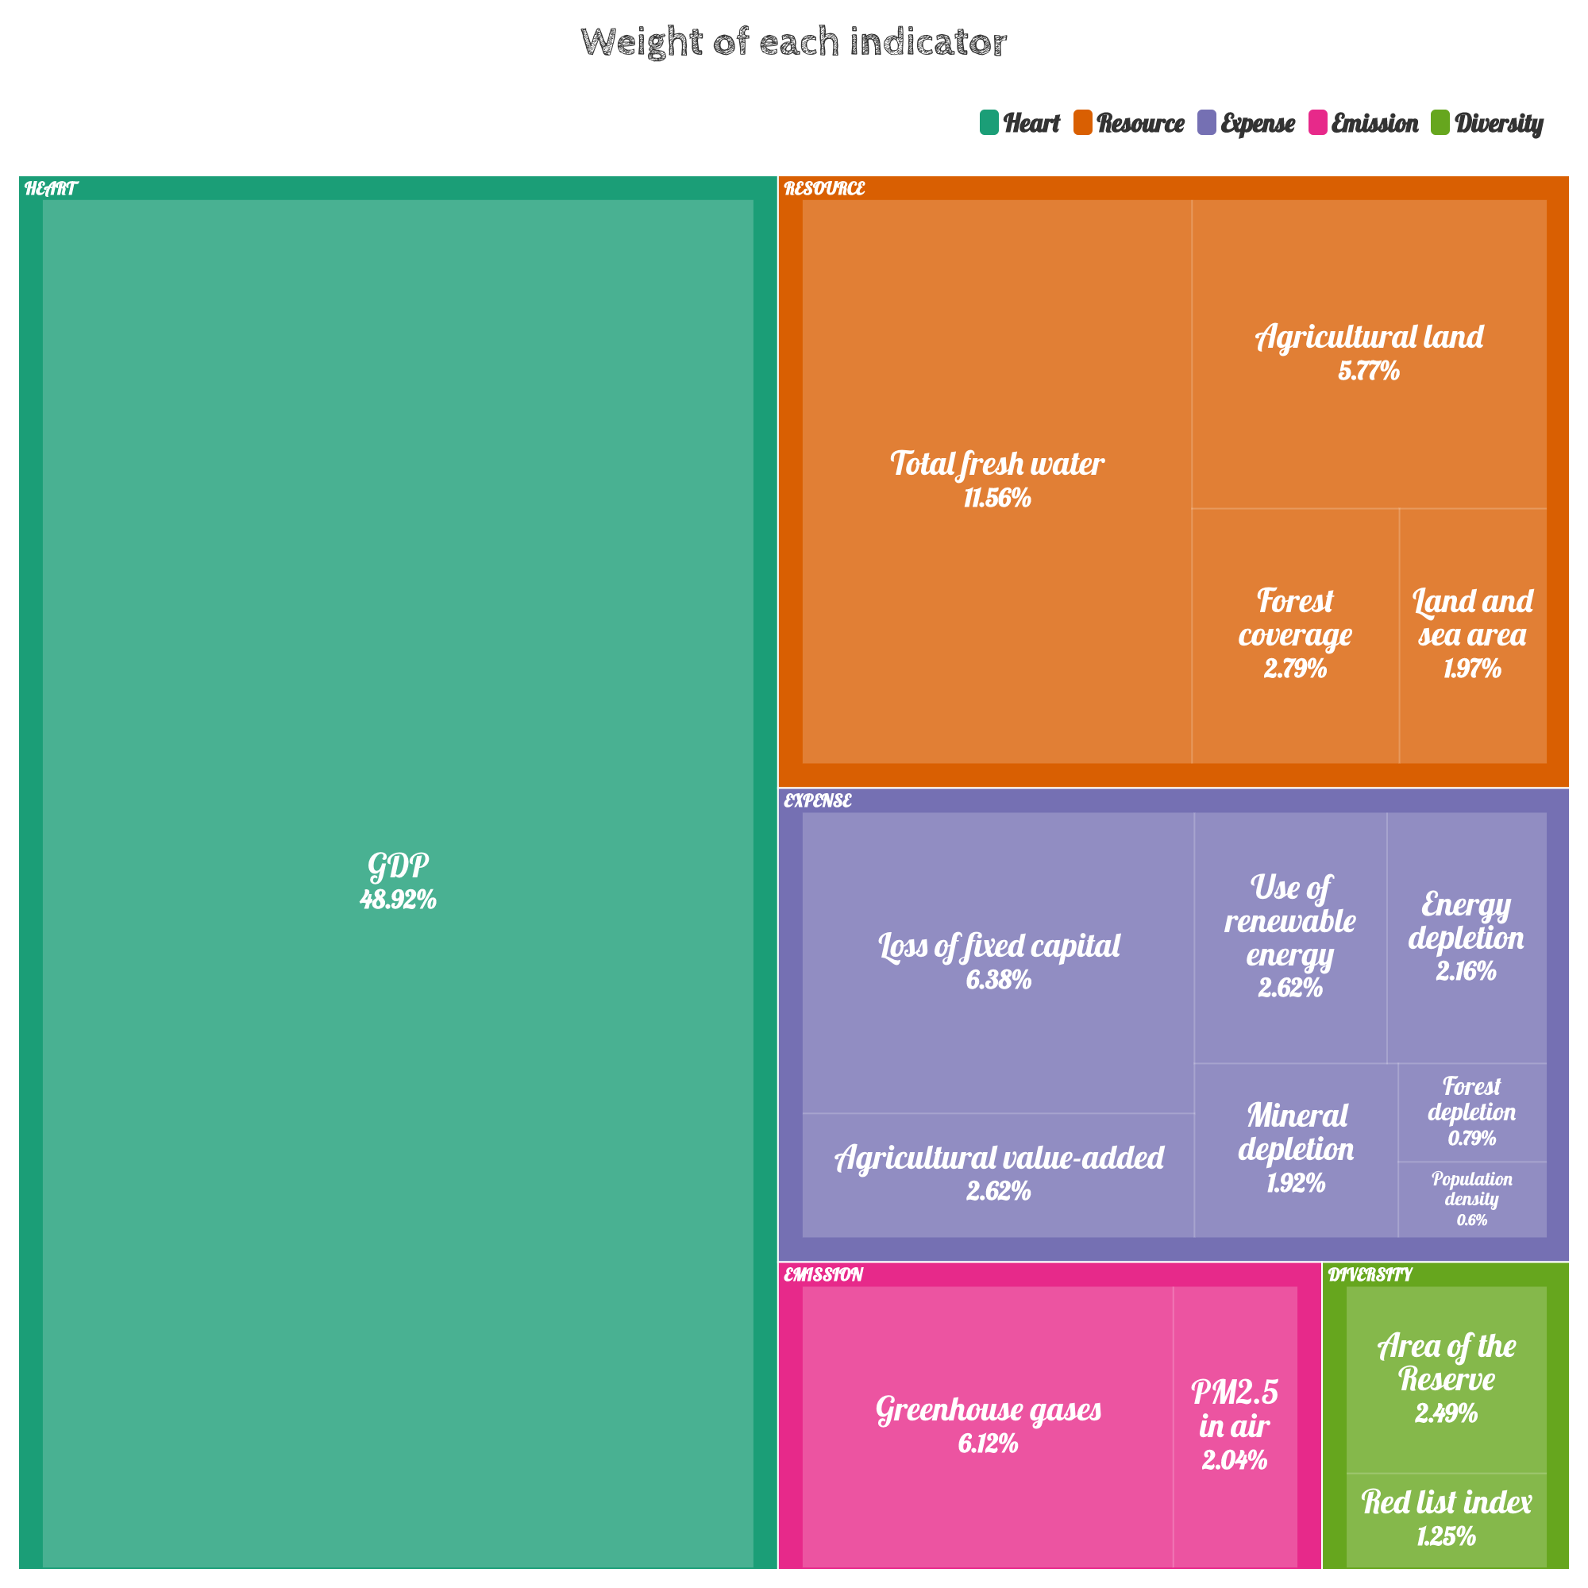

表 2
1st Indicator | 2nd Indicator | Unit (%)
Heart | GDP | 48.92
Resource | Total fresh water | 11.56
Resource | Agricultural land | 5.77
Resource | Forest coverage | 2.79
Resource | Land and sea area | 1.97
Expense | Loss of fixed capital | 6.38
Expense | Agricultural value added | 2.62
Expense | Use of renewable energy | 2.62
Expense | Energy depletion | 2.16
Expense | Mineral depletion | 1.92
Expense | Forest depletion | 0.79
Expense | Population density | 0.6
Emission | Greenhouse gases | 6.12
Emission | PM2.5 in air | 2.4
Diversity | Area of the reserve | 2.49
Diversity | Red list index | 1.25

Select Health Range
我们根据已经求出的的权重，By applying analysis from QS Rankings, we fix the ratio of GGDP to 0.8. This shows that 80% of the population is healthy. Based on the assumptions, we have developed the following principles
for healthy range selection.
• Positive indicators: Select the sample data from high to low 80% quantile as the estimator of the overall lower bound2.
• Negative indicators: Select the sample data from low to high 80% quantile as the estimator of the
overall upper bound.
• Others: Estimate the distribution law of the population through the sample and determine the
interval.
The GGDP range corresponding to positive and negative indicators is better given, and what needs
to be considered is the distribution law of other indicators: GDP and population density. By drawing
the frequency histograms of these two indicators, we found that they have a law similar to the normal
distribution. In order to verify this conjecture, we performed the Kolmogorov - Smirnov test (K-S test)
on these two indicators using SPSS. Due to space limitations, the detailed principles of K-S test will
not be discussed here, only the results will be shown.
表 3: Single sample Kolmogorovs-Minov test
 |  | Population density | GDP
abs |  | 50 | 245
Normal parameter | Average value | 4.3942 | 25.2529
Normal parameter | SD | 1.53211 | 2.99909
Extreme difference | Absolute value | 0.1 | 0.06
Extreme difference | Positive value | 0.084 | 0.06
Extreme difference | Negative value | -0.1 | -0.033
Inspection statistic |  | 0.1 | 0.06
Progressive significance(bilateral) |  | .200 | 0.031

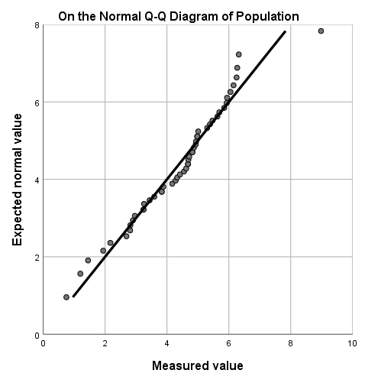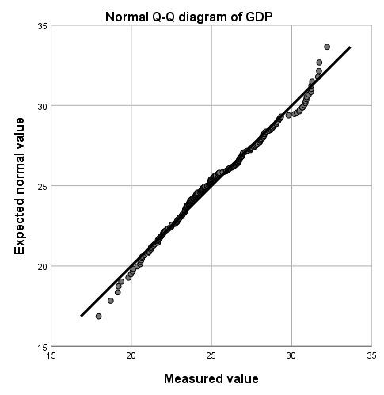
Given the significance level α = 0.05, we obtain the results of the K-S test for the two indicators, as
shown below. Since the significance levels for both indicators are above α, we can conclude that they
all passed the K-S test. Here are the Q-Q plots of the two data to verify the correctness of the results. It can be seen that the data points are distributed near the straight line, and the results of the K-S test can be accepted.
In result, the acceptable health range of the two can be given by using normal distribution proper ties.
指标范围表
表 4
Indicator | Upper Bound | Lower Bound
GDP
Total fresh water
Agricultural land
Forest coverage
Land and sea area
Loss of fixed capital
Agricultural value added
Use of renewable energy
Energy depletion
Mineral depletion
Forest depletion
Population density
Greenhouse gases
PM2.5 in air
Area of the reserve
Red list index

GGDP核算
We use a simple acceptance/rejection model (0-1 model) to determine the GGDP conditions.
The overall GGDP condition can be measured with point gain and the occurring problem can be
located. For each indicator i, if the value falls in the range of GGDP, the point = 1, otherwise = 0.
is the weight of indicator i. We caculated the point gain with the equation below:
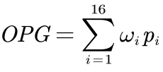
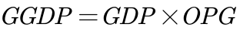
Overall point gain (OPG) describes the GGDP condition of a system, but only when its value is 1 can
it prove that the system is completely proper. If the OPG value is too low, it means that the GGDP of the country
has at least one main indicator or a large number of secondary indicators that are wrong. We have classified the health status as follows:
• Good: OPG = 1, showing that all indicators are normal.
• Sub-good: OPG ⩾ 0.9, showing that the system has small problems.
•Not good: 0.6 ⩽ GGDP < 0.9, showing that one or more main indicators are wrong, which can be improved.
• Extremely not good: 0.4 ⩽ GGDP < 0.6, showing that the overall problem of the system is serious, and more reasonable construction of higher education is needed.
• Serious: 0.2 ⩽ GGDP < 0.4, showing that the higher education system is seriously out of balance and cannot perform its normal functions.
• Bad: GGDP ⩽ 0.2, showing that the country has no higher education system.
The following figure shows the lower bound for each status more intuitively.
【画图GGDP】

基本DEA模型
Data envelopment analysis (DEA) is one of the most common methods in the analysis of the performance of universities. There are several models of DEA. Among them, the CCR model by Charnes, Cooper and Rhodes, has a simple form and a complete theory . The model is easy to understand and perform.
Without prior weights on the inputs and outputs, DEA can be used to evaluate the relative efficiency among multiple-input and multiple-output different decision making units (DMUs) . In a one-input, one-output situation, efficiency is usually defined as the ratio of output over input. Similarly, the efficiency is defined as follow:
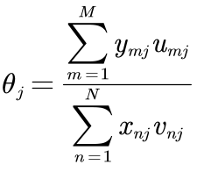
Where 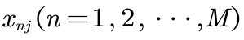,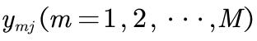 represent N inputs and M outputs of thw 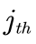 DMU respectively, with the corresponding input weights and output weights 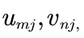with all inputs, outputs and weights non-negative.
Thus the analysis to the performance of the system is transformed to the following linear programing problem:
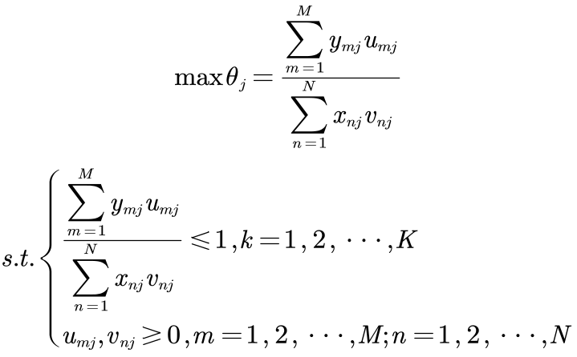
where K is the total of DMUs. If the optimal solution of the above problem exists and 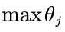is 1,
then we can judge this DMU is effective, meaning the corresponding ratio of outputs to inputs can be
maximized.
基于 Super-SBM 模型的生态效率测算法 （基于评价指标体系）
因为我们团队研究侧重绿色GDP的可持续发展，绿色GDP高水平意味着全球能用较少的资源消耗和环境代价取得社会经济的较大发展，因此选择采优于传统 CCR/ BCC 模型的非期望产出的 Super-SBM 模型，该模型考虑了要素的“松弛”影响，能够有效解决忽略非期望产出而导致效率评价结果偏差的问题，能弥补传统 DEA 模型无法对有效决策单元进行排序和区分的缺陷，对各个国家能够更好地进行GGDP测度。
假定存在n个样本国家，将每个国家作为一个决策单元构造生产前沿，每个决策单元使用m种投入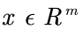，得到种期望产出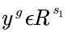和种非期望产出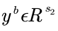。定义矩阵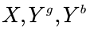分别为：
假设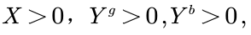可以将生产可能性集合定义为：
生产可能性函数种的三个不等式分别表示实际投入水平不低于前沿投入水平，实际期望产出水平不超过前沿期望水平，实际非期望产出不低于前沿非期望产出水平，其数学规划式如下：
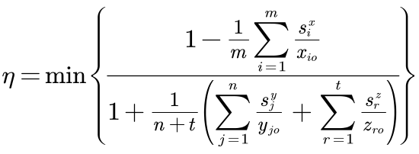

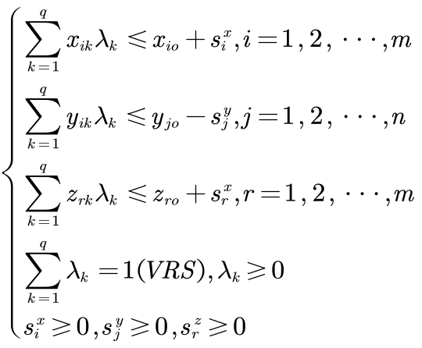
其中，为规模报酬可变（VRS）的决策单元q的超效率值，即第q个沿线国家的可持续发展效率值，当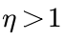时，DMU为DEA无效，即改DMU的投入或产出需要做出相应调整，当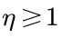时，DMU为DEA有效；min为最小函数；假设社会系统有q个同质DMU，单个DMU都有m种投入，n种期望产出以及t种非期望产出；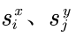和分别为投入、期望产出和非期望产出的松弛变量，即投入、期望产出和非期望产出能够优化的量；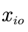为第o个决策单元对第i类输入的投入量，期望产出量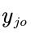和非期望产出量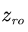可以以此类推；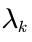为第k个DMU线性规划的权重系数；VRS表示规模报酬可变。

评价部分结果分析：通过Super-SBM模型，我们得到了相邻两年的效率比。基于可持续性和GGDP趋势的四个方面，我们提出了以下标准：
如果在过去【】年里，一个国家的效率连续3年下降，那么这个国家的制度被认为是不可持续的。
如果在过去五年中，一个国家的效率只有连续两年下降，那么该体系的可持续性就被认为很差。
如果在过去五年中，一个国家的效率下降不超过一年，那么这个国家的体系就被认为是高度可持续的。
在第一种情况下，我们认为该系统无法保持其有效性。在第二种场景中，系统有时可以保持当前的状态。最后，我们相信波动是存在的，但一个高度可持续的系统可以迅速从衰退中恢复过来。

绿色健康预测模型
In the 21st century, with the signing of the Kyoto Protocol and the Paris Agreement, climate change has attracted more and more attention from the United Nations and heads of state, we take the carbon reduction targets agreed in the Paris Agreement as the standard for measuring global climate change, specifically divided into global greenhouse gas emissions and global coal, oil and gas consumption, in the output of forecasts, mainly observe the impact of these three indicators on the country
·Our Vision and Comparison
The problems in global GGDP are complex and serious, and it is difficult to make changes simply. In order to analyze the positive impact and the negative impact on the global GGDP , we have to build our vision for different period of time. With the goal of achieving a comprehensive GGDP establishment (OPG = 1), we have formulated the following three-phase vision for short-term, medium-term and long-term.
·Short-term vision: Normalize the main indicators (including school enrollment, employment rate, and related indicators) in 10 - 15 years. The first requirement for disease treatment is to prevent the deterioration of GDP. Similarly, for the higher GGDP over the world, our vision is to prevent the deterioration of the higher GGDP and make it develop sustainably. Compared with the current situation, the OPG value in every country, which has realized its short-term vision, will be greater than 0.7324. At the same time, the stability of the system will be greatly improved, from a downward trend to an upward trend.
• Mid-term vision: Adjust the remaining indicators except the number of countries to make the system close to the sub-health state in 50 years. Through economic development, We gradually improve 自然资源损耗国际标准， According to the best estimate, in about 50 years, global GGDP will break through zero, while other indicators
will basically normalize. The value of OPG will be close to 0.8799, reaching the lower bound of sub-good. Compared with the previous sustainable growth rate, it will gradually slow down and approach a steady state.
• Long-term (final) vision: build a healthy GGDP assessment system in a hundred years. Through centuries of continuous efforts, gradually increase the number of countries using the system. Our vision is to make the value of OPG equal to 1, while maintaining sustainability without decline. This is the final destination for our policies.
GGDP Implementation Model Realized by Using Markov Chain
Since we have selected indicator healthy range for each indicator, we put forward specific policy recommendations for its ‘unhealthy’ indicators to converge towards “healthy” However, our indicators can only provide the direction for the changes, the efficiency can’t be specified. In that case, we believe that the effect of GGDP implementation is a random process. In order to facilitate subsequent modeling, we make the following assumptions based on the general assumptions:
• One of the three states of model implementation is excuted every year: good, poor, counter -productive. If the GGDP is effectively implemented, the indicator will change quickly to approach the normal value, but if the policy is not effectively implemented, the indicator state will remain unchanged or even worse.
• The state that happens in the next year depends on the current state and value of current indicators. If the GGDP system functions well in the previous year, it is easier to implement in the next year. Moreover, the closer the current indicator is to the normal, the weaker the GGDP system plays. This assumption is made in consideration of the relationship between the degree
of unhealthy indicators and the role of policies. The unhealthier the indicators, the greater the willingness to implement the corresponding GGDP system and the greater the acceptability of the countries. On the contrary, if the indicators are reaching the health limit, the GGDP system will not result so obvious.
• Under the control of the GGDP system, unhealthy calculation indicators will eventually reach normal values. The policies are flexible. When the effect is reduced due to its close to the normal value, the GGDP calculation process will be adjusted appropriately, and finally the index will converge to the normal value. We model with the assumptions above, determine the to use Markov chain to predict the trend of indicators under policy intervention. We believe that GGDP implementation effect (GIE) and buffer (BU) are factors determining the current state and they are random variables, whose distribution are shown below. Since the difference between the current value and the normal value of the index (DCN) affects the policy intensity, we add it to the distribution function of GIE to represent its role. The distribution law of GIE and BU is shown in the following table:

表 5
Last state | GIE | BU | Distribution law
Good | 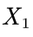 | 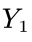 | 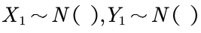
Poor | 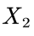 | 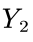 | 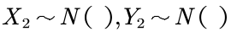
Counterproductive | 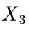 | 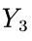 | 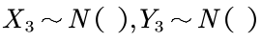
The variable k is used to control the severity of the value change. It varies from indicator to indicator. As for modeling, if 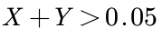, it indicates that the policy is in good state. If 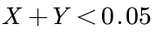, it indicates that the GGDP system has counterproductive effect. With the discussion above, we can use the indicator value of the i-th year to determine the value of the (i + 1)-th year, and the transfer equation can be given in the following form:
Implementation of model
Based on the above model, we have predicted the effect of the implementation of GGDP system. Due to the
large amount of forecast data, we choose the changes of each stage to reflect the overall changes. For the short-term vision, we import the GGDP system, export the Paris Agreement climate standard system. We applying flexible policies to both indicators, the prediction curves are as follows:
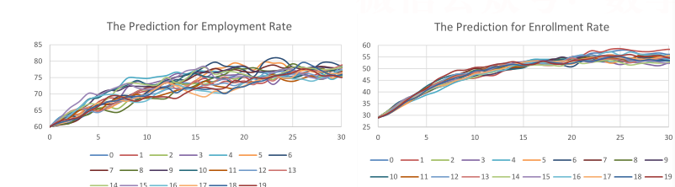
After twenty independent repeated experiments (different curves in the plot), we found that【巴黎协定气候变化体系】achieves the lower bound of health range with the average of 10 years and 【巴黎协定气候变化体系】turns normal in about 13 years. The short-term vision seem to be achieved success fully.
As for the mid-term vision, it can be represented by 【Climate change standard system】。For the vision we proposed, its value would turn normal in 50 years. The Markov chain gives out prediction results shown below:
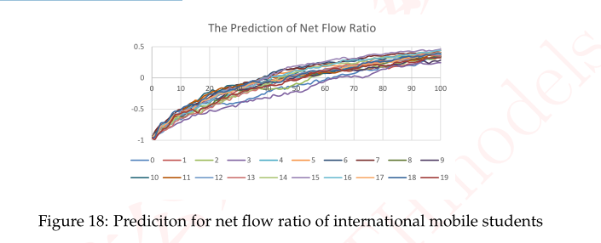
【图表结论】
For the long-time vision, the main factor, through Markov chain, we can set specified goals for the
government to achieve. Here is the implementation timeline for health status:
【长期预测】
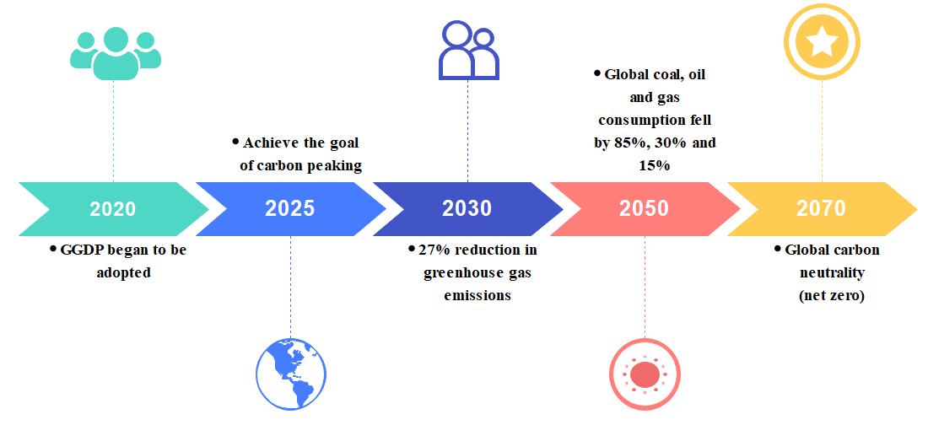
For the sustainability part, our policies begin with curing and maintaining a sustainable system, so【初期预测结论】With short-term and mid-term visions achieved,the【中长期预测结论】，growth of sustainability slows down and shows a stable trend. Using DEA-Malmquist model, we can plot the timeline for sustainability. Through our observation, we can conclude that all our visions are achieved properly.

由于我们为GGDP选定了划分层次的范围，为了具体地预测出每个不同类别的国家的GGDP水平，我们假设【】是随机变量，指标变化只能为预测提供方向，在这种情况下，我们认为GGDP预测执行的效果是一个随机的过程。
Step1:样本选取：选取模型的输入观测序列，包括每年每个国家的每个指标的数据，组成一个原始矩阵
Step2:确定隐状态数目：隐状态数目分别选取【】、【】、【】个，运用OEHS准则进行模型检验，确定模型隐状态的个数，将观测序列分为两组，一组是由位于序列奇数位置的数据组成的序列，另一组是由位于序列偶数位置的数据组成的序列，对奇偶序列随机产生15组初始分布、转移概率矩阵和混合正态分布，通过EM算法对参数进行训练，直至迭代次数到达100次为止。【画出HMM模型的状态参数】
基于交叉检验似然值的OEHS准则得到的表如上，隐状态为【】的变化量最小，为【】，因此，该模型最稳定的隐状态数模为【】状态。
Step3:模型参数估计：随机产生模型的初始参数，包括初始状态的概率分布、状态转移概率矩阵、近似表示为混合正太分布的观测概率密度函数，运用python对模型的参数进行训练，通过逐步迭代，得到模型训练后的参数，即训练后的初始概率分布、状态转移概率矩阵以及观测概率密度函数
Step4:模型识别与预测：已知模型 λ = (A， B， π ) 和观测序列O=(o₁,o₂,…o_{T}),求对给定观测序列条件概率P(I |O) 最大的状态序列I=(i₁,i₂,…i_{T}). 即给定观测序列，求最有可能的对应的状态序列。

5.2.3第二问模型结果分析
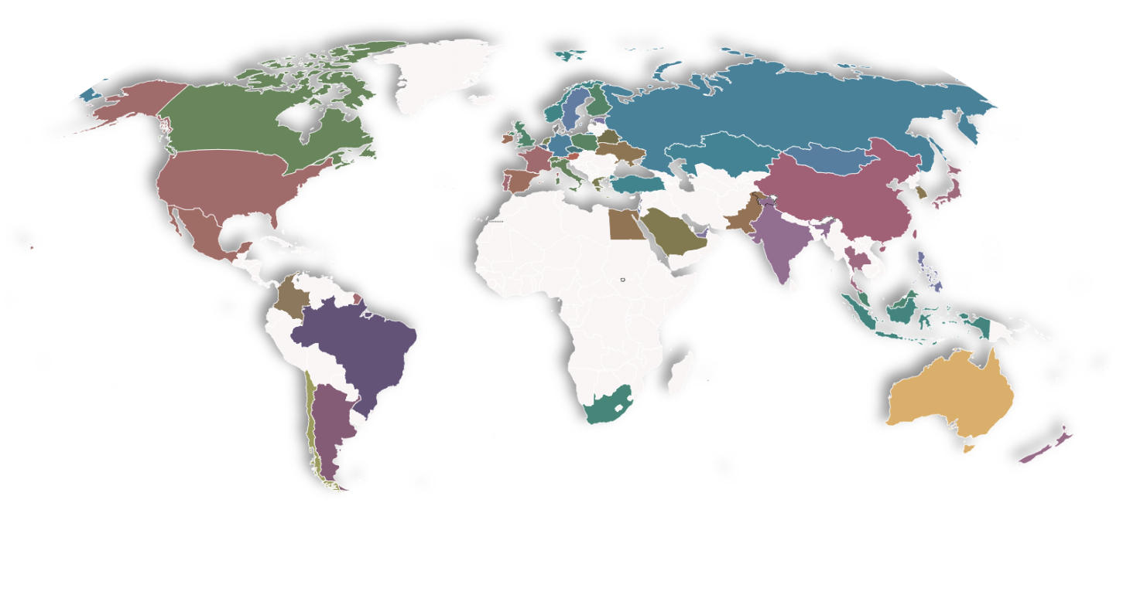

5.2.4 Model 稳健性（或灵敏性）检验

  - Step1:
  - Step2:
  - Step3:

  - Step4:
  - Step5:
  - Step6:
  - Step7:
  - Step8:
  - Step9:

（1）
公示居中，后面要标序号
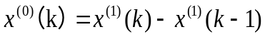 （2）

5.2.5 Results

表格要有标头，居中，在表格上方。
Table 2 The results of the model parameter value table

5.3Model Preparation问题三

(1) Data Processing

(2) Assumptions

(3) The Foundation of Model

Fig3. thinking research paper figure

Model Establishment
  - Step1:
  - Step2:
  - Step3:

  - Step4:
  - Step5:
  - Step6:
  - Step7:
  - Step8:
  - Step9:

Results

Analysis of the Result

Analysis and Solving of Question Three

Model Preparation
(1) Data Processing

(2) Assumptions

(3) The Foundation of Model

Fig4. thinking research paper figure

Model Establishment

  - Step1:
  - Step2:
  - Step3:

  - Step4:
  - Step5:
  - Step6:
  - Step7:
  - Step8:
  - Step9:

Results

Table 3 The results of the model parameter value table

Analysis of the Result

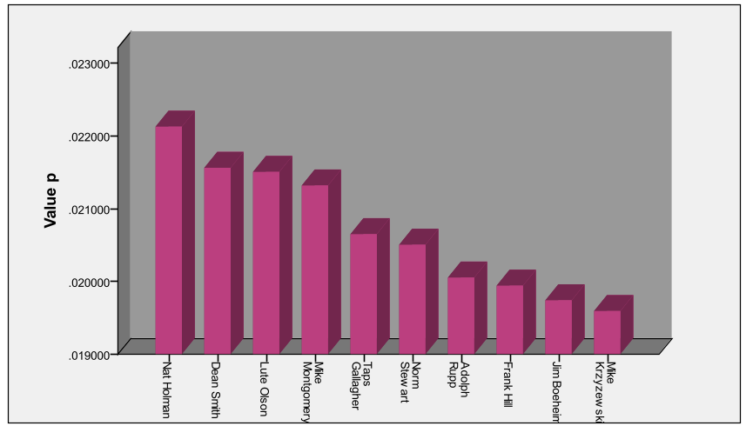
Fig5. Basketball Coaches

Analysis and Solving of Question Four

Model Preparation
(1) Data Processing

(2) Assumptions

(3) The Foundation of Model

Model Establishment

  - Step1:
  - Step2:
  - Step3:

  - Step4:
  - Step5:
  - Step6:
  - Step7:
  - Step8:
  - Step9:

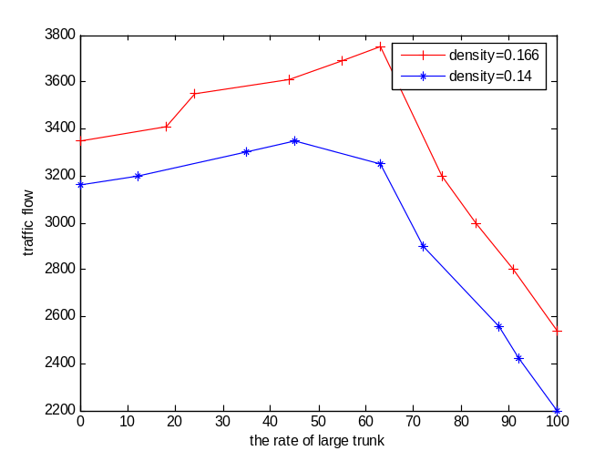
Fig6. Traffic flow changes with the rate of large truck

Results

Table 4 The results of the model parameter value table

Analysis of the Result

VI. Error Analysis and Sensitivity Analysis

Error Analysis

Error Analysis of Model One

Error Analysis of Model Two

Error Analysis of Model Three

Sensitivity Analysis

Sensitivity Analysis of Model One

Sensitivity Analysis of Model Two

Sensitivity Analysis of Model Three

VII. Evaluation and Promotion of Model

Strength and Weakness

7.1.1 Strength

Weakness:

Promotion

Ⅷ. Conclusions

Conclusions of the problem

Methods used in our models

给国家领导人的政策建议
致：国家领导人
日期：2023年1月21日
主题：建议采纳全球GGDP评估体系
落实调整环境问题严重地区的碳排放量，减少东西部地区绿色GDP差距和绿色发展效率差距。经过对中国东西部GGDP的实证分析，我们发现不同地区的GGDP排名与GDP排名呈反相关关系，因此要实现地区之间绿色GDP发展平衡，需要从缩小地区之间绿色经济增长质量开始。
开展绿色GDP试点取得经验，建立我国绿色GDP核算体系。在我们团队选取的样本国家中，中国在GGDP评价体系中的排名相比较于GDP排名有所下降，目前由于资源环境与市场化的进程密不可分的，因此，随着我国市场经济的不断完善，资源、环境市场的逐渐形成，实行绿色GDP的可能性会越来越大。
加大绿色科技创新力度。在我们团队对发达国家和发展中国家的GGDP预测研究中，我们发现引进绿色GDP会给现有的经济带来一定的负面影响，我们需要保持经济和绿色生态的动态平衡，国家及地方政府应当鼓励企业积极的引入绿色生产技术，通过技术升级来减少能源的消耗。
建立“回收-再利用-设计-生产”的循环经济模式生态业园区。我们团队通过【】模型进行人口预测，得出【】，因此，发展循环经济是绿色经济的重要一环。通过不同企业之间形成共享资源，交互衔接，上游生产过程中产生的废物成为下游生产的原料,达到闭合的生态工业网络，在人口爆炸的今天，我们可以实现资源高效回收利用。
Best wishes
2308685团队

I X. References
[1] Xu Lun Hui,Luo Qiang,Fu Hui.Car following safe distance model based on braking process of leading vehicle f [J].Journal of Guangxi Normal University(Natural Science Edition),2010,28(1):1-5.
[2]

[3]

[4]

X. Appendix

Appendix One
美赛中可以有附录也可以没有附录，即此部分可以省略

Appendix Two

