Problem Chosen  F | 2023  MCM/ICM  Summary Sheet | Team Control Number  2308685

2023 Mathematical Contest in Modeling (MCM) Summary Sheet
Title（此处应写论文标题）
Summary
美赛论文的摘要的英文一般用Summary，摘要最好在本页完成。
标题为16号Times New Roman字体加粗并居中
摘要为14号Times New Roman字体加粗并居中
关键词为12号Times New Roman字体加粗并居左
行间距一般为1倍行距，为控制在一页可适当调整。
首页不需要页眉和页码。
“00000”修改为自己的控制编号（Team Control Number），“A”改为自己的选题题号（A/B/C/D/E/F）

使用此模板可以开始输入电子报告的第一页（摘要页）。这个模板使用了一个12点倍的新罗马字体。将您的论文以Adobe PDF电子文件（例如1111111.pdf）的形式提交，以英文输入，可读字体至少为12点类型。 不要在本页或任何页面上包括您的学校、顾问或团队成员的姓名。 论文必须在25页的限制范围内。 请务必更改上面的控制编号和问题选择。

Key words: 三到五个关键词

注：红色字为解释说明部分，使用时应全部删除或换成黑色字。

Contents
I. Introduction 4
1.1 Background 4
1.2 Our works 4
II. The Description of the Problem 5
2.1 Problem statement 5
2.2 Analysis of Specific Issues 5
2.2.1 Analysis of Problem 1 5
2.2.2 Analysis of Problem 2 5
2.2.3 Analysis of Problem 3 5
2.2.4 Analysis of Problem 4 2
III. Basic assumption 2
IV. Glossary & Symbols 3
4.1 Glossary 错误！未定义书签。
4.2 Symbols 错误！未定义书签。
V. Models 3
5.1 Analysis and Solving of Question One 3
5.1.1 Model Preparation 4
5.1.2 Model Establishment 18
5.1.3 Results 19
5.1.4 Analysis of the Result 错误！未定义书签。
5.2 Analysis and Solving of Question Two 4
5.2.1 Model Preparation 错误！未定义书签。
5.2.2 Model Establishment 错误！未定义书签。
5.2.3 Results 错误！未定义书签。
5.2.4 Analysis of the Result 错误！未定义书签。
5.3 Analysis and Solving of Question Three 错误！未定义书签。
5.3.1 Model Preparation 错误！未定义书签。
5.3.2 Model Establishment 错误！未定义书签。
5.3.3 Results 错误！未定义书签。
5.3.4 Analysis of the Result 错误！未定义书签。
5.4 Analysis and Solving of Question Four 错误！未定义书签。
5.4.1 Model Preparation 错误！未定义书签。
5.4.2 Model Establishment 错误！未定义书签。
5.4.3 Results 错误！未定义书签。
5.4.4 Analysis of the Result 错误！未定义书签。
VI. Error Analysis and Sensitivity Analysis 19
6.1 Error Analysis 19
6.1.1 Error Analysis of Model One 19
6.1.2 Error Analysis of Model Two 20
6.1.3 Error Analysis of Model Three 20
6.2 Sensitivity Analysis 20
6.2.1 Sensitivity Analysis of Model One 20
6.2.2 Sensitivity Analysis of Model Two 20
6.2.2 Sensitivity Analysis of Model Three 20
VII. Evaluation and Promotion of Model 21
7.1 Strength and Weakness 21
7.1.1 Strength 21
7.1.2 Weakness: 21
7.2 Promotion 21
Ⅷ. Conclusions 22
8.1 Conclusions of the problem 22
8.2 Methods used in our models 22
I X. References 22
X. Appendix 23
10.1 Appendix One 23
10.2 Appendix Two 24

从目录开始有页眉和页码，把“00000”改为自己的控制编号，页码会自动调整可以不用编辑。

I. Introduction

Background
Environment and ecology are part of a country's comprehensive economy. The current national economic accounting system needs to reflect its financial situation entirely, but it does not include environmental and ecological factors. A series of apparent flaws in GDP statistics have not been corrected for a long time. GGDP is an adjustment to the GDP index, which is the gross domestic product after deducting the cost of resources and environment invested in economic activities.

Under the new situation, each Country should accelerate the research and application of GGDP to provide necessary data support for the implementation of the scientific concept of development. To seize the high ground of future global economic development, governments of various countries have sought the path of green development. The green economy will lead to a new international economic pattern in the foreseeable future.

Our works

- Task 1

- Task 2

- Task 3

- Task 4

II. The Description of the Problem

Problem statement

Analysis of Specific Issues

Analysis of Problem 1

In response to the first problem, we need to use the literature method to collect the relevant existing GGDP accounting methods, the current existing relevant calculation methods are: input-output model, TOPSIS green GDP evaluation model based on DPSIR, DEA combination model, after we collect the methods, we uniformly list the calculation formula of each method and analyze the advantages and disadvantages of the model.

Analysis of Problem 2
For question 2, we need to establish a combination evaluation model based on DEA-TOPSIS on the basis of the model given in question 1. We take into account the actual situation of environmental resources of each country, the specific situation of climate change and the difference of population and other factors, so we need to measure the weight of different indicators in the evaluation model. It is used to distinguish different indicators of different countries, and finally get the GGDP score of each country. Developed countries and developing countries based on GGDP are divided by K-means clustering, and the actual situation of each type of country is predicted by Markov chain model.

Analysis of Problem 3
In response to the third question, our main task is to specifically analyze the positive and negative impacts on the climate after replacing GDP with GGDP to justify the construction of GGDP, so we need to forecast climate change data and GDP, we divide the forecast into short-term, medium-term, long-term, until convergence, and then, we introduce population to form a validity model composed of three major factors of human, economic and environmental factors, by entering GGDP and GDP, Output the prediction of future GGDP and GDP, and then use the predicted GGDP and GDP to predict the population and energy consumption, greenhouse gas emissions and other indicators through the population stagnant growth prediction model, and then solve the comprehensive score through multiple linear regression and TOPSIS evaluation model, through this comprehensive score specifically shows the potential advantages and disadvantages, and also needs to test the accuracy of the model, through the difference in accuracy can also reflect the advantages and disadvantages.

2.2.4 Analysis of Problem 4

III. Basic assumption
To enable the model to reflect a country's economic health through GGDP accurately, we draw inspiration from the health assessment method of the medical system and make the following assumptions.

- The statistical data we collected from the website is accurate and reliable.

- The economy's overall health is only related to our assessment indicators.

- The indicators we choose have the same distribution law as economic population so that we can estimate the overall situation through samples.

- The population of the higher education system conforms to the hypothetical distribution law and can be used to measure health status. The population does not exist, which is inconsistent with the overall situation of all countries.

- Similar to the physical examination index, there is a specific interval to determine whether the index value is healthy.

- In a certain period, some indicators will not be affected by the implementation of GGDP and can be regarded as constants.

- Based on the above assumptions, we selected a good data set and used the processing method of the national economic health comprehensive evaluation standard under the corresponding GGDP standard.

IV. Symbols
Symbols | Definition | Units
Z | The index of development | J
CI | Coordinated index of development | J
DI | Sustainability index of development | J
A | Economic index of development | J
B | Social index of development | K
C | Environment index of development | K
F | Impact index value | km³
S | Reality index value | m
 | Influence coefficient | m²

V. Models

5.1Analysis and Solving of Question One
5.1.1 Concept of GGDP

The green gross domestic product (green GDP or GGDP) is an index of economic growth with the environmental consequences of that growth factored into a country's conventional GDP. Green GDP monetizes the loss of biodiversity and accounts for costs caused by climate change.

5.1.2 Accounting Method Filtering

- GGDP
GGDP accounting consists of three parts: gross domestic product, environmental degradation cost and ecological damage cost.
(1) Cost of environmental degradation: air pollution, water pollution and soil pollution will lead to environmental degradation. The cost of environmental degradation caused by air pollution mainly includes the increase of air pollution control cost and living cleaning cost.
(2) Cost of ecological damage: The cost accounting of ecological damage within the basin is mainly aimed at the loss of ecological regulation services caused by human's irrational use of forest, grassland, wetland and farmland ecosystem.
GGDP= Gross domestic Product - environmental degradation cost - ecological damage cost
Environmental degradation cost =EnDCa + EnDCw + EnDCs
Ecological damage cost =EcDCf + EcDCg + EcDCw + EcDCa
EnDC is the environmental degradation cost, EnDCa is the environmental degradation cost of air pollution, EcDCw is the environmental degradation cost of water pollution, EnDCs is the cost of soil pollution and environmental degradation, EcDCf is the damage loss of forest ecosystem, EcDCg is the damage loss of grassland ecosystem, EnDCw is the damage loss of wetland ecosystem, and EcDCa is the damage loss of farmland ecosystem.
- GeGDP
The value of GGDP is smaller than that of GDP, that is, the value of GeGDP is equal to subtracting the following two values on the basis of the current GDP accounting value: one is called "resource depletion cost", the other is called "environmental degradation cost".
GeGDP=GDP- resource depletion cost - environmental degradation cost.
- MEWGDP
MEWGDP is a model that measures annual real household consumption, called the Measure of Economic well-being. MEW adjusts GDP to include the value of leisure time, unpaid work and environmental damage.The values of the Ministry of Sustainable Water and Power (MEW-S), whose work is a precursor to more complex sustainable development measures, are also defined.
- DEA的组合模型
The DEA method is combined with other models, such as DEA and Malmquist, to measure the efficiency of DMU from different perspectives or conduct further analysis and research based on efficiency, achieving the effect of analysis across different periods.
Some scholars combine DEA method with Tobit regression method. In this method, DEA method is used to measure the relative efficiency of DMUs, and then Tobit regression model is used to analyze the influencing factors of DEA efficiency.
In addition, some scholars combined DEA method with TOPSIS evaluation model, aiming at the problem that traditional DEA model could not effectively rank DMUs, established DEA-TOPSIS combination method based on DEA for organizational multi-attribute decision making. It can measure the efficiency of organizations with multiple input-output indexes and the relaxation improvement of each input-output index. Using TOPSIS method can realize effective DMUs sequencing problem. First, DEA model is used to measure the relative efficiency of DMUs, and based on the efficiency, decision objectives and alternatives are determined. Then, according to the relaxation improvement of each index in DEA method, the decision matrix of each scheme is constructed, and the TOPSIS method is used to sort the alternative schemes. DEA-TOPSIS combination method can not only effectively sort the decision alternatives based on efficiency, but also reflect the actual situation as much as possible by selecting different models and indicator processing methods, which is highly practical. To sum up, our team chose a combination evaluation model based on DEA and TOPSIS.
5.2 Analysis and Solving of Question Two
5.2.1 Main Factors

To achieve the replacement of GDP with GGDP as the primary measure of the country's economic health, we need to make a new and reasonable assessment of the actual state of the country's economy, and we need to consider not only GDP as the primary indicator, but also to judge its impact on natural resources and climate. Similar to the definition of physical health, the health of a system refers to its ability to function correctly and to respond to external changes. A healthy national economic system not only has the function to indicate its financial strength but also to repair and renew itself according to the changes in natural resources and climate and to act back on them to achieve sustainable development of resources.

Based on the above definition, we have developed five factors to measure the economy's health after considering the use of natural resources, which are described below.

- Heart

Gross Domestic Product (GDP) is the final result of the production activities of all resident units in a country (or region) over a certain period. It has long been recognized as the core indicator of national economic accounting and an essential indicator of a country's or region's financial status and development. In our new economic system, it deserves to occupy the heart position.

- Resource

Resource is an evaluation of the level of natural resource holdings in different countries. Its content is vibrant, and we have chosen four indicators to describe it: total freshwater, agricultural land, forest coverage, and land and sea area. The development of society and the progress of science and technology require the development and use of more and more natural resources. This indicator allows for determining the maximum total amount of natural resources available to the country.

- Expense

Expense is a comprehensive assessment of national resource consumption in each country, which is described as seven indicators: loss of fixed capital, agricultural value-added, use of renewable energy, energy depletion, mineral depletion, forest depletion and population density. Fixed capital is the loss in use value and value caused by the use of resources in production and processing and the impact of natural forces. Agricultural value-added is the value added by agricultural, forestry, and fishery production. The use of renewable energy is the value added by the use of renewable energy. The use of renewable energy reflects the development of renewable energy sources and the efforts made by the country in the sustainability of resources; energy depletion, mineral depletion, and forest depletion are the three significant resource losses in the country's economic development. Population density is a reflection of the use of land resources.

- Emission

Emissions are a count of national contributions to global climate change in each country. According to the Kyoto Protocol, greenhouse gas emissions profoundly impact global climate change, and we have selected the emissions of six gases (CO2, CH4, N2O, HFCs, PFCs, SF6), which are subject to emission limits, as the total greenhouse gas emissions. In addition, with the increase in air pollution, PM2.5 not only becomes a significant factor affecting global climate but also endangers human life and health.

- Diversity

Diversity is a measure of the national biological resources of each country. Biological resources are a valuable asset given by nature to each country. Following the UN Millennium Development Goals, we have selected the area of the reserve and the red list index indicators to assess biodiversity.

5.2.2 Data Selection

We used the same dataset but different evaluation methods to evaluate health status and climate impacts. To assess health status, we will calculate the data weights and list the leading indicators, thus constructing a confidence interval similar to the pathology test.

The approach to assessing climate impacts is slightly different. We use the carbon reduction target agreed upon in the Paris agreement as a measure of global climate change, divided explicitly into global greenhouse gas emissions and global energy consumption over the next 50 years after adopting the GGDP standard.

Below is a table of selected indicators. The letter 'P' in the Impact column indicates that the indicator positively impacts GGDP. ' N' refers to the opposite. Specific indicators can have a negative effect on the results when they are too high or too low.

When they are too high or too low, they can negatively affect the results, so we assign them the letter 'M'.

Considering hypotheses 3 and 4 and that the main contributors to climate impacts tend to be countries that are more developed in the economy or natural resources, we surveyed a random sample of these countries for their indicators from 2010 to 2020. The selected example of 50 is shown below.

Countries | 1 | 2 | 3 | 4 | 5
1 | Argentina | Czech Republic | Ireland | New Zealand | South Korea
2 | Australia | Denmark | Israel | Norway | Spain
3 | Austria | Egypt | Italy | Pakistan | Sweden
4 | Belarus | Estonia | Japan | Philippines | Switzerland
5 | Belgium | Finland | Kazakhstan | Poland | Thailand
6 | Brazil | France | Lebanon | Portugal | Turkey
7 | Canada | Germany | Malaysia | Russia | Ukraine
8 | Chile | Greece | Mexico | Saudi Arabia | United Arab Emirates
9 | China | India | Mongolia | Singapore | United Kindom
10 | Colombia | Iodonesia | Netherlands | South Africa | United States

Here is a map showing the countries we have chosen.

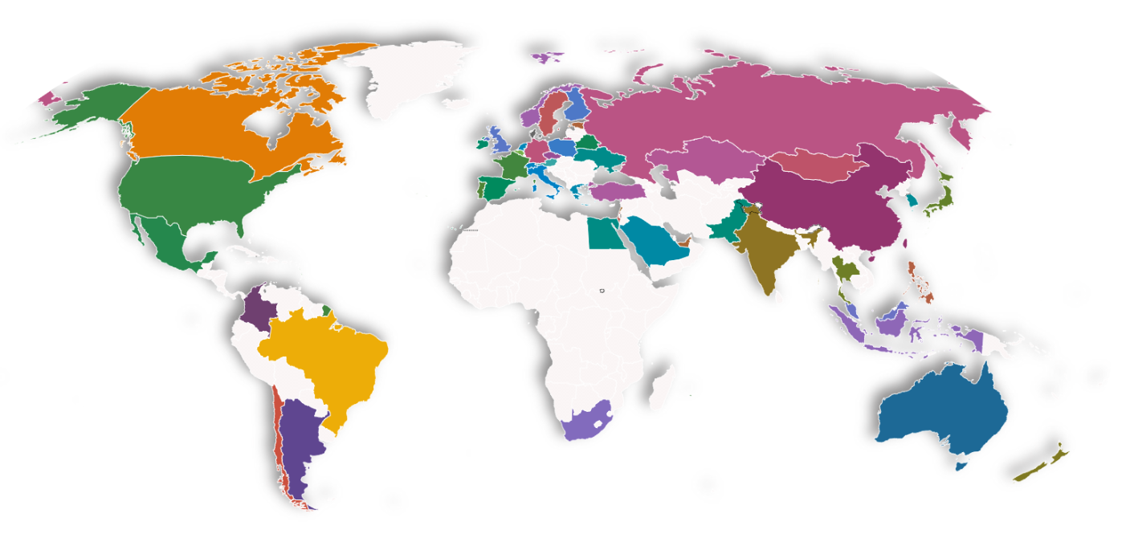
5.3 Models for GGDP and climte

In this section, we build a GGDP health model and a climate impact model of a country's economy. Using these two models, we can perform a medical examination and diagnosis of each country's health and climate impacts. We can describe this process in the following diagram.

5.3.1 GGDP Health Model

During a physical examination, the doctor usually checks the patient's various indicators and determines whether they are within the normal range. Determine whether they are within the normal range or not. These indicators have different weights, and those with larger weights have a greater impact on health status, while those with smaller weights have a relatively smaller impact, and we use a similar approach to measure the health status of the economy. Based on the previous assumptions, we determine the corresponding health range of each indicator and use the Analytic Hierarchy Process to determine the weight of each indicator. Through these analyses, we will give the overall health and the health of each factor.

5.3.2 Determine the Weight of Indicators

The primary method we used to determine the weights was the analytical hierarchy process.
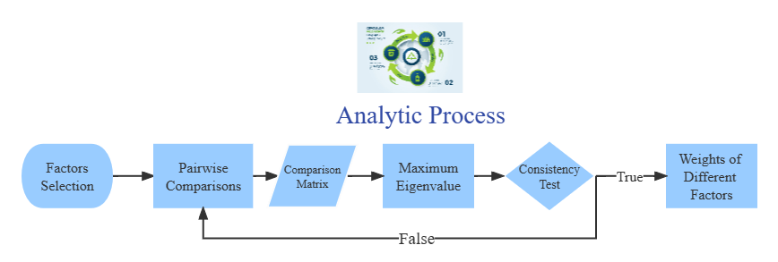
Analytic Hierarchy Process (AHP) is an accurate approach for quantifying the weights of decision criteria, widely used in different decision situations, in fields like government, business, healthcare, shipbuilding, industry and education [8]. In our analysis, we use this method to determine weights of different main factors. Similarly, we determine the weights of different indicators in each factor. The following are the steps.

• Factors selection

We have selected several main factors previously. For each main factor, we have chosen some indicators as well.

• Pairwise comparisons between different factor

According to pairwise comparisons, we establish priorities among the factors. We think that the importance of main factors satisfies the following relationship:

• Calculation of comparison matrix

With the relationship discussed before, we get our comparison matrix 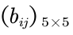
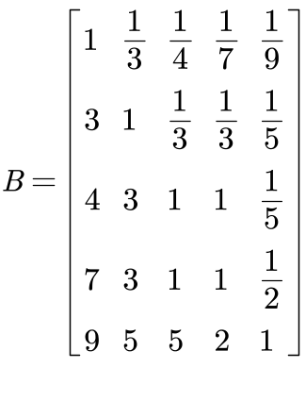
Where Fi for i = 1, 2, · · · , 5 represent heart, resource, expense, emission, diversity respectively.

• Consistency Test

We can calculate the eigenvalues and eigenvectors of the matrix before. Next we need to perform consistency test with the maximum eigenvalue 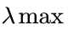.
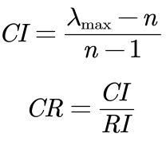
According to the calculation above, CR of the judgment matrix is 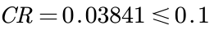, thus the comparison matrix is acceptable.

• Calculation of weights Passing the consistency test

we can get the weights of main factors by the eigenvector corresponding to the maximum eigenvalue, they are as follow: heart(0.4892), resource(0.2209), expense(0.1709), emission(0.0816), diversity(0.0374).

Using the same method, we obtain the weights of the different indicators for each factor, as shown in the figure below.

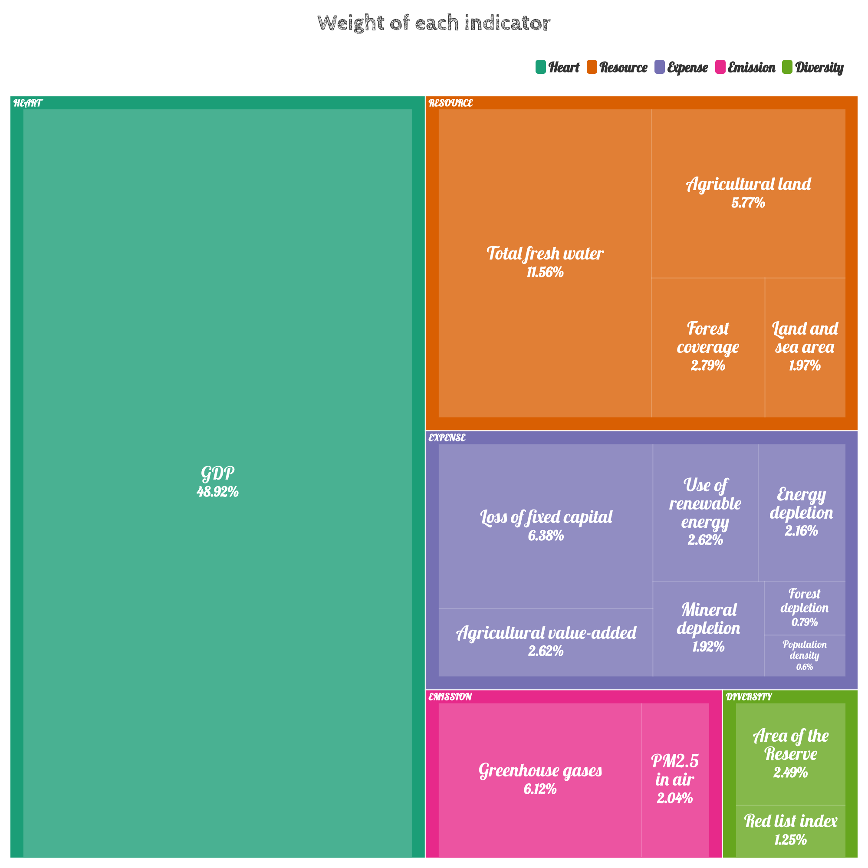

The weighted analysis allows us to obtain the ranking of each indicator by weight. The top-ranked indicators are called primary indicators, which considerably impact overall health. The more down-rated indicators are called secondary indicators, which have little impact on overall health, but we cannot ignore their cumulative effect.

5.3.3 Select Health Range

We fixed the economic health ratio by analyzing the GDP rankings overtime at 0.8. This suggests that 80% of the economic population is healthy. Based on these assumptions, We developed the following principles for selecting health ranges.

- Positive indicators
The sample data from the highest to the lowest 80% quartile were selected as the estimators of the overall lower limit.

- Negative indicators
The sample data from the low to the high 80% quartile was selected as the estimator of the overall upper bound.

- Interval Indicators
Estimate the distribution pattern of the population through the sample and determine the
intervals.

We found the range of health corresponding to the easy positive and negative indicators. Hence, the distribution pattern of the interval indicators needs to be considered: GDP and population density. By plotting the frequency histograms of these two indicators, we found that they have a pattern similar to the normal distribution. To test this conjecture, we tested these two indicators with SPSS using the Kolmogorov - Smirnov (K-S) test. Due to space limitations, we will not discuss the detailed principles of the K-S test here. Instead of discussing it here, only the results are shown.

At the significance level α = 0.05, we obtained the following results of the K-S test for both indicators. Since the significance levels of both hands are higher than α, we can conclude that they both pass the K-S test.

表 1: Single sample Kolmogorovs-Minov test
 |  | Population density |  | GDP
abs |  | 50 |  | 245
Normal parameter | Average value |  | 4.3942 |  | 25.2529
Normal parameter | SD |  | 1.53211 |  | 2.99909
Extreme difference | Absolute value |  | 0.1 |  | 0.06
Extreme difference | Positive value |  | 0.084 |  | 0.06
Extreme difference | Negative value |  | -0.1 |  | -0.033
Inspection statistic |  | 0.1 |  | 0.06
Progressive significance(bilateral) |  | .200 |  | 0.031

Below is the Q-Q plot of the two data to verify the correctness of the results. We can see that the data points of both data are distributed near a straight line, and the results of the K-S test are acceptable.
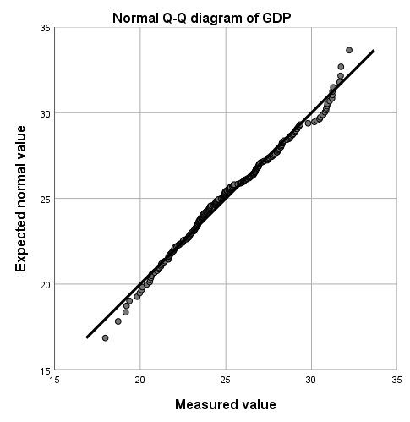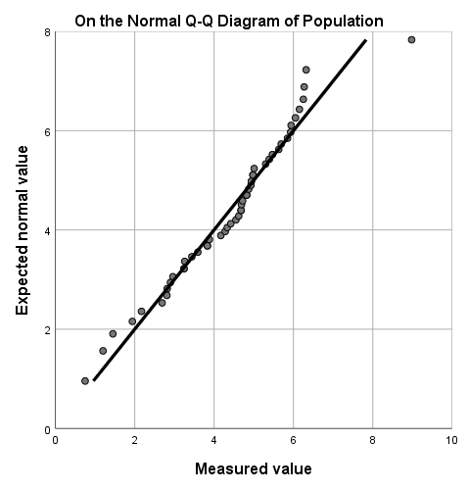
Therefore, we can give the acceptable health range for both in terms of normal distribution.

表 2
Indicator | Upper Bound | Lower Bound
GDP | 1.67E26 | 2.38
Total fresh water | - | 11.34
Agricultural land | - | 20.46
Forest coverage | - | 12.59
Land and sea area | - | 5.06
Loss of fixed capital | 2.4E11 | -
Agricultural value added | - | 4.61E9
Use of renewable energy | - | 1.22
Energy depletion | 1.6E10 | -
Mineral depletion | 3.06E9 | -
Forest depletion | 9259307 | -
Population density | 84.55 | 62.91
Greenhouse gases | 644558 | -
PM2.5 in air | 27.96 | -
Area of the reserve | - | 16.96
Red list index | 1 | 0.78

5.3.3 Diagnosis of Health Conditions

We use a simple acceptance/rejection model (0-1 model) to determine the health conditions. The overall health condition can be measured with point gain and the occurring problem can be located. For each indicator i, if the value falls in the range of GGDP, the point = 1, otherwise = 0. is the weight of indicator i. We calculated the point gain with the equation below:
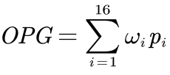
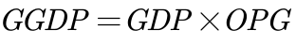
Overall point gain (OPG) describes the GGDP condition of a system, but only when its value is 1 can it proves that the system is completely proper. If the OPG value is too low, it means that the GGDP of the country has at least one main indicator or a large number of secondary indicators that are wrong.

We have classified the health status as follows:

• Good: OPG = 1, showing that all indicators are normal.

• Sub-good: OPG ⩾ 0.9, showing that the system has small problems.

• Not good: 0.6 ⩽ GGDP < 0.9, showing that one or more main indicators are wrong, which can be improved.

• Extremely not good: 0.4 ⩽ GGDP < 0.6, showing that the overall problem of the system is serious, and more reasonable construction of higher education is needed.

• Serious: 0.2 ⩽ GGDP < 0.4, showing that the higher education system is seriously out of balance and cannot perform its normal functions.

• Bad: GGDP ⩽ 0.2, showing that the country has no higher education system.

The following figure shows the lower bound for each status more intuitively.
【画图GGDP】

5.3.4 Climate Model Realized by Using Markov Chain

After each country uses GGDP instead of GDP as a measure of economic health, as we choose the indicator's health range for each indicator, governments will introduce relevant policies to take corresponding measures to promote the growth of GGDP, which is like GDP, except that the aspects that are focused on are much changed and increased. In the future, the "unhealthy" indicators will move closer to the "healthy" ones. However, our hands can only provide the direction of change; efficiency cannot be specified. In this case, we consider the implementation effect of policies later changed by the GGDP influence as a stochastic process. To facilitate subsequent modeling, we make the following assumptions based on general assumptions.

• One of the three states of the implementation model per year: good, poor, or counterproductive. If the politics are effectively implemented, the indicator will change rapidly and approach its expected value. Still, if the policy is not effectively implemented, the indicator state will remain the same or even worse.

• The state that occurs in the following year depends on the current state and the value of the current indicator. If the policy worked well in the previous year, it would be easier to implement in the following year. In addition, the closer the current indicator is to its normal value, the weaker the effect of the policy will be. This assumption considers the degree of unhealthy indicators versus the degree of unhealthy indicators and the role of the policy. The less healthy the indicator is, the stronger the willingness to implement the corresponding policy and the greater the acceptability of countries. On the contrary, if the indicator reaches the health limit, the effect of politics will be less noticeable.

• Under the control of the policies, unhealthy calculated metrics will eventually reach normal values. These policies are flexible. As the effect decreases due to its proximity to normal values, the policies are appropriately adjusted, and finally, the indicators will converge to normal values. We use the above assumptions to build the model and determine the Markov chain to predict the indicator's trend under the policy's influence. We consider the policy implementation effect (PIE) and buffer (BU) as the factors determining the current state, which are random variables with the following distribution. Since the difference between the present value and the health value of the indicator (DCH) affects the policy intensity, we add it to the distribution function of PIE to represent its effect. The distribution laws of PIE and BU are shown in the table below.

表 3
Last state | PIE | BU | Distribution law
Good | 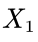 | 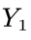 | 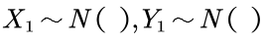
Poor | 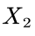 | 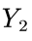 | 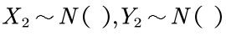
Counterproductive | 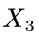 | 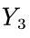 | 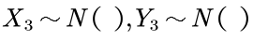

The variable k is used to control the severity of the value change. It varies from indicator to indicator. As for modeling, if 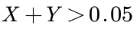, it indicates that the policy is in good state. If 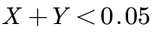, it indicates that policy has counterproductive effect. With the discussion above, we can use the indicator value of the i-th year to determine the value of the (i + 1)-th year, and the transfer equation can be given in the following form:
5.3.5 The Paris Agreement

The Paris Agreement, a climate change agreement signed by 178 parties worldwide, is suitable for global action to address climate change after 2020. The long-term goal of the Paris Agreement is to limit the global average temperature to less than 2 degrees Celsius compared to the pre-industrial period and to work towards limiting the temperature increase to less than 1.5 degrees Celsius.

A more specific timeline is shown below.

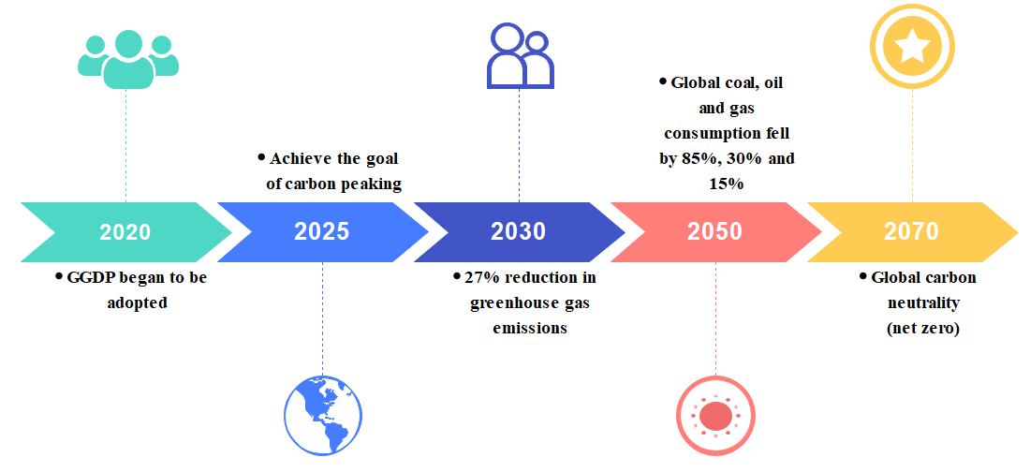

5.3.6 Climate Impact Timeline

Based on the above model, we forecast the achievement of the targets agreed upon in the Paris Agreement. We selected the changes of two indicators, greenhouse gas emissions, and energy depletion, for all countries separately to reflect global climate change.

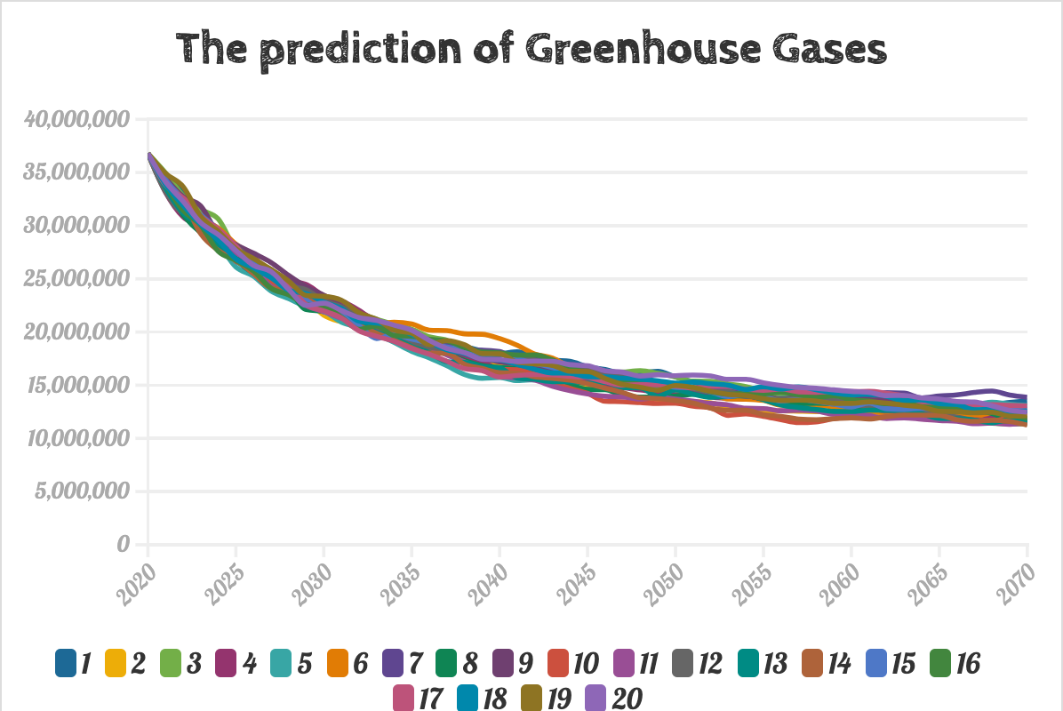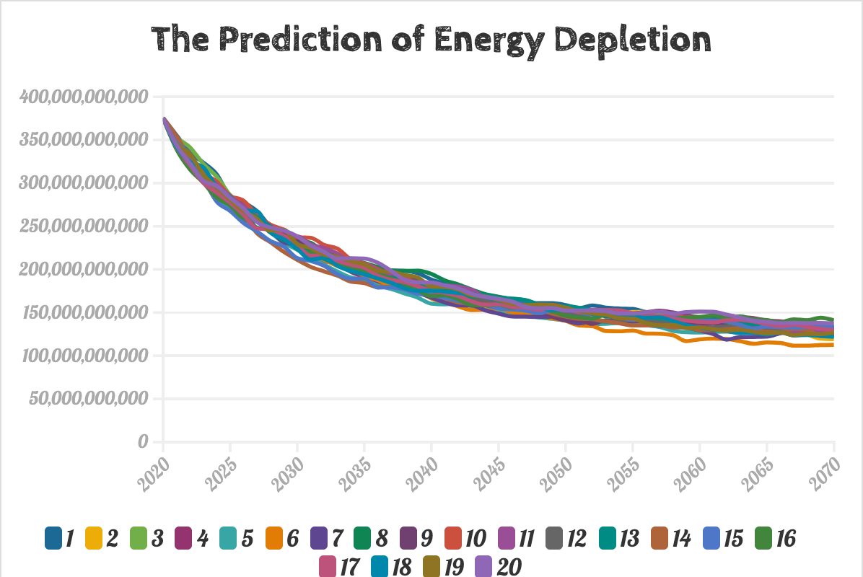

After 20 independent iterations of the experiment (different curves in the graph), we find that GHG emissions have reached an average reduction of about 40% by 2030, exceeding the target and reaching a healthy level by 2070. And energy depletion lives up to expectations, with an average reduction of 60% in 2050, well in line with the target. With the GGDP criteria, the vision of the Paris Agreement seems more achievable and has been realized.

5.4 Model influence analysis

Historical experience shows that the new will replace the old even though there will be a lot of resistance in the process, the general trend is unchanged.

In this regard, we propose the following three hypotheses for the process of GGDP replacing GDP and test each to show that the conversion of the model to a global scale is worthwhile.

• GGDP represents the direction of GDP development and is in line with the law of GDP development.

• GGDP is derived from within GDP, and GDP cannot overcome or eliminate GGDP.

• The GGDP, created based on GDP, discarded the negative, obsolete, and corrupt elements of GDP by "abandoning" them and evolves.

• The GGDP has a new structure and function that adapts to an already changed environment and conditions.

5.4.1 Development direction analysis

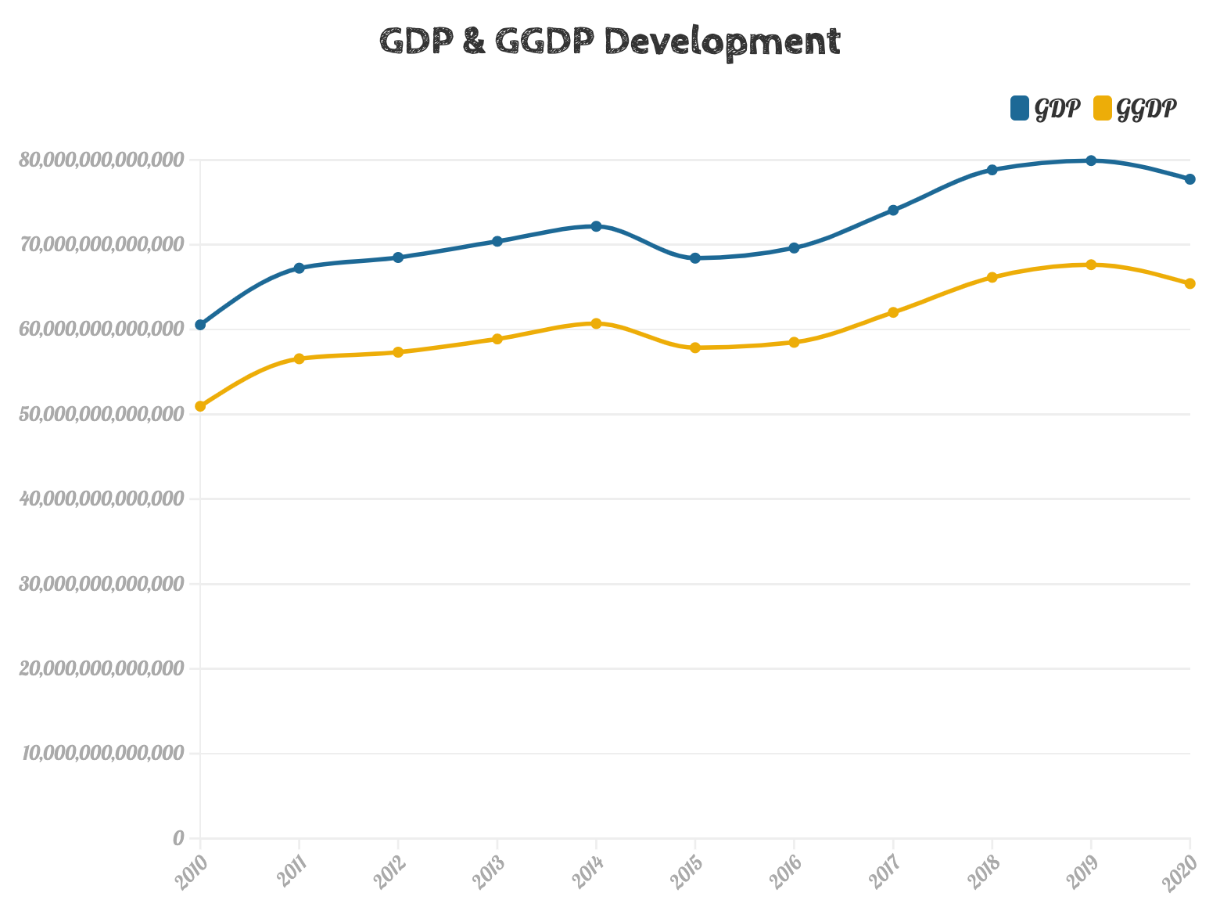

We present the global GDP and GGDP trends from 2010 to 2020, respectively. It shows that the development dynamics of GDP and GGDP are the same, so our hypothesis 1 passes the test.

5.4.2 Relevance analysis

We found that there should be a strong positive correlation between GDP and GGDP since the share of GDP indicator in our economic health index is 48.92%. In this regard, we analyzed the correlation between GDP and GGDP. We obtained a Spearman correlation coefficient of 0.9909 with a p-value = 3.76E-09 < 0.05, accepting the hypothesis that GDP is strongly positively correlated with GGDP. Therefore, hypothesis 2 passed the test.

5.4.3 Superiority Analysis

Our GGDP not only reflects the economic strength of countries but also compensates for the fact that natural resource depletion is not considered in GDP growth. Some countries that seek high economic growth at the expense of depleting natural resources have relatively unhealthy economies, and we penalize them with appropriate rankings. Next, we give the changes in the ranking of the main countries from 2010 to 2020.

We found that GGDP has the following characteristics.

• Stability
For countries such as the U.S. and India, the ranking trend based on GGDP shows a more moderate performance than that based on GDP. It does not suffer from small economic fluctuations due to random events that cause changes in the rankings.

• Rewarding
Countries such as xx, which are lagging in GDP due to their economic underdevelopment and industrial backwardness, can have more room to rise in the GGDP ranking by virtue of their environmental protection and natural resource advantages.

• Punitive
For country xx, its economy is unhealthy due to the abuse and destruction of natural resources caused by the obsessive pursuit of economic growth. Our model will penalize it to some extent. Under the GGDP criterion, the ranking will be reduced due to insufficient natural advantage, even if the GDP is at a relative advantage.

Therefore, hypothesis 3 passes the test.

5.4.4 Adaptability analysis

We perform a sensitivity analysis on us, and sensitivity reflects the degree of adaptation of our GGDP to the already changing environment and conditions.

We increased or decreased the value of each indicator by 5% and observed the change in each country's ranking. We found an average ranking change of 0, which indicates that the GGDP has good adaptability.

Finally, all hypotheses passed the test, which proves that our GGDP will become a global trend and will eventually replace GDP.

5.5 Impact on climate analysis

5.5.1 Advantages

• Catalysts
Through our vision of carbon emissions in the Paris Agreement, we have selected two metrics to measure global climate impact: greenhouse gas emissions and energy depletion. This metric is reliable and accurate. In addition, the conversion from GDP to GGDP helps inspire countries to accelerate the achievement of carbon emission targets and develop renewable energy sources to mitigate the impact on the global environment.

•预测模型稳健性良好
我们将GGDP影响所改变的政策实施效果视为一个随机过程，如果政治得到有效实施，该指标将迅速变化并接近其预期值，反之，指标状态将保持不变或更糟糕。我们针对GGDP取代GDP过程的趋势和特征提出了三个假设，并对每个假设进行了检验，该模型的求解结果均表明GGDP取代GDP的趋势是历史的进步和人类文明向前发展的标志。
•马尔可夫模型敏感度高
我们将该模型进行敏感性：将每个指标的值提高或降低5%，结果反映出我们的GGDP对已经变化的环境和条件的适应程度较高，在全球气候变暖的背景之下，我们只有重视GGDP的衡量标准才能使各个国家产业结果转型升级，从而步入可持续发展的正确轨道，才能让GGDP评估体系将成为全球趋势，并最终取代GDP。

•DEA is a completely objective method.
Using DEA to analyze efficiency does not need to specify the weights of various indicators in advance. Each weight is completely determined by the data. It is a completely objective method. Moreover, the basic DEA model is not suitable for analyzing time series. We adopt the better Super-SBM model that considers the changes in productivity over time. Thus, the analysis is more reasonable.
•Markov chain can predict the impact of policy well.
The premise of Markov chain is that the next state of the system is only related to the current state. In the process of policy implementation, the government will adjust the policy direction of the next year according to the implementation in that year. Therefore, the Markov chain is very suitable for analyzing the impact of policies and GGDP.

    - Weaknesses
- There are not enough countries.
When determining the health range, we assumed and verified that certain indicators obey a normal distribution, thereby determining the reasonable range of the indicators. However, due to the small total number of countries in the world, our calculated range may deviate from the range of true normal distribution.
- We did not consider the changes in standards over time.
When analyzing the GGDP system, we followed the standards in 2018. However, the various indicators of different countries may change in the future. In our model, we have not considered changes in standard.

考虑到某些第三世界国家经济不发达，但有着丰富的自然资源，同时，工业的落后带来对环境影响的减弱，理应在GGDP的排名中相比GDPd 排名有小幅的提升。因此GGDP替换GDP的潜在优势是它刺激了大多数不发达国家挖掘GGDP的未来前景，为以经济快速发展为核心的发达国家敲响了警钟，GDP不再成为国家发展的唯一宗旨和目标，即使在GDP排名中相对靠前，但是在引入GGDP评价模型后国家的综合实力排名也有可能下降，这些后果将引起各个国家对自然资源和环境保护的高度重视。

• Stability
For countries such as the U.S. and India, the ranking trend based on GGDP shows a more moderate performance than that based on GDP. It does not suffer from small economic fluctuations due to random events that cause changes in the rankings.

• Rewarding
Countries such as xx, which are lagging in GDP due to their economic underdevelopment and industrial backwardness, can have more room to rise in the GGDP ranking by virtue of their environmental protection and natural resource advantages.

• Punitive
For country xx, its economy is unhealthy due to the abuse and destruction of natural resources caused by the obsessive pursuit of economic growth. Our model will penalize it to some extent. Under the GGDP criterion, the ranking will be reduced due to insufficient natural advantage, even if the GDP is at a relative advantage.

5.5.2 Disadvantages

• Stability
For countries such as the U.S. and India, the ranking trend based on GGDP shows a more moderate performance than that based on GDP. It does not suffer from small economic fluctuations due to random events that cause changes in the rankings.

• Rewarding
Countries such as xx, which are lagging in GDP due to their economic underdevelopment and industrial backwardness, can have more room to rise in the GGDP ranking by virtue of their environmental protection and natural resource advantages.

• Punitive
For country xx, its economy is unhealthy due to the abuse and destruction of natural resources caused by the obsessive pursuit of economic growth. Our model will penalize it to some extent. Under the GGDP criterion, the ranking will be reduced due to insufficient natural advantage, even if the GDP is at a relative advantage.

5.6 The Impact of the transition on India

We looked at the change in the ranking of each country under GDP and GGDP criteria separately over the period 2010 to 2020 and found a case study worth exploring in depth. India's rapid economic development in the last decade is evident to all. Still, its rankings under the GDP and GGDP criteria are 6 and 7, respectively, and India has instead regressed by 1 place. So we calculated the health of the Indian economy in our model for each indicator and found it to be very unhealthy. Even a drop of 1 unit is a quantity that should not be underestimated, so we chose India to analyze the reasons in depth.

5.6.1 Economic Health Diagnostic

We obtain the current economic health of India by comparing it with the range of economic health in Table 3, with the following series of indicators {pi} and EHI.

{pi} = {1, 1, 1, 1, 0, 0, 1, 1, 1, 0, 0, 0, 0, 0, 0, 0}, EHI = 0.7644

We found many indicators that contribute to the unhealthy Indian economy: land and sea area, loss of fixed capital, mineral depletion, forest depletion. population density, greenhouse gases, PM2.5 in air, area of the reserve, and red list index. There are many hidden problems behind the appearance of India's high economic growth. Despite India's current financial strength, its ability to support future generations and achieve sustainability may be lacking due to the depletion of natural resources.

5.6.2 Our Vision

Putting the above analysis together, we make the following recommendations for unhealthy indicators to help India's economy overgrow even after achieving the shift from GDP to GGDP standards.

• Land and sea area

• Punitive
• Punitive

5.6.3 Sustainability Analysis with DEA-Malmquist Model

Data Envelopment Analysis (DEA) is one of the most common methods for analyzing sustainability. The CCR model developed by CHarnes, Cooper, and Rhodes has a simple form and a complete theory. Without a priori weights for inputs and outputs, DEA can be used to assess the relative efficiency between different decision-making units (DMUs) with multiple inputs and outputs. In the single-input, single-output case, efficiency is usually defined as the ratio of results to inputs. Similarly, efficiency is defined as follows.
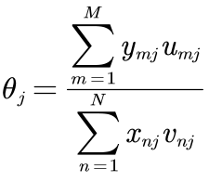
Where 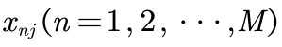,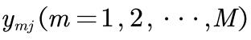 represent N inputs and M outputs of the 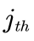 DMU respectively, with the corresponding input weights and output weights 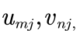with all inputs, outputs and weights non-negative. Thus the analysis to the performance of the system is transformed to the following linear programing problem:
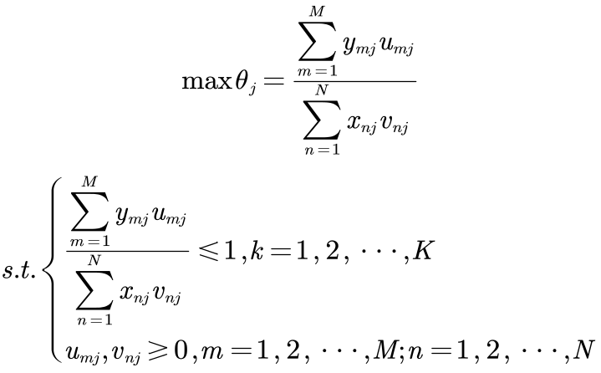
where K is the total of DMUs. If the optimal solution of the above problem exists and 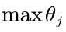 is 1, then we can judge this DMU is effective, meaning the corresponding ratio of outputs to inputs can be maximized.

DEA is a reliable tool for measuring relative efficiency among DMUs. However, the basic CCR model only calculates and compares efficiency values across time in time series analysis. It ignores the changes in productivity over time factors. Therefore, we use the DEA. Malmquist model to perform time series analysis. This approach introduces the Malmquist distance, which considers the time variation of productivity. We can perform dynamic analysis of efficiency in several ways.

• If a country's efficiency has declined for three consecutive years in the last five years, country's GGDP is considered unsustainable.

• If a country's efficiency has declined for only two consecutive years in the last five years, then the country's GGDP sustainability could be better.

• If a country's efficiency has declined over a year in the last five years, then the country's GGDP is healthy and sustainable.

• In the first scenario, we consider the system unable to maintain its effectiveness. In the second scenario, the system can sometimes retain its current state. Finally, volatility exists, but a highly sustainable economic system can recover quickly from a recession.

Based on the above model, we analyze the impact on the country's economic health and sustainability before and after the changes we expect.

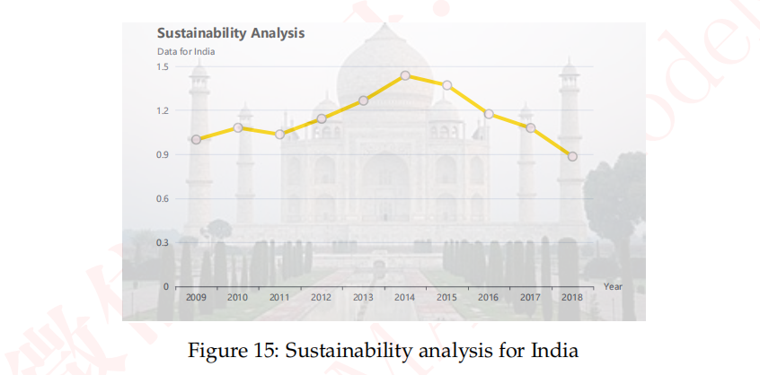

Step4:优势和劣势分析
考虑到某些第三世界国家经济不发达，但有着丰富的自然资源，同时，工业的落后带来对环境影响的减弱，理应在GGDP的排名中相比GDPd 排名有小幅的提升。因此GGDP替换GDP的潜在优势是它刺激了大多数不发达国家挖掘GGDP的未来前景，为以经济快速发展为核心的发达国家敲响了警钟，GDP不再成为国家发展的唯一宗旨和目标，即使在GDP排名中相对靠前，但是在引入GGDP评价模型后国家的综合实力排名也有可能下降，这些后果将引起各个国家对自然资源和环境保护的高度重视。

VII. Evaluation and Promotion of Model

Strength and Weakness

7.1.1 Strength

Weakness:

Promotion

Ⅷ. Conclusions

Conclusions of the problem

Methods used in our models

给国家领导人的政策建议
致：国家领导人
日期：2023年1月21日
主题：建议采纳全球GGDP评估体系
落实调整环境问题严重地区的碳排放量，减少东西部地区绿色GDP差距和绿色发展效率差距。经过对中国东西部GGDP的实证分析，我们发现不同地区的GGDP排名与GDP排名呈反相关关系，因此要实现地区之间绿色GDP发展平衡，需要从缩小地区之间绿色经济增长质量开始。
开展绿色GDP试点取得经验，建立我国绿色GDP核算体系。在我们团队选取的样本国家中，中国在GGDP评价体系中的排名相比较于GDP排名有所下降，目前由于资源环境与市场化的进程密不可分的，因此，随着我国市场经济的不断完善，资源、环境市场的逐渐形成，实行绿色GDP的可能性会越来越大。
加大绿色科技创新力度。在我们团队对发达国家和发展中国家的GGDP预测研究中，我们发现引进绿色GDP会给现有的经济带来一定的负面影响，我们需要保持经济和绿色生态的动态平衡，国家及地方政府应当鼓励企业积极的引入绿色生产技术，通过技术升级来减少能源的消耗。
建立“回收-再利用-设计-生产”的循环经济模式生态业园区。我们团队通过【】模型进行人口预测，得出【】，因此，发展循环经济是绿色经济的重要一环。通过不同企业之间形成共享资源，交互衔接，上游生产过程中产生的废物成为下游生产的原料,达到闭合的生态工业网络，在人口爆炸的今天，我们可以实现资源高效回收利用。
Best wishes
2308685团队

I X. References
[1] Xu Lun Hui,Luo Qiang,Fu Hui.Car following safe distance model based on braking process of leading vehicle f [J].Journal of Guangxi Normal University(Natural Science Edition),2010,28(1):1-5.
[2]

[3]

[4]

X. Appendix

Appendix One
美赛中可以有附录也可以没有附录，即此部分可以省略

Appendix Two

