Lab 10

1)

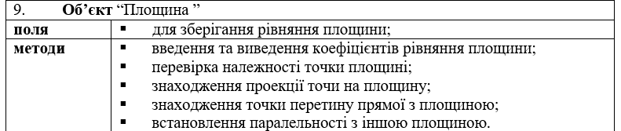

def a1_and_a2(a, b):  
 return a / b  
  
  
def a_coef_equal_b_coef(*args):  
 for i in range(0, len(args)-3, 2):  
 if a1_and_a2(args[i], args[i+1]) != a1_and_a2(args[i+2], args[i+3]):  
 return False  
 return True  
  
  
class Plane:  
 def __init__(self, _a, _b, _c, _d=0):  
 self.a = _a  
 self.b = _b  
 self.c = _c  
 self.d = _d  
  
 def return_of_coefficients(self):  
 return self.a, self.b, self.c, self.d  
  
 def point_in_plane(self, _x, _y, _z):  
 return self.a * _x + self.b * _y + self.c * _z + self.d == 0  
  
 def parallel_planes(self, a1, b1, c1, d1):  
 return a_coef_equal_b_coef(self.a, a1, self.b, b1, self.c, c1, self.d, d1)  
  
 def intersection_of_line_and_plane(self, _x, _y, _z, l, m, p):  
 ch = self.a * _x + self.b * _y + self.c * _z + self.d  
 zn = self.a * l + self.b * m + self.c * p  
 t = - (ch / zn)  
 x1 = l * t + _x  
 y1 = m * t + _y  
 z1 = p * t + _z  
 m = [x1, y1, z1]  
 return m  
  
 def point_projection(self, _x, _y, _z):  
 ch = self.a * _x + self.b * _y + self.c * _z + self.d  
 zn = self.a ** 2 + self.b ** 2 + self.c ** 2  
 t = - (ch / zn)  
 x1 = self.a * t + _x  
 y1 = self.b * t + _y  
 z1 = self.c * t + _z  
 m = [x1, y1, z1]  
 return m

2) 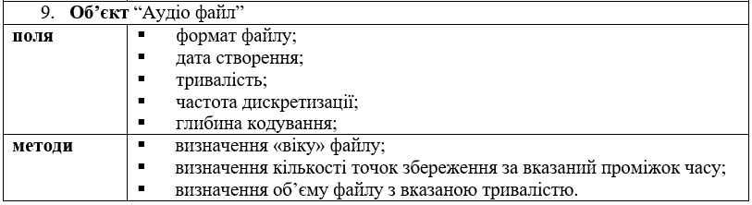

import datetime  
  
  
class Audio_file:  
 def __init__(self, _format, _date, _duration, _frequency, _deep):  
 self.format = _format  
 self.date = _date  
 self.duration = _duration  
 self.frequency = _frequency  
 self.deep = _deep  
  
 def age(self):  
 now = datetime.datetime.today()  
 delta = now - self.date  
 return delta  
  
 def points_of_save(self):  
 return self.frequency * self.duration  
  
 def size_file(self):  
 return self.deep * self.duration