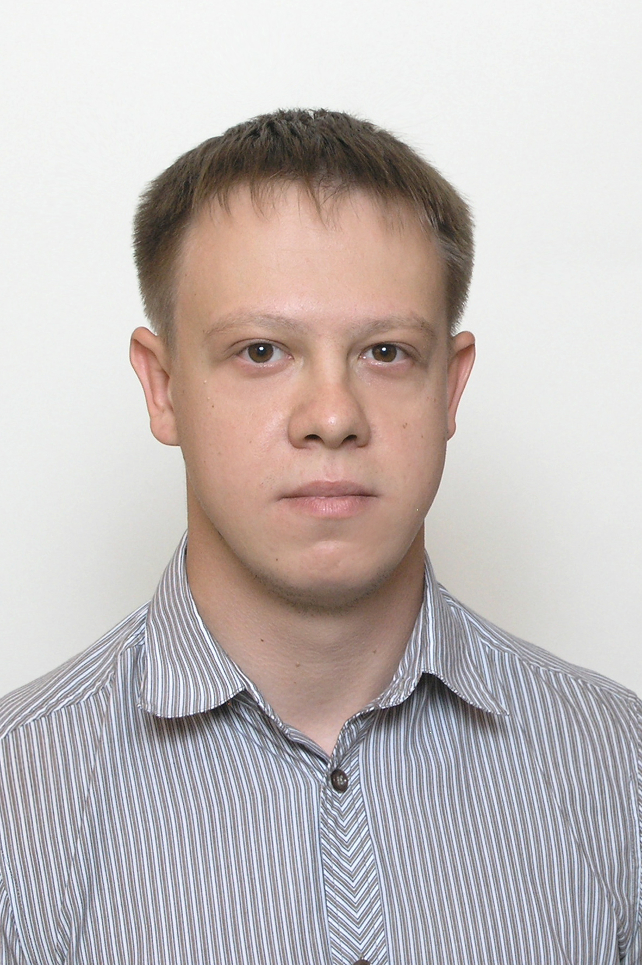
Starchyk Kostiantyn
Date of birth: 06.09.1989
City: Dnipro
Phone: +38 063 935 97 83
E-mail: kostiastarchick@i.ua
Skype: kostiastarchick
LinkedIn: linkedin.com/in/kostiantyn-s
GitHub: github.com/Kostiantyn-S
Getting junior position JS Developer or front end developer

Programming: JavaScript, HTML5, CSS3.
Frameworks and libraries: Bootstrap4, jQuery.
Tools: Git, Grunt, Gulp, JetBrains WebStorm, CSS Bliss, CSS БЭМ, Less, SASS.

Education:
2016 - 2017
Dnipropetrovsk State University of Internal Affairs
Specialist, Jurisprudence, criminal law specialization;
2006 – 2011
Dneprodzerzhinsk State Technical University
Master's degree, Cars and car industry;

Additional education:
Hillel IT-school Dnipro
«Front-End Pro»
12.2018 – 04.2019;

Hillel IT-school Dnipro
«Front-End Basic»
06.2018 – 08.2018;

Own projects:
You can find my portfolio following the link below:
https://kostiantyn-s.github.io/

Additional information:
Hello, my name is Starchyk Kostiantyn. As of the moment I finished the Front End Pro course for JavaScript knowledge and before, completed the Front End Basic course which gave me opportunity to know HTML and CSS. While preparing my works I use different tools, like for example Gulp or Grunt streaming build systems for building projects and Jet Brains WebStorm environment for development. Usually I use also a distributed version-control system GIT to keep my works on GitHub repositories.
Recently the Front-End development attracted my attention and interested me a lot, so by 2018 I took final decision to change the career and with that purpose joined Hillel IT school. 2011, after getting Master’s degree and an engineering qualification from automobiles and automobile industry in the State Technical University of my hometown Kamianske (old name Dnieprodzerjinsk), I start working as a brigadier at the wheel-roller shop of the vagonload depot “LEMTRANS”. 2015 as a result of a reform of National Police, the Patrol Police was created by Ukrainian government. I applied and was selected among few thousands of volunteers to serve there, what I actually did from 2015 till 2018. Working there, I got a bachelor degree from Law in National University of Internal Affairs of Dnipro City and a position of police investigator later on. However after some time I realized that still prefer changing my way towards front end development.
I have low intermediate level of English, which I got after studying it in University and Hillel IT school, however I'm working on it and already started my course with a private teacher.
My lifestyle is quite active. I am doing sports , like travelling, biking , hiking, programming and motorcycling. I like also getting unusual tasks and looking for non-standard solutions for it.
As of the moment I am looking forward to get the position of Front-End developer or JavaScript developer to be able to apply my knowledge and get new experience.

