|  |
| --- |
|  |
| Course Work  EHU, SQL and Data Processing |

**Created by:  
Kanstatnsin Loseu**

**Topic:**

**"Art prints or original artworks."**

### Part 1: Design and develop all needed DB objects to support functionality of your Application. OLTP Schema:

* Contains 10 normalized tables supporting detailed transactional operations.
* Key entities include:
* users, artists, artworks, orders, order_items, payments, reviews,
* and metadata tables like categories, artwork_categories, and Primary keys uniquely identify records;
* foreign keys ensure referential integrity.
* For example: Artworks are linked to artists via artist_id, orders are linked to users, reviews reference both artworks and users
* Relationships are primarily one-to-many (e.g., one user → many orders), with one many-to-many link (artworks<->categories).

**Schema:**

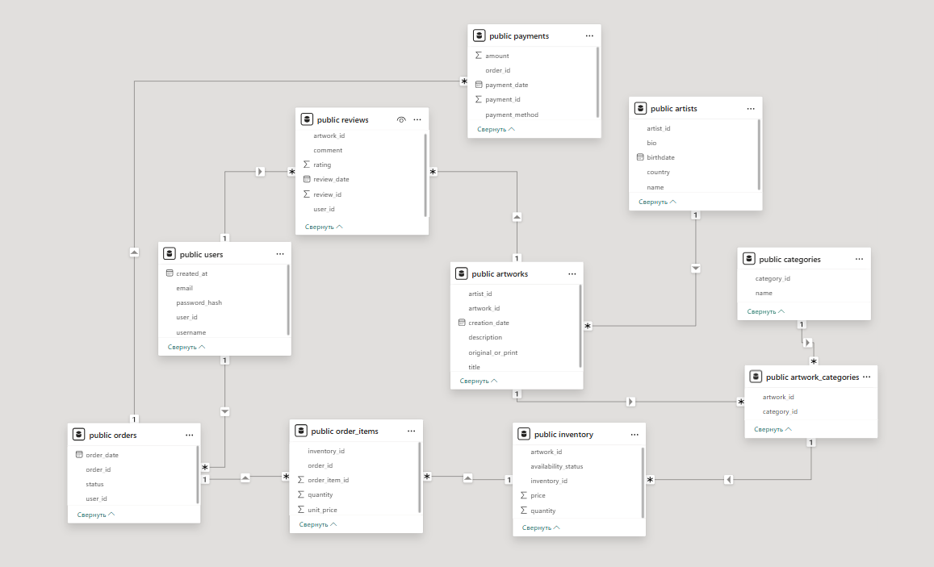

### OLAP Schema:

* Implements a snowflake schema with dimension tables (dim_date, dim_artwork, dim_artist, dim_user) and fact tables (fact_sales, fact_reviews).
* A bridge table (bridge_artwork_category) supports a many-to-many relationship between artworks and categories.
* Uses surrogate keys such as artist_sk in dim_artist for decoupling from the operational artist_id and supporting better version control.
* The table dim_artist implements Slowly Changing Dimension Type 2 (SCD Type 2) to track historical changes in artist data using effective_from, effective_to, and is_current fields.
* The table bridge_artwork_category handles many-to-many relationships between artworks and their categories, allowing aggregation by genre or style.
* Fact tables store aggregated data for analytical queries:
* fact_sales includes quantity, total_amount
* fact_reviews stores rating values over time
* All tables are linked using foreign key constraints to ensure referential integrity and enable robust business intelligence reporting via tools like Power BI.

**Schema:**

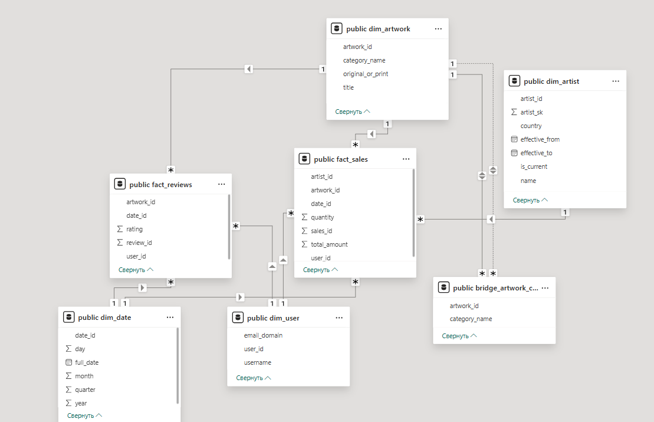

**Part 2:** **Instructions how to run scripts:**(Run in order)

1. SCRIPT to create db tables of OLTP:

CREATE TABLE Users (

user_id SERIAL PRIMARY KEY,

username VARCHAR(50) NOT NULL UNIQUE,

email VARCHAR(100) NOT NULL UNIQUE,

password_hash VARCHAR(255) NOT NULL,

created_at TIMESTAMP DEFAULT CURRENT_TIMESTAMP

);

CREATE TABLE Artists (

artist_id SERIAL PRIMARY KEY,

name VARCHAR(100) NOT NULL,

bio TEXT,

birthdate DATE,

country VARCHAR(50)

);

CREATE TABLE Artworks (

artwork_id SERIAL PRIMARY KEY,

artist_id INT NOT NULL REFERENCES Artists(artist_id),

title VARCHAR(150) NOT NULL,

description TEXT,

original_or_print VARCHAR(20) CHECK (original_or_print IN ('original', 'print')),

creation_date DATE

);

CREATE TABLE Categories (

category_id SERIAL PRIMARY KEY,

name VARCHAR(50) NOT NULL UNIQUE

);

CREATE TABLE Artwork_Categories (

artwork_id INT REFERENCES Artworks(artwork_id),

category_id INT REFERENCES Categories(category_id),

PRIMARY KEY (artwork_id, category_id)

);

CREATE TABLE Inventory (

inventory_id SERIAL PRIMARY KEY,

artwork_id INT NOT NULL REFERENCES Artworks(artwork_id),

quantity INT CHECK (quantity >= 0),

price NUMERIC(10,2) NOT NULL,

availability_status VARCHAR(20) CHECK (availability_status IN ('in_stock', 'sold_out', 'preorder'))

);

CREATE TABLE Orders (

order_id SERIAL PRIMARY KEY,

user_id INT NOT NULL REFERENCES Users(user_id),

order_date TIMESTAMP DEFAULT CURRENT_TIMESTAMP,

status VARCHAR(20) CHECK (status IN ('pending', 'shipped', 'delivered', 'cancelled')) NOT NULL

);

CREATE TABLE Order_Items (

order_item_id SERIAL PRIMARY KEY,

order_id INT NOT NULL REFERENCES Orders(order_id),

inventory_id INT NOT NULL REFERENCES Inventory(inventory_id),

quantity INT CHECK (quantity > 0),

unit_price NUMERIC(10,2) NOT NULL

);

CREATE TABLE Payments (

payment_id SERIAL PRIMARY KEY,

order_id INT NOT NULL REFERENCES Orders(order_id),

payment_method VARCHAR(20) CHECK (payment_method IN ('card', 'paypal', 'bank_transfer')),

amount NUMERIC(10,2) NOT NULL,

payment_date TIMESTAMP DEFAULT CURRENT_TIMESTAMP

);

CREATE TABLE Reviews (

review_id SERIAL PRIMARY KEY,

artwork_id INT NOT NULL REFERENCES Artworks(artwork_id),

user_id INT NOT NULL REFERENCES Users(user_id),

rating INT CHECK (rating BETWEEN 1 AND 5),

comment TEXT,

review_date TIMESTAMP DEFAULT CURRENT_TIMESTAMP

);

1. SCRIPT to put data into OLTP

COPY Users(username, email, password_hash)

FROM 'D:/SQLCourseWork/users.csv' DELIMITER ',' CSV HEADER;

COPY Artists(name, bio, birthdate, country)

FROM 'D:/SQLCourseWork/artists.csv' DELIMITER ',' CSV HEADER;

COPY Artworks(artist_id, title, description, original_or_print, creation_date)

FROM 'D:/SQLCourseWork/artworks.csv' DELIMITER ',' CSV HEADER;

COPY Categories(name)

FROM 'D:/SQLCourseWork/categories.csv' DELIMITER ',' CSV HEADER;

COPY Artwork_Categories(artwork_id, category_id)

FROM 'D:/SQLCourseWork/artwork_categories.csv' DELIMITER ',' CSV HEADER;

COPY Inventory(artwork_id, quantity, price, availability_status)

FROM 'D:/SQLCourseWork/inventory.csv' DELIMITER ',' CSV HEADER;

COPY Orders(user_id, order_date, status)

FROM 'D:/SQLCourseWork/orders.csv' DELIMITER ',' CSV HEADER;

COPY Order_Items(order_id, inventory_id, quantity, unit_price)

FROM 'D:/SQLCourseWork/order_items.csv' DELIMITER ',' CSV HEADER;

COPY Payments(order_id, payment_method, amount, payment_date)

FROM 'D:/SQLCourseWork/payments.csv' DELIMITER ',' CSV HEADER;

COPY Reviews(artwork_id, user_id, rating, comment, review_date)

FROM 'D:/SQLCourseWork/reviews.csv' DELIMITER ',' CSV HEADER;

1. SCRIPT to create OLAP:

CREATE TABLE Dim_Date (

date_id SERIAL PRIMARY KEY,

full_date DATE NOT NULL,

day INT,

month INT,

quarter INT,

year INT

);

CREATE TABLE Dim_Artwork (

artwork_id INT PRIMARY KEY,

title VARCHAR(150),

original_or_print VARCHAR(20),

category_name VARCHAR(50)

);

CREATE TABLE Dim_Artist (

artist_sk SERIAL PRIMARY KEY,

artist_id INT NOT NULL,

name VARCHAR(100),

country VARCHAR(50),

effective_from DATE,

effective_to DATE,

is_current BOOLEAN

);

CREATE TABLE Dim_User (

user_id INT PRIMARY KEY,

username VARCHAR(50),

email_domain VARCHAR(50)

);

CREATE TABLE Bridge_Artwork_Category (

artwork_id INT NOT NULL,

category_name VARCHAR(50) NOT NULL,

PRIMARY KEY (artwork_id, category_name)

);

CREATE TABLE Fact_Sales (

sales_id SERIAL PRIMARY KEY,

date_id INT NOT NULL REFERENCES Dim_Date(date_id),

artwork_id INT NOT NULL REFERENCES Dim_Artwork(artwork_id),

user_id INT NOT NULL REFERENCES Dim_User(user_id),

artist_id INT NOT NULL REFERENCES Dim_Artist(artist_sk),

quantity INT,

total_amount NUMERIC(10, 2)

);

CREATE TABLE Fact_Reviews (

review_id INT PRIMARY KEY,

date_id INT NOT NULL REFERENCES Dim_Date(date_id),

artwork_id INT NOT NULL REFERENCES Dim_Artwork(artwork_id),

user_id INT NOT NULL REFERENCES Dim_User(user_id),

rating INT CHECK (rating BETWEEN 1 AND 5)

);

4. SCRIPT to move data from OLTP database to OLAP database ( run in order #) ) :  
  
 SELECT dblink_connect(

'oltp_conn',

'dbname=CourseProject user=postgres password=тайна'

);

INSERT INTO Dim_Date (full_date, day, month, quarter, year)

SELECT DISTINCT date::DATE,

EXTRACT(DAY FROM date),

EXTRACT(MONTH FROM date),

EXTRACT(QUARTER FROM date),

EXTRACT(YEAR FROM date)

FROM (

SELECT order_date::DATE AS date

FROM dblink('oltp_conn', 'SELECT order_date FROM Orders')

AS t(order_date DATE)

UNION

SELECT payment_date::DATE

FROM dblink('oltp_conn', 'SELECT payment_date FROM Payments')

AS t(payment_date DATE)

UNION

SELECT review_date::DATE

FROM dblink('oltp_conn', 'SELECT review_date FROM Reviews')

AS t(review_date DATE)

) AS all_dates

WHERE NOT EXISTS (

SELECT 1 FROM Dim_Date d WHERE d.full_date = all_dates.date

);

INSERT INTO Dim_User (user_id, username, email_domain)

SELECT user_id, username, SPLIT_PART(email, '@', 2)

FROM dblink('oltp_conn', 'SELECT user_id, username, email FROM Users')

AS t(user_id INT, username TEXT, email TEXT)

WHERE NOT EXISTS (

SELECT 1 FROM Dim_User du WHERE du.user_id = t.user_id

);

INSERT INTO Dim_Artist (artist_id, name, country, effective_from, effective_to, is_current)

SELECT artist_id, name, country, CURRENT_DATE, NULL, TRUE

FROM dblink('oltp_conn', 'SELECT artist_id, name, country FROM Artists')

AS t(artist_id INT, name TEXT, country TEXT)

WHERE NOT EXISTS (

SELECT 1 FROM Dim_Artist da WHERE da.artist_id = t.artist_id AND da.is_current = TRUE

);

INSERT INTO Dim_Artwork (artwork_id, title, original_or_print, category_name)

SELECT a.artwork_id, a.title, a.original_or_print, c.name

FROM dblink('oltp_conn', 'SELECT artwork_id, title, original_or_print FROM Artworks')

AS a(artwork_id INT, title TEXT, original_or_print TEXT)

JOIN dblink('oltp_conn', 'SELECT artwork_id, category_id FROM Artwork_Categories')

AS ac(artwork_id INT, category_id INT) ON a.artwork_id = ac.artwork_id

JOIN dblink('oltp_conn', 'SELECT category_id, name FROM Categories')

AS c(category_id INT, name TEXT) ON ac.category_id = c.category_id

WHERE NOT EXISTS (

SELECT 1 FROM Dim_Artwork da WHERE da.artwork_id = a.artwork_id AND da.category_name = c.name

);

INSERT INTO Bridge_Artwork_Category (artwork_id, category_name)

SELECT a.artwork_id, c.name

FROM dblink('oltp_conn', 'SELECT artwork_id, category_id FROM Artwork_Categories')

AS a(artwork_id INT, category_id INT)

JOIN dblink('oltp_conn', 'SELECT category_id, name FROM Categories')

AS c(category_id INT, name TEXT) ON a.category_id = c.category_id

WHERE NOT EXISTS (

SELECT 1 FROM Bridge_Artwork_Category b WHERE b.artwork_id = a.artwork_id AND b.category_name = c.name

);

INSERT INTO Fact_Sales (date_id, artwork_id, user_id, artist_id, quantity, total_amount)

SELECT

d.date_id,

i.artwork_id,

o.user_id,

da.artist_sk,

oi.quantity,

(oi.quantity * oi.unit_price)

FROM dblink('oltp_conn', 'SELECT order_item_id, order_id, inventory_id, quantity, unit_price FROM Order_Items')

AS oi(order_item_id INT, order_id INT, inventory_id INT, quantity INT, unit_price NUMERIC)

JOIN dblink('oltp_conn', 'SELECT order_id, user_id, order_date FROM Orders')

AS o(order_id INT, user_id INT, order_date DATE) ON oi.order_id = o.order_id

JOIN dblink('oltp_conn', 'SELECT inventory_id, artwork_id FROM Inventory')

AS i(inventory_id INT, artwork_id INT) ON oi.inventory_id = i.inventory_id

JOIN dblink('oltp_conn', 'SELECT artwork_id, artist_id FROM Artworks')

AS a(artwork_id INT, artist_id INT) ON i.artwork_id = a.artwork_id

JOIN Dim_Date d ON d.full_date = o.order_date

JOIN Dim_Artist da ON da.artist_id = a.artist_id AND da.is_current = TRUE

WHERE NOT EXISTS (

SELECT 1 FROM Fact_Sales fs

WHERE fs.date_id = d.date_id AND fs.artwork_id = i.artwork_id AND fs.user_id = o.user_id

);

INSERT INTO Fact_Reviews (review_id, date_id, artwork_id, user_id, rating)

SELECT

r.review_id,

d.date_id,

r.artwork_id,

r.user_id,

r.rating

FROM dblink('oltp_conn', 'SELECT review_id, artwork_id, user_id, rating, review_date FROM Reviews')

AS r(review_id INT, artwork_id INT, user_id INT, rating INT, review_date DATE)

JOIN Dim_Date d ON d.full_date = r.review_date

WHERE NOT EXISTS (

SELECT 1 FROM Fact_Reviews fr WHERE fr.review_id = r.review_id

);

**Part 3: Power BI report**

Power BI report representing 3 visual components:  
1) Sum of total sales by date.  
2) Quantity of goods sold by product name.  
3) Total sales by brand.  
All visual components can be sorted by day and month

**Part 4: SCRIPT to run queries based on OLTP and OLAP DBs:**

* OLTP:

Number of artworks sold by each artist:

SELECT a.name AS artist_name, COUNT(i.artwork_id) AS artworks_sold

FROM Artists a

JOIN Artworks ar ON a.artist_id = ar.artist_id

JOIN Inventory i ON ar.artwork_id = i.artwork_id

JOIN Order_Items oi ON i.inventory_id = oi.inventory_id

GROUP BY a.name

ORDER BY artworks_sold DESC;

Average rating per artwork:

SELECT ar.title, AVG(r.rating) AS avg_rating

FROM Artworks ar

JOIN Reviews r ON ar.artwork_id = r.artwork_id

GROUP BY ar.title

ORDER BY avg_rating DESC;

Number of orders by status:  
SELECT status, COUNT(*) AS total_orders

FROM Orders

GROUP BY status;

* OLAP:  
  Total sales by year

SELECT dd.year, SUM(fs.total_amount) AS total_sales

FROM fact_sales fs

JOIN dim_date dd ON fs.date_id = dd.date_id

GROUP BY dd.year

ORDER BY dd.year;

Total sales by category:

SELECT bac.category_name, SUM(fs.total_amount) AS total_sales

FROM fact_sales fs

JOIN dim_artwork da ON fs.artwork_id = da.artwork_id

JOIN bridge_artwork_category bac ON da.artwork_id = bac.artwork_id

GROUP BY bac.category_name

ORDER BY total_sales DESC;

Average rating by category:

SELECT bac.category_name, AVG(fr.rating) AS avg_rating

FROM fact_reviews fr

JOIN dim_artwork da ON fr.artwork_id = da.artwork_id

JOIN bridge_artwork_category bac ON da.artwork_id = bac.artwork_id

GROUP BY bac.category_name

ORDER BY avg_rating DESC;