**Data Communication via Satellite**

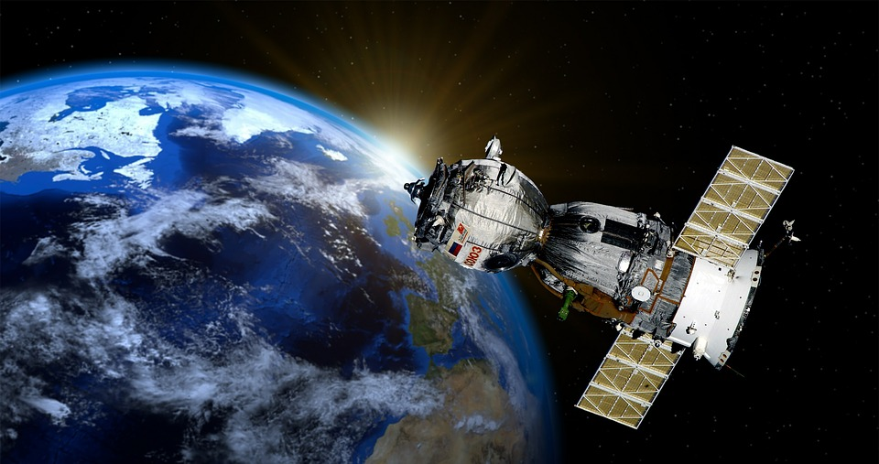

**Abstract**

Most people around the world utilize satellite communication in more ways than they realize, and it is indispensable to our life. In modern society, space is getting closer to us, for instance, development and launch a lot of satellites by various organizations in the world, and driving the Artemis program. We will pay more attention to space as the place of business and life, and it could be the future of humanity. This report focuses on satellite communication.

**Introduction**

**What is satellite communication?**

Satellite communication, in telecommunication, allows us to provide communication between many areas on Earth, especially for global communication. Approximately 2,000 artificial satellites are operating now, and both analog and digital signals transfer the information, such as data, records, voice, video, and so on, from one or more locations in the world.

**Construct of satellite communication**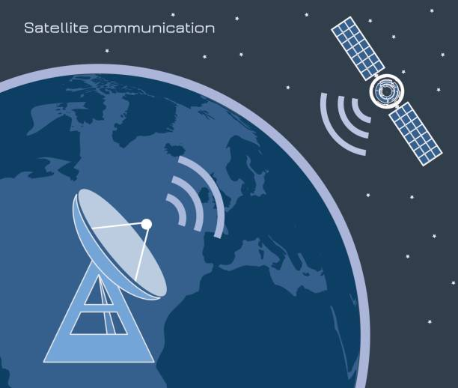

The earth station consists of a dish antenna transmitter which can transmit high frequencies (5.9-6.4GHZ) microwave signals, some earth stations also called the ground station, which can transmit and receive the signals while others can only receive signals. A high directive and a high gain antenna are necessary at the earth station because the losses over the long T/N path is very high, the power of the signals reaching back to the earth station from the satellite is very small. Therefore, at the receiving end a parabolic dish antenna with a 61m diameter provides a high gain and thus amplify the signal power, it is important to have a low noise amplifier before the mixer stage in the receiver C, K, T at the satellite earth terminal.

**Use of satellite Communication**

* **Phone**  
  – Satellite phones reach out directly to the constellation of either geostationary or low-earth-orbit satellites. Calls are then forwarded to a satellite teleport connected to the Public Switched Telephone Network.
* **TV**  
  – Satellite television is when television programming is delivered to viewers by relaying it from a communications satellite orbiting the earth directly to the viewer’s location.
* **Radio**  
  – Satellite radio is basically a digital radio signal that is relayed by a communications satellite and this typically covers a wider geographical range than terrestrial radio signals.
* **Internet**  
  – Satellite Internet access refers to Internet access made possible through communication satellites. After the 1990s, satellite communication technology has been used as a means to connect to the Internet using broadband data connections. This is particularly useful for people in remote areas who cannot avail of a broadband connection.
* **Military purpose**  
  – Communication satellites are used for military communications applications, such as Global Command and Control Systems. Military satellites usually operate in the UHF, SHF, or EHF frequency bands.

**Problem: Cyber Concerns for Satellite communication**

The satellite system is very significant to global communication, many people and organizations utilize it, - cell phone network, GPS technologies, TV broadcast, weather forecast, climate monitoring, military communication. So much information and data are transferred all over the world. That’s why the satellite system can be a target for cybercriminals.

**What happened when the hackers attack the satellite system?**

A successful attack on telecommunications satellites can lead to unthinkable scenarios such as a massive disruption in communications, espionage, jamming, and even commandeering satellites to collisions – to name a few. It may not seem obvious but life on this planet has become so reliant on satellites that any major breach can cause havoc.  
According to the Union of Concerned Scientists (UCS), there are 1,459 operating satellites orbiting the space, more than half of which are communications satellites. Of this number, around 38% operate for commercial communications and another 16% for government communications. Satellites used for telecommunications functions account for almost half of all the satellites in orbit. This means future attempts to hack satellites could probably hit those used in telecommunications.  
Considering the volume of information that these satellites manage and the array of industries that are wholly or partially dependent on them, it makes it imperative to protect them from attacks. Not to mention, the amount of money that the telecommunications industry costs – which makes it a prime target for cybercriminals.

**Vulnerabilities of the satellite system**

Andy Davis, transport assurance practice director, the NCC Group, highlights vulnerabilities in the small satellite sector, which is expanding quickly. He highlighted the fact that because the investment required is reducing due to cheaper Commercial Off the Shelf (COTS) hardware, open-source software, and new initiatives such as Ground Stations-as-a-Service, this increases the likelihood of a cyber-attack significantly. Inconsistent software patching, weak encryption, and old IT equipment are key vulnerabilities to satellite networks. Legacy satellite communications platforms are not easily updated and must undergo significant testing to ensure that upgrades for communications, encryption, or improved operability with next-generation platforms will not interfere with other, possibly critical, system functions.

**Methodology**

**What do the industry need to do?**

* Acknowledge the threats to respective unique critical assets
* Evaluate the security posture
* Identify any vulnerabilities
* Pursue risk mitigation strategies to enhance the defenses  
  While the satellite industry has been a leader in this, Ron Clifton, founder of Clifton Associates and satellite industry veteran, has some advice for newcomers to the industry. He says, “For the newcomers, again I strongly suggest they adopt the NIST Cybersecurity Framework and put an active set of physical and cyber controls in place if they have not already done so — either the full set defined in ISO 27001 or, for less demanding applications, a more tailored set such as the top 20 controls defined by the Center for Internet Security (CIS). Bottom line, there is no substitute for experience, rigorous attention to established protocols, and vigilance.”

**Result**

It is impossible to prevent targeting of the system or attempted attacks. However, when developing and improving the system, vital things are seeking to prevent, detect, and respond to incidents as soon as possible. So many organizations concentrate on the security system really carefully when developing the satellite. And also, people deal with some satellites, has been used hacker, by discarding and improving the systems.

**Future of Satellite Communication**

**Space is our future.**  
Satellite Communication utilization is spreading widely all over the world. The overall demand for satellite data will grow annually at 30% between now and 2025. The global market for new launch technology for small satellites will be worth £25 billion over the next 20 years.

**Future Trends in Satellite Communication**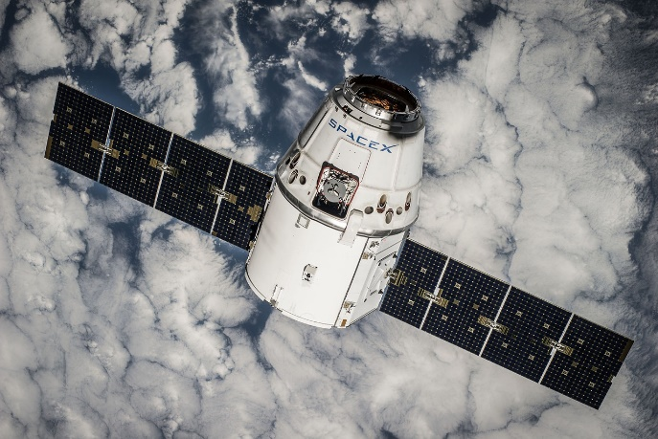

* Starlink - providing us with satellite Internet access, is a satellite constellation produced by SpaceX. The constellation has thousands of small satellites that are in Low Earth Orbit. This main characteristic is to be able to supply low-cost Internet for remoting locations.
* Improving ground station network - As the space sector keeps rapidly expanding, businesses coming up with the best technologies to meet its new requirements are set to thrive. Ground stations network enabling real-time, cost-effective, and easy access to micro/nano-satellite data, these ground stations make it suitable for the small satellite operators’ market.
* Anti-satellite weapons (ASAT) - are space weapons designed to incapacitate or destroy satellites for strategic military purposes. United States, Russia, China, and India have demonstrated this capability successfully.
* Wideband Global SATCOM – The U.S. Air Force launched a Wideband Global Satcom satellite aboard a United Launch Alliance Delta 4 medium rocket from Cape Canaveral, Florida. This is the 10th satellite of the WGS constellation that provides broadband communications for the U.S. military and allies
* Autonomous Vehicles - One of the most important components in an autonomous vehicle is its communications technology—which allows it to access the data needed to navigate its route.  
  and so on…

**Conclusion**

The development of satellite communication occurred really fast, for several decades, and the technology is indispensable to our society. In order to keep up with the time and changing technology, and understanding more about satellite communication can make our life being more interesting. On the other hand, the more important satellite communication becomes in life, the more risk of the cyber-attack may increase. The ways of hacking get more and more sophisticated as well as the technologies grow up, so people should keep changing and updating the security systems. Anyway, satellite data communication will be greater and more interesting, so we can’t take our eyes off from its amazing development!!

**References**

* Satellite Communication, <https://www.britannica.com/technology/satellite-communication>
* Future of Satellite Communication, <https://witanworld.com/article/2020/07/17/future-of-satellite-communication/>
* Cyber-Attacks: A Major Challenge Forced by Telecommunications Satellites, <https://globalsatshow.com/cyber-attacks-a-major-challenge-faced-by-the-telecommunications-satellites/>
* The Growing Risk of Major Satellite Cyber Attack, <http://interactive.satellitetoday.com/the-growing-risk-of-a-major-satellite-cyber-attack/#:~:text=The%20Growing%20Risk%20of%20a%20Major%20Satellite%20Cyber,and%20vectors%20for%20a%20cybersecurity%20attack%20on%20satellites.>
* What Is Satellite Communication and How Does it Work, <https://www.youngwonks.com/blog/What-is-Satellite-Communication-and-How-Does-It-Work>
* Satellite Communication, <https://www.daenotes.com/electronics/communication-system/satellite-communication>