<https://github.com/Kosuke9311/Data-communication-CS320/wiki/Assignment%234>

# Differences between VPN, NAT, and DHCP

## VPN

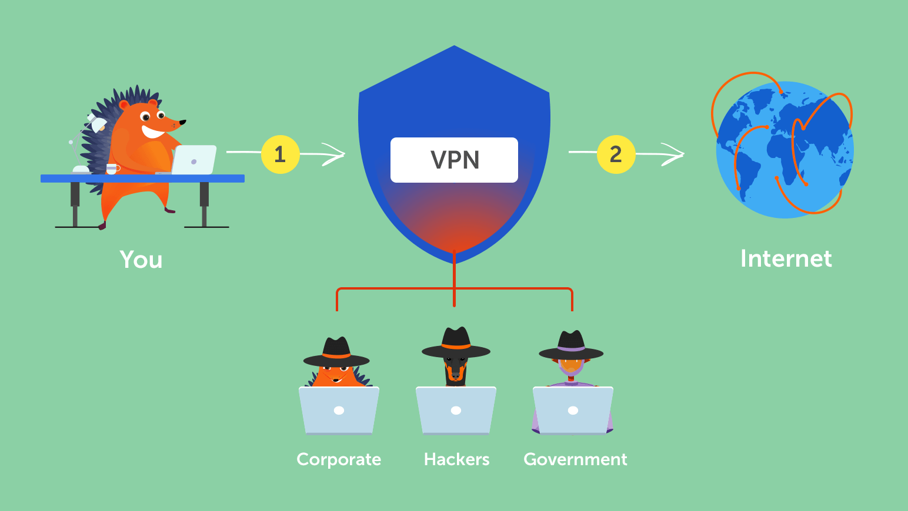

### What Is VPN?

VPN (Virtual Private Network) has been around for a long time as a technology to prevent third parties from stealing and tampering with information. Especially, Public network such as free Wi-Fi has a risk to be stolen personal information, so it is not good to interconnect directly through the public network. In this situation, the VPN is very helpful to protect the information. On the Internet, VPN creates a virtual leased line and allows you to have a secure route for the exchange of important information.  
For example, when you go through a road which is really dangerous, you will be not safe if you are alone. However, if you take a cab to go through the road, you can get to the destination safely. VPN refers to the cab in this example, and it is a system to make safe data communication possible, protecting from the various risks.

### Pros and Cons

##### While the main purpose of using a VPN is to improve security, there are other benefits of using a VPN, such as

* Reducing the risk of snooping and tampering with free Wi-Fi and other wireless networks.
* Building a pseudo-LAN regardless of physical distance
* Access anonymously, so you don’t have to worry about a third party knowing your IP address
* Much less expensive than a leased line and close to leased line security

##### VPN has many advantages, but there are disadvantages as well.

* VPN doesn’t make your security perfect (don’t overconfident)
* Especially for global network communication, speeds may not be satisfactory.
* If you use the VPN by your mobile device, a large amount of battery power is consumed

### VPN Services and App for Improving The Network Security

* Norton Secure VPN Provided by Norton, this is a VPN application which helps to exchange important information such as passwords, information of credit card and bank account during using public Wi-Fi on your smartphone, PC, tablet, and other mobile devices.  
  <https://us.norton.com/products/norton-secure-vpn>
* Hotspot Shield VPN When you enjoy watching movies on YouTube, Netflix, and Prime video, you can get a secure network with Hotspot Shield VPN. Hotspot Shield VPN has the ability to stay anonymous at an encrypting skill comparable to the military level.  
  <https://www.hotspotshield.com/>

### Main Types of VPN

Since a VPN is a virtual leased line, there are several types of VPNs, depending on how you want to set up a leased line like mechanism. The following are the most commonly used ones.

#### IPsec

The is the abbreviation for IP security Architecture, which is a technology or mechanism for encrypting the content of a communication. Even if the content of a communication is stolen, the content can’t be read due to the encryption.

#### L2TP/IPsec

L2TP/IPsec has a technology called tunneling, which makes it possible to set up a virtual private line and use it as a pseudo-network. Actually, only L2TP is not enough to encrypt the contents of communication, so it is used with IPsec which is an encryption technology, which means L2TP/IPsec can protect the information by both tunneling and encrypting.

#### PPTP

PPTP is the abbreviation for Point to Point Tunneling Protocol, provided by Microsoft Corporation. That’s why the user of Windows can utilize it.

#### SSL-VPN

SSL-VPN is like IPsec, which is prevent snooping and falsification by encrypting, however, the difference between IPsec and SSL is that SSL is an encryption technology widely used in websites and does not require any specific software, so all you need is a general web browser to be able to communicate with it.

## NAT

### What Is NAT?

NAT (Network Address Translation) is a technology to translate the type of IP address. Typically, NAT works for remapping the private IP address into the public IP address.  
Private IP address is not routed on the Internet, so the receiver can’t identify who sent the information from. Therefore, data communication on the Internet requires to change a private IP address to a public one. Although it is possible to set a public IP address directly, you need to consider security. Having multiple public IP addresses in households is not practical in terms of cost, so NAT should be taken.

### Types of NAT

Mainly there are two kinds of NAT. NAT performs “one to one” address translation, while NAPT (PAT) is a “multiple to one” address translation technology.

#### NAT

DNAT (Destination Network Address Translation) is a translation from the public to a private IP address, and SNAT (Source Network Address Translation) refers to convert private to public.

#### NAPT

The difference between NAT is that it assigns a port number to the public IP address to be converted, making it possible to convert multiple private IP addresses into a single public IP address.

## DHCP

### What Is DHCP

DHCP (Dynamic Host Configuration Protocol) is the protocol that assigns IP addresses automatically and other necessary information to computers that are temporarily connected to a network. Without the knowledge of the network settings, you can easily connect to the network. In addition, network administrators can easily manage a large number of clients centrally. A long time ago, Setting IP address are conducted manually, but in the modern age, you can connect to the Internet as soon as you buy the computer and plug in a LAN cable (without setting anything up).

### DHCP Servers

A computer or network device that has the ability to provide configuration information via DHCP is called a DHCP server. It contains the information necessary to connect to the network, such as the IP addresses, if the gateway and DNS servers, the subnet mask, and the range of IP addresses that may be assigned to clients, provides this information to computers. When a connected computer disconnects from the network, it automatically retrieves the addresses and other information, and it assigns them to other computers that have newly connected to the network.  
In the company networks, the server computer often operates as a DHCP server along with other network management functions. On the other hand, in the home internet connection environment, broadband routers often have built-in DHCP server functions.

## References

* How does VPN work? <https://www.namecheap.com/vpn/how-does-vpn-virtual-private-network-work/>
* SNAT VS DNAT – Detailed Comparison Table <https://ipwithease.com/snat-vs-dnat/>
* DHCP: The Networking Protocol That Gives You an IP Address <https://whatismyipaddress.com/dhcp>