Github wiki link : https://github.com/Kosuke9311/Data-communication-CS320/wiki/Assignment%232

**<Preview>**

**Communication Networks**



**Abstract**

When some network troubles happen to your company where you work, people might be upset, and it can have a bad impact on the business. In this situation, if you can have knowledge about communication network and solve the problem smartly, you may be a little hero and get the chance of a promotion.  
Anyway, in the modern age, technology supports our life and society all over the world, and especially the tech of communication networks helps to enhanced development. Like it’s said, Communication networks are indispensable for us.  
Let’s look at the world of communication networks!!

**Introduction**

The communication network in which computers and other devices operate autonomously and are interconnected to each other to provide computing and data services. These computers and devices connected either with or without wire.

**Types of Communication Networks**

**LAN (Local Area Network)**

A LAN is a network that enables data communication between computers, communications devices, and information equipment within a limited area (basically up to 100 meters) by connecting them with cables and radio waves. A LAN is generally constructed within a room or a building.  
A wired LAN is one in which devices are connected to each other with communication cables using copper wire or optical fiber, etc., and a wireless LAN is one in which devices are connected to each other using radio waves, etc. "Ethernet" (IEEE 802.3) standards are widely used as the communication system for wired LAN, and "Wi-Fi" (IEEE 802.11) standards are used as the communication system for wireless LAN. The term "network" often refers to a network that uses these methods. There are other methods, such as the use of power lines that are laid out to supply electricity to buildings for communication.

**Topology**

* Bus – The Main channel is connected to secondary channels or nodes like a branch.
* Ring – it is made of the closed-circuit which each of computer is connected to 2 neighbor computers
* Star – It has a central computer that is connected to other computers directly, so each computer will interconnect through the central one.

**MAN (Metropolitan Area Network)**

A MAN is a network that has an ability to interconnect between computers and computer devices, and the connection is available within the range which is larger than LAN and smaller than WAN.  
MAN applies to the interconnection of networks within a city or state (which can also provide an efficient connection to a wide area network). It is also used when it means interconnecting several local area networks by bridging them with backbone circuits. The latter usage is sometimes referred to as a campus network.

**Topology**

It is usually established with fiber optics to increase the speed of data transmission. In other words, a MAN can be viewed as a group of one or more LAN networks connected by cables.  
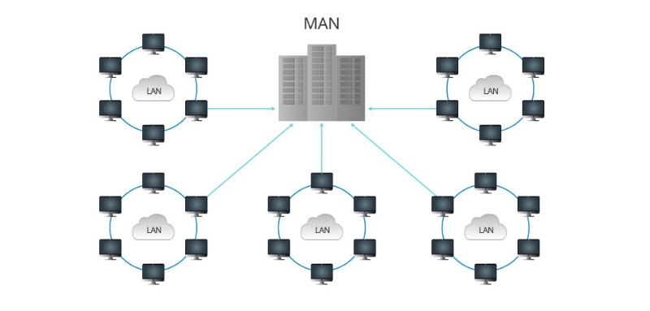

**WAN (Wide Area Network)**

A WAN is a communication network that connects geographically distant points. This term is used in contrast to the Local Area Network (LAN) that connects buildings and grounds (campus), and often refers to the circuit networks installed and operated by telecommunications carriers.  
The Internet is sometimes referred to as a WAN because of the implication that it is an interconnected network of carriers, companies, and various organizations around the world.

**Topology**

* Point-To-Point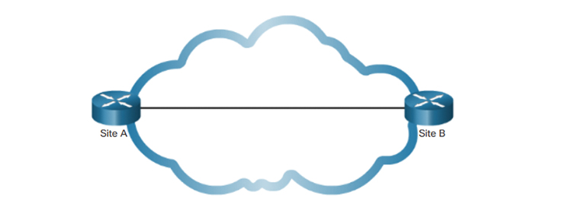

A point-to-point topology uses a point-to-point line between two endpoints; using a leased line connection, such as a T1 or E1 line, a point-to-point connection provides Layer 2 transport services over a service provider network. Offer. Packets sent from one site are delivered to the other site. A point-to-point connection is transparent to the customer network as if there were a direct physical link between the two endpoints.

* Hub-And-Spoke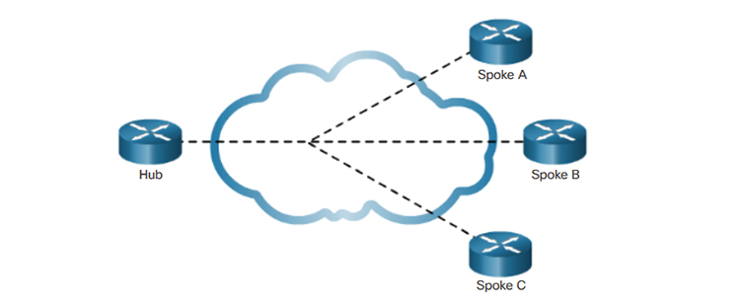  
  When creating a private network connection between multiple sites, a point-to-point topology is one option. However, this interface can be expensive.　Multiple point-to-point requires multiple routers with multiple WAN interface cards. Thus, a less expensive option is the point-to-multipoint topology, also known as hub-and-spoke topology.
* Full Mesh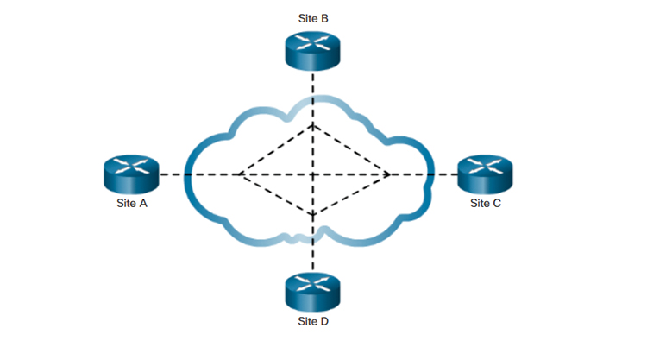  
  One of the drawbacks of a hub-and-spoke topology is that all communication has to go through the hub. In a full mesh topology with virtual circuits, any site can communicate directly with other sites. The disadvantage of Full Mesh is the many virtual circuits that should be structured and maintained.
* Dual Homed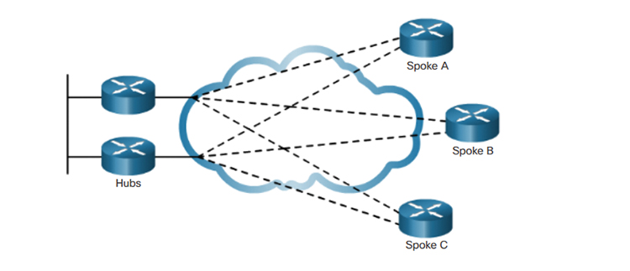  
  The dual-homed topology provides redundancy. Spoke routers are dual-homed and are redundantly connected to two hub routers across the WAN cloud. The disadvantage of a dual-homed topology is that it is more expensive than a single-homed topology.

**HAN (Home Area Network)**

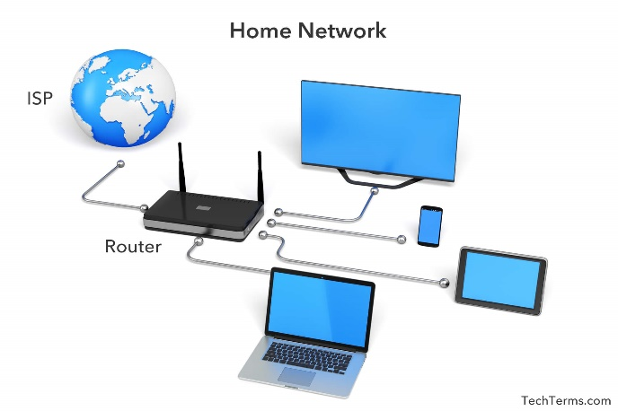  
A HAN is a network which can also be called home network, and it can be established both wired and wireless devices.  
HAN is mainly involved routers, and routers are connected to modems in order to communicate with ISP. Modem plays a important role in providing the internet to router, and routers play a important role in providing the each device with the access to the internet.  
In addition, one of the advantages of HAN is that it becomes easy to share the file, data, and information with the devices in the same internet connection. Moreover, a HAN allows you to use the internet without bothering slow network connection. Wireless signals are often influenced by the long distance and objects such as walls. However, if you take a HAN, it helps the signal to enhance and be faster.

**PAN (Personal Area Network)**

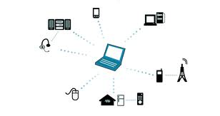  
A HAN is a network which can also be called home A PAN is a form of computer network that connects multiple digital devices used primarily by individuals and allows them to send and receive data to and from each other. Normally, it refers to the use of wireless communications, but in the situation of distinguishing it from wired systems, it is sometimes called a WPAN.  
It refers to a communication network that uses a communication method capable of transmitting data over a distance of generally the same room or several meters, and that connects devices owned and used by individuals.

The main target devices include personal computers and peripherals, smartphones, tablets, portable music players, car navigation systems, and earphones, and are used to transmit audio and video between these devices and to access the Internet and domestic LANs.

**References**

* WAN Concepts, <https://www.ciscopress.com/articles/article.asp?p=2832405&seqNum=4>

**<Write>**

# Communication Networks

![CommunicationNetworks](https://cdn.ttgtmedia.com/visuals/LeMagIT/hero_article/Cloud-networking.jpg)

## Abstract

When some network troubles happen to your company where you work, people might be upset, and it can have a bad impact on the business. In this situation, if you can have knowledge about communication network and solve the problem smartly, you may be a little hero and get the chance of a promotion.<br>

Anyway, in the modern age, technology supports our life and society all over the world, and especially the tech of communication networks helps to enhanced development. Like it’s said, Communication networks are indispensable for us.<br>

Let’s look at the world of communication networks!!

## Introduction

The communication network in which computers and other devices operate autonomously and are interconnected to each other to provide computing and data services. These computers and devices connected either with or without wire.

## Types of Communication Networks

### LAN (Local Area Network)

A LAN is a network that enables data communication between computers, communications devices, and information equipment within a limited area (basically up to 100 meters) by connecting them with cables and radio waves. A LAN is generally constructed within a room or a building. <br>

A wired LAN is one in which devices are connected to each other with communication cables using copper wire or optical fiber, etc., and a wireless LAN is one in which devices are connected to each other using radio waves, etc. "Ethernet" (IEEE 802.3) standards are widely used as the communication system for wired LAN, and "Wi-Fi" (IEEE 802.11) standards are used as the communication system for wireless LAN. The term "network" often refers to a network that uses these methods. There are other methods, such as the use of power lines that are laid out to supply electricity to buildings for communication.

#### Topology

* Bus – The Main channel is connected to secondary channels or nodes like a branch.

* Ring – it is made of the closed-circuit which each of computer is connected to 2 neighbor computers

* Star – It has a central computer that is connected to other computers directly, so each computer will interconnect through the central one. <br>

![LAN](https://cdn.britannica.com/s:1500x700,q:85/37/24337-004-B57997F0/area-networks-bus-Ethernet-token-IBM-office.jpg)

### MAN (Metropolitan Area Network)

A MAN is a network that has an ability to interconnect between computers and computer devices, and the connection is available within the range which is larger than LAN and smaller than WAN.<br>

MAN applies to the interconnection of networks within a city or state (which can also provide an efficient connection to a wide area network). It is also used when it means interconnecting several local area networks by bridging them with backbone circuits. The latter usage is sometimes referred to as a campus network.<br>

#### Topology

It is usually established with fiber optics to increase the speed of data transmission. In other words, a MAN can be viewed as a group of one or more LAN networks connected by cables.<br>

![MAN](https://img-en.fs.com/community/upload/wangEditor/202001/15/_1579075695_JM6oSiDcas.png)

### WAN (Wide Area Network)

A WAN is a communication network that connects geographically distant points. This term is used in contrast to the Local Area Network (LAN) that connects buildings and grounds (campus), and often refers to the circuit networks installed and operated by telecommunications carriers.<br>

The Internet is sometimes referred to as a WAN because of the implication that it is an interconnected network of carriers, companies, and various organizations around the world.

#### Topology

* Point-To-Point <img align="right" width="350" height="120" src="https://ptgmedia.pearsoncmg.com/images/chap1_9781587134326/elementLinks/01fig02_alt.jpg">

<br>

A point-to-point topology uses a point-to-point line between two endpoints; using a leased line connection, such as a T1 or E1 line, a point-to-point connection provides Layer 2 transport services over a service provider network. Offer. Packets sent from one site are delivered to the other site. A point-to-point connection is transparent to the customer network as if there were a direct physical link between the two endpoints.

* Hub-And-Spoke<img align="right" width="350" height="120" src="https://ptgmedia.pearsoncmg.com/images/chap1_9781587134326/elementLinks/01fig03_alt.jpg"><br>

When creating a private network connection between multiple sites, a point-to-point topology is one option. However, this interface can be expensive.　Multiple point-to-point requires multiple routers with multiple WAN interface cards. Thus, a less expensive option is the point-to-multipoint topology, also known as hub-and-spoke topology.

* Full Mesh<img align="right" width="370" height="110" src="https://ptgmedia.pearsoncmg.com/images/chap1_9781587134326/elementLinks/01fig04_alt.jpg"><br>

One of the drawbacks of a hub-and-spoke topology is that all communication has to go through the hub. In a full mesh topology with virtual circuits, any site can communicate directly with other sites. The disadvantage of Full Mesh is the many virtual circuits that should be structured and maintained.

* Dual Homed<img align="right" width="350" height="120" src="https://ptgmedia.pearsoncmg.com/images/chap1_9781587134326/elementLinks/01fig05_alt.jpg"><br>

The dual-homed topology provides redundancy. Spoke routers are dual-homed and are redundantly connected to two hub routers across the WAN cloud. The disadvantage of a dual-homed topology is that it is more expensive than a single-homed topology.

### HAN (Home Area Network)

<img align="right" width="300" height="200" src="https://cdn.techterms.com/img/lg/han_1418.jpg"><br>A HAN is a network which can also be called home network, and it can be established both wired and wireless devices. <br>

HAN is mainly involved routers, and routers are connected to modems in order to communicate with ISP. Modem plays a important role in providing the internet to router, and routers play a important role in providing the each device with the access to the internet. <br>

In addition, one of the advantages of HAN is that it becomes easy to share the file, data, and information with the devices in the same internet connection.

Moreover, a HAN allows you to use the internet without bothering slow network connection. Wireless signals are often influenced by the long distance and objects such as walls. However, if you take a HAN, it helps the signal to enhance and be faster.

### PAN (Personal Area Network)

<img align="right" width="300" height="200" src="https://mohannetworking.files.wordpress.com/2010/10/pan.jpg"><br>A HAN is a network which can also be called home A PAN is a form of computer network that connects multiple digital devices used primarily by individuals and allows them to send and receive data to and from each other. Normally, it refers to the use of wireless communications, but in the situation of distinguishing it from wired systems, it is sometimes called a WPAN. <br>

It refers to a communication network that uses a communication method capable of transmitting data over a distance of generally the same room or several meters, and that connects devices owned and used by individuals. <br>

The main target devices include personal computers and peripherals, smartphones, tablets, portable music players, car navigation systems, and earphones, and are used to transmit audio and video between these devices and to access the Internet and domestic LANs. <br>

## References

* WAN Concepts, [https://www.ciscopress.com/articles/article.asp?p=2832405&seqNum=4](https://www.ciscopress.com/articles/article.asp?p=2832405&seqNum=4)