Expense Tracker
Internship Information
Full Name: Kota Sravanthi
Intern ID: CITS1751
No. of Weeks: 8 Weeks
Project Name: Expense Tracker – Personal Finance Management System
Domain: Full Stack Web Development
College: Andhra University College of Engineering for Women (AUCEW)

1.Introduction
Overview
The Expense Tracker is a full-stack web application developed to help users efficiently manage their personal finances. The application provides a centralized platform where users can record income and expenses, monitor spending habits, manage monthly budgets, set savings goals, and track financial progress through interactive dashboards.
With increasing digital transactions and growing financial responsibilities, individuals require effective tools to understand and control their spending patterns. This application addresses that need by providing a simple, secure, and user-friendly financial management system.

2. Problem Statement
Many individuals struggle to maintain proper records of their income and expenses. Traditional methods such as maintaining notebooks or spreadsheets can be time-consuming and prone to errors.
The major challenges faced by users include:
- Lack of visibility into spending habits.
- Difficulty in tracking monthly expenses.
- Inability to monitor savings progress.
- Lack of financial planning tools.
- Difficulty in maintaining organized financial records.
The Expense Tracker application was developed to solve these challenges through automation and visualization.

3. Objectives
The primary objectives of this project are:
- To provide a secure financial management platform.
- To record income and expense transactions.
- To generate financial summaries and reports.
- To help users manage monthly budgets.
- To assist users in achieving savings goals.
- To provide data visualization through charts and graphs.
- To improve personal financial planning.

4. Scope of the Project
The scope of the Expense Tracker includes:
4.1 User Management
- User Registration
- User Login
- Secure Authentication using JWT
- Profile Management
4.2 Financial Management
- Add Income Transactions
- Add Expense Transactions
- Update Transactions
- Delete Transactions
- Categorize Expenses
4.3 Budget Management
- Monthly Budget Setting
- Budget Consumption Tracking
- Remaining Budget Calculation
4.4 Savings Management
- Savings Goal Creation
- External Savings Tracking
- Savings Progress Monitoring
- Monthly Savings Requirement Calculation
4.5 Dashboard Analytics
- Total Income
- Total Expenses
- Current Balance
- Category-wise Expense Analysis
- Monthly Expense Visualization

5. System Architecture
The application follows a three-tier architecture.
Frontend (React.js)
↓
Backend API (Node.js + Express.js)
↓
Database (MySQL)
5.1 Frontend Layer
- Responsible for:
- User Interface
- Form Validation
- Data Visualization
- API Communication
  - Backend Layer
- Responsible for:
- Business Logic
- Authentication
- Database Operations
- API Endpoints
  - Database Layer
- Responsible for:
- Data Storage
- Data Retrieval
- Relationship Management

6. Database Design
6.1 Users Table
Stores user account information.
Field | Type
id | INT
name | VARCHAR
email | VARCHAR
password | VARCHAR
budget | DECIMAL

6.2 Transactions Table
Stores income and expense records.
Field | Type
id |  | INT
user_id | INT
type | ENUM
category | VARCHAR
amount | DECIMAL
description | TEXT
transaction_date | DATE

6.3 Savings Goals Table
Stores savings goals.
Field | Type
id | INT
user_id | INT
goal_amount | DECIMAL
extra_savings | DECIMAL
target_date | DATE

6.4 Savings Entries Table
Stores additional savings entries.
Field | Type
id | INT
user_id | INT
amount | DECIMAL
description | VARCHAR
created_at | DATE

7. Modules Implemented
7.1Authentication Module
Features:
- User Registration
- User Login
- Password Encryption
- JWT Authentication
Benefits:
- Secure access control
- Personalized user data

7.2 Dashboard Module
Features:
- Total Income Display
- Total Expense Display
- Current Balance
- Budget Status
- Financial Charts
Benefits:
- Quick financial overview
- Better decision making

7.3 Transaction Management Module
Features:
- Add Transactions
- Edit Transactions
- Delete Transactions
- Search Transactions
Benefits:
- Organized financial records
- Easy transaction tracking

7.4 Savings Goal Tracker Module
Features:
- Goal Amount Setting
- Target Date Selection
- Progress Calculation
- Monthly Saving Requirement
Benefits:
- Encourages disciplined saving
- Tracks goal achievement

7.5 Profile Module
Features:
- View Profile
- Edit Profile Information
- Account Management
Benefits:
- Personalized user experience

8. Screenshots
Insert screenshots with descriptions:
8.1 Login Page
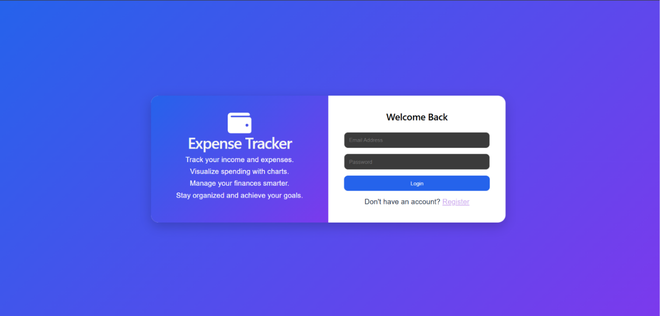
Fig 1 : Secure login interface for authenticated access.
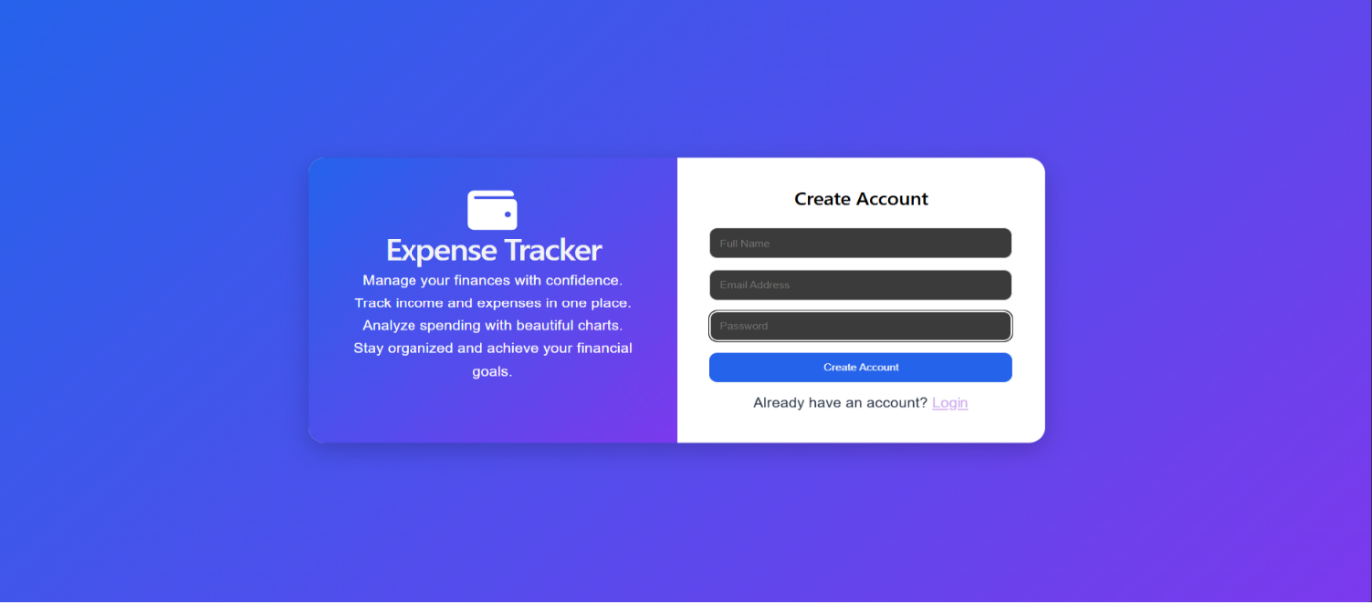
Fig 2 : Registration page
8.2 Dashboard

Fig 3,4 : Displays income, expenses, balance, charts, and savings information.

Fig 5 : Tracks savings goals and financial progress.

8.3 Transactions Page
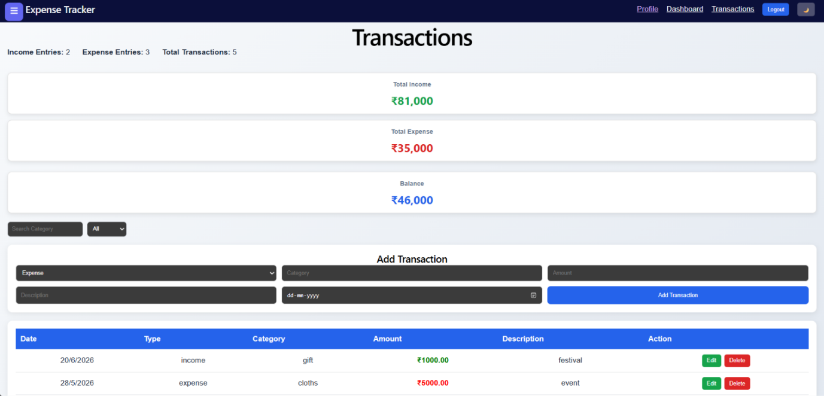
Fig 6 : Allows users to manage financial transactions.
8.4 Profile Page
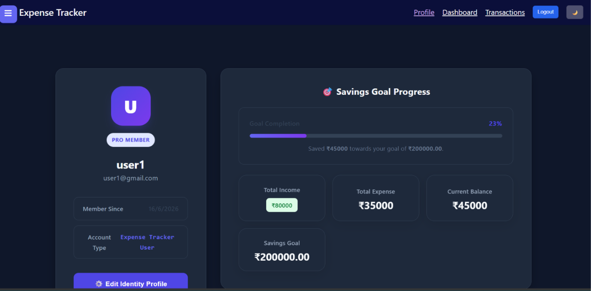
Fig 7 : Displays user information and account settings.

9. Testing
The application was tested for:
Test Case | Result
User Registration | Passed
User Login | Passed
Add Transaction | Passed
Edit Transaction | Passed
Delete Transaction | Passed
Budget Update | Passed
Savings Goal Update | Passed
Profile Update | Passed

10. Challenges Faced
During development, the following challenges were encountered:
- Managing JWT Authentication.
- Handling API integration.
- Designing responsive UI components.
- Synchronizing dashboard data.
- Managing savings calculations.
- Handling database relationships.
These challenges were resolved through debugging, testing, and optimization.

11. Future Enhancements
Future improvements may include:
- Bank Account Integration
- UPI Transaction Import
- AI-based Spending Analysis
- Expense Prediction using Machine Learning
- Email Notifications
- Mobile Application Development
- Multi-Currency Support
- Export Reports to PDF/Excel

12. Learning Outcomes
Through this project, the following skills were enhanced:
- React.js Development
- Node.js Backend Development
- REST API Development
- MySQL Database Management
- JWT Authentication
- Frontend-Backend Integration
- Data Visualization
- Git and GitHub Version Control

13. Conclusion
The Expense Tracker project successfully demonstrates the implementation of a modern full-stack web application for personal financial management. The system enables users to monitor expenses, manage budgets, track savings goals, and visualize financial data effectively. The project provided valuable experience in full-stack development and strengthened practical knowledge of React.js, Node.js, Express.js, MySQL, and RESTful API development.

