Hospital-Management-System

Internship Information
- Intern ID: CITS1751
- Full Name: KOTA SRAVANTHI
- No. of Weeks: 8 Weeks
- Project Name: Hospital-Management-System
- Domain: Full Stack Web Development
- College: Andhra University College of Engineering for Women (AUCEW)

1. Introduction

Overview
- The Hospital Management System is a full-stack web application developed to manage hospital activities digitally.
- The system provides different modules for patients, doctors, and administrators. Patients can search doctors and book appointments, doctors can manage their appointments, and administrators can manage hospital operations.
- The main aim of this project is to reduce manual work and provide an efficient for healthcare management.

2. Problem Statement
Hospitals manage a large amount of information related to patients, doctors, and appointments. In traditional systems, managing these activities manually requires more paperwork, consumes time, and may lead to errors in maintaining records.
Patients often face difficulties in finding suitable doctors and booking appointments conveniently. Doctors need an organized way to manage their schedules and patient appointments. Hospital administrators require a centralized system to monitor doctors, patients, and overall hospital activities.
The objective of this project is to develop a Hospital Management System that provides a digital platform for managing hospital operations efficiently. The system allows patients to book appointments, doctors to manage appointments, and administrators to control and monitor the complete system.

3. Objectives
The main objectives of the project are:
- To develop an online healthcare management platform.
- To provide easy doctor appointment booking.
- To manage patient and doctor information.
- To provide role-based access control.
- To reduce paperwork in hospital operations.
- To improve communication between patients and doctors.

4. Scope of the Project
The scope of the Hospital Management System includes the development of a web-based platform that provides different functionalities for patients, doctors, and administrators.
4.1 Patient Scope:
- Patients can register and login securely.
- Patients can search for available doctors.
- Patients can view doctor details such as specialization, qualification, and consultation fee.
- Patients can book appointments with doctors.
- Patients can view their appointment history.
- Patients can manage their personal profile.

4.2 Doctor Scope:
- Doctors can create and manage their profiles.
- Doctors can provide information such as specialization, experience, and hospital details.
- Doctors can view scheduled appointments.
- Doctors can manage appointment status.
- Doctors can access patient appointment details.

4.3 Admin Scope:
- Admin can access a centralized dashboard.
- Admin can view system statistics.
- Admin can manage doctors.
- Admin can manage patients.
- Admin can monitor appointment
4.4 Technical Scope:
The project is developed using the MERN stack:
- React.js for frontend development.
- Node.js and Express.js for backend services.
- MongoDB for database management.
- JWT for secure authentication.
The system can be further extended with additional healthcare features in the future.

5. System Architecture
Patient
|
Doctor
|
Admin
|
React Frontend
|
REST API
|
Node.js + Express Backend
|
MongoDB Database

6. Database Design
6.1 User Collection
- _id
- name
- email
- password
- phone
- role
- createdAt
6.2 Doctor Collection
- _id
- user
- specialization
- qualification
- experience
- hospital
- consultationFee
- timings
- about
- verified
6.3 Appointment Collection
- _id
- patient
- doctor
- appointmentDate
- appointmentTime
- reason
- status
- createdAt

7. Modules Implemented
7.1 Patient Module
Features:
- User registration
- User login
- Search doctors
- View doctor details
- Book appointments
- View booked appointments
- Manage profile
7.2 Doctor Module
Features:
- Doctor registration
- Create doctor profile
- Add specialization details
- View appointments
- Manage appointment status
- View patient details
7.3 Admin Module
Features:
- Admin dashboard
- View total doctors
- View total patients
- Manage doctors
- Manage patients
- Manage appointments
- Monitor hospital activities

8. Screenshots
8.1 Home page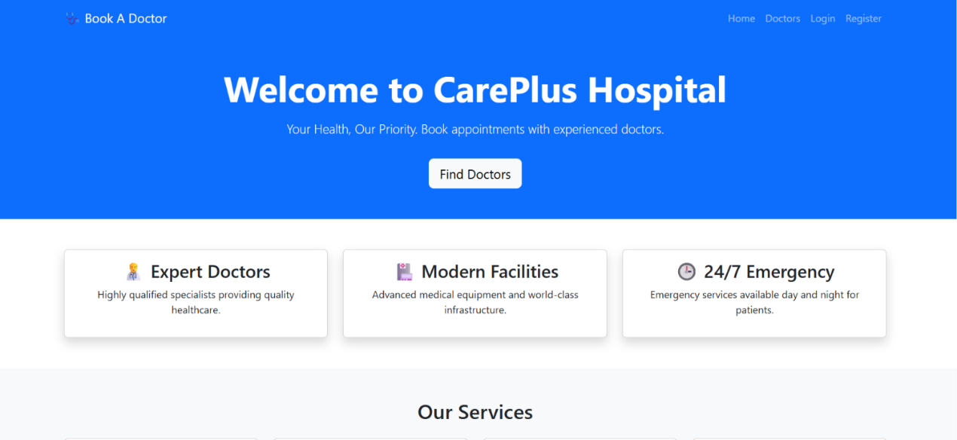

8.2 Login page
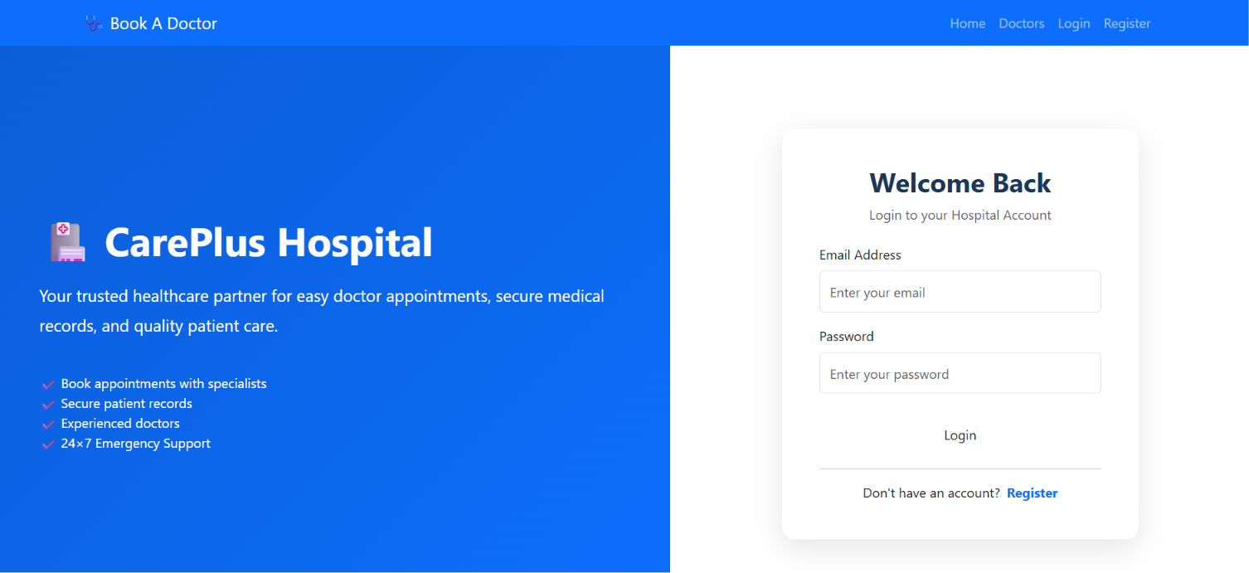
8.3 Doctors Dashboard

8.4 Patients dashboard

8.5 Admin Dashboard

9. Advantages
- Easy appointment management.
- Secure authentication system.
- Reduces manual paperwork.
- Centralized hospital information.
- Improves healthcare accessibility.
- Provides separate access for different users.

10. Future Enhancements
- Online payment integration.
- Video consultation.
- Medical reports upload.
- Email/SMS notifications.
- Prescription management.
- AI-based healthcare assistant.

11. Conclusion
- The Hospital Management System provides a digital solution for managing healthcare services. The application successfully connects patients, doctors, and administrators through a single platform.
- The project demonstrates the implementation of full-stack development using React.js, Node.js, Express.js, and MongoDB.

