😘❤️😁

**In any of the word doc use Ctrl + F to go to that topic page directly**

** Try to remember important key terms to refer while talking to interviewer **

Linux

* Use notes document for linux
* Press Ctrl + F and search for topic
* If any topic not found use chat gpt tell “show in short with code example”
* File system hierarchy (page 5) just read as story
* HTTP status code (page 1)
* What is kernel (page 7)
* Refer from page 16 to 28 for important underlying and highlights and connection topics like (ssh, scp ).
* Virtualization – type1 hypervisor, type2 hypervisor (page 11)
* Basic commands
* **Head, tail**

1. **ls**: List directory contents.
2. **cd**: Change the current directory.
3. **pwd**: Print the name of the current working directory.
4. **mkdir**: Make directories.
5. **rm**: Remove files or directories.
6. **cp**: Copy files or directories.
7. **mv**: Move files or directories.
8. **touch**: Create an empty file.
9. **cat**: Concatenate and display files.
10. **echo**: Display a line of text.

* Process Management:
  + ps
  + top
  + kill
  + pkill
  + pgrep
  + nice
  + renice
  + killall
  + pidof
  + htop
* Network Management:
  + ifconfig
  + ip
  + netstat
  + ping
  + traceroute
  + nslookup
  + dig
  + route
  + iwconfig
  + ss
* File System Management:
  + ls
  + cd
  + cp
  + mv
  + rm
  + mkdir
  + rmdir
  + touch
  + chmod
  + chown
* User Management:
  + useradd
  + userdel
  + usermod
  + passwd
  + chpasswd
  + su
  + sudo
  + id
  + groups
  + finger
* Package Management:
  + apt
  + yum
  + dpkg
  + rpm
  + apt-get
  + dnf
  + zypper
  + snap
  + pacman
  + emerge
* System Information:
  + uname
  + hostname
  + uptime
  + dmesg
  + lsb_release
  + free
  + df
  + top
  + hwinfo
  + cat /proc/cpuinfo
* Disk Management:
  + df
  + du
  + fdisk
  + mkfs
  + mount
  + umount
  + lsblk
  + blkid
  + parted
  + fsck
* Service Management:
  + systemctl
  + service
  + chkconfig
  + systemctl
  + init
  + start
  + stop
  + restart
  + status
  + journalctl
* Cron jobs
* Shell scripting
* GUI vs API vs CLI vs CUI (page 41)
* What is daemon? (page 42)
* Any scenario-based question can be answered with below two answers in linux
* 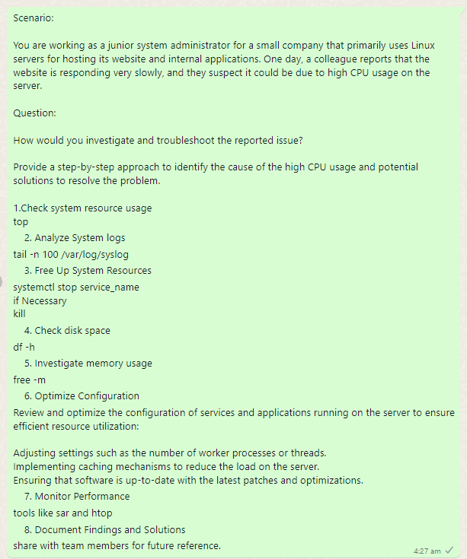
* 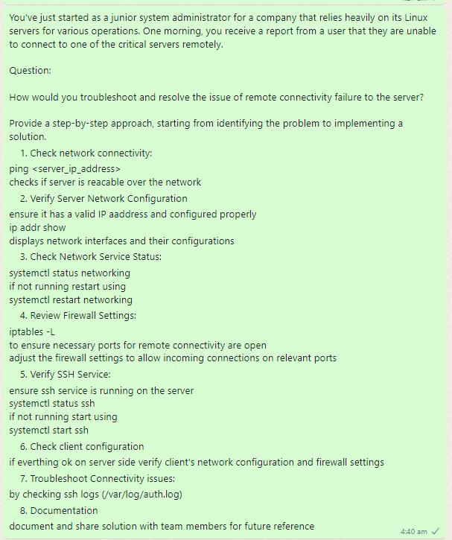

Python

Check “python” folder notes

1. Day1.py
2. PythonDay2.py
3. PythonDay3.py
4. PythonDay4.py
5. PythonDay5.py
6. PythonDay6.py
7. PythonDay7-Pandas.py
8. Dictionaries.py
9. Set vs List vs Tuple vs Dictionary.py
10. Overloading vs Overriding.py
11. String Methods.py
12. Exceptions.py
13. Generators.py
14. Bytecode.py
15. .py vs .pyc file.py
16. _pycache_files.py
17. Garbage Collection.py
18. Dynamic vs Static Typing.py
19. Precedence vs Associativity.py

Dbms

Refer to “Wiley 5.Database.doc” word document file for dbms

1. What is database? (page 43 definition below aggregate functions)
2. Joins (page 55)
3. OLTP vs OLAP (page 3)
4. Normalization (page 5 chatgpt snapshot definitions enough give random table examples if asked or refer below pages for examples)
5. Constraints in SQL (page 13)
6. Char vs varchar (page 18)
7. Candidate key vs composite key (page 24)
8. Aggregate functions (page 43)
9. Order of execution (page 46)
10. Where vs group by vs Having vs order by(page 47)
11. Subquery (page 51)
12. Union vs union all statement (page 60)
13. Locks and deadlocks (page 61)
14. Fact table vs dimension table (page 65)
15. Cardinality (page 65)
16. Types of relationship (page 69 chatgpt snapshot enough)
    1. Take a example for each relationship from info below snapshot
17. Window function and common table expression (page 73)
18. Views (page 81)
19. Are views updatable? (page 83)
20. Does updating view changes data in source table? (page 83)
21. Procedures (page 85)
22. ACID properties (page 94,95)
23. Truncate vs delete (page 97)
24. Indexing (page 99)
25. Trigger (page 101)
26. Cursors and clusters definitions (page 106)
27. Go through glimpse for “IMPORTANT CODES” (page 106)

Docker and Jenkins and Kubernetes

* Go to notes.doc document
* Page no. 245
* Definitions enough
* Go through basic commands to remember roughly may ask
* Example Codes not much important

Finance

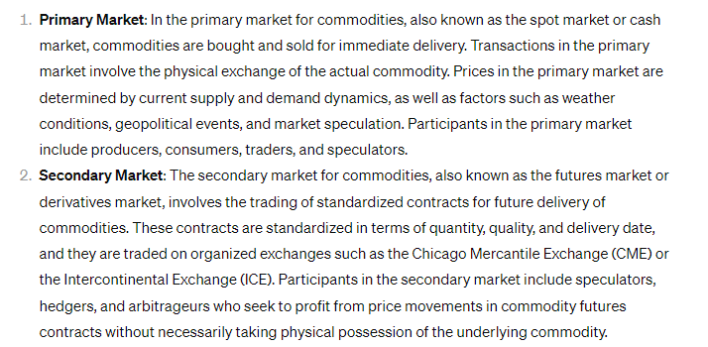

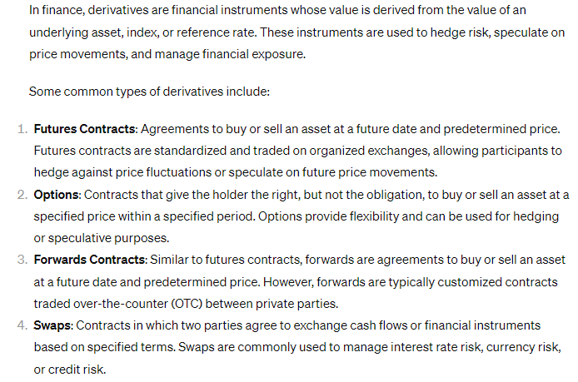

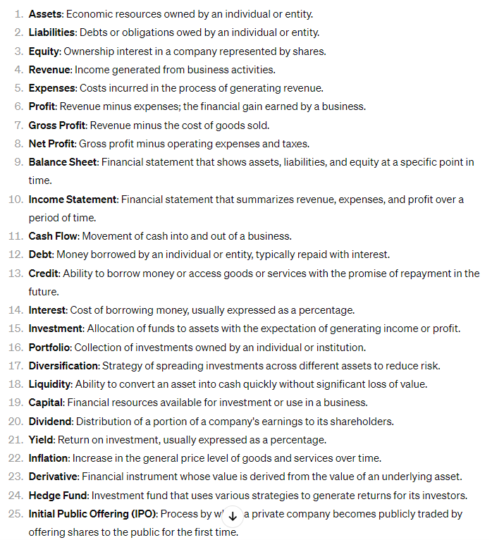

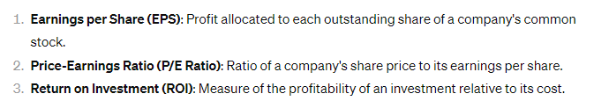



Git & GitHub

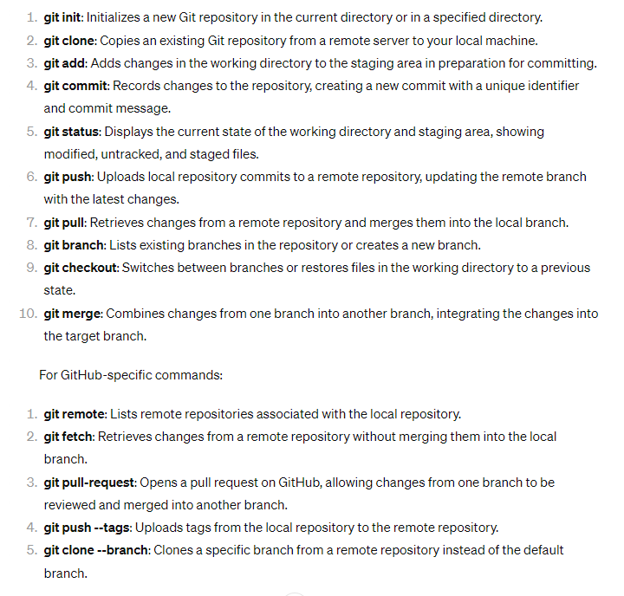

Behavioral questions

* This section can be cracked if interviewer feels if you are a “learner/ready to learn/excited to learn etc”
* Read all questions having learning as key aspect
* Refer to “interview Questions.doc” document
* Remember important terms while answering to interviewer
* Some include (team collaboration, timely and effective solution, consistent group discussions, as a team leader I would make sure I had a one on one interaction for less interactive team member, making specific document for each issue raised during project completion, importance of the project and how it would help personal career development – this is motivation, if there is a issue taking personally with them and asking if there is any issue from my side and resolving accordingly so that project doesn’t get hampered)

Go through all the below topics for some of the basic questions

Any unknown devops/SRE/Production support analyst questions can be answered using some of the key terms below to save ourself at that time.

If completely out of scope say politely with a decent smile “Sorry, I couldn’t recall at this moment”

**SRE important topics**

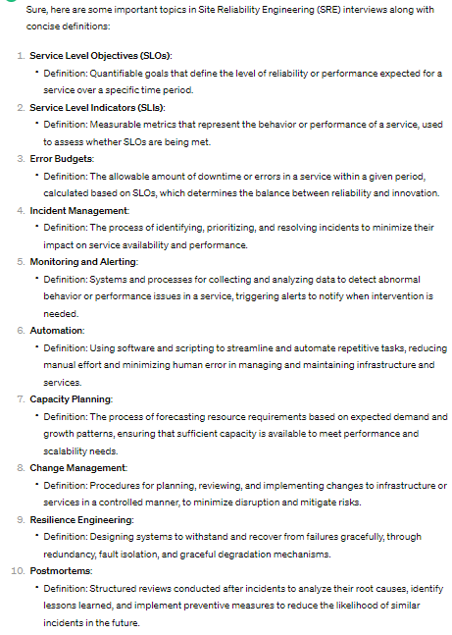

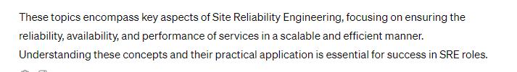

**ITIL**

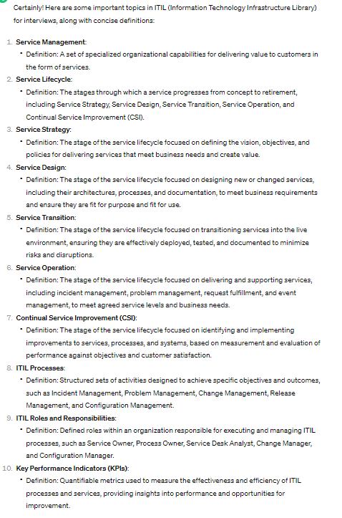

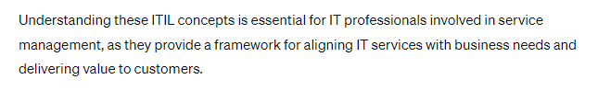

**Incidents**

