Train Ticket Booking System- PHASE_2

Presented By:

Vasavi Kota

CMRCET,Hyderabad

# Phase 2: Org Setup & Configuration

## 🔹 1. Company Profile Setup

* Go to **Setup → Company Information → Edit**.
* I Set **Company Name** = Railway Ticketing System.

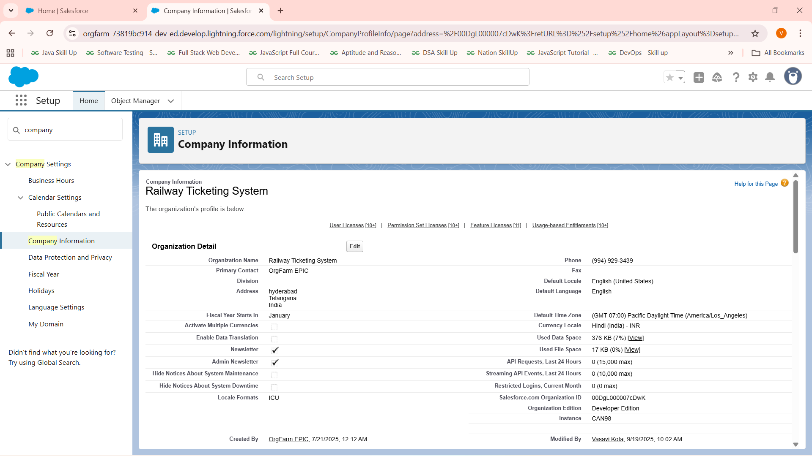

## 🔹 2. Business Hours & Holidays

* **Setup → Business Hours** → Defining as 24/7 as they can book tickets anytime.
* **Holidays** → Not adding any sample holidays because agents can manage the bookings .
* If needed we can add for **approval processes** and **flows** (like refunds not processed on holidays).

## 🔹 3. Fiscal Year Settings

* **Setup → Fiscal Year** → Use Standard Fiscal Year.
* Defines reporting cycles for dashboards and revenue tracking.

## 🔹 4. User Setup & Licenses

* Created users for **Admin, Agent, Passenger**.
* **Admin** → System Administrator license (My own account).
* **Agent** → Salesforce Platform license.
* **Passenger** → Simulated as a Contact (Standard User) and salesforce licence.
* This allows testing from different perspectives.

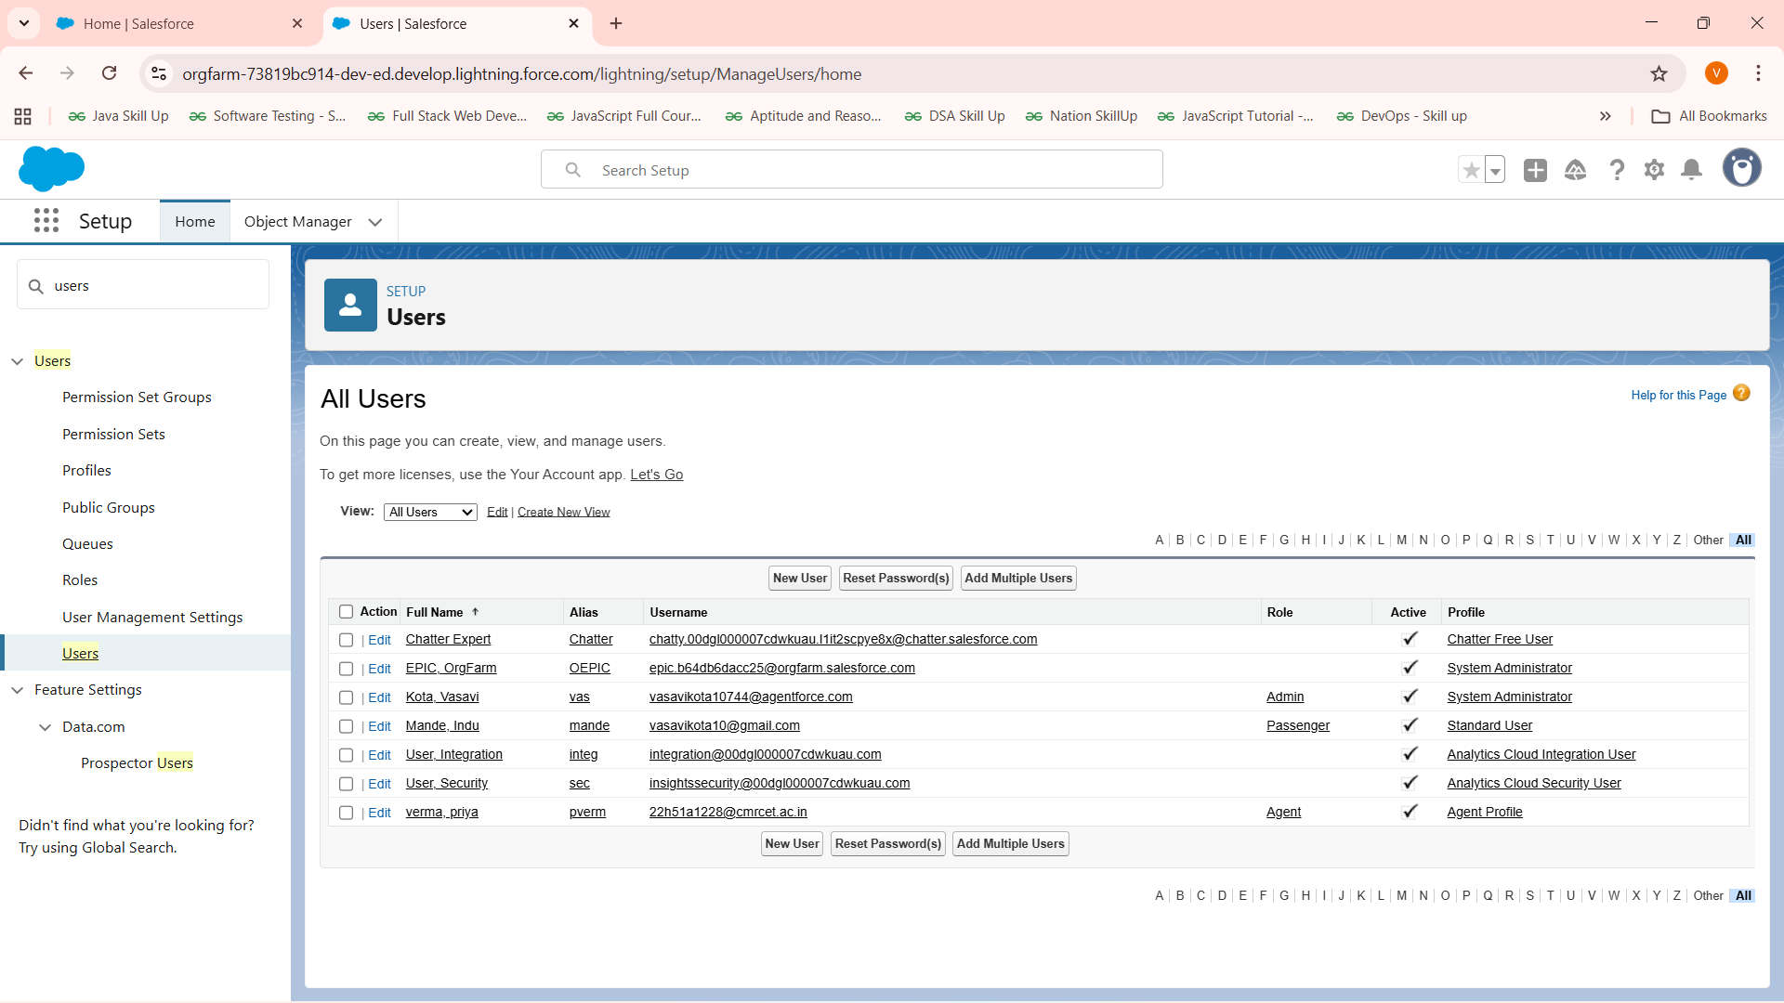

## 🔹 5. Profiles

Profiles control object and field-level access.

* **Passenger Profile**:
  + Access only to their own Tickets/Bookings.
  + Read-Only access to Trains & Routes.
* **Agent Profile**:
  + Create/Edit Tickets for passengers.
  + Manage Passenger records.
  + Read access to Trains & Routes.
* **Admin Profile**:
  + Full access (System Administrator).

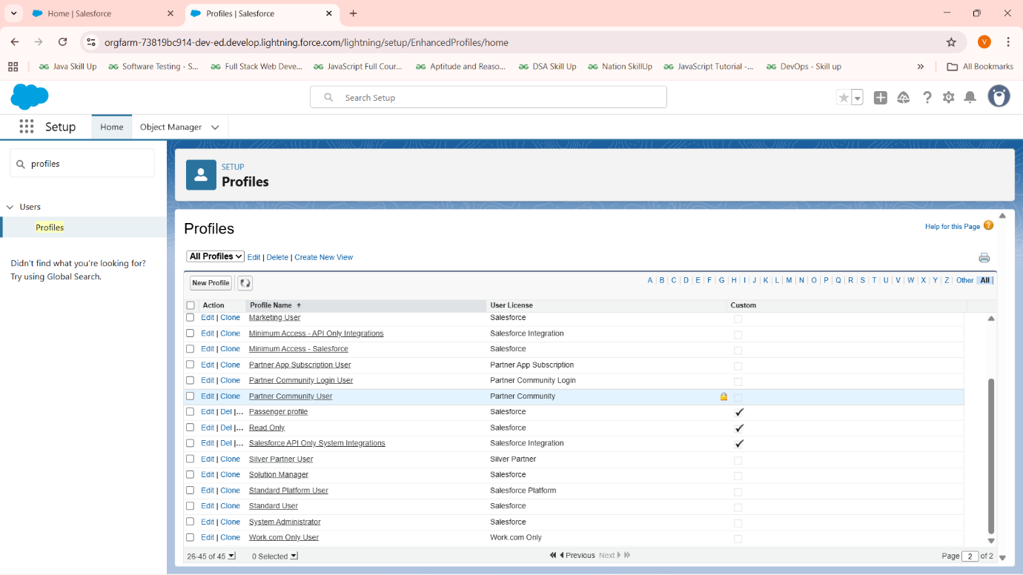

## 🔹 6. Roles

Roles control data visibility in the hierarchy.

* Created hierarchy: **Admin → Agent → Passenger**.
* Assigned users to each role.
* Ensures Agents can see their customers’ Tickets, while Passengers can only see their own.

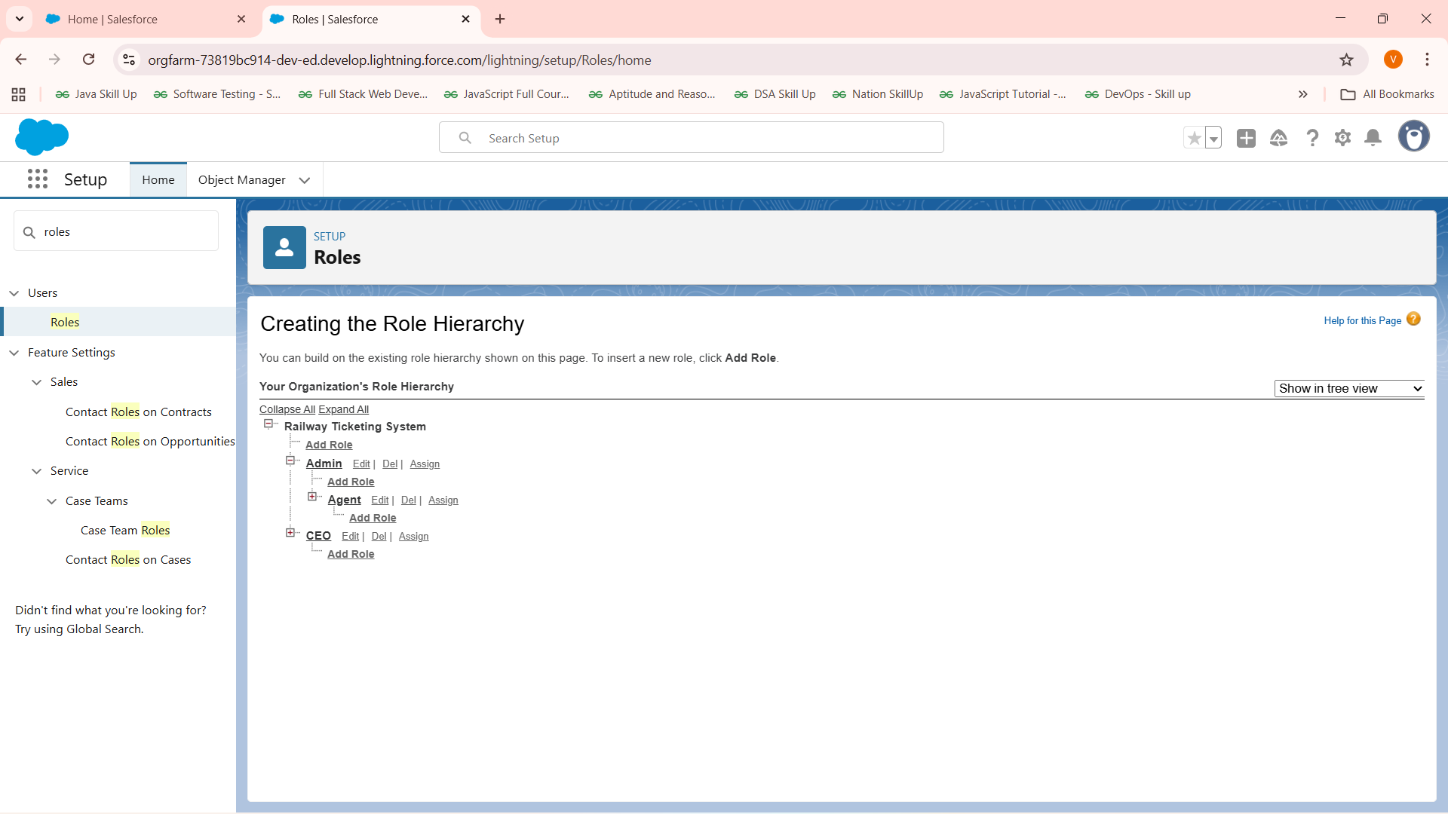

## 🔹 7. Permission Sets

Permission sets give additional access beyond profiles.

* **Manage Refunds** Permission Set:
  + Grants edit access to Refund_Status__c field on Ticket.
  + Assigned to **Agents & Admins** only.
  + Ensures passengers cannot manipulate refunds.

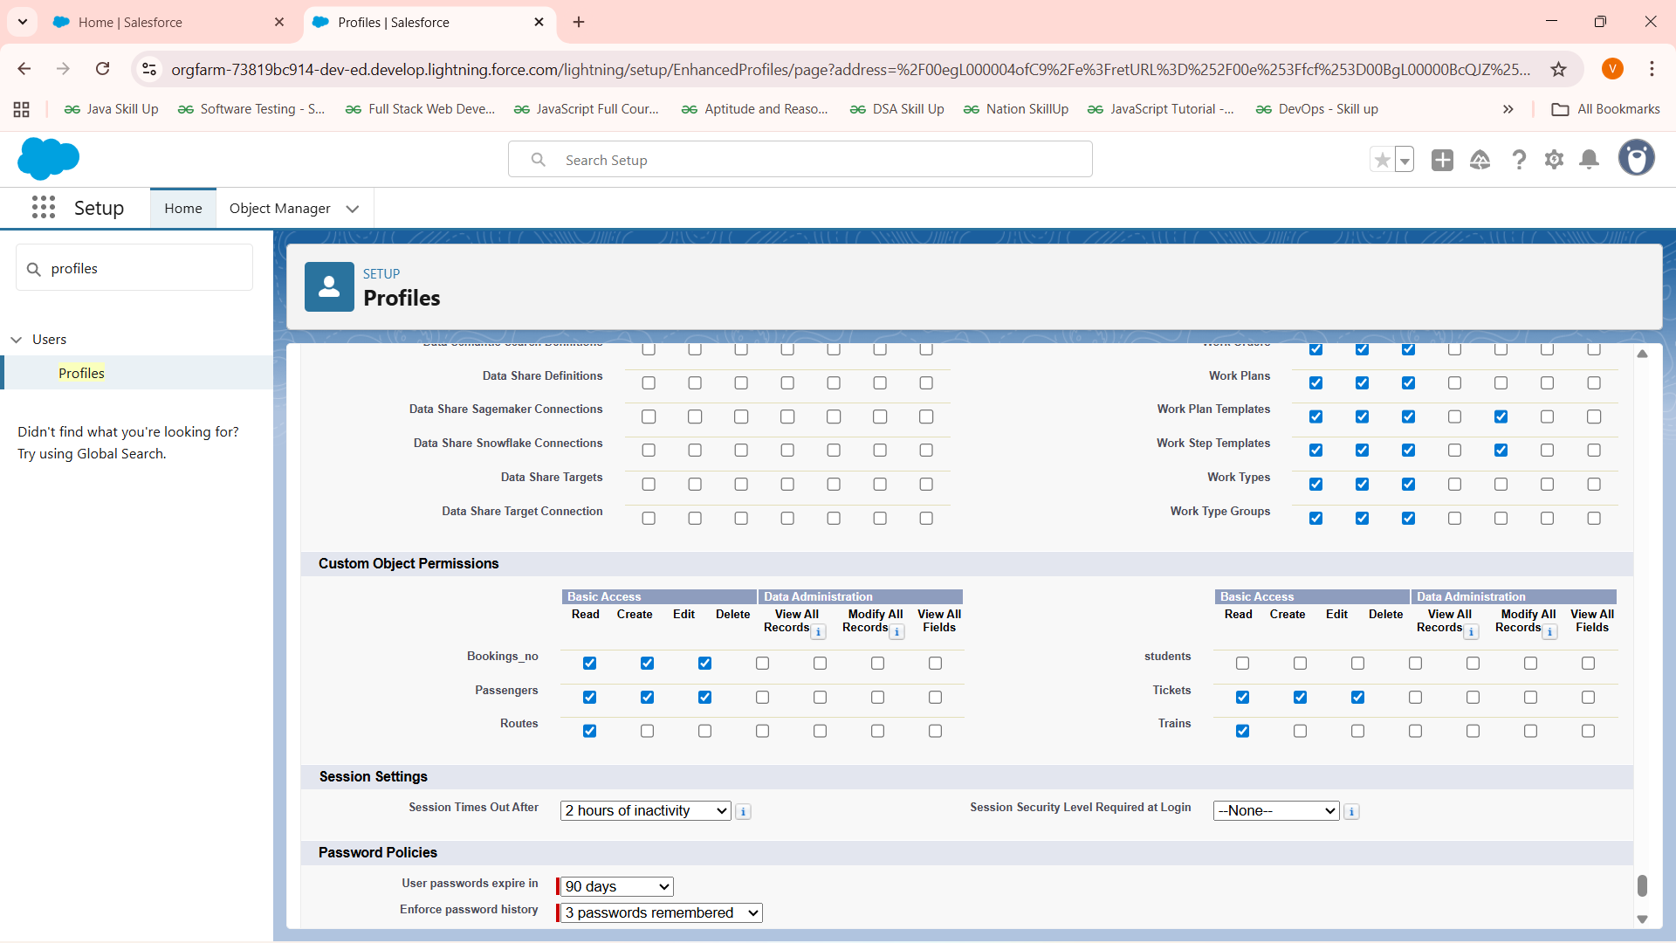

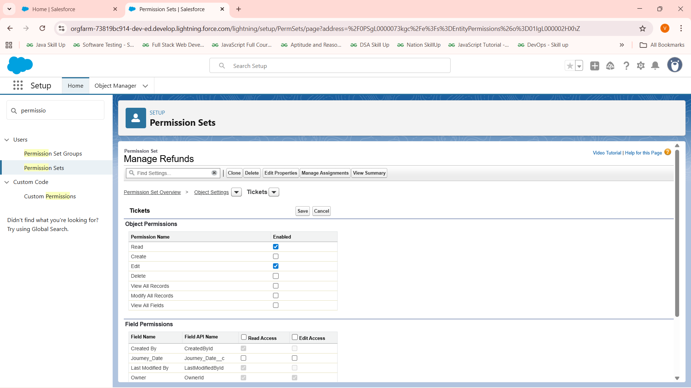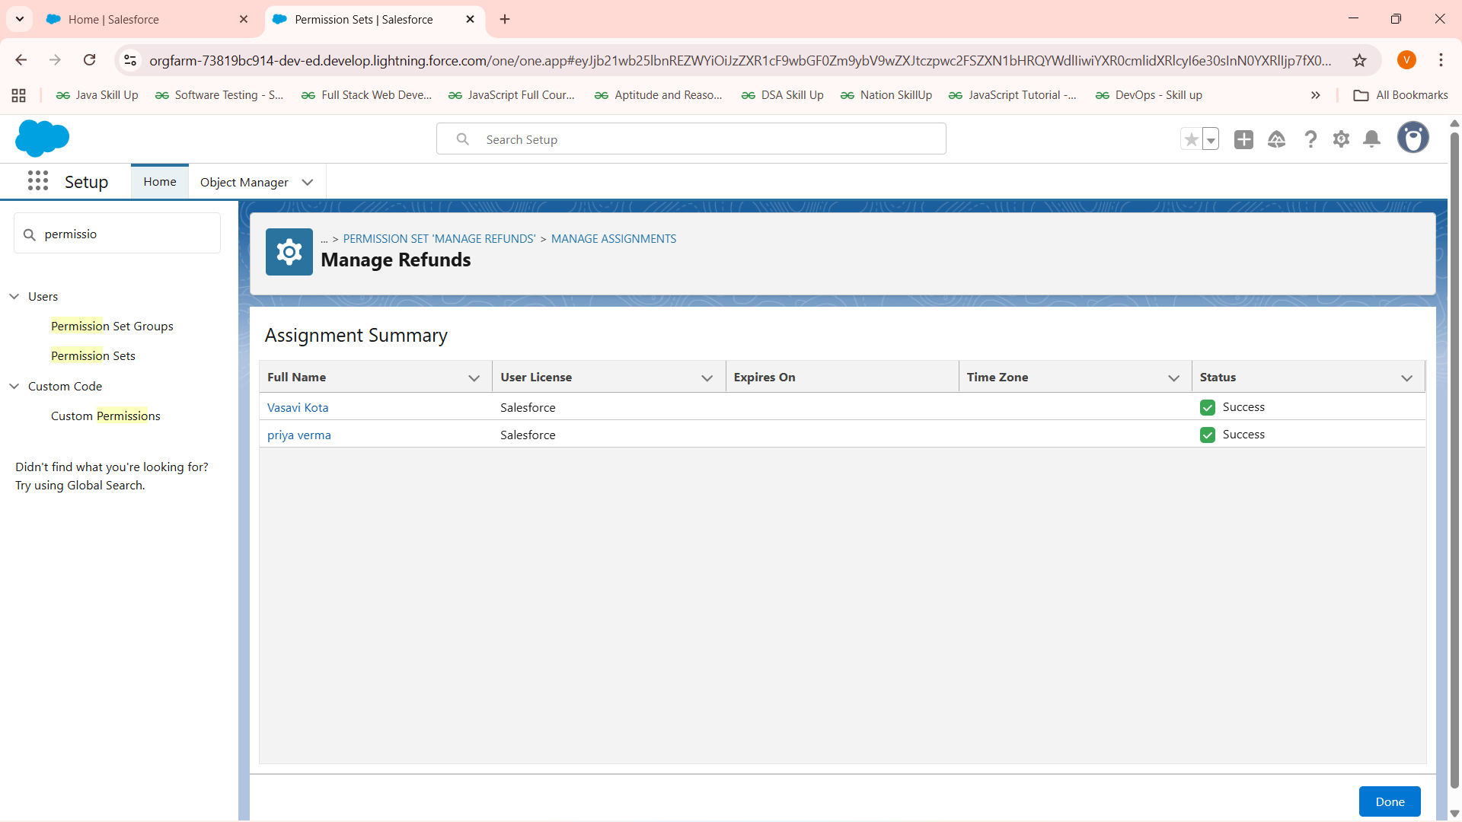

## 🔹 8. Organization-Wide Defaults (OWD)

Defines the baseline sharing level for all records.

* **Ticket** = Private (only owner/Admin sees by default).
* **Booking** = Private.
* **Passenger** = Private.
* **Train** = Public Read Only.
* **Route** = Public Read Only.

This ensures data privacy by default. 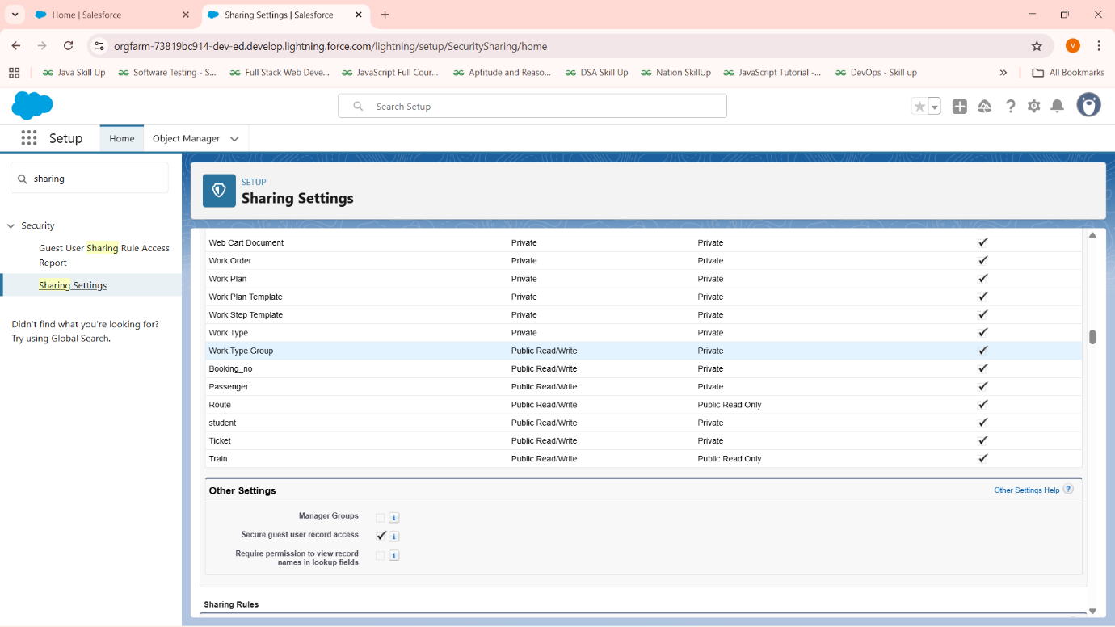

## 🔹 9. Sharing Rules

Used to open access where needed.

* Created a Sharing Rule on **Ticket**:
  + Criteria: Assigned Agent is not blank.
  + Shared with **Role: Agent**.
  + Access: Read/Write.
* This allows Agents to see Tickets assigned to them while Passengers remain restricted.

## 🔹 10. Login Access Policies

* **Setup → Login Access Policies** → Enabled “Administrators Can Log in as Any User.”
* Allows Admin to test flows by logging in as Passenger or Agent without needing passwords.

✅ Phase-2 Outcome

At the end of Phase 2, the Salesforce org is fully prepared with:

* Company information and working hours.
* Users, roles, profiles, and permission sets.
* Data access secured through OWD and Sharing Rules.
* Admin can impersonate users for testing.