Train Ticket Booking Management System

In this phase, we design and configure the data model for the **Train Ticket Booking System**. This involves creating custom objects, fields, relationships, record types, layouts, and schema visualization.

**🔹 1. Standard & Custom Objects**

* **Standard Objects Used**: User (for Agent assignment), Contact (optional alternative to Passenger).
* **Custom Objects Created**:
  + **Train__c** → Stores train details.
  + **Passenger__c** → Stores passenger/customer details.
  + **Ticket__c** → Stores ticket information (PNR, journey, status).
  + **Booking__c** (optional junction) → Groups passenger & ticket if many-to-many is required.
  + **Route__c** → Stores source, destination, and station details.

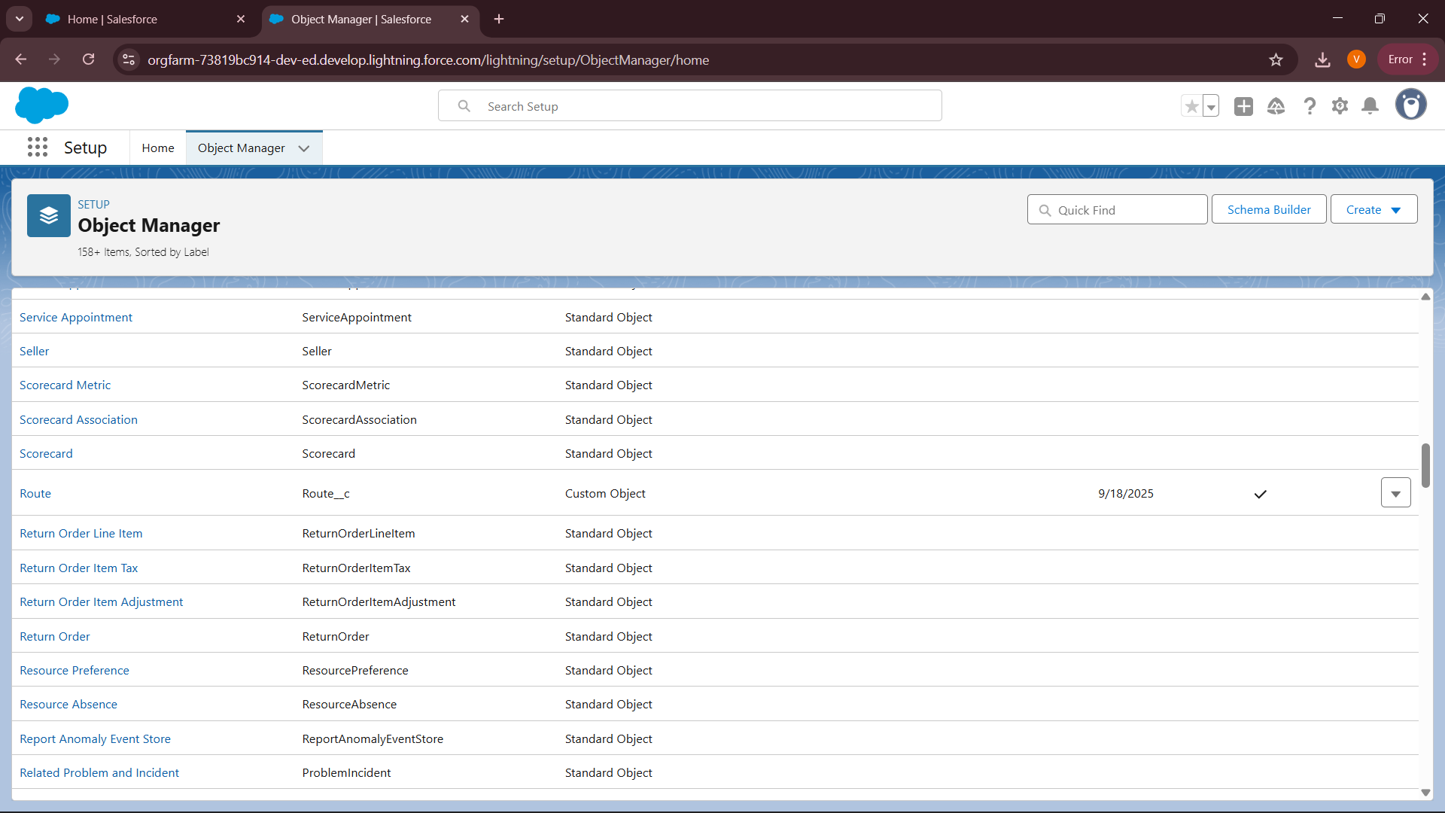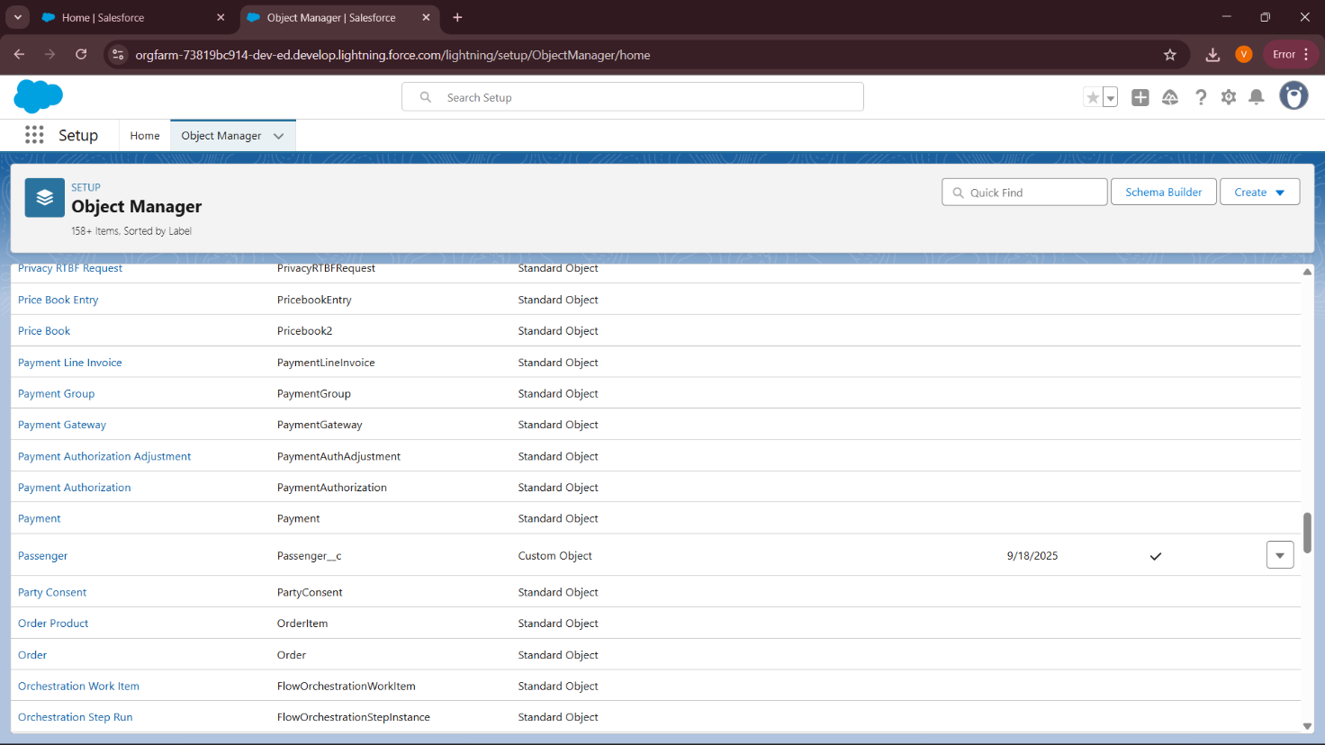

**🔹 2. Fields**

**Example Fields Created:**

* **Train__c** → Train_No, Train_Name, Source, Destination, Class_Type, Total_Seats, Available_Seats.
* **Passenger__c** → Name, Age, Gender, Email, Phone, Wallet_Balance, ID_Proof, ID_Number.
* **Ticket__c** → PNR (Auto Number), Journey_Date, Status, Seat_No, Price, Booking_Date, Passenger (Lookup), Train (Lookup), Assigned Agent (Lookup to User), Payment_Status, Refund_Status.
* **Route__c** → Route_Name, Source_Station, Destination_Station, Station_List, Departure_Time, Arrival_Time.

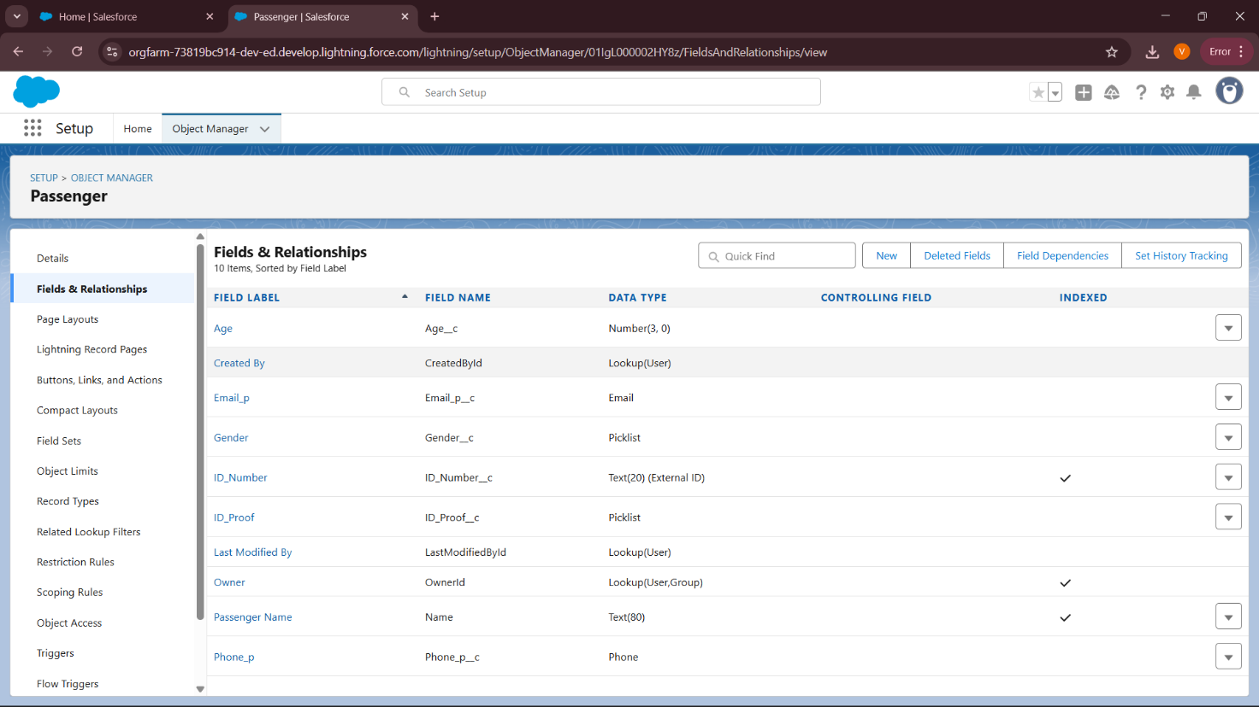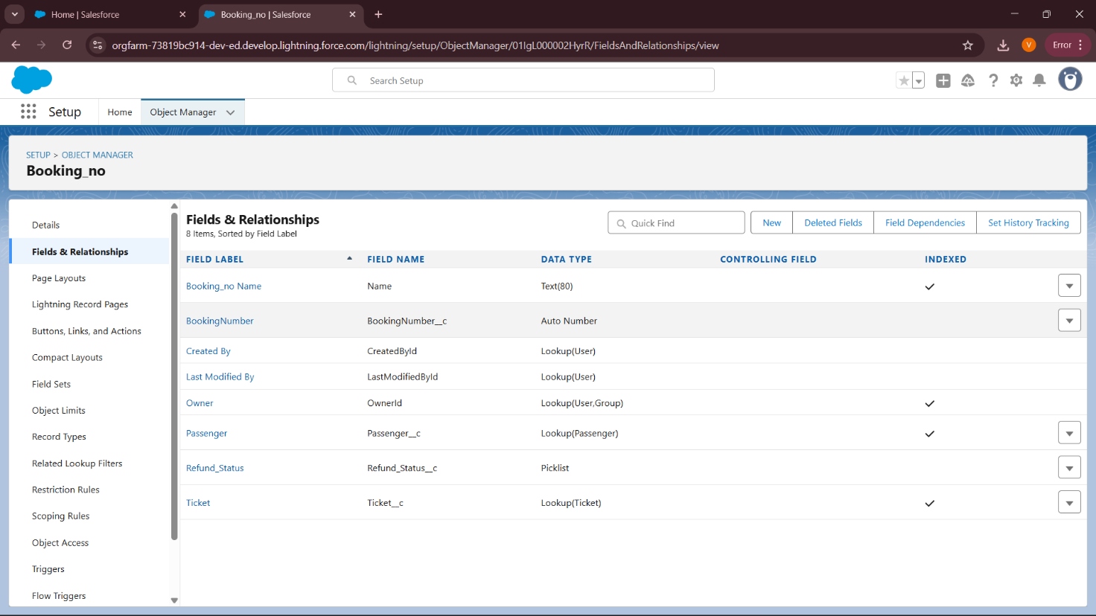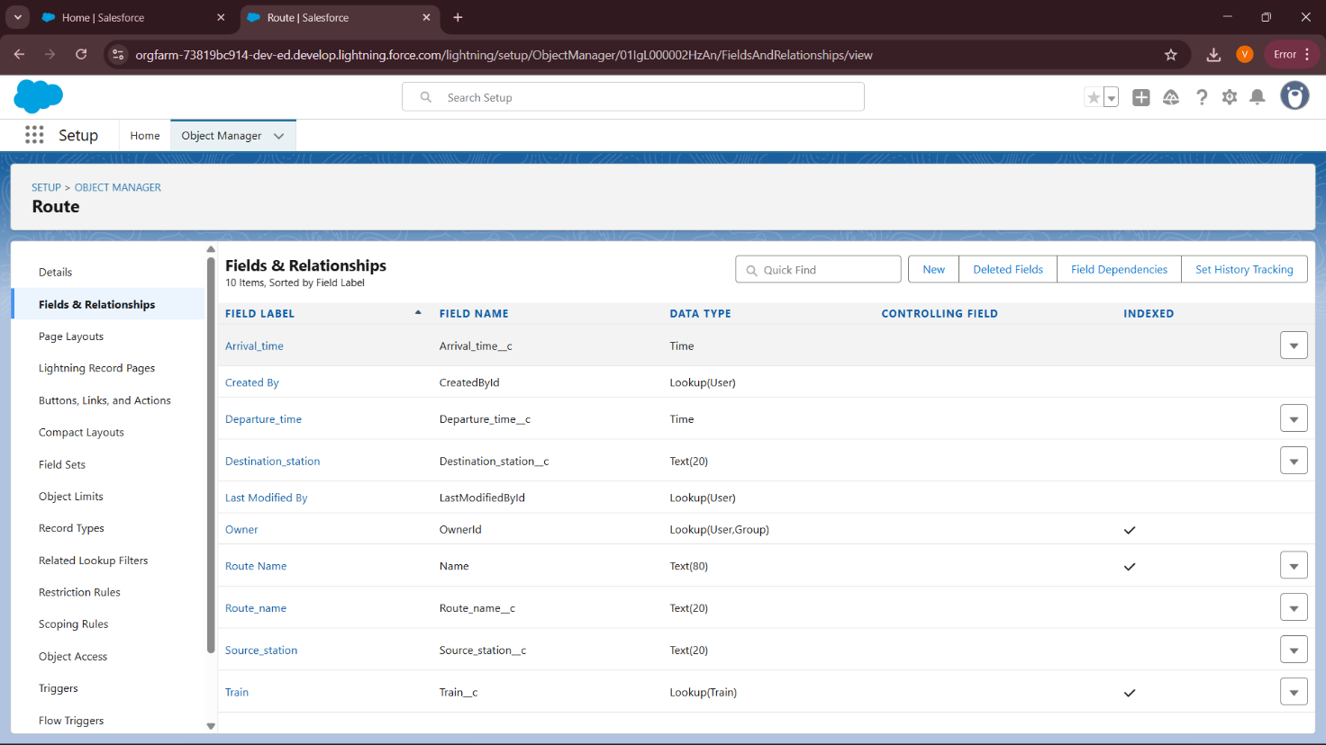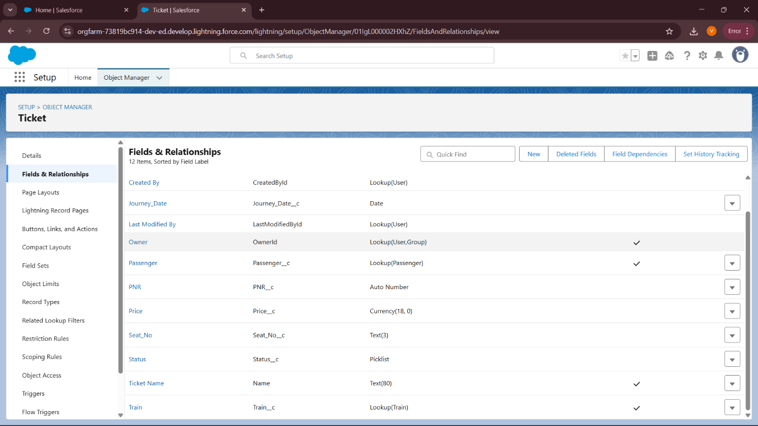

**🔹 3. Record Types**

Created record types on **Ticket__c** to manage business processes:

* Booked
* Cancelled
* Waitlisted
* Pending Payment

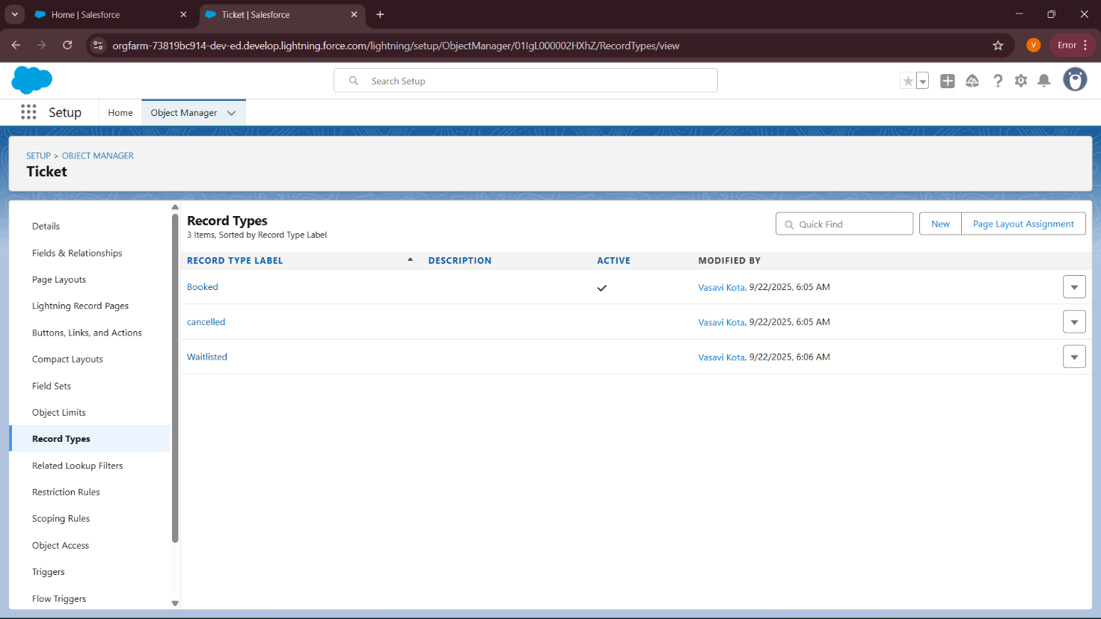

**🔹 4. Page Layouts**

* **Ticket — Passenger Layout**: Only booking details, no refund or agent fields.
* **Ticket — Agent Layout**: Includes Assigned Agent, Refund Status, Payment Status.
* **Ticket — Admin Layout**: Full access to all fields.

Layouts are assigned to profiles based on record type.

**🔹 5. Compact Layouts**

Compact layouts were configured for quick view in Lightning header & mobile:

* **Train__c** → Train Name, Train No, Available Seats.
* **Ticket__c** → PNR, Status, Journey Date, Train.
* 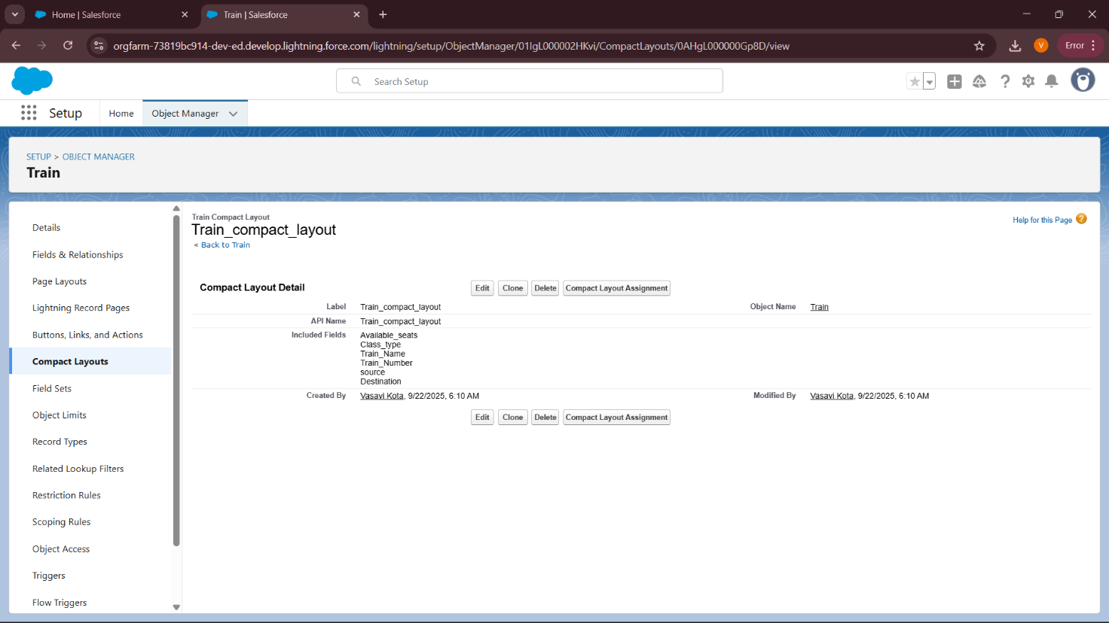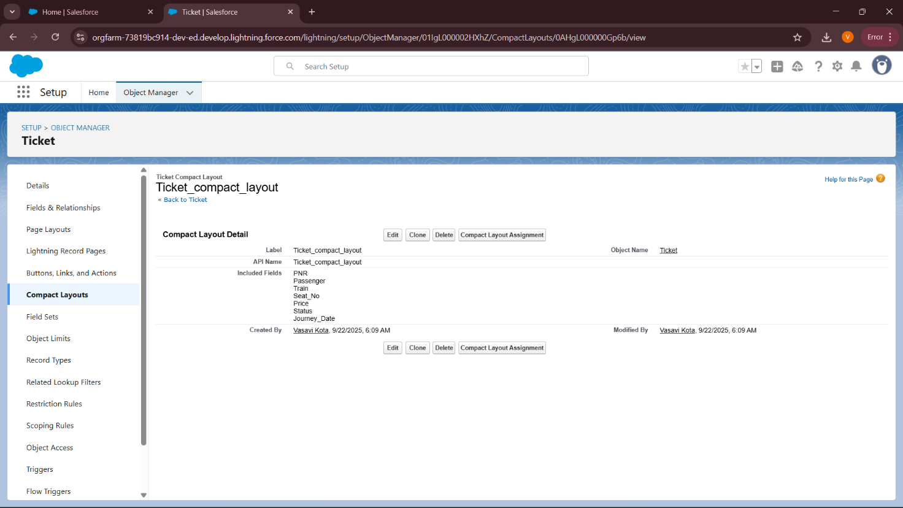

**🔹 6. Schema Builder**

* Verified relationships using **Schema Builder**.
* Relationships configured:
  + **Ticket → Train** = Lookup (1 Train : Many Tickets).
  + **Ticket → Passenger** = Lookup (1 Passenger : Many Tickets).
  + **Ticket → Assigned Agent** = Lookup(User).
  + **Booking → Ticket & Passenger** = optional Master-Detail (junction).
  + **Route → Train** = Lookup.
* Schema Builder used to visualize and confirm links between objects.

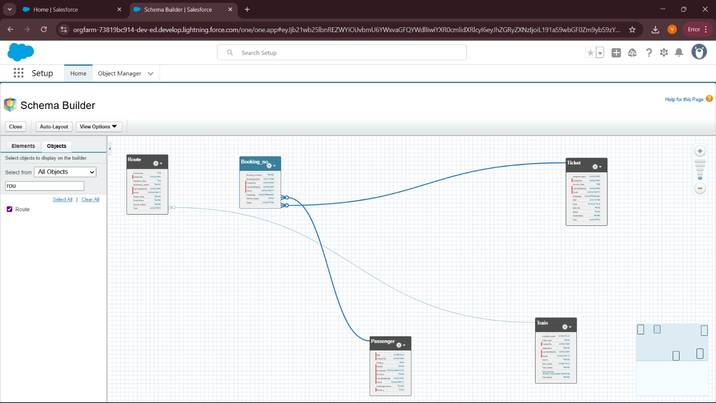

**🔹 7. Relationship Choices**

* **Lookup** used where we want flexibility (Train ↔ Ticket, Passenger ↔ Ticket).
* **Master-Detail** used in junction (Booking ↔ Ticket, Booking ↔ Passenger) if grouping is required.
* **Hierarchical Relationship** is only for User object (not applied here).
* This design ensures data safety (Tickets not auto-deleted if Train is deleted)