Train Ticket Booking System

**Phase 7: Data Management & Deployment**

**Data Import Wizard**

1. In Salesforce Setup, search "Data Import Wizard".
2. Select "Data Import Wizard".
3. Choose the object (e.g., Passenger, Booking, Train).
4. Upload CSV file containing the data.
5. Map your CSV columns to Salesforce fields.
6. Run the import and review results.

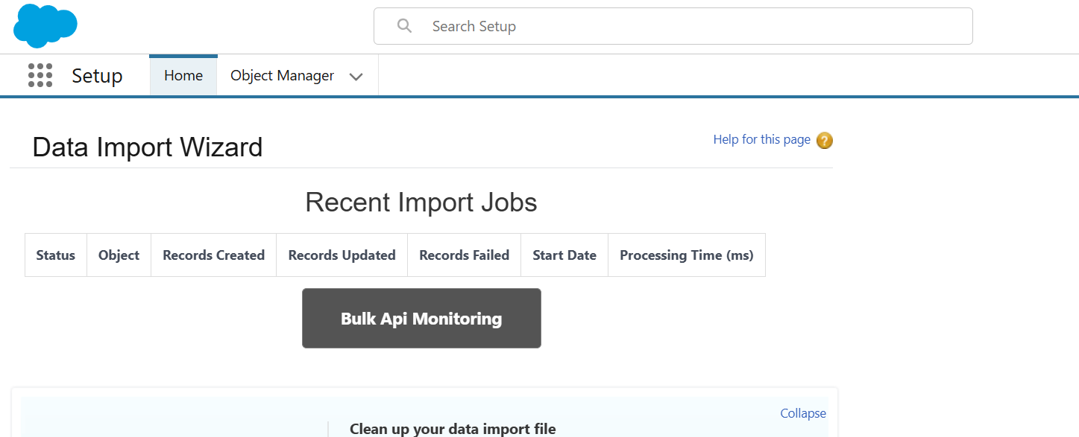

**Data Export & Backup**

1. In Setup, search for Data Export.
2. Schedule regular exports or export on demand.
3. Select objects to export.
4. Salesforce will generate zipped files with CSVs.
5. Download and backup externally.

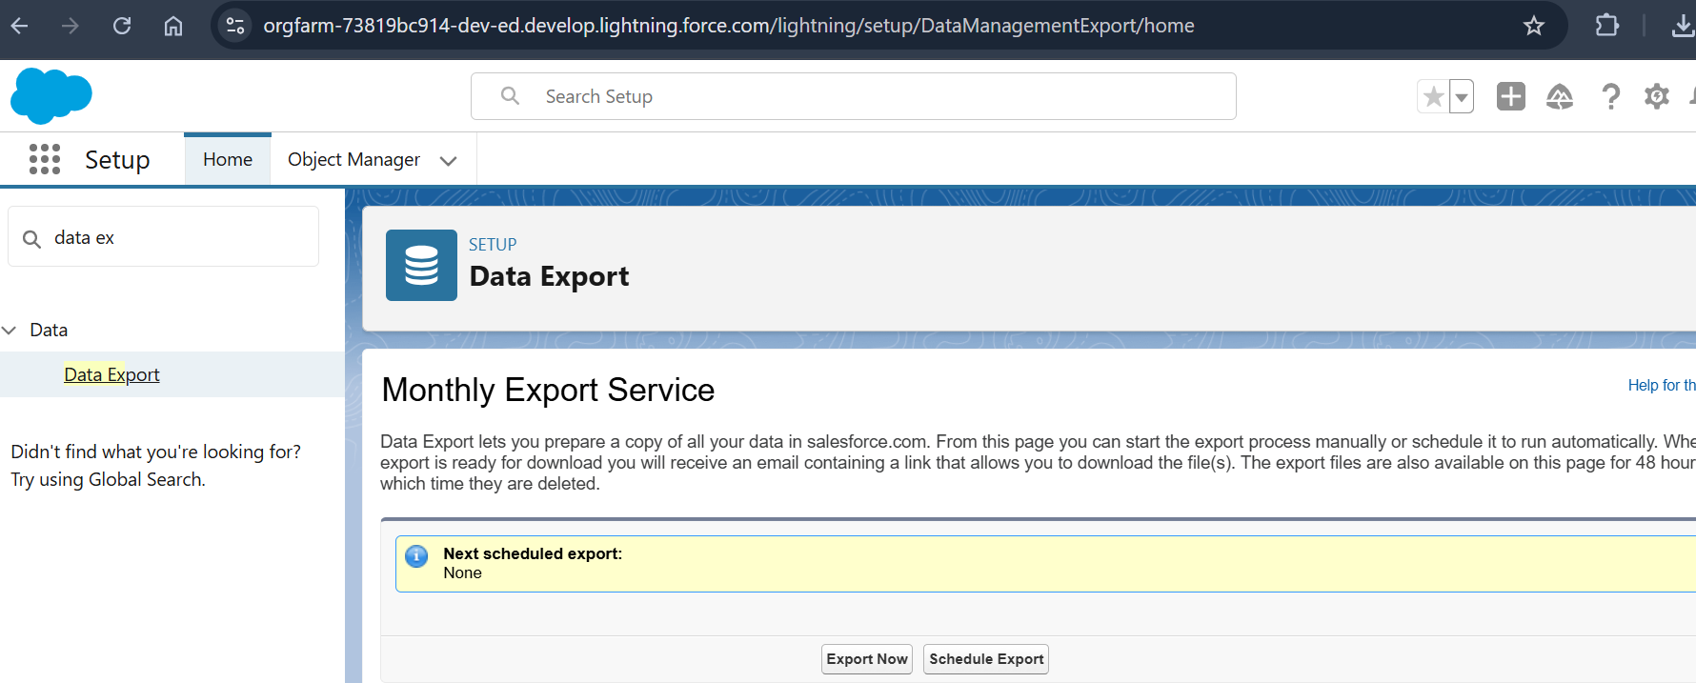

**Change Sets**

1. Setup → Outbound Change Sets.
2. Create new Change Set.
3. Add components (Apex classes, LWCs, etc).
4. Upload to target org (sandbox or production).
5. In target org, deploy the change set.

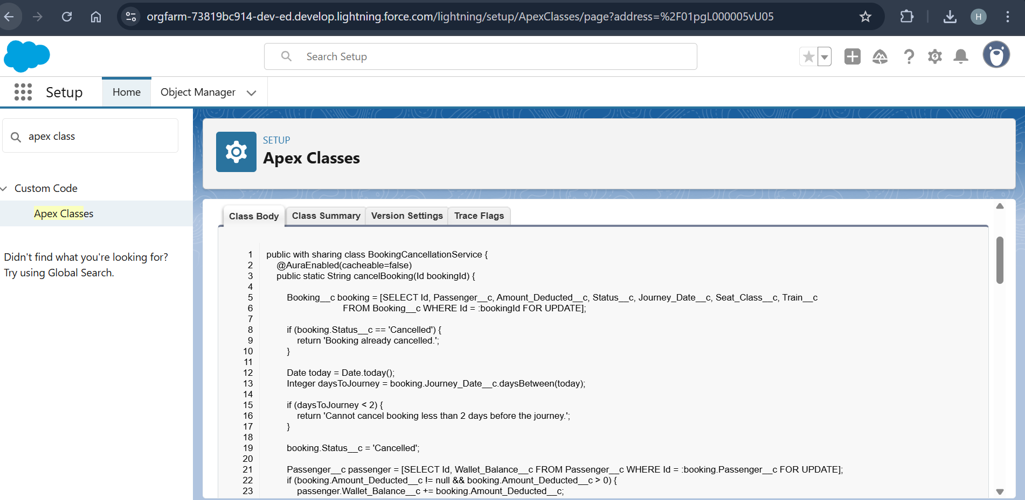

**Phase 8 :Unmanaged vs Managed Packages**

* Use Unmanaged Packages for one-time distribution (customization allowed).
* Use Managed Packages for controlled, upgradeable applications.
* Package components via Setup → Packages.
* Upload and distribute packages as needed.

**VS Code & SFDX**

1. Use Visual Studio Code with Salesforce Extensions.
2. Used commands like sfdx force:source:push, sfdx force:source:pull, and sfdx force:source:deploy for deploying lwc components
3. Manage source-driven development and integrate with Git or other version control.

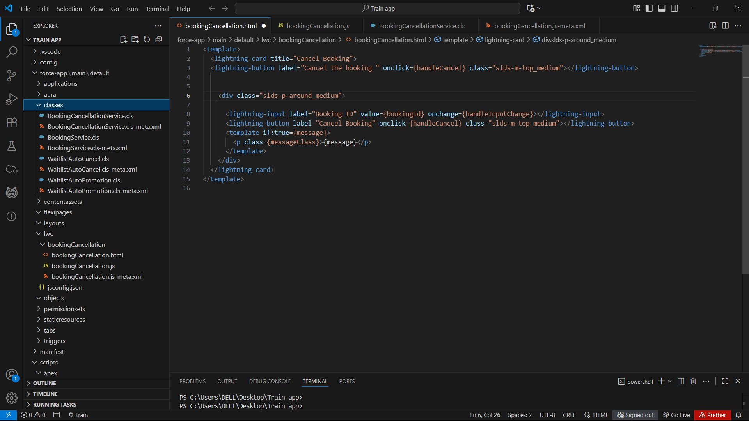

**Phase 9: Reporting, Dashboards & Security Review**

**Reports (Tabular, Summary, Matrix, Joined)**

1. Go to the Reports tab.
2. Click New Report.
3. Choosed a report type using booking,train.
4. Run and save the report.

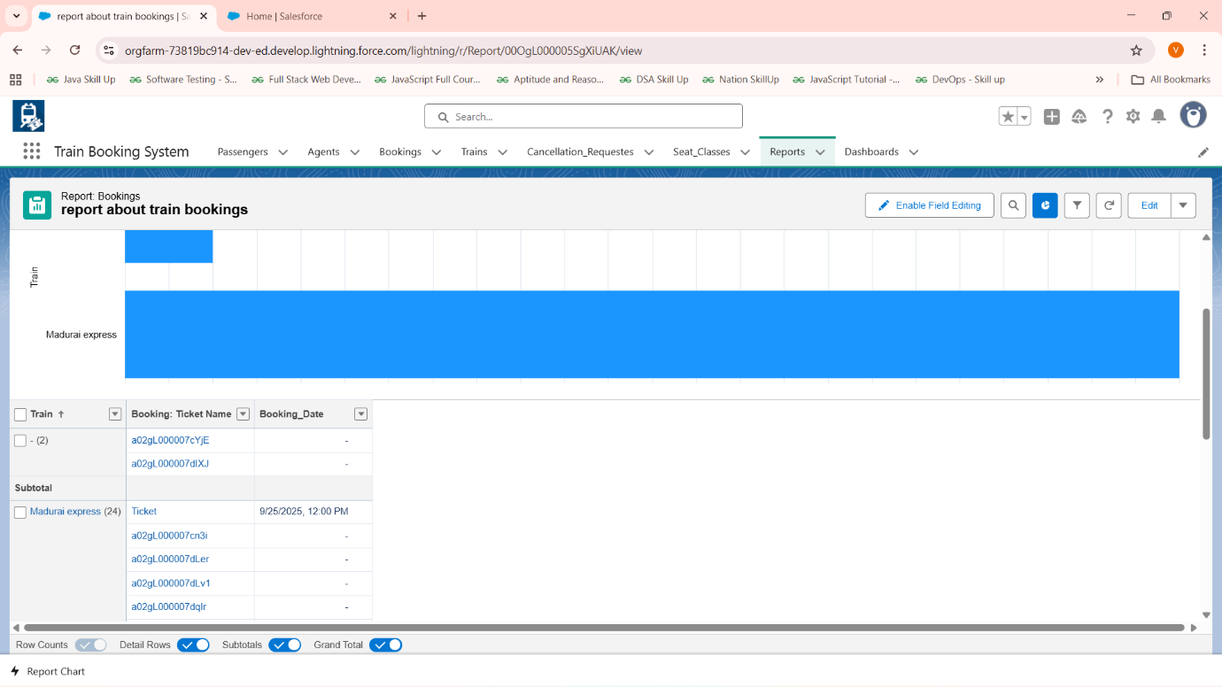

**Dashboards**

1. Go to Dashboards tab.
2. Create new dashboard.
3. Added components based on saved reports-train bookings.

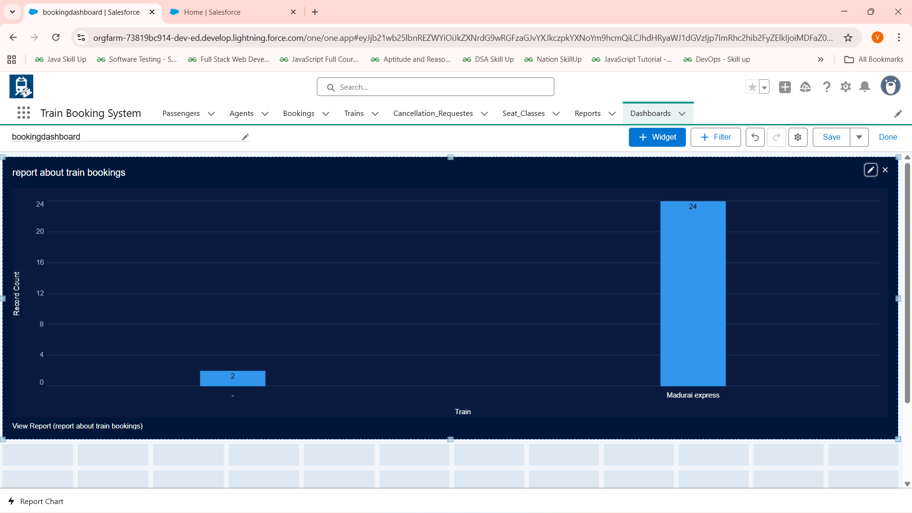

**Sharing Settings-already set in phase2**

1. Setup → Sharing Settings.
2. Define Organization-Wide Defaults (OWD).
3. Configure Sharing Rules for records.
4. Define manual sharing and role hierarchies.

**Field Level Security (FLS)-already set in phase2**

1. Setup → Object Manager → Select Object → Fields & Relationships.
2. Set field-level security per profile.
3. Control editable/read-only fields on UI and API.

**Session Settings**

1. Setup → Session Settings.
2. Configured session timeout to 15min.
3. Enabled high-security options like multi-factor authentication .

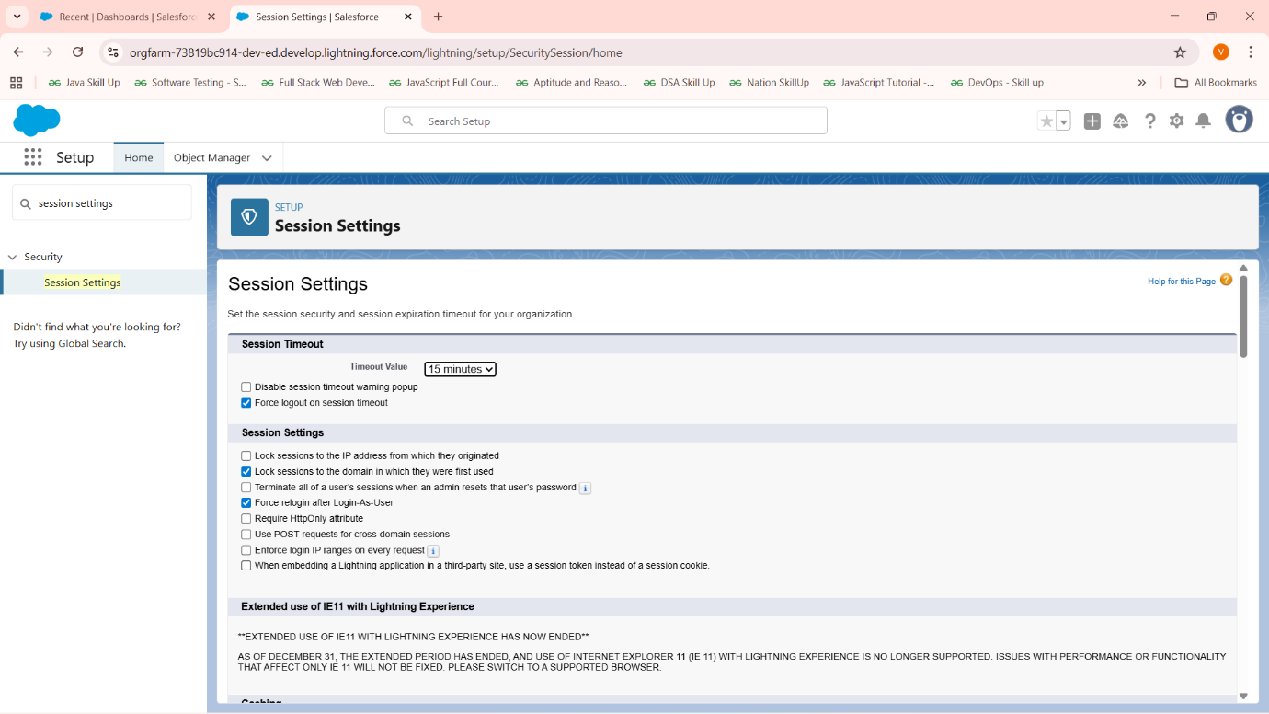

**Login IP Ranges**

1. Setup → Profiles → Select Profile.
2. Define allowed IP ranges for login restrictions.