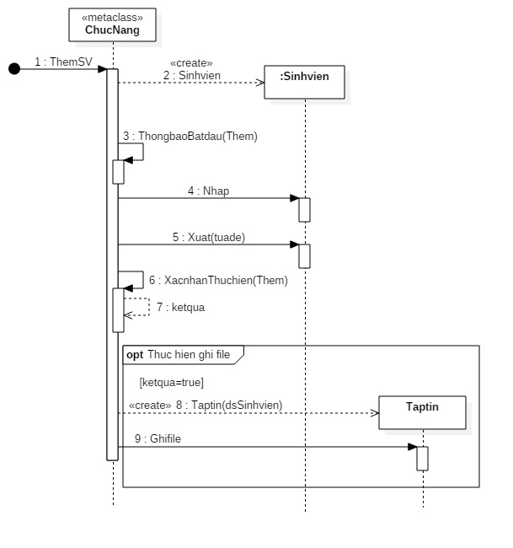

public static class ChucNang

{

public static void ThemSV()

{

string Them = "";

XacNhanThucHien(Them);

ThongBaoBatDau(Them);

bool KetQua = XacNhanThucHien(Them);

if (KetQua)

{

TapTin t = new TapTin(sv);

SinhVien sv = new SinhVien();

t.GhiFile();

}

}

public static bool XacNhanThucHien(string Them)

{

return true;

}

public static void ThongBaoBatDau(string Them)

{

}

}

public class SinhVien

{

public SinhVien()

{

}

public void Nhap()

{

}

public void Xuat()

{

}

}

public class TapTin

{

public TapTin(SinhVien dsSinhVien)

{

}

public void GhiFile()

{

}

}