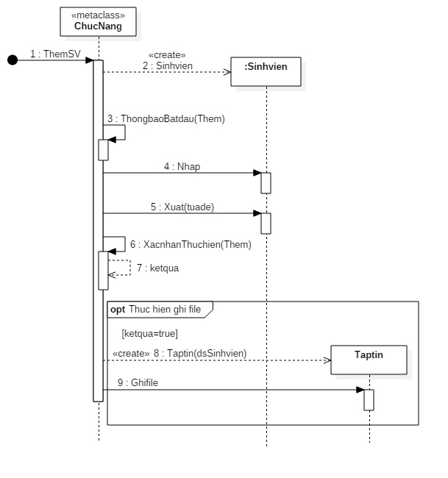

using System;

using System.Collections.Generic;

using System.Linq;

using System.Text;

using System.Threading.Tasks;

namespace OOAD

{

static class ChucNang

{

public static void ThemSV()

{

string tuade = "";

string Them = "";

SinhVien sinhVien = new SinhVien();

ThongbaoBatDau(Them);

sinhVien.Nhap();

sinhVien.Xuat(tuade);

bool ketqua = XacnhanThuchien(Them);

if (ketqua)

{

List<SinhVien> dsSinhvien = new List<SinhVien>();

TapTin tapTin = new TapTin(dsSinhvien);

tapTin.Ghifile();

}

}

public static void ThongbaoBatDau(string Them)

{

}

public static bool XacnhanThuchien(string Them)

{

return true;

}

}

class SinhVien

{

public SinhVien()

{

}

public void Nhap()

{

}

public void Xuat(string tuade)

{

}

}

class TapTin

{

public TapTin(List<SinhVien> dsSinhVien)

{

}

public void Ghifile() { }

}

}