# Assignment 1

Download income2.csv from <http://www-bcf.usc.edu/~gareth/ISL/Income2.csv>

For each section copy-paste your written python codes.

1. Explore the data through various figures.

*As the years of education is increased, income also increased in the linear fashion.*

1. Predict “y = Income” as a linear function of “x = Years of Education” using simple linear regression, and predict Income for a new individual with “x = 18”.

*Income for the new Individual is approximately 73.0 for 18 years of Education.*

*Raw value is 73.05228969661982.*

1. Show the scatter plot of Income versus Years of Education, and add the fitted line over the scatter plot.

*Below is the scatter plot of Income (Y- axis) vs years of Education (X- axis).*

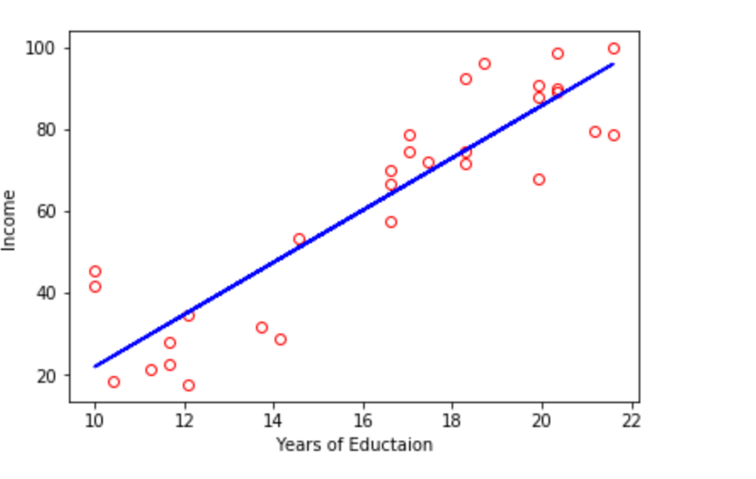

1. Predict “y = Income” as a linear function of “x1 = Years of Education” and “x2 = Seniority” for a new individual with (x1 = 18, x2 = 60)

*Raw value of Income is 66.40569670315645.*

*New Individual with 18years of Education & 60 years of Seniority will have the Income as 66.0*

1. Discuss “Years of Education” is a stronger predictor of “Income” or “Seniority”? Why?

*Looking at the standard error, Seniority sample data is more accurate compared to the Education data, which implies the prediction for the Seniority is stronger predictor than the Education.*

