1.Design DFA to accept bcaaaaaaaaaaaaa,bcand c

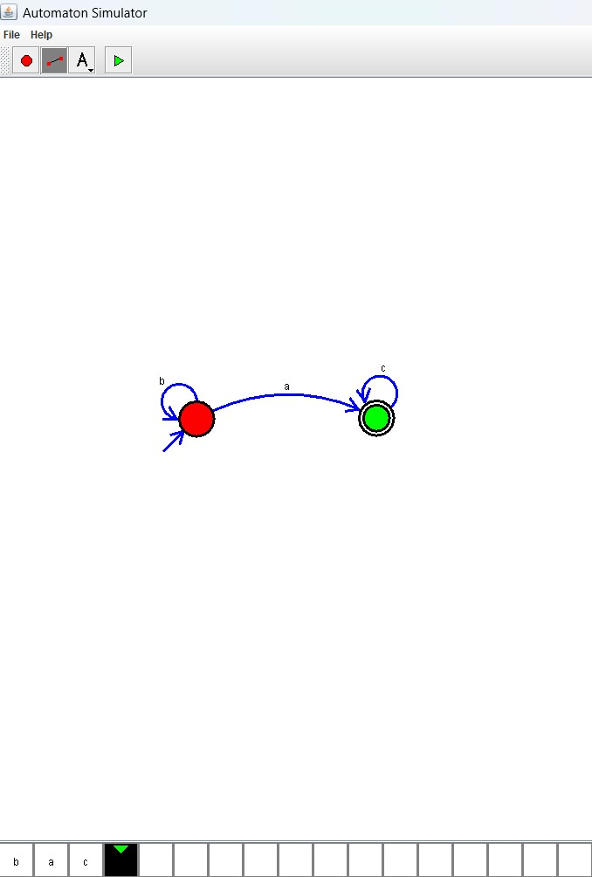

Result:

All the three given input strings are satisfied by using the above DFA simulator