INTRODUCTION

Time is more precious than anything in our life. Now-a-days clothing plays a vital role in our daily life both in online and offline stores. While shopping a lot of time gets wasted. In this paper, a concept is proposed entitled as Smart Mirror(Virtual Mirror) which saves time during clothing.

This deals with

* About smart mirror.
* Usage of present technology with smart mirror
* Minimization of time

The above mentioned three properties created an interest to work in this area. Yes, Smart Mirror is like a mirror which reflects our image. But its task is not only reflection but also helps to save our valuable time. It is very easy, this smart mirror helps customers when they stand in front of the mirror, customer photo will be appeared with his selected dress model which can be retrieved from database.

This smart mirror helps not only in offline shopping but also helps in online shopping. By this smart mirror everyone can check whether it is suited for him or not. This study is going to develop an android application. To work this android application, didn’t require any internet connection.

Literature Survey

**Nikita Deshmukh et.al;(2016);** implemented a virtual dressing room by using machine learning algorithms. To detect face in image they used FDA by using Haar Classifier. After detection of face they used skin colour detection algorithm to find the face of the customer. To find the shoulder positions they used lower body detection algorithm.

**Bhalekar Sourabh et.al;(2017);** implemented virtual dressing room by using Newton’s Mechanics. In this study, they used image based rendering techniques and low level image features for fitting the clothes to the customer.

**Zambare Triveni V et.al;(2018);**  detected the customer upper and lower body by using Laplacian filter and then edge detection. After that they extracted the positions of customer by human basic structure. By those positions the dress model is warped to fit to the customer.

**Saurabh Botre, et.al;(2014);** discussed about different methodologies for detecting face of the customer. The techniques used for face detection of the customer are finding faces using images with controlled background, finding faces by colour and finding faces by motion.

**Ms. Kirti N et.al(2017),.**  developed a virtual try-on system by using Augmented Reality(AR). This virtual try-on system uses accessories like eyeglasses which is developed by image processing and other some augmented reality techniques. They had developed some more extra features like selecting a multiple number of clothes at a time, changing background image, etc.

**Krishna Gunjal, et.al,.** had developed a website for cloning and dressing to customer. This website is developed by using some machine learning algorithms like Frame Extraction, Current Frame Subtraction, Thresholding, Blob detection, Gesture Estimation, Post Processing.

**Nikki Singh, et.al(2017),.** developed a virtual mirror by using machine learning algorithms like face detection using Haar Classifier(shoulder detection also), Open Computer Vision(OpenCV), Superimposing, Blending, Edge Detection, Scaling and Clipping.

**Stefan Hauswiesner, et.al(2011),.** studied on image-based clothes transfer. They developed a virtual room by using machine learning algorithms low-level image processing, image based rendering to resulting images appearing, matching recorded current data, runtime phase, rigid registration, rendering, non-rigid registration.

**M. Augusta Angel, et.al(2018),.** developed a V-Dressing room application using web camera. To implement this application the algorithms used are mask image, translation and rotation, face recognition, segmentation, upper body detection, scaling, fitting. By the end of the application, the user will appear with selected image.

**G.Rajaram, et.al(2014),.** developed a Try-on Reality Application. This application mainly deals about detecting and sizing of body by using FDA, OpenCV, Marker Detection used to displaying the clothes over the customer body. To work this application on different platforms they used VFR implementation and interface.

Methodology

In this study, smart mirror is going to be implemented by using Machine Learning Algorithms.

They are: Face Detection Algorithm(FDA).

Skin Colour Detection Algorithm(SKDA).

Lower Body Detection Algorithm(LBDA).

**FDA:** It is a one of the most popular Machine Learning Algorithm used for Image Processing. They are so many techniques for face detection like OpenCV, Neural Networks, MATLAB, etc. This algorithm is performed by using Haar Classifier. Since, face is the most important and easiest thing for identifying the face of customer. This algorithm is used for detection of faces of customer in given image(photo).

Object detection for haar classifier is done by haar like feature. These features use the change in value of contrast between the adjacent rectangles. Here rectangle is a group of pixels. The haar like feature is formed using using two or more rectangles. The haar features can be easily scaled by maximizing and minimizing the size of the pixels. This haar feature is used for face detection. These haar feature is shown in figure 1, figure 2 and figure 3

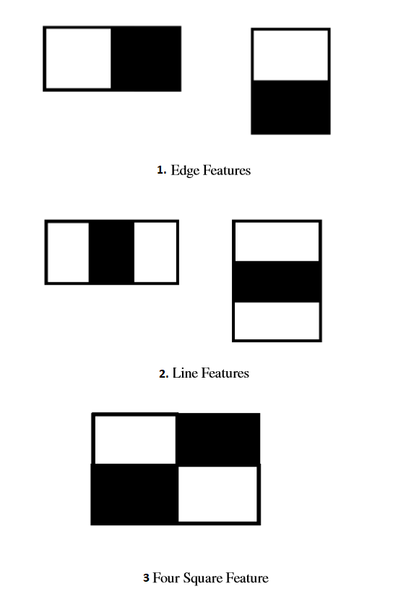



If any face is identified it returns a location of face, that is it returns a (x, y, w, h) values where (x, y) are starting position, w is width and h is height of face.

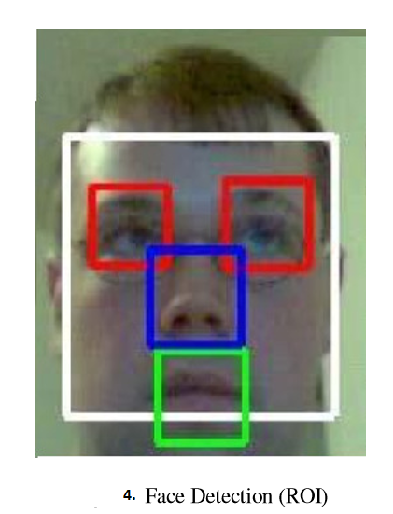

**SKDA:** Since, after detecting faces using FDA there is chance for detecting more than one face i.e., containing 2 or more people in given image. In skin color detection we are using YCbCr color space. It is widely used in image processing. Component Y is used for representing luminance information and color information is stored in two components, Cb and Cr. Cb is difference between the blue component and reference value. Cr is difference between red component and reference value. Cr and Cb are the red-difference and blue-difference chroma components respectively. The corresponding skin pixel is in the range which is specified below,

i) Y>80

ii) 85<Cb<135

iii) 135<Cr<180

In this algorithm a Skin Pixel Quantifier is used to count the number of pixels of human skin.

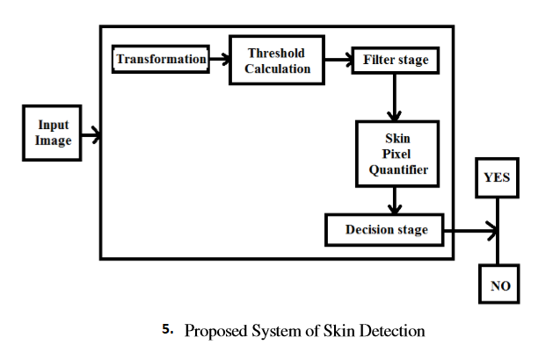

Hence, customer face is identified by highest percentage of pixel count of same person.

**LBDA:** This algorithm also performed by using Haar classifier which is used to detect the people in a movie video, by using features like upper body, lower body, full body, face detection and eye detection. From the above said, the positions of the shoulder are traced which makes clothing easier to the customer by superimposing. Besides, there exists a disadvantage for calculating the distance between mirror and customer positions, which cannot lead the superimpose between clothe and customer. For finding the distance between customer and mirror an Euclidian Distance Formulae is introduced.

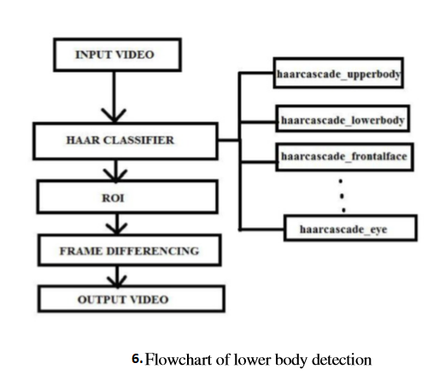

**Euclidian Distance Formulae:**

Let (q1, q2) are the coordinates of mirror and (p1, p2) are the coordinates of customer.

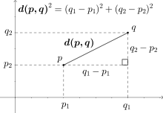

Distance between customer and mirror (D)^2= (q1-p1)*(q1-p1)+(q2-p2)*(q2-p2)

=>D=SQRT((q1-p1)^2+(q2-p2)^2)

By using this formulae, the length of clothe that is to be superimposed on customer body is identified.

**Advantages:**

* Customer can save his valuable time.
* Customer can try more number of clothes in less time.
* Without wearing clothes he can judge it is suitable for him or not.
* Customer can save his human effort i.e., without trying clothes.

**Disadvantages:**

* Customer cannot judge whether it is comfortable or not.
* Customer cannot identify the quality of clothes.

**Implementation of Virtual Dressing Room using Newton’s Mechanics:**

In this paper, virtual dressing room is implemented by using as followed algorithms.

**MOTION SENSOR:**

Kinect is a sensor by Microsoft Corp. That mainly aims at depth calculations. The following subsections will take a look at the tracking procedure and will discuss the frameworks that are needed in order to successfully use the Kinect.

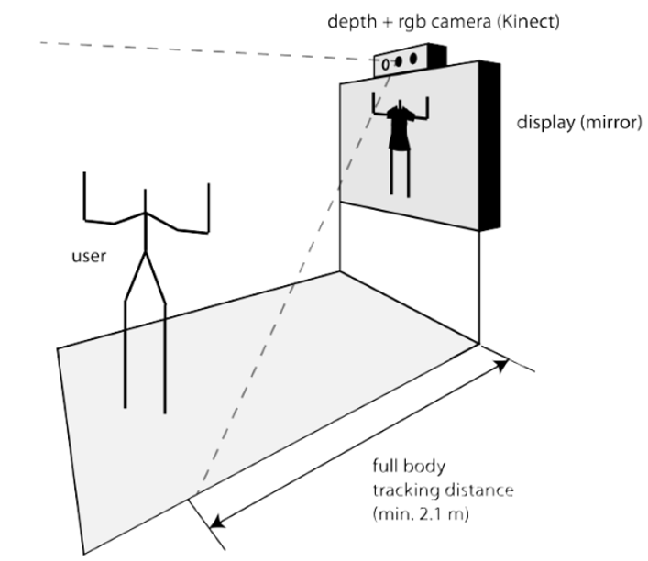

**SKELETON TRACKING:** A substantial part in the tracking process is the retrieval of the particular body joint positions. This is achieved by an algorithm introduced in Real-Time Human Pose Recognition in Parts from Single Depth Images. The algorithm allows a full rotation of the body and a robust distinction between the left and right side of a body. Figure below gives an overview of the recognition process. The joint positions are needed in order to move a skeleton, for instance, or in case of the Virtual Dressing Room, a piece of garment in respect to the motion of a user. The human body can be captured accurately and robustly even processing different sizes of a person’s body correctly.

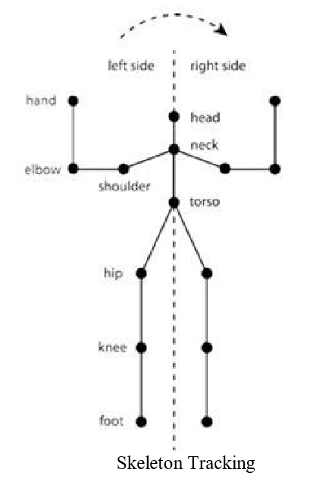

**Automatic Dressing Method:**

In this method, the clothe is kept on the mannequin. And then at every corner of the clothe the force is applied such a way that the clothe should be fitted to the body i.e, similar to the posture of the mennequin.

Based on the theorem of Newton mechanics, the automatic dressing process will first calculate the force F of each cloth vertex, and then adjust their positions. In the mass-spring model [10], each cloth vertex is under the combined effect of various forces, such as gravity g, supportive force of body S, pulling forces of other adjacent vertexes N1, N2, as shown in.

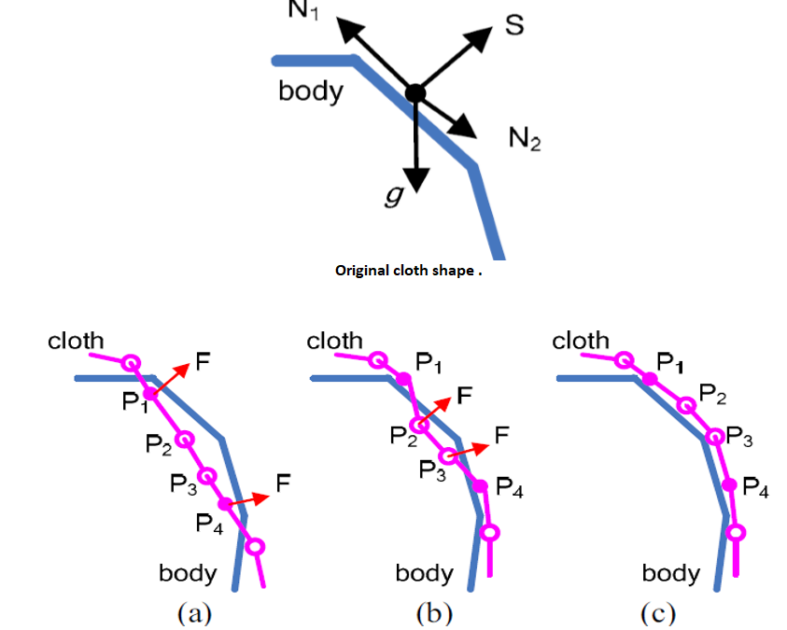

**REGION GROWING ALGORITHM:**

Start region growing until similarity between the region and neighboring pixels is higher than a threshold.

1. Initialize: region = seed

(1) Find all neighboring pixels of the region.

(2) Measure the similarity of the pixels and the region. s1, s2, and sort the pixels according to the similarity.

(3) If smin< threshold

(3.1). Add the pixel with the highest similarity to the region.

(3.2). Calculate the new mean depth of the region.

(3.3). Repeat (1)-(3) Else Algorithm terminates.

iii. Return the region.

Design

**User Interface Flow:**

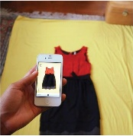

Take photos of clothes

Database

If image appears



Choose Clothes Photo

Show gallery

Start Smart mirror App



Check it is dress or not

invalid

Fitting Dress to customer

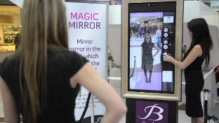

The overall procedure is as following pictures

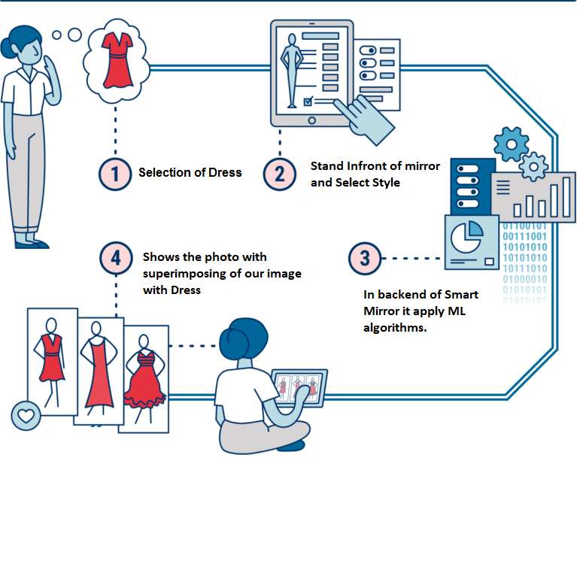

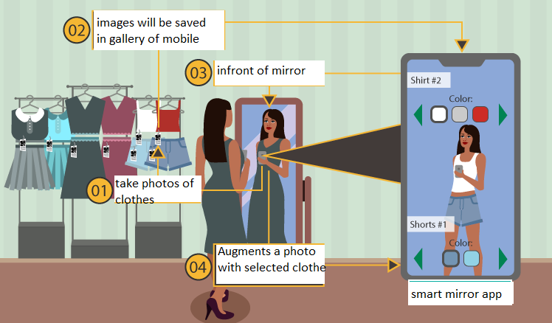

EXPECTED RESULTS

The following figure-8 shows the image of a girl before using the smart mirror. When the girl is started using smart mirror at the bottom of the mirror shows camera. By selecting that camera it will open gallery in respective mobile phone and it will show the all the recent pictures. By selective respective picture the clothe will superimposed on the user as shown in fig-9.

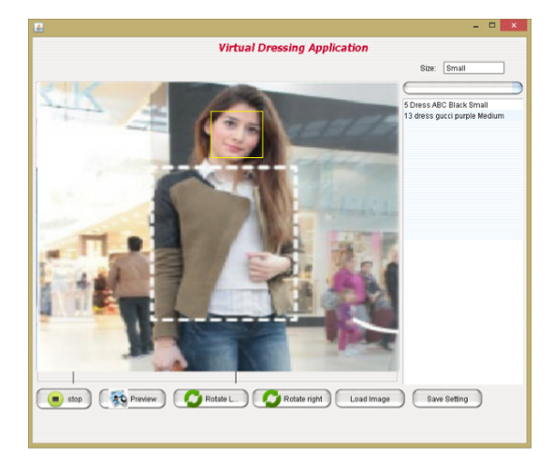

Fig-8 Before using Smart Mirror

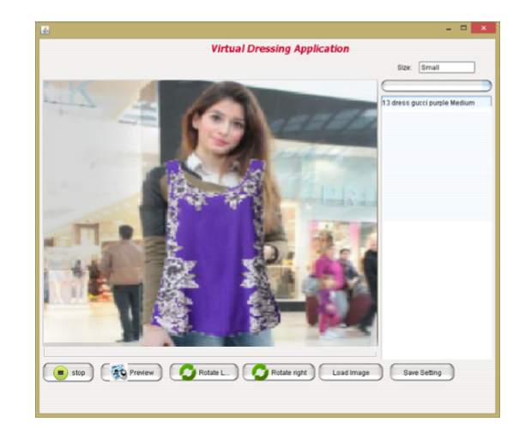

Fig-9 shows after superimposing of clothe

CONCLUSIONS

The smart mirror helps to save time during clothing in both online and offline. Since, this smart mirror is an android application which doesn’t require any technical knowledge, everyone can access. It is user friendly. Machine learning algorithms like face detection, skin colour detection and lower body detection algorithms which are the basic image processing techniques applied for obtaining the better results, the developed android application with minimal scope for implementation is also represented in our results. Finally, the work ended up with the development of mobile application which includes machine learning algorithms, image processing for pre-processing and classification of best clothe for superimposing.

REFERENCES

1. Kokni Aaliya Samsamuddin, Jejurkar Nishigandha Shamrao, Sawashere Reshma Sanjay, Sonawane Vrushali Shantaram,” VIRTUAL CHANGING ROOM USING IMAGE PROCESSING”, International Research Journal of Engineering and Technology, Volume: 05 Issue: 10, Oct 2018

2. Nikita Deshmukh, Ishani Patil, Sudehi Patwari, Aarati Deshmukh, Pradnya Mehta,” Real Time Virtual Dressing Room”, International Journal of Computer Science and Network, Volume 5, Issue 2, April 2016

3. Bhalekar Sourabh, Chitte Darshan, Dhamal Hemant, Ganeshwade Priyanka, Rankhambe J.P.,” Implementation of Virtual Dressing Room using Newton’s Mechanics”, International Journal of Advanced Research in Computer Science and Software Engineering, Volume 7, Issue 5, May 2017

4. Ms. Kirti N. Datar, Ms. Prajakta V. Jogdand, Ms. Neha M. Kadam, Ms. Chaitali R. Mohokar,” Virtual Try-on System using Image Processing and Augmented Reality”, Volume 3,Issue 09 , March 2017

5. Krishna Gunjal, Prasad Patil, Akash Phalle, Prof. A.V. Kanade,” A survey on virtual changing room using augmented reality”, Volume 6, Issue 10, October 2017

6. K.-L. Cheng, R.-F. Tong, M. Tang, J.-Y. Qian, and M. Sarkis, ‘‘Parametric human body reconstruction based on sparse key points,’’ IEEE Trans. Vis. Comput. Graphics, vol. 22, no. 11, pp. 2467–2479, Nov. 2016..

7. J Tong, J. Zhou, L. Liu, Z. Pan, and H. Yan, ‘‘Scanning 3D full human bodies using Kinects,’’ IEEE Trans. Vis. Comput. Graphics, vol. 18, no. 4,pp. 643–650, Apr. 2012.

8. J.Boisvert, C .Shu, S. Wuhrer, and P. Xi,‘‘Three dimensional human shape inference from silhouettes: Reconstruction and validation,’’ Mach. Vis. Appl., vol. 24, no. 1, pp. 145–157, Jan. 2013.

9. International Journal of Computer Science Trends and Technology (IJCST)- Volume 2 Issue 2, Mar-Apr. 2014.

10. Y. Gao. E. Petersson, and A.L. Brooks, “The Performance of Self in the Context of Shopping in a Virtual Dressing Room System,” “in press” HCI International 2014, 22-27 June, Creta Maris, Heraklion, Crete, Greece, 2014

11. Kaoru Nakamura, “Basics.”, in The Kinect for Windows SDK Programming for C++, PlaS ONE, Volume 1, pp.34-103,(2012)

12. Gary Btadski and Syouiti Madtuda,”Defined.” In Learn OpenCV, PloS ONE, Volume 1, pp.225266,(2012)

13. Toyobuki Tanisiri,”Kinect SDK Programming.” In Kinect Sensor image processing program. PloS ONE, Volume 1, pp.42-115,(2011)

14. Masao Shimizu, “The detection of a pattern and the figure.” In Digital image Processing, PloS ONE, Volume 1, pp.202-219,(2011)

15. P. Ian Wilson and Dr. J. Fernandez “Facial feature detection using Haar classifiers,” JCSC 21, 4(April 2006)

16. J. Young Choi, Y. Man Ro and Konstantinos N. Plataniotis,” Color Local Texture Features for Color Face Recognition” in proceedings of IEEE Conference, 2011

17. Volino P. Magnenat-Thalmann N. (2000) “Virtual Clothing-Theory and Practice”. Springer, Berlin Heidelberg.

18. Yinghua Lu, Yuanhui Wangl, Xianliang Tong, Zebai Zhao 1, Hongru Jia, Jun Kong, “ Face Tracking in Video Sequences Using Practicle Filter based on the Skin Color Model and Facial Contour”, IEEE Tranas. Second International Symposium on Intelligent Information Technology Application, VOL. 29. No. 8, pp. 978-0-7695-3497-8. August 2007.

19. R. Bajcsy and S.Kovacic. Multiresolution elastic matching. Computer vision, graphics, and image processing, 46(1): 1-21, 1989

20. Brooks, A. L., Petersson, E. (2014), “Towards an Inclusive Virtual Dressing Room for Wheelchair-Bound Customers”. ,In W. W. Smari, G. C. Fox, M. Nygrd (Eds.), Proceedings of the 2014 International Conference on Collaboration Technologies and Systems (CTS 2014).

21. Diplom-Ingenieur, Medieninformatik, Philipp Presle, “A Virtual Dressing Room based on Depth Data”. In fakultat fur informatics(2012).

22. Stefan Hauswiesner, Matthias Straka, Gerhard Reitmayr, “Image-Based Clothes Transfer” in IEEE International Symposium on Mixed and Augmented Reality 2011.

23. Brooks, A. L., Petersson, E. (2014),”Towards an Inclusive Virtual Dressing Roomfor Wheelchair-Bound Customers.",In W. W. Smari, G. C. Fox, M. Nygrd (Eds.),Proceedings of the 2014 International Conference on Collaboration Technologiesand Systems (CTS 2014).

24. Jan Smisek, Michal Jancosek and Tomas Pajdla, “3D with Kinect”, 2011 IEEE International Conference on Computer Vision Workshops, Barcelona, Spain,November 2011.

25. Kaoru Nakamura,”Basics in The Kinect for Windows SDK Programming for C++",PloS ONE, Volume 1, pp.34103,(2012).

26. ToyobukiTanisiri,”Kinect SDK Programming. in Kinect Sensor image processing program”. PloS ONE, Volume 1, pp.42-115,(2011).

27. KouichiSakai,”A binary image. in Introduction to digital image processing”, PloSONE, Volume 1, pp.63-100.

28. Liu, Y.J., Zhang, D.L., and Yuen, M. M.-F., “A survey on CAD methods in 3Dgarment design", Computers Industry, vol. 61, pp. 576-593, 2010.

29. H., Qin, S., Sun, G., andWright, D. K., “On Generating Realistic Avatars: Dressin Your Own Style.", Multimedia Tools and Applications, Springer Publisher,2011.

30. Frederic Cordier and Nadia Magnenat-Thalmann,”A Data-Driven Approachfor Real-Time Clothes Simulation", 2005 published in COMPUTER GRAPHICSforum.

31. Nadia Magnenat-Thalmann, Pascal Volino, Bart Kevelham, Mustafa Kasap, QuiTran, MarlneArvalo, Ghana Priya and Nedjma Cadi,”An Interactive Virtual TryOn".

32. Yueh-Ling Lin and Mao-Jiun J. Wang ,”Digital Human Modeling and Clothing Virtual Try-on13 Plan of Project Execution”. In Proceedings of the 2014 International Conference on Industrial Engineering and Operations Management Bali,Indonesia, January 7 9, 2014.

33. Srinivasan K. and Vivek S.proposed,” Implementation Of Virtual Fitting Room Using Image Processing”, IEEE International Conference on Computer, Communication and Signal Processing (ICCCSP-2017).

34. Diplom-Ingenieur, Medieninformatik, Philipp Presle, “A Virtual Dressing Room based on Depth Data”. In fakultat fur informatics(2012).

35. P. Ian Wilson and Dr. J. Fernandez “Facial feature detection using Haar classifiers,” JCSC 21, 4 (April 2006).

36. Euratex (2000), Bulletin 2000/5, “The European Textile/Clothing Industry on the eve of the New Millennium,” Brussels.

37. Philipp Presle “A Virtual Dressing Room based on Depth Data,” Vienna University of Technology, Klosterneuburg.

38. K. Onishi, T. Takiguchi, and Y. Ariki, ”3D Human Posture Estimation using the HOG Features from Monocular Image,” in proceedings of 19th International Conference on Pattern Recognition, 2008.

39. D. Chai, and K. N. Ngan, “Face Segmentation using Skin-Color Map in Videophone Applications,” IEEE Transactions on Circuits and Systems for Video Technology, vol. 9, no. 4, June 1999.

40. J. Young Choi, Y. Man Ro and Konstantinos N. Plataniotis,” Color Local Texture Features for Color Face Recognition” in proceedings of IEEE Conference, 2011.   
41. P. J. Phillips, H. Moon, S. A. Rizvi, and P. J. Rauss, “The FERET evaluation methodology for face recognition algorithms,” IEEE Trans Pattern Anal. Mach. Intell., vol. 22, no. 10, pp. 1090–1104, Oct. 2000.

42. Brooks, A. L., Petersson, E, “Towards an Inclusive Virtual Dressing Room for Wheelchair-Bound Customers”. ,In W. W. Smari, G. C. Fox, M. Nygrd (Eds.), Proceedings of the 2014 International Conference on Collaboration Technologies and Systems (CTS 2014).

43. M.Augusta Angel , N.Augustia, A.J. Immanuel Gem Isaac, “A Computer Vision based V-Dressing room application using web camera”, International Journal of New Technologies in Science and Engineering Vol. 5, Issue. 7, 2018.

44. Saurabh Botre, Sushant Chaudhari, Shamla Mantri,” Virtual Trial Room”, International Journal of Computer Science Trends and Technology (IJCST) – Volume 2 Issue 2, Mar-Apr 2014.

45. Zambare Triveni V.,Keskar Ankita D., Shinde Prajakta S., Deo Juilee V.4 Prof. Ratnaraj Kumar,” VIRTUAL DRESSING VIEW”, International Journal of Advance Research in Science and Engineering, Volume No. 7, Special Issue No.3, April 2018.