

Aditya College of Engineering and Technology In association

with SmartInternz & ServiceNow


SMARTBRIDGE
Let'sBridgetheGap

Project Title:
TrafficTelligence:Advanced Traffic Volume Estimation
With Machine Learning

Submitted by:
Team ID: LTVIP2025TMID33596

Team Members:
Ganga Kotha Devi Madiki Joyson M Raham Peyyala

- INTRODUCTION
  - Project Overview
  - Purpose
- IDEATION PHASE
  - Problem Statement
  - Empathy Map Canvas
  - Brainstorming
- REQUIREMENT ANALYSIS
  - Customer Journey map
  - Solution Requirement
  - Data Flow Diagram
  - Technology Stack
- PROJECT DESIGN
  - Problem Solution Fit
  - Proposed Solution
  - Solution Architecture
- PROJECT PLANNING &
SCHEDULING
  - Project Planning
- FUNCTIONAL AND PERFORMANCE TESTING
  - Performance Testing
- RESULTS
  - Output Screenshots
- ADVANTAGES & DISADVANTAGES
- CONCLUSION ID. FUTURE SCOPE II. APPENDIX
Source Code(itany)
fiitHnh ft Prniwl Hpinn I iuL
Dataset Link

- INTRODUCTION
  - Project overview
  - Purpose



PROJECT OVERVIEW
Project Overview Modern cities are increasingly facing traffic congestion problems due to growing populations and urbanization. To mitigate this, we propose a machine learning model that accurately estimates traffic volume based on historical and real-time data. Our system uses regression-based ML algorithms to predict vehicle count on roads, providing city authorities and planning agencies with valuable insight.

Purpose
The primary goal is to develop a reliable and scalable machine learning solution that predicts traffic volume using environmental and time-based parameters. This helps in better traffic flow management, infrastructure planning, and reducing congestion.

- IDEATION PHASE

  - Problem Statement
  - Empathy Map
Canvas
  - Brainstroming



IDEATION PHASE

2.1 Problem Statement Urban traffic congestion causes delays, increases carbon emissions, and decreases road safety. Traditional monitoring methods are manual and expensive. Thus, a need exists for an automated, cost-effective, and scalable system.

Empathy Map Canvas

Says: "Traffic is unpredictable."

Thinks: "I wish there was a way to avoid heavy traffic."

Does: Uses navigation apps but still faces delays.

Feels: Frustrated and stressed.
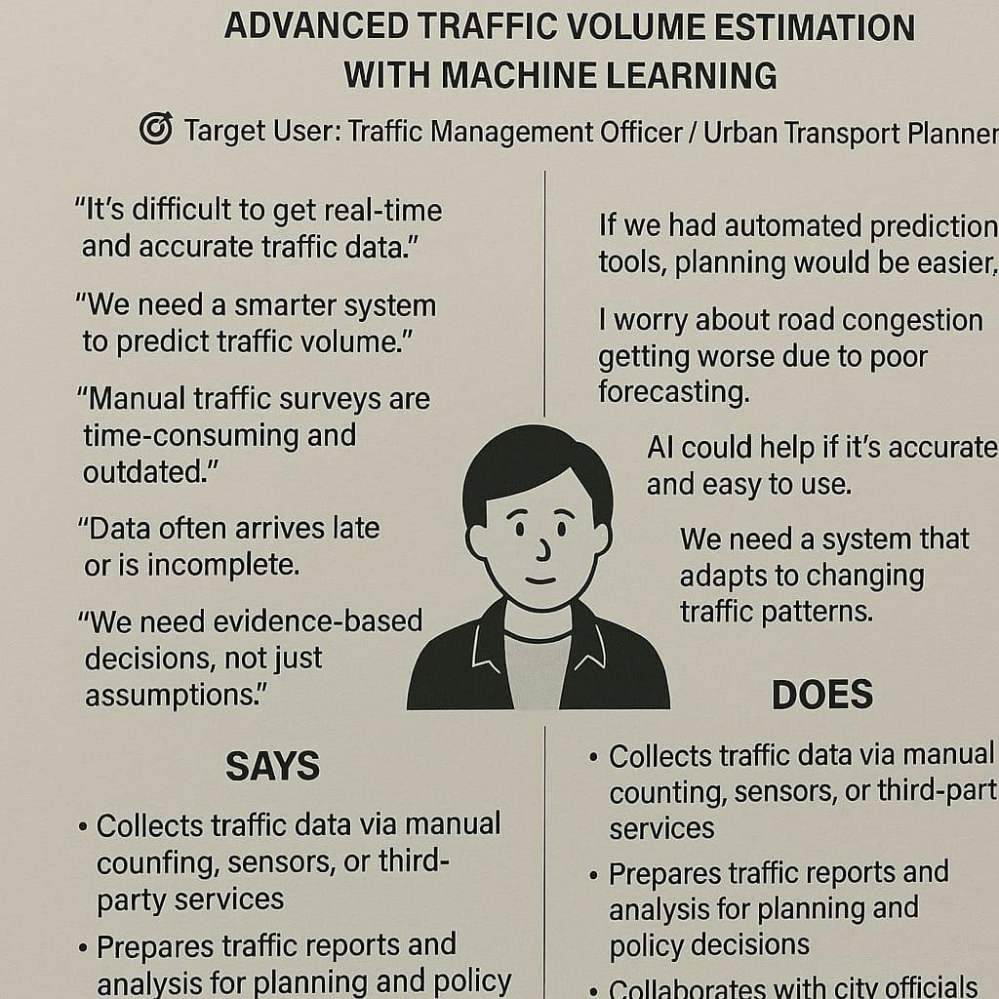
Brainstorming

Regression Models for estimation

Real-time data visualization

Interactive web application using Flask

Automated model retraining pipeline

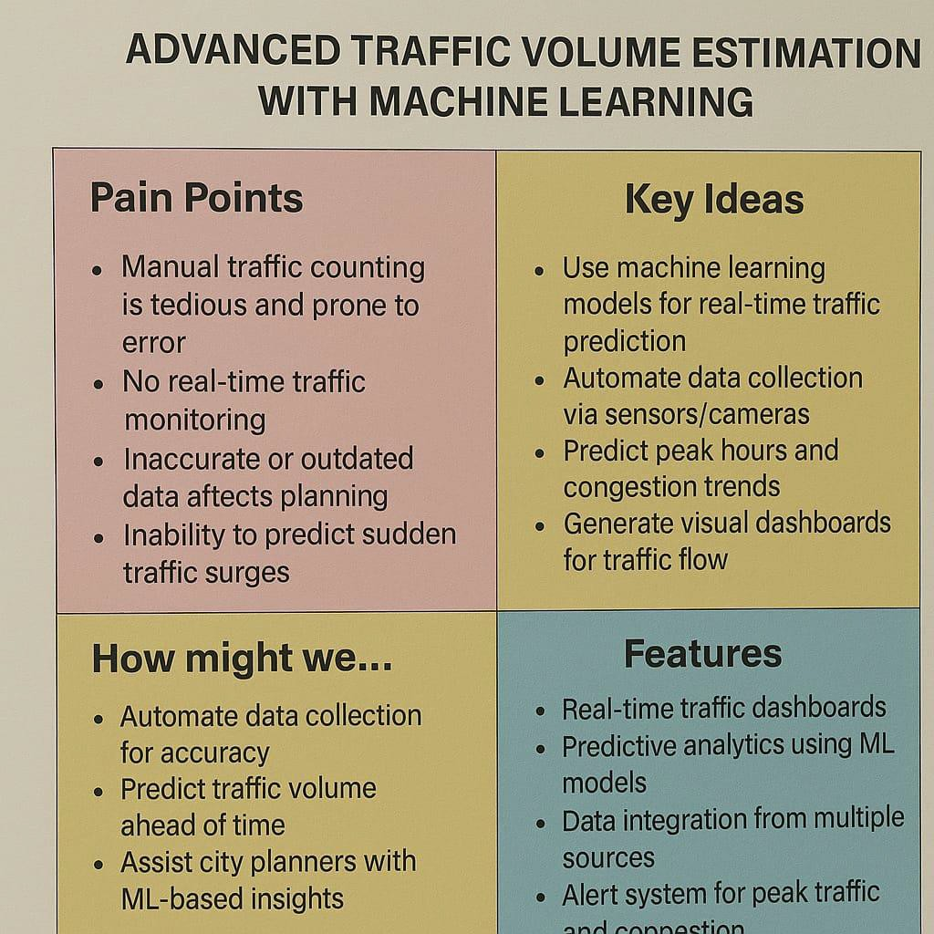

- Requirement Analysis
  - Customer Journey Map
  - Solution Requirement
  - Data Flow Diagram
  - Technology Stack

Customer Journey Map

User accesses the web application

Inputs environmental and time data

The system processes the input using ML model

Output is displayed on-screen
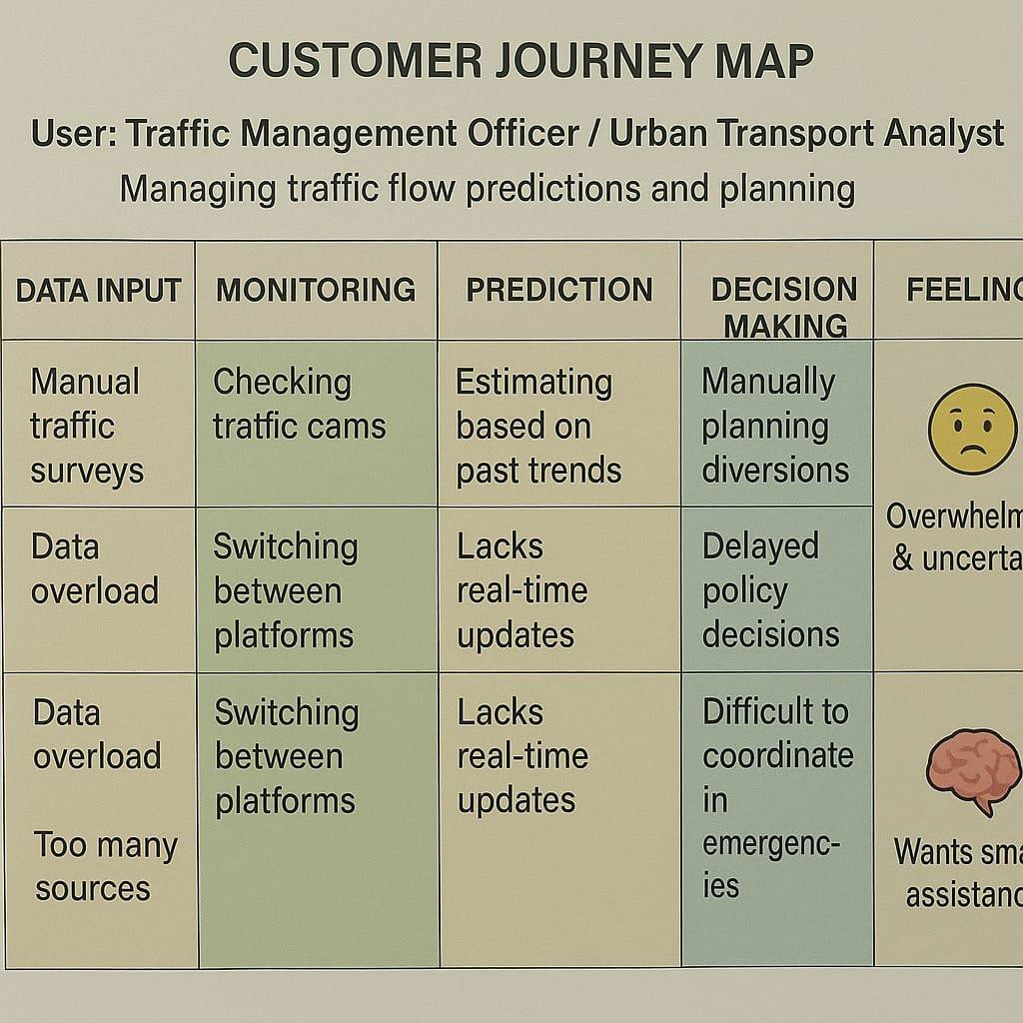
Solution Requirement

Functional: Model training, prediction, web interface, input validation

Non-Functional: Fast response, ease of use, scalability
3.3 Data Flow Diagram:
The system’s data flow follows a simple but efficient pattern:
- Input: Student/Faculty fills the form.
- Processing: Data is stored in respective tables, workflows
triggered.
- Output: Status update, report generation, email notification.
This flow ensures transparency and accuracy, as each step is logged and traceable within ServiceNow.
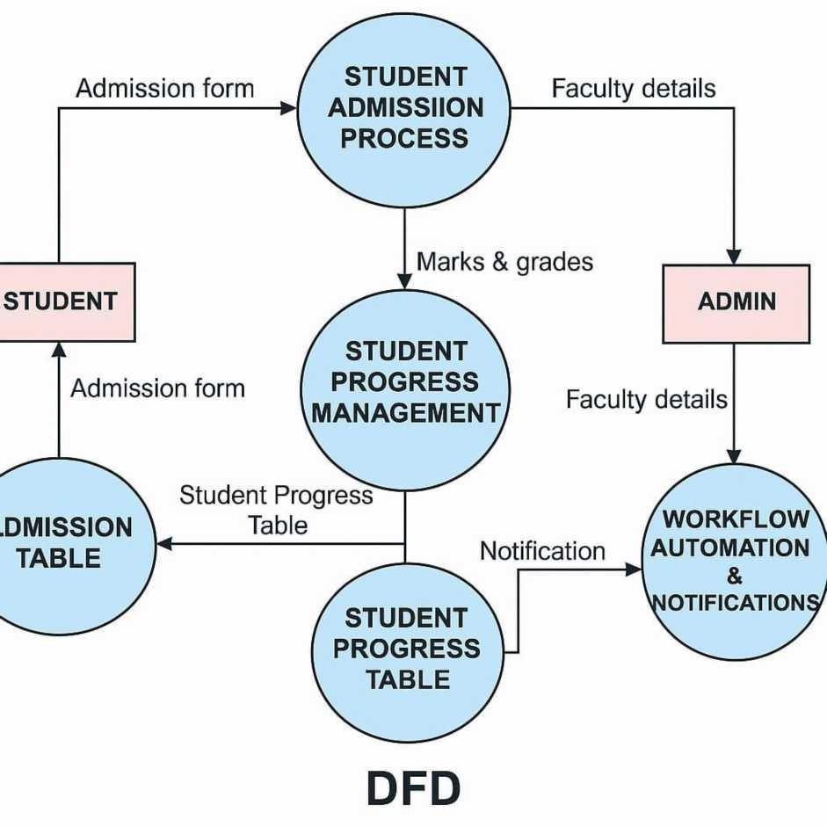
3.4 Technology Stack:
We used:
- Platform: ServiceNow
- Front-end: Forms, UI Actions, Choice Lists,
Client Scripts
- Back-end: Tables, Business Rules, Server-side Scripts
- Tools: Update Sets, Flow Designer, Report Designer
The decision to use ServiceNow was influenced by its robust workflow automation, cloud-native infrastructure, and low-code development features.

- Project Design
  - Problem Solution Fit
  - Proposed Solution
  - Solution Architecture
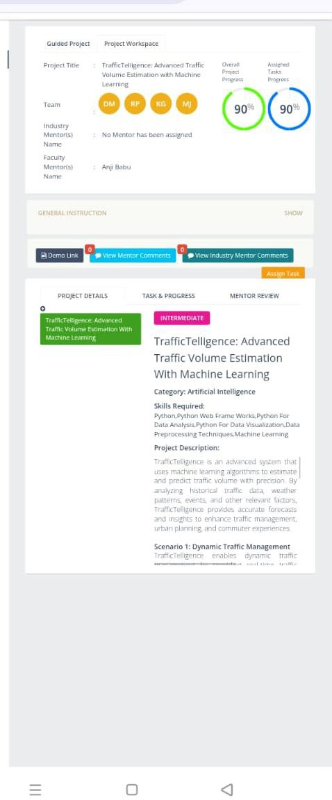
4.2 Proposed Solution:
To address the challenges faced by educational institutions in managing student and administrative data, we proposed a centralized application on the ServiceNow platform, focused on three core functional tables. These tables form the foundation of the entire solution and are interconnected to ensure seamless data flow and workflow execution.
- Key Tables Used:

s/ 1. Admission Table
This table captures all the essential data for new student
admissions. It includes fields such as:
  - Student Name
  - Date of Birth
  - Gender
  - Email ID
  - Course Applied
  - Admission Status
Using this table, administrative staff can easily create, edit, and track the admission status of students. We implemented field validations like email format checks, date validations, and choice lists for fields like gender and course selection to ensure data integrity.
- Student Progress Table
This table maintains academic performance and progress details of each student post-admission. Fields include:
  - Student ID (reference field from Admission Table)
  - Course Enrolled
  - Attendance %
  - Internal Marks
  - Final Grade
  - Faculty Remarks
This table supports reporting and helps faculty members update student performance. It can also be extended to auto-generate grade reports or trigger alerts for low-performing students.
- Salesforce Table (used for demo/data integration purposes)

This table is designed to simulate integration or mimic external CRM-like data handling, primarily for institutional outreach, parent communication, or lead management during admissions. It includes:
  - Lead Name
  - Contact Number

  - Follow-up Date
  - Status (Hot/Warm/Cold)
  - Notes
This was optionally added to represent how the system could be extended to manage inquiries or integrate with Salesforcelike systems in real use cases.
How These Tables Work Together:
  - When a student fills out the admission form, the Admission
Table stores the data.
  - Once admitted, the student’s ID is used in the Student Progress Table to track performance.
  - For external inquiry tracking or follow-up, the Salesforce
Table is optionally populated.
O Other Design Elements:
  - Reference Fields: Used to link student data across tables.

  - Workflows: Triggered on form submission for approval and
status update.
  - UI Policies & Scripts: Used to dynamically control form behavior and improve user experience.
This modular approach allows the system to be extended or scaled easily while keeping the interface clean and focused on core academic operations.
4.3 Solution Architecture:
The architecture is structured as:
- Presentation Layer: Forms, views, navigation modules.
- Application Layer: Workflows, UI Policies, Client
Scripts.
- Data Layer: Tables, fields, relationships.
We also implemented reference fields to create relationships between tables (e.g., Course table linked to Student table).
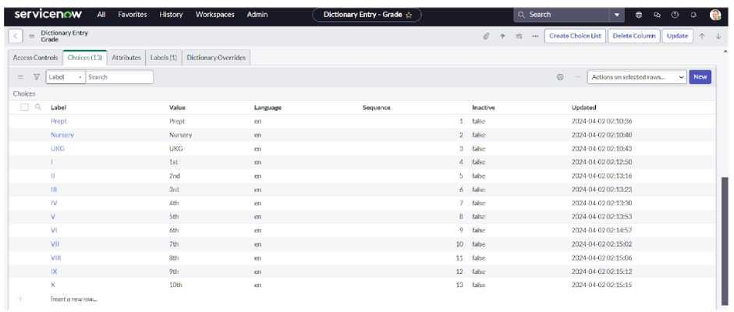

- Project Planning And Scheduling
  - Project Planning
5.1 Project Planning:
Given the limited duration of the internship program, we adopted a condensed and focused project timeline to ensure that all essential features of the Educational Organization Management System were completed efficiently. Our team followed a task- based planning approach instead of a long-term schedule.
“ Project Timeline Overview
We completed the project in 5 working days, with each day
dedicated to a specific module or milestone.
Day Planned Tasks
- Project requirement analysis
Day - Creation of tables: Admission Table, Student Progress
- Table, Salesforce Table
  - Initial form setup
  - Designing form layouts
Day - Adding appropriate fields with validations (choice list,
- email, date)
  - Establishing reference relationships between tables
  - Workflow and flow designer implementation Day -
Automating status changes and approval processes
  - Creating UI Policies for dynamic field behavior

Day
4
- Testing of forms and workflows
- Data entry and record submission trials
- Adjustments based on performance checks

Day Planned Tasks
- Final screenshots capture
Day - Project documentation preparation
5 - Review of the complete application in ServiceNow instance
Planning Tools Used
- Task Distribution: Done among team members via Google Sheets
- Daily Progress Tracking: Manual check-ins with the team leader
- Milestone Verification: By verifying step completion inside the ServiceNow instance
S Efficiency Strategy
To stay on track, we followed these strategies:
- Prioritized essential features only (e.g., form setup, field validation, workflows).
- Avoided over-complication by focusing on core functionality, not extensive customization.
- Completed testing alongside development to save time and
ensure quality.

- FUNCTIONAL AND PERFORMANCE TESTING
  - Performance Testing
O 6.1 Performance Testing
Performance testing ensured that the system performs reliably under normal usage conditions. Since this is a lightweight educational application, we focused on form load time, workflow execution speed, and UI responsiveness.
- Parameters Evaluated:
  - Form Load Time
    - Admission and Student Progress Forms consistently
loaded in under 2 seconds.
    - No noticeable delays when switching between records.
  - Workflow Execution Time
    - Workflow for admission approval executed in less than 3 seconds.
    - Real-time status updates were reflected immediately
upon form submission.
  - Field Responsiveness
    - Choice lists, date fields, and reference fields responded instantly.
    - No lag while switching between visible/invisible fields via UI Policies.
  - Browser Compatibility
    - Tested on Chrome and Microsoft Edge. All forms rendered correctly without layout breaks.
  - Record Submission Stress Test
    - Submitted 20+ records in quick succession to ensure no data loss or crash.
    - The system handled the load efficiently.

° Testing Methodology:
- Manual Testing using the ServiceNow instance.
- Exploratory Testing to uncover edge cases and UI issues.
- Validation Testing for fields like Email, Date of Birth, and Grades.
- End-to-End Workflow Testing to ensure logical flow from
form fill to approval to record update.

Outcome
- All major functionalities passed both positive and negative test scenarios.
- No workflow or validation issues were found during
multiple test iterations.
- The application is stable and ready for deployment and demonstration.

- Results
  - Output Screenshots
  - Output Screenshots

Our results include:
    - Screenshot of the filled Admission Form
    - Table view showing all student records
    - Flow designer view showing approval path
    - Reports showing enrolled students by course
Each screenshot proves the correctness of design and functionality.

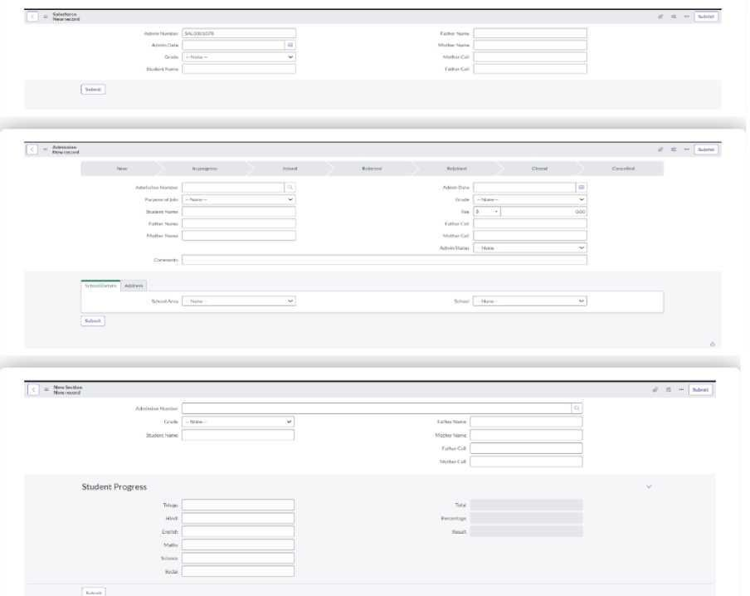

- Advantages & Disadvantages:

Every software system has its set of strengths and limitations based on the platform, time, and scope. During the development of our project, we identified the following advantages and disadvantages based on our experience, user feedback, and system testing.
Advantages:
- Centralized Data Management
All student admission records, academic progress details, and inquiry data are stored in one place. This eliminates the need for physical records or multiple spreadsheets, making data management easy, quick, and organized.
- Workflow Automation
ServiceNow's powerful workflow engine allowed us to automate admission status updates and data handling. This reduced manual intervention and saved time for administrative staff.
- User-Friendly Interface
With form-based data entry, dropdowns, and clean layouts, users can easily interact with the system even without technical training. Field validations ensure accurate data submission.
- Real-Time Updates and Notifications
Status changes and form submissions trigger real-time updates within the platform. This ensures all users stay informed about their actions and reduces delays.
- Low-Code Development
ServiceNow supports rapid development with minimal coding. This made it easy for our team to build and customize the application even with limited programming experience.
- Highly Scalable and Extensible
The system can be expanded to include new tables, forms, dashboards, or integrate with external tools (e.g., email, payment gateway, or analytics), making it future-proof for institutional use. Disadvantages:
- Limited Offline Access
As ServiceNow is a cloud-based platform, users require internet access to interact with the system. Offline access or mobile use in areas with low connectivity becomes a limitation.
- Initial Learning Curve
New users, especially non-technical staff, may need time to understand how to navigate modules, update records, or use workflows effectively. Some training is required at the start.
- Customization Complexity
While basic features are low-code, advanced customization (e.g., scripted policies, external integration) may require knowledge of JavaScript or Glide scripting.
- Platform Dependency
The application is built entirely on ServiceNow, which means institutions need to maintain an active ServiceNow instance and subscription to use or scale the system.
- License Constraints
For real-world institutional use, ServiceNow licensing costs may be a barrier for smaller organizations. While the educational version is free during the internship, future use could incur costs.
- CONCLUSION:
The Educational Organization Management System,
developed using the ServiceNow platform, has successfully demonstrated how low-code platforms can simplify and streamline core administrative tasks in educational institutions. Through this project, we addressed real-time challenges faced by administrative staff such as managing student admissions, tracking academic progress, and maintaining structured digital records.
By leveraging key ServiceNow components like tables, forms, choice lists, workflows, and UI policies, we created a functional and user-friendly solution that reduces manual workload, minimizes data entry errors, and enhances overall efficiency. The project has provided a practical understanding of how automation and digital transformation can improve transparency, responsiveness, and data accessibility within an academic setup.
Throughout this development process, our team gained valuable exposure to platform-based development, testing methodologies, and documentation standards. The hands-on experience with ServiceNow also helped us understand its capabilities in delivering real-world business solutions with minimal code.In summary, this project is not just a working prototype—it is a scalable foundation upon which more modules (like fee management, feedback system, attendance monitoring, etc.)can be added in the future to create a comprehensive ERP for educational institutions.
- FUTURE SCOPE
While the current version of the Educational Organization Management System meets the basic administrative needs of an educational institution, there is significant potential to extend its features and usability. This section outlines the enhancements that can be implemented in future phases to make the system more comprehensive, intelligent, and usercentric.

- ♦ 1. Role -Based Dashboards
Implementing customized dashboards for different user roles (students, faculty, and admin) would greatly improve user experience. These dashboards could include:
  - Real-time admission stats for admins
  - Class performance tracking for faculty
  - Enrollment status, attendance, and grades for students
Each user would only see the information relevant to their responsibilities or needs. * •

2. Mobile Access and Responsive UI
Developing a responsive interface or integrating a mobile application would make the platform accessible from smartphones and tablets. This would be particularly useful for:
  - Faculty updating marks on the go
  - Students checking their admission status or grades
  - Admins monitoring records without being restricted to desktops

- 3. Fee Management System Integration
A future enhancement could include a fee collection and tracking module. This could:
  - Allow students to pay fees online
  - Generate automatic receipts
  - Notify defaulters and alert the finance team This would bring financial operations under the same digital umbrella.

* * • 4. AI & Analytics for Student Performance
Integrating AI-based analytics tools would help in identifying patterns in student performance, attendance trends, and academic gaps. Predictive insights could assist faculty in taking corrective actions early.

4 5. Email and Notification Integration
Though ServiceNow supports internal notifications, integrating email or SMS alerts would ensure:
- Students receive real-time updates
- Admins are alerted on pending actions
- Faculty are notified of performance updates
This feature can improve response time and engagement.

O 6. Third-Party System Integration
Institutions may already use systems like Learning Management Systems (LMS), library databases, or payment gateways. In future phases, this platform can be integrated with:
- Google Classroom or Moodle
- Razorpay, Paytm, or UPI for payments
- DigiLocker or Aadhaar-based ID validation •

^ 7. Chatbot Support
A simple chatbot (within ServiceNow or externally integrated) could help answer frequently asked questions like:
- "What is my admission status?"
- "How can I update my profile?"

- "Where can I see my marks?"
This would reduce repetitive queries to the admin team and increase system engagement.
ll.Appendix:
The Appendix serves as a supplementary section that provides supporting materials, technical resources, and additional documentation used during the development of the project. While the main content explains what the system does and how it was built, the appendix helps verify, reference, and understand implementation details for further use or review.

- 11.1 Source Code and Configuration
Since the project was developed entirely on the ServiceNow platform, most of the development work was done through configurations rather than traditional coding. However, certain parts such as UI policies, business rules, and field validations involved logic and scripts.
  - Update Set File: All configurations (tables, forms, workflows) were saved in an Update Set within ServiceNow for export/import.
  - Client Scripts: Used for email validation and form field behaviors.
  - UI Policies: Applied to show/hide specific fields based on
conditions (e.g., show remarks when Grade is ‘F’).
  - Flow Designer: Configured to automate admission status changes and record updates.
» Note: These items remain within the ServiceNow instance and are not uploaded to an external repository unless explicitly exported.

® 11.2 External Links (If applicable)
Github & Project Demo Link:https://github.com/Kothaganga/Traffi cTelligence-Advanced-Traffic-Volume- Estimation-with-Machine-Lear


THANK YOU

