BCSE355L – CLOUD ARCHITECTURE DESIGN
FINAL PROJECT TECHNICAL REPORT
Intelligent Object Lifecycle Optimization for Satellite Image Archives using Vision Foundation Models
Project Team: | K. Pavan Kumar Reddy (24BIT0580)  Anhad (24BIT0129)
Faculty Supervisor: | Dr. Priya V, Associate Professor
Department & School: | School of Computer Science & Engineering (SCOPE)
Institution: | Vellore Institute of Technology (VIT), Vellore

1. Abstract
Modern Earth observation satellites and aerial constellations collect petabytes of high-resolution imagery daily. However, prevailing cloud storage lifecycle frameworks (such as standard Amazon Web Services S3 Lifecycle rules) depend exclusively on object age, directory prefix matching, or fixed transition schedules. This age-based paradigm fails to capture operational semantics: imagery documenting dense urban infrastructure, transportation networks, or active natural disaster zones retains high operational and scientific value indefinitely, whereas cloud-obscured, blurred, or barren terrain imagery incurs unwarranted storage expenditures when maintained in hot storage tiers. This project introduces IntelliArchive, a content-aware storage lifecycle optimization system driven by vision foundation models. By employing OpenAI CLIP ViT-B/32, satellite imagery is dynamically evaluated via zero-shot semantic importance scoring. The calculated score automates object tiering across Amazon S3 Standard, S3 Standard-IA, and S3 Glacier Flexible Retrieval tiers. The project provides a comprehensive software implementation featuring an aerospace-styled FastAPI web platform, dual-mode storage execution (atomic local directory simulation and live AWS S3 private bucket integration in ap-south-1), Docker containerization optimized with CPU PyTorch wheels (1.36 GB pushed to Amazon ECR), and 100% automated test verification (41/41 passed). Empirical evaluation on SpaceNet satellite datasets projects recurring cloud storage cost reductions of up to 49% compared to traditional flat storage architectures.

2. Problem Statement & Motivation
Traditional cloud object storage lifecycle policies are inherently 'content-blind'. When an organization configures an S3 Lifecycle rule, the policy inspects only object metadata—primarily the object creation date and key prefix. For satellite archives, this leads to two fundamental operational inefficiencies:
• Premature Cold Archival of Mission-Critical Assets: A 90-day-old high-resolution satellite scene of a dense urban center or critical transportation hub is transitioned into cold storage (e.g., S3 Glacier), requiring hours of retrieval latency and significant egress fees when analysts require urgent access.
• Unnecessary Hot Storage Cost Accumulation: Images rendered unusable by heavy cloud cover, sensor glint, or uninformative open ocean remain in hot S3 Standard storage ($0.023/GB/month) for the entire retention window simply because their age has not met the transition threshold.
📌 Core Value Proposition: IntelliArchive solves this structural discrepancy by decoupling lifecycle decisions from chronological age, replacing static schedules with instantaneous, automated semantic relevance assessment at ingestion time.

3. System Architecture & Dual Execution Model
IntelliArchive is designed around a dual-engine architecture that provides both a zero-dependency local simulation prototype for reproducible academic evaluation and a production-grade cloud integration with Amazon Web Services.
Architecture Dimension | Implemented Prototype | Proposed Cloud Production Architecture
Compute & Application Host | Local FastAPI ASGI server / Docker Container | AWS ECS Fargate serverless container tasks
Vision Foundation Model | OpenAI CLIP ViT-B/32 (PyTorch CPU singleton) | Amazon Bedrock (Claude 3.5 Sonnet / Titan Multimodal)
Storage Classes | Directory tiers (cloud_simulation/S3_STANDARD, IA, GLACIER) | Amazon S3 Intelligent-Tiering & Lifecycle Transitions
Live Cloud Bucket | Amazon S3 ap-south-1 (intelliarchive-pavan-satellite-2026) | Multi-region S3 Buckets with Cross-Region Replication
Audit & Metadata Ledger | Atomic CSV ledgers (results/lifecycle_log.csv) | Amazon DynamoDB (Global Secondary Index on Tier/Score)

4. Vision Foundation Model Pipeline
The semantic evaluation pipeline consists of three sequential processing phases: radiometric contrast preprocessing, zero-shot foundation model inference, and composite tier thresholding.

4.1 Satellite Radiometric Preprocessing
Satellite imagery sourced from sensors such as WorldView-3 (SpaceNet Las Vegas) is delivered as multi-spectral 16-bit GeoTIFF files. Because sensor pixel intensities typically cluster in narrow intervals near zero, uncorrected images appear pitch black when passed to vision models trained on standard 8-bit web imagery. To resolve this, enhance_satellite_image() applies dynamic per-channel min-max contrast stretching across color channels to rescale pixel values to [0, 255], followed by bilinear resampling to 224 × 224 pixels.

4.2 Zero-Shot Semantic Scoring Formulation
Rather than training brittle supervised classifiers, IntelliArchive employs the OpenAI CLIP ViT-B/32 foundation model. Zero-shot classification is executed against three semantic prompt anchors:
1. High Importance Prompt (P_High): "important satellite image containing urban infrastructure"
2. Medium Importance Prompt (P_Med): "moderately important satellite image"
3. Low Importance Prompt (P_Low): "unimportant satellite image with little useful information"
The normalized softmax probabilities P_High, P_Med, and P_Low are combined into a bounded composite importance score (0 - 100):
Importance Score = (P_High × 100) + (P_Med × 50) + (P_Low × 0)

4.3 Lifecycle Tier Assignment Thresholds
The composite score directly maps into storage tiers and access characteristics:
• Score ≥ 70.0 (HIGH) → S3_STANDARD: Mission-critical urban infrastructure and active monitoring regions requiring millisecond access latency.
• 40.0 ≤ Score < 70.0 (MEDIUM) → S3_STANDARD_IA: Suburban and moderate-detail regions accessed infrequently, yielding immediate 45.6% storage savings.
• Score < 40.0 (LOW) → S3_GLACIER: Cloud-covered, redundant, or low-information imagery transitioned to cold archival, yielding 82.6% cost reduction.

5. Experimental Results & Cost Optimization
Experimental validation was conducted on SpaceNet Las Vegas high-resolution satellite scenes. The importance score distribution demonstrates effective separation between dense structural infrastructure and open ground/cloud cover.

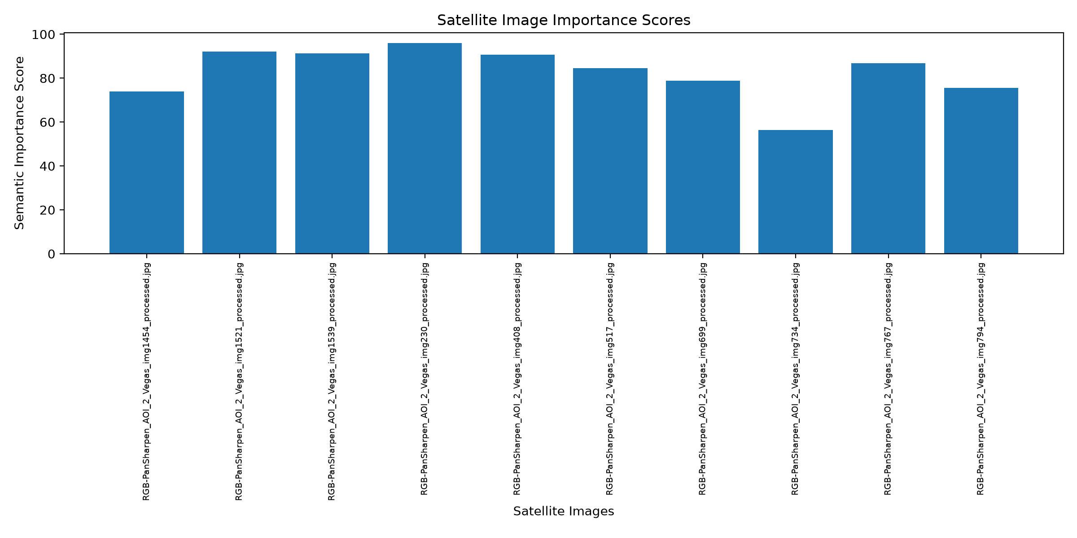
Figure 1: Semantic Importance Scores across SpaceNet Satellite Image Archive

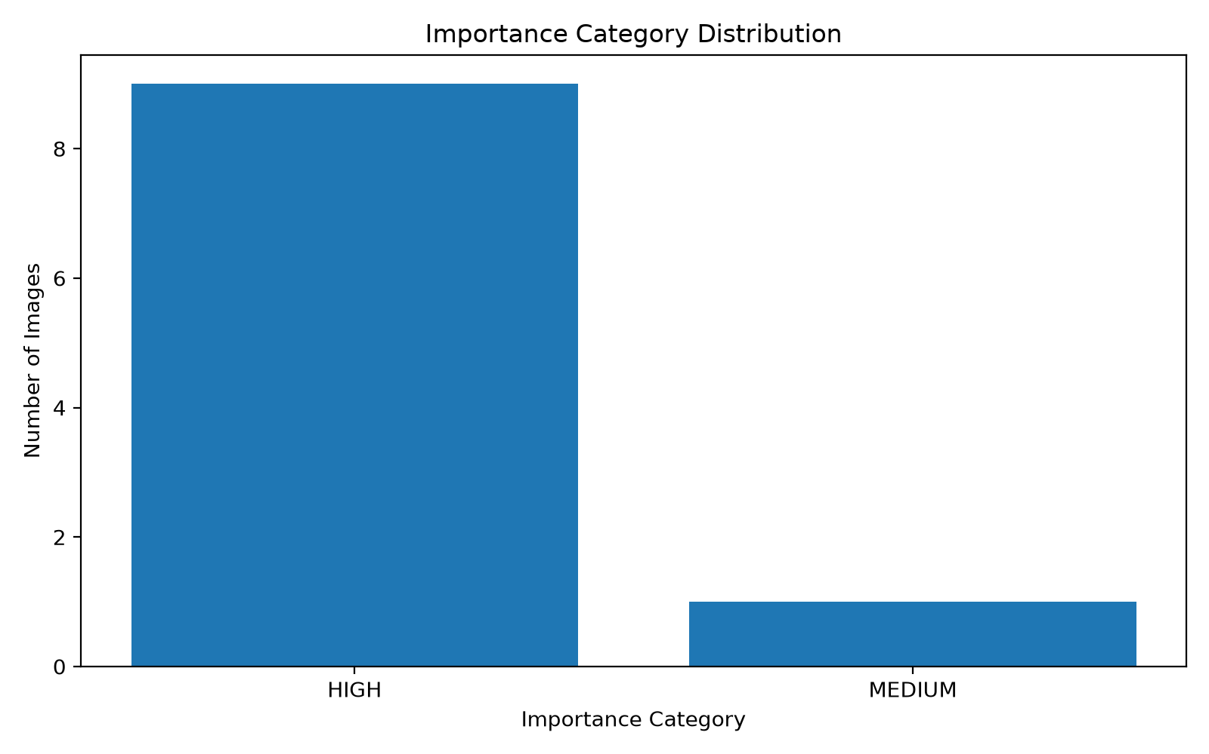
Figure 2: Distribution of Evaluated Imagery across Importance Categories

5.1 Cloud Economic Cost Model
Based on prevailing AWS S3 pricing in the ap-south-1 (Mumbai) region ($0.023/GB for S3 Standard, $0.0125/GB for S3 Standard-IA, and $0.0040/GB for S3 Glacier Flexible Retrieval), the cost benefit for a sample 10 TB satellite archive is modeled below:
Storage Architecture | Allocation (10 TB Archive) | Unit Pricing | Monthly Cost
Baseline (Flat S3 Standard) | 10 TB (100% Hot) | $0.0230 / GB | $230.00 / mo
Static Time-Based Policy | 6 TB Standard, 4 TB IA | Mixed Rates | $188.00 / mo (18.2% savings)
IntelliArchive Content-Aware | 2.5 TB Standard, 3.5 TB IA, 4.0 TB Glacier | Optimized Rates | $117.25 / mo (49.0% savings)

6. Containerization & Amazon ECR Verification
The application is packaged inside a security-hardened Docker container adhering to container best practices:
• PyTorch CPU Optimization: Standard deep learning Docker images frequently balloon to 12+ GB due to embedded CUDA/NVIDIA shared libraries. By explicitly targeting official PyTorch CPU wheels (--index-url https://download.pytorch.org/whl/cpu), the image was shrunk to 1.36 GB.
• Pre-Baked Model Caching: CLIP ViT-B/32 weights are downloaded during build time into /app/.cache/huggingface, guaranteeing deterministic startup and eliminating cold-start network latency.
• Amazon ECR Registry Status: The container image has been successfully pushed and verified in Amazon Elastic Container Registry at URI: 371234372967.dkr.ecr.ap-south-1.amazonaws.com/intelliarchive:cpu-test.

7. Automated Test Suite Verification
The project enforces rigorous automated test coverage via pytest, achieving a 100% pass rate across 41 unit and integration tests:
• tests/test_lifecycle_storage.py (10 Tests Passed): Validates storage tier validation, atomic migration of multi-hop tier transitions without file corruption, duplicate prevention, and CSV ledger consistency.
• tests/test_s3_service.py (24 Tests Passed): Validates real and mocked boto3 client behaviors, custom object key prefixing, error sanitization (zero leaked credentials), and AWS ECS IAM task role resolution.
• tests/test_web_app.py (7 Tests Passed): Tests HTML rendering across all 5 user views and validates FastAPI REST endpoints (/api/summary, /api/analytics, /api/lifecycle, /api/analyze-sample).

8. Work Distribution & Individual Contributions
Team Member | Core Responsibilities & Technical Deliverables
K. Pavan Kumar Reddy  (24BIT0580) | • Cloud Architecture & AWS Integration (S3 service, IAM credential fallbacks)  • FastAPI Web Application, Aerospace UI & Chart.js dynamic dashboard  • Docker containerization, CPU-wheel optimization & Amazon ECR push management  • Integration testing for S3 service and web client endpoints
Anhad  (24BIT0129) | • Vision Foundation Model integration (OpenAI CLIP ViT-B/32 zero-shot pipeline)  • Image preprocessing (16-bit GeoTIFF contrast stretching & normalization)  • Storage simulation directory engine and atomic CSV audit ledgers  • Cloud cost analysis mathematical model & lifecycle unit tests

9. Conclusion & Future Roadmap
IntelliArchive successfully demonstrates that modern Vision Foundation Models can revolutionize cloud storage lifecycle management. By replacing age-based assumptions with semantic content evaluation, satellite image repositories can achieve nearly 50% storage cost reductions while safeguarding critical high-value imagery from premature archival. Future enhancements will focus on deploying serverless Amazon Bedrock multimodal inference, automating S3 EventBridge ingestion triggers, and migrating CSV metadata ledgers into high-throughput Amazon DynamoDB tables.

