
PROMPT ENGINEERING CERTIFICATION PROGRAM
MODULE 3 — ACADEMIC & PROFESSIONAL APPLICATIONS

SESSION 11
Research & Knowledge Synthesis with AI

MODULE  3 of 6 | SESSION  11 of 30
DURATION  60–90 minutes | FORMAT  Self-paced + Activities
UpSkill Global Education Technologies Inc.Canada

SESSION OVERVIEW

Learning Objectives
By the end of this session, you will be able to:
- Use AI to accelerate the research process across all stages
- Prompt AI to synthesize information across multiple sources
- Generate structured literature summaries and knowledge maps
- Use AI to identify research gaps and formulate strong research questions
- Apply critical thinking to evaluate AI generated research content
- Build a research workflow that combines AI speed with human verification

11.1 AI as a Research Accelerator


Research is traditionally one of the most time intensive professional activities reading, synthesizing, organizing, and drawing conclusions from large volumes of information. AI can compress this timeline dramatically while improving the quality of the synthesis.

What AI Can and Cannot Do in Research
AI Excels At | AI Cannot
Explaining concepts and theories | Access real-time journal databases
Synthesizing themes across sources | Provide reliable specific citations
Generating research questions | Guarantee factual accuracy
Creating structured summaries | Replace reading primary sources
Identifying potential gaps | Access your organization's internal data
Simplifying complex academic text | Produce legally citable academic work
Building frameworks and taxonomies | Know what was published after training cutoff

The Professional Research Standard
⚡ Use AI to accelerate and structure your research but always verify key claims, statistics, and citations against primary sources before using them professionally.

11.2 Stage-by-Stage AI Research Workflow

Stage 1: Topic Orientation — Building Foundational Understanding
Before diving into primary sources, use AI to build your conceptual map of the field.
Concept mapping prompt:
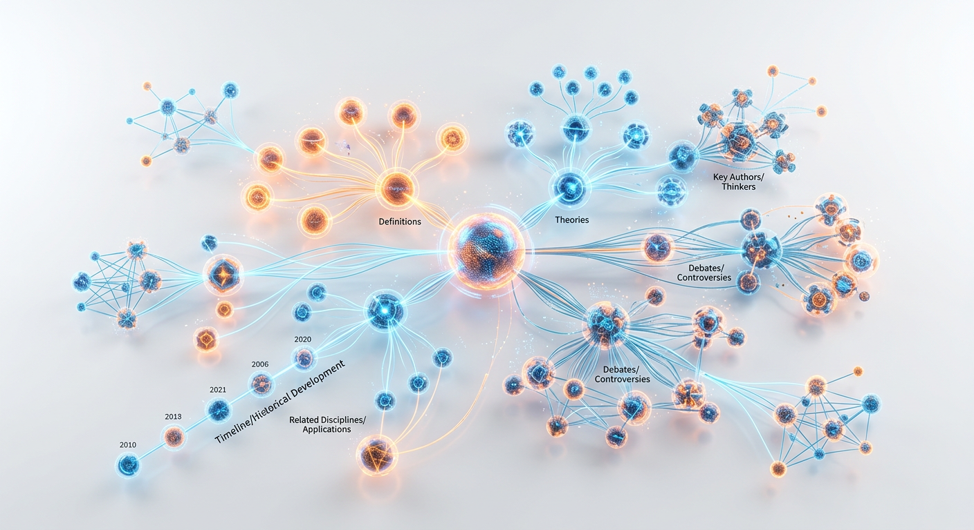

You are a senior research consultant who specializes in synthesizing
complex academic fields for practitioners.

I am beginning research on [YOUR TOPIC]. I have [BASIC /
INTERMEDIATE / ADVANCED] background in this area. My purpose is
[academic dissertation / business report / policy brief / personal
learning].

Create a comprehensive concept map for this topic that includes:
1. Core definition and key concepts (5–7 terms with explanations)
2. Major theoretical frameworks or schools of thought (3–5)
3. Key debates or contested areas in the field
4. Timeline of major developments (last 20 years)
5. Connections to adjacent fields or disciplines
6. Key authors or researchers typically associated with this field

Topic: [YOUR TOPIC]

Understanding depth levels prompt:
Explain [CONCEPT] at three levels of depth:

Level 1 — For a general educated adult with no background
(3 sentences)
Level 2 — For a professional practitioner who needs working
knowledge (1 paragraph)
Level 3 — For an academic researcher entering this field
(3 paragraphs with key terminology and theoretical context)

Label each level clearly.

Stage 2: Research Question Development
Strong research questions are specific, researchable, and address genuine gaps.
Research question generation prompt:
You are a research methodology expert who has supervised 50+
graduate theses in [FIELD].

My broad research interest is: [DESCRIBE YOUR BROAD INTEREST]
My context/setting: [describe — industry, geography, organization
type, etc.]
My purpose: [What will this research be used for?]

Generate:
1. 5 specific, researchable research questions on this topic
2. For each question: classify as Descriptive / Explanatory /
Predictive / Evaluative
3. For each question: identify the likely research method (survey,
case study, experiment, etc.)
4. Rate each question for originality and feasibility (both out of 5)
5. Recommend the TOP 2 questions to pursue and explain why

Then identify: what information or data would be needed to answer
each top question?



Gap identification prompt:
Based on the following summary of what I know about [TOPIC]:
[Paste your current knowledge summary]

Identify:
1. What are the most significant questions that remain unanswered
in this area?
2. What populations, contexts, or settings are under-researched?
3. What methodological gaps exist (things that are theorized but
not empirically tested)?
4. What contradictions or debates exist that need resolution?

Format as a table: Gap Type | Description | Why It Matters |
Potential Research Approach

Stage 3: Source Summarization — Extracting Value from Documents
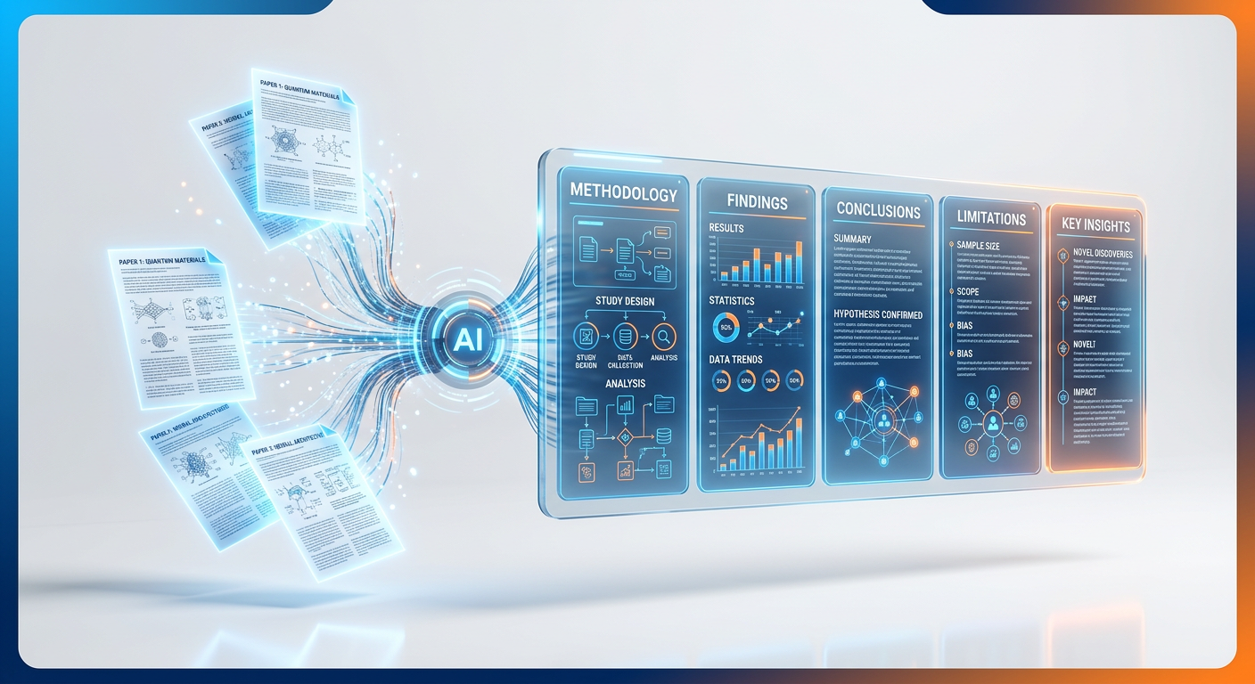
When you have actual source documents (papers, reports, articles), use AI to extract structured value.

Comprehensive paper summarization prompt:
Read the following research content and produce a structured
summary. If any section is not present in the provided text,
write "Not mentioned." Do not invent or infer information not
in the text.

Summarize using this structure:

BIBLIOGRAPHIC INFO: Title / Authors / Publication / Year

RESEARCH OVERVIEW: Research problem (2 sentences) / Research
question(s) / Study context/setting

METHODOLOGY: Research design / Data collection method / Sample
size / Analysis approach

FINDINGS: Key finding 1 / Key finding 2 / Key finding 3 /
Surprising or counterintuitive finding (if any)

CONCLUSIONS: Main conclusion / Practical implications /
Theoretical contribution

LIMITATIONS (as stated by authors):

MY CRITICAL NOTES: Potential weaknesses not mentioned by authors /
Questions this raises for my research / Connection to other
sources I've read

[PASTE YOUR DOCUMENT/EXCERPT HERE]

Stage 4: Cross-Source Synthesis

After reading several sources, use AI to synthesize across them.

Multi-source synthesis prompt:
You are an expert research synthesizer. I have summarized [N]
sources on the topic of [YOUR TOPIC]. Your job is to synthesize
these — not just list them — into a coherent narrative that
shows the field's current state of knowledge.

Here are my source summaries:
SOURCE 1: [Paste summary]
SOURCE 2: [Paste summary]
SOURCE 3: [Paste summary]
[...continue...]

Synthesize these into a structured literature review section
with these parts:
1. CONSENSUS THEMES (What do most or all sources agree on?)
Present as a flowing paragraph, not a list.
2. CONTRADICTIONS AND DEBATES (Where do sources disagree? Why
might they?) For each debate: state both positions, identify
likely reason for divergence (different context? different
methodology? different time period?)
3. EVOLUTION OVER TIME (How has thinking on this topic changed?)
Only include if temporal differences are visible across sources.
4. GAPS AND WHAT'S MISSING (What important questions remain
unanswered?)
5. SYNTHESIS CONCLUSION (In 2–3 sentences: what does the
collective evidence tell us?)

Write in academic report style. Attribute sources as Source 1,
Source 2, etc. (I will replace with proper citations later.)

Stage 5: Knowledge Application — Translating Research to Action
Research is only valuable when it informs decisions or practice.


Research to action translation prompt:
I have completed research on [TOPIC]. Here is a summary of my
key findings: [Paste findings]

My context: I work as [YOUR ROLE] at [YOUR ORGANIZATION TYPE].

Translate these research findings into:
1. PRACTICAL IMPLICATIONS — 3 things I should do differently
based on this evidence
2. POLICY/PROCESS RECOMMENDATIONS — 2 changes to current practices
3. FURTHER INVESTIGATION — 2 areas where I need more information
before acting
4. RISKS OF NOT ACTING — what happens if these findings are ignored
5. QUICK WINS — 1 action I could implement within 2 weeks with no
additional resources

Keep all recommendations specific to my context.

11.3 Specialized Research Prompt Templates
For Business Research
You are a market research analyst with expertise in [INDUSTRY].

I need to understand [RESEARCH TOPIC] for [PURPOSE: strategic
planning / competitive analysis / investment decision / product
development].

Provide a structured market intelligence brief:

MARKET OVERVIEW: Current size and growth trajectory (flag
approximate figures for verification) / Key market segments /
Geographic considerations

KEY PLAYERS: Top 3–5 players and their positioning / New entrants
or disruptors to watch

TRENDS AND DRIVERS: 3 major trends shaping this market (next 3–5
years) / 2 key drivers of growth / 2 key headwinds or risks

OPPORTUNITIES: 2–3 white space opportunities

SOURCES TO VERIFY: Recommend 3 specific reports, databases, or
sources I should consult for authoritative data on this market

Note: Flag any figures with [VERIFY] where you are uncertain of
accuracy.

For Academic Literature Review
Help me write a literature review section on [TOPIC] for
[TYPE OF PAPER].

I have these key themes from my reading:
[Paste your notes — bullet points are fine]

Write a 500 word literature review section that:
- Flows as coherent academic prose (not a list of summaries)
- Integrates the themes, not just reports them sequentially
- Uses hedged academic language ("suggests," "indicates," "argues")
- Identifies tensions or debates between perspectives
- Ends with a clear statement of the gap this current research
addresses

Use citations as [AUTHOR YEAR] placeholders — I will fill in real
citations. The tone should match: [quantitative journal /
qualitative journal / professional report / policy brief]

For Policy Research
You are a policy research specialist with expertise in [DOMAIN].

Analyze the following policy issue for a brief that will be
presented to [AUDIENCE: government ministers / senior executives /
NGO leadership].

Policy issue: [DESCRIBE THE ISSUE]
Context: [COUNTRY / SECTOR / POPULATION AFFECTED]

Structure the policy brief as:
1. PROBLEM STATEMENT (3 sentences — what, who affected, why urgent)
2. EVIDENCE BASE (3 key research findings supporting action)
3. CURRENT POLICY/RESPONSE (what exists now — strengths and gaps)
4. POLICY OPTIONS (3 options with pros and cons — neutral, not
advocacy)
5. RECOMMENDED OPTION (your assessment of the best option with
evidence-based rationale)
6. IMPLEMENTATION CONSIDERATIONS (2–3 practical barriers and
solutions)
7. MONITORING AND EVALUATION (how to know if the policy works)

Flag all statistics with [VERIFY: source type needed].

11.4 Critical Evaluation of AI Research Output

Because AI can hallucinate, every research output needs evaluation before use.
The SIFT Framework for AI Research Verification
SIFT FRAMEWORK
S — STOP: Pause before sharing or acting on AI research output.
Ask: “Would I stake my professional reputation on this claim?”

I — INVESTIGATE THE SOURCE: For any specific claim, what is the
actual source? Has the AI cited a real, verifiable document?

F — FIND BETTER COVERAGE: Search for the same claim in a
reputable database (Google Scholar, PubMed, JSTOR, EBSCO,
government databases). If you can't find it, assume it may be
hallucinated.

T — TRACE CLAIMS: For statistics, trace back to the original
source. For quotes, verify the exact wording in the original.

AI Research Red Flags
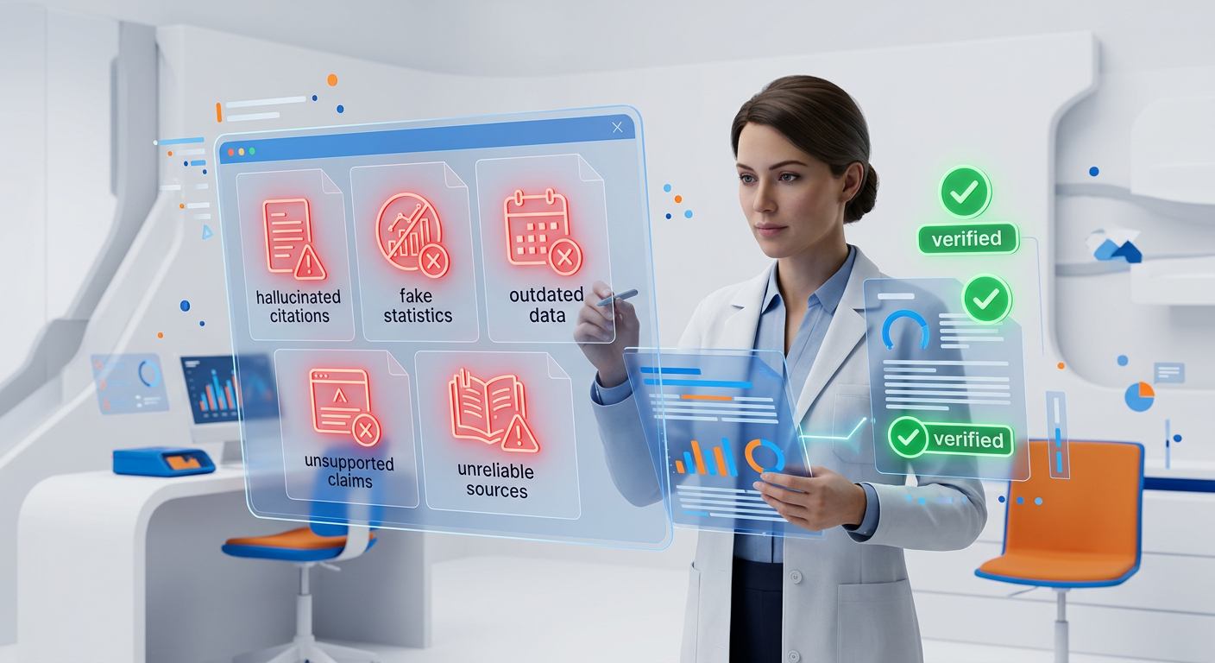

✓ Very specific statistics without context (e.g. “87.3% of companies that implemented X saw Y improvement”) —almost certainly requires verification
✓ Named academic citations (“According to Smith and Johnson, 2022...”) — high hallucination risk; verify every citation independently
✓ Claims about recent events (within 1 to 2 years) — may be after training cutoff; verify with current sources
✓ Industry statistics by exact dollar or percentage — always verify against the original market research report
✓ “Research shows...” without specifying what research — ask AI: “What specific research are you referring to?”

Verification Prompts
After receiving research content, use these to test reliability:
For each factual claim in your response above, rate your
confidence level:
HIGH (well established, widely documented)
MEDIUM (generally understood but may have nuances)
LOW (you have limited confidence or this may be uncertain)

Mark each claim with its confidence level, then list the
LOW-confidence claims separately and suggest where I can verify
them.

List all statistics and specific figures you cited in your
previous response. For each: What is the likely original source?
How recent is this data? Flag any that are over 3 years old or
that you are uncertain about.

11.5 Building a Research Knowledge Base

Use AI to help organize and structure your accumulated research knowledge.
Knowledge Taxonomy Builder
I have accumulated research on [TOPIC] from [NUMBER] sources over
[TIME PERIOD]. Here are my key notes and findings: [paste notes]

Help me build a structured knowledge taxonomy:
1. Identify the 5–7 main themes emerging from this research
2. Under each theme: identify sub-themes and key questions answered
3. Map any conflicts or contradictions between my sources
4. Identify the 3 strongest, best-supported conclusions I can draw
5. Identify the 3 areas where I need more evidence before
concluding

Present as a hierarchical outline I can use as a reference
document.

Research Question to Hypothesis Pipeline
For those building research tools programmatically, this workflow converts broad research interests into structured hypotheses:
research_pipeline = {
"step_1_broad_topic": {
"prompt": "Given this broad research interest: {broad_topic}
And this context: {context}
Generate 5 specific, testable research questions.
For each: type (descriptive/explanatory/predictive) |
method | feasibility (1-5)",
"output": "research_questions"
},
"step_2_hypothesis": {
"prompt": "For this research question: {selected_question}
Formulate: 1. Null hypothesis (H0) 2. Alternative
hypothesis (H1) 3. Key variables: independent | dependent
| control 4. Operationalization 5. Assumptions required",
"output": "hypothesis_framework"
},
"step_3_literature_gaps": {
"prompt": "Given this hypothesis: {hypothesis} And what I
know from literature: {literature_summary} Identify:
what evidence exists for? against? missing entirely?
Conclude: does this hypothesis address a genuine gap?",
"output": "gap_analysis"
}
}

Hands-On Activities — Session 11
Activity 11.1 — Research Topic Orientation
Objective: Use AI to build a complete conceptual map of an unfamiliar topic.
- Choose a topic you need to research but don't know well (professional or academic)
- Run the Concept Mapping prompt (Section 11.2, Stage 1) for your topic
- Identify 3 concepts from the map you don't fully understand. Run the Understanding Depth Levels prompt for each
- Based on the concept map, identify what you most need to know for your specific purpose
Deliverable
📄 A 1-page “Research Orientation Document” summarizing your conceptual map.

Activity 11.2 — Source Summarization Practice

Objective: Practice extracting structured knowledge from real sources.
- Find a real article, report, or paper on any topic (your field, LinkedIn articles, news analysis, or academic papers)
- Paste the full text (or as much as fits in the context window) into the Comprehensive Paper Summarization prompt
- Critically evaluate the summary, did it miss important points? Add anything not in the original? Correctly represent the source's main arguments?
- Note any areas where the AI misrepresented or missed content, this is evidence for why verification matters.

Activity 11.3 — Multi-Source Synthesis
Objective: Synthesize knowledge across 3 real sources.
- Find 3 articles on the same topic (news, reports, or summaries they don't need to be academic)
- Summarize each using the Paper Summarization prompt
- Run the Multi-Source Synthesis prompt with all 3 summaries
- Evaluate the synthesis did the AI identify genuine themes or just repeat each source? Did it identify real contradictions? Is the conclusion well supported?

Activity 11.4 — Verification Exercise
Objective: Test your AI research output verification skills.
Step 1: Run this prompt:
Give me 5 key statistics about the current state of AI adoption
in Indian businesses. Include the source, year, and specific
figure for each.

Step 2: For each statistic
search for the original source on Google, Google Scholar, or the organization's website. Mark each as: Verified | Partially correct | Cannot verify / Incorrect.

Step 3: Write a 2 paragraph reflection
what percentage were verifiable? What does this tell you about using AI-generated statistics in professional reports?

Revision Questions — Session 11
- What are 3 things AI does well in research and 3 things it cannot do? Give a specific risk example for each limitation.
- Describe the 5-stage AI research workflow. What is the purpose of each stage?
- Why is cross-source synthesis more valuable than simply summarizing each source separately?
- What is the SIFT framework and how does it apply to evaluating AI research outputs?
- Name 4 red flags that should trigger independent verification of AI research claims.
- You need to quickly understand the competitive landscape of a new industry before a client meeting tomorrow. Design a prompt sequence (3 prompts) to accomplish this efficiently.
- What is the difference between a research question and a hypothesis? How would you use AI to develop both?
- A colleague uses AI to write the literature review section of a business report, then submits it without checking. What specific risks does this create?



Key Takeaways — Session 11
✓ AI accelerates all 5 research stages: orientation → questions → summarization → synthesis → application
✓ AI cannot reliably provide citations — always verify independently
✓ Synthesis is more valuable than summarization — ask AI to find themes, contradictions, and gaps across sources
✓ Use the SIFT framework: Stop → Investigate → Find coverage → Trace claims
✓ Statistics are highest-risk: always trace back to original source before using in professional documents
✓ Research-to-action translation: always end research with specific, context-relevant implications

Session 11 Complete → Proceed to Session 12: AI for Professional Writing
Prompt Engineering Certification Program | UpSkill Global Education Technologies Inc., Canada

