
PROMPT ENGINEERING CERTIFICATION PROGRAM
MODULE 3 — ACADEMIC & PROFESSIONAL APPLICATIONS

SESSION 12
AI for Professional Writing

MODULE  3 of 6 | SESSION  12 of 30
DURATION  60–90 minutes | FORMAT  Self-paced + Activities
UpSkill Global Education Technologies Inc. Canada

SESSION OVERVIEW

Learning Objectives
By the end of this session, you will be able to:
- Use AI to plan, draft, and refine professional reports and documents
- Generate business proposals and executive briefs with structured AI prompts
- Apply the right prompting technique for each stage of the writing process
- Use AI to improve existing writing for tone, clarity, and conciseness
- Build reusable prompt templates for your most common professional document types
- Maintain your own voice while using AI as a co author

12.1 AI as Your Professional Writing Co-Author

AI is most powerful in professional writing not as a replacement for your thinking, but as an accelerator of your writing process. The best professional AI writers use a model of:

THE PROFESSIONAL WRITING MODEL
YOUR THINKING → AI DRAFTING → YOUR EDITING → AI REFINING →
YOUR FINAL REVIEW

This model:
- Keeps your professional judgment at the center
- Eliminates blank-page paralysis (AI produces the first draft)
- Dramatically reduces time from idea to polished document
- Allows you to focus cognitive energy on content decisions, not word-by-word writing

The Five Writing Tasks AI Does Best
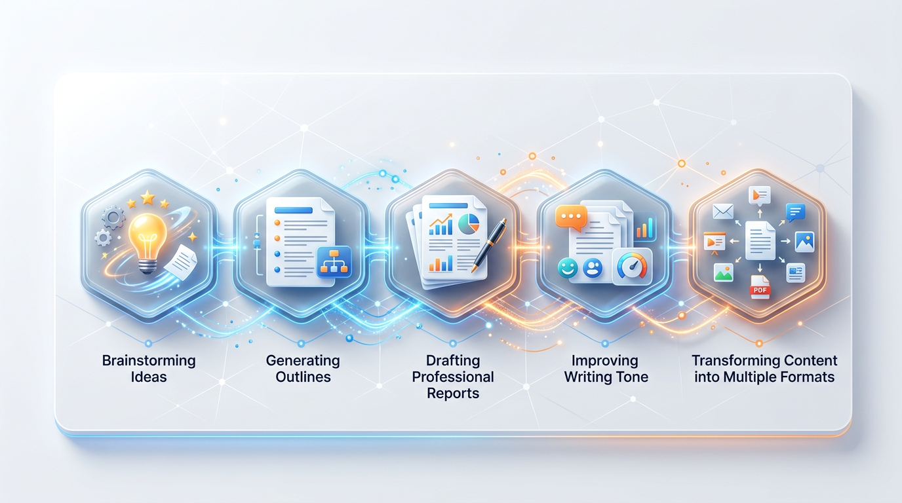

Task | AI Contribution | Time Saved
First draft from notes | Convert bullet notes into flowing prose | 60–80%
Structure/outline generation | Create logical document architecture | 70%
Tone editing | Adjust formality, remove jargon, sharpen clarity | 50%
Section completion | Fill in any section given the surrounding context | 65%
Document repurposing | Convert one document type to another | 75%

12.2 Report Writing — Full Workflow
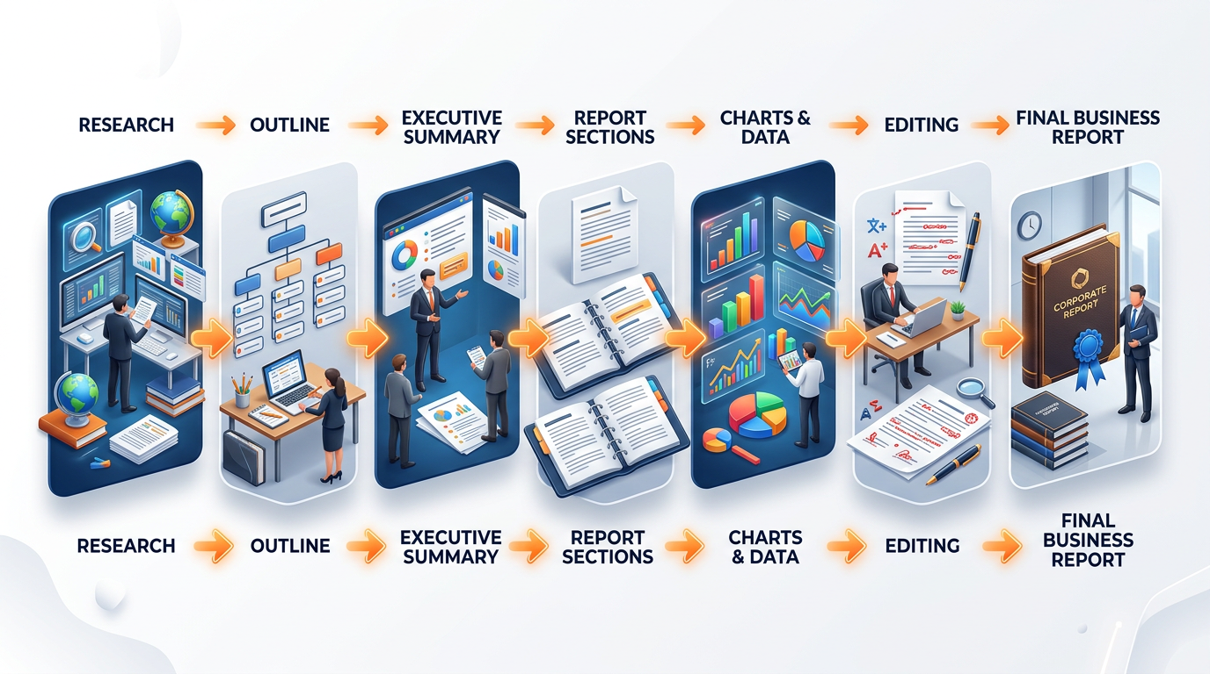

Phase 1: Structure First
Before writing a single word of content, generate the document architecture.
You are a senior business report writer who has produced 200+
professional reports for C-suite and board audiences.

I need to write a [REPORT TYPE] for [AUDIENCE].
Purpose: [WHAT DECISION OR ACTION SHOULD THIS REPORT ENABLE?]
Context: [KEY FACTS AND BACKGROUND]

Generate a complete report outline with:
- Report title (professional, descriptive)
- Recommended sections in logical order
- For each section: purpose (1 sentence), recommended length,
key content points (3 bullets)
- Overall recommended length
- Format recommendations (tables, charts, appendices suggested)

Report type: [e.g., Market Entry Analysis / Performance Review /
Feasibility Study]
Audience: [e.g., Board of Directors / Department Head / External
Client]
Subject: [DESCRIBE]

Phase 2: Executive Summary First
Always write the executive summary after the body — but position it first. Use AI to produce a tight, compelling executive summary.
Write an executive summary for the following report.

The executive summary must:
- Stand alone — a reader who reads ONLY this should understand
the situation, key findings, and recommended action
- Follow this structure:
LINE 1: The single most important finding or recommendation
(bold)
PARAGRAPH 1: Context — why this report was needed, what was
examined (2–3 sentences)
PARAGRAPH 2: Key findings — 3 numbered findings, most important
first
PARAGRAPH 3: Recommendation — 1–2 specific recommended actions
with rationale

Length: 200–250 words maximum.
Tone: Executive — authoritative, evidence-referenced, no padding.
Tense: Present tense throughout.

Report body: [Paste full report or detailed notes]

Phase 3: Section-by-Section Drafting
For long reports, draft section by section giving AI the context from completed sections.
Market Analysis Section Prompt:
You are writing the Market Analysis section of a business report.

Context from sections already written:
- Executive Summary: [paste]
- Background section: [paste]

Write the Market Analysis section covering:
1. Market size and growth (use placeholder [X] for figures to be
verified)
2. Key market segments and their relative size
3. Growth drivers (3–4 factors)
4. Key challenges and headwinds (2–3 factors)
5. Regulatory and compliance considerations
6. Our position in this market

Format: Use H3 subheadings for each subsection. Body text as
flowing paragraphs.
Include a summary table at the end: Factor | Assessment |
Implication for us

Length: 400–500 words.
Tone: Professional report style — factual, evidence-referenced,
objective.
Flag all market figures with [VERIFY: suggest source type].

Phase 4: Document Polish
After all sections are drafted, use AI to polish the complete document.


Consistency check:
Review the following report for:
1. Tense consistency (all present tense? all past tense?)
2. Terminology consistency (are key terms used the same way
throughout?)
3. Format consistency (headings, bullet points, number formatting)
4. Tone consistency (does any section sound noticeably different
from the others?)

For each inconsistency found: state the issue, where it occurs,
and the correction.

Report: [paste full document]

Clarity and concision edit:
Edit the following report for clarity and concision.

Rules:
- Remove all filler phrases ('it is important to note that', 'as
mentioned above')
- Convert passive voice to active voice where possible
- Replace any word that could be replaced with a shorter, clearer
word
- Flag any paragraph over 80 words that could be split
- Do not change the substance — only the expression

Track changes format: show [ORIGINAL → REVISED] for each change.

Report: [paste]

12.3 Business Proposals — Complete Framework
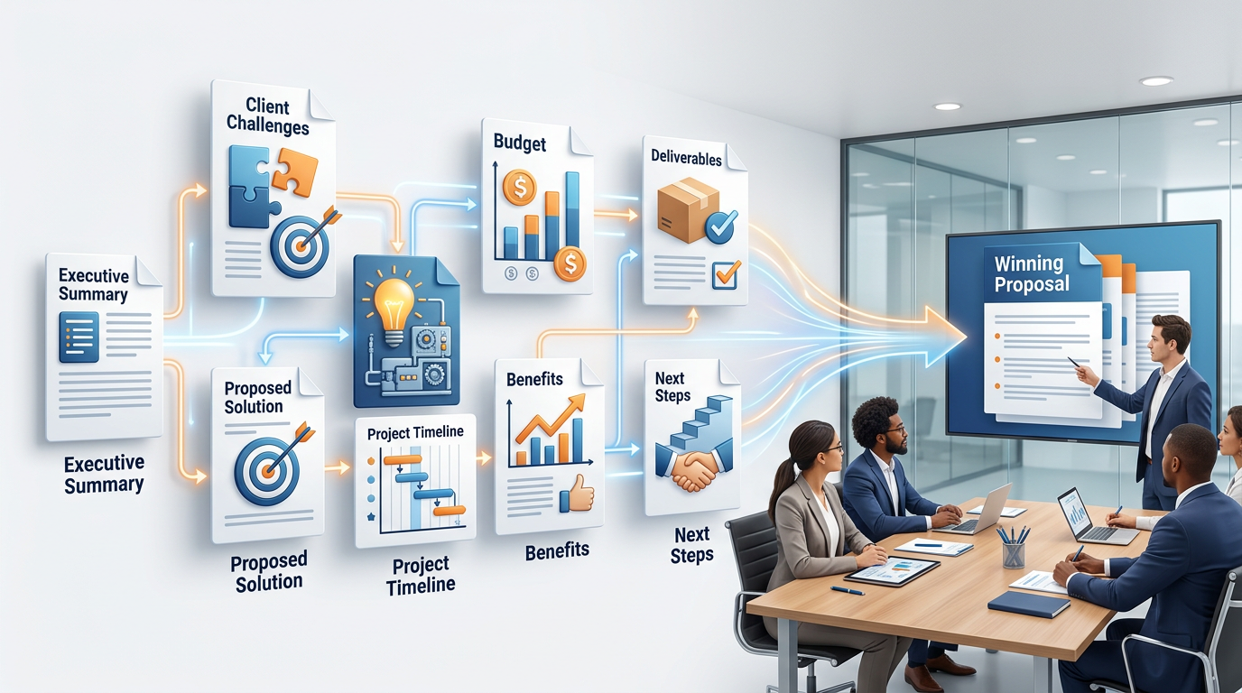

Proposal Structure Prompt
You are an experienced proposal writer who has won $50M+ in
contracts. You write proposals that win because they focus
entirely on the client's problem and outcomes — not on the
vendor's capabilities.

I need to write a business proposal for:
Client: [CLIENT NAME AND TYPE]
Our company: [YOUR COMPANY AND WHAT YOU DO]
Project: [WHAT WE WILL DELIVER]
Client's key pain point: [THE PROBLEM THEY NEED SOLVED]
Our differentiator: [WHY WE, NOT COMPETITORS]
Budget range: [IF KNOWN]

Create a complete proposal outline with these sections:
1. Cover page details
2. Executive Summary (150 words — focused on their outcome, not
our services)
3. Understanding of the Challenge (demonstrate we understand
their problem deeply)
4. Proposed Solution (what we will do, not how we do it)
5. Methodology / Approach (how we will do it)
6. Deliverables and Timeline (table format)
7. Investment (pricing — frame as investment, not cost)
8. Our Team (relevant experience only)
9. Why Us (3 differentiators with proof)
10. Next Steps (specific, low-friction)

For each section: purpose + key content points + recommended
length.

Proposal Executive Summary (Win-Focused)
Write the executive summary of this business proposal.

The rule of proposals: The executive summary is written for the
decision-maker who will not read the full proposal. It must
answer:
- Do they understand our problem? (demonstrate deep empathy with
their challenge)
- Can they solve it? (show capability through outcomes, not
activities)
- Is the investment justified? (ROI logic in 1–2 sentences)
- What happens next? (one clear call to action)

Format: 4 paragraphs matching the 4 questions above.
Tone: Client-focused — "you/your" language throughout. No "we
are proud to present."
Length: 200 words maximum.

Our proposal context:
Client problem: [DESCRIBE]
Our proposed solution: [DESCRIBE]
Key deliverables: [LIST]
Expected outcome: [MEASURABLE RESULT]
Investment: [AMOUNT]
Timeline: [DURATION]

Proposal Differentiator Section
Write the "Why Choose Us" section of our proposal.

We have these real differentiators:
[LIST YOUR GENUINE DIFFERENTIATORS — be specific and honest]

Transform each differentiator into a client-benefit statement
that:
- States the differentiator (bold header)
- Explains the client benefit (not what we have, but what it
means for them)
- Supports with a specific proof point (case study reference,
metric, or credential)
- Addresses the implicit objection this differentiator answers

Format: 3 differentiators, each as a headed subsection (approx.
80 words each).
Tone: Confident but not boastful — evidence-led, not
self-congratulatory.

12.4 Document Transformation — Converting Between Types
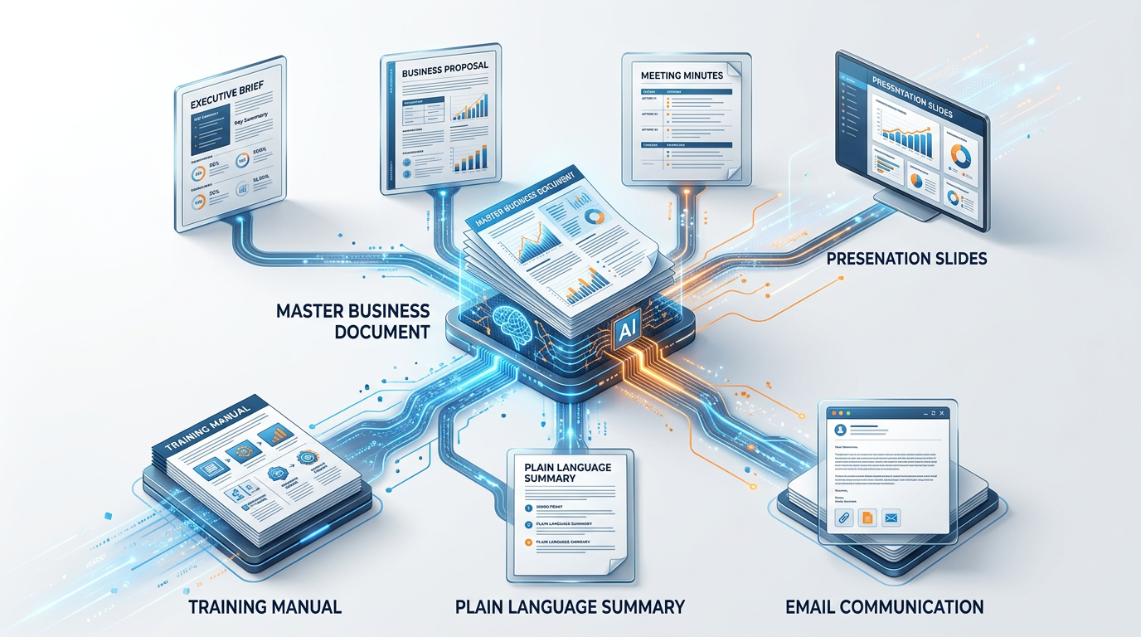
One of AI's most powerful writing uses is converting documents from one type to another.
Report to Executive Brief
An executive brief is NOT a summary, it is a standalone decision document.
EXECUTIVE BRIEF STRUCTURE
SUBJECT: [Report title as decision question]
DATE: [date] | PREPARED BY: [author]
SITUATION: [2 sentences — what is happening]
KEY FINDINGS: [3 bullet points — most important]
OPTIONS CONSIDERED: [2–3 options with trade-offs]
RECOMMENDATION: [1 sentence — clear and specific]
REQUESTED ACTION: [What decision-maker must do]
DECISION NEEDED BY: [Date]
Prompt: “Convert the following full report into a 1 page executive brief” using the structure above. Full report: [paste]

Meeting Notes to Formal Minutes
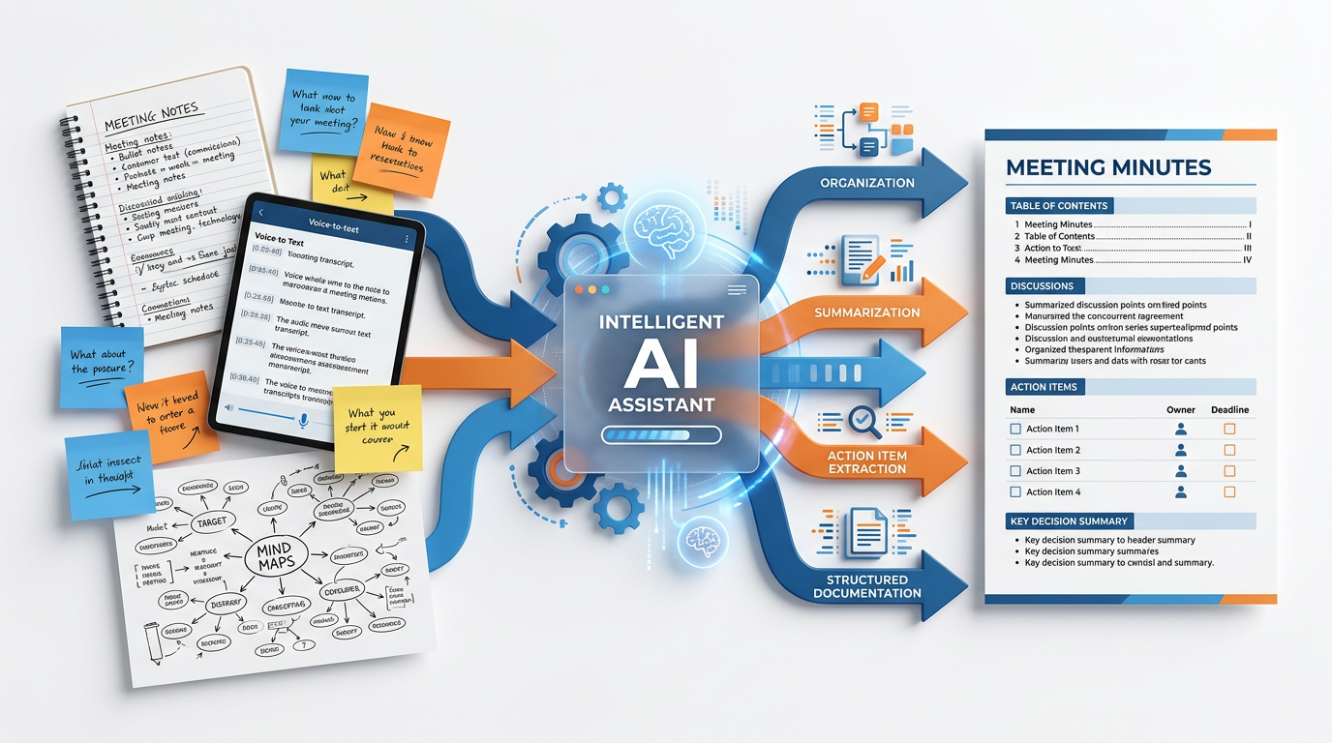

Convert the following raw meeting notes into formal meeting
minutes.

Minutes format:
MEETING MINUTES
[Meeting Name] | [Date] | [Time] | [Location/Platform]
Attendees: [list] Absent: [list]
Chairperson: [name] Minutes prepared by: [name]

1. CALL TO ORDER
2. APPROVAL OF PREVIOUS MINUTES (if applicable)
3. AGENDA ITEMS DISCUSSED
[For each item: discussion summary, decisions made, votes if
any]
4. ACTION ITEMS
[Table: Item | Owner | Deadline | Status]
5. NEXT MEETING: [Date, time, location]
6. ADJOURNMENT

Rules:
- Use past tense throughout
- Report discussions, not verbatim quotes
- Actions must be specific: verb + deliverable + owner + date
- Mark unresolved items as DEFERRED with reason

Raw notes: [paste]

Technical Document to Plain Language
Rewrite the following technical document for a non-technical
audience.

Target audience: [describe — business managers / general public /
frontline staff]
Their background: [what they know and don't know]
Their goal: [what they need to be able to DO after reading this]

Rewriting rules:
- Replace every technical term with a plain English equivalent
(format: "Technical term (what this means in plain English)")
- Use active voice
- Use short sentences (under 20 words each)
- Use the "you" form — address the reader directly
- Replace abstract concepts with everyday analogies
- Add a "What this means for you" summary at the end

Technical document: [paste]

12.5 Writing Quality Improvement — Editing Prompts

The Full Editing Suite:
Stage 1 — Structural Edit
Review the structure of this document.
Does the argument flow logically from beginning to end?
Are there sections that should be reordered?
Is anything critical missing? Is anything included that doesn't
belong?
Give me a brief structural critique and a recommended revised
order.
Document: [paste]

Stage 2 — Paragraph-Level Edit
For each paragraph in this document, provide:
- A one-word label for the paragraph's purpose
- A score for clarity (1–5)
- The single most important improvement for paragraphs scoring
below 4
Document: [paste]

Stage 3 — Sentence-Level Polish
Edit this document at the sentence level.
Apply these rules:
1. No sentence over 25 words — break into two if needed
2. Active voice throughout
3. No adverbs that weaken verbs ('very important' → 'critical')
4. Remove throat-clearing openers ('The purpose of this section
is to...')
5. Remove redundant pairs ('each and every', 'first and foremost')
Show changes in [ORIGINAL → REVISED] format.
Document: [paste]

Stage 4 — Final Proofread
Proofread this document for:
- Grammatical errors
- Punctuation errors
- Inconsistent capitalization
- Number formatting inconsistencies (e.g., '3' vs 'three' in the
same context)
- Any word that appears to be used incorrectly (not just spelled
wrong)
List each issue as: LOCATION (approximate) | ISSUE TYPE | ORIGINAL
| CORRECTED
Document: [paste]

12.6 Maintaining Your Voice with AI

The most common professional concern about AI writing: “Will it sound like me?”
Technique 1: Voice Sample Training
Here are 3 examples of my professional writing style:
SAMPLE 1: [Paste a paragraph you've written]
SAMPLE 2: [Paste another paragraph]
SAMPLE 3: [Paste another paragraph]

Analyze my writing style and identify:
- My average sentence length
- My vocabulary level and preferred word choices
- My structural patterns (how I open paragraphs, how I close)
- My tone characteristics (formal/conversational? hedged/direct?)
- Any distinctive phrases or patterns

Then write the following in MY style:
[Your writing task]

Technique 2: AI Draft + Human Voice Layer
- Generate the AI draft using your structured prompt
- Read it aloud — identify sentences that “don't sound like you”
- Rewrite only those sentences in your own voice
- Use AI to check if the edited version flows naturally
I've edited sections of this AI-generated draft to match my
voice. Check that the document now reads as a consistent whole —
identify any jarring transitions between my edits and the
surrounding AI text.
Edited document: [paste]

Technique 3: Content-First, Words-Second
You provide all the ideas, examples, and key points in bullet form. AI only handles the prose:
Convert my bullet-point notes into polished professional prose.
Keep ALL my ideas, examples, and specific details.
Only change: sentence structure, transitions, and flow.
Do NOT add information I haven't provided — only rephrase what's
here.

My notes:
- [Paste your bullet points]

Hands-On Activities — Session 12
Activity 12.1 — Report Section Writing
Objective: Practice phased report writing with AI.
Task: Write a 3-section mini-report on: “The case for implementing an AI writing tool in our department.”
- Generate the structure using the structure prompt
- Write the Executive Summary using the executive summary prompt
- Write one body section (Problem Statement or Proposed Solution) using the section drafting approach

Deliverable
📄 A 500-word mini-report with 3 sections. Then run the polish prompts and document what changed.

Activity 12.2 — Document Transformation
Objective: Practice converting documents between types.
- Find a news article or business blog post (~500 words)
- Convert it to an executive brief using the Report to Executive Brief prompt
- Convert the same original article to formal meeting minutes (imagine it represents notes from a strategic discussion about the topic)
Reflection: How did the AI transform the content? What had to change structurally between the original format and each output format?

Activity 12.3 — Voice Matching Exercise
Objective: Maintain your professional voice while using AI.
- Write 3 short paragraphs (50–80 words each) on any professional topic in your natural writing style
- Run the Voice Sample Training prompt with your samples
- Ask AI to write 2 new paragraphs on a different topic in YOUR style
Compare the AI's attempt to your real writing — what did it capture well? What felt off? How would you refine the style specification prompt?

Activity 12.4 — Full Editing Suite Practice
Objective: Apply all 4 stages of the editing suite.
- Take a real document you have written (email, report, project brief — any professional document)
- Run all 4 editing stages: structural → paragraph → sentence → proofread
- Make the changes. Count how many edits were made across all stages
Reflection: Which editing stage produced the most improvements? Which stage did you feel most confident doing without AI?

Revision Questions — Session 12
- What is the recommended human AI writing model and why does it keep your professional judgment at the center?
- Why should you write the executive summary last, even though it appears first in a document?
- What is the key difference between a summary and an executive brief?
- In proposal writing, why should the executive summary focus on the client's outcome rather than your company's capabilities?
- Describe the 4 stage AI editing suite. What does each stage address?
- Name 3 techniques for maintaining your own professional voice when using AI for writing.
- A colleague says “I just ask ChatGPT to write the full report and submit it.” What risks does this approach create?
- Describe how you would use AI to convert a 3,000-word technical feasibility study into a 1 page executive brief without losing critical information.

Key Takeaways — Session 12
✓ Best model: Your thinking → AI drafts → You edit → AI refines
✓ Always generate structure first — then fill sections
✓ Executive summaries: standalone decision documents (not summaries) — focus on situation, findings, recommendation, action
✓ Proposal writing: client-focused language throughout — “you/your” not “we/our” — outcomes not activities
✓ Document transformation is one of AI's highest-value uses: report → brief → minutes → plain language → slides
✓ 4-stage editing: structural → paragraph → sentence → proofread
✓ Maintain your voice: use content-first approach — give AI your ideas in bullets, let it handle only the prose structure

Session 12 Complete → Proceed to Session 13: AI for Presentations
Prompt Engineering Certification Program | UpSkill Global Education Technologies Inc., Canada

