
PROMPT ENGINEERING CERTIFICATION PROGRAM
MODULE 3 — ACADEMIC & PROFESSIONAL APPLICATIONS

SESSION 14
AI for Email & Professional Communication

MODULE  3 of 6 | SESSION  14 of 30
DURATION  60–90 minutes | FORMAT  Self-paced + Activities
UpSkill Global Education Technologies Inc. Canada

SESSION OVERVIEW

Learning Objectives
By the end of this session, you will be able to:
- Use AI to draft, edit, and improve professional emails across all common scenarios
- Apply tone, audience, and purpose calibration to every email type
- Handle difficult communication scenarios (complaints, refusals, apologies, escalations) with AI
- Build an email template library covering your most frequent communication needs
- Use AI to analyze and improve your existing email drafts
- Apply professional email etiquette standards through targeted prompting

14.1 Why Email Remains the Most Important Professional Skill
Despite the rise of messaging apps and collaboration tools, email remains the primary formal channel for:
- External client and vendor communication
- Legal and compliance-relevant correspondence
- Cross-organizational communication
- Documentation of decisions and agreements
- Professional relationship management

Poor email communication has measurable career and business consequences:
- Misunderstandings that cost time and client relationships
- Emails that fail to get responses or actions
- Tone that damages professional reputation
- Ambiguous requests that create confusion

The Opportunity
⚡ AI transforms email from a time-consuming, stressful task into a rapid, precise, professional exercise — when used with the right prompting approach.

14.2 The Professional Email Formula
Every effective professional email answers these questions:
- WHY am I writing? (Purpose stated in the first sentence)
- WHAT do I need? (The ask clear and specific)
- WHY should you care? (Context that motivates the reader)
- WHAT happens next? (Next step one specific action with a deadline if applicable)
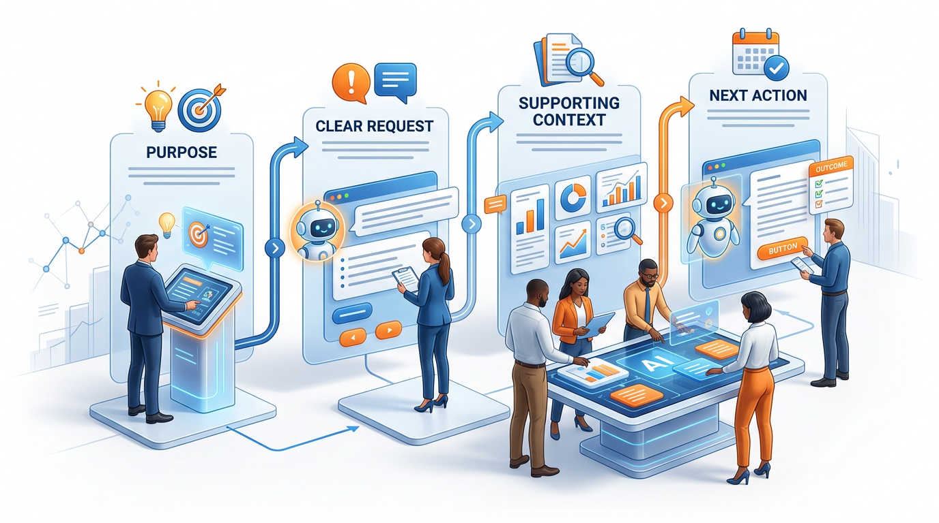

The Core Email Prompt Template
You are a professional business communicator who writes clear,
purposeful emails.

CONTEXT:
- Sender: [Your role, company]
- Recipient: [Their role, company, your relationship with them]
- Situation: [2-sentence description of the background]
- Previous interaction: [Any relevant history]

EMAIL PURPOSE: [Request / Follow-up / Apology / Complaint /
Announcement / Proposal / Rejection / Confirmation / Introduction]
KEY MESSAGE: [The one thing this email must communicate]
DESIRED ACTION: [What should the recipient do after reading this?]
DEADLINE (if any): [When does the action need to happen?]

FORMAT:
- Subject line: [Action-oriented, max 8 words]
- Greeting: [Formal/semi-formal/informal — match relationship]
- Structure: [Specify: 2–3 short paragraphs / bullet points / etc.]
- Closing: [Formal/professional/warm]
- Length: [Under X words]

TONE: [Formal / Professional / Conversational / Empathetic /
Urgent / etc.]

CONSTRAINTS:
- [e.g., Do not sound apologetic — be direct and confident]
- [e.g., The recipient is time-poor — get to the point in
sentence 1]
- [e.g., We have an existing relationship — warm but professional]

14.3 Email Types — Complete Prompt Library
Type 1: Request Email
Write a professional email requesting [WHAT YOU NEED].

Context: I am [ROLE] at [COMPANY]. I am writing to [RECIPIENT
ROLE] at [THEIR COMPANY].
Our relationship: [First contact / Existing client / Vendor /
Colleague etc.]

Request specifics:
- What I need: [Be precise — what exactly are you asking for?]
- Why I need it: [Brief justification]
- By when: [Deadline]
- What I'm offering in return (if applicable): [Any reciprocity]

Format: Subject line + 3 sentences maximum (situation → ask →
next step)
Tone: [Professional / direct / collegial]
Constraint: Do not over-explain. One clear ask. One clear next
step.

Example output for a meeting request:


Subject: 20-Minute Call to Discuss Q4 Partnership Opportunity

Hi [Name],

Following our conversation at the CX Summit last month, I believe
there's a strong fit between [My Company]'s customer intelligence
platform and [Their Company]'s growth plans for Q4.

I'd like to schedule a 20-minute discovery call to explore
whether a partnership makes sense for both teams.

Would [Date Option 1] at [Time] or [Date Option 2] at [Time]
work for you? I've also shared a 2-page overview at [link] in
case you'd like context beforehand.

Best,
[Name]

Type 2: Follow-Up Email

Write a follow-up email for a [situation] where I have not
received a response.

Original communication: [What you asked / proposed / submitted
and when]
Follow-up #: [1st / 2nd / 3rd follow-up]

Tone calibration:
- 1st follow-up: Warm, assumes they're busy — no pressure
- 2nd follow-up: Direct, creates mild urgency
- 3rd follow-up: Professional, provides a graceful exit

Context: [Describe relationship and stakes]
Desired action: [What you still need from them]
Deadline (if any): [Any real deadline to reference]

Constraints:
- Do not sound passive-aggressive
- Do not repeat everything from the original email
- Keep it under 80 words
- Include an easy response path (yes/no question if possible)

Follow-up sequence example:


1ST FOLLOW-UP (3–5 days after):
Subject: Re: [Original Subject] — Quick Check-In
"Hi [Name], just circling back on my note from [Date]. Happy to
provide any additional information that would be helpful. Would
[specific date] work for a brief call? [Your name]"

2ND FOLLOW-UP (1 week after):
Subject: Re: [Original Subject] — Still Relevant?
"Hi [Name], following up one more time on this. [Brief restate
of value]. If timing isn't right, I completely understand —
just let me know and I'll reach back out next quarter.
[Your name]"

3RD FOLLOW-UP (2 weeks after):
Subject: Re: [Original Subject] — Closing the Loop
"Hi [Name], I'll take your silence as a 'not right now' — no
problem at all. I'll reach back out in [timeframe] if that's
okay. Wishing you a good [season/quarter]. [Your name]"

Type 3: Apology Email


Write a professional apology email for: [WHAT WENT WRONG].

Context:
- What happened: [Describe the mistake/issue clearly]
- Impact on recipient: [What was the effect on them?]
- Our fault level: [Fully our fault / Partially ours /
Third-party issue but we're responsible]
- What we've done to fix it: [Actions already taken]
- What we're doing to prevent recurrence: [Process change or
commitment]

Apology structure (mandatory):
1. Direct acknowledgment (no "if you feel" language — own it)
2. Impact acknowledgment (show you understand what it cost them)
3. Explanation (brief — NOT excuse)
4. What we did to fix it
5. What we're doing to prevent it
6. Specific offer / next step

Tone: Genuinely accountable, not defensive, not over-apologetic

Constraints:
- Do NOT use: "We apologize for any inconvenience"
- Do NOT use: "If this caused any confusion"
- Do NOT use passive voice ("mistakes were made")
- Use active ownership: "We made an error..." "I failed to..."

Length: Under 200 words

Type 4: Bad News / Rejection Email
Write a professional email delivering bad news or a rejection.

Situation: [Describe what you're declining or what bad news
you're delivering]
Recipient: [Describe relationship and stakes]
Reason (if shareable): [Can you explain why? Should you?]
Alternative or next step (if any): [Any constructive path
forward?]

Bad news email principles:
1. Deliver the news early (don't make them read 3 paragraphs to
find out)
2. Be clear — no ambiguous language that gives false hope
3. Be brief — do not over-explain or justify excessively
4. Be kind — declining is not a character judgment
5. Offer something forward-looking if you genuinely can

Constraint: Do NOT use the phrase "We have decided to move
forward with other candidates" without offering something
genuine.

Tone: [Direct and kind / Formal and brief / Warm but clear]
Length: Under 150 words

Type 5: Complaint / Escalation Email


Write a professional complaint or escalation email.

Situation:
- What went wrong: [Describe clearly and factually]
- When it happened: [Timeline]
- What impact it had: [Business / financial / operational impact]
- Previous attempts to resolve: [What I've already tried]
- Who I'm escalating to: [Their role — senior person at the
company]

Complaint email rules:
1. Factual, not emotional — describe what happened, not how
angry you are
2. Specific — dates, amounts, names, reference numbers where
possible
3. Clear ask — what resolution do you want? State it explicitly
4. Professional stakes — note impact without threatening
5. Deadline — by when do you need a response?

Format: Subject (states the issue, not "complaint") | 4
paragraphs: situation → impact → attempts to resolve → specific
request with deadline

Tone: Firm, professional, factual — not aggressive or emotional
Length: Under 250 words

Type 6: Introduction Email
Write a professional introduction email: [SELF-INTRODUCTION /
INTRODUCING SOMEONE ELSE]

Context:
- Who is being introduced: [Name, role, background]
- Being introduced to: [Who — name, role, company]
- Purpose of introduction: [Why should these two people connect?]
- The connection/context: [How do you know both parties?]
- Warm intro or cold intro: [Do both parties know of each other?]

For a double-opt-in introduction:
"Step 1: Ask both parties before connecting them"

Prompt: "Write a brief email to [Person A] asking if they're
open to an introduction to [Person B]. Explain who Person B is
and why I think they'd benefit from connecting. Under 100 words."

For the actual introduction email:
Structure: 1 sentence each person → reason for connection → hand it over. Constraint: Under 150 words. Get out of the way let them take it from here.

Type 7: Difficult Conversation Email


Write an email addressing a sensitive workplace situation.

Situation: [Describe the issue — performance, conflict,
expectation gap, etc.]
Recipient: [Their role, your relationship — peer, direct report,
manager]
My goal: [Resolve the issue / Set expectations / Request
behavior change]
Desired outcome: [What should be different after this exchange?]

Sensitive email principles:
1. Request a conversation — don't resolve complex interpersonal
issues by email
2. Keep the email's role: to set up the conversation, not to be
the conversation
3. Be factual — describe behavior/situation, not
personality/character
4. Use non-accusatory language: "I noticed..." "I wanted to
discuss..." not "You always..."
5. Create safety: make it easy for the other person to respond
without defensiveness

Format: 3–4 sentences: acknowledgment of the situation → your
intention → specific request (for a call or meeting) → positive
framing

Tone: Non-confrontational, professional, direct but kind

14.4 Email Editing — Improving What You've Already Written
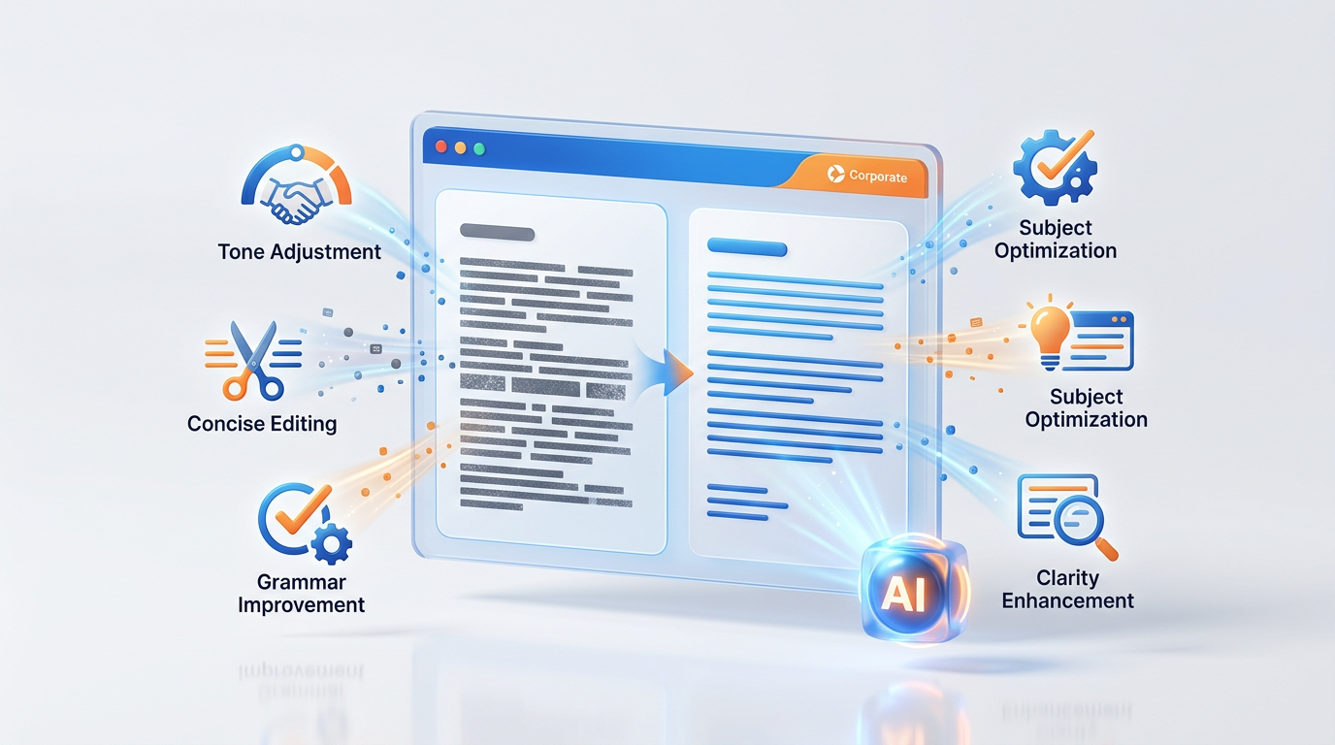

Quick Tone Fix
Edit this email to change the tone from [CURRENT TONE] to
[DESIRED TONE].
Preserve the complete content and all facts. Change only the
tone and expression.

Current email: [paste]

Tone transformation:
From: [e.g., passive-aggressive / overly apologetic / too casual]
To: [e.g., professionally direct / confidently assertive / warm
but professional]

Conciseness Edit
This email is too long. Edit it to under [WORD COUNT] words.

Rules:
- Keep every distinct point of substance
- Cut: throat-clearing, repetition, over-explanation
- Combine sentences where meaning is preserved
- Do not cut the ask or the next step
- Flag [OMITTED: brief description] for anything you must
remove to hit the target

Current email ([WORD COUNT] words): [paste]

Subject Line Optimization
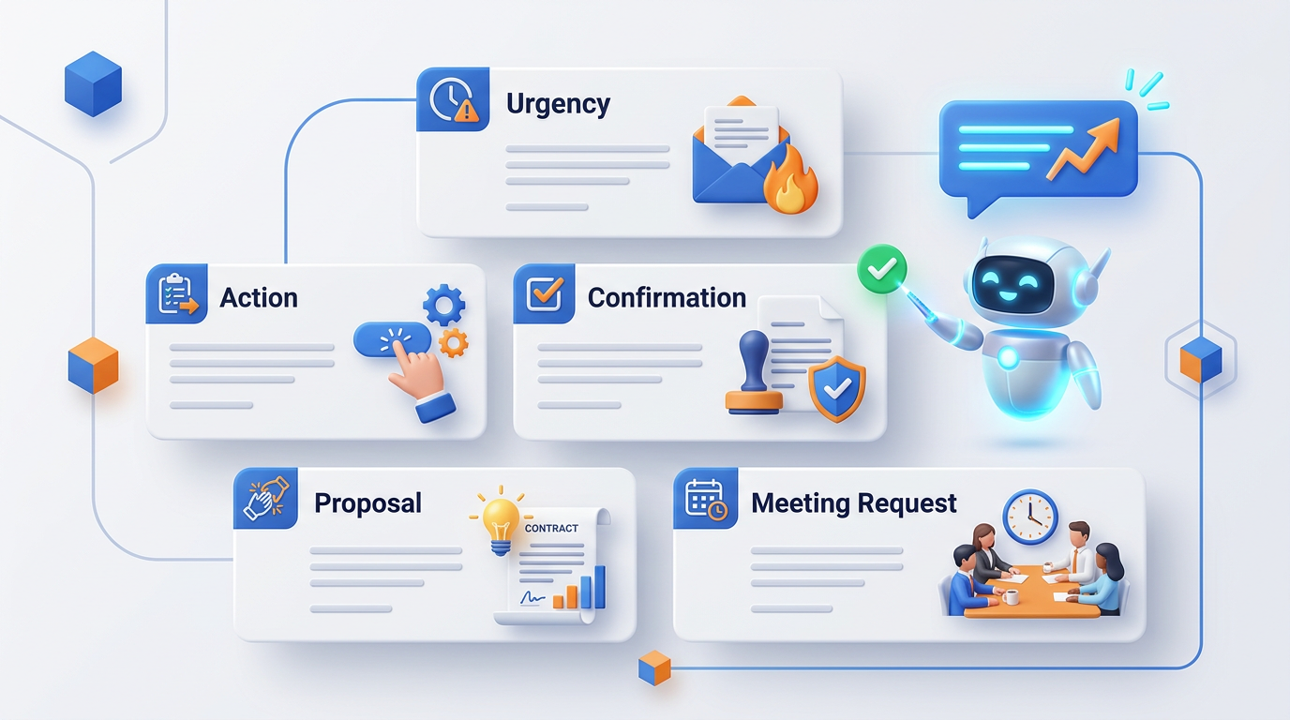

My current subject line is: [CURRENT SUBJECT]
This email is about: [1-sentence description]
The recipient is: [DESCRIBE — cold contact / existing
relationship / senior leader]
The desired action: [What do I want them to do?]

Generate 5 alternative subject lines that:
- Are under 50 characters (mobile-friendly)
- Are specific, not generic
- Create the right level of urgency (not clickbait, not boring)
- Match the email's tone

Label each: [Direct] [Curiosity] [Benefit-led] [Action-oriented]
[Relationship]

Email Critique Prompt
Critique this email as a professional communication coach.

Evaluate on:
1. Subject line (compelling? specific? right length?)
2. First sentence (does it immediately answer 'why am I
reading this'?)
3. Clarity of ask (is it 100% clear what I need and by when?)
4. Tone appropriateness for the relationship and purpose
5. Length (too long? too short?)
6. Closing and next step (clear? specific?)

For each criterion: score (1–5) and specific improvement
suggestion.
Then rewrite the weakest element.

Email: [paste]

14.5 Email Communication Standards
Subject Line Principles
EFFECTIVE SUBJECT LINE FORMULA
[Action/Status] + [Specific Topic] + [Timeframe if urgent]
Examples:
- “Review Needed: Q3 Marketing Budget Due Friday”
- “Introduction: Priya Sharma / Rahul Mehta EdTech Partnership”
- “Meeting Confirmed: Wednesday 2PM Project Phoenix Kickoff”
- “Proposal Attached: Customer Support AI Solution for Wipro”
- “Quick Question: Timeline for Phase 2 Delivery”
Avoid:
- “Hi” no context
- “FYI” what do they do with this?
- “Important” overused and vague
- “Following up” from what? about what?
- “Check this out” too casual for professional use

Professional Email Length Guide
Email Type | Appropriate Length | Justification
Quick request / confirmation | 3–5 sentences | Reader is busy; respect their time
Meeting agenda | 5–8 sentences | Context needed, but not a document
Project status update | 150–250 words | Regular, structured format
Proposal / recommendation | 300–500 words | Requires context and argument
Formal complaint | 200–300 words | Facts need stating; don't ramble
Response to complaint | 150–250 words | Resolve it; don't over-explain

The 500-Word Rule
⚡ If you need more than 500 words in an email, the information should be in an attachment and the email becomes a 3 sentence cover note.

14.6 Building Your Email Template Library
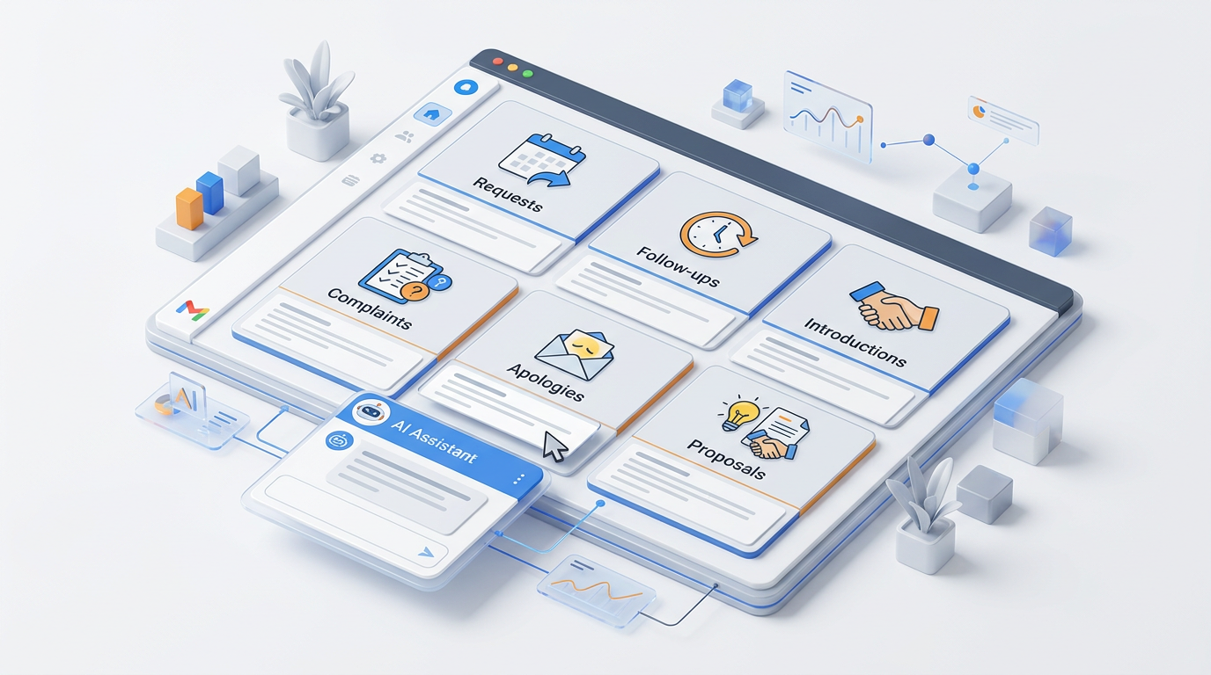

Template Library Structure
For each template entry:
EMAIL-ID: [e.g., EMAIL-R001 = Request type 001]
TYPE: [Request / Follow-up / Apology / etc.]
USE CASE: [Specific scenario this is designed for]
RELATIONSHIP: [Internal / External | Formal / Semi-formal /
Informal]

WHEN TO USE:
[2-sentence description of the exact situation]

VARIABLES (replace before sending):
[RECIPIENT_NAME] — recipient's first name
[COMPANY_NAME] — their company
[SPECIFIC_ASK] — exact thing you're requesting
[DEADLINE] — date by which action is needed
[YOUR_NAME] — your name

SUBJECT LINE OPTIONS:
Option A (direct): [Subject line]
Option B (benefit-led): [Subject line]

EMAIL TEMPLATE:
[COMPLETE EMAIL TEXT WITH VARIABLES IN BRACKETS]

TONE NOTES:
[Any specific notes on how to customize tone]

SUCCESS METRIC:
[How do you know this email worked? e.g., 'response within
48 hours']

Hands-On Activities — Session 14
Activity 14.1 — The Email Transformation Challenge
Objective: Transform weak emails into professional communication.
Rewrite each of the following emails using the appropriate prompt template:

Email 1 — Too aggressive:
Original
“I CANNOT BELIEVE you haven't responded to my last 3 emails. This is completely unprofessional. I need the report by EOD or I'm going to have to escalate this to your manager. This is not okay.”
Transform to: Professional escalation email.

Email 2 — Too long / no clear ask:
Original
“Hi, I hope you're doing well! I've been meaning to reach out for a while now. We met at the conference in February and had a really great chat. I was thinking about what you said and it really resonated with me. I've been working on some things that might be relevant to you. I was wondering if maybe at some point, if you have the time, we might be able to connect sometime for a call to catch up and maybe explore some potential areas of mutual interest and collaboration between our teams?”
Transform to: Clear, concise meeting request (under 100 words).

Email 3 — No ownership in apology:
Original
“Hi, we wanted to reach out regarding the delivery issue. We are sorry if this caused any inconvenience. The situation was due to circumstances beyond our control. Hopefully this won't happen again.”
Transform to: Genuine, accountable apology email.

Activity 14.2 — Build Your Personal Email Template Library
Objective: Create 5 reusable email templates for your most common communication scenarios.
- List the 5 emails you write most often at work
- For each, use the Core Email Prompt Template (Section 14.2) to generate a professional version
- Add variable placeholders ([NAME], [DATE], [SPECIFIC DETAIL], etc.) so each template is genuinely reusable
- Test each template with a real scenario. Refine once

Deliverable
📄 5 complete, tested, reusable email templates in the library format from Section 14.6.

Activity 14.3 — Subject Line Optimization Workshop
Objective: Master subject line writing.
- Collect 5 subject lines from your own sent emails from the past month
- Run the Subject Line Optimization prompt for each
- Compare your original subject lines to the 5 AI alternatives for each
Reflection questions: Were your original subject lines specific enough? Did they communicate the desired action? Which AI option would you use and why? What pattern do you notice in the most effective subject lines?

Activity 14.4 — Email Critique Self-Assessment
Objective: Get AI feedback on your real email communication style.
- Choose 3 emails you sent in the last 2 weeks that represent your typical style
- Run the Email Critique Prompt (Section 14.4) on each
- Identify the single most consistent weakness across all 3 critiques
- Build a personal writing rule to address that weakness
Example rules: “Always state the ask in the first paragraph” / “Use subject lines with action verbs” / “Never exceed 150 words for internal updates”

Revision Questions — Session 14
- What are the 4 questions every professional email should answer?
- Describe the structure of an accountable apology email. What language should always be avoided?
- What is the double-opt-in introduction and why is it a professional best practice?
- A follow-up email sequence has 3 different tones for 1st, 2nd, and 3rd follow-up. Describe each.
- What is the professional email length rule for content that exceeds 500 words?
- Describe 5 elements of an effective subject line and give an example of each.
- You need to decline a vendor proposal you received. Write the complete CRAFT prompt you would use to generate this email.
- A colleague's emails are frequently misunderstood and receive low response rates. What are the 3 most likely causes and what would you recommend?

Key Takeaways — Session 14
✓ Every email answers 4 questions: Why am I writing? What do I need? Why should you care? What happens next?
✓ Subject line = your email's most important sentence Formula: [Action/Status] + [Specific Topic] + [Timeframe]
✓ 7 email types, each with distinct structure: Request | Follow up | Apology | Bad news | Complaint | Introduction | Difficult conversation
✓ Apology emails: direct ownership, no “if you feel” language, explain what you did to fix and prevent it
✓ 500-word rule: longer than 500 words → use an attachment. Email becomes a 3 sentence cover note
✓ Build a template library: 5 core templates saves hours weekly

Session 14 Complete → Proceed to Session 15: Building Your AI Productivity System
Prompt Engineering Certification Program | UpSkill Global Education Technologies Inc., Canada

