
PROMPT ENGINEERING CERTIFICATION PROGRAM
MODULE 3 — ACADEMIC & PROFESSIONAL APPLICATIONS

SESSION 15
Building Your Personal AI Productivity System

MODULE  3 of 6 | SESSION  15 of 30
DURATION  60–90 minutes | FORMAT  Self-paced + Capstone
UpSkill Global Education Technologies Inc.
Canada

SESSION OVERVIEW

Learning Objectives
By the end of this session, you will be able to:
- Audit your workday to identify the highest-value AI integration points
- Design a personal AI workflow for your specific role and responsibilities
- Build a structured daily/weekly AI routine
- Integrate your prompt library into your working process
- Measure the productivity impact of AI adoption in your role
- Create a 30-day AI adoption plan for yourself or your team

15.1 The Productivity System Philosophy

Using AI occasionally for one off tasks is useful. Building a systematic AI productivity practice where AI is woven into your daily professional routine is transformative.
The Difference:
Ad-Hoc AI Use | Systematic AI Productivity
Use AI when stuck | AI is part of every repeating workflow
Start from scratch each time | Reusable templates accelerate every run
No consistent output quality | Consistent quality through tested prompts
Forget which prompts worked | Documented prompt library grows over time
Hard to measure impact | Clear before/after metrics
Tool you use occasionally | System that works while you focus elsewhere

The Goal
🎯 Move from the left column to the right column.

15.2 The AI Productivity Audit

Before building your system, you need to know WHERE AI will add the most value in your specific role.

Workday Audit Prompt
Help me conduct an AI productivity audit for my professional
role.

My role: [JOB TITLE]
Industry: [INDUSTRY]
Organization type: [SIZE AND TYPE]
Key responsibilities: [LIST 5–7 MAIN RESPONSIBILITIES]
Tools I currently use: [List tools — email, CRM, project
management, etc.]

For my role, analyze and create a prioritized matrix of AI
opportunities:
CATEGORY 1 — HIGH VALUE, EASY TO IMPLEMENT (Start here
immediately)
CATEGORY 2 — HIGH VALUE, REQUIRES SETUP (Build next)
CATEGORY 3 — MEDIUM VALUE, EASY TO IMPLEMENT (Add to routine)
CATEGORY 4 — LOW VALUE OR HIGH RISK (Avoid for now)

For each opportunity in Categories 1 and 2, provide:
- Specific task AI can assist with
- Estimated time saved per week (hours)
- Risk level (data privacy, accuracy, stakeholder expectations)
- Recommended AI tool or approach
- Prerequisites before implementing

Present as a table. Total estimated weekly time savings at the
bottom.

The Time-Value Matrix
Run this assessment on your most time-consuming tasks:
For each task below, rate it on:
- Time consumed (hours per week): [high / medium / low]
- Strategic value (importance to your outcomes): [high / medium
/ low]
- AI suitability (how well can AI assist?): [high / medium / low]

Tasks: [List your 10 most time-consuming tasks]

Plot each task into the quadrants:
HIGH VALUE + HIGH AI SUITABILITY = PRIORITIZE FOR AI AUTOMATION
HIGH VALUE + LOW AI SUITABILITY = Keep doing yourself (but AI
can support)
LOW VALUE + HIGH AI SUITABILITY = Automate or delegate to AI
immediately
LOW VALUE + LOW AI SUITABILITY = Eliminate or minimize

Then recommend: which 3 tasks should I automate with AI this
week?

15.3 Designing Your Daily AI Workflow
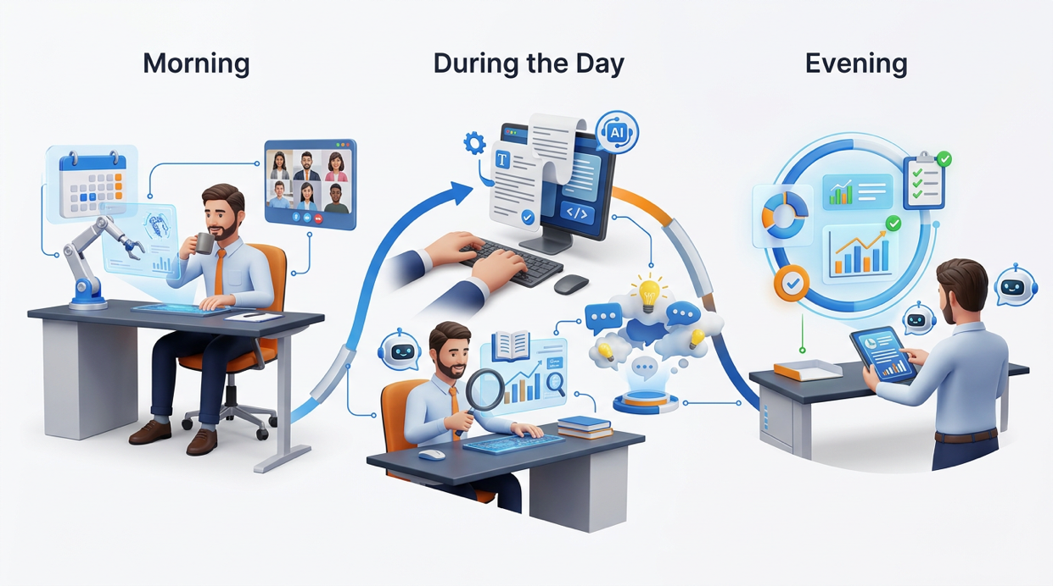
The AI-Enhanced Workday Structure
A well-designed AI productivity system has three integration points each day:
MORNING AI ROUTINE (15–20 minutes)
Daily planning: AI helps prioritize today's tasks
Overnight messages: AI summarizes what needs response
Research brief: AI prepares context for today's meetings

DURING THE DAY — TASK-LEVEL AI ASSISTANCE
Writing: Emails, reports, proposals (using templates)
Analysis: Data interpretation, decision support
Research: Quick context and synthesis for meetings
Brainstorming: Idea generation for problems

EVENING AI ROUTINE (10–15 minutes)
Capture: AI converts notes into action items
Summarize: AI creates tomorrow's priority list
Reflect: AI helps review what was accomplished
Morning Routine Prompts
Daily Priority Planner:
You are my personal productivity coach.

Here are my tasks, meetings, and commitments for today:
MEETINGS: [List meetings with times]
DEADLINES: [Any items due today or tomorrow]
CARRY-FORWARD: [Tasks I didn't finish yesterday]
NEW ITEMS: [Anything that came in overnight]
My energy profile today: [High / Medium / Low — and why]
My most important outcome for today: [1 thing that must happen]

Create my daily priority plan:
1. MITs (Most Important Tasks) — 3 items I MUST complete
2. Schedule recommendation — when to do deep work vs. shallow
tasks
3. What to defer or delegate — tasks that don't need to happen
today
4. Risk flag — anything that could derail today's plan

Present as a simple, actionable daily plan I can follow
immediately.


Pre-Meeting Research Brief:
I have a meeting with [WHO] about [TOPIC] in [TIME FROM NOW].
Context I know: [What you already know about the meeting]
Purpose: [What you need to accomplish in this meeting]

Prepare a 5-minute pre-read brief for me covering:
1. Key background on [TOPIC] I should know
2. The likely agenda / what they'll want to discuss
3. My objective for this meeting and how to achieve it
4. 3 questions I should ask to advance my goals
5. Any risks or sensitivities to be aware of

Keep it to the essentials — I have [X] minutes to prepare.

End-of-Day Routine Prompts
Daily Capture & Forward:
Here are my raw notes and actions from today:
[Paste meeting notes, scribbles, to-do items, anything from
today]

Process these into:
1. COMPLETED TODAY — what was actually finished
2. ACTIONS CREATED — new tasks with suggested deadlines and
owners
3. DECISIONS MADE — any decisions that should be documented
4. TOMORROW'S TOP 3 — most important items for tomorrow
5. INFORMATION TO FILE — anything worth storing (not tasks)
6. WAITING FOR — items that depend on someone else's action

Format cleanly so I can paste this into my project management
tool.

15.4 Building Your AI Workflow by Role
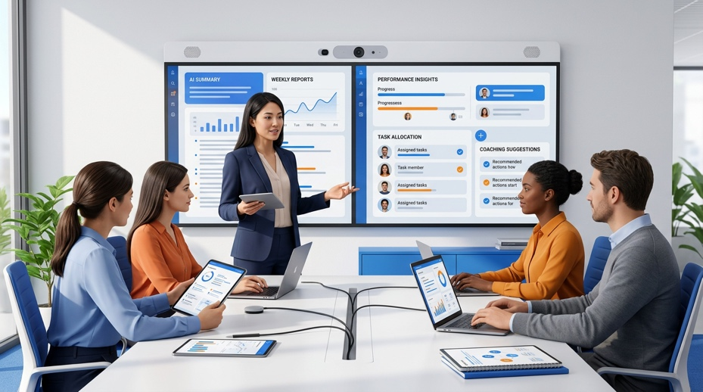
For Managers and Leaders
Weekly Team Brief Generator:
Template: Weekly Manager Briefing
Variable inputs: [TEAM_UPDATES], [BLOCKERS], [WINS],
[FOCUS_NEXT_WEEK]

You are a manager who communicates clearly and keeps your team
motivated.
This week's inputs:
Updates: [PASTE YOUR NOTES]
Blockers: [LIST BLOCKERS]
Wins: [LIST WINS]
Next week focus: [KEY PRIORITIES]

Generate my weekly team briefing email:
- Opening: Acknowledge one specific team win (warm, specific,
not generic)
- Updates: 3–5 bullets (outcome-focused, not activity-focused)
- Blockers: What's stuck and what you're doing about it
- Next week: 2–3 clear priorities with why they matter
- Closing: One sentence — forward-looking and energizing

Under 300 words. Tone: Direct leader who respects team's time.

1:1 Meeting Preparation:
I have a 1:1 meeting with [TEAM MEMBER NAME], [THEIR ROLE].
They have been with us for [DURATION]. Current project:
[PROJECT].
Recent context: [Any recent wins, challenges, or feedback]
My observations this week: [What you've noticed]

Help me prepare for this 1:1:
1. 3 topics to cover (in order of priority)
2. 2 coaching questions to help them think through their
challenges
3. Any feedback I should give — how to frame it constructively
4. Recognition I should offer — specific and genuine
5. One question to close: what does this person need from me
this week?

Format as a 1:1 agenda I can use in the meeting.

For Analysts and Researchers


Data Interpretation Workflow:
I have data from [SOURCE] about [TOPIC].
My audience: [Who will receive this analysis]
Decision this data will inform: [What decision?]
[PASTE DATA, TABLE, OR SUMMARY]

Interpret this data in 4 layers:
1. WHAT — What do the numbers literally show? (1 paragraph,
factual)
2. SO WHAT — What does this mean for our business/situation?
(3 bullets)
3. NOW WHAT — What should we do based on this? (2–3
recommendations)
4. WATCH — What should we monitor going forward? (2
metrics/signals)

Format as an analysis brief. Flag any conclusions that require
additional data validation with [VERIFY NEEDED].

Report Automation Template:
I produce a [WEEKLY/MONTHLY] [REPORT TYPE] for [AUDIENCE].
The data inputs are: [LIST DATA SOURCES AND WHAT THEY CONTAIN]

Help me build a repeatable prompt template that converts my raw
data inputs into a formatted [REPORT TYPE] every [FREQUENCY].

The template should:
1. Accept data input in [FORMAT — table / paste / numbers]
2. Generate all standard sections automatically
3. Highlight variances from the previous period
4. Flag any data points that are outside normal range
5. Generate the executive summary last (after all sections)

Build the complete template prompt with variable placeholders.

For Writers and Content Creators
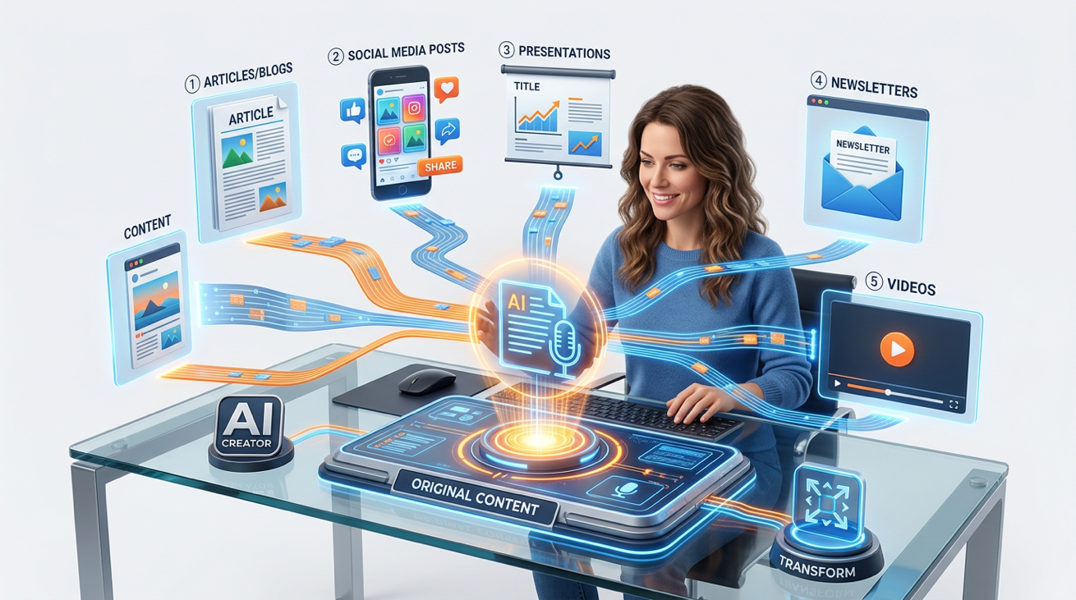

Content Calendar Planning:
I create content for [PLATFORM/AUDIENCE] on the topic of
[NICHE].
My publishing frequency: [X posts per week/month]
Upcoming dates/events relevant to my audience: [LIST]
My best-performing content themes: [LIST IF KNOWN]

Generate a 4-week content calendar:
Format: Week | Date | Platform | Topic | Angle/Hook | Format |
CTA

Principles for this calendar:
- Variety: no two consecutive posts with the same format
- Value: each piece must be immediately useful or engaging
- Brand fit: consistent with my positioning as [DESCRIBE YOUR
POSITIONING]
- Realistic: achievable with [TIME] available per week for
content

Content Repurposing Engine:
I have produced [ORIGINAL CONTENT TYPE — blog post / webinar /
report / video transcript].
I need to repurpose it into [LIST TARGET FORMATS].
Original content: [paste]

For each target format, generate:
1. LINKEDIN POST — 200-word thought leadership post with hook
+ 3 insights + question
2. TWITTER THREAD — 7 tweets, each under 280 characters
3. EMAIL NEWSLETTER SECTION — 150 words with a clear CTA
4. SHORT VIDEO SCRIPT — 60-second script (hook + 3 points + CTA)
5. SLIDE DECK OUTLINE — 5 slides with message headlines

Label each section clearly. Maintain consistent messaging and
key examples across all formats.

For Sales and Business Development
Prospect Research Brief:
I have a sales call with [PROSPECT NAME] at [COMPANY] in
[TIME].
Their role: [TITLE]
Company context I know: [WHAT YOU KNOW]
What our product/service does: [BRIEF DESCRIPTION]
My goal for this call: [FIRST CALL / DEMO / PROPOSAL / CLOSE]

Generate a pre-call research brief:
1. Company snapshot (size, industry, recent news if known)
2. Likely pain points for someone in their role
3. Tailored value propositions — what about our solution is
most relevant TO THEM
4. Personalized opening (reference their context, not a generic
intro)
5. 5 discovery questions for this specific call
6. Objections I'm likely to face and suggested responses
7. Ideal outcome of this call — what does "success" look like?

15.5 Your Prompt Library — System Design
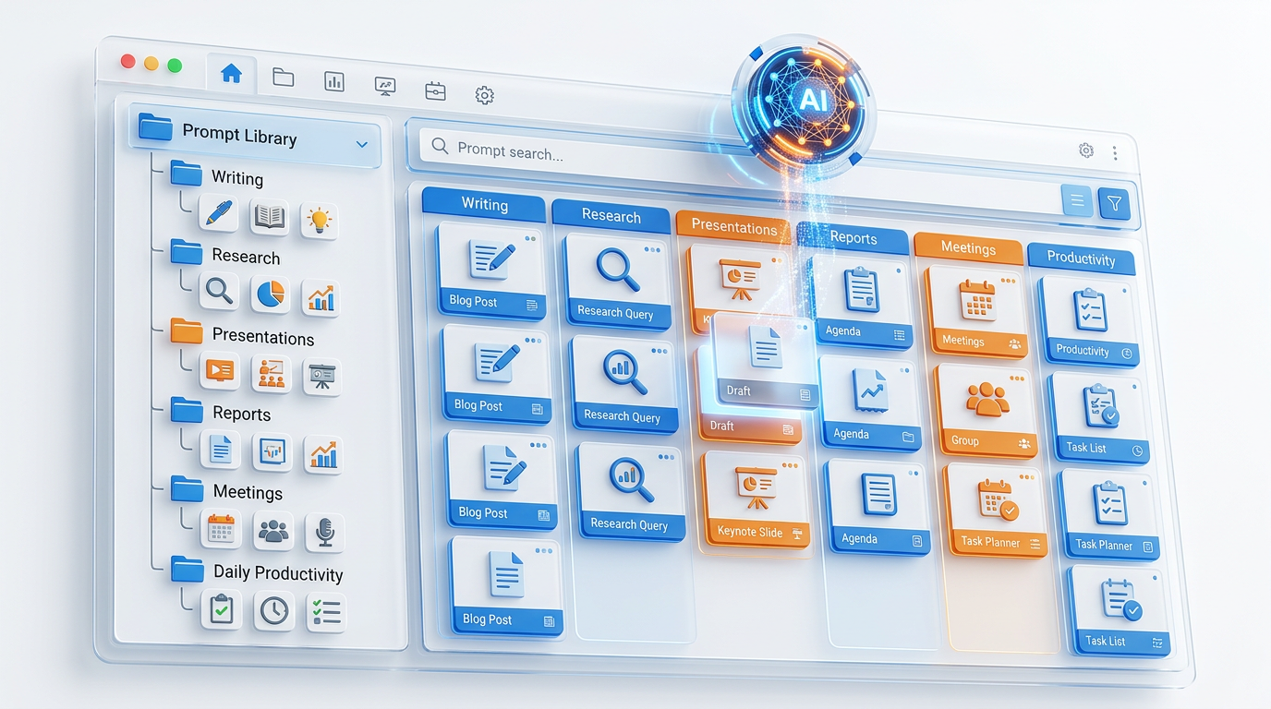
Library Architecture
Your prompt library should be organized for retrieval speed — you need to find the right prompt in under 30 seconds during a busy workday.

Recommended structure:
PROMPT LIBRARY/
├── DAILY_ROUTINES/
│ ├── morning_planning.md
│ ├── daily_capture.md
│ └── meeting_prep.md
├── WRITING/
│ ├── EMAIL/
│ │ ├── email_request.md
│ │ ├── email_followup.md
│ │ ├── email_apology.md
│ │ └── email_badnews.md
│ ├── REPORTS/
│ │ ├── report_structure.md
│ │ ├── executive_summary.md
│ │ └── report_polish.md
│ └── CONTENT/
│ ├── linkedin_post.md
│ ├── blog_outline.md
│ └── content_calendar.md
├── ANALYSIS/
│ ├── data_interpretation.md
│ ├── competitor_brief.md
│ └── decision_matrix.md
├── RESEARCH/
│ ├── topic_orientation.md
│ ├── source_summary.md
│ └── synthesis.md
└── PRESENTATIONS/
├── architecture.md
├── slide_content.md
└── qa_preparation.md

Maintenance Habits
Weekly (5 minutes)
✓ Review prompts used this week
✓ Note any that underperformed — flag for revision
✓ Add any new one-off prompts that worked well

Monthly (15 minutes)
✓ Revise flagged prompts
✓ Archive deprecated prompts
✓ Check for gaps — new use cases you encountered

Quarterly (30 minutes)
✓ Full library review — is structure still logical?
✓ Update for new AI tool capabilities
✓ Share useful prompts with team (if applicable)

15.6 Measuring Your AI Productivity Impact
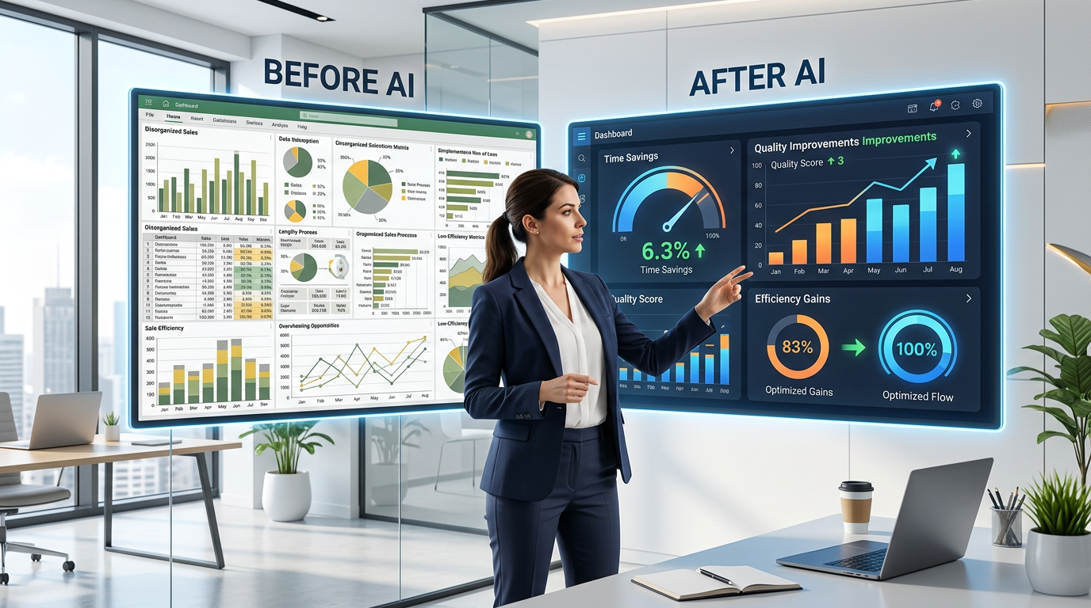

The Before/After Measurement Framework
Track this for your first 30 days of systematic AI use:

Task Tracking Log
For each AI-assisted task, record:
Date | Task | Time WITHOUT AI (estimate) | Time WITH AI |
Quality Rating (1–5) | Iterations needed | Would use AI for
this again? (Y/N)

Key metrics to track:
Metric | How to Measure | Target (First Month)
Time saved | Before vs. after times | 3–5 hours/week
Quality improvement | Self-rate output quality | +1 point on 5 point scale
First-draft acceptance rate | % of AI drafts used with minimal editing | >60%
Template reuse rate | % of tasks using existing templates | >50%
New capabilities unlocked | Tasks you couldn't do well before AI | Identify 2 to 3

15.7 Your 30-Day AI Adoption Plan

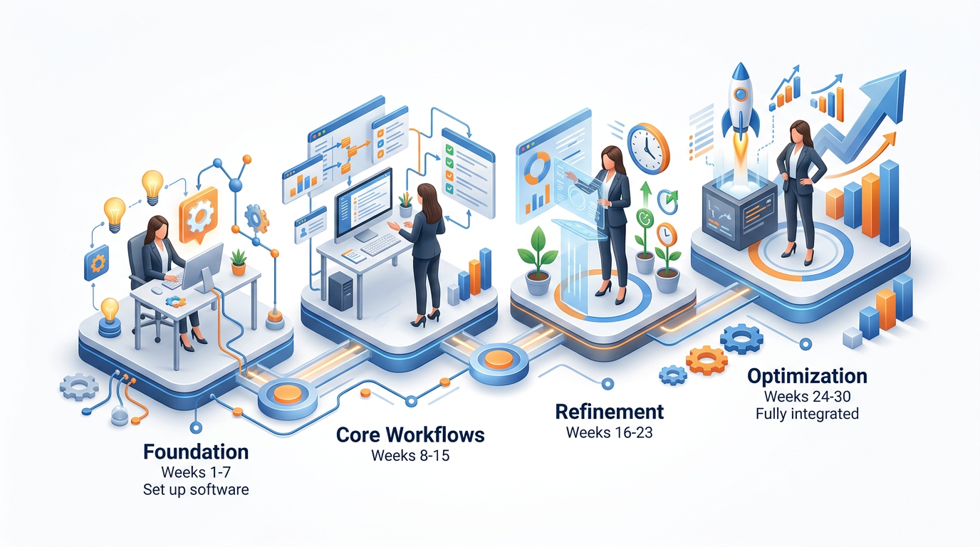

Week 1 — Foundation
✓ Complete AI productivity audit
✓ Build 5 core email templates
✓ Build daily planning routine (morning + evening)
✓ Set up prompt library folder structure

Week 2 — Core Workflows
✓ Add research workflow to library
✓ Add report writing workflow
✓ Build your role-specific templates (manager / analyst / writer / sales)
✓ Begin tracking time saved

Week 3 — Refinement
✓ Revise 2–3 templates that underperformed in Weeks 1–2
✓ Add presentation workflow
✓ Experiment with one advanced technique (CoT or persona) for your hardest tasks
✓ Share 1 useful template with a colleague

Week 4 — Optimization
✓ Review tracking data — what's working best?
✓ Identify the 3 remaining high-value tasks not yet AI-assisted
✓ Build prompts for those 3 tasks
✓ Calculate your total estimated weekly time savings
✓ Plan Month 2: what to automate or improve next

15.8 Team AI Productivity — Scaling Beyond Yourself
Once your personal system works, you can scale it to your team.
Team Prompt Library Introduction:
I want to introduce a shared prompt library to my team of [N]
people in [TEAM FUNCTION].

Help me design:
1. A simple file structure we can share (cloud folder, Notion,
Confluence, etc.)
2. A template format everyone should use for new prompt entries
3. A 30-minute intro session agenda for getting the team started
4. 5 "starter prompts" for my team's most common shared tasks
5. A lightweight governance model: who can add/edit/archive
prompts?

Team context:
- Function: [What your team does]
- Most common repeating tasks: [List 5]
- Current AI tool access: [ChatGPT / Copilot / Gemini / None]
- Team AI experience level: [Beginner / Mixed / Intermediate]

Module 3 Assessment
Knowledge Check
- What is the difference between ad-hoc AI use and a systematic AI productivity system? Why does the distinction matter?
- Describe the three daily AI integration points (morning, during day, evening) and give one specific prompt use case for each.
- What is the Time-Value Matrix and how do you use it to prioritize AI adoption?
- Name 4 role-specific AI workflows from this session. What does each accomplish?
- How should you structure a prompt library for maximum retrieval speed?
- What 5 metrics should you track in your first 30 days of AI productivity adoption?
- Describe the 30-day AI adoption plan. What is the focus of each week?
- How does building a team prompt library differ from building a personal one? What additional considerations arise?

Practical Assessment — Module 3 Capstone
Task
🎯 Design your complete personal AI productivity system.

Deliverables:
Part | Requirement | Points
1 — Audit | Complete the Workday Audit Prompt for your actual role. Present the results as the prioritized matrix, including estimated weekly time savings. | 20
2 — Workflow Design | Design your morning and end-of-day AI routines with at least 2 prompts each. Show the actual prompts, not just descriptions. | 25
3 — Library Foundation | Build 5 complete prompt library entries (in the library format from Session 10) for your 5 highest-priority AI opportunities. Each must be tested and include iteration history. | 30
4 — 30-Day Plan | Write your personal 30-day AI adoption plan with specific, measurable goals for each week. | 15
5 — Reflection | Write 200 words: How has your approach to using AI changed from Session 1 to Session 15? What is the most important mindset shift you have experienced? | 10

Module 3 Summary
Session | Topic | The One Sentence
Session 11 | Research & Synthesis | AI accelerates all research stages — but every fact must be verified before professional use.
Session 12 | Professional Writing | Your thinking drives the content; AI handles the prose — always in that order.
Session 13 | Presentations | Narrative arc first, message headlines second, slide content third — never the reverse.
Session 14 | Email & Communication | Every email must answer 4 questions; subject lines are the most important sentence you write.
Session 15 | AI Productivity System | The difference between tools and transformation is systematic integration, measured improvement, and a growing library.

Module 3 Complete → Proceed to Module 4: Business & Industry Applications (Session 16)
Prompt Engineering Certification Program | UpSkill Global Education Technologies Inc., Canada

