
PROMPT ENGINEERING CERTIFICATION PROGRAM
MODULE 4 — BUSINESS & INDUSTRY APPLICATIONS

SESSION 16
AI for Marketing & Content Creation

MODULE  4 of 6 | SESSION  16 of 30
DURATION  60–90 minutes | FORMAT  Self-paced
UpSkill Global Education Technologies Inc.
Canada

SESSION OVERVIEW

Learning Objectives
By the end of this session, you will be able to:
- Generate high quality marketing content across all major formats using targeted prompts
- Maintain consistent brand voice using few shot persona techniques
- Build a multi platform content pipeline using AI assisted workflows
- Use AI for SEO content optimization and keyword integration
- Create A/B test variations for headlines, CTAs, and ad copy
- Build a content calendar and repurposing system with AI

16.1 AI's Impact on Marketing

Marketing is among the highest value domains for AI assisted prompt engineering:
- High volume: A brand needs content across 5 to 10 platforms simultaneously
- Brand consistency: Every piece must sound like the brand, not the writer
- Speed demands: Content calendars run 30 to 90 days ahead
- A/B testing: Requires multiple variations of every asset
- Repurposing: One piece of cornerstone content should fuel 10+ derivative pieces
Well-prompted AI can reduce content production time by 60% to 80% while maintaining or improving quality freeing marketing professionals to focus on strategy, audience insight, and creative direction.

16.2 Brand Voice Establishment

Before generating any marketing content, you must establish brand voice. This is the most critical foundation.

Brand Voice Discovery Prompt
You are a brand strategist who specializes in defining and codifying
brand voice for growth-stage companies.

Analyze the following brand samples and define our brand voice:
SAMPLE 1: [Paste existing brand copy — website hero text, email, social post]
SAMPLE 2: [Paste another sample]
SAMPLE 3: [Paste another sample]

Define our brand voice across these dimensions:
1. PERSONALITY (3–5 adjectives that describe our brand's character)
2. TONE SPECTRUM (where do we sit on each axis?)
- Formal ←→ Casual
- Serious ←→ Playful
- Technical ←→ Simple
- Reserved ←→ Bold
3. VOCABULARY RULES (words we love / words we never use)
4. SENTENCE STYLE (length preference, structure patterns, punctuation style)
5. BRAND PROMISES (recurring themes and values we always express)
6. WHAT WE ARE NOT (explicit anti-patterns to avoid)

Then write a 50-word brand voice statement that captures our essence.
This becomes the foundation for all content prompts going forward.

Brand Voice Template (Once Established)
BRAND VOICE SUMMARY FOR PROMPTS:
Our brand voice is: [3 adjectives]
We sound like: [short analogy — e.g., "a knowledgeable friend, not a salesperson"]
We always: [2–3 key stylistic commitments]
We never: [2–3 explicit exclusions]
Example of our voice: "[Paste a best-in-class example sentence]"

16.3 Social Media Content
Instagram — Caption + Hashtags

Write 3 Instagram post captions for [BRAND NAME], a [TYPE OF BUSINESS].
Brand voice: [Paste your brand voice summary]
Product/topic: [WHAT THIS POST IS ABOUT]
Campaign theme: [OVERARCHING CAMPAIGN IF APPLICABLE]
Target audience: [DESCRIBE — demographics + what they care about]

Each caption must:
- Hook in the first 1–2 lines (before the "more" cutoff — under 125 characters)
- Deliver the key message in the body (2–4 sentences)
- End with a clear, specific CTA
- Include 8–12 relevant hashtags (mix: 3 broad, 3 medium, 3 niche)
- Be under 150 words (body only, before hashtags)

Three style variations:
Caption A: Inspirational/aspirational tone
Caption B: Educational/value-led tone
Caption C: Storytelling/human tone

Label each clearly. Do not repeat vocabulary between captions.

LinkedIn — Thought Leadership
Write a LinkedIn thought leadership post for [AUTHOR NAME], [THEIR ROLE]
at [COMPANY].
Author's perspective: [What is their unique professional insight?]
Topic: [SPECIFIC INSIGHT OR OBSERVATION FROM THEIR WORK]
Target audience: [WHO FOLLOWS THEM — professionals in what field?]
Core message: [The one takeaway the reader should have]

LinkedIn post structure:
- HOOK (line 1 only — bold, 1 punchy sentence — under 15 words)
- LINE BREAK
- CONTEXT (1–2 sentences expanding the hook — why this matters)
- INSIGHT (3–5 short paragraphs or bullets with the actual meat)
- PERSONAL ELEMENT (1–2 sentences connecting this to author's experience)
- CLOSING QUESTION (1 question that invites comments — specific, not generic)
- 3–5 hashtags

Tone: Authoritative but human. Professional but not stiff.
First person ("I" voice). No buzzwords.
Length: 200–280 words (body only, excluding hashtags).

Twitter/X Thread
Write a Twitter/X thread on [TOPIC] for [BRAND/AUTHOR].
Target audience: [DESCRIBE]
Core argument: [What is the thread's thesis?]
Style: [Educational / Controversial / Story-driven / List-based]

Thread structure:
Tweet 1 (HOOK): Bold claim or compelling question — makes people stop
scrolling. Under 220 characters. Must work as a standalone tweet.
Tweets 2–7 (BODY): One distinct point per tweet. Each must:
- Start with a number or strong transition word
- Be self-contained (understandable without reading others)
- Include a concrete example or statistic where possible
- Under 250 characters
Tweet 8 (SUMMARY): Distill the thread's lesson in 1–2 sentences
Tweet 9 (CTA): What should people do? Follow / Save / Share / Comment / Link

Rules:
- No tweet longer than 270 characters
- Each tweet must be valuable on its own — not a cliffhanger
- Vary tweet length and structure for readability
- 2–3 emojis maximum per tweet (only where they add meaning)

Email Newsletter
Write an email newsletter for [BRAND] sent to [AUDIENCE DESCRIPTION].
Newsletter name: [IF APPLICABLE]
This edition's theme: [THEME OR TOPIC]
Tone: [BRAND VOICE — conversational / educational / inspirational]
Send frequency: [Weekly / Bi-weekly / Monthly]

Structure:
SUBJECT LINE: [2 options — one curiosity, one benefit-led]
PREVIEW TEXT: [Under 90 characters — expands the subject line]

SECTION 1 — OPENER (100 words):
Personal, conversational note from the brand. Something real, not
generic. Reference something timely or audience-relevant.

SECTION 2 — MAIN CONTENT (200–300 words):
Core educational or valuable content for this week's theme.
Subheadline + 3–4 short paragraphs or bullets.

SECTION 3 — FEATURED RESOURCE OR CTA (50–75 words):
One clear recommendation or action (article, product, event, offer).
Button text suggestion included.

SECTION 4 — CLOSING (30–50 words):
Warm, on-brand sign-off.

Total under 500 words. Mobile-first: short paragraphs, plenty of white space.

16.4 Blog & Long Form Content
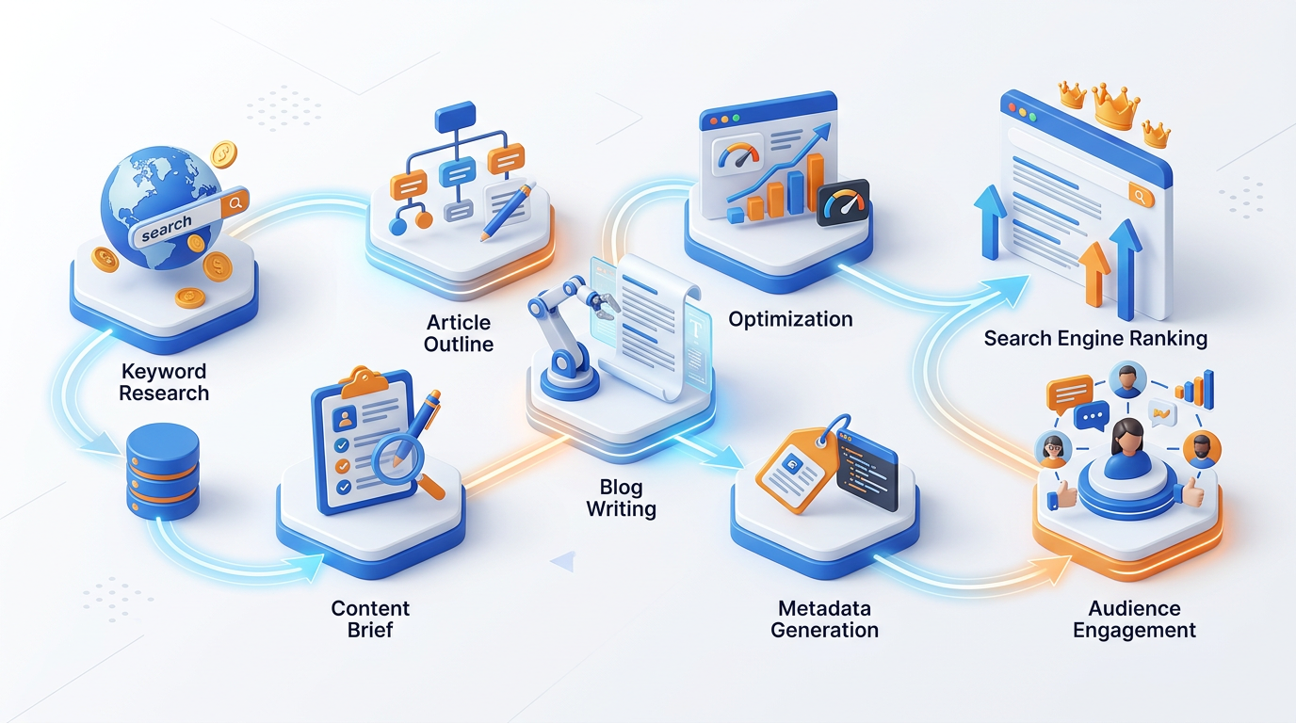

SEO Blog Post — Full Production Workflow
Step 1 — Keyword Brief:
Generate an SEO content brief for a blog post targeting the keyword:
Primary keyword: [KEYWORD]
Secondary keywords: [2–3 related terms]
Target audience: [DESCRIBE]
Search intent: [Informational / Commercial / Transactional]

Brief should include:
1. Recommended title (60 characters max, contains primary keyword)
2. Meta description (155 characters max, contains keyword, has CTA)
3. H2 structure (5–7 sections) — each H2 should target a secondary
keyword or question
4. H3 sub-sections for the 2 most detailed sections
5. Word count recommendation
6. Content type (how-to / listicle / pillar / opinion / case study)
7. Tone and audience calibration
8. 3 internal link opportunities (topics to reference)
9. Competitor gap: what do top-ranking articles NOT cover that ours should?

Step 2 — Introduction:
Write the introduction for a blog post on: [TOPIC]
Primary keyword: [KEYWORD]
Target reader: [DESCRIBE]
Their pain point this article solves: [DESCRIBE]

Introduction rules:
- Hook in first sentence (question, statistic, bold claim, or scenario)
- Acknowledge the pain point (empathize — show you understand their problem)
- Promise (what will they know/be able to do after reading?)
- Primary keyword in first 100 words (naturally, not forced)
- Under 150 words total
- No "In this article, we will..." opener

Step 3 — Section Writing:
Write the [SECTION NAME] section of my blog post about [TOPIC].
Section heading (H2): [HEADING]
Word count target: [150–250 words]
Key points to cover: [LIST 3–4 POINTS]
Examples to include: [ANY SPECIFIC EXAMPLES]
Keywords to weave in naturally: [SECONDARY KEYWORDS]

Style:
- 1 clear idea per paragraph
- Short paragraphs (3–4 sentences max)
- Include one actionable tip or concrete example
- End with a transition to [NEXT SECTION TOPIC]

Step 4 — CTA and Meta:
Complete the blog post with:
1. CONCLUSION (100 words):
- Summarize the 3 most important takeaways
- Reinforce the transformation promised in the intro
- CTA: specific next step (not generic "learn more")
2. META TITLE (60 chars max, keyword first):
3. META DESCRIPTION (155 chars max, keyword + CTA + benefit):
4. SLUG (URL — lowercase, hyphens, under 60 chars):
5. SOCIAL SHARING HEADLINE (for Facebook/LinkedIn — 80 chars max):
6. ALT TEXT for 3 suggested images:

16.5 Ad Copy & Conversion Copywriting
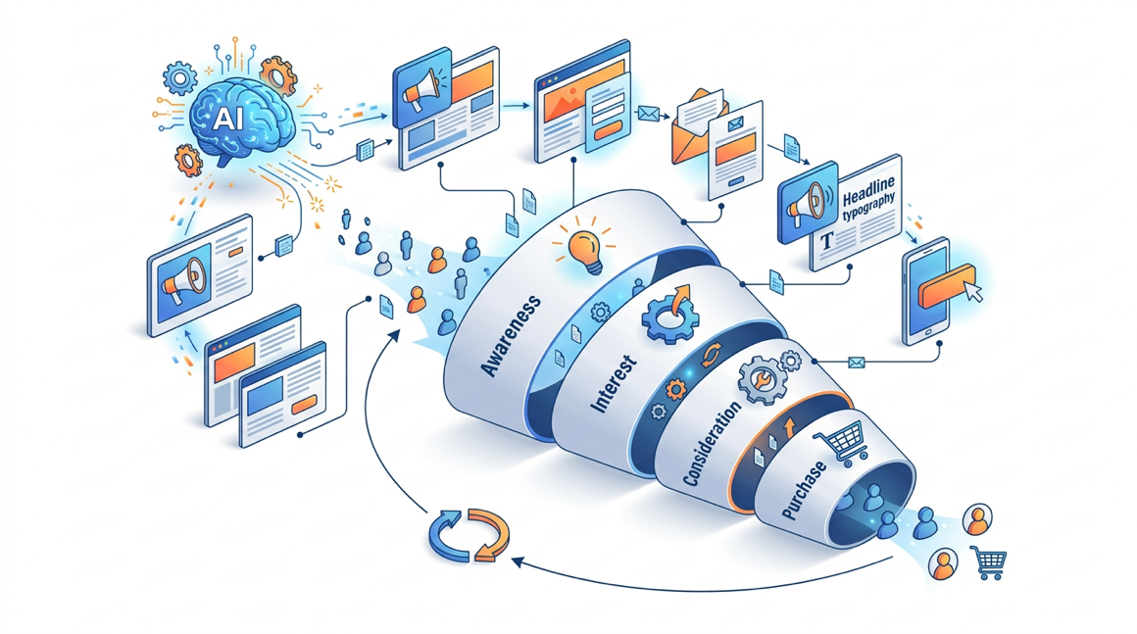
PPC Ad Copy (Google Ads)
Write Google Search Ad copy for:
Product/Service: [DESCRIBE]
Target keyword: [PRIMARY KEYWORD]
Key differentiator: [WHY US vs. COMPETITORS]
Offer or CTA: [WHAT ACTION, WHAT INCENTIVE]

Generate 3 Responsive Search Ad variations, each containing:
- Headline 1 (30 chars max): [Primary keyword inclusion]
- Headline 2 (30 chars max): [Key benefit or differentiator]
- Headline 3 (30 chars max): [CTA or trust signal]
- Description 1 (90 chars max): [Expand benefit + specific detail]
- Description 2 (90 chars max): [Social proof + urgency/offer]

Variations:
Version A: Benefit-led (lead with outcome for the user)
Version B: Problem-led (lead with the pain they're solving)
Version C: Trust-led (lead with proof point or credential)

Label each clearly. Character counts shown in [brackets] after each line.

Landing Page Copy
Write conversion-optimized landing page copy for:
Product: [NAME AND 1-SENTENCE DESCRIPTION]
Target audience: [WHO IS THIS PAGE FOR]
Their primary pain point: [WHAT PROBLEM DO THEY HAVE]
Our primary solution: [HOW WE SOLVE IT]
Offer: [WHAT ARE WE ASKING THEM TO DO — free trial, book a call, buy now]
Key social proof: [TESTIMONIALS, STATS, LOGOS IF ANY]

Landing page sections:
1. HERO SECTION:
- Headline (10 words max): Focus on outcome, not product
- Sub-headline (20 words max): Clarify who this is for and how
- CTA button text (3–5 words): Action + outcome
- Trust signal (1 line below CTA): [e.g., "Trusted by 1,200+ teams"]
2. PROBLEM SECTION (100 words):
Agitate the pain. Make the reader feel understood.
3. SOLUTION SECTION (150 words):
Present our solution as the natural answer. Benefits not features.
4. SOCIAL PROOF SECTION:
- 3 testimonial templates (structure: RESULT + SITUATION + RECOMMENDATION)
- Stats section (3 numbers with labels)
5. CTA SECTION (50 words):
Final push. Repeat the core promise. Low-friction ask. Remove objections.

Copywriting rules: "You" language throughout. Benefits before features.
Specificity over generality. One CTA repeated, not multiple different CTAs.

16.6 A/B Testing with AI
I need to A/B test this email subject line:
Original: [CURRENT SUBJECT LINE]
The email is about: [DESCRIBE]
Current open rate: [IF KNOWN]
Audience: [DESCRIBE]

Generate 8 test variations covering these angles:
1. Curiosity gap (makes them wonder what's inside)
2. Benefit-first (leads with the value they'll get)
3. Urgency (time or scarcity element)
4. Social proof (what others are doing)
5. Personal/direct (addresses "you" directly)
6. Question (prompts self-reflection)
7. Number-led (e.g., "5 ways..." or "₹10,000 saved...")
8. Contrarian (challenges conventional wisdom)

For each: Subject line (under 50 chars) | Preview text (under 90 chars) |
Why this might outperform the original

Then recommend the TOP 2 to test first and explain your reasoning.

16.7 Content Repurposing Engine
I have a long-form content piece (blog post / webinar / report):
[PASTE CONTENT OR SUMMARY]
Topic: [TOPIC]
Brand voice: [PASTE VOICE SUMMARY]
Primary audience: [DESCRIBE]

Repurpose this into 6 derivative pieces:
1. LINKEDIN POST (250 words): Extract the most counterintuitive insight
2. TWITTER THREAD (8 tweets): The 7 most actionable points + CTA
3. EMAIL NEWSLETTER (400 words): Friendly breakdown of the key lesson
4. INSTAGRAM CAROUSEL (10 slides): Key statistics and insights as slides
(For each slide: Slide title + 2–3 words of body text + visual
suggestion)
5. YOUTUBE/PODCAST DESCRIPTION (150 words): SEO-optimized episode
description
6. SHORT VIDEO SCRIPT (90 seconds): Hook + 3 insights + CTA (spoken word)

Ensure each piece:
- Can stand alone (reader doesn't need to have read the original)
- Matches the platform's native format and tone
- Drives back to the original piece with a natural CTA
- Maintains our brand voice throughout

Hands-On Activities — Session 16
Activity 16.1 — Brand Voice Establishment

Objective: Create a reusable brand voice summary for a real or hypothetical brand.
- Step 1: Choose a brand your company, a brand you work with, or a hypothetical brand you invent.
- Step 2: Collect 3 samples of their existing content (website copy, social posts, emails).
- Step 3: Run the Brand Voice Discovery Prompt.
- Step 4: Write a 50 word brand voice summary and 3 specific "we always / we never" rules.
Test: Generate an Instagram caption and a LinkedIn post using your brand voice summary. Do they feel consistently on-brand?

Activity 16.2 — Multi-Platform Content Sprint

Objective: Build a week of content for one brand using AI.
Choose a topic relevant to your brand (product launch, industry insight, how-to, etc.). Generate:
- 1 LinkedIn thought leadership post
- 3 Instagram captions (different tones)
- 1 Twitter thread (7 tweets)
- 1 email newsletter section
Evaluate consistency: Read all pieces together. Does every piece sound like the same brand? Where does the voice drift?

Activity 16.3 — Full Blog Post Production

Objective: Run the complete 4-step SEO blog workflow.
Choose a topic you genuinely know well (professional or personal expertise).
- Step 1: Generate a keyword brief
- Step 2: Write the introduction
- Step 3: Write 2 body sections
- Step 4: Write conclusion + meta copy
Evaluate: Is the final post something you would publish with minor edits? What would still need human refinement?

Activity 16.4 — A/B Variant Generation

Objective: Build testing discipline into your content creation.
Take any real marketing asset you own or can access:
- An email subject line you've used
- A social media post
- A CTA button you've seen
Generate 8 A/B variants using the A/B Testing prompt.
Analysis questions:
- Which variant would you be most excited to test?
- Which does the AI think would win? Do you agree?
- What would you need to track to measure winner vs. loser?

Revision Questions — Session 16
- Why is brand voice establishment the most important step before generating any marketing content?
- Describe the hook formula for an Instagram caption. What must the first 1–2 lines accomplish?
- What is the difference between a benefit-led and a problem-led ad copy approach? When would you use each?
- Describe the 4-step SEO blog post workflow. What does each step produce?
- What is content repurposing and why is it valuable for marketing teams using AI?
- How many A/B variants should you generate for a subject line test? What 8 angles should you cover?
- You have one long-form webinar recording. List 6 derivative content pieces you would create from it using AI.
- A brand manager says "Our AI-generated posts don't sound like us." What is the most likely cause and how would you fix it?

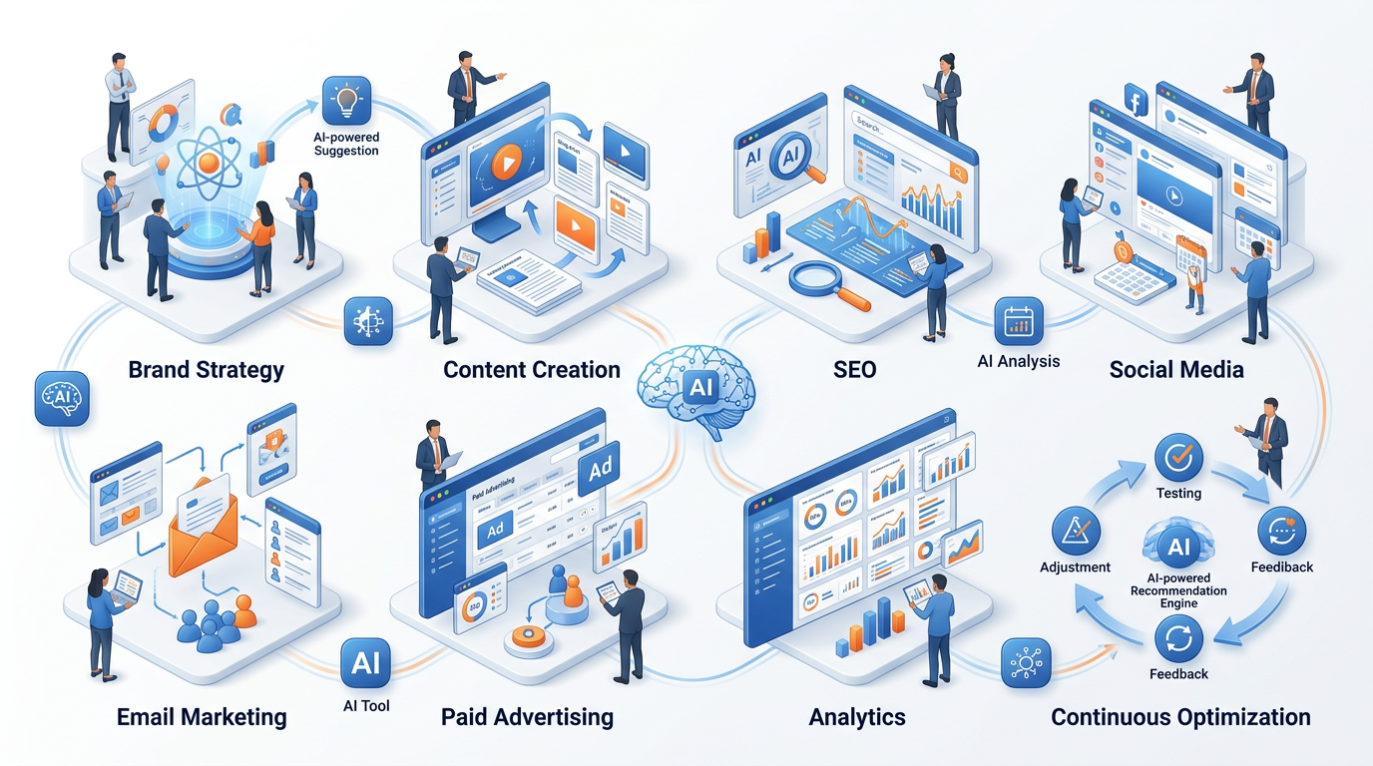

Key Takeaways — Session 16
SESSION 16 KEY TAKEAWAYS
✓ Brand voice summary is the foundation — establish it once, include it in every content prompt
✓ Each platform has a distinct format, native tone, and ideal length — one prompt fits one platform, not all
✓ SEO blog workflow: keyword brief → intro → sections → meta. Never write a full post in one prompt
✓ A/B test everything: 8 angle types (curiosity, benefit, urgency, social proof, personal, question, number, contrarian)
✓ Content repurposing: 1 cornerstone piece → 6+ derivative formats. This is the highest ROI use of AI in marketing
✓ AI produces drafts — human judgment drives strategy, direction, audience insight, and final brand quality call

Session 16 Complete → Proceed to Session 17: AI for HR
Prompt Engineering Certification Program | UpSkill Global Education Technologies Inc., Canada

