
PROMPT ENGINEERING CERTIFICATION PROGRAM
MODULE 4 — BUSINESS & INDUSTRY APPLICATIONS

SESSION 19
AI for Strategy & Business Development

MODULE  4 of 6 | SESSION  19 of 30
DURATION  60–90 minutes | FORMAT  Self-paced
UpSkill Global Education Technologies Inc.
Canada

SESSION OVERVIEW

Learning Objectives
By the end of this session, you will be able to:
- Use AI to build strategic frameworks: SWOT, Porter's Five Forces, PESTLE
- Generate competitive intelligence briefs and market entry analyses
- Use AI to assist in business case development and investment justification
- Apply AI to partnership development and business development workflows
- Use AI for strategic planning facilitation and scenario thinking
- Build strategic documents that support senior leadership decision-making

19.1 AI's Role in Strategy Work
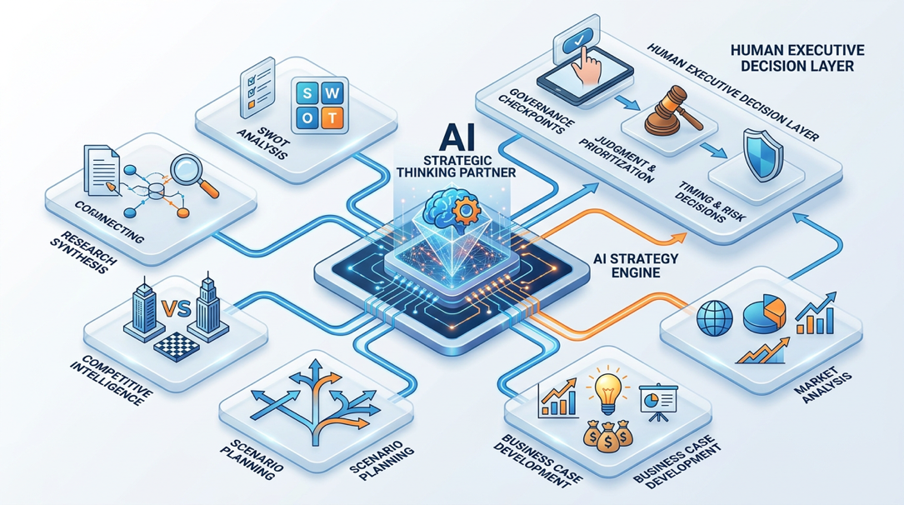
Strategy work involves two types of thinking that AI can support in different ways:
TYPE 1 — ANALYTICAL (AI is very helpful):
- Structuring information into frameworks
- Generating options and alternatives
- Synthesizing research and competitive data
- Writing strategic documents and narratives
- Stress-testing plans through devil's advocate analysis
TYPE 2 — JUDGMENT (AI is a thinking partner, not the decision-maker):
- Which option is actually right for your company
- How much risk your organization can absorb
- Which stakeholders will resist and why
- Whether the culture can support the strategy
- Timing and sequencing decisions
The strategic AI principle:
✓ Use AI to do the thinking infrastructure so that human judgment can focus on the judgment-intensive decisions that actually require it.

19.2 Strategic Analysis Frameworks
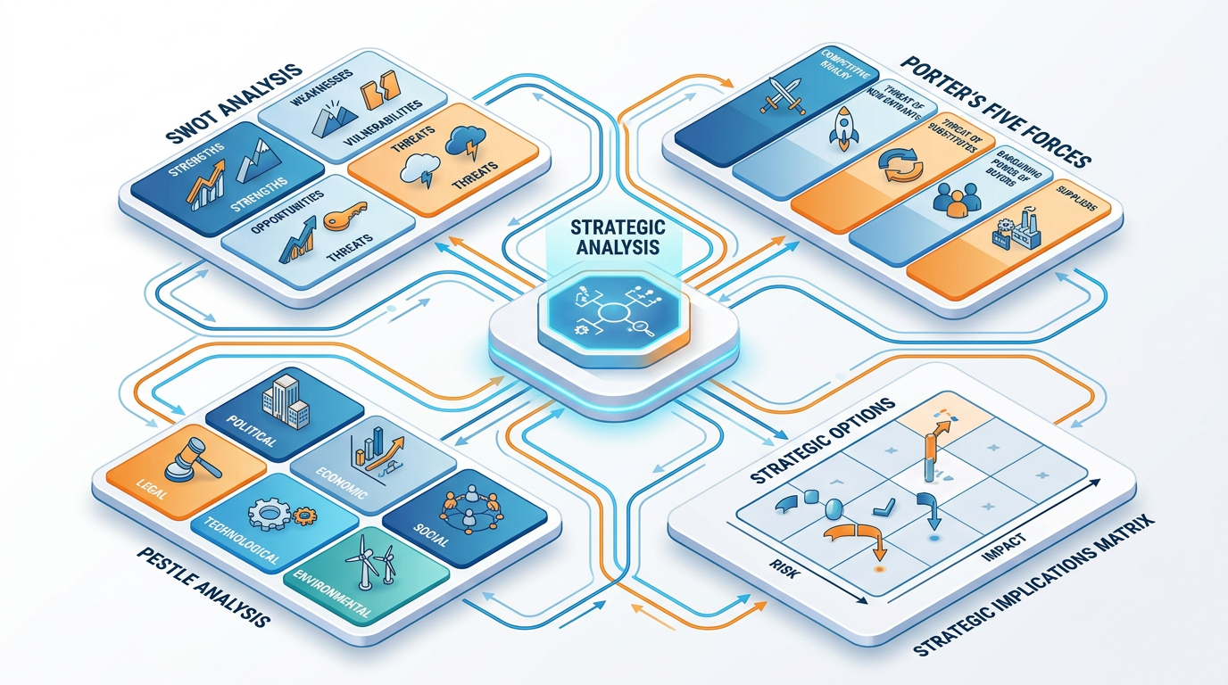
SWOT Analysis
You are a strategy consultant who facilitates SWOT analyses for
leadership teams. You are known for producing SWOTs that are genuinely
specific and actionable — not generic statements that could apply to
any company.

Conduct a SWOT analysis for [COMPANY/PRODUCT/INITIATIVE].

Context:
Company: [DESCRIBE]
Industry: [INDUSTRY]
Stage/size: [STAGE — startup / growth / mature enterprise]
Primary market: [GEOGRAPHY AND SEGMENT]
Current situation: [DESCRIBE WHAT'S HAPPENING — why is this SWOT being
done?]
Key competitor: [WHO ARE THEY COMPETING AGAINST?]

SWOT format:
STRENGTHS (What we do better than competitors — specific and factual):
• [3–5 strengths — each with a "because..." explaining why it's a
genuine strength]

WEAKNESSES (Where we are genuinely at a disadvantage — honest and
specific):
• [3–5 weaknesses — each with a "which means..." showing the real
consequence]

OPPORTUNITIES (External conditions we can capitalize on — with time
horizon):
• [3–5 opportunities — each with: what it is | why now | how we could
capture it]

THREATS (External forces that could harm us — with likelihood rating):
• [3–5 threats — each with: what it is | likelihood H/M/L | our
vulnerability H/M/L]

STRATEGIC IMPLICATIONS (the SWOT's value — what should we DO):
SO Strategy: Use Strengths to capture Opportunities (2 specific
strategies)
ST Strategy: Use Strengths to mitigate Threats (2 specific strategies)
WO Strategy: Address Weaknesses to pursue Opportunities (2 specific
strategies)
WT Strategy: Minimize Weakness exposure to Threats (2 specific
strategies)

Specificity rule: If a SWOT point could be copy-pasted into any
company's analysis without change, it is too generic — replace with
something specific.

Porter's Five Forces
Apply Porter's Five Forces framework to analyze the competitive
environment of [INDUSTRY/MARKET SEGMENT].

For each force, provide:
- FORCE ASSESSMENT: High / Medium / Low pressure on profitability
- KEY FACTORS: 3–4 specific factors driving this force in this industry
- TREND: Is this force getting stronger, weaker, or stable? Why?
- IMPLICATION: What does this mean for strategy?

The Five Forces:
1. THREAT OF NEW ENTRANTS
2. BARGAINING POWER OF SUPPLIERS
3. BARGAINING POWER OF BUYERS/CUSTOMERS
4. THREAT OF SUBSTITUTE PRODUCTS/SERVICES
5. COMPETITIVE RIVALRY AMONG EXISTING PLAYERS

After analyzing all five forces:
OVERALL INDUSTRY ATTRACTIVENESS:
- Summary assessment (High / Medium / Low attractiveness for
profitability)
- The most dominant force that shapes competition
- The force that is changing most rapidly and why

STRATEGIC RECOMMENDATIONS:
- 3 specific strategies to reduce competitive pressure in this industry
- 1 "blue ocean" opportunity — a way to compete where forces are weaker

Industry context for this analysis: [DESCRIBE YOUR INDUSTRY AND
SITUATION]

PESTLE Analysis
Conduct a PESTLE analysis for [COMPANY] considering expansion into
[MARKET/GEOGRAPHY].

For each dimension, provide:
- 3 specific factors (not generic statements — country/sector/
time-specific)
- Assessment of each factor: Opportunity / Threat / Neutral
- Impact severity: High / Medium / Low
- Time horizon: Immediate (0–1yr) / Near (1–3yr) / Long (3+yr)

Dimensions:
P — POLITICAL (government stability, trade policy, regulation,
political risk)
E — ECONOMIC (GDP, inflation, interest rates, purchasing power,
currency risk)
S — SOCIAL (demographics, cultural factors, consumer behavior,
workforce)
T — TECHNOLOGICAL (infrastructure, adoption rates, digital maturity,
IP environment)
L — LEGAL (employment law, data protection, industry regulations,
IP protection)
E — ENVIRONMENTAL (climate risk, sustainability regulations, ESG
expectations)

SUMMARY TABLE:
| Factor | Dimension | Opportunity/Threat | Impact | Timeline |
[Generate one row per factor identified]

TOP 3 WATCH ITEMS: The three factors that most need active monitoring

GO / NO-GO RECOMMENDATION: Based on this analysis, is this expansion
advisable? With what conditions or mitigations?

19.3 Competitive Intelligence
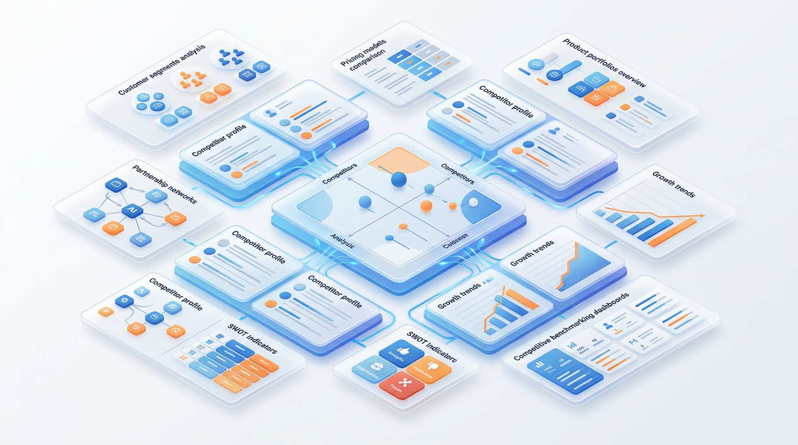

Competitor Profile Brief
Build a comprehensive competitive intelligence brief for [COMPETITOR
NAME].

Context: We are [OUR COMPANY], competing in [MARKET SEGMENT].
Purpose: [WHY WE NEED THIS — new market entry / pitch prep / product
strategy]

Competitor brief structure:
COMPANY OVERVIEW:
- Founded, HQ, employee count (approximate)
- Funding/ownership status and approximate valuation
- Core product/service offering (1–2 sentences)
- Primary target market segment

MARKET POSITIONING:
- Their stated positioning (how they describe themselves)
- Implied positioning (what they actually compete on)
- Price positioning: Premium / Mid-market / Value / Freemium

STRENGTHS (as their best customer would describe them):
[3–5 genuine strengths]

WEAKNESSES (as their most frustrated customer would describe them):
[3–5 genuine weaknesses — sourced from reviews, public feedback]

RECENT STRATEGIC MOVES:
[Last 12 months — product launches, funding, partnerships, hiring
signals, pricing changes]

HOW THEY SELL:
- Sales motion: Enterprise / Mid-market / PLG (product-led growth) /
Channel
- Primary acquisition channels
- Pricing model and typical deal size

HOW WE BEAT THEM:
- Our 3 best arguments against this competitor
- The customer type most likely to choose us over them
- Their most vulnerable accounts (where are they weakest?)

HOW THEY BEAT US:
- Their 3 best arguments against us (be honest)
- When we should walk away from a deal vs. fight for it

Flag all specific claims with [VERIFY] — confirm against current public
sources.

Market Entry Analysis
You are a market strategy consultant advising on expansion decisions.
Analyze the opportunity for [COMPANY] to enter [NEW MARKET].

Company profile: [DESCRIBE — size, current market, resources,
capabilities]
New market: [DESCRIBE — geography, segment, what specifically]
Strategic rationale: [WHY are we considering this? Growth /
defensiveness / following customers?]

Market Entry Analysis:
1. MARKET OPPORTUNITY ASSESSMENT
- Market size and growth rate (flag for verification)
- Addressable segment for our offering
- Time to meaningful revenue (realistic estimate with rationale)
2. READINESS ASSESSMENT
- What we have that transfers (capabilities, brand, relationships)
- What we must build or acquire (gaps)
- Estimated investment required to reach breakeven
- Timeline to achieve meaningful market presence
3. ENTRY STRATEGY OPTIONS
Option A: [e.g., Direct / Organic growth]
Option B: [e.g., Partnership / Distribution]
Option C: [e.g., Acquisition]
For each: how to enter | time to market | cost | risk | success
probability
4. COMPETITIVE DYNAMICS
- Who we'll face and their response to our entry
- First-mover vs. fast-follower considerations
5. KEY RISKS
- Top 3 risks of entering
- Top 3 risks of NOT entering
6. RECOMMENDATION
- Go / Go with conditions / Wait / Don't go
- Rationale (3–4 sentences)
- If go: recommended entry option + top 3 priorities for first 90
days

19.4 Business Case Development


Business Case Structure Generator
You are a management consultant who builds business cases for capital
investment and strategic initiatives. You ensure every business case
is investment-ready — clear, credible, and decision-enabling.

Build a business case framework for: [INITIATIVE NAME]
Initiative description: [DESCRIBE WHAT YOU'RE PROPOSING]
Decision-maker: [WHO APPROVES THIS — CEO / Board / Investment
Committee]
Investment required: [APPROXIMATE AMOUNT]
Timeline: [WHEN RESULTS EXPECTED]
Strategic context: [WHY NOW — what strategic imperative does this
address?]

Business case sections:
1. EXECUTIVE SUMMARY (200 words max)
- The decision being requested
- The problem/opportunity being addressed
- The recommended solution
- Financial summary (investment, payback, ROI)
- The recommendation
2. PROBLEM/OPPORTUNITY STATEMENT
- Current state: what is happening now and why it's a problem
- Cost of inaction: what happens if we don't act
- The opportunity: what becomes possible if we do act
3. PROPOSED SOLUTION
- What we are proposing (specific and detailed)
- How it works
- Why this solution vs. alternatives
4. FINANCIAL ANALYSIS
- Investment required (one-time + ongoing)
- Expected benefits (quantified — flag assumptions clearly)
- Payback period
- NPV / ROI (provide formula; I will insert actual numbers)
- Sensitivity: what if key assumptions are 20% worse?
5. ALTERNATIVES CONSIDERED
- 2–3 alternatives we assessed
- Why we rejected each in favor of the proposed solution
6. RISKS AND MITIGATIONS
- Top 5 risks (likelihood × impact matrix)
- Specific mitigation for each
7. IMPLEMENTATION PLAN
- Phases with milestones
- Resource requirements
- Dependencies
8. RECOMMENDATION AND DECISION REQUIRED
- Clear recommendation
- Specific decision needed from the approver
- Decision deadline and why it matters

Note: Flag all quantitative claims with [ASSUMPTION: state what you
assumed]. I will verify and replace with actual figures.

19.5 Business Development & Partnership


Partnership Proposal Framework
Write a partnership proposal for [OUR COMPANY] to present to
[POTENTIAL PARTNER].

Our company: [DESCRIBE — what we do, who we serve, our scale]
Potential partner: [DESCRIBE — what they do, who they serve, why
they're attractive]
Partnership type: [Technology / Distribution / Co-marketing / Joint
venture / Referral]
The mutual value: [WHY this partnership makes sense for BOTH parties]
The ask: [What specifically are you proposing?]

Partnership proposal structure:
1. EXECUTIVE OVERVIEW (1 page)
- Partnership vision (1 sentence — what we'll achieve together)
- Why [THEIR COMPANY] + [OUR COMPANY] = greater value than either
alone
- The 3 headline benefits for THEM (not for us — lead with their
gain)
2. MARKET OPPORTUNITY WE'RE ADDRESSING TOGETHER
- The customer problem this partnership uniquely solves
- The market size and timing rationale
3. WHAT EACH PARTY BRINGS
| Our Contribution | Their Contribution |
| Key asset 1 | Key asset 1 |
| Key asset 2 | Key asset 2 |
| Key asset 3 | Key asset 3 |
4. PARTNERSHIP MECHANICS
- How it works operationally (step by step)
- Revenue / cost sharing model (framework — specific terms to be
negotiated)
- Governance and decision rights
5. PROJECTED OUTCOMES (year 1, year 2, year 3)
For both parties: revenue opportunity, customer reach, strategic
benefit
Flag all projections as [ESTIMATE — to be validated jointly]
6. NEXT STEPS
- 3-step path to partnership agreement
- Our proposed timeline
- The one decision we need from them to move forward

Negotiation Preparation Prompt
You are an experienced business negotiator preparing me for an
upcoming negotiation with [COUNTERPARTY].

Negotiation context:
What we're negotiating: [DESCRIBE THE DEAL]
Our goal: [WHAT'S THE IDEAL OUTCOME FOR US?]
Their likely goal: [WHAT DO THEY WANT?]
Our BATNA (Best Alternative to Negotiated Agreement): [IF THIS DEAL
FAILS, WHAT DO WE DO?]
Their likely BATNA: [IF WE DON'T DEAL, WHAT DO THEY DO?]
Our leverage: [WHERE DO WE HAVE POWER?]
Their leverage: [WHERE DO THEY HAVE POWER?]
Key points of potential conflict: [DESCRIBE]

Prepare my negotiation strategy:
1. ZONE OF POSSIBLE AGREEMENT (ZOPA): What's the realistic range of
outcomes?
2. OPENING POSITION: Where should I start and why?
3. CONCESSION STRATEGY: What can I give up and in what order?
4. NON-NEGOTIABLES: What must I protect at all costs?
5. TACTICS THEY MAY USE: 3 tactics to expect and how to respond
6. MY OPENING STATEMENT: First 60 seconds — how I set the tone
7. KEY QUESTIONS TO ASK: 5 questions that reveal their real priorities
8. DEAL-KILLER DETECTOR: Signs this deal should be walked away from

19.6 Strategic Planning — Facilitation Support
Strategy Workshop Agenda Generator
Design a [DURATION] strategy workshop agenda for [ORGANIZATION]
leadership team.

Context:
Team: [WHO IS IN THE ROOM titles, number of people]
Purpose: [WHAT DECISIONS MUST THIS WORKSHOP PRODUCE?]
Current situation: [WHAT'S HAPPENING — why is this workshop needed
NOW?]
Prework completed: [Any analysis, surveys, or reading done
beforehand]
Facilitator: [Internal leader / External consultant]

Workshop design:
1. AGENDA with time blocks (each block: duration | topic | method |
output)
2. OPENING EXERCISE (15 min): Energy-setting and alignment activity
3. FRAMEWORKS TO USE: Which strategic tools are appropriate for this
agenda
4. DECISION POINTS: The 3 specific decisions the team must make by end
of day
5. PARKING LOT PROCESS: How to handle topics that need separate
sessions
6. CLOSING: How to capture decisions and assign accountability
7. FOLLOW-UP: What happens in the 48 hours after the workshop

Output-driven design: Every block should produce a specific
deliverable (a decision, a ranked list, a framework, a draft strategy
— not just discussion).

Hands-On Activities — Session 19
Activity 19.1 — Full SWOT for a Real Business
Objective: Build a genuinely specific SWOT that creates strategic insight.
Choose: your company, a company you're familiar with, or a public company.
- Step 1: Run the SWOT Analysis prompt with full context.
- Step 2: Evaluate the specificity of each point. Apply this test: "Could this exact bullet appear in a competitor's SWOT without changing a word?" If yes, it's too generic — improve it.
- Step 3: Generate the 4 SO/ST/WO/WT strategic implications.
Reflection: Did the SWOT produce any strategies you hadn't considered before?

Activity 19.2 — Competitive Intelligence Brief
Objective: Build a complete competitor profile for a company you compete with or study.
- Step 1: Choose a real company (public or well-known).
- Step 2: Run the Competitor Profile Brief prompt.
- Step 3: Verify 5 specific claims against public sources (website, news, LinkedIn, Crunchbase).
Deliverable: A ready to use competitor brief with verified and flagged claims clearly marked.

Activity 19.3 — Business Case Framework
Objective: Apply AI to a real investment or initiative you're considering.
Think of any initiative at work or personally:
- A technology tool you want to purchase
- A training program you want to run
- A new process you want to implement
- A market or product line you want to enter
Run the Business Case Structure Generator. Fill in all sections conceptually (use [ESTIMATE] where you don't have real numbers).
Evaluate: Would this business case convince a skeptical decision maker? What's the weakest section?

Activity 19.4 — Negotiation Preparation
Objective: Use AI to prepare for a real upcoming negotiation.
Think of any negotiation you have coming up (salary, vendor contract, project scope, partnership terms, resource allocation).
Run the Negotiation Preparation Prompt.
Reflection: What did the BATNA analysis reveal? What was your reaction to the concession strategy AI suggested do you agree with the order?

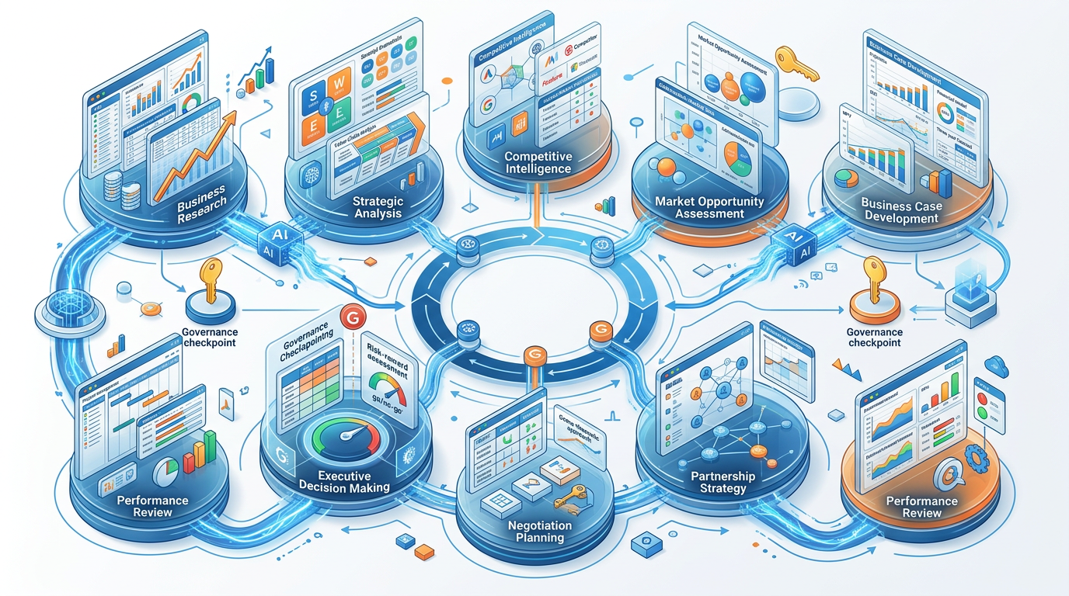

Revision Questions — Session 19
- Describe the two types of thinking in strategy work. Where is AI most helpful and where does human judgment remain essential?
- What is the Porter's Five Forces framework and what does analyzing it reveal?
- What makes a SWOT analysis genuinely useful vs. generic? Give an example of a generic weakness and its specific version.
- What should a competitor brief include beyond basic company facts?
- Describe the 6 sections of a business case. What is the purpose of each?
- What is a BATNA and why is it the most important concept in negotiation preparation?
- What is the ZOPA (Zone of Possible Agreement) and how do you determine it?
- A strategy consultant runs a PESTLE analysis using AI for a client's market entry into a new country. What verification steps are essential before presenting it?

Key Takeaways — Session 19
SESSION 19 KEY TAKEAWAYS
✓ AI handles thinking infrastructure; human judgment handles the decision itself never reverse this
✓ Strategic frameworks (SWOT, Porter, PESTLE): AI generates the structure and language; you provide the specific business context
✓ Specificity test for SWOT: if any point could appear in any competitor's analysis unchanged, it needs to be more specific
✓ Business cases: AI structures and writes; you own the numbers, assumptions, and recommendation
✓ Negotiation: BATNA is the most critical input know yours and estimate theirs before any negotiation begins
✓ Competitive intelligence: always verify specific claims before presenting to leadership or clients

Session 19 Complete → Proceed to Session 20: AI for Customer Support
Prompt Engineering Certification Program | UpSkill Global Education Technologies Inc., Canada

