
PROMPT ENGINEERING CERTIFICATION PROGRAM
MODULE 5 — ADVANCED PROMPT ENGINEERING

SESSION 21
Multi-Step AI Workflows

MODULE  5 of 6 | SESSION  21 of 30
DURATION  60–90 minutes | FORMAT  Self-paced
UpSkill Global Education Technologies Inc. Canada

SESSION OVERVIEW

Learning Objectives
By the end of this session, you will be able to:
- Design multi step prompt chains for complex professional tasks
- Apply the pipeline architecture: sequential, parallel, and conditional chains
- Use context injection to carry information between prompt steps
- Build a content production pipeline from brief to published asset
- Design a research-to-report pipeline with quality gates
- Implement error handling and quality checks within prompt chains

21.1 Why Multi Step Workflows?
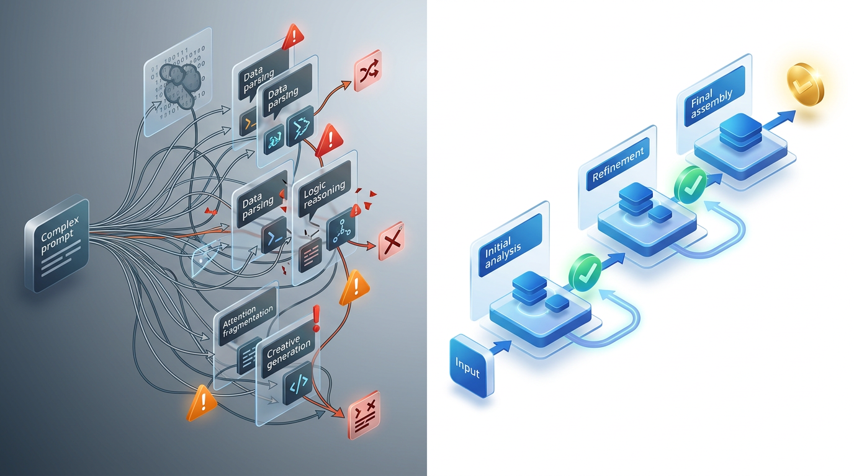

Single prompts have fundamental limitations for complex tasks:
PROBLEM WITH SINGLE COMPLEX PROMPTS
1. ATTENTION DILUTION: When asked to do 8 things at once, the model
allocates limited attention across all 8. Each gets ~12% of focus.
Result: shallow output across all dimensions.

2. CONTEXT OVERFLOW: Complex outputs require a full context window.
If the prompt is long, less room remains for generation quality.

3. UNVERIFIABLE STEPS: You can't catch errors in intermediate steps
because you never see them — only the final output.

4. NO COURSE CORRECTION: If step 3 of a 10-step process is wrong,
you've wasted all 10 steps. With a pipeline, you catch it at step 3.

SOLUTION: PROMPT CHAINS
Each prompt does one thing well. Output of step N becomes input to
step N+1.
You see, verify, and approve each step before proceeding.
Quality compounds across steps rather than averaging down.

21.2 Chain Architecture Types
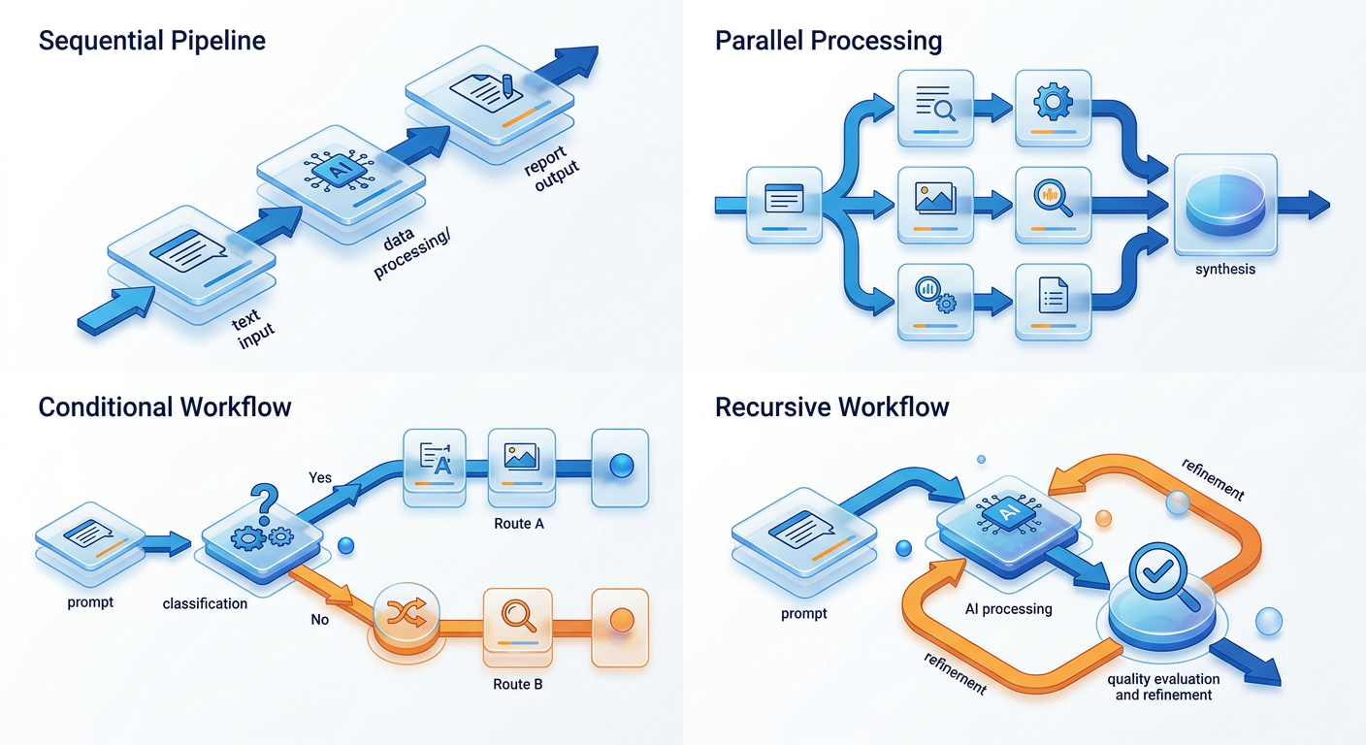

Type 1: Sequential Chain
Each step feeds directly into the next. The classic pipeline.
Input → [Step 1] → Output 1 → [Step 2] → Output 2 → [Step 3] →
Final Output
Best for: Linear processes where each step builds on the previous (research → outline → draft → polish).

Type 2: Parallel Chain
Multiple prompts run independently on the same input, then results are synthesized.
┌──[Step 1A: Expert A perspective]──┐
Input ────┼──[Step 1B: Expert B perspective]──┼──[Synthesis Step]── Output
└──[Step 1C: Expert C perspective]──┘
Best for: Multi-perspective analysis, A/B variation generation, cross-domain evaluation.

Type 3: Conditional Chain
The next step depends on the output of the previous step.
Input → [Step 1: Classify] → IF Category A → [Step 2A]
→ IF Category B → [Step 2B]
→ IF Category C → [Step 2C]
Best for: Triage systems, adaptive content generation, support ticket routing.

Type 4: Recursive / Iterative Chain
A prompt loop that refines output until a quality threshold is met.
Input → [Generate] → [Evaluate Quality] → IF below threshold →
[Refine] → [Evaluate]
→ IF above threshold → Output
Best for: High-quality content generation, prompt optimization, code refinement.

21.3 The Content Production Pipeline
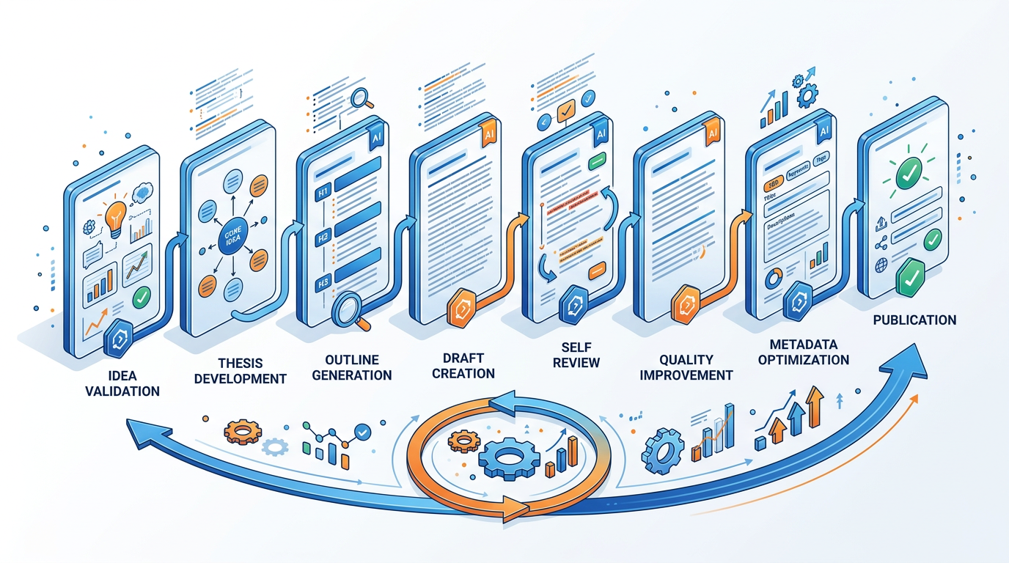
A complete example of a sequential chain for professional content production.
Goal: Transform a rough idea into a published-ready LinkedIn article.

STEP 1 — Idea Validation and Expansion
You are a content strategist who evaluates LinkedIn article ideas for
engagement potential.

My rough idea: [DESCRIBE IN 2–3 SENTENCES]
My audience: [WHO FOLLOWS ME / WHO I WANT TO REACH]
My purpose: [THOUGHT LEADERSHIP / LEAD GENERATION / COMMUNITY
BUILDING]

Evaluate and expand this idea:
1. ANGLE ASSESSMENT: Is this angle original? What would make it more
distinctive?
2. AUDIENCE FIT: Will this resonate with my described audience?
Why/why not?
3. REFINED THESIS: Rewrite my idea as a sharp, specific thesis
statement (1 sentence)
4. HOOK OPTIONS: 3 opening hook options (one statistic, one story,
one contrarian claim)
5. GO / REFINE / DISCARD: Recommendation with rationale

Output this evaluation before I proceed to the next step.

STEP 2 — Structured Outline (uses Step 1 output)
Based on this validated idea and thesis:
Thesis: [PASTE STEP 1 REFINED THESIS]
Selected hook: [PASTE CHOSEN HOOK FROM STEP 1]

Build a detailed outline for a 1,000-word LinkedIn article:
- Title (2 options: one curiosity-driven, one benefit-driven)
- Introduction structure (hook → context → thesis → promise)
- 4–5 main sections with H2 titles (each as a complete, compelling
statement)
- For each section: 2–3 bullet points of the specific content to
include
- Conclusion structure (synthesis → insight → call to engagement)

The outline should create narrative momentum — each section should
make the reader want to read the next one.

STEP 3 — First Draft: Sections 1 & 2 (uses Step 2 outline)
Write sections 1 and 2 of my LinkedIn article using this outline:
[PASTE STEP 2 OUTLINE]

Rules:
- First person ("I") voice throughout
- Short paragraphs: 2–3 sentences maximum
- Every claim supported by a specific example, statistic, or anecdote
- No buzzwords: "game-changer," "synergy," "leverage," "disruption"
- Active voice only
- Target: 200–250 words for these two sections combined

STEP 4 — First Draft: Sections 3, 4 & Conclusion (continues)
Continue writing my LinkedIn article. Here is what's been written:
[PASTE TITLE + INTRO + SECTIONS 1 & 2]

Now write sections 3, 4, and the conclusion following the same
outline. Maintain identical tone, paragraph length, and style.

Conclusion: synthesize the key insight → memorable closing line →
engagement CTA
(CTA should be a specific question that invites comments — not
"What do you think?")

Target: 300–350 words for sections 3, 4, and conclusion.

STEP 5 — Self-Critique and Polish (full draft)
Here is my complete LinkedIn article draft:
[PASTE FULL DRAFT]

Critique and improve it:
CRITIQUE (score each 1–10):
- Hook strength: does it stop the scroll?
- Thesis clarity: is the core argument crystal clear?
- Evidence quality: are claims supported specifically?
- Flow: does each section lead naturally to the next?
- Voice consistency: does it sound like one person throughout?
- Ending: does the conclusion leave a memorable impression?

IMPROVEMENTS:
- Rewrite the weakest paragraph (lowest score)
- Suggest 2 places where a specific example could replace a general
claim
- Propose a stronger final sentence for the CTA

METADATA:
- Suggested LinkedIn hashtags (5)
- Optimal publishing day/time recommendation with rationale

21.4 The Research-to-Report Pipeline

Goal: Transform raw notes and sources into a polished client-ready report.

STEP 1: Source Processing
For each source, run: [Source Summarization Prompt from Session 11]
Output: Structured summaries (one per source)

STEP 2: Synthesis
Run: [Multi-source synthesis prompt]
Input: All source summaries
Output: Thematic synthesis with consensus, conflicts, gaps

STEP 3: Report Structure
"Based on this synthesis: [paste]
And this brief: [client objective + audience + deliverable format]

Generate a complete report outline with section titles (as message
headlines), purpose of each section, recommended length, and key
content points."

STEP 4: Section Drafting
For each section (run separately):
"Write [SECTION TITLE] of this report.
Context: [executive summary so far + relevant synthesis points]
Target: [word count]
Format: [structure for this section]"

STEP 5: Executive Summary
"Based on the complete report: [paste all sections]
Write the executive summary (last written, first read):
[Executive summary prompt from Session 12]"

STEP 6: Final Consistency Polish
"Review this complete report for:
Consistency of tense, terminology, tone, and formatting.
List all inconsistencies with location and correction."

STEP 7: Client Deliverable Formatting
"Convert the polished report into an executive brief
[Executive brief template from Session 12]
And generate: 5 LinkedIn post ideas based on key report insights."

21.5 Context Injection — Carrying Information Between Steps
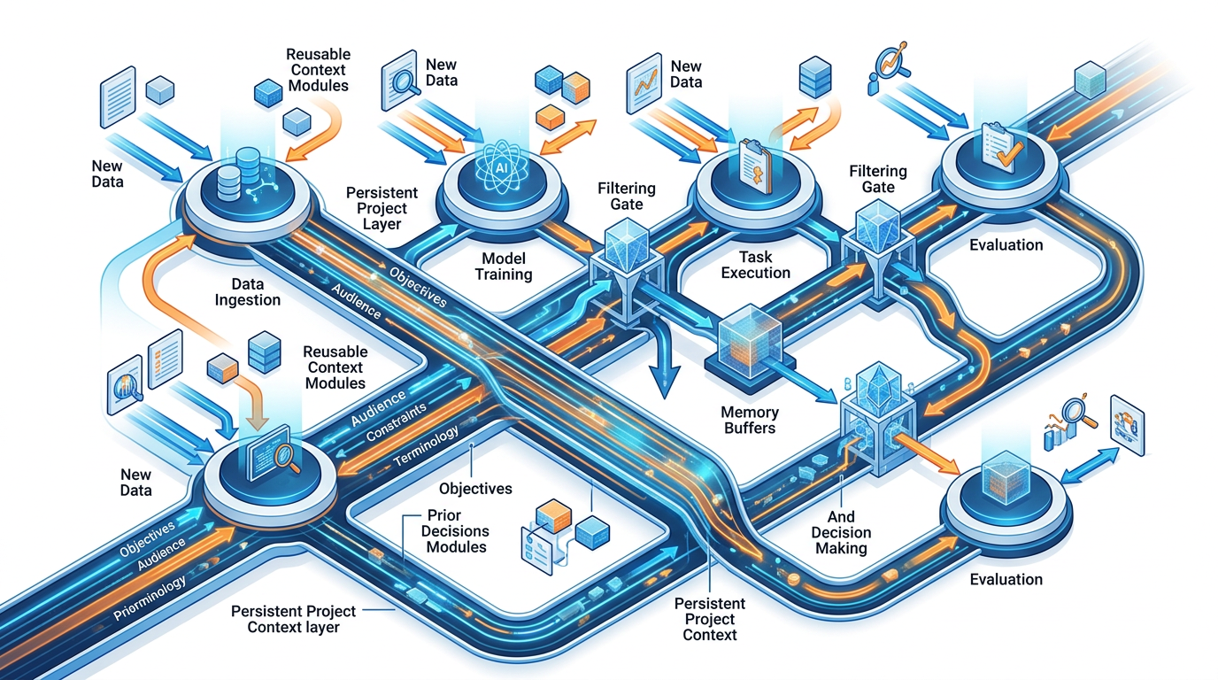
The key technical skill in multi-step workflows: what to carry forward and how.
What to Carry Forward
ALWAYS carry forward:
✓ The core brief / objective (so every step stays aligned)
✓ Key constraints (audience, tone, word count, format)
✓ Key terms and definitions (consistency across steps)
✓ The output of the immediately preceding step
CARRY FORWARD SELECTIVELY:
~ Earlier steps: include summary or the specific relevant portion
~ Long outputs: paste the key section, not the full text
~ Established decisions: a brief "previously decided: X" note

DO NOT carry forward:
✗ Everything from every previous step (context window pollution)
✗ Failed drafts or rejected options
✗ Meta-commentary about the process
Context Injection Template
CONTEXT BRIEF (carry at top of every step):
────────────────────────────────────────
Project: [ONE-LINE DESCRIPTION]
Audience: [WHO THIS IS FOR]
Purpose: [WHAT IT MUST ACHIEVE]
Key constraints: [TONE / LENGTH / FORMAT / MUST-INCLUDE]
Previously decided: [KEY DECISIONS ALREADY MADE]
────────────────────────────────────────

PREVIOUS STEP OUTPUT (relevant portion):
[PASTE RELEVANT OUTPUT]

CURRENT STEP TASK:
[THIS STEP'S SPECIFIC TASK]

21.6 Quality Gates in Pipelines
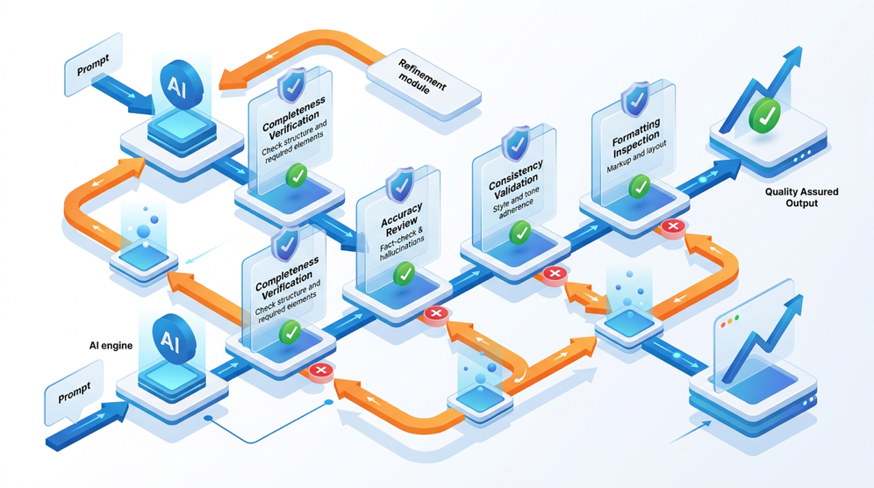
A quality gate is a checkpoint where you evaluate output before proceeding. Without gates, errors compound across steps.
Quality Gate Prompt Template
Before I proceed to [NEXT STEP], evaluate the output of [CURRENT
STEP]:

Output to evaluate: [PASTE OUTPUT]

Quality gate criteria for this step:
Criterion 1: [SPECIFIC, BINARY — PASS or FAIL]
Criterion 2: [SPECIFIC, BINARY — PASS or FAIL]
Criterion 3: [SPECIFIC, BINARY — PASS or FAIL]
Criterion 4: [SPECIFIC, BINARY — PASS or FAIL]

For any FAIL:
- State what was expected
- State what was produced
- Recommend the specific fix
- Indicate if this is a minor revision or requires restarting the
step

Overall gate decision: PROCEED / REVISE / RESTART

When to Place Quality Gates
Step Type | Gate Needed? | What to Check
Research synthesis | YES — always | Accuracy, no hallucinated citations
Strategic framework | YES | Specificity, not generic statements
First draft (any) | YES — light | Structure, tone, completeness
Subsequent drafts | OPTIONAL | Improvement from previous version
Final polish | YES — thorough | All quality dimensions
Code generation | YES — always | Logic, edge cases, runs without error

21.7 Programmatic Pipeline (Python)
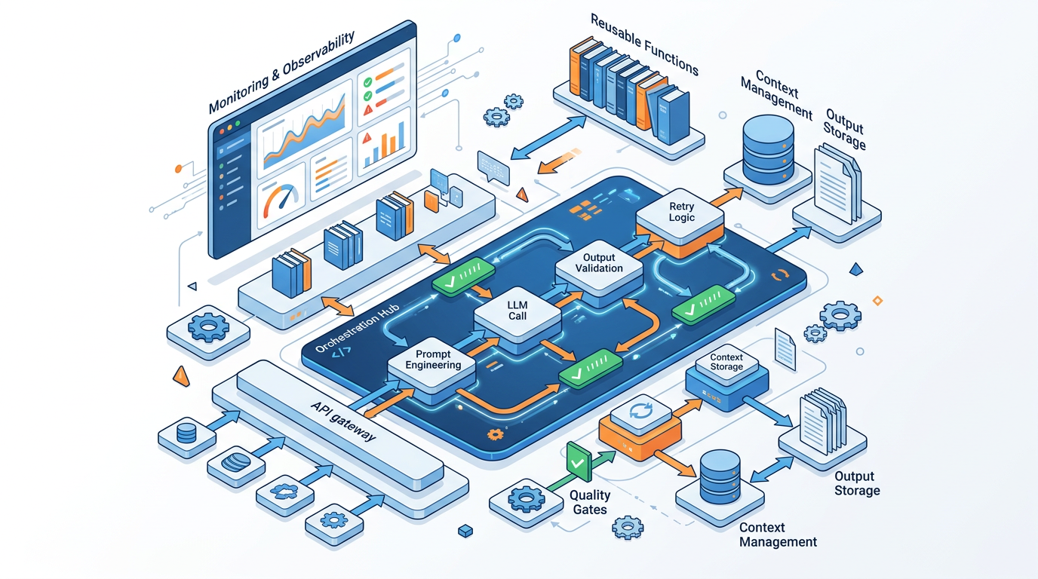

For teams building systematic AI workflows programmatically:
from openai import OpenAI
from typing import Callable

client = OpenAI()

class PromptPipeline:
"""
A sequential prompt pipeline that carries context between steps
and supports quality gate evaluation.

Example usage:
pipeline = PromptPipeline(model="gpt-4o")
pipeline.add_step("ideation", ideation_prompt)
pipeline.add_step("outline", outline_prompt,
gate=outline_gate_fn)
pipeline.add_step("draft", draft_prompt)
result = pipeline.run(
initial_input="Write about AI in healthcare")
"""

def __init__(self, model: str = "gpt-4o",
temperature: float = 0.7):
self.model = model
self.temperature = temperature
self.steps: list[dict] = []
self.outputs: dict[str, str] = {}
self.context_brief: str = ""

def set_context_brief(self, brief: str) -> None:
"""Set a persistent context brief injected at every step."""
self.context_brief = brief

def add_step(
self,
step_name: str,
prompt_template: str,
gate: Callable[[str], tuple[bool, str]] | None = None,
temperature: float | None = None
) -> None:
"""
Add a step to the pipeline.

Args:
step_name: Unique identifier for this step
prompt_template: Prompt text with {previous_output}
placeholder
gate: Optional quality gate function returning
(passed: bool, feedback: str)
temperature: Override temperature for this step
"""
self.steps.append({
"name": step_name,
"prompt_template": prompt_template,
"gate": gate,
"temperature": temperature or self.temperature
})

def _run_step(self, prompt: str, temperature: float) -> str:
"""Execute a single prompt and return the response."""
response = client.chat.completions.create(
model=self.model,
messages=[{"role": "user", "content": prompt}],
temperature=temperature
)
return response.choices[0].message.content

def run(self, initial_input: str,
max_gate_retries: int = 2) -> dict:
"""
Execute the full pipeline.

Args:
initial_input: The starting input for step 1
max_gate_retries: How many times to retry a failed
quality gate

Returns:
Dictionary of all step outputs
"""
current_input = initial_input

for step in self.steps:
print(f"\n{'='*50}")
print(f"STEP: {step['name']}")
print(f"{'='*50}")

# Build prompt with context brief and previous output
prompt = f"{self.context_brief}\n\n" \
f"{step['prompt_template']}".format(
previous_output=current_input
)

retries = 0
while True:
output = self._run_step(prompt, step["temperature"])
print(f"Output preview: {output[:200]}...")

# Run quality gate if defined
if step["gate"]:
passed, feedback = step["gate"](output)
if passed:
print("✅ Quality gate PASSED")
break
elif retries < max_gate_retries:
print(f"⚠ Quality gate FAILED: {feedback}")
print(f"Retrying... ({retries + 1}/"
f"{max_gate_retries})")
prompt += (
f"\n\nPREVIOUS ATTEMPT FEEDBACK: "
f"{feedback}\nPlease address this in "
"your revised output."
)
retries += 1
else:
print(
f"❌ Quality gate failed after "
f"{max_gate_retries} retries. "
"Proceeding with best output."
)
break
else:
break # No gate — always proceed

self.outputs[step["name"]] = output
current_input = output

return self.outputs

# ── Example Gate Function ────────────────────────────────────
def check_has_sections(output: str) -> tuple[bool, str]:
"""
Simple quality gate: check that the output has at least 3
sections indicated by numbered points or headers.
"""
has_sections = (
output.count("\n\n") >= 3 or
any(f"{i}." in output for i in range(1, 6))
)
if has_sections:
return True, "Structure check passed"
return False, (
"Output appears to lack clear sections. Add numbered "
"sections or clear paragraph breaks."
)

# ── Example Pipeline Usage ───────────────────────────────────
if __name__ == "__main__":
pipeline = PromptPipeline(model="gpt-4o", temperature=0.7)
pipeline.set_context_brief(
"PROJECT: Blog post for a B2B SaaS marketing audience.\n"
"AUDIENCE: Marketing managers at 50-200 person tech companies.\n"
"TONE: Professional but conversational. First person. No buzzwords."
)

pipeline.add_step(
"ideation",
"Generate 3 unique angles for a blog post on this topic: "
"{previous_output}\n"
"For each angle: thesis (1 sentence) + hook (1 sentence) + "
"why it's original."
)

pipeline.add_step(
"outline",
"Using the best angle from: {previous_output}\n"
"Write a detailed 6-section outline with message headline titles.",
gate=check_has_sections
)

pipeline.add_step(
"draft",
"Write the full blog post from this outline: {previous_output}\n"
"Target 800 words. Follow the established tone exactly.",
temperature=0.8
)

results = pipeline.run("AI tools for B2B marketing teams")

print("\n\nFINAL OUTPUT:")
print(results["draft"])

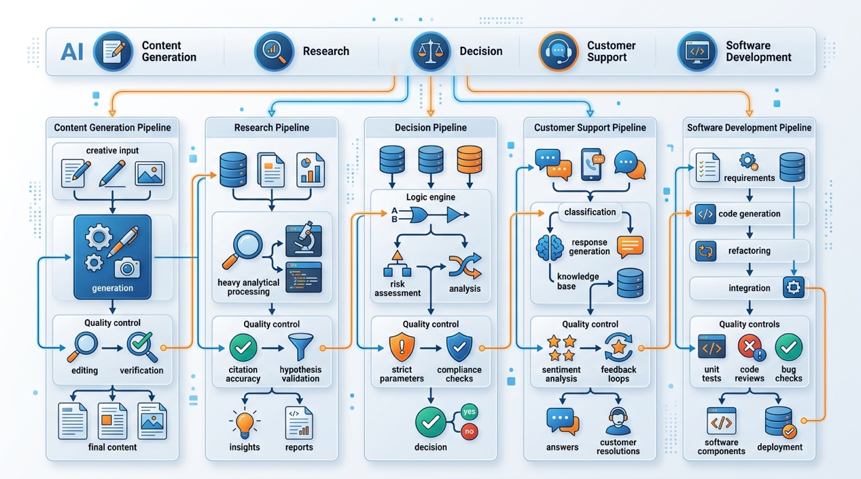

Hands-On Activities — Session 21

Activity 21.1 — Run the Content Production Pipeline
Objective: Experience a full 5-step sequential chain.
- Step 1: Choose a topic you know well and have a genuine opinion on.
- Step 2: Run all 5 steps of the Content Production Pipeline (Section 21.3) in sequence.
- Step 3: After each step, evaluate: Is this output good enough to feed into the next step? If not, revise before continuing.
Deliverable: A complete, polished 1,000-word LinkedIn article produced through the pipeline.
Reflection: At which step did quality improve the most? Which step was the most critical to get right?

Activity 21.2 — Design a Custom Pipeline
Objective: Build a multi-step pipeline for a recurring task in your role.
Think of any complex task you repeat regularly. Design a pipeline for it with:
- 4–6 steps
- Step name and purpose for each
- What gets carried forward from each step
- A quality gate for at least 2 steps (what you check and what constitutes a pass)
Write this as a reference document you could actually use.

Activity 21.3 — Parallel Chain Analysis
Objective: Experience the multi-perspective power of parallel chains.
Choose a strategic question facing your organization (or use: "Should a mid-size Indian IT services company expand into the US market?").
Run 3 simultaneous prompts, each with a different expert persona:
- CFO perspective (financial risk and return)
- Chief Strategy Officer perspective (market positioning and competitive dynamics)
- CHRO perspective (talent and organizational readiness)
Then run a synthesis step:
Given these three expert perspectives: [paste all three]
Synthesize into a unified recommendation that weighs all three
viewpoints.
Where perspectives conflict, acknowledge the tension and recommend
how to resolve it.

Activity 21.4 — Quality Gate Practice
Objective: Build quality gate checkpoints for a pipeline.
For the pipeline you designed in Activity 21.2, build a detailed quality gate for each identified checkpoint:
- 4–5 binary pass/fail criteria per gate
- Specific failure response (what to do if it fails)
- Maximum retries before accepting and moving on

Revision Questions — Session 21
- What are the 4 limitations of single complex prompts that multi-step pipelines solve?
- Describe the 4 chain architecture types. Give a professional use case for each.
- What is context injection and why is it the most important skill in pipeline design?
- What should always be carried forward between steps? What should never be carried forward?
- What is a quality gate? Describe where in a content pipeline you would place gates and what each would check.
- What is the difference between a sequential and a conditional chain? Give an example of when conditional branching is valuable.
- Describe the Content Production Pipeline. What does each of the 5 steps accomplish?
- A colleague complains that their AI pipeline produces great results in step 1 but the final output is poor. What are the most likely causes and what would you diagnose first?

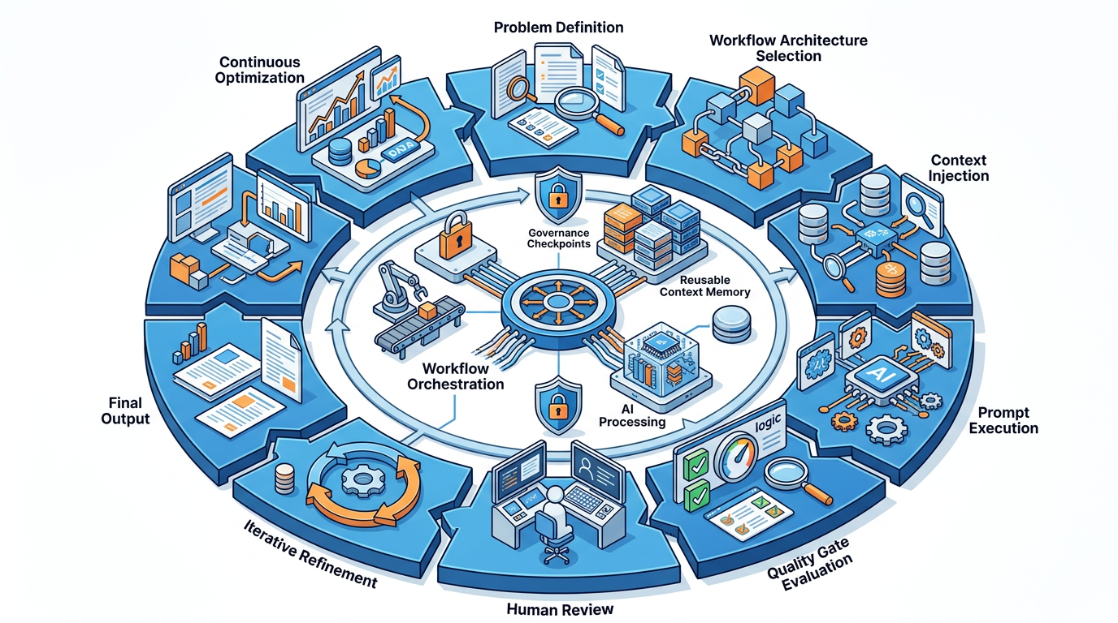

Key Takeaways — Session 21
SESSION 21 KEY TAKEAWAYS
✓ Multi-step chains solve attention dilution, error compounding, and unverifiable intermediate steps
✓ 4 chain types: Sequential | Parallel | Conditional | Iterative. Match the architecture to the task structure
✓ Context injection: carry project brief + constraints + previous step output at every step trim aggressively
✓ Quality gates are mandatory for professional pipelines — PASS/FAIL criteria at each critical step
✓ The Content Production Pipeline: 5 steps from idea to published LinkedIn article each step earns the right to the next
✓ Programmatic pipelines (Python) scale multi-step workflows across hundreds of inputs with consistent quality control

Session 21 Complete → Proceed to Session 22: Advanced Prompt Frameworks
Prompt Engineering Certification Program | UpSkill Global Education Technologies Inc., Canada

