
PROMPT ENGINEERING CERTIFICATION PROGRAM
MODULE 5 — ADVANCED PROMPT ENGINEERING

SESSION 24
Building a Professional Prompt Library

MODULE  5 of 6 | SESSION  24 of 30
DURATION  60–90 minutes | FORMAT  Instructor-Led + Practice
UpSkill Global Education Technologies Inc. Canada

SESSION OVERVIEW

Learning Objectives
By the end of this session, you will be able to:
- Design a comprehensive, scalable prompt library architecture
- Apply full metadata standards to every prompt entry
- Build a versioning and iteration tracking system for prompts
- Create team-level prompt governance and contribution workflows
- Measure prompt library ROI and library health metrics
- Build a shareable prompt library that survives team member changes

24.1 Why Your Prompt Library is a Strategic Asset


A prompt library is not a collection of text files. Treated professionally, it is:
WHAT A PROMPT LIBRARY IS
✓ Institutional knowledge that doesn't leave when people do
✓ Consistent quality baseline across your entire team
✓ Time savings that compound with every new use
✓ A platform for systematic experimentation and improvement
✓ A competitive advantage — your library reflects your expertise

WHAT IT IS NOT
✗ A bookmark folder of prompts that happened to work once
✗ Something only you can understand or use
✗ A static collection that's never updated
✗ Informal Slack messages about "the prompt that worked"
✗ A dumping ground for every prompt ever tried

The difference between an amateur and a professional prompt library is documentation quality, versioning discipline, and governance.

24.2 Library Architecture — Complete Design


Folder and File Structure
PROMPT_LIBRARY/
│
├── _LIBRARY_INDEX.md ← Master list of all entries
├── _GOVERNANCE.md ← Rules, contribution process
├── _CHANGELOG.md ← Version history for library
│
├── 01_DAILY_OPERATIONS/
│ ├── daily_planning.md
│ ├── meeting_prep.md
│ ├── daily_capture.md
│ └── weekly_review.md
│
├── 02_WRITING/
│ ├── EMAIL/
│ │ ├── email_request.md
│ │ ├── email_followup_sequence.md
│ │ ├── email_apology.md
│ │ ├── email_bad_news.md
│ │ └── email_introduction.md
│ ├── REPORTS/
│ │ ├── report_structure_generator.md
│ │ ├── executive_summary.md
│ │ ├── variance_commentary.md
│ │ └── board_brief.md
│ └── CONTENT/
│ ├── linkedin_post.md
│ ├── blog_seo_workflow.md
│ └── content_calendar.md
│
├── 03_ANALYSIS/
│ ├── data_interpretation.md
│ ├── swot_analysis.md
│ ├── competitor_brief.md
│ ├── decision_matrix.md
│ └── root_cause_analysis.md
│
├── 04_RESEARCH/
│ ├── topic_orientation.md
│ ├── source_summarization.md
│ ├── multi_source_synthesis.md
│ └── research_to_action.md
│
├── 05_PRESENTATIONS/
│ ├── presentation_architecture.md
│ ├── slide_content_generator.md
│ ├── opening_hook_types.md
│ └── qa_preparation.md
│
├── 06_ROLE_SPECIFIC/
│ ├── HR/
│ ├── FINANCE/
│ ├── MARKETING/
│ ├── SALES/
│ └── CUSTOMER_SUCCESS/
│
├── 07_ADVANCED/
│ ├── chain_prompts/
│ ├── automation_ready/
│ └── rag_templates/
│
└── 08_ARCHIVED/
└── [deprecated prompts with retirement date and reason]

24.3 The Complete Prompt Entry Standard
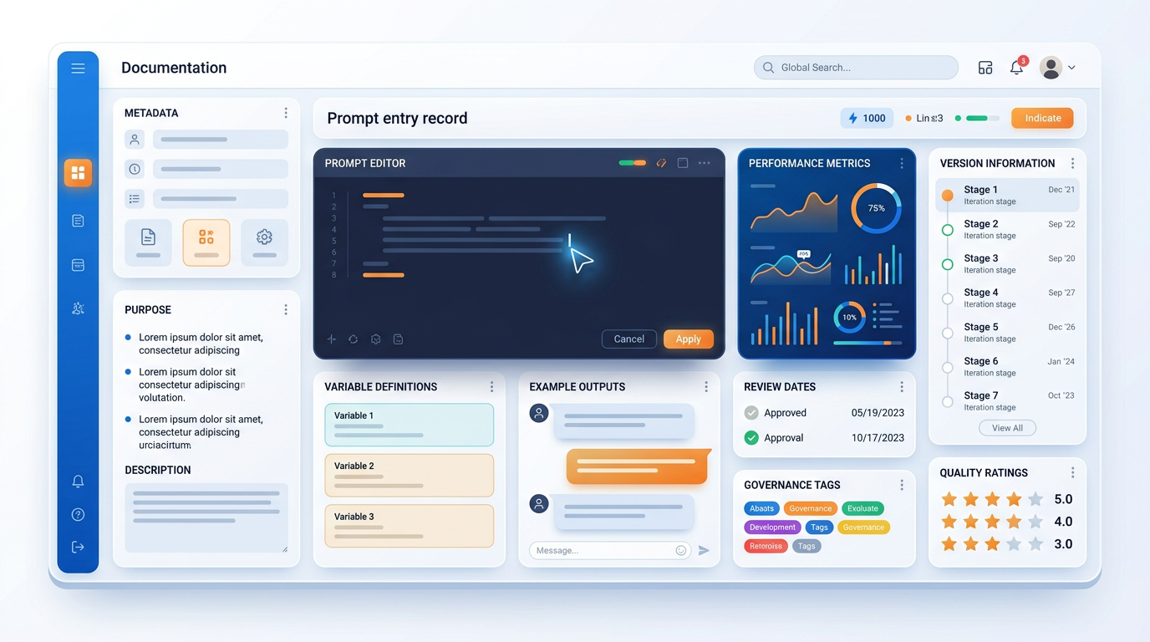
Every prompt in a professional library must follow this complete documentation standard.
══════════════════════════════════════════════════════════════════════════
PROMPT LIBRARY ENTRY — FULL STANDARD
══════════════════════════════════════════════════════════════════════════

## METADATA
────────────────────────────────────────────────────────────────────────
PROMPT-ID: [CATEGORY-SUBCATEGORY-NUMBER] e.g., WRITE-EMAIL-003
CATEGORY: [Main category]
SUBCATEGORY: [Specific subcategory]
NAME: [Descriptive name — clear enough for a new team member]
VERSION: [Semantic versioning: MAJOR.MINOR e.g., 2.1]
STATUS: [Active / Under Test / Deprecated]
CREATED BY: [Name]
CREATED DATE: [YYYY-MM-DD]
LAST MODIFIED: [YYYY-MM-DD]
LAST MODIFIED BY: [Name]
REVIEWED DATE: [YYYY-MM-DD — quarterly review]
NEXT REVIEW: [YYYY-MM-DD]

## PURPOSE
────────────────────────────────────────────────────────────────────────
[2–3 sentences describing:]
- What this prompt is designed to accomplish
- The professional situation where it should be used
- What problem it solves or time it saves

## TECHNIQUE CLASSIFICATION
────────────────────────────────────────────────────────────────────────
PRIMARY TECHNIQUE: [Zero-shot / Few-shot / CoT / Persona / Chain / RAG / ToT / APE]
SECONDARY TECHNIQUE: [If combination]
FRAMEWORK USED: [CRAFT / ReAct / Skeleton-of-Thought / Other]

## PERFORMANCE PROFILE
────────────────────────────────────────────────────────────────────────
SUCCESS RATE: [e.g., "~88% — produces usable output in most runs"]
AVG TIME SAVED: [e.g., "~25 minutes per use"]
TESTED ON MODELS: [GPT-4o / Claude 3.5 / Gemini Pro / etc.]
BEST MODEL: [Which model produces best results]
TOKEN ESTIMATE: [Input: ~X tokens | Output: ~Y tokens]
CONSISTENCY: [High / Medium / Low — how variable is output quality?]

## KNOWN LIMITATIONS
────────────────────────────────────────────────────────────────────────
[When does this prompt underperform? What inputs break it?
What situations require manual adjustment?]

## VARIABLES
────────────────────────────────────────────────────────────────────────
[VARIABLE_NAME] — Description | Example value | Required/Optional
[VARIABLE_NAME] — Description | Example value | Required/Optional
[...]

## THE PROMPT
────────────────────────────────────────────────────────────────────────
### SYSTEM PROMPT (if applicable):
[Paste system prompt here]

### USER PROMPT:
[Paste complete, ready-to-use prompt here with [VARIABLES] in brackets]

## EXAMPLE RUN
────────────────────────────────────────────────────────────────────────
### Example Input:
[What you would fill in for each variable]

### Example Output:
[Paste the best real output you've received from this prompt — or a
representative ideal output]

### Quality Rating: [X/5]
### Notes on this output: [What made this a good example]

## DO NOT USE WHEN
────────────────────────────────────────────────────────────────────────
[List specific situations where this prompt is inappropriate or
should be replaced with a different prompt]

## RELATED PROMPTS
────────────────────────────────────────────────────────────────────────
- [PROMPT-ID]: [Brief description of how it relates — often used before/after]
- [PROMPT-ID]: [...]

## ITERATION HISTORY
────────────────────────────────────────────────────────────────────────
v1.0 [date] [author]: Initial version — basic zero-shot approach
v1.1 [date] [author]: Added negative instructions to prevent generic openers
v1.2 [date] [author]: Added few-shot example after inconsistent tone
v2.0 [date] [author]: Major revision — switched to persona + CoT approach
Reason: v1.x producing inconsistent length; v2 much tighter
v2.1 [date] [author]: Minor — added word count constraint
══════════════════════════════════════════════════════════════════════════

24.4 The Library Index
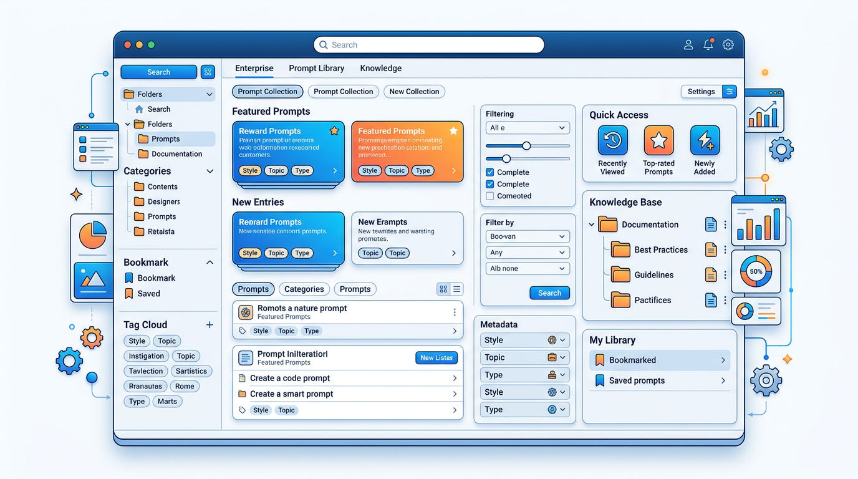

The LIBRARY INDEX.md is the master reference file the table of contents that lets anyone find the right prompt in under 30 seconds.
# PROMPT LIBRARY INDEX
Last updated: [DATE] | Total active entries: [N]

## QUICK FIND TABLE
| Prompt-ID | Name | Category | Technique | Use When | Status |
|-----------|------|----------|-----------|----------|--------|
| WRITE-EMAIL-001 | Professional Request Email | Writing/Email | Zero-shot | Sending a new request | Active |
| WRITE-EMAIL-002 | Follow-Up Sequence (3 levels) | Writing/Email | Zero-shot | No response received | Active |
| WRITE-EMAIL-003 | Apology Email | Writing/Email | Zero-shot | Service failure occurred | Active |
| ANAL-001 | SWOT Analysis Generator | Analysis | CoT + Persona | Strategic review | Active |
| ANAL-002 | Competitor Profile Brief | Analysis | Zero-shot | Competitive research | Active |
| PRES-001 | Presentation Architecture | Presentations | CoT | New presentation needed | Active |
| [...] | | | | | |

## BY USE CASE — QUICK REFERENCE

### I need to write an email...
- New request → WRITE-EMAIL-001
- Follow up on no response → WRITE-EMAIL-002
- Apologize for a mistake → WRITE-EMAIL-003
- Decline a request → WRITE-EMAIL-004
- Introduce two people → WRITE-EMAIL-005

### I need to analyze something...
- SWOT analysis → ANAL-001
- Competitive landscape → ANAL-002
- Data interpretation → ANAL-003
- Root cause of a problem → ANAL-004

### I need to create a presentation...
- Build the structure → PRES-001
- Write individual slides → PRES-002
- Prepare for Q&A → PRES-003

[Continue for each category...]

24.5 Versioning and Iteration Discipline
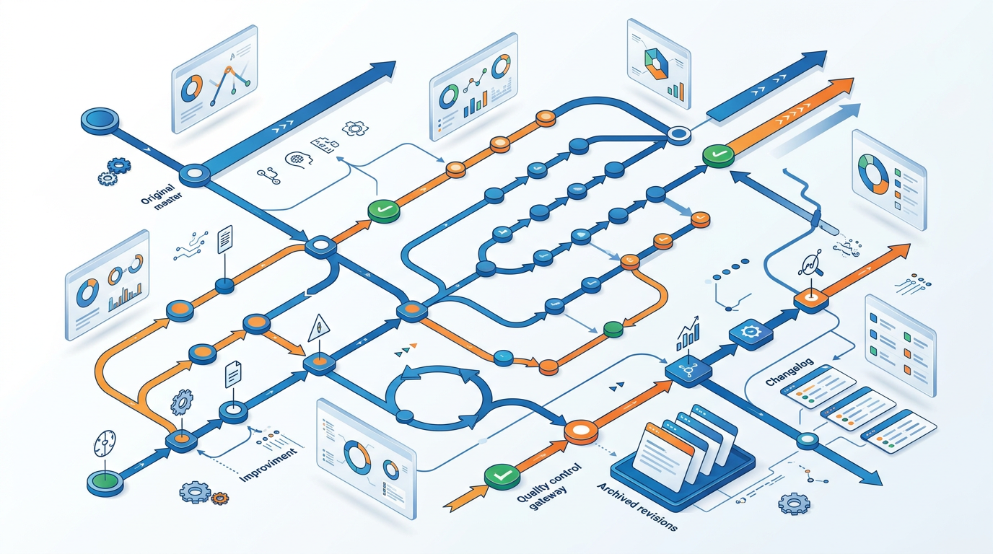
Semantic Versioning for Prompts
Adapt software semantic versioning (MAJOR.MINOR) for prompts:
VERSION NUMBERING:

MAJOR version bump (e.g., 1.x → 2.0):
→ Fundamental change in approach or technique
→ Output format changes significantly
→ Incompatible with previous use cases
→ Requires re-testing all existing use cases

MINOR version bump (e.g., 2.0 → 2.1):
→ Refinement within the same approach
→ Added constraint or instruction
→ Fixed a specific failure mode
→ Extended an example or added context
→ Output format unchanged; quality improved

The A/B Prompt Versioning Protocol
When you want to test whether a change improves a prompt, don't overwrite the current version:
STEP 1: Duplicate the current entry as v[N+1]-TEST
STEP 2: Make your change in the TEST version
STEP 3: Run both v[N] and v[N+1]-TEST on the same 5 test cases
STEP 4: Score both versions against the quality rubric
STEP 5: If v[N+1]-TEST wins: promote it (remove -TEST suffix, archive old version)
If v[N] wins: discard the test version, document what you learned
STEP 6: Add a line to the Iteration History explaining the test outcome

The “One Change at a Time” Rule
When iterating on a prompt, change exactly ONE element per iteration:
Iteration sequence for a prompt with tone problems:

v1.0 → v1.1: Added tone specification
(still inconsistent? now we know tone spec alone wasn't enough)

v1.1 → v1.2: Added persona role
(better? now we know persona helps)

v1.2 → v1.3: Added example of desired tone (few-shot)
(consistent now? great — this is the winner)

If you had changed all three at once, you'd never know which one fixed it.

24.6 Team Library Governance
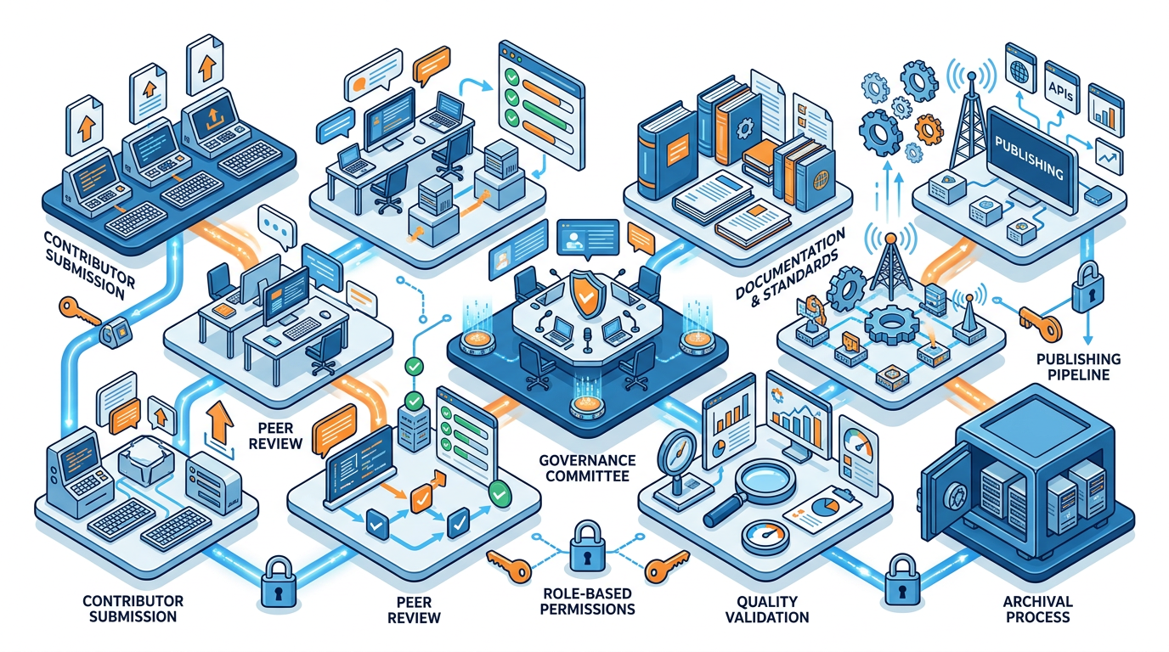
A team prompt library is a shared asset — it needs governance to stay useful.
Governance Document (GOVERNANCE.md)
# PROMPT LIBRARY GOVERNANCE

## OWNERSHIP
Library Owner: [Name, Role]
Backup Owner: [Name, Role]
Review Committee: [List of team members who review new entries]

## CONTRIBUTION PROCESS

### Adding a New Prompt
1. Use the standard entry template (copy from _TEMPLATE.md)
2. Complete ALL mandatory fields (metadata, purpose, performance, variables)
3. Include at least one tested example input and output
4. Submit for peer review: share with [reviewer name/channel]
5. Reviewer checks: completeness, quality, no duplicate exists, correct categorization
6. Owner approves and assigns a Prompt-ID
7. Add to _LIBRARY_INDEX.md under the correct category

### Modifying an Existing Prompt
1. Never modify Active entries directly — duplicate first
2. Version bump: MINOR for refinements, MAJOR for rewrites
3. Document the change in Iteration History
4. Test on at least 3 representative inputs before promoting
5. Update _LIBRARY_INDEX.md if name or use case changed

### Retiring a Prompt
1. Change status to DEPRECATED
2. Add DEPRECATED tag and date to entry header
3. Add note: "Replaced by [PROMPT-ID]" or "Use case no longer valid because..."
4. Move to /08_ARCHIVED/ folder
5. Update _LIBRARY_INDEX.md — remove from active list

Quality Standards
Every Active prompt must meet:
✓ Success rate ≥ 80% on representative test inputs
✓ Complete documentation (no empty mandatory fields)
✓ At least one real example run documented
✓ Iteration history showing at least v1.0 baseline

Review Schedule
- Individual prompts: Review every 6 months (or when AI models update significantly)
- Full library: Quarterly health check by Library Owner
- Ownership: Annual review of governance document

Privacy and Security Rules
✓ Never include real customer data in examples (anonymize)
✓ Never include employee personal data
✓ Never include proprietary business data in examples used for external sharing
✓ Prompts that process sensitive data must be flagged: [SENSITIVE DATA]
✓ System prompts used in production tools are confidential do not share externally

24.7 Library Health Metrics
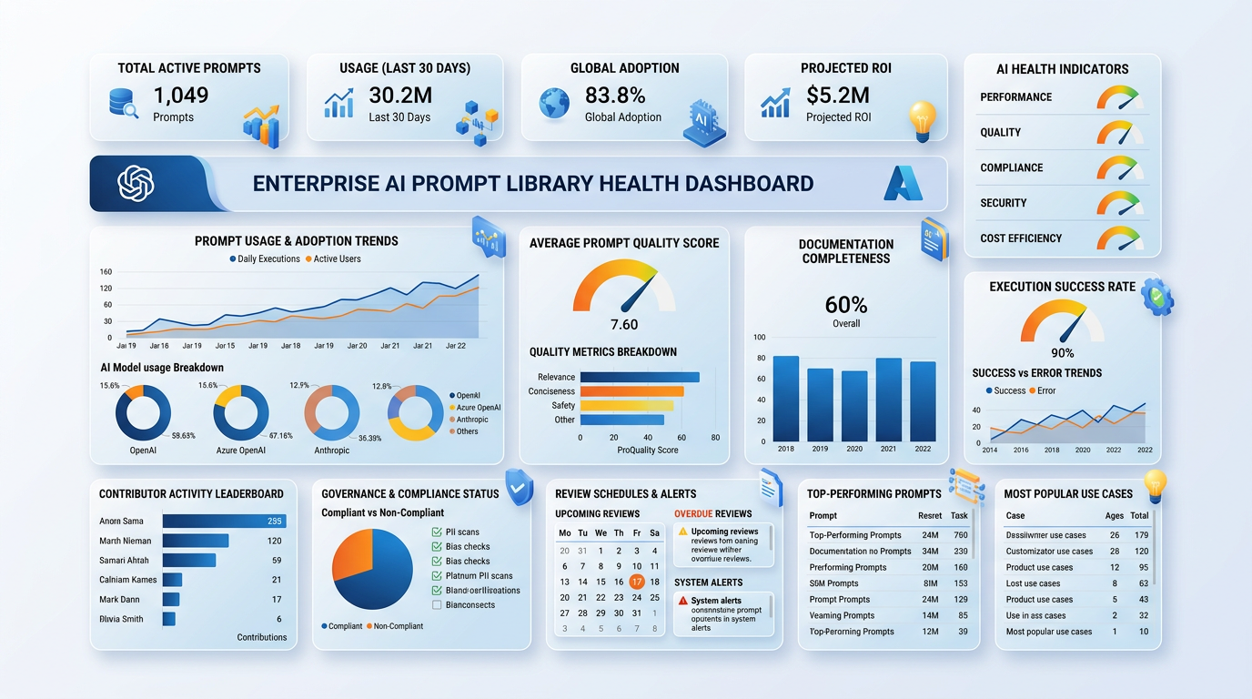
Measure whether your library is actually working.
LIBRARY HEALTH DASHBOARD — MONTHLY METRICS:

USAGE METRICS:
- Prompts in library (total): [N]
- Active prompts: [N] (target: >80% of library should be Active)
- Prompts used this month: [N] (low usage = either bad UX or bad prompts)
- Most-used prompt: [name] — [N uses]
- Least-used Active prompt: [name] (review for relevance)

QUALITY METRICS:
- Average success rate across library: [X%] (target: >80%)
- Prompts with documented examples: [X%] (target: 100%)
- Prompts overdue for review: [N] (target: 0)
- User-reported quality issues this month: [N]

CONTRIBUTION METRICS:
- New prompts added this month: [N]
- Prompts updated/versioned: [N]
- Prompts archived: [N]
- New contributors: [N]

ROI METRICS:
- Estimated weekly time saved (team): [hours]
- Most impactful prompt: [name] [estimated time saved/month]
- Library value this month: [hours × average hourly rate]

HEALTH SCORE = (Active% × 0.3) + (AvgSuccessRate% × 0.4) + (UsageRate% × 0.3)
Target health score: >75

24.8 Sharing and Scaling Your Library
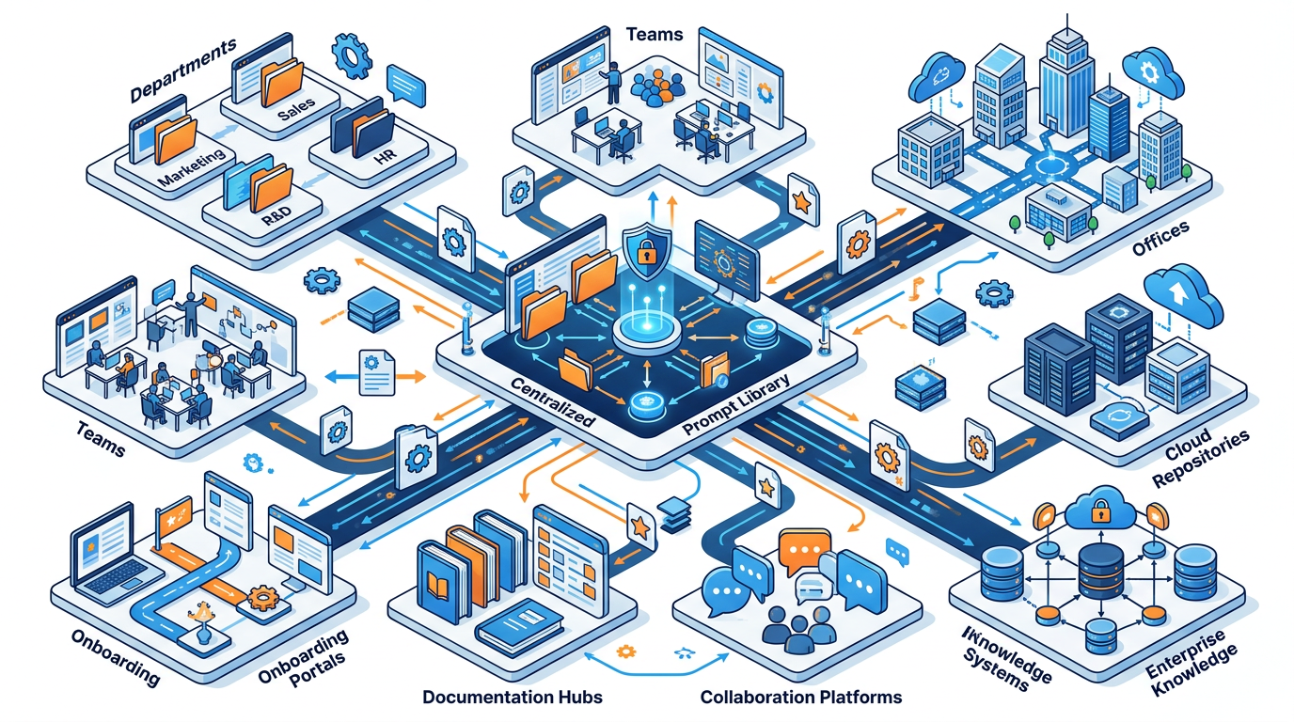

Formats for Different Team Sizes
TEAM SIZE | RECOMMENDED FORMAT | TOOL
1 to 3 people | Personal folder + backup | Obsidian, Notion, Google Docs
4 to 15 people | Shared wiki with search | Notion, Confluence, GitBook
15 to 50 people | Structured wiki + PR-style contribution | Confluence, Notion, GitHub
50+ people | Dedicated knowledge management tool | Custom app, SharePoint, internal tool

Converting Your Library for Sharing
When sharing your library with a new team or onboarding new members:
ONBOARDING PROMPT:

Here is our team prompt library structure and 3 sample entries:
[paste index + 3 best examples]

Help me create:
1. A 15-minute onboarding guide for new team members joining our library
2. A "Quick Start" card — the 5 most commonly needed prompts with brief usage notes
3. A FAQ for new contributors: "How do I add a prompt?" "What makes a good example?"
4. A first-week challenge: tasks for a new member to run 5 existing prompts and
submit their first new prompt to the library

Format each as a separate section clearly labeled.

Hands-On Activities — Session 24
Activity 24.1 — Library Audit
Objective: Evaluate the current state of your prompt collection.
Step 1: Collect all prompts you currently use regularly (from chat history, notes, documents, memory).
Step 2: For each, rate it on:
- Is it documented (not just in your head)? Y/N
- Does it have an example run? Y/N
- Do you know why it works? Y/N
- Could a colleague use it without your help? Y/N
- Does it have a versioned record of changes? Y/N
Step 3: Tally the score. Calculate: what percentage of your prompts meet professional library standards?
Goal: By end of this session, convert your 5 most-used prompts to full library standard.

Activity 24.2 — Build 5 Full Library Entries
Objective: Apply the complete entry standard to 5 real prompts.
Step 1: Identify your 5 most frequently used prompts.
Step 2: For each, complete the Full Prompt Entry Standard (Section 24.3) — every field.
Step 3: Create the _LIBRARY_INDEX.md file with all 5 entries in the Quick Find table.
Criteria for completion:
- All mandatory fields filled (no blanks)
- Real example input and output for each
- Iteration history showing at least 2 versions

Activity 24.3 — Governance Document
Objective: Write a governance document for your personal or team library.
Adapt the governance template from Section 24.6 for your actual situation:
- Solo practitioner: a personal discipline document (what rules you hold yourself to)
- Team setting: a full team governance document
Key decisions you must explicitly make:
- Who can add/modify/retire prompts?
- What is the minimum quality standard for a new entry?
- How often will you review the library?
- What privacy rules apply to examples?

Activity 24.4 — Library Health Baseline
Objective: Establish your library's health score.
Using the Library Health Dashboard from Section 24.7:
- Fill in all metrics for your current prompt collection
- Calculate your health score
- Identify the single metric that most needs improvement
- Set a specific 30-day goal for that metric

Revision Questions — Session 24
- Why is a prompt library described as a "strategic asset" rather than just a useful collection?
- Describe the complete folder architecture for a professional team prompt library.
- What 5 pieces of metadata must every prompt entry contain and why is each important?
- What is the difference between a MAJOR and MINOR version bump in prompt versioning? Give an example of each.
- Describe the "One Change at a Time" rule. Why is it critical for understanding what actually improved a prompt?
- What is the A/B prompt versioning protocol? Walk through all 6 steps.
- What is the "Contribution Process" for a team library? What happens between writing a prompt and it becoming Active?
- Describe the 5 key categories in the Library Health Dashboard and what target values indicate a healthy library.


SESSION 24 KEY TAKEAWAYS
✓ A professional library has: architecture, metadata standards, versioning discipline, governance, and health metrics
✓ Complete entry standard: 12 metadata fields + purpose + performance + variables + prompt + example + history
✓ Versioning: MAJOR = new approach; MINOR = refinement one change at a time, so you know what worked
✓ Team governance: clear ownership, contribution process, quality standards, review schedule, and privacy rules
✓ Library Index is the navigation layer without it, prompts can't be found and won't be used
✓ Health score: Usage + Quality + Contribution metrics combined target: >75 health score, >80% active, >80% success rate

Session 24 Complete → Proceed to Session 25: Responsible AI
Prompt Engineering Certification Program | UpSkill Global Education Technologies Inc., Canada

